

# 

# PRISMS Factsheet

# Indicative Allocations and Ministerial Direction 111

The Australian Government is committed to ensuring the quality, integrity and sustainability of Australia’s international education sector. Arrangements to improve the integrity and sustainability of the international education sector are set out in the *Education Services for Overseas Students Amendment (Quality and Integrity) Bill 2024*.

This Bill has not passed Parliament in time for arrangements to be implemented by 1 January 2025. The proposed legislative amendments are not in operation.

The Government will continue to manage the sector at sustainable levels and improve its quality and integrity. The Department of Education and Department of Employment and Workplace Relations have informed providers of their 2025 indicative new overseas student commencement (NOSC) allocations. These indicative allocations will now be used to guide the new prioritisation process for offshore student visa processing, under the new [Ministerial Direction 111](https://immi.homeaffairs.gov.au/news-media/archive/article?itemId=1282) which replaces Ministerial Direction 107 from 19 December 2024.

### Ministerial Direction 111 - Prioritisation Process

There will be more even access to offshore student visa processing through a new prioritisation approach, informed by consultation with the international education sector throughout 2024:

**Priority 1 – High** visa processing will apply to:

* Offshore student visa applications associated with providers who have approved Confirmation of Enrolments for up to 80 percent of their 2025 indicative allocation of New Overseas Student Commencements - referred to as a provider’s prioritisation threshold - for the following sectors:
  + Higher Education
  + Vocational education and training (VET)
* A range of cohorts, sectors and student types will also be allocated ‘Priority 1 – High’ processing. Please see [section 8 of Ministerial Direction 111](https://immi.homeaffairs.gov.au/support-subsite/files/ministerial-direction-111.pdf) for a complete list.

**Priority 2 – Standard** visa processing will apply to providers who have reached their prioritisation threshold, subsequent entrants, and any other offshore Student visa application.

Provider’s Prioritisation Threshold

Providers have been advised of their 2025 indicative allocations, which are available from the following websites and available from the Summary sheet in a providers New Overseas Student Commencement (NOSC) Identification Export report in PRISMS:

* [Indicative allocations for higher education new overseas student commencements 2025 - Department of Education, Australian Government](https://www.education.gov.au/international-education/resources/indicative-allocations-higher-education-new-overseas-student-commencements-2025) and
* [Indicative allocations for VET new overseas student commencements 2025 - Department of Employment and Workplace Relations, Australian Government](https://www.dewr.gov.au/international-skills-engagement/resources/indicative-allocations-vet-new-overseas-student-commencements-2025)​

The terms ‘prioritisation threshold’ and ‘New Overseas Student Commencement’ (NOSC) are defined at sub section 6 (1) of [Ministerial Direction 111](https://immi.homeaffairs.gov.au/support-subsite/files/ministerial-direction-111.pdf).

### New Overseas Student Commencements (NOSCs)

An international student will count as a New Overseas Student Commencement (NOSC) when they are onshore and start their first non-exempt course at their first provider. This includes each time the student changes into a non-exempt course at a different provider. Students who move courses within a provider or commence a subsequent course at the same provider immediately after the first course, will not be counted as an additional NOSC (they are deemed ‘continuing students’).

Indicative allocations for higher education and vocational education and training providers are at the following links and in the ‘Summary sheet’ tab of the NOSC Identification Export report:

* [Indicative allocations for higher education new overseas student commencements 2025 - Department of Education, Australian Government](https://www.education.gov.au/international-education/resources/indicative-allocations-higher-education-new-overseas-student-commencements-2025)
* [Indicative allocations for VET new overseas student commencements 2025 - Department of Employment and Workplace Relations, Australian Government](https://www.dewr.gov.au/international-skills-engagement/resources/indicative-allocations-vet-new-overseas-student-commencements-2025)

##### Categories that are not defined as NOSCs

The following categories of students are **not** defined as a NOSC and will **not** count as part of a provider’s use of their indicative allocations:

* Schools
* Students studying standalone ELICOS courses
* Higher degree by research students
* Non-award students, including short term exchange students
* Students awarded [scholarships](https://www.education.gov.au/international-education/resources/factsheet-scholarship-holders) including from foreign governments, multilateral organisations and Australian governments
* Students that are part of an Australian [Transnational Education (TNE) arrangement](https://www.education.gov.au/international-education/resources/factsheet-definition-students-certain-transnational-education-programs)
* Students from the Pacific and Timor Leste
* Students in pilot training courses.

Scholarship and transnational education arrangements (TNE) are currently manually collected from higher education providers (and will also similarly be collected from VET providers) and uploaded into PRISMS. Data collected from providers in November 2024 and January 2025 has been applied to PRISMS and can be accessed from the NOSC Identification Export report. Instructions will be available on the Department of Education website (and linked to the Department of Employment and Workplace Relations website) from early 2025 on how to submit information on TNE students and scholarship holders**.**

**New Overseas Student Commencement (NOSC) Identification Export report**

* Data in this report lists all a provider’s approved Confirmation of Enrolments (CoE) for 2025.
* The report identifies which CoEs are defined as NOSCs for 2025 and are therefore counted towards the provider’s use of their indicative allocations for 2025.
* The report also identifies CoEs that are **exempt** from NOSC, and therefore are **not** counted towards the provider’s use of their indicative allocations for 2025.
* For each CoE listed, the report identifies student information, if it is counted as a NOSC, or if it is exempt and not counted as a NOSC including the exemption reason. However, the data contained in this report is **indicative only** as it may not contain all up to date exemptions, such as for foreign government scholarship and transnational education program arrangements, which are currently collected manually from providers.

##### How do I access the report?

## Navigate to the left-hand menu, and select ‘Reports’

## The list of available Exports and Reports will be displayed

## Under the ‘Data Exports’ folder, scroll down and select the ‘New Overseas Student Commencement (NOSC) Identification Export’ report

## Once the NOSC Identification Export report is selected, details about the report will display in the section to the left of the ‘Select a report’ section.

## Select ‘Generate Report’ to create a full downloadable Microsoft Excel copy of the report. The ‘Generate Comma-Separated’ to create a partial downloadable CSV version of the file.

*Please note* - the difference between the Excel and Comma-Separated (CSV) files is that the Excel file includes three tabs and the CSV file only includes one. The Excel file has the ‘Purpose Statement’ which is a cover sheet with explanatory information about the report, the ‘Summary’, which includes provider indicative allocation information, and the ‘NOSC Details’ which is the report containing all CoEs and detail on the NOSC status. The Comma-Separated (CSV) file only has the ‘NOSC Details’ of the report.

**How to access the New Overseas Student Commencement (NOSC) Identification Export report from PRISMS:**

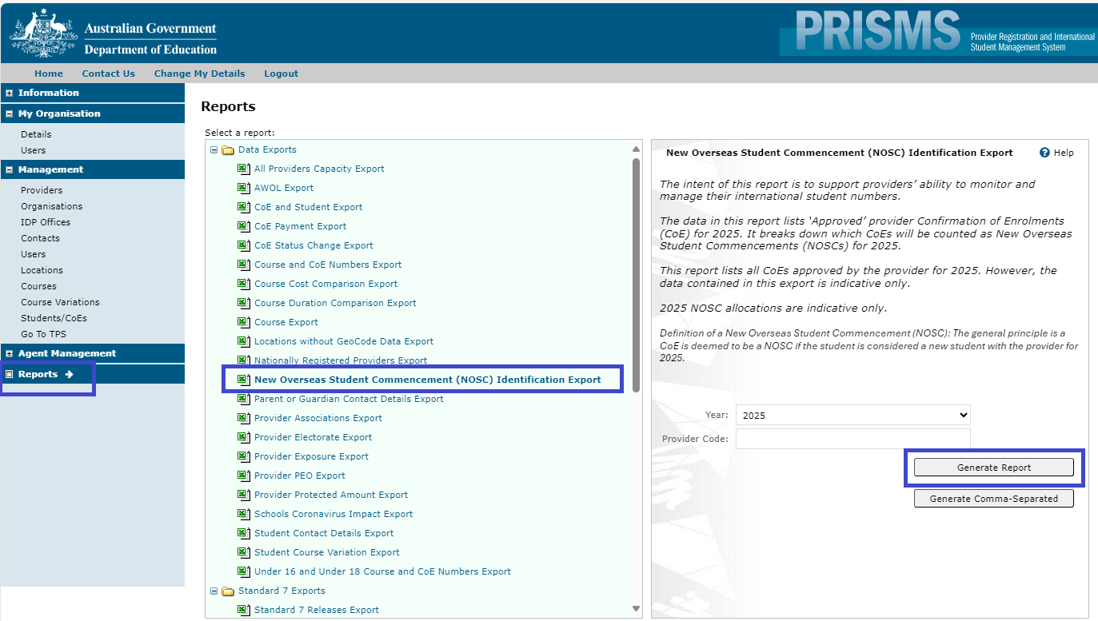

Figure 1. Generate NOSC Identification Export Report

How to calculate an *estimated prioritisation threshold using the NOSC Identification Export report

To calculate an \***estimated** prioritisation threshold, providers should download the NOSC Identification Export report (Excel version) in PRISMS and identify the following data points:

* **NOSC Details Tab** – ‘Visa Status’ and ‘Will NOSC Apply’ columns
* **Summary Tab** - ‘Indicative Allocation’ column

The **estimated** prioritisation threshold is calculated by identifying the total ‘Will NOSC Apply’ CoEs that have a visa ‘In Effect’ and dividing by the indicative allocation.

**Step 1**

On the NOSC Details sheet, count the number of CoEs where:

* ‘*Will NOSC Apply*’ is ‘*Yes’* **and**
* ‘*Visa Status*’ is *‘*In Effect*’

**Step 2**

Divide this count by the ‘*Indicative Allocation*’ figure on the Summary sheet.

For the below example, the calculation is:

***3*** *(‘Will NOSC Apply’ with a visa ‘In Effect’),* ***divided*** *by* ***20*** *(‘Indicative Allocation’) =* ***0.15*** *(15% = under 80% threshold)*

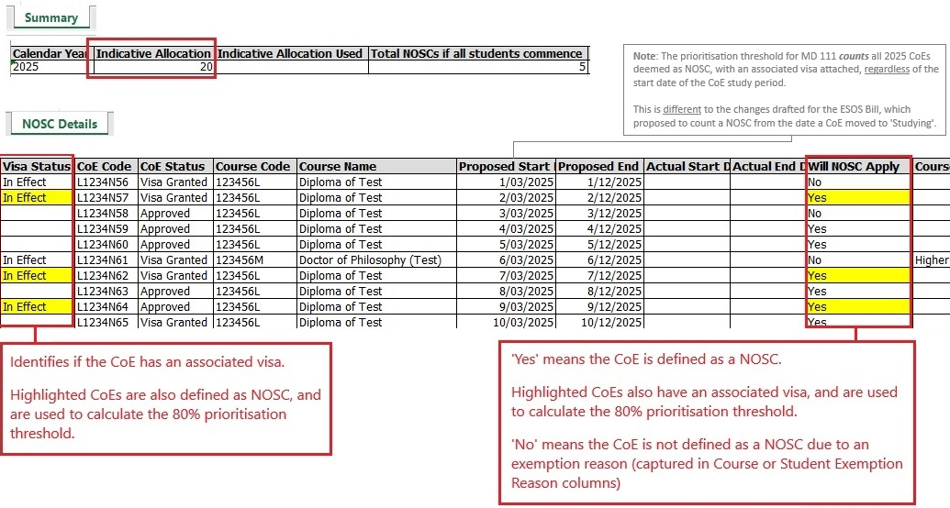

Figure 2. Identify data points

The above calculation will generate an \***estimated** calculation of a provider’s prioritisation threshold. This calculation may not replicate all CoEs used in the prioritisation threshold used by the Department of Home Affairs.

This is because some very uncommon scenarios are not currently captured in the NOSC Identification Export report, and therefore some CoEs will not be captured in the above calculation instructions. The NOSC Identification Export report will be updated soon to provide all data points required to easily replicate the prioritisation threshold percentage used by the Department of Home Affairs.

In the meantime, to identify allscenarios and CoEs included in the calculation of the prioritisation threshold, providers can use a combination of data from the NOSC Identification Export report and the CoE and Student Export report which contains more detailed visa status and visa end date data.

Appendix A of this factsheet provides step by step instructions on how to merge the information from the two reports to replicate the data used to calculate the prioritisation threshold percentage.

## Further Information

To access further information, please see the following resources:

*Department of Home Affairs*

* [Ministerial Direction No. 111 – Department of Home Affairs, Australian Government](https://immi.homeaffairs.gov.au/news-media/archive/article?itemId=1282)

*Department of Education*

* [Supporting a Sustainable International Education Sector - Department of Education, Australian Government](https://www.education.gov.au/international-education/supporting-sustainable-international-education-sector)

*Department of Employment and Workplace Relations*

* [Indicative allocations for VET new overseas student commencements 2025 - Department of Employment and Workplace Relations, Australian Government](https://www.dewr.gov.au/international-skills-engagement/resources/indicative-allocations-vet-new-overseas-student-commencements-2025)
* [Factsheet – Definition of students of certain transnational education programs - Department of Employment and Workplace Relations, Australian Government](https://www.dewr.gov.au/international-skills-engagement/resources/factsheet-definition-students-certain-transnational-education-programs)

**Appendix A**

How to calculate the prioritisation threshold using the NOSC Identification Export and CoE and Student Export report

The following instructions will modify the NOSC Identification Export report to incorporate more detailed CoE and Student Export report visa status and visa end data, to identify all CoEs that are included in the calculation to determine a provider’s prioritisation threshold.

A recording is available on the Department website to guide providers through the following instructions.

**Step 1**

***Download and prepare the NOSC Identification Export and the CoE and Student Export report for analysis.***

When downloading the ‘CoE and Student Export’ report, set date range to ‘Proposed Dates’ with proposed date from ‘01/01/2025’:

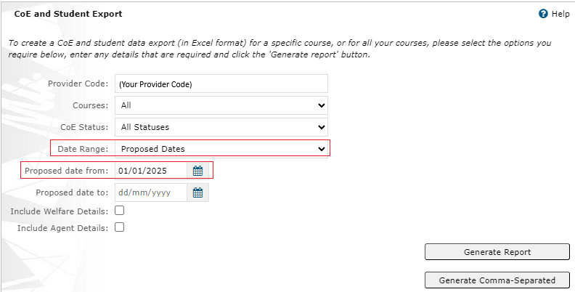

Figure 3. Generate CoE Student Export report

**Step 2**

***Copy the CoE and Student Export Report data to the New Overseas Student Commencement (NOSC) Identification Export.***

**Both reports must be open.**

1. In the ‘CoE and Student’ export, right click the ‘CoE and Student Export’ in the bottom left and click ‘Move or Copy…’
2. In the pop-up box, select the New Overseas Student Commencement (NOSC) Identification Export file under ‘To book’, then click ‘(move to end)’ under ‘Before sheet’, then click ‘OK’

**Step 3**

***Create prioritisation threshold indicator***

To prepare the data to identify all CoEs that are included in the Prioritisation Threshold calculation, make the following amendments to the NOSC Details tab in the NOSC Identification Export report.

1. Insert three columns after column D [Visa Status] in the NOSC Details tab:
   1. Column E: Visa Grant Status (new)
   2. Column F: Visa End Date
   3. Column G: Prioritisation Threshold Indicator
2. Add a new column after 'Actual Start Date' in the NOSC details tab
3. In O6 add the following formula, ensuring there are no spaces at the end of the formula, and extend the formula to the last row by double clicking the box in the bottom right corner of the cell

=IFERROR(DATEVALUE(N6), "")

1. Using formulas, we will insert the following columns from the CoE and Student Export ‘Visa Grant Status’ (column BO) and ‘Visa End Date’ (column BT) into Column E and F for CoEs in the NOSC Details tab.
   1. In cell E6 add the following formula, ensuring there are no spaces at the end of the formula, and extend the formula to the last row by double clicking the box in the bottom right corner of the cell

=XLOOKUP(H6, 'CoE and Student Export'!B:B, 'CoE and Student Export'!BO:BO)

* 1. In cell F6 add the following formula, ensuring there are no spaces at the end of the formula, and extend the formula to the last row by double clicking the box in the bottom right corner of the cell

=XLOOKUP(H6, 'CoE and Student Export'!B:B, 'CoE and Student Export'!BT:BT)

**Step 4**

***Count the CoEs included in the Prioritisation Threshold calculation***

To identify all CoEs that are included in the Prioritisation Threshold calculation, make the following calculations:

Count the number of CoEs where:

1. ‘Actual NOSC applied’ is ‘Yes’ AND
2. ‘Visa status’ (Column E) is not blank AND
3. Is the Visa End date (column F) on or after the CoEs actual start date (column O)'

AND add the number of CoEs where:

1. ‘Will NOSC Apply’ is ‘Yes’ AND
2. Actual NOSC applied is ‘No’ AND
3. ‘Visa Status’ is ‘In Effect’ or ‘Cancellation overturned’

This can be done using the following formula

1. In cell G6 add the following formula, ensuring there are no spaces at the end of the formula, and extend the formula to the last row by double clicking the box in the bottom right corner of the cell

=IF(AND(V6="Yes", ISBLANK(E6)=FALSE, F6>=O6), "Yes", IF(AND(Q6="Yes", V6="No", OR(E6="In Effect", E6="Cancellation Overturned")), "Yes", "No"))

1. Column G will now indicate the number of CoEs counting towards your Visa Prioritisation allocation when filtered to ‘Yes’

**Step 5**

***Calculation prioritisation percentage***

Take the amount of ‘Yes’ records in Column G and divide this by the indicative allocation to work out the prioritisation threshold.

If the value is greater than or equal to 0.8 (80%), your provider has met or exceeded the prioritisation threshold.