

# 

# PRISMS Factsheet

# Indicative Allocations and Ministerial Direction 111

The Australian Government is committed to ensuring the quality, integrity and sustainability of Australia’s international education sector. Arrangements to improve the integrity and sustainability of the international education sector are set out in the *Education Services for Overseas Students Amendment (Quality and Integrity) Bill 2024*.

This Bill has not passed Parliament in time for arrangements to be implemented by 1 January 2025. The proposed legislative amendments are not in operation.

The Government will continue to manage the sector at sustainable levels and improve its quality and integrity. The Department of Education and Department of Employment and Workplace Relations have informed providers of their 2025 indicative new overseas student commencement (NOSC) allocations. These indicative allocations will now be used to guide the new prioritisation process for offshore student visa processing, under the new [Ministerial Direction 111](https://immi.homeaffairs.gov.au/news-media/archive/article?itemId=1282) which replaces Ministerial Direction 107 from 19 December 2024.

### Ministerial Direction 111 - Prioritisation Process

There will be more even access to offshore student visa processing through a new prioritisation approach, informed by consultation with the international education sector throughout 2024:

**Priority 1 – High** visa processing will apply to:

* Offshore student visa applications associated with providers who have approved Confirmation of Enrolments for up to 80 percent of their 2025 indicative allocation of New Overseas Student Commencements (NOSCs) - referred to as a provider’s prioritisation threshold - for the following sectors:
  + Higher Education
  + Vocational education and training (VET)
* A range of cohorts, sectors and student types will also be allocated ‘Priority 1 – High’ processing. Please see [section 8 of Ministerial Direction 111](https://immi.homeaffairs.gov.au/support-subsite/files/ministerial-direction-111.pdf) for a complete list.

**Priority 2 – Standard** visa processing will apply to providers who have reached their prioritisation threshold, subsequent entrants, and any other offshore student visa application.

Provider’s Prioritisation Threshold

Providers have been advised of their 2025 indicative allocations, which are available from the following websites and available from the Summary tab in a providers New Overseas Student Commencement (NOSC) Identification Export report in PRISMS:

* [Indicative allocations for higher education new overseas student commencements 2025 - Department of Education, Australian Government](https://www.education.gov.au/international-education/resources/indicative-allocations-higher-education-new-overseas-student-commencements-2025) and
* [Indicative allocations for VET new overseas student commencements 2025 - Department of Employment and Workplace Relations, Australian Government](https://www.dewr.gov.au/international-skills-engagement/resources/indicative-allocations-vet-new-overseas-student-commencements-2025)​

The terms ‘prioritisation threshold’ and ‘New Overseas Student Commencement’ (NOSC) are defined at sub section 6 (1) of [Ministerial Direction 111](https://immi.homeaffairs.gov.au/support-subsite/files/ministerial-direction-111.pdf).

### New Overseas Student Commencements (NOSCs)

An international student will count as a New Overseas Student Commencement (NOSC) when they are onshore and start their first non-exempt course at their first provider. This includes each time the student changes into a non-exempt course at a different provider. Students who move courses within a provider or commence a subsequent course at the same provider immediately after the first course, will not be counted as an additional NOSC (they are deemed ‘continuing students’).

##### Categories that are not defined as NOSCs

The following categories of students are **not** defined as a NOSC and will **not** count as part of a provider’s use of their indicative allocations:

* Schools
* Students studying standalone ELICOS courses
* Higher degree by research students
* Non-award students, including short term exchange students
* Students awarded [scholarships](https://www.education.gov.au/international-education/resources/factsheet-scholarship-holders) including from foreign governments, multilateral organisations and Australian governments
* Students that are part of an Australian [Transnational Education (TNE) arrangement](https://www.education.gov.au/international-education/resources/factsheet-definition-students-certain-transnational-education-programs)
* Students from the Pacific and Timor Leste
* Students in pilot training courses.

Scholarship holders and transnational education arrangements (TNE) are currently manually collected from higher education providers (and will also similarly be collected from VET providers) and uploaded into PRISMS fortnightly. Instructions will be available on the Department of Education website (and linked to the Department of Employment and Workplace Relations website) from early 2025 on how to submit information on TNE students and scholarship holders.

**New Overseas Student Commencement (NOSC) Identification Export report**

* The Summary tab now includes a provider’s offshore visa processing prioritisation percentage and Priority Status under Ministerial Direction 111.
* Data in this report lists a provider’s approved Confirmation of Enrolments (CoEs) for 2025.
* The NOSC Details tab identifies which CoEs are defined as NOSCs for 2025 and now identifies CoEs counted towards the prioritisation threshold calculation for the provider.
* The report also identifies CoEs that are **exempt** from being deemed a NOSC, and therefore are **not** counted towards the provider’s use of their indicative allocations for 2025.
* For each CoE listed, the report identifies student information, if it is counted as a NOSC, or if it is exempt and not counted as a NOSC including the exemption reason. However, the data contained in this report is **indicative only** as it may not contain all up to date exemptions, such as for foreign government scholarship and transnational education program arrangements, which are currently collected manually from providers.

##### How do I access the report?

## Navigate to the left-hand menu, and select ‘Reports’

## The list of available Exports and Reports will be displayed

## Under the ‘Data Exports’ folder, scroll down and select the ‘New Overseas Student Commencement (NOSC) Identification Export’ report

## Once the NOSC Identification Export report is selected, details about the report will display in the section to the left of the ‘Select a report’ section.

## Select ‘Generate Report’ to create a full downloadable Microsoft Excel copy of the report. The ‘Generate Comma-Separated’ to create a partial downloadable CSV version of the file.

*Please note* - the difference between the Excel and Comma-Separated (CSV) files is that the Excel file includes three tabs and the CSV file only includes one. The Excel file has the ‘Purpose Statement’ which is a cover sheet with explanatory information about the report, the ‘Summary’, which includes provider indicative allocation information, and the ‘NOSC Details’ which is the report containing all CoEs and detail on the NOSC status. The Comma-Separated (CSV) file only has the ‘NOSC Details’ of the report.

How to access the New Overseas Student Commencement (NOSC) Identification Export report from PRISMS:

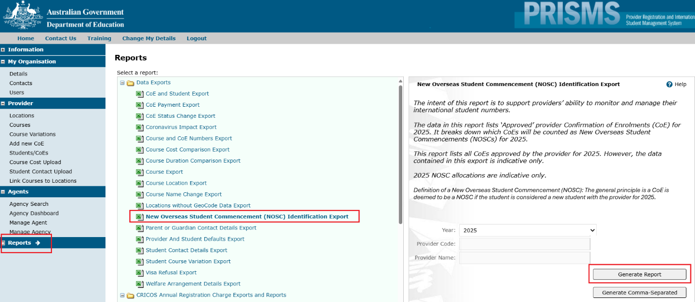

Figure 1. Generate NOSC Identification Export Report

Key data points relating to MD111 in the NOSC Identification Export report

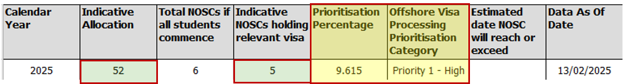

Figure 2. Summary tab now provides Prioritisation Percentage and Priority Category

Select the Summary tab to view the ‘Prioritisation Percentage’ and ‘Offshore Visa Processing Prioritisation Category’ for the provider (see yellow shaded cells).

The ‘Prioritisation Percentage’ is calculated by identifying the CoEs identified as NOSCs where a relevant visa is attached. This data is displayed in the ‘Indicative NOSCs holding relevant visa’ column (see second green shaded cell). Next, divide this count by the ‘Indicative Allocation’ (see first green shaded cell). This calculation replicates the data used by the Department of Home Affairs.

How to manually calculate the prioritisation threshold

To calculate the prioritisation threshold, providers should download the NOSC Identification Export report (Excel version) in PRISMS and identify the following data points from the Summary tab:

* ‘Indicative Allocation’ column
* ‘Indicative NOSCs holding relevant visa’ column

**Step 1**

* Divide the ‘*Indicative NOSCs holding relevant visa*’ count by the ‘*Indicative Allocation*’ figure.

For the below example, the calculation is:

* ***5*** *(‘Indicative NOSCs holding relevant visa’)*
* ***divided*** *by* ***52*** *(‘Indicative Allocation’)*
* *=* ***9.615*** *(9% = under 80% threshold)*

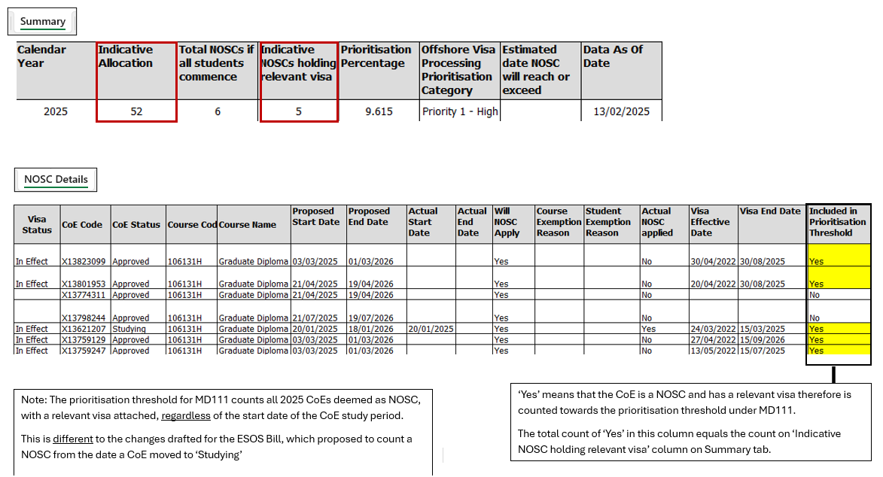

Figure 3. Identify data points

The above calculation will generate a provider’s prioritisation threshold. This calculation will replicate the ‘Prioritisation Percentage’ displayed on the Summary tab.

Scholarship holders and TNE arrangements, currently collected manually from providers, are added to this report fortnightly and shared with the Department of Home Affairs.

Please note – if you identify any discrepancies or inconsistencies with the data for your provider, please email: [PRISMS@education.gov.au](mailto:PRISMS@education.gov.au)

## Further Information

To access further information, please see the following resources:

*Department of Home Affairs*

* [Ministerial Direction No. 111 – Department of Home Affairs, Australian Government](https://immi.homeaffairs.gov.au/news-media/archive/article?itemId=1282)

*Department of Education*

* [Supporting a Sustainable International Education Sector - Department of Education, Australian Government](https://www.education.gov.au/international-education/supporting-sustainable-international-education-sector)
* F[actsheet – Definition of students of certain transnational education programs](https://www.education.gov.au/international-education/resources/factsheet-definition-students-certain-transnational-education-programs)
* [Factsheet - Scholarship holders](https://www.education.gov.au/international-education/resources/factsheet-scholarship-holders)

*Department of Employment and Workplace Relations*

* [Indicative allocations for VET new overseas student commencements 2025 - Department of Employment and Workplace Relations, Australian Government](https://www.dewr.gov.au/international-skills-engagement/resources/indicative-allocations-vet-new-overseas-student-commencements-2025)
* [Factsheet – Definition of students of certain transnational education programs - Department of Employment and Workplace Relations, Australian Government](https://www.dewr.gov.au/international-skills-engagement/resources/factsheet-definition-students-certain-transnational-education-programs)