**The Distributed and Networked University Collaboration (DNUC).**

**Executive Summary**

In this proposal we respond to several suggestions made in the Interim Report of the Universities Accord. Specifically, we argue that many of the suggestions could be acted upon through the development of the ‘Distributed and Networked University’.

We are proposing the Distributed and Networked University as an alternative to the new National Regional University. Rather than establish a new university, we envisage a new distributed infrastructure to allow students from disadvantaged backgrounds to be able to access courses offered by collaborating universities whose courses would be distributed more widely and effectively than at present.

Fully implementing this concept would embrace many of the excellent ideas for the future contained in the Interim Report of the Accord (IR), especially those that underpin the proposal for a National Regional University.

We also describe how the Distributed and Networked University could contribute to international education.

We also identify a major area which the IR has omitted, that of the need for the higher education sector to take urgent and serious action on climate change, and how the Distributed and Networked University might contribute in part to this.

**Our proposal relates to several recommendations** which we quote directly from the Report:

*“Extend visible, local access to tertiary education by creating further Regional University Centres (RUCs) and establish a similar concept for suburban/metropolitan locations.” (*Priority Action 1)

and

“*The Review considers there is merit taking this work forward, with the potential to establish a new National Regional University (NRU) which could have regional universities opt in to become part of the NRU.” (*3.1.1.6 A new National Regional University)

In addition:

*“The Review will explore the concept of Cooperative Skills Centres, linking higher education, VET and industry, as a way to develop new skills and qualification pathways in priority areas such as energy.” (*2.2.3 Moving towards an aligned tertiary system)

*“The Review considers the concept of the RUCs should be expanded to other areas of need, including outer suburban areas, where accessing higher education can also be difficult. While many prospective students in outer metropolitan and peri-urban areas have access to universities, including remotely through online delivery, such students typically seek to enrol internally at ‘local’ institutions.”* (2.3.2.3 Creating accessible places of learning for communities)

*“To meet student and industry demand, higher education providers need a more targeted approach to online delivery, designing content and learning activities with digital and hybrid delivery in mind. It will also need to draw from online resources and shared content repositories to keep pace with the most recent innovations in a field of study.”* (2.4.2.1 Utilising knowledge from across the sector, Australia and the world)

*“Improving online learning capability also presents an opportunity for Australia to expand its teaching footprint and reach new students and overseas markets. Current regulatory and policy settings are limiting innovation by restricting access to offshore online delivery for international students.”* (2.4.2.2 Embracing new tools and methods for teaching)

*“launching a competitive funding program across multiple institutions (universities and TAFEs) with material produced to be available under open access. This concept could be modelled in terms of collaboration and advisory boards on the ARC Centres of Excellence”* (2.4: Excellence in learning, teaching and student experience: Potential proposals)

*“promoting flexibility and innovation in international education, including digital and offshore delivery options”* (2.5.3 Leveraging research and international education to advance Australia’s interests: Considerations for change)

There are numerous references in the Interim Report to ‘collaboration’.

**The Distributed and Networked University Collaboration (DNUC).**

The partners of this initiative would be drawn mainly but not exclusively from regional universities (whose reservations on the proposed National Regional University are listed in the IR).

The main features of the proposed DNUC are consistent with the various chapter headings in the IR:

*Equity in participation, access and opportunity:*

* The DNUC would establish enrolment pathways for disadvantaged groups identified in the IR as having less access to higher education.
* Online resources and delivery are core, supported by physical hubs where face-to-face contact is necessary.
* The online nature of education delivery is scalable to allow for the proposed future increased need for university places.
* Delivery hubs would be both virtual and physical, and would include RUCs as well as outer metropolitan and peri-urban tertiary study hubs.
* Physical hubs are placed in local community and industry facilities, preferably not as new builds (saving funds and the environment).

*Excellence in learning, teaching and student experience:*

* In the DUNC partners populate repositories of educational resources including portions of courses which, if completed successfully, lead to the award of microcredits. The resources are published as open access under an appropriate Creative Commons licence.
* A system for peer review of the resources is developed to ensure quality and offer academic credit to the academics who provide them.
* Assessment is offered by the partners who provided the resources carrying microcredits
* Individual students enrol in the course of their choice, supported by RUCs and tertiary study hubs, who can also advise on how the microcredits may be used to build degrees in the partner universities.
* Partner universities collaborate and agree to recognise the microcredits towards their awards, even if not gained from their own courses

*Fostering international engagement*:

* The DNUC would host an online network for global education[1], based on materials in the repositories but supplemented by other materials, created by partners both from universities in Australia and the Global South. This would help correct the global inequalities in access to higher education which are not currently met by Australia’s international student programmes. This aspect of the DNUC would be an appropriate call on the proposed levy of income derived from international student fees.

**Figure taken from:** The Distributed and Networked University pivots to online delivery and is based in physical or virtual hubs that have strong community and industry links. The items above the horizontal line, in the top half of the figure, can address both geographical and socio-economic disadvan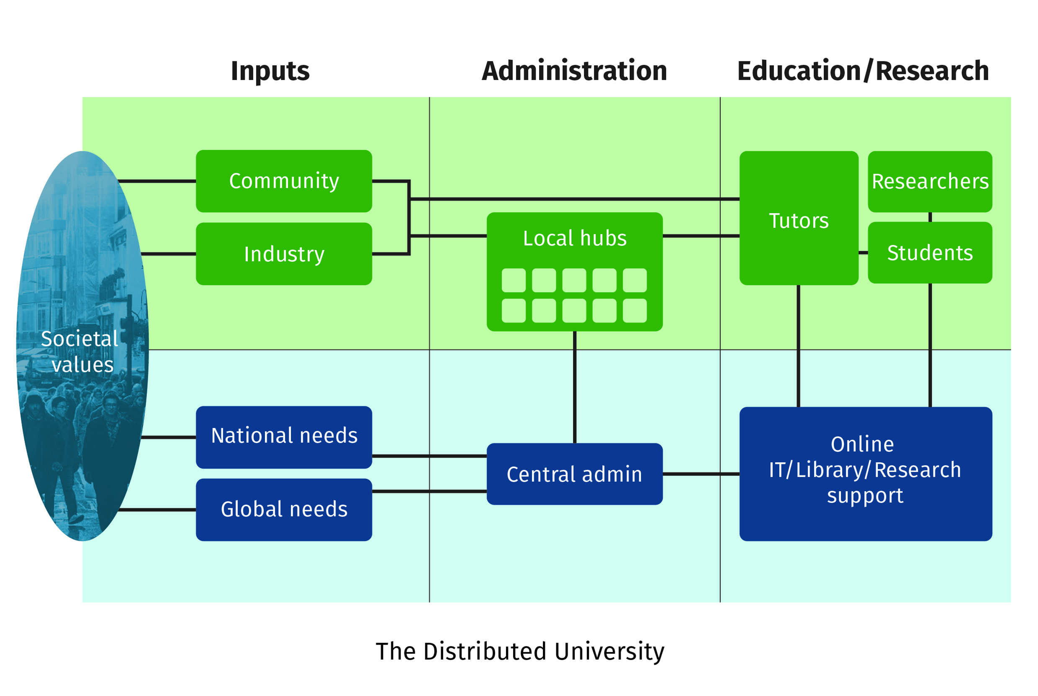tage.

**Missing from the Interim Report: Action on climate change**

*Institutional and collaborative governance*:

* Despite the mention of climate change in the IR, it contains no proposal that university reform should focus on reducing the sector’s carbon footprint. However, the proposed DNUC through its extensive use of online learning and community and industry facilities, would have a lower carbon footprint than that produced by the creation of more physical plant. We further propose that the Final Report should require universities to establish a sector-wide standardised and comprehensive system to measure, publicly report and act on greenhouse gas emissions from their activities. (Please see a separate submission on this topic, to which we have contributed.)

**Note 1: Distributed *and*** **Networked**

We have included both terms in the title as they have distinct meanings although they have features in common and are each appropriate for the digital age.

Distributed education offers education where it is needed, over time and place to reduce local and global inequalities in access. It has been defined to occur “...when the teacher and student are situated in separate locations and learning occurs through the use of technologies (such as video and internet), which may be part of a wholly distance education programme or supplementary to traditional instruction.[2]”

Networking requires collaboration between institutions, as in this definition of networked learning: “Networked learning involves processes of collaborative, co-operative and collective inquiry, knowledge-creation and knowledgeable action, underpinned by trusting relationships, motivated by a sense of shared challenge and enabled by convivial technologies. Networked learning promotes connections: between people, between sites of learning and action, between ideas, resources and solutions, across time, space and media.[3]”

**Note 2: Online or face-to-face**

There is a large literature which concludes that online does not result in worse educational outcomes than face-to-face learning. Despite this, students are reported to be keen to return to their traditional campuses after experiencing online education during the COVID-19 epidemic[4]. Reported reasons include a desire to resume in-person learning and socialisation. Countering this are the pictures of empty lecture theatres that populate social media, the context of urgent transit to the online mode at the start of the epidemic which limited the adoption of best practice methods, and the availability of modern communication and collaboration technology to facilitate socialisation. Given the other benefits as presented here, we suggest that a pivot to online learning should be pursued.

**In conclusion**

We find many of the proposals in the IR to which we refer to be exciting and innovative and agree that they could lead to important reform of the sector. Our overarching proposal for the establishment of the Distributed and Networked University Collaboration (DNUC) would support many of these proposals and provide a framework to put them into practice. We would be very happy to provide more detail and discuss further.

**This submission is from**: Richard Heller, Emeritus Professor of Medicine, University of Newcastle, NSW and of Public Health, University of Manchester, UK, and Stephen Leeder AO, Emeritus Professor of Public Health and Community Medicine, University of Sydney.

1. How Australian universities could stop inequality and save the planet in one easy move. <https://www.aare.edu.au/blog/?p=14344>
2. Distributed learning. <https://www.qualityresearchinternational.com/glossary/distributededucation.htm>
3. Networked Learning: Inviting Redefinition. <https://link.springer.com/article/10.1007/s42438-020-00167-8>
4. Students returning to campus want the ‘university experience’ missed during COVID-19. <https://theconversation.com/students-returning-to-campus-want-the-university-experience-missed-during-covid-19-186507>