Briefing note in response to the Australian Universities Accord Discussion Paper;

Research translation and impact:

The discussion paper highlights Australia’s high concentration of investment in pure basic and strategic basic research relative to many comparable countries which have higher concentrations of investment in applied research and experimental development. Given this pattern of investment Australia has for many years scored poorly compared to OECD peers in international innovation rankings such as the Global Innovation Index.

The discussion paper also notes that the synergies between industry and universities are not extensive, despite long-running grant programs such as the ARC Linkage grants, NHMRC Partnership grants and programs which incentivise collaboration such as the Cooperative Research Centres program. The paper poses the question as to whether universities should do more experimental development and applied research, and goes on to ask “fundamental questions” about how the impact and relevance of research in the Australian higher education sector can be best ensured and enhanced –in particular, whether the current arrangements provide sufficient focus on quality, opportunity to focus on clear missions of national importance, and support for the specialisation of different institutions across Australian higher education.

It is likely that you will receive many submissions that argue the case for “full funding” of research reflecting the legitimate challenges faced by Universities in building and sustaining research infrastructure and a productive research environment. We recognise the case for funding that better matches the full cost of research but find it unlikely that Governments will agree to additional funding without some mechanisms for greater accountability and productivity in research that provide a response to some of the questions in the Discussion paper about research translation and impact referred to above.

With this in mind we would like to draw to the Panel’s attention work commissioned by the NSW Health Ministry and led by the Faculty of Medicine and Health, University of Sydney to develop and test a research impact assessment framework that could be used by the Ministry to better understand, communicate and direct the impact of its investments in research. The Framework has been developed over the past year drawing upon international experience in impact assessment and with the guidance of international experts.

We have designed a new Research Impact Assessment Framework (RIAF) to guide NSW Health, and other funding bodies in making funding decisions that build a research translation ecosystem and enable institutions to deliver impactful research that is aligned to government and community priorities and needs.

Whilst recognising the merits of traditional measures of “impact” based on academic track records (publications and citations), the goals of the RIAF are to:
- Ensure health and medical research contributes optimally to purposeful real-world solutions that are aligned with priority government and community health needs.
- Increase the focus and value placed on creating a research environment that fosters innovation, collaboration and partnerships, in addition to academic excellence measures
- Provide institutions with benchmarking information to inform decisions to enhance research translation

These goals are closely aligned with the issues raised in the Discussion paper about research translation and impact referred to above.

The RIAF assesses organisations that undertake health and medical research on two assessment domains: Research environment; and Alignment and influence of research which are described below.

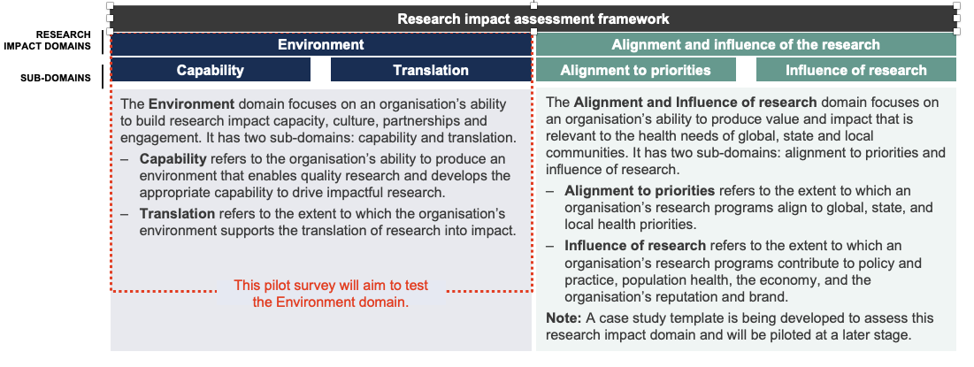

We are currently piloting the survey tool for the Environmental domain in nine organisations in Sydney. The organisations include metropolitan and rural local health districts, medical research institutes and a University. This analysis will capture employees assessment of their institutional research environment. The second aspect of the assessment will use case studies to determine the alignment and influence of the research. This work will be completed by September 2023. In each case we are mindful of the balance between providing a system for accountability and the additional burden this places on research organisations and individual researchers. We are concurrently exploring options for using publicly accessible information on research grants, publications, patents, and clinical trials to mine data for relevant information on impact.

Although the project is being developed for use by a State Government and currently focussed on health and medical research we believe that the methodology and underpinning principles have far broader application. We would be very pleased to share more detailed information with the Panel as is helpful.

Robyn Ward
Don Nutbeam
April 2023

