2020

Submission on targets for the Universities Accord – April 2023

Andrew Norton

Professor in the Practice of Higher Education Policy ANU Centre for Social Research and Methods

The Australian National University

This is a personal submission that should not be taken to represent the views of the Australian National University.

Table of Contents

Lists of figures and tables 3

Overview 5

1. Setting targets 8

Targets versus scenarios 8

Overall attainment targets/scenarios 8

Who is included in an attainment target? 11

Setting an attainment target/scenario range 13

Equity student targets 17

Managing student risks 24

Tracking progress towards an attainment target 26

2. Allocative systems and targets 28

Broad systems of allocating student funding 28

Allocating student places to reach attainment targets 28

Technocratic systems 29

Block grants 30

Demand driven funding 31

University-level targets for equity groups 32

University contribution to participation rate targets under technocratic or block grant models 32

Participation rate targets under demand driven systems 33

Are limited demand driven systems worth considering? 38

Overview of first submission 40

References 43

# Lists of figures and tables

Figure 1: Long-term trends in professional and managerial employment as a share of all early career employment, 1986 to 2022 10

Figure 2: Recent graduates still looking for full-time work, 1982 to 2022 11

Figure 3: Australian and overseas university contributions to Australian higher education attainment rates, 2022 13

Figure 4: Australian citizen higher education attainment and enrolment aged 18 to 34 years, 2021 14

Figure 5: Skill level one occupations employment share, early career workers aged 25 to 34 years, 2014 to 2022 16

Figure 6: University applications rates in NSW, by SES and ATAR, 2017 20

Figure *7*: Year 9 NAPLAN results by parental education, 2022 21

Figure 8: Weekly earnings ranges by gender an d qualification, 2022 22

Figure 9: Offer rates by SES and ATAR, 2021 24

Figure 10: Attrition rates of domestic commencing bachelor degree students after four years, commencing years 2005 to 2018 26

Figure 11: Rates of quick exits from higher education among those not enrolled or completed after four years, 2005 to 2018 commencing cohorts 27

Figure 12: Year-to-year changes in applications by university, 2020 to 2021 32

Figure 13: School leaver students tend to live with relatives, usually parents 34

Figure 14: Low SES compared to other SES commencing domestic undergraduate enrolments, 2001 to 2021 36

Figure 15: Regional and remote compared to metropolitan commencing domestic undergraduate enrolments, 2001 to 2021 37

Figure 16: Regional compared to metropolitan population trend age 15 to 29 years, 2010 to 2022 37

Figure 17: Indigenous compared to non-Indigenous commencing domestic undergraduate enrolments, 2001 to 2021 38

Table 1: Early career skill level two occupations with significant graduate employment, 2021 17

Table 2: Systems of allocating higher education public funding 29

Table 3: Funding estimates for the Indigenous regional and remote demand driven program, 2021 to 2023 39

# Overview

My first submission to the Universities Accord moved straight to substantive policy issues on student contributions and the allocation of student places. It has material related to consultation paper questions 2, 4, 5, 6, 7, 8, 9, 12, 47, 48, and 49. The overview of the first submission has been included at the end of this submission and the full document is on the Accord website.[1]

This second submission is focused on the issue of targets, for overall attainment and for equity groups. It has material related to consultation paper questions 3, 11, 12, 28, 30, and 33.

This second submission opposes target setting for enrolment shares, participation rates and attainment rates. Policy should aim to achieve individual-level best interest outcomes for prospective and current students rather than enrolments that fit preconceived patterns.

Target-setting based on the labour market faces the inherent difficulties of predicting future needs for graduates and allocating resources to meet them.

A higher education system that can adapt to needs and demands as they emerge – something like the demand driven system of 2012 to 2017 – would be better than one with fixed goals.

However, accepting that the Panel is required by the terms of reference to recommend targets, this submission discusses matters to consider when setting them.

*Scenarios and data*

Avoiding setting specific targets does not mean abandoning all the analytical work that might have supported them. Developing scenarios of what needs might be placed on the sector and how it might perform when or if they emerge is important to good overall policy design. Scenario data can also assist with university-level planning.

Expected demographic growth in school leavers from the mid-2020s is the most obvious example of a scenario for which the sector needs to prepare, which I discussed in my first submission to the Accord. In this submission I note other areas in which increased or improved analytical work could improve opportunities and outcomes for students and prospective students:

* Using schools data to better identify school leavers who might be suited to higher education but are not pursuing post-school study (the schools USI, a behind-schedule project, would greatly help with this);
* Using applications and offers data to see whether there are significant numbers of applicants not receiving offers because they did not apply for seemingly suitable substitute courses or use all the admission concessions available to them;
* Using enrolment, ABS population and Department of Home Affairs migration data to calculate accurate participation rates;
* Using the ABS Multi-Agency Data Integration Project (MADIP), which links multiple government data sources, to quantify higher education participation rates using individual-level measures of disadvantage rather than the mostly proxy measures used in higher education policy.
* Ensuring forecasts of which jobs graduates could usefully fill include occupations where degrees are now common despite not being classified by the ABS as ‘skill level one’;
* Using enrolment data to forecast future graduate numbers (although this depends on the troubled TCSI system being capable of producing timely data);
* Using immigration data from the Department of Home Affairs to measure and forecast the contribution of migrants to skills supply;
* Using ATO-HELP integrated data to investigate the earnings of students who do not complete their course.

*Who is included in an attainment rate?*

* While Australia overall has achieved the 40 per cent attainment rate for people aged 25 to 34 years this is only partly due to the Australian higher education system. If only people with degrees from Australian universities were counted attainment in 2022 would have been 36.8 per cent.
* If the target is just about the labour market then migrants with overseas qualifications can be included; if it is about a broader social policy agenda than domestic enrolments need to be considered.

*Targets and funding system design*

* How targets are implemented depends on the underlying student funding system architecture. The three main models are technocratic, block and demand driven.
* A technocratic system with relatively detailed allocation of student places to achieve public policy goals places the greatest pressure on government-driven data analysis.
* In block grant and demand driven systems there is more scope for providers to adapt to circumstances as they emerge.
* In technocratic and to a lesser extent block grant systems there is a risk of stranded resources, of student places or dollars allocated to a purpose for which there is insufficient demand.
* Limited demand driven systems run some of the same risks, due to money clawed back from general university grants in the transition period and in the Commonwealth budget process.
* A full demand-driven system is the best option.

*Protecting students*

The Accord Panel is required by the terms of reference to recommend new overall attainment targets and new targets to increase enrolments for equity groups. Ensuring educational opportunities are spread as widely as possible is a desirable policy goal. However going to university has risks as well as potential rewards, and the people who would deliver growth in participation and attainment rates are not necessarily well-advised to do so on an individual best-interests basis.

* In the top 30 per cent of the age cohort by academic achievement as measured by ATAR all but a small minority of school leavers already apply for and receive an offer of a student place;
* Growth must therefore come mainly from the lower 70 per cent of the cohort by academic achievement, many of whom also have other barriers to participation and success;
* Low SES school leaver higher education enrolments are heavily influenced by Year 12 completion rates and ATARs received; unfortunately Year 9 NAPLAN results still show large SES differences in academic achievement.;
* Although large numbers of people have an incomplete bachelor degree there is almost no research into what happens to them;
* Research into outcomes for people who complete upper-level vocational qualifications (Certificate III or above) shows that for men especially many are doing well. The case for diverting them to higher education seems weak;
* While higher education enrolments have been majority female for decades, low SES, regional and Indigenous numbers are more affected by this gender imbalance. More male students are needed to increase equity metrics. However many of the missing men make sensible choices in favour of vocational education;

Note: This submission includes some material from my first Accord submission and from my forthcoming *Mapping Australian higher education 2023*.

# Setting targets

The Accord terms of reference call for new targets for overall higher education attainment and equity groups. This submission first raises doubts about the use of targets and then, accepting that the Panel must recommend them, suggests factors to consider in target setting.

## Targets versus scenarios

Targets signal the need for improvements in indicators of interest to policymakers. The first objection to them is empirical; that we do not and cannot know enough to set specific targets that will be both feasible and desirable at some point in the future. The second objection is that the underlying policies to ensure the target is met could have counter-productive consequences. These include students being pressured to take courses with a high risk of leaving them worse off and resources going unused because they are locked into target purposes for which there is insufficient demand.

An alternative approach is to use scenarios without formal targets, or if targets exist without policies that lock in or encourage actions that are unnecessary or detrimental at the time of implementation. A scenario approach requires policies that support achievement of a range of seemingly desirable outcomes, without mandating a precise target. Arguably the demand driven system of the 2010s fell into this category, despite the announced target of 40 per cent of people aged between 25 and 34 years to have a degree by 2025.[2]

## Overall attainment targets/scenarios

The terms of reference and the discussion paper signal a desire to increase the proportion of the population with a bachelor degree or higher. The need is put in labour market terms, reporting a forecast that over half of new jobs will require a bachelor degree or higher (first ‘key area for review’ in the terms of reference). The section below discusses the difficulties of labour market forecasting. A later section discusses which jobs should be considered in target setting.

*Employment trends*

A consultation paper chart shows projected growth in ‘skill level one’ occupations, which the ABS classifies as typically requiring a degree and/or relevant experience, is plausible in its general direction.[3] Despite downturns and periods of stability Australia’s labour market shows a long-term trend towards higher-skill professional employment, consistent with underlying structural shifts in the economy (Figure 1). For example the health industry, which has many occupations with mandated university qualifications, should continue to grow in ways that are partly insulated from the business conditions affecting other industries.

Figure 1: Long-term trends in professional and managerial employment as a share of all early career employment, 1986 to 2022

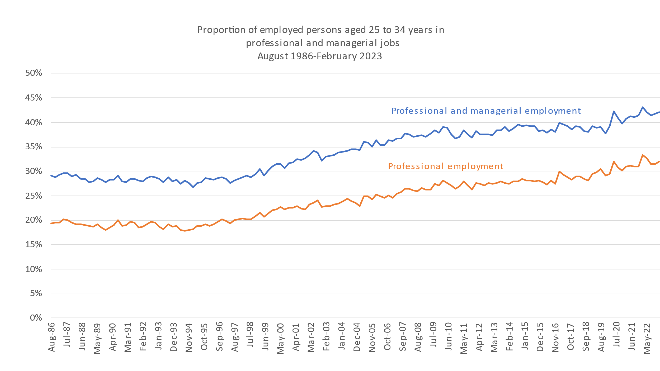

Note: Skill level trends are only available over shorter periods. At the time of the 2021 Census, the ABS classified 73 per cent of managerial and 98 per cent of professional employment as skill level one.[4] ABS occupational classifications are dated and under review, with some occupations not counted as professional now commonly requiring degrees. See Table 1.

Source: ABS, *Labour force Australia, Detailed*, table EQ13

While a long-term increase in high-skill employment opportunities is plausible labour market forecasting is complex and prone to error, at both the occupation and aggregate level. Labour market analysis commissioned for the 2008 Bradley report, which assumed growth in student numbers, forecast labour market demand for people with undergraduate qualifications to exceed supply during the 2010s.[5] While the final Bradley report recognised that the global financial crisis would moderate labour market demand, the 2010s were not a period of graduate shortages other than in a few occupations.[6] Overall the 2010s were a difficult decade for new graduates. The worst-ever short-term graduate employment outcome was recorded in 2014 (Figure 2). The flat 2010s for professional employment can also be seen in Figure 1.

Figure 2: Recent graduates still looking for full-time work, 1982 to 2022

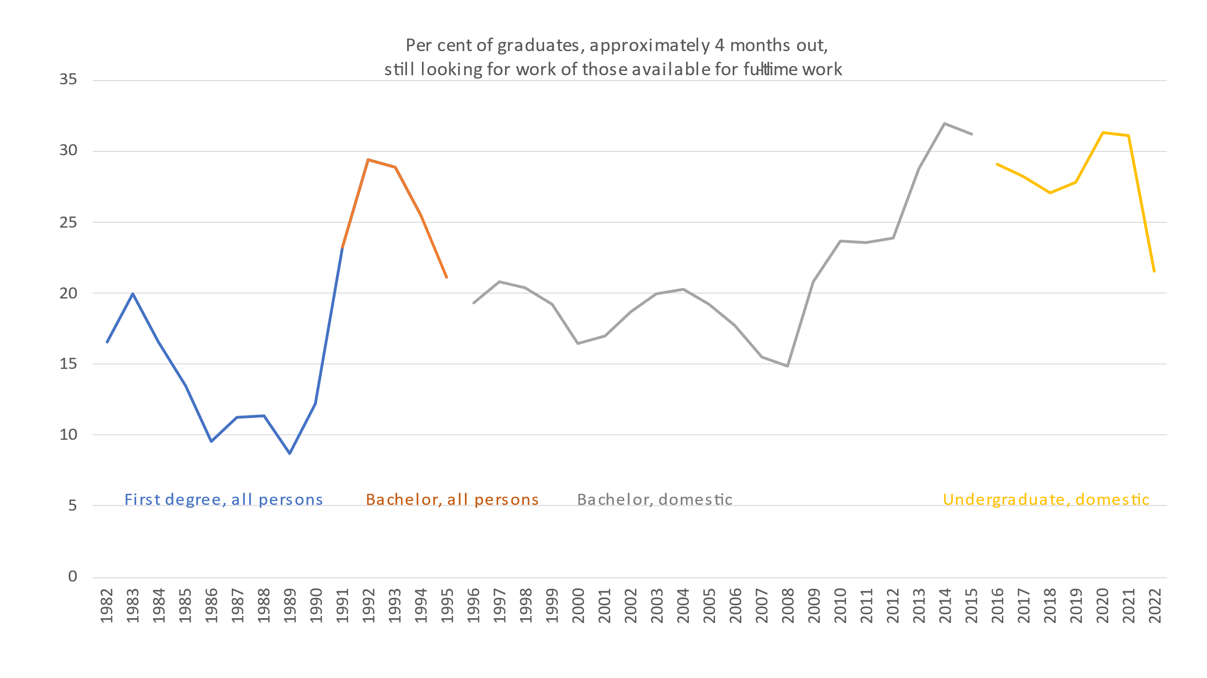

Notes: Graduates are not necessarily unemployed, because they may have part-time or casual employment. The graduate survey includes increasing numbers of higher education institutions, and this may affect the results.

Sources: Graduate Careers Australia, Graduate Destinations Surveys 1982-2015; Social Research Centre, Graduate Outcomes Survey 2016-2022.

More recent labour market forecasts, by contrast, under-stated employment growth. A COVID-19 downturn in employment was brief, with the subsequent employment boom causing under-estimated forecasts for professional employment made for 2022 from the base of 2017, especially for ICT professionals (although some ICT firms are now retrenching).[7] In 2022 a skills shortage analysis identified 127 professional occupations in shortage out of the 327 it analysed.[8] An earlier skill shortage survey peaked at 37 out of 54 professional occupations in shortage in 2008, the year of the over-optimistic Bradley analysis.[9]

While current skills shortages are part of the rationale for expanding higher education, they will probably alleviate well before higher education policy changes take effect. More sober forecasts would be based on a) the economy’s coordination mechanisms were disrupted due to COVID-19 measures and as things move back to a more normal equilibrium shortages will decrease; b) tighter macroeconomic policy to reduce inflation will reduce labour demand; and c) the latest developments in artificial intelligence will lead to job losses in some occupations (while noting that mid-to-late 2010s forecasts of large technology-driven job losses have not come true in the aggregate.[10]).

The essential point is that the labour market is too unpredictable to support detailed and high-accuracy long-term forecasts of skills needs. While a perfect match between the supply of graduates and the demand for them is impossible, policy can affect how well the system can respond to shorter-term changes in demand for skills. This is discussed in Chapter 2.

## Who is included in an attainment target?

While as the discussion paper observes the original 40 per cent attainment target in the 25 to 34 years age group has been achieved, this is only partly due to higher education policy. If only higher education qualifications awarded in Australia were counted attainment would have been 36.8 per cent in 2022 rather than the 44.5 per cent overall total (Figure 3). The Australian degree figure includes qualifications held by current and former international students, who have a mix of visa types – not all of whom will choose to, or be able to, remain in Australia long term. The overseas qualification figure also includes international students and other temporary migrants, only some of whom will remain in Australia permanently. In the short term at least, Australia’s rates of higher education attainment can be more easily influenced by migration than higher education policy.

Figure 3: Australian and overseas university contributions to Australian higher education attainment rates, 2022

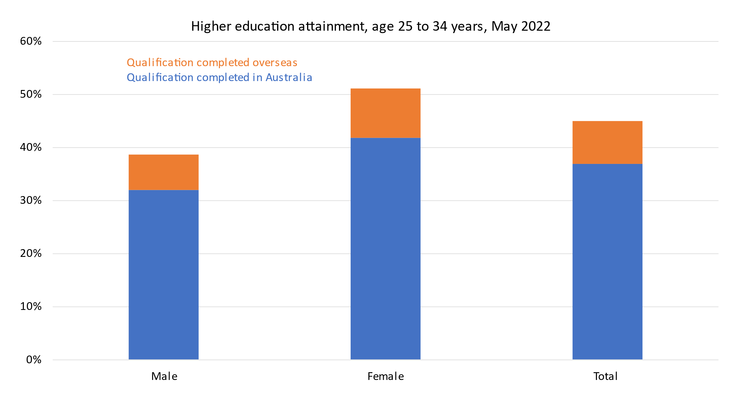

Source: ABS, *Education and Work*, TableBuilder

If an attainment target is just about the labour market, and Australia is confident about its competitiveness for skilled migrants, then this reduces pressure on domestic higher education policy. Labour market needs can be met with fewer domestic student enrolments than would otherwise be the case. Figure 4 reports citizen attainment and enrolment trends by age from 18 to 34 years, citizens chosen as the group likely to remain in Australia (permanent residents are in addition to this but not identifiable in my data source[11]). There is uncertainty around completions for those who are still enrolled, but through a combination of Australian education and migrants attaining citizenship these cohorts look to be on track for around 40 per cent bachelor degree or above attainment by their mid-30s.

Although migration can be used to increase the overall skill level of the labour force domestic capacity is obviously important. Politically the government will want to avoid high levels of domestic unmet demand. It also has a clear commitment to an equity participation agenda, which only includes domestic students. This raises the question of whether there should be a target for domestic student attainment rates, which also relates to the equity goals required by the terms of reference.

Figure 4: Australian citizen higher education attainment and enrolment aged 18 to 34 years, 2021

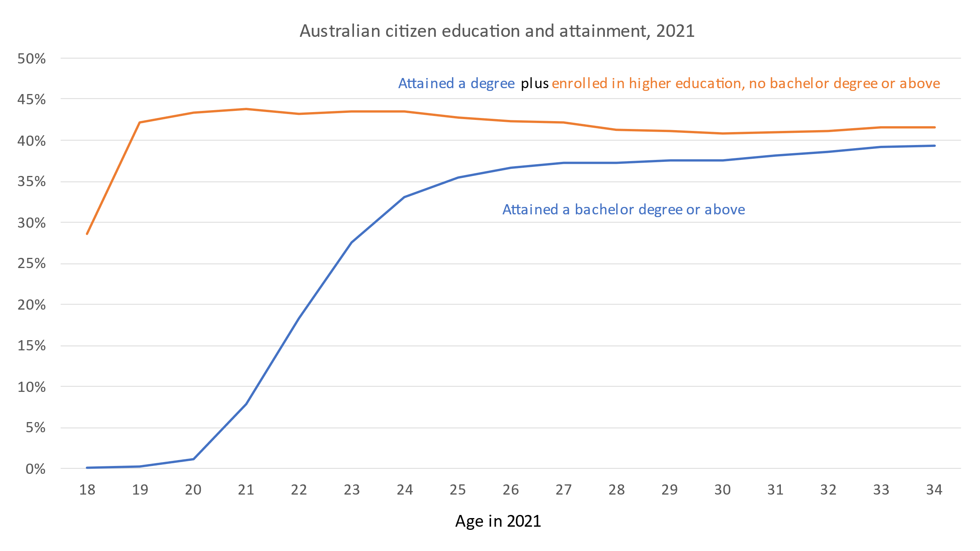

Source: ABS, *Census 2021, TableBuilder*

## Setting an attainment target/scenario range

Target setting for attainment needs to answer some threshold questions about what exactly it is for before its implications for higher education policy can be determined.

*Non-labour market goals*

In setting a target the Panel needs to decide whether to include objectives other than the labour market. While public policy focuses on the connection between employment and education this underexplains educational participation and choices. In a forced choice question on the main reason for study, 12 per cent of recent bachelor degree students gave interest or enjoyment over a range of work-related options.[12] About three-quarters of first-year students gave ‘developing my talents and creative abilities’ as a reason for enrolling.[13] Demand for courses with relatively poor employment outcomes, such as the humanities and the visual and performing arts, is significant at around 13 per cent of domestic bachelor degree subject-level enrolments (although generally trending down in recent years).[14]

Although connected to labour market goals, attending university has become something many young people expect and are expected to do. For decades most upper-year school students in Australia have expressed an interest in going to university.[15] The share of first-year university students citing parental/family expectations as a reason for attending has increased significantly over time.[16]

These are perhaps not reasons to which governments would often give prominence in their reasons for promoting and funding access to higher education. Yet this demand for higher education is a political reality and one reason for the long-term trend towards increased participation in higher education.

*Are international comparisons relevant?*

In the discussion paper Australia’s 2021 bachelor degree or above attainment of people aged 25 to 34 years, which is stated as 41.5 per cent (but this may be wrong), is described as lagging behind several countries where this figure is over 50 per cent.[17]

International comparisons need to be used carefully, since differences in qualification structures and qualification requirements for different occupations can affect reported attainment rates, and different industry structures can affect the extent to which the education system is a match for national needs. As in Australia, other countries debate the meaning and consequences of ‘over-education’ – people holding qualifications that would not normally be needed for the job they hold.

Any Australian target must be based on Australia’s circumstances. While for reasons partly canvassed above and below ‘over-education’ is an inevitable feature of the labour market, its consequences in wasted time, effort and money should be part of the policy discussion.

*Types of jobs for graduates*

The share of jobs classed as skill level one has increased in recent years, reaching 38.5 per cent in 2022 for people aged 25 to 34 years (Figure 5). The upward trend is consistent with the labour market forecasts reported in the discussion paper. In 2022 graduates held 80 per cent of skill level one positions; while two-thirds of employed graduates were in skill level one occupations.

Figure 5: Skill level one occupations employment share, early career workers aged 25 to 34 years, 2014 to 2022

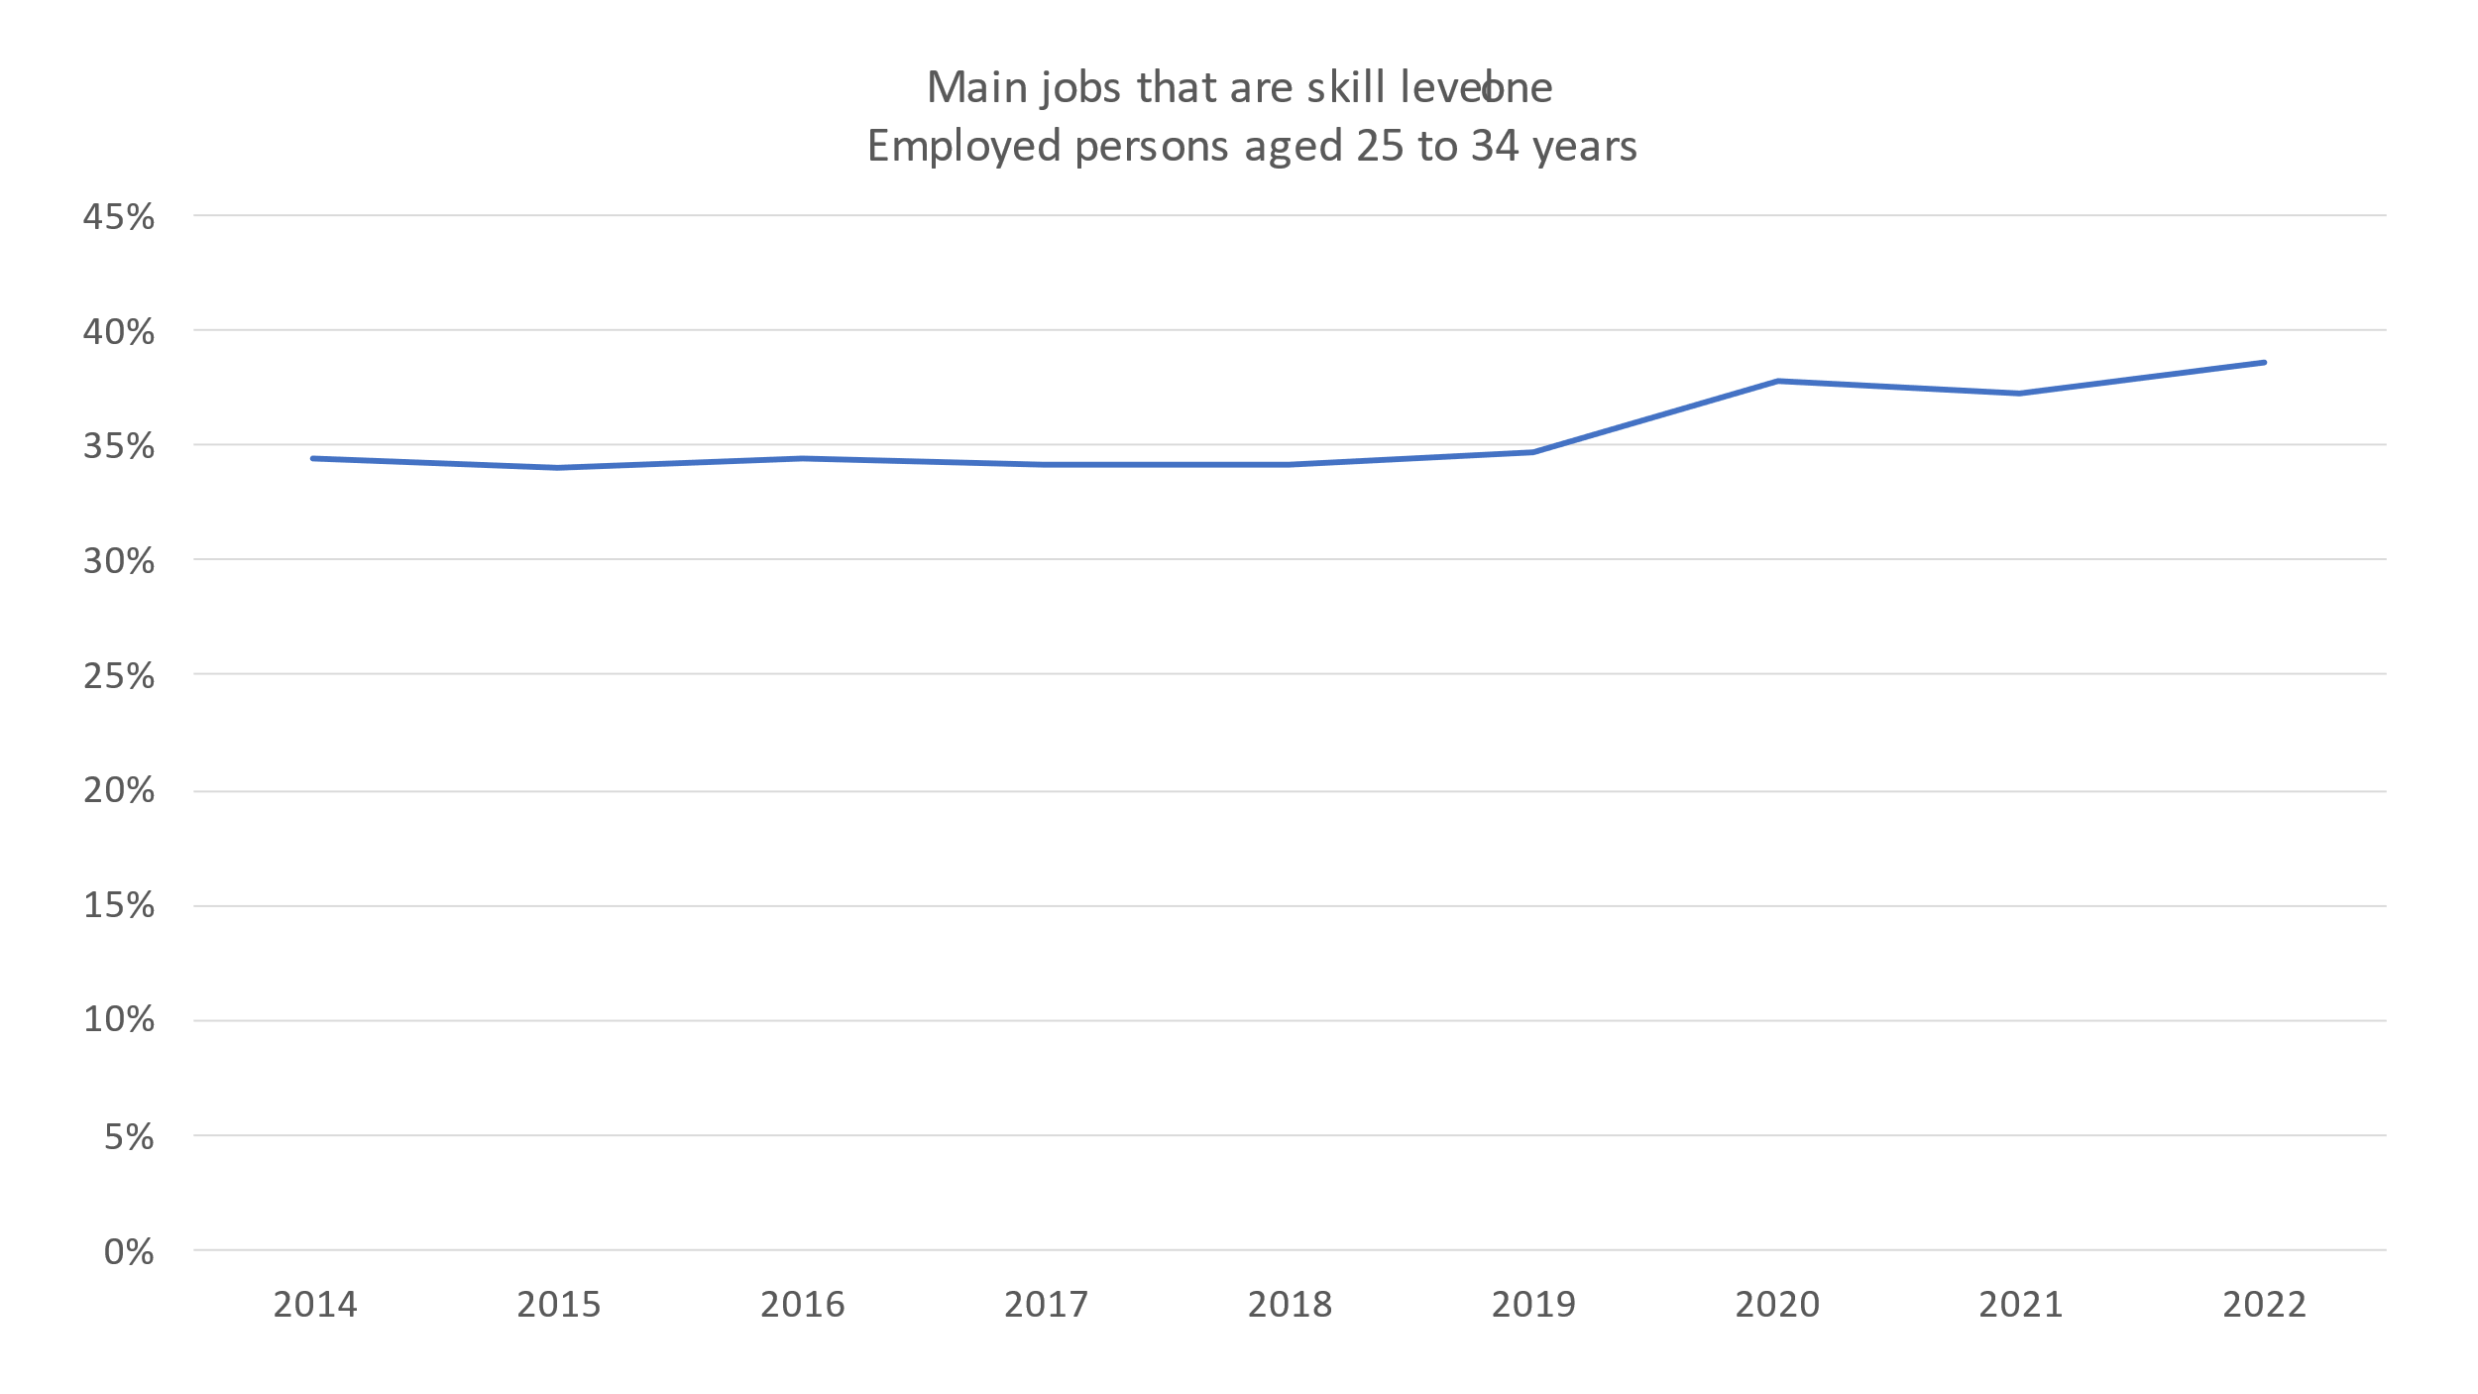

Source: ABS, *Characteristics of Employment, TableBuilder*

Figure 5 underestimates the share of jobs suited to graduates. The ABS occupational framework is being revised and currently classifies a range of technical, health and social service jobs often held by graduates to skill level two. Table 1 reports skill level two occupations that draw on, or are likely to draw on, the knowledge and skills learned in higher education and also employ significant numbers of graduates. Skill level two jobs make up 9.5 per cent of graduate employment in the 25 to 34 age group.

Table 1: Early career skill level two occupations with significant graduate employment, 2021

|  |  |  |
| --- | --- | --- |
| **Occupation** | **Number of employees aged 25 to 34 years 2021** | **Share of employees with a bachelor degree or above 2021** |
| Ambulance Officers and Paramedics | 6,795 | 86.6% |
| Science Technicians | 3,795 | 59.4% |
| Medical Technicians | 7,789 | 53.9% |
| ICT Support Technicians | 15,527 | 50.5% |
| Welfare Support Workers | 18,710 | 44.8% |
| Nursing Support and Personal Care Workers | 24,046 | 38.8% |
| Child Carers | 44,100 | 37.7% |
| Architectural, Building and Surveying Technicians | 17,370 | 32.7% |

Source: ABS, *Census 2021, TableBuilder*

The ABS occupational classifications are built around clusters of related skill specialisations and levels. As well as these changing over time and new occupations emerging they are only ever about general patterns. An individual job may require fewer, more or other skills than assumed in the ABS categories. Surveys that ask graduates about the relationship between their qualification and their job find apparent discrepancies with the ABS classifications. About one-third of recent graduates in professional jobs do not see their qualification as important for the job. But significant minorities of graduates in jobs classified in the occupational clusters of ‘technicians and trade workers’, ‘community and personal service workers’ and ‘clerical and administrative workers’ self-report their qualifications as important to their jobs. Adding another layer of complexity, the supervisors of these graduates typically see their qualifications as more than important to the job than the graduates themselves. [18]

*The availability of graduates*

While acknowledging the complexity of a ‘match’ between degrees and jobs, about one quarter of employed graduates aged between 25 and 34 years in 2022 were in skill level three to five occupations for which a degree is unlikely to be required or much of an advantage. Some of this reflects choice by graduates and often it is temporary, but past research has shown that many young graduates in lower skill employment were still in it a decade later.[19] These graduates may have qualifications or other attributes that don’t suit the available jobs, or prefer to work in ‘non-graduate’ jobs.

Better matching of graduates with the available work could reduce the share of graduates in non-graduate jobs. However if the goal is ensure employers have a pool of suitable job applicants the graduate share of the workforce should be larger than employment demand at any given time.

## Equity student targets

The terms of reference also call for ‘new targets and reforms to support greater access and participation for students from underrepresented backgrounds’, including First Nations, low SES, disability, and regional and remote (second ‘key area of review’).

As a large proportion of the Australian population satisfies at least one of these equity group definitions, their enrolments have a significant effect on domestic and overall participation and attainment rates.[20]

*Participation rate versus enrolment share*

Equity targets are usually expressed as enrolment shares (equity group students/all students) rather than participation rates (equity group students/all equity group members; probably age adjusted).[21] Enrolment share is administratively convenient as the numerator and denominator data is collected at the same time. As discussed below in the section on measuring attainment, population data matched to the specific domestic student definitions of higher education is less readily available.

If the policy objective is improvement in individual-level life opportunities then participation rates are, despite their collection difficulties, of the most interest. Are members of equity groups increasing their chance of going to university? An enrolment share cannot tell us, since both the numerator (equity group) and the denominator (non-equity group) influence the percentage. Participation rates can improve despite flat or falling equity group enrolment shares, if the non-equity group population is growing as or more quickly than the equity group population.

Calculating participation rates would require work with other government and statistical agencies to improve data quality, but this would be important to making progress as well as just measuring it.

In identifying potential equity students the extension of the Unique Student Identifier (USI) to school students, while delayed, could be an important resource. It could be used to identify and locate students meeting equity group criteria with school results that make them candidates for university. Over subsequent years, with the USI now used in both vocational and higher education, their post-school education status can be checked. This group could be the basis of a realistic participation rate goal. This data source would also help universities identify schools or regions where participation is low despite students who could potentially benefit from higher education. In the interim, TAC data could be used.

Data from the Multi-Agency Data Integration Project (MADIP) has been used for some interesting higher education related work but potentially could be used for much more. It has Census data, ATO data, MBS and PBS data, and social security data. These could be used to calculate participation rates using individual level measures of disadvantage rather than the proxy measures of the higher education equity categories.

*Scope for increasing low SES student numbers – applications*

Partly due to data limitations little has been published on the realistic scope for increased equity group enrolments. The terms of reference and the discussion paper allude to high-level discrepancies between enrolment and population shares rather than specific evidence that significant numbers of equity group members who would like to attend university do not, or should consider higher education but do not.

For low SES Year 12 students there is no evidence that they are less likely to apply at a given ATAR level. Low, medium and high SES NSW Year 12s in 2017 groups were as likely as each other to apply in the 70-plus ATAR group that provides most school leaver university students, with low and medium SES students more likely to apply at the lower ATAR levels (Figure 6). Similar findings have been reported previously, with the caveat that regional young adults are less likely to go to university than their metropolitan contemporaries after controlling for school results.[22]

Figure 6: University applications rates in NSW, by SES and ATAR, 2017

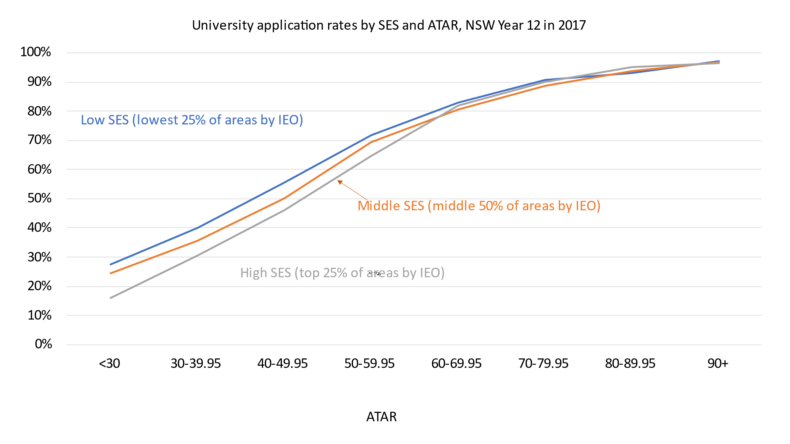

Source: A. Manny, *Socio-economic status and the ATAR*, Universities Admissions Centre

For school leavers the differences in participation rates are largely the consequence of prior differences in school results.[23] While improving school outcomes has long been the focus of both national and state governments the differences in educational performance remain large. Figure 7 shows Year 9 NAPLAN results by the highest educational level of either of the student’s parents. Students with a parent with a bachelor degree are twice as likely as students with parents with vocational certificates or Year 12 to test in the top three bands, 8 to 10 for NAPLAN reading and numeracy.[24]

Figure *7*: Year 9 NAPLAN results by parental education, 2022

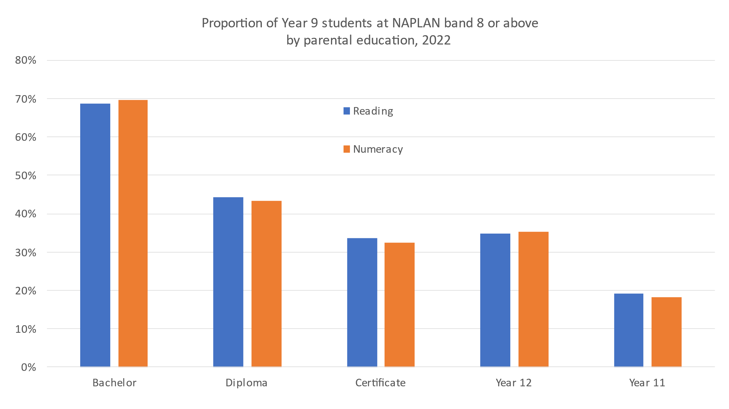

Source: ACARA*, NAPLAN results PowerBI*

Patterns of self-selection into higher education based on prior educational performance such as measured by ATAR are rational given its strong association with academic success.[25] For the students who complete their courses there is a positive statistical relationship between ATAR and early career graduate income, which means that lower-ATAR students tend to earn less.[26] With only small numbers of 70+ ATAR school leavers not already applying for university (Figure 6), the young people not applying are typically at a relatively high risk of not achieving a favourable outcome.

For students who complete their courses higher education was not necessarily their best option. As the charts in Figure 8 show earnings for people with both upper vocational qualifications and bachelor degrees range across a spectrum (age 35-44 chosen to capture the career phase when graduate earnings continue increasing while the others tend to plateau[27]). Graduates are more likely to earn high incomes, but many do not and especially for men a significant minority of vocational qualification holders earn $2000 a week or more. Although there are currently skill shortages across the labour market, the largely vocational education trained ‘technicians and trade workers’ cluster of occupations has higher rates of occupations in shortage than the mostly university-qualified ‘professional’ group.[28]

At the individual level, a key question is whether the more marginal higher education student – say a person with an ATAR below 70 – is more likely to earn a high income going down the university or vocational education path. This is a matter for further research, but courses associated with high earnings, such as medicine, law and engineering, typically require high ATARs.

Figure 8: Weekly earnings ranges by gender and qualification, 2022

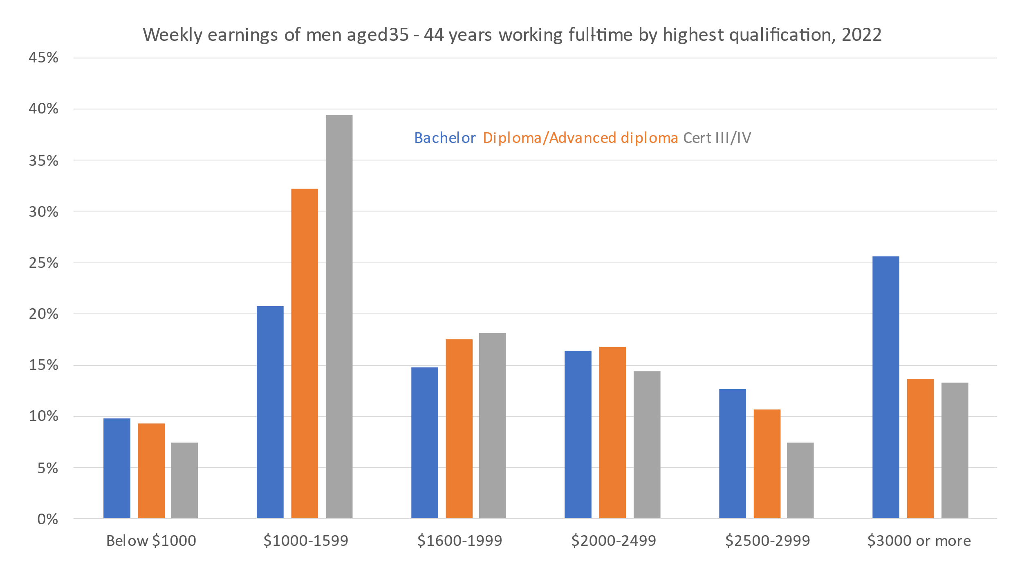

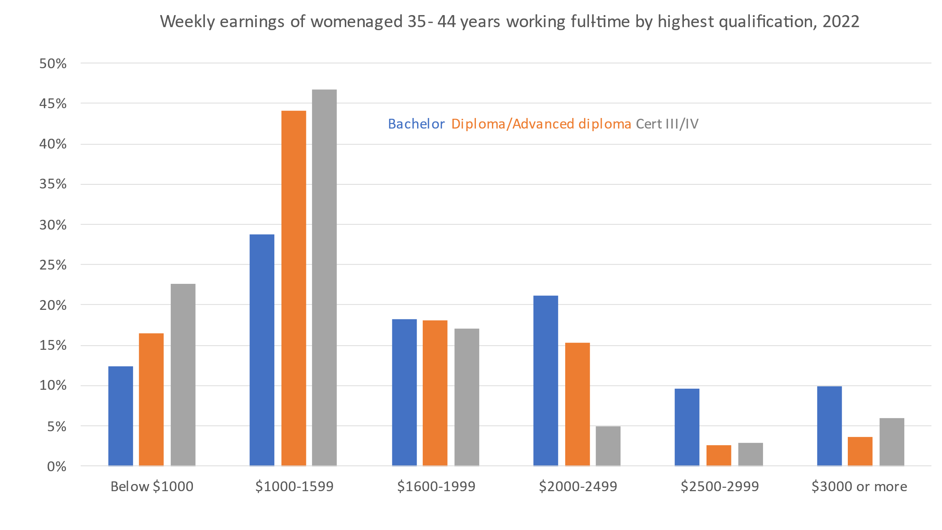

Source: ABS, *Characteristics of Employment*

Women’s earnings are generally lower than men’s, and especially with vocational education qualifications a low percentage of women earn $2000 a week or more. This is likely to be one reason for large education sector gender imbalances, with 60 per cent of domestic higher education students being women while more than 70 per cent of apprentices and trainees are men.[29]

The relative financial attractiveness of stereotypically male occupations served by vocational education is one reason for the higher education gender imbalance. The gender imbalance is larger in the equity groups. Men were 36 per cent of low SES students in 2021 compared to 41 per cent of non-low SES students. Men were 34 per cent of regional and remote and 31 per cent of Indigenous students.[30]

Policies to push up overall (Figure 3) and equity group higher education attainment would need a focus on men and/or the courses that typically attract men to have any prospect of significantly changing overall outcomes. However, due to men being less likely to complete Year 12 or get an ATAR this is not an easy task.[31] The Year 9 NAPLAN results show that on average boys are well behind girls in reading, writing, spelling and grammar and punctuation, and only slightly ahead in maths.[32]

*Scope for more low SES students – offers*

Not every applicant receives an offer, especially for those with ATARs below 70 (Figure 9) or who do not have an ATAR (78 per cent offer rate compared to 90 per cent of those with an ATAR). In the under 70 group, low SES applicants are slightly more likely to receive offers than medium SES applicants, and more likely to receive offers than high SES applicants. No research has investigated to what extent this is because low SES and medium SES students are more likely to apply to courses with lower ATAR requirements compared to the numerous schemes which admit low SES students on lower ATARs than are required of other students.

Figure 9: Offer rates by SES and ATAR, 2021

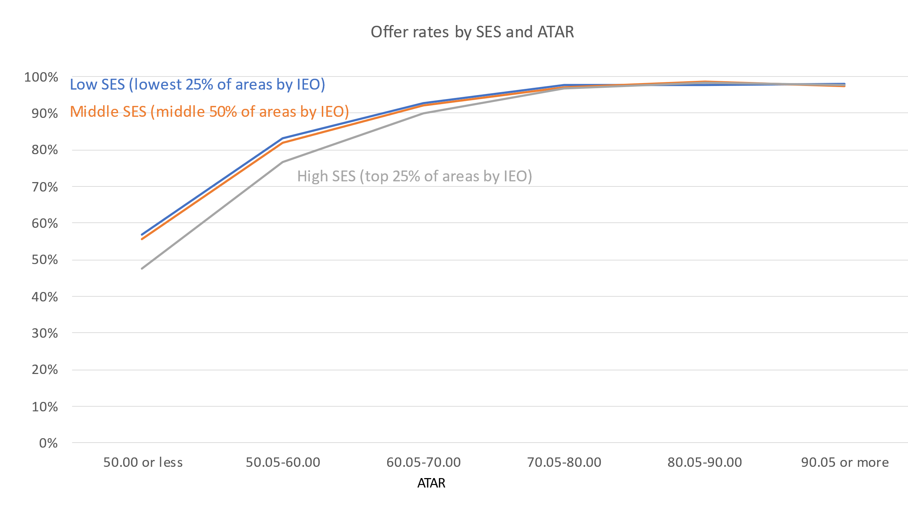

Source: Department of Education*, Undergraduates applications, offers and acceptances PowerBI*

If all demand from low SES students in 2021 was met it would have increased low SES offers by 23 per cent, mostly from applicants with no ATAR. However, the no ATAR group includes current students seeking to change courses or universities so additional offers would not necessarily convert into additional students. Less than 2 per cent of low SES unmet demand is in the 70.05 plus ATAR group with high application and offer rates. However another 19 per cent of low SES applicants with no offer did receive an ATAR of 70 or below. While 100 per cent acceptance rates would probably not be legal or ethical (below), this group is worth further investigation in equity policy. One topic to explore is whether a student could have received an offer aligned with their apparent preferences (for example, they have applied for several courses in the same field of education) with a better application strategy. For example, did they consider another course with similar outcomes or use all the preferential admission schemes for which they were eligible?[33]

Unmet existing demand is also relevant to overall funding policy design (next chapter).

## Managing student risks

Policies aimed at student best-interests also need to manage student risks after they enrol. While adverse outcomes are often noted with concern in the equity literature, it typically argues that equity students need more ‘support’ rather than asking harder questions about the best next steps. The two of course are not mutually exclusive, but the bias is to retention.

As Figure 10 shows the risk of not completing is high for regional, low SES and Indigenous students. Attrition has trended down over recent years for these equity groups after increasing in the 2010s. This is a good sign but the attrition gap between low SES and high SES students has widened since the start of this time series, from 7 to 10 percentage points. Attrition rates for Indigenous students have improved significantly but remain very high.

To better understand the risks being faced by this group, their HELP debt levels on exit should be separately reported and the HELP-ATO integrated dataset used to investigate the earnings of people with incomplete degrees.[34]

Figure 10: Attrition rates of domestic commencing bachelor degree students after four years, commencing years 2005 to 2018

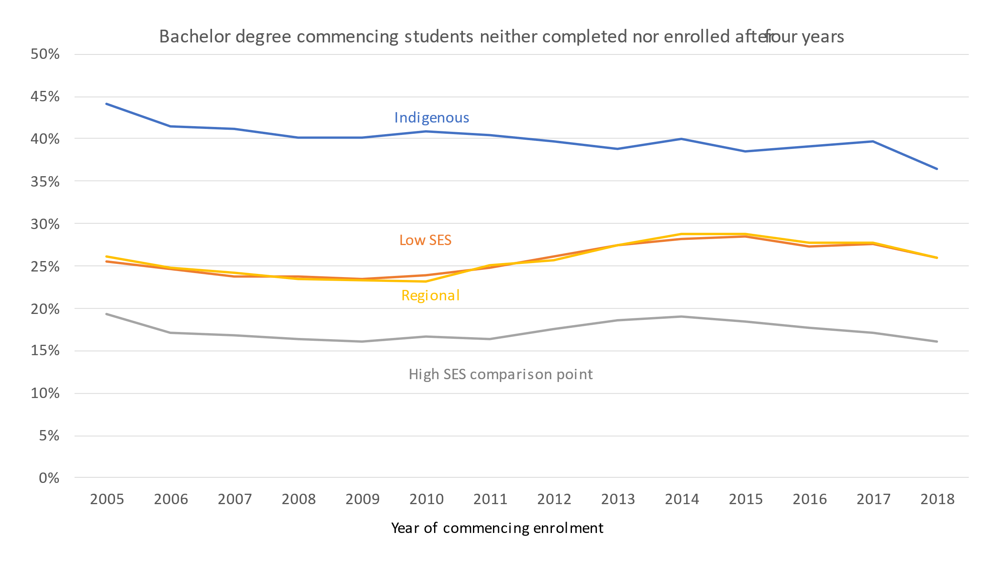

Source: Department of Education, *Completion rates of higher education students – cohort analysis 2005-2021*, table 3

Quick attrition with zero or low HELP debt is not necessarily a major problem. The admissions process cannot manage all the risks of enrolment; it can only identify some factors correlated with success or failure. If entry requirements are too strict people who could benefit from higher education will miss out. I have argued before for seeing the months after enrolment as continuing a ‘mutual selection’ process where students and education provider assess the suitability of their match.[35] If things are not working out a quick exit, ideally before the first census date when HELP debt accrues, or if not that after first semester, keeps time and money costs down. The Productivity Commission’s recent *From learning to growth* report included similar ideas, with a ‘fail fast’ approach and exit qualifications for those who have completed enough subjects to warrant one.[36]

No time series data on exits before first census dates is published. Figure 11 shows some recent improvements in speed of exit after reaching a census date, with slightly larger shares of those who have left after four years never having come back after first year, although for the equity groups the share is still below what it was at the start of the time series in the mid-2000s. However, about half of equity students who have left after four years re-enrolled after first year, accruing more HELP debt.

Figure 11: Rates of quick exits from higher education among those not enrolled or completed after four years, 2005 to 2018 commencing cohorts

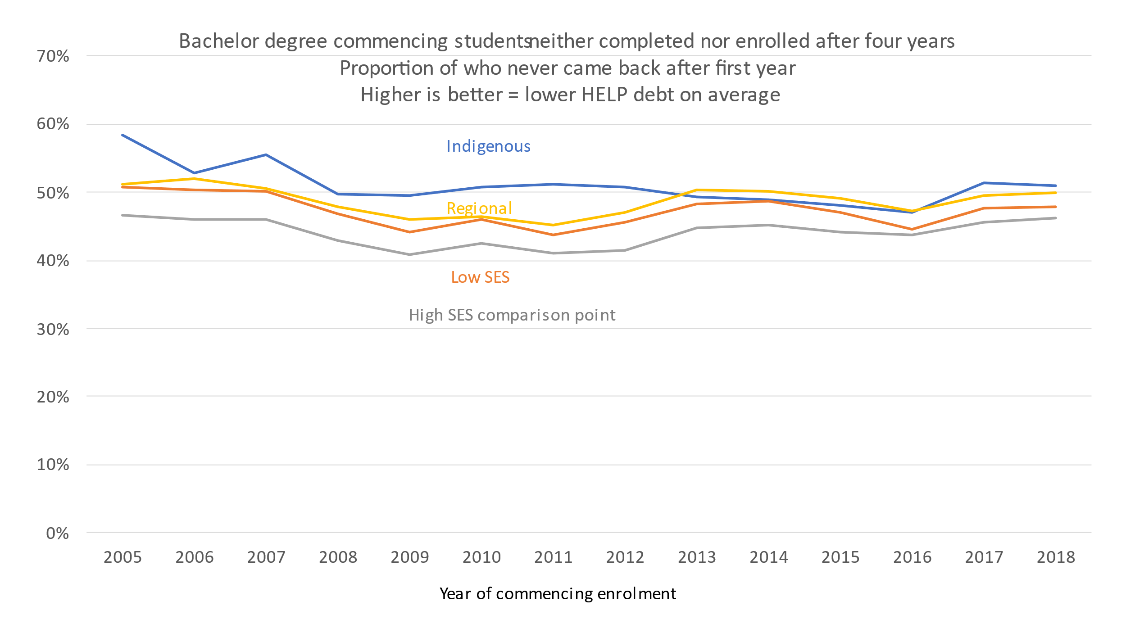

Source: Calculated from Department of Education, *Completion rates of higher education students – cohort analysis 2005-2021*, table 3

## Tracking progress towards an attainment target

Although an attainment target was put in place after the Bradley report progress towards it does not seem to have been tracked other than via the ABS Education and Work survey. Identifying whether Australia was on track to meet it would have required age-specific participation rates, completion rates and times, and monitoring of migration flows.

Age-specific higher education participation rates are not commonly reported and are hard to calculate – while domestic enrolments by age are reported in the annual higher education statistics report the corresponding population figure is not, in the higher education statistics report or anywhere else. The large number of temporary migrants typically resident in Australia, including international students, means that the ABS population figures inflate the denominator figure in the participation rate calculation. Strangely, given its high relevance for numerous government programs, the population of people with varying levels of government assistance benefits – citizens, permanent residents, and New Zealand citizens (all entitled to CGS support) – is not available. Grattan Institute estimates deducted onshore international students from the ABS population estimate to derive a participation rate at age 19 years.[37] This alleviated but did not eliminate the problem, due to temporary migrants other than international students in the population figure.

An issue in monitoring participation rates is slow enrolment reporting. The TCSI system was supposed to provide more real time data but instead seems to have worsened already long delays in reporting. If this cannot be resolved then it is a significant problem in implementing policy and monitoring progress. Under current arrangements it will be two years before we aware of potential problems or opportunities, and up to three years before we can do anything about them.

Converting participation rates into projected attainment rates requires estimates of completion rates. While these fluctuate from year-to-year completion rates based on various commencing student characteristics already exist.[38] Among other trends, the completions reports show increasing time to completion, which is important to estimating the future supply of graduates, whether in the aggregate or for specific occupations.

If migrants are included in the target the Department of Home Affairs will need to report the qualifications of long-term or permanent migrants to Australia. While DHA have not historically published this number they would have it for skilled migrants. Generally DHA’s reporting is a model the Department of Education should follow, with monthly and sometimes weekly updates.

# Allocative systems and targets

If the government adopts targets the question is which funding model will support their achievement. My first submission outlined different systems of allocating public funding, with the broad types and their features repeated in Table 2. The three models currently (and to varying extents previously) used are technocratic, block and demand driven systems. A capped voucher system, previously suggested but not used to date, incorporates elements of technocratic and demand driven models.

## Broad systems of allocating student funding

Table 2: Systems of allocating higher education public funding

|  |  |  |  |  |
| --- | --- | --- | --- | --- |
| **Decision** | **Technocratic** | **Block** | **Demand driven** | **Capped voucher** |
| Total number of places/dollars | Government decision | Government decision | University and student decision. | Government decision |
| Total number of places /dollars for each university | Government decision | Government decision | University and student decision. | University and student decision. |
| Total number of places/dollars for each course or discipline | Government decision | University and student decision. | University and student decision. | Either government or university/student depending on model. |
| Student-level allocative criteria, such as academic results or equity group. | Government decision | University and student decision. | University and student decision. | Government decision |

The technocratic and block systems give governments control over the supply of resources to support students, in the aggregate and for specific universities. This control can be used to set sub-targets for universities in support of national goals. A pure demand driven system by contrast sets no institution-level goals, but facilitates achievement of national goals by removing funding caps.

## Allocating student places to reach attainment targets

Under technocratic or block funding systems the government would need to allocate student resources to universities in ways that support achieving the targets.

### Technocratic systems

In current and past Australian technocratic systems universities are allocated student places and so the maximum number of Commonwealth-contribution supported student places is known. The total number of places can be increased over time in line with estimates of how many are needed to achieve the target.

*Issues in technocratic models – the relationship between places and persons*

Enrolment share, participation rate and attainment rate targets are measured in persons rather than places. Due to part-time study CSP persons per place vary between universities, ranging from 1.2 persons per place to 1.95, with an average of 1.39.[39] For a quick boost to enrolment shares or participation rates one place at a university that attracts part-time students (universities with online courses aimed at mature age students) delivers more than a place at a university that has mostly full-time students (usually on-campus school leavers). However due to high attrition by part-time students a place allocated to a university that mainly attracts full-time students will make a larger contribution to eventual degree attainment.

In 2022 the government capped CSP EFTSL consumption with the Student Learning Entitlement. However there is little public analysis of EFTSL consumption and how it converts into different student outcomes. The number of EFTSL required to complete a pass degree varies between courses, but there is no published data on average EFTSL consumed per degree completion, after taking into account students who do not complete and students who do complete but consume more than the minimum EFTSL, due to repeated subjects and course changes without full academic credit.

Students who complete two or more courses are only counted once in the attainment statistics. In 2018-19 the average graduate held 1.4 qualifications at a bachelor degree level or above.[40] While this figure is largely due to postgraduate qualifications, with a majority of postgraduate students not enrolled on a CSP basis, in 2020 14 per cent of domestic bachelor enrolments were enrolled in combined courses.[41]

*Issues in technocratic models – flexibility*

A problem with technocratic systems is inflexibility, although the extent of the problem depends on the level of detail in the allocation. A technocratic system compared to a block grant system aims to achieve sub-goals beyond total enrolment levels, by specifying how student places are to be used. But the level of detail can be high – such as a funding cluster – or very specific, such as named courses and types of students.

When student places are tied to specific uses it creates a risk that some allocated resources will go unutilised. I have argued that this is a flaw in the government’s ’20,000 places’ policy.[42] For a place to be used a student (i) has to meet equity criteria and (ii) want to do a specific course at (iii) a specific university. Every policy goal that is added reduces the chance that a student can be found that meets all the criteria. As a result, the system’s actual capacity to deliver student places could be well below its theoretical capacity. It is also poorly positioned to adapt to changing needs and demands.

### Block grants

The logic of block grants is the allocation of resources in dollars rather than student places. This is the current system for higher education courses, creating flexibility in moving resources between disciplines and course levels. This facilitates the meeting of skill needs and other demand but creates more uncertainty around how many student places will be delivered. For example in 2023 $1 million in Commonwealth Grant Scheme funding would support 910.6 student places in business courses but only 61.6 places in engineering or nursing courses.[43]

My first submission to the Accord panel argued that these large Commonwealth contribution differences and other issues create significant concerns about how many additional places the Job-ready Graduates system will support.[44] Participation rates going down rather than up from the mid-2020s is a possible scenario on current policy settings, as any increase in places may not be enough to counter-act the effect of increased population.

Before 2005 block grants included university-level target numbers of student places. There was therefore an average per student funding rate. These targets gave the government an idea of how many student places would be delivered and universities flexibility in moving student places between disciplines, although with more of an incentive to move to low cost than high cost disciplines.

*Moving resources between universities*

Both technocratic and block models are weak on moving resources between institutions. Prospective students can miss out because the university of their choice had exhausted its funding allocation – a significant danger on current policy settings.[45] University-level applications fluctuate significantly year-to-year in ways that are not obvious from the year-to-year aggregate changes (Figure 12). It is difficult for technocratic and block grant systems, which typically rely on multi-year agreements to allocate funding, to manage these fluctuations.

Figure 12: Year-to-year changes in applications by university, 2020 to 2021

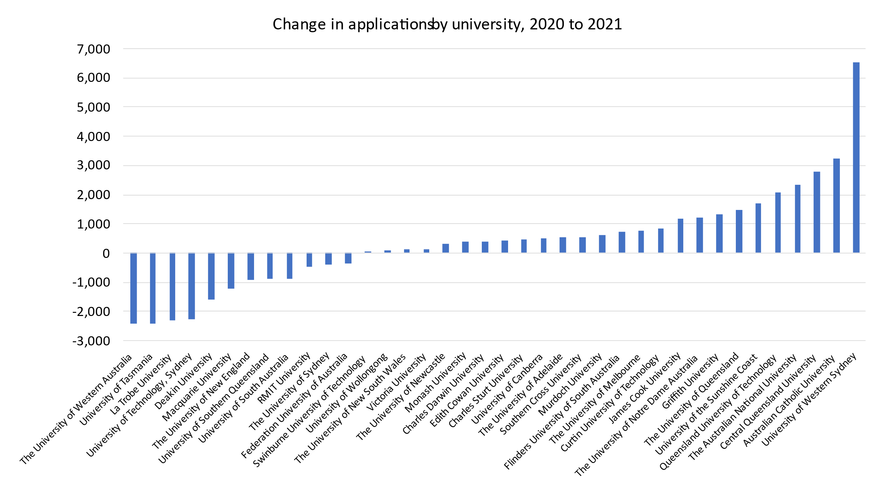

Source: Department of Education, *Undergraduate applications, offers and acceptances 2021*

### Demand driven funding

No funding system can guarantee an attainment target will be achieved. The system is post-compulsory and students cannot be forced to enrol or to complete their courses. But within this constraint a well-designed demand-driven system should out-perform technocratic and block grant systems in meeting attainment targets. It lets supply rise to demand and does not have the allocative constraints that might cause available resources not to be used. In the language of Chapter 1, a demand driven system can manage a range of plausible scenarios without a premature policy lock-in to targets that turn out to be misguided.

*The risk of demand-driven funding 2.0 being less effective than demand driven funding 1.0*

A poorly designed demand driven system, however, has risks. During the first demand driven system the focus was largely on removing upper limits on student numbers, but lower limits were also removed. In my first submission I raised some concerns about whether demand driven funding might be less effective in its second iteration than its first.[46]

The risks were:

* The geographic location of the increased school leaver age population, often in outer-metropolitan areas a significant distance from existing campuses, could lead universities to think these prospective students are outside their area of responsibility.
* School leaver numbers will increase more quickly in the second half of the 2020s than during the demand driven funding period, leaving universities less time to respond, However there is now a smaller proportion of Year 12 students who are potentially interested in higher education who are not already applying and enrolling.
* Job-ready Graduates cut total student funding rates for many courses, which weakens supply-side capacity and incentives. This supply-side risk affected a shorter list of disciplines in the first demand driven system.[47]
* For various practical, strategic or mission reasons universities may decide not to meet domestic demand.

If these risks are high and not fixed a technocratic or block grant system may perform better. The difference is that although universities are legally autonomous and could in theory decline an allocation of student places, their high reliance on Commonwealth support means that they can be pressured into offering student places that they would not in a demand driven system.

## University-level targets for equity groups

University-level equity group targets fit most neatly with technocratic systems. The government is quasi-contracting with universities to deliver specified student places. With block grant systems university-level grants could be set based on their potential to recruit equity students, with that made a condition of grant. University-level targets for specific categories of students don’t fit with the logic of a demand driven system, since it assumes that student demand drives the system rather than provider manipulation of supply. However, mission-based compacts implemented alongside the previous demand driven system set goals for incremental enrolment share increases in low SES students and another equity group. Funding rewards were offered as an incentive for meeting the targets but abolished in a subsequent round of Commonwealth budget savings.

### University contribution to participation rate targets under technocratic or block grant models

In the previous chapter I suggested targets based on equity group participation rates rather than enrolment shares. The focus would be on whether equity group members are getting the right opportunities, not how many non-equity students have enrolled. Improved data work could provide a much better idea of where potential students are living and attending school, and this could be matched against university catchment areas (not just campus locations as in the current growth formula; university enrolment data can be used to check where the students for each university typically come from).

Students from the regions often move to study, but most school leaver students remain at home (Figure 13), making the higher education institutions they might choose between more predictable.

Figure 13: School leaver students tend to live with relatives, usually parents

Source: ABS, *Census, TableBuilder Pro*

Notes: Australian citizens only, place of enumeration

Hard targets such a money exclusively for an equity group or mix of equity groups should be avoided as they risk stranded resources. Using current equity group criteria to allocate resources also risks unfairness to students who miss out as a result. Except for disability, none of the equity group categories are designed to capture individual disadvantage. People who live in the regions, or in an area classified as low SES, or are Indigenous can all come from educated and affluent families.

### Participation rate targets under demand driven systems

The strength of demand driven systems in meeting ambitious equity and attainment goals is removing funding obstacles to meeting demand where and when it emerges. There are no stranded resources, of money allocated to specific universities, courses, funding clusters or student types that then cannot be used due to insufficient demand that meets all the criteria. Within their capacity and admissions policies, universities are free to reduce current unmet demand.

In the first demand driven system (easing of funding caps 2008-2011, bachelor degree caps removed 2012-2017) equity group enrolments increased significantly. In the charts below enrolment numbers are converted to an index, with 2001 as 1, so that the proportional increases can be clearly seen despite differences in base numbers.

Because equity group members tend to be more at the margins of meeting academic requirements their numbers are expected to be more sensitive to the supply of student places relative to overall demand. As Figure 14 shows a reduction in commencing places in the 2000s caused a larger drop in low SES compared to others SES commencing domestic undergraduates. During the demand driven period low SES enrolments grew more quickly than other SES groups, creating an increase in their enrolment share.

Since the end of the demand driven system commencing domestic undergraduate low SES numbers have declined. Applications have trended down so this is not just a supply-side issue.[48] Weaker demand from mature-age students is a factor.[49] While potentially concerning there are also benign interpretations of this trend. The earlier years of the demand driven system may have satisfied some pent-up demand, possibly from people who missed out earlier in the 2000s. If so, demand fell back after it was met. With more people going straight to university after school in the demand driven system possibly there is a smaller pool of people left in the cohort for later mature age education. More job opportunities for older workers in the later 2010s may have may have altered the education/employment trade-offs for some potential students. If so, the strong labour market in 2022 and 2023 suggests a further decline in low SES enrolments. Some of the data sources discussed in chapter 1 could be used to identify the cause of this trend and whether it is a matter for concern.

Figure 14: Low SES compared to other SES commencing domestic undergraduate enrolments, 2001 to 2021

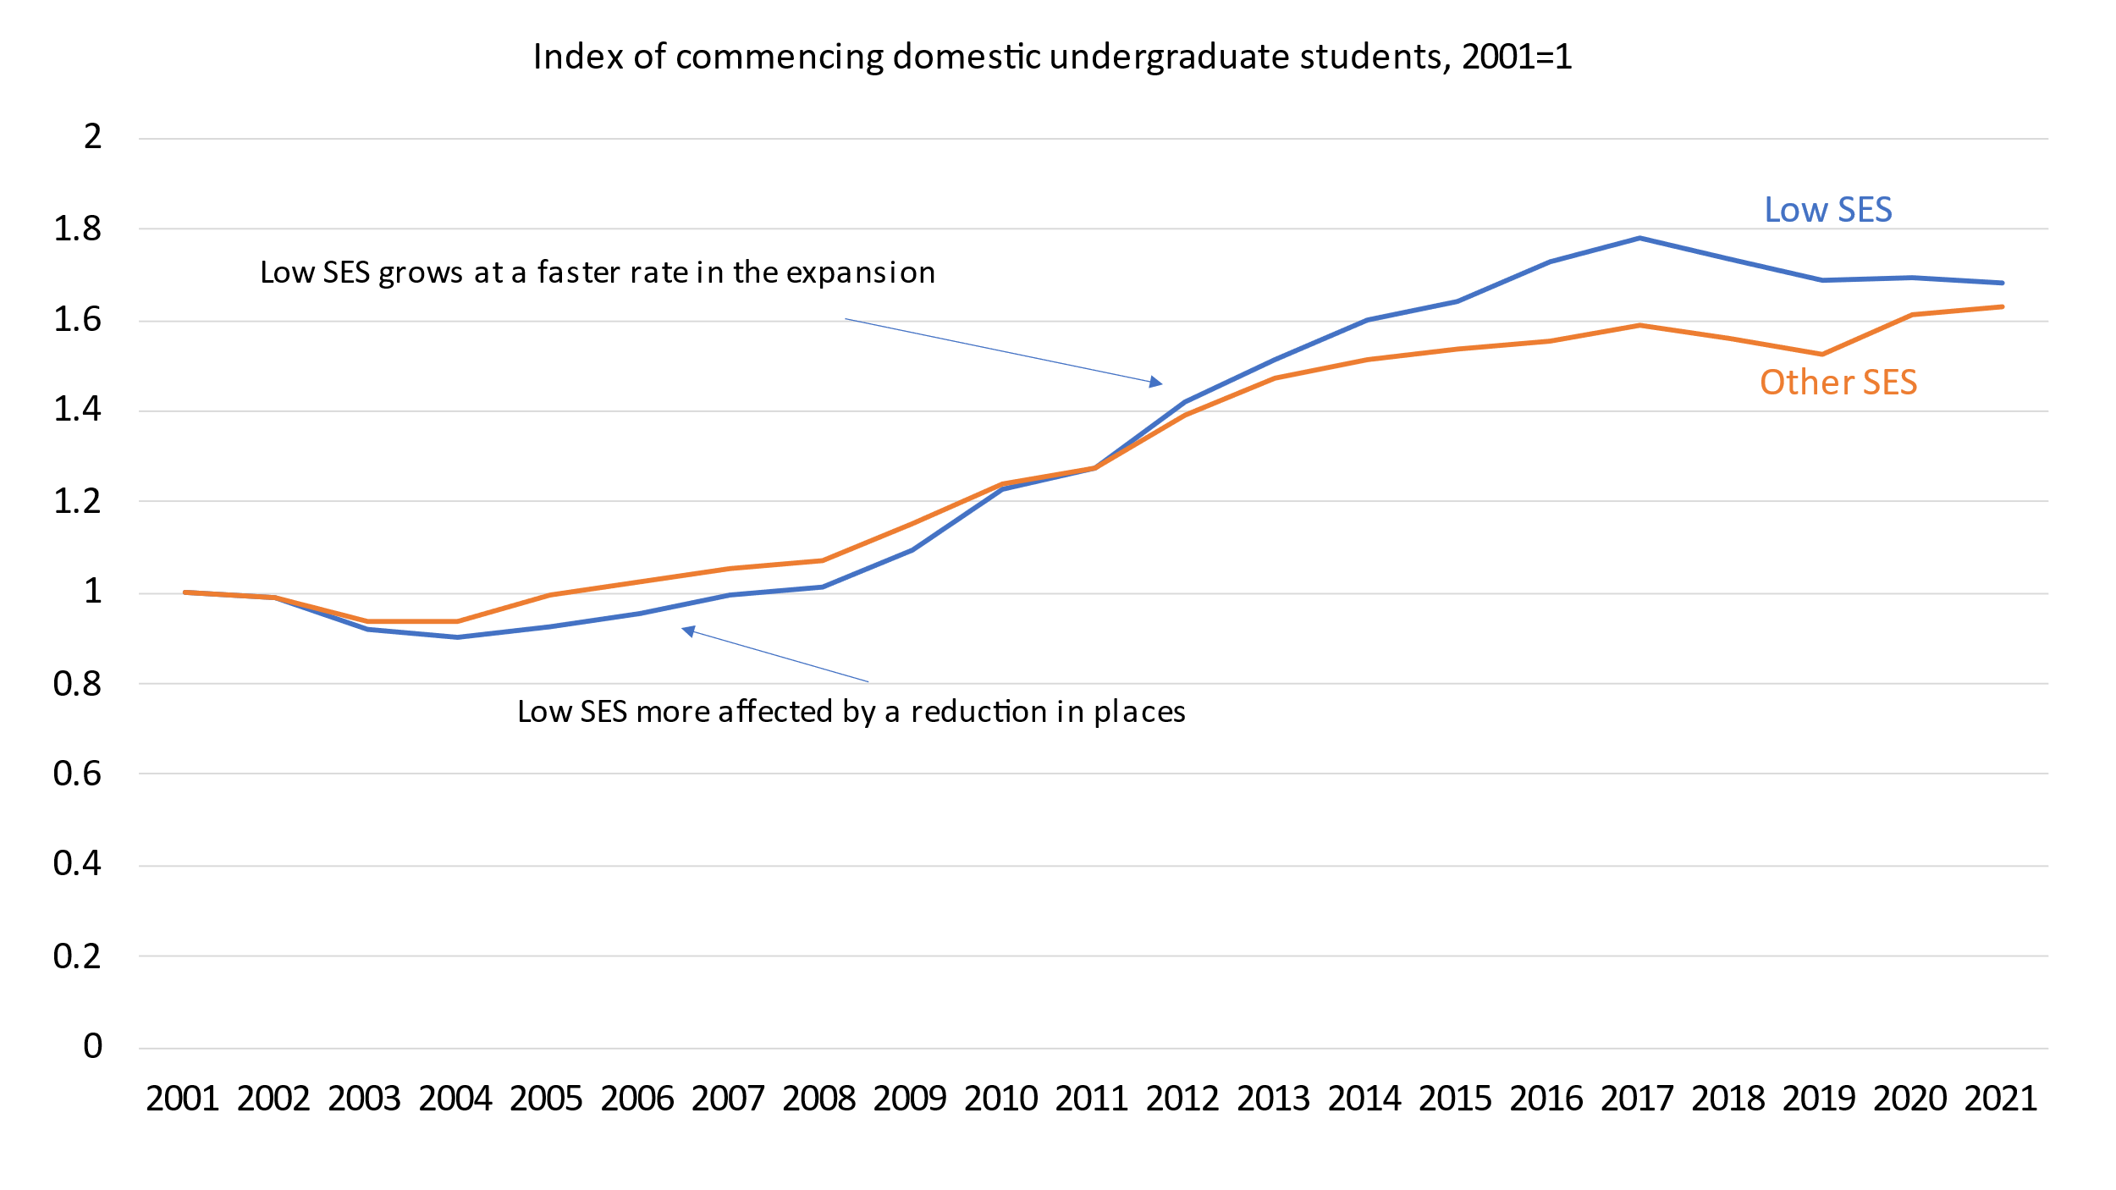

Note: Postcode SES used at it has a time series going back to 2001. With each census the postcodes are re-ranked on the Index of Education and Occupation which creates a small discontinuity in the time series.

Source: *Department of Education, Selected higher education statistics*, table 11.2

Regional commencing undergraduate enrolments show a similar pattern to low SES (partly because there is overlap between the categories) but with a more prolonged decline in the 2000s before an increase in the demand driven period (Figure 14). Regional and remote enrolments, however, never overtake the growth rate of metropolitan students.

An issue that needs further exploring is how the underlying populations are affecting these results. The low SES measure used in higher education statistics is relative based on ranked geographic areas. A population-based measure is used so that each the number of people at different SES ranks is roughly the same. However the regional measure is an either-or based on ABS classifications of regions. The population numbers in Figure 16 are elevated by temporary migrants but despite this the regional population in the peak university attending years has declined. This demographic factor must partly explain the enrolment trend.

Figure 15: Regional and remote compared to metropolitan commencing domestic undergraduate enrolments, 2001 to 2021

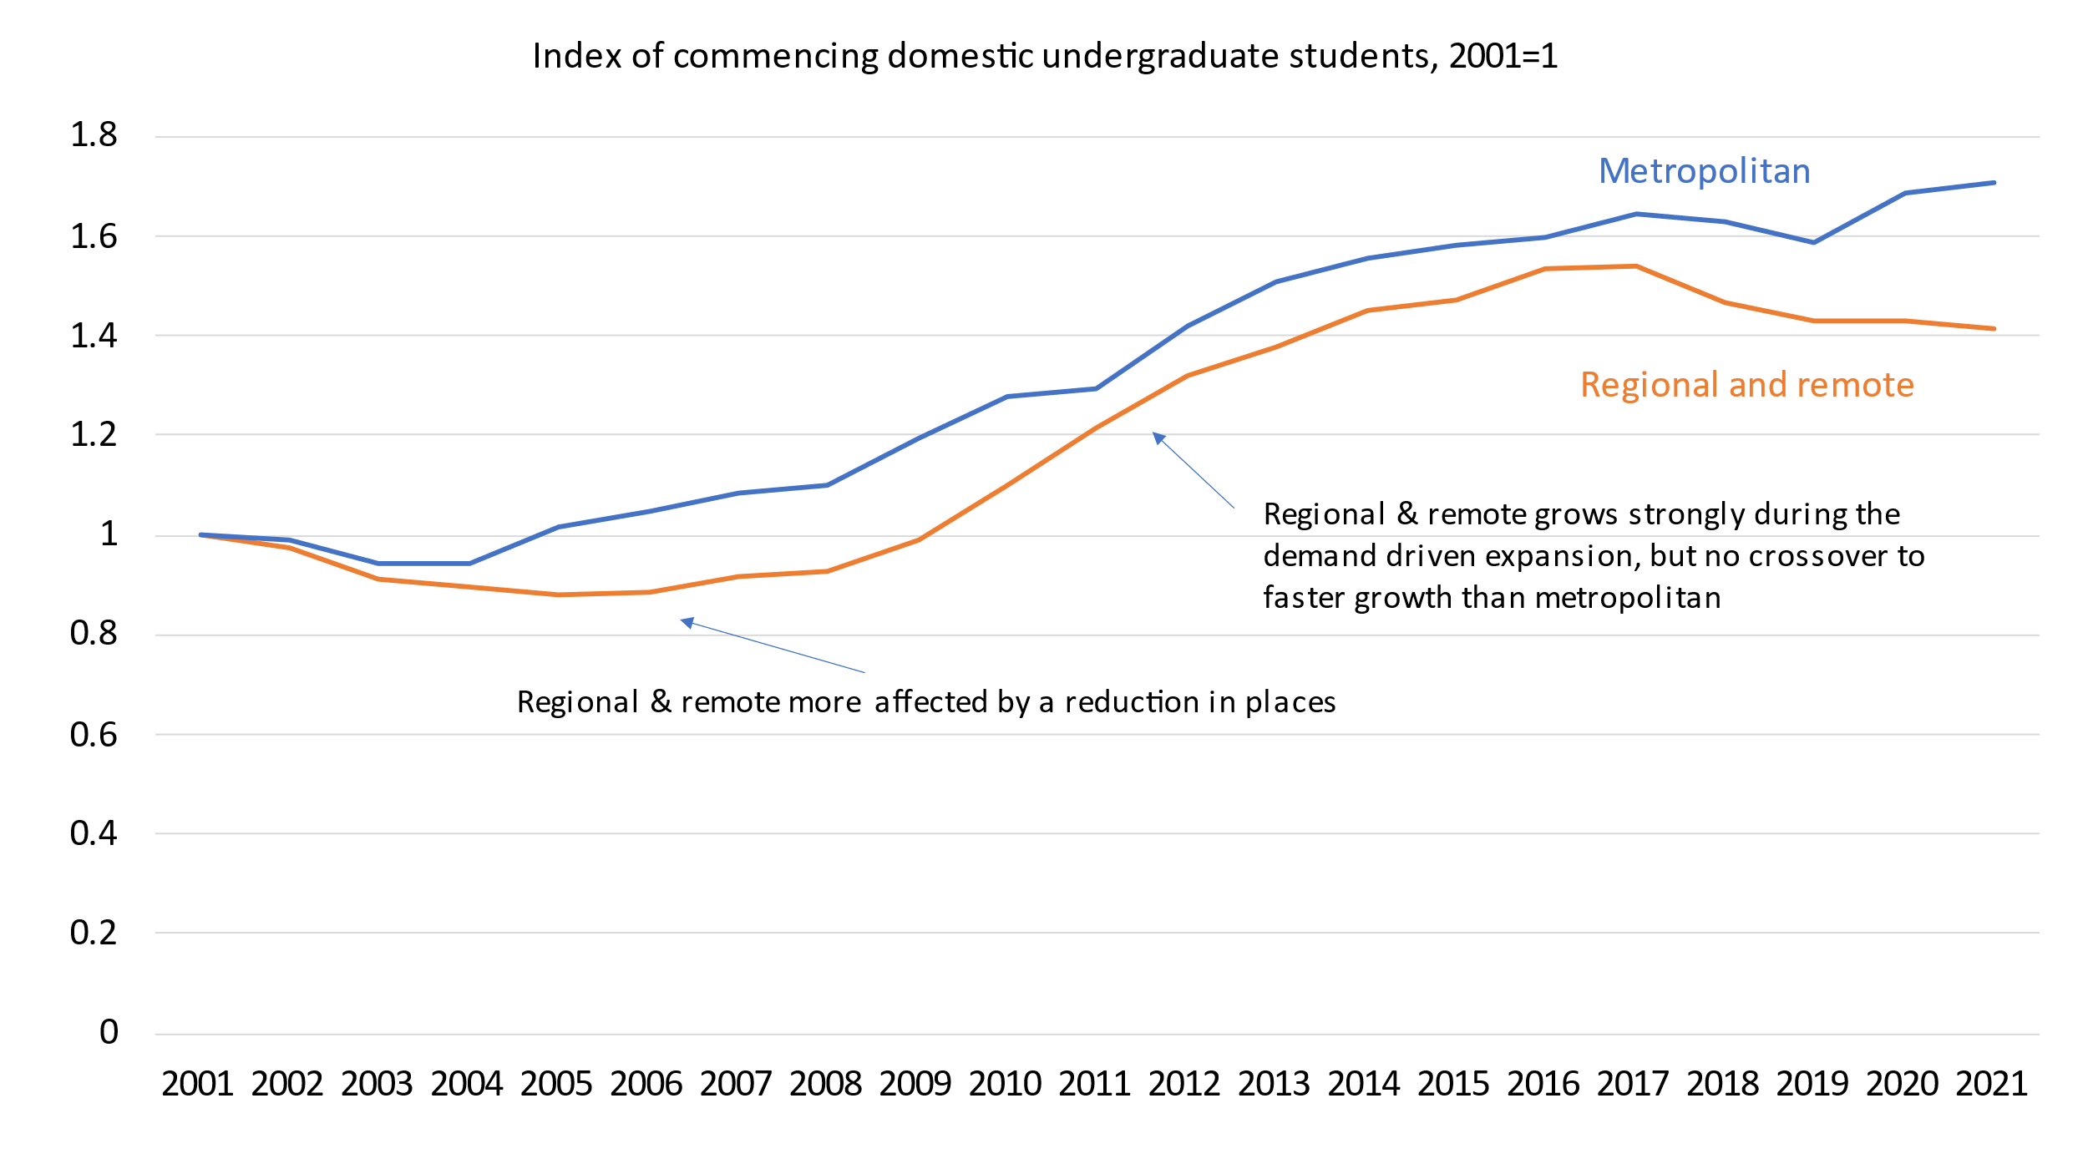

Note: Regional definitions also change with each census which creates a small discontinuity in the time series. From 2016 the ‘first address’ system is used, to reduce the effect of regional students giving city addresses near their university.

Source: Department of Education*, Selected higher education statistics*, table 11.2

Figure 16: Regional compared to metropolitan population trend age 15 to 29 years, 2010 to 2022

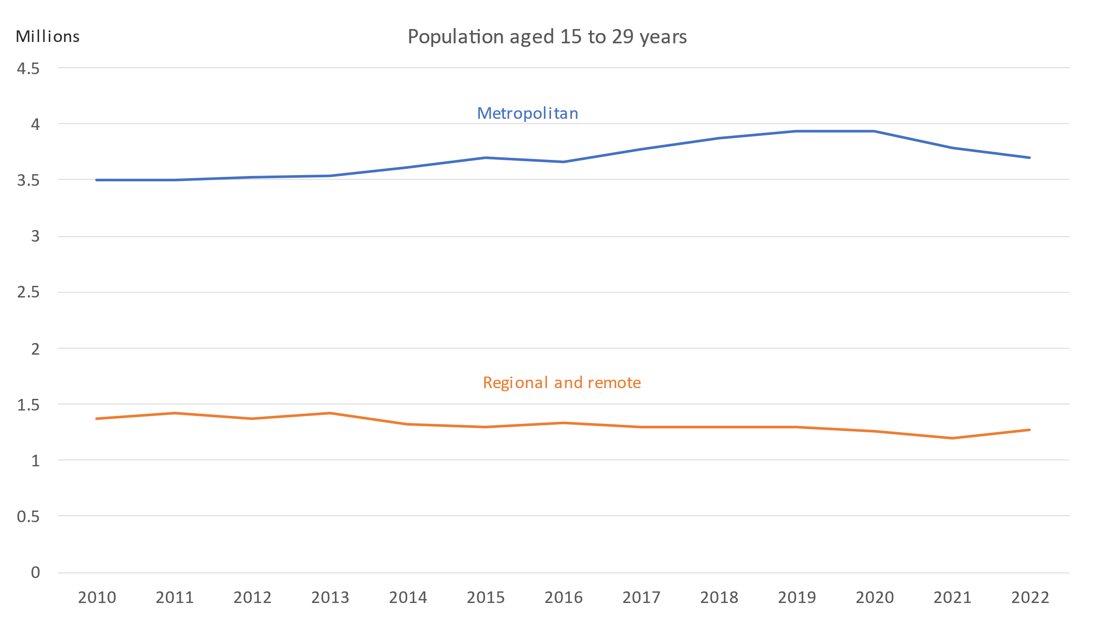

Note: All persons

Source: ABS, *Education and Work*

Of a low base Indigenous commencing undergraduate enrolments have increased significantly since the demand driven system was phased in. Unlike the other equity categories Indigenous enrolments have continued growing (Figure 17). While the regional population in the main university-attending ages seems to be falling the Indigenous population is growing more quickly than the general Australian population, which helps explain the Figure 17 trend.[50] Since 2021 Indigenous students from a regional and remote areas have had a specialised demand driven system. This removed some supply-side obstacles to enrolment growth, but as the next section explains demand for this program has been lower than expected.

Figure 17: Indigenous compared to non-Indigenous commencing domestic undergraduate enrolments, 2001 to 2021

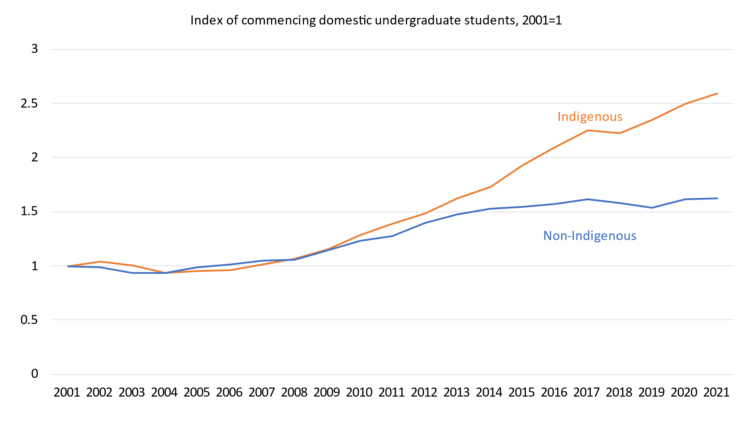

Source: Department of Education, *Selected higher education statistics*, table 11.2

If a second demand driven system was introduced would there be any value in also having institution-level targets? There is little sign in Figure 14, Figure 15 or Figure 17 that universities held back on equity enrolments during the first demand driven system. Every university has special admissions and support programs for both the official equity groups and other disadvantaged groups. But the consequence of many universities trying to improve their equity enrolments is that the pool of new potential equity students is not large, and as shown in Figure 9 concentrated in ATAR ranges below where some universities are usually prepared to take students. The empirical work suggested in the previous chapter could however be passed on to universities to assist in identifying additional potential equity students.

### Are limited demand driven systems worth considering?

The most significant objection to a demand driven system is that the cost is potentially large and less predictable than under technocratic or block grant systems. A mid-point would be limited demand driven systems such as the existing regional and remote Indigenous scheme. Universities Australia, for example, has called for all Indigenous students to be included in demand driven funding.[51] There could be limited demand driven systems for other types of students or for courses the government wants to promote. The eligibility criteria would limit the scope for unexpected cost increases.

One issue with limited demand driven systems is how they would work in the initial transition and subsequent budget processes, and how this would in turn affect the stranded places problem.

In the transition each university is likely to lose from its overall maximum block or technocratic grant amount its estimated funding for the students being moved to a demand driven funding program. The university therefore runs a risk that it won’t use the estimated funding for the demand driven category of students, when it could have used the money for other students. The available funds will not be fully used, and other students will miss out.

As Table 3 shows the cost of the Indigenous regional and remote demand driven scheme was over-estimated for both 2021 and 2022 and has started at a more cautious level for 2023. Universities have lower resources than they anticipated (although this may reflect weak overall demand as much as any factors specific to the regions or Indigenous students). In this case the total amounts of money are not large at a sector level, but the example highlights the issue.

Table 3: Funding estimates for the Indigenous regional and remote demand driven program, 2021 to 2023

|  |  |  |  |
| --- | --- | --- | --- |
| Year | Original estimate | Latest estimate | Percentage change |
| 2021 | $52,887,696 | $49,078,560 | -7.2% |
| 2022 | $50,079,591 | $45,384,502 | -9.3% |
| 2023 | $46,346,865 | n/a | n/a |

Source: Department of Education, Funding determinations webpage

Without a full demand driven system the Commonwealth budget process would probably still assume a fixed maximum amount for the Commonwealth Grant Scheme. If so, the estimated cost of the demand driven student categories would be deducted from the overall allocation for the Commonwealth Grant Scheme, leaving a smaller pool of money for other courses and students.

In limited demand driven systems the Commonwealth takes the financial risk of the value of demand driven student places being higher than expected, and universities take the risk of the value being lower than expected. However, the Commonwealth could come out ahead over multiple budget rounds. It will keep the under-spends, such as shown in Table 3, while deducting higher than expected demand driven expenditure from the next allocations of general grants.

An issue for demand driven systems based on student personal characteristics is the potential for gaming the system by universities or students. Indigenous identification is already an issue due to concessional admissions and specialised support.[52] Low SES and regional students are classified based on their address. Numbers vary depending on how far back in the student’s history the address records go, but these are not authenticated.[53] Whether a student is truly first in family is not easily checked. Documenting and verifying student backgrounds would be costly for both students and universities.

As with technocratic allocations of resources to equity groups a further problem is that, apart from disability, none of the equity categories are individual level indicators of disadvantage. Consequently, even verifying the claims of individual students against the official definitions would not provide a high level of confidence that resources are well targeted.

# Overview of first submission

This submission focuses on the coursework funding system: overall funding rates, student contributions, Commonwealth contributions and different ways of distributing resources to higher education providers. It therefore relates primarily to ‘key areas’ one to three in the Accord’s terms of reference.

The goal of the submission is to outline issues and potential policy responses to them. It recommends ruling out early some policy ideas that are less effective than their alternatives or are not politically viable. This will focus analytical resources over the limited time available to the Accord panel on considering the relative merits of realistic options.

*Overall funding rates*

Current overall funding rates by discipline are based on average teaching and scholarship costs. The submission provides reasons why the funding rates should include a margin above the average.

*Student contributions*

Student contribution reform is more urgent than other issues because some students are already incurring HELP debts that impose an unreasonable burden on them and unnecessary costs on taxpayers.

The submission suggests considering the following in a student contribution system: the financial burden on students, taking into account how long it will take them to repay as well as the total dollar amount charged; the cost to taxpayers through the HELP loan scheme as well as the Commonwealth Grant Scheme; and the marginal cost of providing additional student places, when these are ‘over-enrolments’ funded on the student contribution rate only.

Two student contribution systems, the Job-ready Graduates system of incentives and disincentives, and systems which charge students according to courses costs, should be ruled out early as failing policy and political tests. Two credible contender systems are a flat rate across all disciplines and one linked to earnings prospects. Both these systems have been used before.

*Commonwealth contributions*

Commonwealth contributions affect the system in different ways depending on student contribution levels and the system of allocating total Commonwealth resources (discussed below).

The Job-ready Graduates Commonwealth contributions combined with fixed total allocations of funding per university create the following issues:

* Job-ready Graduates mostly uses dollars rather than student places as the unit of allocation in providing resources to higher education providers. As Commonwealth contributions vary according to discipline, the same total Commonwealth grant can produce high or low numbers of student places. Inherently, this reduces certainty about the number of higher education opportunities for students compared to systems which allocate according to student places or set minimum numbers of student places.
* Job-ready Graduates increased this uncertainty by significantly increasing the ratio between the lowest and highest Commonwealth contributions.
* Job-ready Graduates created different indexation systems for university grants (inflation estimated over three years, with grants increased annually by the estimate) and Commonwealth contributions (indexed automatically each year according to actual but lagged CPI). High indexation of Commonwealth contributions will reduce how many student places higher education providers need to deliver to get their maximum funding. This will occur at the same time as demand for places increases.

A new Commonwealth contribution system should narrow the differences between Commonwealth contribution levels.

*Models of allocating public resources to higher education providers*

The submission sets out four broad models of allocating resources to higher education providers: technocratic, block grant, demand driven, and capped voucher. Which system or systems are chosen will affect how, and how well, the Accord’s attainment, equity and skills objectives are met.

Technocratic systems are (ideally) characterised by expert input to achieve the government’s goals. Block grant systems let higher education providers decide how to allocate fixed resources across courses and students. Demand driven systems remove both system and provider-level caps, letting supply move to meet demand by institution and course. Capped voucher systems also allow these movements between institutions, but vouchers may be restricted by course and are limited in total. The first three models are in use now for different purposes.

The current system is primarily a block grant, but with a small demand driven system for regional Indigenous students and a technocratic system for allocating medical places. The current and previous governments have put technocratic overlays on block grant systems: the COVID-19 short courses, the recent 20,000 new places for equity students, and proposed allocations of teacher education places.

For all its other faults, Job-ready Graduates recognised a problem with the technocratic approach: every condition added to funding reduces the chance that a student can be found that meets all the criteria. Micro-allocations risk stranded funding, money unused because too few students match all the criteria while elsewhere in the system needs go unmet due to a lack of funding. What looks like problem solving can turn out to be problem creating.

Block and technocratic systems typically grow by adding incrementally to historical allocations to universities. Job-ready Graduates provides ‘growth’ funding based on campus location: 3.5 per cent annually for regional campuses, 2.5 per cent for metropolitan campuses in high growth areas, and 1 per cent for other campuses. Based on the current location of the young people who will go to university from the mid-2020s most growth capacity will be needed in the outer suburbs of capital cities. As most school leaver university students live at home misallocation of funding will further reduce the system’s effective capacity to meet demand. Failure to meet demand would disproportionately affect urban lower SES students.

Demand driven funding offers the most flexibility in meeting the attainment, skills and equity objectives of the Accord. Its drawback from the government’s perspective is less predictable cost. The submission also warns that a second demand driven system may not operate in the same way as the first. The first demand driven system relied on a list of universities that was unchanged since the late 1990s. No new public higher education institution has been created this century. New institutions may be necessary to meet growth objectives.

*Research projects that could assist the Accord panel*

* Future demand for higher education by geographic area, mapped against existing university catchment areas.
* Estimates of median time to repay HELP debt by course taken.
* Increased understanding of how providers respond to total funding rates, student contributions for over-enrolments, and whether they see themselves as responsible for meeting student demand.

# References

ABS. *Census of population and housing, 2016, TableBuilder Pro* (Australian Bureau of Statistics, 2017).

———. *Qualifications and work, Australia, 2018-19, TableBuilder* (Australian Bureau of Statistics, 2020).

———. *Census of population and housing, 2021, TableBuilder Pro* (Australian Bureau of Statistics, 2022).

———. *Schools* (Australian Bureau of Statistics, 2022).

———. *Work-related training and adult learning, 2020-2021, TableBuilder* (Australian Bureau of Statistics, 2022).

———. *Labour Force, Australia, Detailed* (Australian Bureau of Statistics, 2023).

———. *Understanding change in counts of Aboriginal and Torres Strait Islander Australians: Census* (Australian Bureau of Statistics, 2023).

ACARA. *NAPLAN results PowerBI* (Australian Curriculum, Assessment and Reporting Authority, 2023).

Access Economics. *Future demand for higher education* (Access Economics, 2008).

Aungles, P., H. Hodgson, and S. Parbery. *Graduate incomes: insights from administrative data* (Department of Education, Skills and Employment, 2021).

Australian Government. *Australian Universities Accord discussion paper: February 2023* (Australian Government/Department of Education, 2023).

Baik, C., R. Naylor, and S. Arkoudis. *The first year experience in Australian universities: findings from two decades 1994-2014* (Centre for the Study of Higher Education/University of Melbourne, 2015).

Bradley, D., P Noonan, H Nugent, and B Scales. *Review of Australian higher education: final report* (Department of Education, Employment, and Workplace Relations, 2008).

Cardak, B., M. Bowden, and J. Bahtsevangolou. *Are low SES students disadvantaged in the university application process?* (National Centre for Student Equity in Higher Education, 2015).

Cardak, B., M. Brett, M. Bowden, J. Vecci, P. Barry, J. Bahtsevanoglou, and R. McAllister. *Regional student participation and migration* (National Centre for Student Equity in Higher Education (NCSEHE), 2017).

Cardak, B., and C. Ryan. 'Participation in higher education in Australia: equity and access'. *Economic Record* 85, no. 271 (2009) 433-48.

Cherastidtham, I., A. Norton, and W. Mackey. *University attrition: what helps and what hinders university completion?* (Grattan Institute, 2018).

DEEWR. *Transforming Australia's higher education system* (Department of Education, Employment and Workplace Relations, 2009).

Department of Jobs and Small Business. *Australian Jobs 2018* (Department of Jobs and Small Business, 2018).

DESE. *Historical list of skills shortages in Australia* (Department of Education, Skills and Employment, 2019).

———. *Historical list of skills shortages in Australia 1986-2018* (Department of Education, Skills and Employment, 2019).

DofE. *Student applications time series, PowerBI* (Department of Education, 2022).

———. *Completion rates of domestic bachelor degree students: a cohort analysis, 2005-2021* (Department of Education, 2023).

———. *Student enrolment pivot table* (Department of Education, 2023).

———. *Student enrolment time series, PowerBI* (Department of Education, 2023).

———. *Students: Selected higher education statistics 2021* (Department of Education, 2023).

Huong, B., and M. Justman. 'NAPLAN scores as predictors of access to higher education in Victoria'. *Melbourne Institute Working Paper Series* 22, no. 14 (2014) 1-34.

Kemp, D., and A. Norton. *Review of the demand driven system: final report* (Department of Education, Department of Education, 2014).

NCVER. *VOCSTATS: TVA program enrolments 2015-2021* (National Centre for Vocational Education Research, 2022).

Norton, A. 'Does ATAR measure more than SES?', *Andrew Norton's blog*, 14 June 2018.

———. 'Why is mature-age university demand trending down?', *Andrew Norton's blog*, 18 March 2019. <https://andrewnorton.net.au/2019/03/18/why-is-mature-age-university-demand-trending-down/>.

———. *Submission on priority student funding policy issues for the Universities Accord - December 2022* (Universities Accord submission website, 2022).

———. 'The 20,000 equity places that nearly weren’t allocated and that will probably never be delivered', *Andrew Norton: Higher education commentary from Carlton (blog)*, 6 February 2023.

Norton, A., and I. Cherastidtham. *Risks and rewards: when is vocational education a good alternative to higher education?* (Grattan Institute, 2019).

Norton, A., I. Cherastidtham, and W. Mackey. *Dropping out: the benefits and costs of trying university* (Grattan Institute, 2018).

———. *Mapping Australian higher education 2018* (Grattan Institute, 2018).

NSC. *Skills Priority List: Key findings report* (National Skills Commission, 2022).

PC. *5-year Productivity Inquiry: From learning to growth - volume 8* (Productivity Commission, 2023).

SRC. *2022 Employer Satisfaction Survey* (Social Research Centre/Department of Education, 2023).

Tuffey, D. 'Australia must prepare for massive job losses due to automation', *The Conversation*, June 16 2015.

UA. 'Postcodes shouldn't matter - helping more Indigenous Australians go to universities', *Universities Australia media releases*, 22 October 2022.

UAC. *Report on the scaling of the 2021 NSW Higher Education Certificate* (Universities Admission Centre, 2022).

Ward, M. 'Sydney Uni cracks down on staff, students 'self-identifying' as Indigenous', *Sydney Morning Herald*, October 9 2022.

Wilkins, R. *The Household, Income and Labour Dynamics in Australia Survey: Selected findings from waves 1 to 14, the 11th annual statistical report of the HILDA survey* (Melbourne Institute of Applied Economic and Social Research, 2016).

Yu, M., and D. Warren. 'Shaping futures: school subject choice and enrolment in STEM'. In *Growing up in Australia: the longitudinal study of Australian children: annual statistical report 2018*, edited by G. Daraganova and N. Joss (Australian Institute of Family Studies, 2019).

1. A. Norton, *Submission on priority student funding policy issues for the Universities Accord - December 2022* (Universities Accord submission website, 2022).
2. DEEWR, *Transforming Australia's higher education system* (Department of Education, Employment and Workplace Relations, 2009), p. 12.
3. Australian Government, *Australian Universities Accord discussion paper: February 2023* (Australian Government/Department of Education, 2023), p. 13.
4. Calculated from ABS, *Census of population and housing, 2021, TableBuilder Pro* (Australian Bureau of Statistics, 2022).
5. Access Economics, *Future demand for higher education* (Access Economics, 2008).
6. DESE, *Historical list of skills shortages in Australia 1986-2018* (Department of Education, Skills and Employment, 2019); D. Bradley et al., *Review of Australian higher education: final report* (Department of Education, Employment, and Workplace Relations, 2008), p. 17.
7. Department of Jobs and Small Business, *Australian Jobs 2018* (Department of Jobs and Small Business, 2018), p. 26 compared to ABS, *Labour Force, Australia, Detailed* (Australian Bureau of Statistics, 2023), table EQ08.
8. NSC, *Skills Priority List: Key findings report* (National Skills Commission, 2022), p. 8.
9. DESE, *Historical list of skills shortages in Australia* (Department of Education, Skills and Employment, 2019). Not all occupations were necessarily surveyed each year; this list was focused on occupations with a history of shortages.
10. Eg D. Tuffey, 'Australia must prepare for massive job losses due to automation', *The Conversation*, June 16 2015.
11. They can be analysed in the ABS DataLab.
12. Calculated from ABS, *Work-related training and adult learning, 2020-2021, TableBuilder* (Australian Bureau of Statistics, 2022).
13. C. Baik, R. Naylor and S. Arkoudis, *The first year experience in Australian universities: findings from two decades 1994-2014* (Centre for the Study of Higher Education/University of Melbourne, 2015), p. 24.
14. Calculated from DofE, *Students: Selected higher education statistics 2021* (Department of Education, 2023), table 4.5.
15. See the references in A. Norton, I. Cherastidtham and W. Mackey, *Mapping Australian higher education 2018* (Grattan Institute, 2018) p. 18, footnote 46. Also M. Yu and D. Warren, 'Shaping futures: school subject choice and enrolment in STEM', in *Growing up in Australia: the longitudinal study of Australian children: annual statistical report 2018*, ed. G. Daraganova and N. Joss (Australian Institute of Family Studies, 2019), p. 99.
16. Baik, Naylor and Arkoudis, *The first year experience in Australian universities: findings from two decades 1994-2014*, p. 24.
17. The discussion paper puts Australia’s figure at 41.5 per cent in 2021 but OECD.Stat reports 44.5 per cent, if the methodology is simply adding up of bachelor+masters+doctorate. This method gets the same results as the Accord discussion paper for the other countries mentioned. Australian Government, *Australian Universities Accord discussion paper: February 2023*, p .7. However, it is possible that neither are right for 2021. The OECD lists at its source for Australia as the ABS Education and Work survey. The 44.5 per cent figure matches the Education and Work result for 2022. The 2021 figure using Education and Work was 43.5 per cent. However, given the standard errors included with Education and Work and also reported in OECD.Stat for Australia and other countries little weight should be put on minor differences between years or countries.
18. SRC, *2022 Employer Satisfaction Survey* (Social Research Centre/Department of Education, 2023), p. 16.
19. A. Norton and I. Cherastidtham, *Risks and rewards: when is vocational education a good alternative to higher education?* (Grattan Institute, 2019), p. 27.
20. At the time of the 2016 Census 46.5 per cent of the 18 to24 year old Australian citizen population was at least one of living in area classified in the lowest three deciles by the Index of Education and Occupation, living in a regional or remote area, or Indigenous. Calculated from ABS, *Census of population and housing, 2016, TableBuilder Pro* (Australian Bureau of Statistics, 2017). The SEIFA and regional variables are not yet in the 2021 Census TableBuilder.
21. The term ‘participation rate’ in the Department of Education’s equity data is used in an idiosyncratic way. It is an enrolment share. However, this enrolment share is then compared with the percentage of the state’s population age 15-64 years with the equity group characteristic. With 72 per cent of domestic higher education students aged between 17 and 29 years so this age range is overly wide. Conceptually, however, it is getting closer to a more interesting comparison point than the enrolment numbers of other student groups. Figure 5 on page 24 of Australian Government, *Australian Universities Accord discussion paper: February 2023* uses a ‘participation ratio’, which is enrolment share of equity group/population share of equity group (except for low SES, which is low SES enrolment share/high SES enrolment share).
22. B. Cardak and C. Ryan, 'Participation in higher education in Australia: equity and access,' *Economic Record* 85, no. 271 (2009); Norton, Cherastidtham and Mackey, *Mapping Australian higher education 2018*, p. 26. For the regional difference: B. Cardak et al., *Regional student participation and migration* (National Centre for Student Equity in Higher Education (NCSEHE), 2017).
23. Norton, *Submission on priority student funding policy issues for the Universities Accord - December 2022*, pp. 38-39.
24. Higher NAPLAN scores tend to predict higher ATARs: B. Huong and M. Justman, 'NAPLAN scores as predictors of access to higher education in Victoria,' *Melbourne Institute Working Paper Series* 22, no. 14 (2014).
25. DofE, *Completion rates of domestic bachelor degree students: a cohort analysis, 2005-2021* (Department of Education, 2023); I. Cherastidtham, A. Norton and W. Mackey, *University attrition: what helps and what hinders university completion?* (Grattan Institute, 2018); A. Norton, 'Does ATAR measure more than SES?', *Andrew Norton's blog*, 14 June 2018.
26. Norton and Cherastidtham, *Risks and rewards: when is vocational education a good alternative to higher education?*, p. 26.
27. R Wilkins, *The Household, Income and Labour Dynamics in Australia Survey: Selected findings from waves 1 to 14, the 11th annual statistical report of the HILDA survey* (Melbourne Institute of Applied Economic and Social Research, 2016), pp. 50-51.
28. NSC, *Skills Priority List: Key findings report*, p. 7.
29. For vocational education domestic students aged 15 to 25 years, calculated from NCVER, *VOCSTATS: TVA program enrolments 2015-2021* (National Centre for Vocational Education Research, 2022). If all Certificate III and above vocational education is included 52 per cent of enrolments are men. For higher education calculated from DofE, *Student enrolment pivot table* (Department of Education, 2023).
30. Calculated from DofE, *Student enrolment time series, PowerBI* (Department of Education, 2023), student enrolments by equity groups page. For applications for 2021 the male shares were 34 per cent of low SES applicants, 37 per cent of medium SES applicants and 44 per cent of high SES applicants: calculated from DofE, *Student applications time series, PowerBI* (Department of Education, 2022).
31. For the 2021 to 2020 school years 84.1 per cent of boys and 88.8 per cent of girls continued from Year to Year 12: ABS, *Schools* (Australian Bureau of Statistics, 2022), table 63a. UAC analysis shows that in NSW women are a majority in all ATAR categories except 98 or over: UAC, *Report on the scaling of the 2021 NSW Higher Education Certificate* (Universities Admission Centre, 2022), p. 19.
32. Calculated from ACARA, *NAPLAN results PowerBI* (Australian Curriculum, Assessment and Reporting Authority, 2023).
33. Previous research has shown that low SES students do less than high SES students to revise their applications for a better result after receiving their ATAR: B. Cardak, M. Bowden and J. Bahtsevangolou, *Are low SES students disadvantaged in the university application process?* (National Centre for Student Equity in Higher Education, 2015).
34. One report has been published from this dataset, looking at people who completed their degrees: P. Aungles, H. Hodgson and S. Parbery, *Graduate incomes: insights from administrative data* (Department of Education, Skills and Employment, 2021).
35. A. Norton, I. Cherastidtham and W. Mackey, *Dropping out: the benefits and costs of trying university* (Grattan Institute, 2018), chapter 1.
36. PC, *5-year Productivity Inquiry: From learning to growth - volume 8* (Productivity Commission, 2023), chapter 4.
37. Norton, Cherastidtham and Mackey, *Mapping Australian higher education 2018*, p. 22.
38. DofE, *Completion rates of domestic bachelor degree students: a cohort analysis, 2005-2021*.
39. Calculated from DofE, *Students: Selected higher education statistics 2021*, tables 5.4 and 5.6.
40. Calculated from ABS, *Qualifications and work, Australia, 2018-19, TableBuilder* (Australian Bureau of Statistics, 2020).
41. Department of Education, special data request.
42. A. Norton, 'The 20,000 equity places that nearly weren’t allocated and that will probably never be delivered', *Andrew Norton: Higher education commentary from Carlton (blog)*, 6 February 2023.
43. Norton, *Submission on priority student funding policy issues for the Universities Accord - December 2022*, pp. 29-30, 34-35.
44. Norton, *Submission on priority student funding policy issues for the Universities Accord - December 2022*, chapter 5.
45. Norton, *Submission on priority student funding policy issues for the Universities Accord - December 2022*, pp. 35-38.
46. Norton, *Submission on priority student funding policy issues for the Universities Accord - December 2022*, pp. 40-42.
47. D. Kemp and A. Norton, *Review of the demand driven system: final report* (Department of Education: Department of Education, 2014), p. 72-74. However, it is possible that the logic could run the other way if a university can reduce its average costs by enrolling more students.
48. DofE, *Student applications time series, PowerBI*.
49. A. Norton, 'Why is mature-age university demand trending down?', *Andrew Norton's blog*, 18 March 2019.
50. ABS, *Understanding change in counts of Aboriginal and Torres Strait Islander Australians: Census* (Australian Bureau of Statistics, 2023).
51. UA, 'Postcodes shouldn't matter - helping more Indigenous Australians go to universities', *Universities Australia media releases*, 22 October 2022.
52. M. Ward, 'Sydney Uni cracks down on staff, students 'self-identifying' as Indigenous', *Sydney Morning Herald*, October 9 2022.
53. See DofE, *Students: Selected higher education statistics 2021*, table 11.1. There is an odd reversal of the usual relativities for ‘first address’ and the other SES categories for 2021. This may be due to problems with the TCSI system.