An Imperative To Improve the Work Quality of Staff in the Higher Education Sector
The University Accord discussion paper poses many questions about the future direction of the university sector. A theme throughout the discussion paper is ambition, or how the sector is to grow, excel, and contribute globally, while supporting the local population.
Ultimately, the Australian university sectors’ capacity to deliver on its ambitious agenda is contingent on the academic and professional staff that work within and adjacent to the sector. A vast amount of research evidence shows that productivity, innovation, and effectiveness are enhanced with a committed, engaged, and healthy workforce. In a nutshell, for the sector to thrive, its workforce must thrive.
Unfortunately, a great deal of evidence suggests the sector is far from provident great places to work. As a clear example, see the Accord statement from ARC Laureate Fellow Maureen Dollard, which demonstrates the excess levels of burnout and unhealthy working practices in Australia’s higher education sector relative to other sectors.
There is also a legislative imperative for change. With revisions to work health and safety legislation now making clearer than previously the responsibility of employers to prevent workers from harm, there is a legal imperative to create healthy work that does not incur psychosocial risks such as excess workload.
In recognition of these issues, the Accord’s discussion paper poses the question “How can the Accord support higher education providers to adopt sector-leading employment practices?” (Question 38). As researchers investigating this topic for many years, and working closely with industry across Australia, we recommend the following:
Recommendation 1. Develop and support strategies and policies to promote the mental health and well-being of the higher education workforce.
We have developed an evidence-based, practically-informed model of Thriving At Work which identifies three critical pillars. This model (or others like it) could inform the development of mental health strategy within the sector.
The first pillar, Mitigate Illness, focuses on supporting workers experiencing mental illness, ill-health, and injury, regardless of cause. Mental illness can impact people across all types of workplaces, and all industries: approximately 45% of adults between the ages of 16 and 85 will experience a mental health issue in their lifetime. Research consistently shows that untreated mental illnesses negatively impact turnover, absenteeism, and workforce productivity. Organisations that mitigate mental illness can experience a significant return on investment, through increased productivity and reduced absenteeism. Three sets of evidence-based workplace strategies that organisations can adopt to mitigate illness include:
(1) Detect and Support Illness - organisational strategies to facilitate the early detection and support of employees experiencing mental ill-health, including crisis support;
(2) Accommodate Illness - organisational strategies to assist employees who have been unwell to recover, whilst undertaking appropriate and meaningful work; and
(3) Increase Individual Resources for Managing Mental Health - organisational strategies aimed at increasing employee mental health literacy and help-seeking
The second pillar, Prevent Harm, focuses on creating work that protects employees against known psychosocial risks through good work design and organisational management. Work conditions and the work itself significantly impact the likelihood of employees developing physical and mental health conditions, including musculoskeletal conditions, depression, anxiety, and substance abuse. Importantly, as noted above, there is a legal imperative to engage in preventative approaches such as work redesign to address psychosocial risks. Strategies for preventing harm are summarised below and discussed in more detail in Recommendation 2:
- Maintain/ Increase Job Resources – strategies that create work conditions that help people to achieve goals, manage demands, and/or stimulating personal development. This includes designing work that is Stimulating, promotes Mastery, has Agency, and is Relational.
- Ensure Tolerable Job Demands – strategies that ensure the different types of demands experienced in work do not exceed the personal resources of individuals (that is, are Tolerable, see Recommendation 2).
- Increase Individual Resources for Preventing Harm- strategies to help individuals themselves to create job resources and effectively manage, reduce, or prevent excessively high job demands, such as job crafting.

The third pillar, Promote Thriving, has as its goal optimising employee well-being, or employee thriving, and thereby helps employees to realise their potential and lays the foundation for their outstanding performance. Evidence-based strategies include:
- Create Conditions for Growth - organisational strategies that cultivate continuous learning, development, and growth of their employees
- Create Conditions for Connection - organisational strategies can focus on maximising the connection employees derive from their work, with relationships being an important source of subjective well-being and thriving.
- Increase Individual Resources for Thriving - strategies that enable individuals themselves to create a better work experience, such as training individuals in mindfulness practices, and encouraging their strengths-based crafting.

In sum, we urge that the higher education sector embrace the need for a mentally healthy workforce and invest in the above sorts of strategies. This will require upskilling those with responsibility for managing others, and especially the very senior leaders who design and implement work systems, to equip them with the knowledge and skill required. Especially important is building understanding of the need for the second pillar above, Prevent Harm, which is arguably the most important - yet the most neglected - in the higher education sector. We therefore elaborate the need for strategies in this pillar in Recommendation 2.
Recommendation 2. Prevent harm to the higher education workforce by creating and supporting higher quality jobs.
There is considerable research that demonstrates that the conditions under which people work can have profound effects of the wellbeing and productivity of the workers. We encourage the Accord to embrace the learnings from this body of work to design a future higher education sector that places the quality of working life at the forefront. For example, the ARC Laureate-funded Centre for Transformative Work design’s SMART work design model (Parker and Knight, under review; transformativeworkdesign.com.au) identifies the following as crucial elements of work for mental health, well-being, and performance:
Stimulating work: Individuals’ job satisfaction, commitment and well-being are higher when they have variety and challenge in their work, and when they have the opportunity for growth and development.
Mastery: Workers’ need to be clear about what is required from them, and receive feedback on how they are performing.
Agency: Humans have a fundamental need for control, and much evidence shows that job performance, innovation, well-being, and other such outcomes are enhanced when individuals have a degree of influence and autonomy over important aspects of their work.
Relational: Workers’ thrive and are psychologically healthier at work when they have support from their managers and peers, when they feel part of something larger (e.g., a team or organisation), and when they feel that can impact positively other people’s lives.
Tolerable: All work has demands, but the demands people experience – be they physical, time pressures, emotional, or other demands – need to be experienced as reasonable and manageable. Intolerable demands, such as excess work pressure or long work hours, cause stress, impact on cardiovascular functioning, and contribute to negative behaviours such as alcohol and drug use.
SMART work design is shaped by multilevel forces (Parker, van den Broeck, & Holman, 2018). In the university sector, one such factor is the excessive levels of bureaucracy and administrative procedures. For many academics, the level of bureaucracy they face creates deeply unstimulating work, removes autonomy, and makes the workload increasingly intolerable. The complex procedures required for PhD recruitment, selection, supervision; for ethical approval of research; for the establishment of research contracts; for grant applications; for reporting; for teaching procedures, and more, are time-consuming and often inefficient. At the same time, administrative support has been reduced significantly from many universities. Highlighting the scale of the challenge, in a very welcome initiative, Curtin University has embarked on a “Battling Bureaucracy” project which has aimed to identify and reduce the bureaucratic burden on staff. So far, more than 1500 procedures have been registered by staff and the university is taking measures to reduce or eliminate unnecessary procedures.
Much of the bureaucracy stems from a desire to manage risk in the sector yet, perversely, these processes create a different form of risk – that of unworkable, intolerable systems that overwhelm staff on a daily basis. Technology could be part of the solution to these challenges, but it needs to be recognised that - unless the technology is appropriately designed and implemented - much of the time the technical systems seem to create additional layers of complexity and frustration for the end users (academics and professional staff).
A further cause of poor work design is the addition of more and more KPIs, targets, and ever- increasing performance expectations. These include expectations associated with teaching, research performance, student experience, Sustainable Development Goals, Diversity and Inclusion, non-academic Impact, income generation, commercialisation, and more. This is not to say these goals have no value nor to say they should not be part of successful universities’ portfolios, however, it must be remembered that continually adding KPIs translates into ever increasing workloads for academics, generating ever more intolerable demands.
There are no doubt other causes of poor-quality work (funding models, systems that tacitly encourage managerial approaches in senior roles, loss of income during COVID, and more). The point here is not to exhaustively identify all possible influences, but to identify the need for a systematic analysis of the factors impairing work quality in the higher education sector, and then, most crucially, to urge efforts to address these factors.
In sum, we admire the ambition of the Accord, but fear the aspirations cannot be realised without addressing the serious challenges facing staff in the sector.
Please note that we are very happy to be further consulted on any of the issues or ideas identified in our statement.
ARC Laureate Fellow Sharon K. Parker, Director, Centre for Transformative Work Design; Future of Work Institute; Curtin University.
Associate Professor Patrick Dunlop, Future of Work Institute, Curtin University
John Curtin Distinguished Professor Marylène Gagné, Future of Work Institute, Curtin University

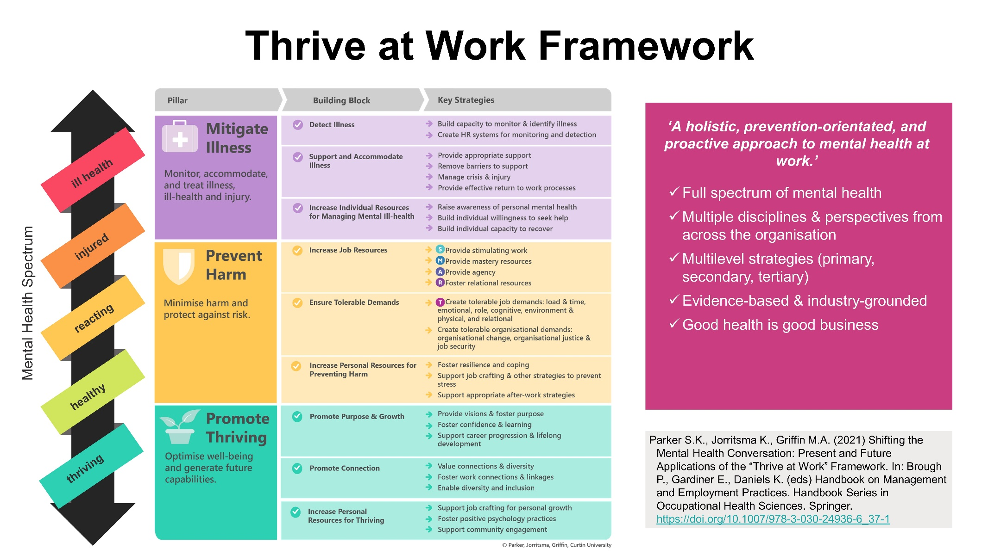
Appendix 1. Thrive at Work Framework.
More information is available from https://www.thriveatwork.org.au/
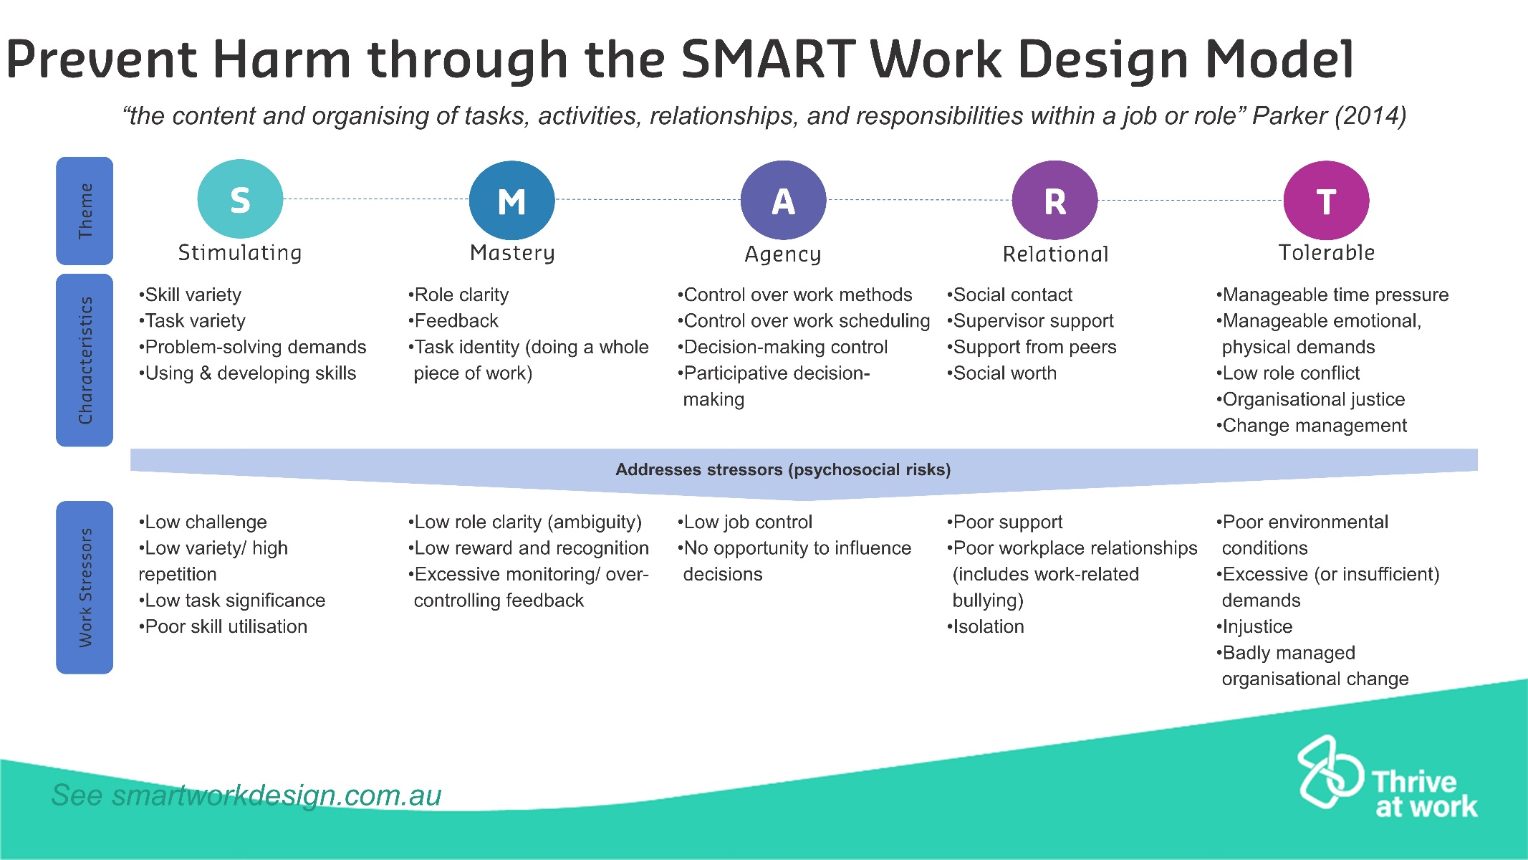
Appendix 1. The SMART Work Design Model.
More information is available from https://www.smartworkdesign.com.au/

Parker, SK., Jorritsma, K., and Griffin, M. A. (2022). Shifting the Mental Health Conversation: Present and Future Applications of the “Thrive at Work” Framework. In P. Brough, E. Gardiner, and K. Daniels. (Eds). Handbook on Management and Employment Practices, Series in Occupational Health Sciences, Springer Nature: London.
Please see the above publication for references that support these statements.

