Submission to the Australian University Accord Process

30th March 2023

**Brain Strain: The Hazardous Corporate Climate in Australian Universities for Employee Psychological Health**

We are writing in the hope that the Australian University Accord can put Australian university employees and their humanity as central in its vision.

Evidence is mounting that the average university staff member is working in a high-risk environment for psychological damage and distress. An ARC Discovery-funded survey of mental health and workplace conditions across Australian universities revealed that the Psychosocial Safety Climate (the corporate climate for worker psychological health, Dollard & Bakker, 2010) is not safe. Poor workplace conditions are putting university staff at a high to very high risk for future job strain and depression.

Psychosocial Safety Climate refers to senior management commitment and support for stress prevention, management priority for worker psychological health over productivity imperatives, organisational communication in relation to psychosocial risks that could affect employees, and the possibility for participation and consultation (by all stakeholders including employee representatives, NTEU) in relation to the prevention of risks to employee psychological health. As such, Psychosocial Safety Climate reflects the organisational system for the prevention and management of psychosocial hazards.

A high Psychosocial Safety Climate is good for worker health and productivity. National and international findings show that Psychosocial Safety Climate is a leading indicator of future work conditions. At low levels it can lead to job strain (high work pressure, low control), fewer rewards, less support, workplace violence, bullying, and harassment, and is therefore referred to as a ‘cause of the causes’ of psychological distress. Psychosocial Safety Climate affects health outcomes (e.g., burnout, anxiety, depression, and muscular skeletal disorders), and performance and productivity metrics (e.g., turnover, sickness absence, workers compensation, return to work time and cost, organisational restructuring, work engagement, performance and creativity). Recent research published in the British Medical Journal (Open) revealed that in a sample of Australian workers with no depressive symptoms, those who were employed in workplaces with low Psychosocial Safety Climate experienced a three-fold increase in depressive symptoms within a year compared to those in a high Psychosocial Safety Climate (Zadow et al., 2021).

**Figure 1**. Psychosocial Safety Climate Benchmarks by National, Public and University Sector

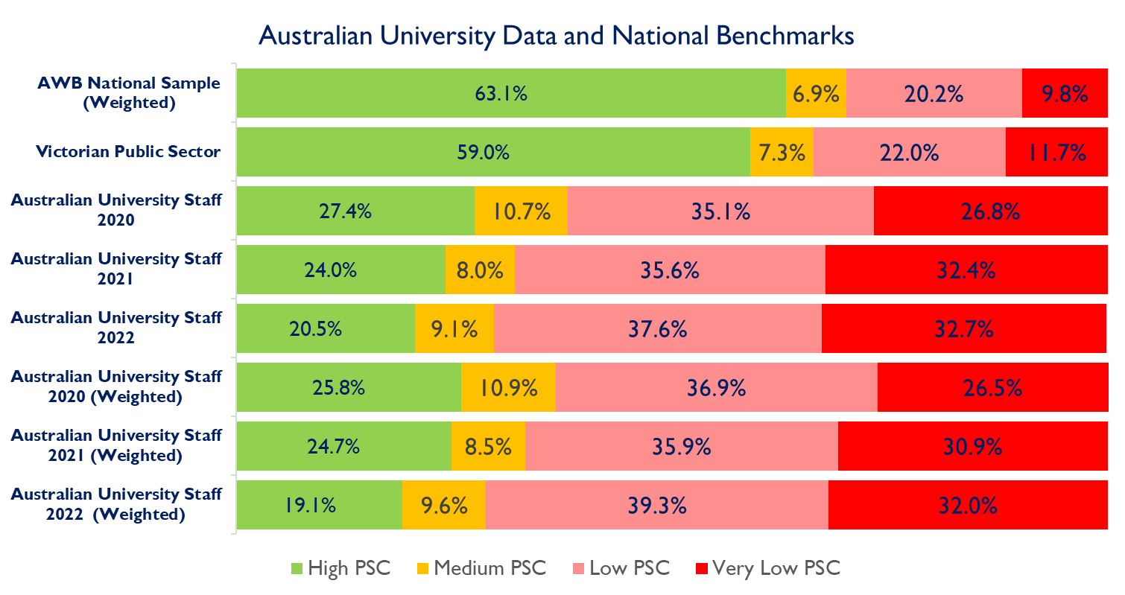

The urgency of this crisis in Australian universities is highlighted when their survey results are compared to other industry samples. Figure 1 presents benchmark data from the ARC funded Australian Workplace Barometer national data from Australian employees, and from Victorian public sector employee data. Both samples show that around 60% of staff report high Psychosocial Safety Climate (this is good for employee psychological health). By comparison in the university sector from 2020-2022, high Psychosocial Safety Climate is reported from only 20 to 27% of personnel and has remained consistently low. University staff are three times less likely to experience psychologically safe work conditions (i.e., a high Psychosocial Safety Climate). At the other end of the PSC spectrum, 30 to 34% of Australian workers and public sector workers report low to very low PSC versus around 60 to 70% of Australian university personnel. The results are similar even when weighted sample adjustments are applied to accurately reflect Australian university population sample data.

The prevalence of poor results across universities across 3 years, from 2020 to 2022, strongly indicates that university workplace conditions are failing to provide a context for employees to meet their basic human needs of safety and security, upon which to build higher order cognitive functions (creativity, innovation) required in the future of work. Instead, the national university results suggests that the sector is locked into a cycle of brain strain.

As an ILO founding member State, Australia and its institutions are committed to a safe and healthy work environment as a fundamental human right. Further, the model work health and safety (WHS) regulatory policy framework now includes regulations on psychosocial hazards and requires organisations to implement a system of hazard management. Various jurisdictions have now adopted this new legislation that specifically delineates the management of psychosocial hazards and risks. Assessing and fostering PSC is the best practice approach for managing psychosocial hazards and risks. Ignoring PSC is ignoring the system of hazard management and the evidence based ‘cause of the causes’ of many of these hazards, which is against the new regulations and the principle of due diligence. Building a strong organisational climate for worker psychological health should be a WHS target and a KPI (via achieving a prescribed performance standard of high PSC) for Australian Universities to achieve future goals.

As experts in the field of work health and safety and occupational health psychology, we support the call for big and bold ideas by the panel chair Professor Mary O’Kane. However, current national results present a serious problem for the future of higher education in Australia. How can we re-imagine our education and research, how can we call for more outputs, when our staff are seemingly already at breaking point? Poor Psychosocial Safety Climate severely constrains the ability of staff to deliver on their core responsibilities, but also limits the creative and innovative potential that is needed from a tertiary education sector. We cannot progress an Accord without addressing fundamental issues such as workplace mental health conditions.

University staff have been hit hard in the past few years. Those who left or were forced out under auspices of financial necessity have not been rehired when finances bounced back, creating what might be described as a massive brain drain. Those staff who stayed, however, have been deeply affected by their experiences of a sector that is demonstrably far worse for working conditions for mental health (i.e., Psychosocial Safety Climate) than the Australian average. This low PSC context is the backdrop to the anecdotal reports of those who left finding it hard to turn their back on their passions for research or students they cared for, but all the happier to be out of a pressurised, competitive and often mentally debilitating workplace (Baum et al., 2022). A creative, lively and innovative collegial environment can only be built when managerial approaches are human-centred, passion and dedication is rewarded, not exploited by long working hours, job uncertainty and high student-staff ratios.

**----------------------------------------------------------------------------------------------**

**STATEMENT**

We are appealing to the members of the Australian University Accord Review to take seriously the mental health crisis in our universities. If this Accord is serious about advancing the sector, prioritising our people should be a key consideration of any change. The teaching of our next generations and our research capabilities will be fundamentally hamstrung if we remain mired in a workplace climate which entrenches burnout and distress. We remind the university sector of their obligations in providing safe workplaces, especially in psychosocial safety, and call on universities to properly measure and address Psychosocial Safety Climate within their organisations. Upon this foundation we will be best placed to build a higher education system that Australia needs, now and in the future.

**Signatories**

**Psychosocial Safety Climate Global Observatory (ARC Laureate Funded), University of South Australia**

**References**

**DP190100853** Digital communication and work stress in universities: a multilevel study, Lushington et al

Dollard, M. F., & Bakker, A. B. (2010). Psychosocial safety climate as a precursor to conducive work environments, psychological health problems, and employee engagement. *Journal of Occupational and Organizational Psychology, 83*, 579-599.

Zadow, A.J., Dollard, M.F., Dormann, C., Landsbergis, P. (2021). [Predicting new major depression symptoms from long working hours, psychosocial safety climate and work engagement: a population-based cohort study](https://scholar.google.com.au/citations?view_op=view_citation&hl=en&user=J6oH3rgAAAAJ&sortby=pubdate&citation_for_view=J6oH3rgAAAAJ:c1e4I3QdEKYC), BMJ open 11 (6), e044133

Baum, F., Dollard, M., Fisher, M., Freeman, T., & Newman, L. (2022). The corporate university and its impact on health in Australia. *Social Alternatives*, *41*(1), 52-62.

Addendum

The UniSA Psychosocial Safety Climate Global Observatory is funded by an ARC Laureate Fellowship. Psychosocial Safety Climate work stress theory is an Australian innovation and has inspired over 200 studies internationally.

Psychosocial safety climate is included in the:

* US Quality of Worklife Survey
* Australian Workplace Barometer, the NZ Workplace Barometer, Vic WorkWell Surveys
* Minimum data requirement in the Victorian Public Sector for risky agency. It is included in the psychosocial safety climate annual survey across the VPS.
* Widely used around the world, and recognised by leading organisational psychology journals
* Wellbeing SA’s Healthy Workplace Check (HWC) Tool
* BAuA (Federal Institute of Occupational Health) Germany is actively involved in using the psychosocial safety climate
* Quebec public health officials and WorkSafe BC are discussing its use as a leading indicator for WHS purposes.

Appendix

**Table 1.** Psychosocial Safety Climate benchmarks by National, Public and University Sector

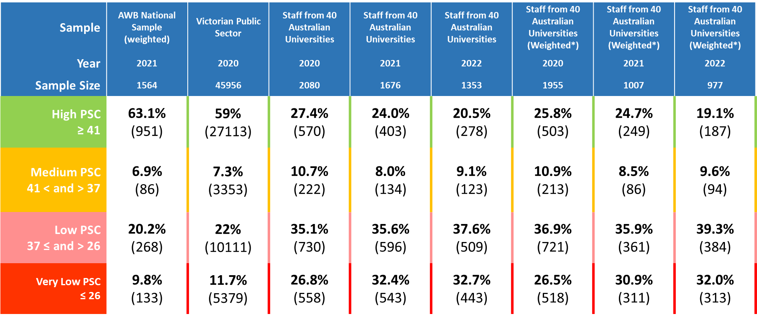

* University data weighting is based on 2020 population statistics from the Department of Education, and weights the data based on the population proportions of staff by university, work role, gender, and casual status. Only those who responded 2020 were subsequently counted in the weighted data for 2021 and 2022.