This submission addresses the following priority issues:

* The connection between the vocational education and training and higher education systems
* Delivering new knowledge, innovation and capability
* Meeting Australia’s knowledge and skills needs, now and in the future
* Access and opportunity
* Investment and affordability

*To Australian Universities Accord Panel,*

I write to you today for two purposes.   
  
The first purpose is to highlight context and certain trends in the current and future Tertiary Education(TE) landscape. I will use the context of Space to describe the urgent need to develop interdisciplinary skills, in particular with two priority industries: Cyber and Manufacturing. In this way, the Space industry’s situation is analogous to a great many industries, and this will illustrate the necessity of an interdisciplinary workforce in the 2030s.

The crux of the findings is that any recommendation by Australian Universities Accord Panel model must be:

* Cheap
* Profitable
* Sustainable
* Quick to implement and modify
* Minimally destructive
* Able to leverage existing investment and strategy

The second purpose is to propose a model that addresses skills needs *cheaply*, *profitably* and *in the spirit of equity.* It will drive students into industry and provide critical and priority skills to key access groups that will in turn build sovereign industrial and defence capability.

The Model has been derived with the emphasis on the above parameters.

I am the BDM for the NSW Space Research Network. My expertise is in Tertiary Education governance, having an M.TEM from the University of Melbourne and a wealth of experience. The SRN, a network of 8 universities, coordinates space activity in research, industry and in the training landscape. The Network is coordinating the NSW/ACT implementation group that will respond to the Space Agency’s Workforce Roadmap.  
  
I would be very pleased to further discuss any of the below if it is of interest.   
  
My contact details are:  
E: . | Ph: .

**A Movement for Universities to pre-select for TAFE experience, with Sovereign Capability and Space as context.**

**David Reynolds  
NSW Space Research Network**

Abstract:

The Australian Higher Education System is at a unique point in the history of the nation.

The Australian Universities Accord Panel, and what will come to be known as the O’Kane Review, is the first opportunity in more than a decade for the universities to act cohesively*,* which is to say act in a way that is *conscious of* and *contrary to* what the funding environment mandates.It is my understanding that this is not only the way to drive the cultural change needed to produce favourable outcomes for the seven priorities identified, but also the spirit with which the Review was assembled.

A model of hybridising TAFE and University learning is proposed, that provides a method by which to install necessary job skills into existing higher learning in a responsive and conscientious way. The model places an emphasis on the responsiveness with which TAFE can develop and deliver skills and make use of its considerable industrial relations ability.

This paper will highlight major past, present and future forces that are and will shape our decision-making landscape at the start of 2023. In short, these are:

* The climb up the Cybernetic Kondratiev Wave
* COVID-19
* The Job Ready Graduates Package,
* The National Reconstruction Fund,
* The need for a skilled workforce and the push to rebuild TAFE,
* The National Priority Industry Linkages Program

There are two types of problems that are addressed by this paper, the granular Organisational and the grander Cultural. Despite the adage that ‘culture eats strategy for breakfast’, it is the view of this author that a culture does not change itself until the environment is self-evidently otherwise. It is the power and responsibility of the Panel and the Review to make the recommendations that will change the environment so that the culture can change.

The paper will use Space as a means by which to illustrate the two core elements of modernity for any industry in 2030 – by being a participant in an Advanced and Sustainable Manufacturing ecosystem, and by servicing or being serviced within the Informational and Cyber spheres.

Index:

1. The Cybernetic Wave, pgs. 4 – 6
2. Population Trends, pgs 6 – 8
3. The O’Kane Review, pgs 8 – 9
4. Future Workforce and Skills, pgs 9 – 10
5. The Model, Abstract and Benefits , pgs 11 – 17   
   5.1 – Subsidies for Sub Bachelor Courses  
   5.2 – Pathway to University via ATAR  
   5.3 – Tertiary Education Overlap  
   5.4 – A Hybrid TAFE/University environment  
   5.5 – A United Tertiary Education Sector and Possible programs

Suggestion 1: Preferential Selection for TAFE experience

Suggestion 2 & 3: A Concurrent Skills Certificate / Parcel Offers

1. Earn and Learn Schemes, pg 18
2. Space and Other Industries pgs 18 - 20
3. Conclusion, pg 21
4. **The Cybernetic Wave**

Education has and always will be inextricably linked with Industry. With the goal of monopolising on an identifiable global trend, Governments develop and deliver funding packages and priorities for education that are aimed at constructing industry.

Importantly, these global trends tend to correlate with the interplay of national and global periods of economic recession and inflation, and how *these* interplay with periods of technological development. This phenomenon has been quantified in the form of Kondratiev waves. A wave describes a technological and economic maturation period in which certain technologies are born, rise to a maximum of adoption and then become encompassed by new technologies.

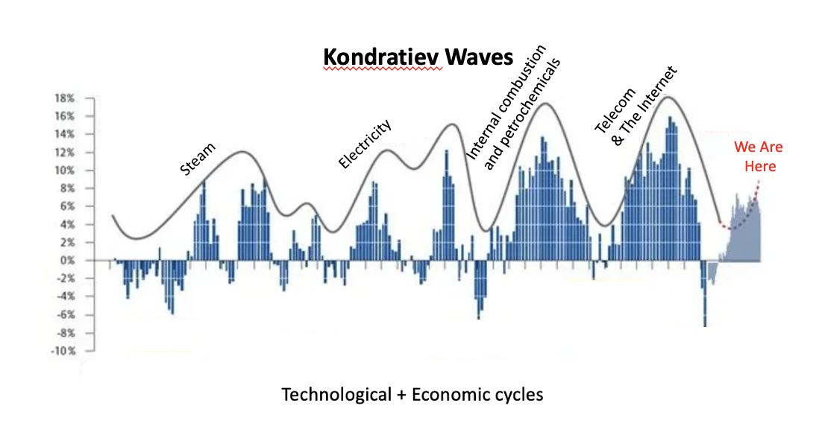

Fig.1: Kondratiev waves and the climb to the 2030s. This is an adapted graphic from an article based around the US economy, and it is illustrative only. Kondratiev illustrations for Aus. economy unavailable at this time.

The technology of the next technological revolution has been defined - Cyber. The world economies are climbing what has been dubbed the ‘Cybernetic Wave’. While the precise point of beginning for the wave is arguable, there is broad consensus that the Cybernetic Wave is slightly less than a decade old.

In newer revisions of the Kondratiev theory, it has been observed that the total length of a wave is shortening,[1] such that any one wave, which once could account for the whole or majority of a working lifetime, now performs its full lifecycle in less than that time. Now an average worker will likely see the growth and decline of at least one wave in their working lifetime.

For the purposes of the Panel, the Cybernetic Wave has a few major implications:

* **Skills learnt during education may become obsolete more quickly than in previous waves, and at previous times of Higher Education review.**

This fact is at the core of the ‘Breadth of Skills’ trend. University of Melbourne and Charles Sturt’s Breadth Units, Broadening Units at UWA, Flexible Zone units at Macquarie University, and a host of other broadened elective pools built into degrees as well as matriculation and graduate pathways reflect the need for responsiveness to a rapidly changing landscape.

This is especially evident and needful at the bottom of the wave – also known as the Innovation period – and maps closely with the timeline of these units being added to the curricula. There is also an Innovation period at the top of the wave as stemming technologies are developed, creating new skills needs.   
  
In this part of the climb, re-trainers and up-skillers are an increasingly necessary part of the equation,   
  
and the late 2020s will see a new surge in skills needs – this will likely happen before the next Higher Education Review.

* **The Peak of the Cybernetic wave is expected in the 2030s, and we are in the industrialisation phase.**

The innovation phase of the Cybernetic wave is ending, and the adoption/industrialisation phase is beginning. There is a surge in industry-led course design and an emphasis on turnaround time for both course development and graduate turnover. While this is not solely attributable to the Wave, it is observable in the funding environment. The New Education and Training Model is a good example of this, and Training NSW’s funding apparatus for skills is another.

* **The Defence viewpoint**

There’s some literature, to suggest that the time toward the peak of a Kondratiev wave is when the most versions of a technology crowd a market. Especially when there is a national interests at stake, the systems compete on a technological and economic basis. [2] They begin to encumber each other and, insodoing, cause tensions which can force an escalation in the circumstances from which war can arise[3]. Cyber is the means and method by which war will be fought over the coming decades.

This means that in a Higher Education review in 2023, it is necessary to consider the needs of the Australian Defence Force. In the next decade, The Cyber sector and other sectors (Space in particular) will be substantially dual-purpose.

Regardless of whether Australia or its allies enter a conflict, the skills needs of the Australian Defence Force are well stated and in a state of urgency – this being can be described in short as a competently technical population, and the associated industry. Whether expressly listed in the final report or not, the author urges the Panel to consult the ADF in the design of the review.

The relationship and pathways between TAFE and Universities is a crucial piece of infrastructure, and this calls for a collaborative coordinated approach to skills generation and delivery.

1. **Population trends**

Fig.2: There will be a growth in annual number of school-leavers over the coming decade. Between 2023 and 2025, the annual number of students will grow by 87,247. The figure is form 2018, pre-covid. However was quoted in 2022 Higher Education Facts and Figures. Source, Bureau of Statistics.

As the Panel is aware, in the lead up to 2032 the annual feedthrough of school leavers into the higher education system will continually grow. The most dramatic growth will be between 2023 and 2025. Combined, this makes for an extra 168,262 students on top of the school leaver age cohort for 2022.

However, this statistic is best viewed in conjunction with this:

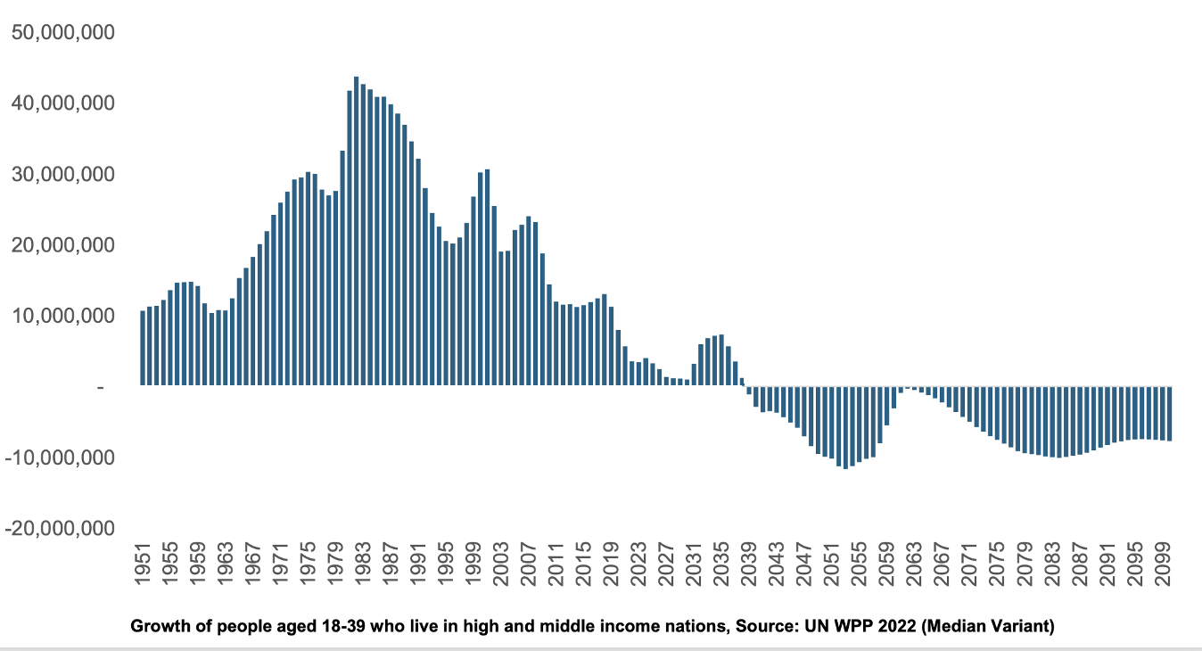

Fig. 3: Graph showing decline in global working age population, with a small swell during the 30s. Sources: Simon Keustenmacher, the Demographics Group. Data pulled from United Nations World Population Prospectus.

This graph shows the statistics for the working-age population in Australia’s source regions. In the 2030s, there will be a slight increase in the working age population, however the following decades will see a negative position in this statistic. This decade long boom-and-bust cycle brings about several unique challenges.

First and foremost – our education system must be functional and agile enough to deal with the decadal fluctuation in numbers. The graph in Fig.2 paints a picture of Australia’s domestic share of the projected 10mil/pa boom in the preceding decade.

Resilience is being ‘built into’ the Australian University model after the shock of COVID and the appetite for international students is in negotiation. However, even if this appetite were to remain the same as in 2019, the influx of international students may not reach parity with 2018 numbers until 2028[4]. This indicates that the makeup of the student body in Australia will be decidedly Domestic, at least in the short-term. It also suggests that at the end of the 30s, the international student model will not function in the same way as it did pre-COVID.

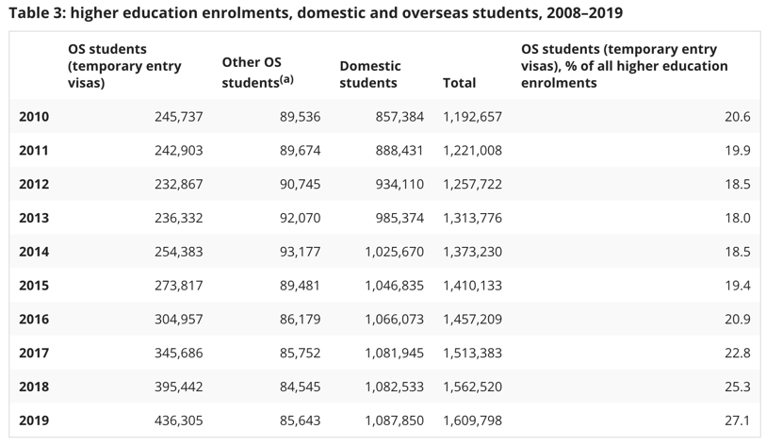

Fig. 4 : a chart illustrating the numbers of international vs domestic students nationally since 2010.

On Nov.20 2022, the Financial Review published an article in which Vice-Chancellor of University of Melbourne Prof. Duncan Maskell has been quoted: “The money we receive per student for teaching is not enough to teach them. We have to go somewhere else to get that money.” While Prof. Maskell was discussing his own institution - Australia’s top university by some metrics - his words ring true of the entire Tertiary Education landscape.   
  
For brevity’s sake, suffice it to say that while universities’ situations differ, the financial situation is uniformly tight across the sector.

1. **The O’Kane Review**

In the wake of COVID, the O’Kane Review finds itself in an almost opposite position to that of the Bradley review, albeit with some unique challenges and advantages:

1. The review starts with the negative flow-on effect of a Globalisation response strategy now making it a liability to the sector,
2. It looks to make up the ground in equity categories that the Bradley Review did not.
3. Amid this, there is the Morrison Government’s Job-Ready Graduates Package, which makes Science and Engineering much more affordable while simultaneously creating an epicentre of active *disadvantage* among low-accessing groups due to lower requirements for entry and higher fees.
4. Universities are making slim profit, if any, on domestic students
5. Universities are looking to diversify portfolios with the view to derisking international student intake and making research more profitable.
6. The Albanese government has just authorised the National Reconstruction Fund, an historically massive funding package at $15b.
7. 10,000 extra CSP places will be provided in both 2023 and 2024 for under-represented groups in Bachelor and sub-Bachelor courses.
8. Fee-Free jobTrainer places are offered at TAFE.
9. All Australian universities now have some distance-learning capability, though contentious.
10. The National Priority Industry Linkages Fund is slated to be renewed in 2025.

With these environmental factors in mind, we turn to the practicalities.

1. **Future workforce and Skills**

The working population boom in the 30s will be seen as the high-water mark for both domestic and international student education to those in the 2050s. How best to do the algebra of international vs. domestic student cohorts will be particular to the situation of each institution, however it will be a rare period of competition for educational resources before competition for human resources begins in earnest. The workforce will shrink again in the 2040s.

It is realistic to expect that there will be an increase in mechatronic and digital automation across a large variety of industries to counteract this trend. For the purposes of illustration, we will work backwards from there.

**2040s:**

Around the 2040s (late 30s inclusive), Australia will need a ready and powerful body of smart manufacturing *Technicians* for both machine and digital trades.   
  
Techniciansare workers who have had skill training on some wide-spread or standardised work that can used for many purposes, ie, a CNC machinist or Printing technician on a particular type of machine.   
  
Critically, the nature of this work will likely fall astride the traditional skillset of a machinist and a programmer, ie: deburring and finishing combined with CAD modelling.

The amount of technicians will be large, and skills and training refurbishment will need to be available on a rolling basis. Technicians will be lifelong retrainers, upskilling as new processes are developed and as advancement opportunities (technological and professional) arise.   
  
The apparatus for this training to occur must be both well-established infrastructure and attractive on a cultural basis. These are skills that are well taught by a VET institution.

**2030s:**

In the 2030s, Australia will need *Automators.*Automatorsare multidisciplinary roboticists, engineers and workflow specialists who will work together to design tools and processes that the Technicians will use. They will design and adapt the automation product to the application.

This group will be smaller, will be able to produce work that is modular, adaptable and replicable. In doing this, the Automators will set industry benchmarks and standards that will inform the work of the 2040s and onward. The skill set of the Automators is a translational mix of practical skills and deep learning.

This period is when automation will become more affordable as the number of automation services grows. In early 2020s Australia, this is and will continue to be a largely disruptive practice that is starting to become more common.

**2020s:**

The current-day qualification required for this kind of work is some combination of Engineering and Mechatronics, to the Honours-Level at minimum, more commonly with a Master in Engineering for certification purposes. For this discussion, the assumption of the interval between high school and the job market with a Mechatronics qualification is 5 years. The likelihood of completing a PhD is reasonably high in this field.

This means that a school leaver at end-2022 is likely to enter the workforce in this field in the beginning of 2028. To follow on, the recommendations of this review may be finalised and announced at the end of 2023. The universities may take a year for development and another for approvals. This would mean that the first cohort to enter an adjusted course stemming from this review would begin in 2026, and complete in 2031 – the peak of the Cybernetic wave.

In the 2020s, Australia is behind.

1. **The Model – Abstract and Benefits**

The secondary purpose of this paper is to express to the Panel the sense of urgency that must be conveyed to the Australian Tertiary Education landscape and to outline the environmental factors in which a new model must act. A new model must be:

* Cheap
* Profitable
* Sustainable
* Quick to implement and modify
* Minimally destructive
* Able to leverage existing investment and strategy

The *primary* purpose of this paper is to propose a model that not only adheres to these stipulations, but also allows for Universities to innovate while acting conscientiously and continuing to serve the public good.

**The crux of the proposed model is simple:** *That creating a nationally consistent model by which Universities and TAFEs collaborate is a cost effective and transformative way to achieve all of the above, while also creating enriched industry, improving the employability of students, and imparting the ability to earn and learn on a national scale.*

The model proposes the following (non-exclusive) benefits –

* That Universities can outsource many of the skills they are currently struggling to deliver
* That TAFE will be able to diversify their training packages and eventually rebuild to previous levels in time for the 2030s
* That university applicants will be of a higher calibre
* That universities may be able to deliver higher level material, delivering better rankings and justifiably charging more
* That Skill Sets for certain industries can be studied alongside the courses
* That fee-free TAFE packages (some states) and the 20,000 CSPs in 2023 and 24 can be best utilised
* That concentrations of skills can be delivered in the regional centres
* Promote two-way traffic between Universities and TAFEs
* That rural and remote access to university can be more easily arranged
* That the Voucher system can be properly accessed (if not addressed by the review)
* That the successful application of the Model may lead to greater participation of women in trades
* That TAFE’s industry reference apparatus can be maximised
* That dual-sector universities, universities with existing TAFE partnerships and non-Go8 universities will be able to serve their communities to greater effect.
* That students who gain high ATARs can be fast tracked into research where they are statistically more likely to excel
* A greater conjunction of STEAM and skilled Arts students
* Reduced the pressure on high school students during HSC time,
* That high school students can study VET skills during year 11 and 12
* That the total number of Australians engaging in Higher Education may increase.

The concept of allowing two-way traffic between TAFE and university is based on these observations:

**5.1**

In the Productivity Commission’s report “5-year Productivity Inquiry: From Learning to Growth”[5], the first point made is on ‘The Value of Human Capital’. This being not simply the time and money spent on education, but personal talent, opportunity cost, personal costs such as travel and the analysis of benefit over costs, including personal.   
  
In this report, there was a call to set proper subsidies for certificates below Diploma level, which the Panel may choose to support with the view of maximising the benefit of the Model.

**5.2**

Pathway into University:

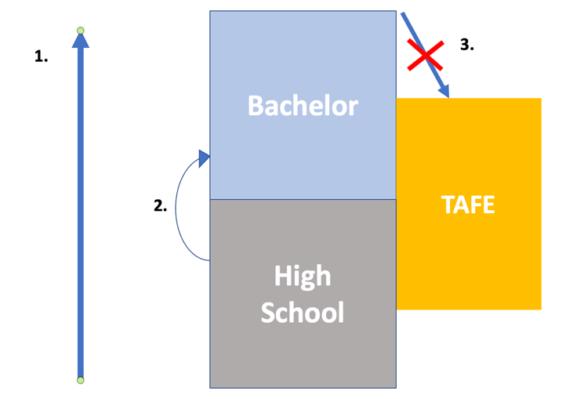

Fig. 4: An infographic showing a generalised direction of travel through high school and into university. This graphic depicts how students that do go to university generally travel straight into university, but bypass TAFE.

1. Direction of advancement through high school to Tertiary Education.
2. If offered a place, students generally continue straight to university. This is for many reasons, not only that the culture of the ATAR pushed students toward University, but also the perceived act of social climbing that comes with studying at University, and the price of some TAFE courses.
3. At the end of ‘higher’ education, students can be disinclined to study again at a ‘lower’ level. The Voucher system (National subsidisation allocation) has previously acted as a barrier to job skills. This has been partially addressed with JobTrainer and fee-free places (State-led initiatives)

**5.3**

TAFE can be studied in high school, and its teaching content overlaps (in terms of level) with both High School and University.

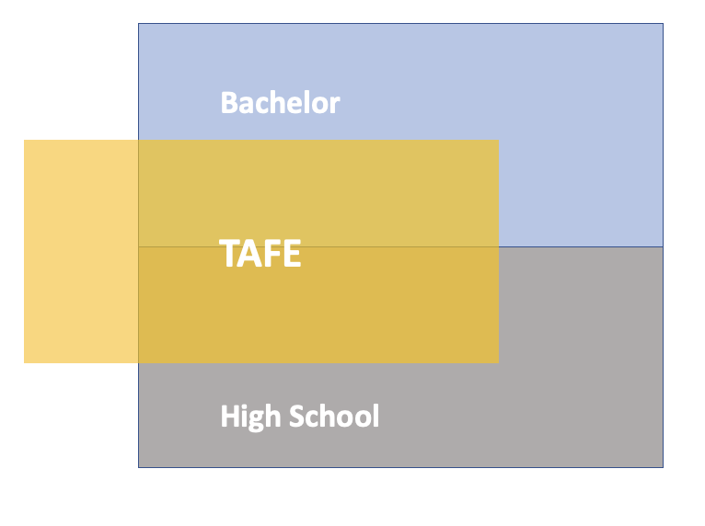

Fig. 5: an infographic as in Fig.4, where TAFE is visually represented as overlapping, rather than standing separately to, high schools and Universities.

* We know that only roughly one quarter of students go to university as a direct result of their ATAR alone[6]. This is because, as Pilcher and Torii stated, ‘the ATAR is most useful in a system of limited supply’.
* This is in reference to demand-driven funding, which has been suspended since 2017, universities now have an enrolment cap, creating that limited supply.
* Presumably, then, the ATAR will be staying for the foreseeable future.
* However the decision to cap enrolments seems to be largely a financial one, even though Pilcher and Torii(2018) and Leadbeater criticise the structure of the ATAR.[7]
* The design should possibly be designed so that it is functional with the ATAR, but can function without it, allowing the ATAR system to be redesigned.
* Could High schools utilise pre-existing partnership models with TAFE to allow students to Study VET skills during high school?
* Can TAFE be made to overlap with University in a way that is consistent among universities?
* In this situation, could universities preferentially select for TAFE experience, and therefore guarantee a better calibre of student?
* Could non-university students gain higher education through an enriched and rebuilding TAFE environment?

**5.4 – A hybrid TAFE/University environment**

The below is a suggestion for a TAFE/University hybrid environment, which illustrates an enmeshed learning atmosphere that involves skills and university education, but does not mandate a particular program for bringing them together.

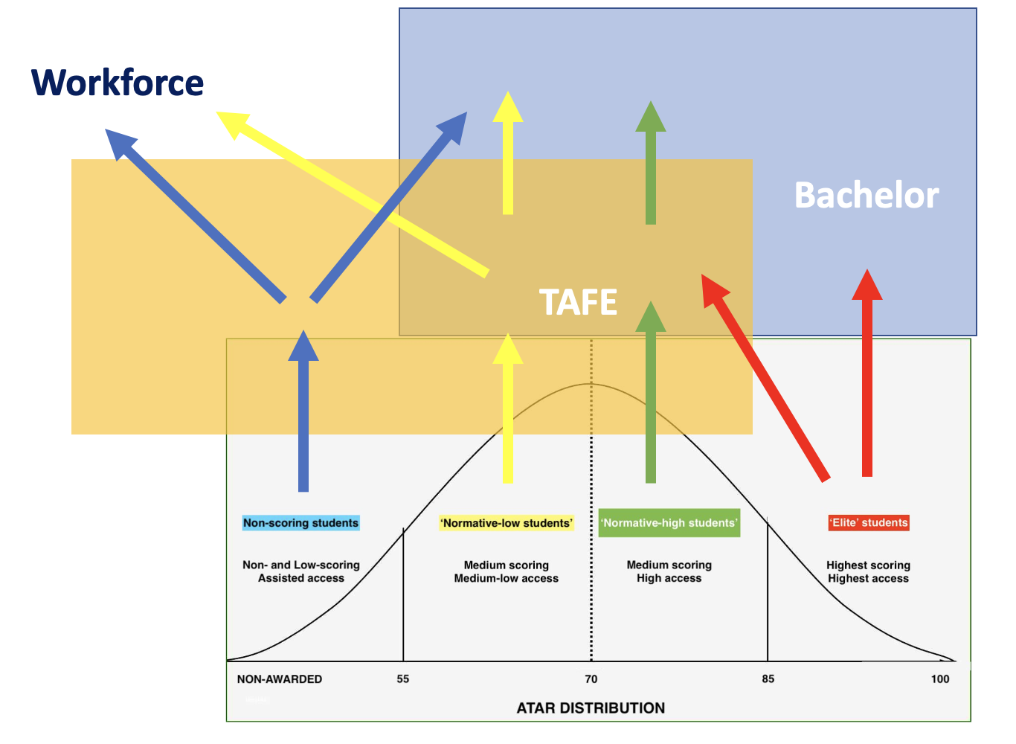

Fig. 5: an infographic as in Fig.4 and 5, where pathways into a hybrid TAFE/ University system are based on ATAR.

In this model:

* Students move upward into higher education based on ATAR group.
* There is a correlation between ATAR, SES status and ability to access higher education of any kind, and this is labelled in general terms.
* Non-ATAR-scoring students (Blue) are able to study TAFE through High School, and then enter the workforce, or enter university due to completed courses at TAFE. This is in sequence, rather than the hybrid.
* Normative-low scoring students (yellow) are entered into the university/TAFE hybrid environment, and are then able to enter the workforce, or continue with university with advanced standing.
* Normative-high students (Green) enter the hybrid environment and continue with advanced standing.
* Elite students (Red) can move into the hybrid environment, or fast track to research, where they are statistically most likely to succeed, compared with the other ATAR groups.

Notes:

* The green ‘normative high’ group encompasses the majority of students eligible for university, due to the bell curve and ATAR requirements.
* The sequenced nature of the blue ‘non-scoring’ group’s progression from TAFE only to University only is based on the assumption that a student who has completed their TAFE study may not be interested in a hybrid TAFE/University environment. This is not intended to indicate barring the student from that environment.
* For simplicity’s sake, assessment and transcripts, etc, would likely need to happen on a cross-institutional basis.

**5.5 A United Tertiary Education Sector and possible programs**

There are many innovative TAFE/University linkages across the country.   
For example, the dual-sector Universities in VIC, the TAFE SA university partnerships and the Institute for Applied Technologies – a collaboration between UTS, Macquarie, Microsoft and TAFE NSW Meadowbank.

All of the existing programs have merit and tie(or can be tied) into a regionality of skills strategy. However, none of these address the national need to any great extent because, by the same token, they only serve a small geographic area.

The national need is far greater than any university, State or Territory, the need for a skilled workforce in general.

Culturally, TAFE is seen not only as lesser than University, but has also been a victim to the Market Design trend, and in most States and Territories has reverted from the unified national Vocational organ into varyingly private and public institutions. This, too varies from state to territory.

There is a cultural issue as much a logistical one, and as such achieving consistency can only happen as a result of the effort of the universities working in a coordinated fashion.

With the view to driving students through TAFE as well as University, the Model suggests three separate engagement models, each with its own challenges and benefits. It is possible that one or more of these can be adopted at once.

**Suggestion 1:**

**Preferential selection for TAFE Experience**

Threshold-setting for the selection of students is strategic, manual process that sets a minimum ATAR, below which offers are not be made. This is as much a labour-saving device for the admissions staff as it is a way of communicating the presence and stature of the university itself and affirming the value of its courses.

This kind of messaging also communicates the chances of a student submitting a successful application. Because of the preference-ranking system in UAC, students must make game-theory decisions around the likelihood of an offer for their first preference vs. a second preference. The messaging of what will not be accepted is crucial for this decision.

Universities also admit students with prior learning to their courses, and see those applicants as higher value than those with just the ATAR. Each university has a developed Advanced Standing system.

* Universities may be able to drive students through TAFE, by advertising that they will preferentially select a certain number of students with TAFE experience.
* Particularly of interest to considering the number of students who don’t access university because of their ATAR.

In a more advanced version of this model, the universities may be able to specify types of TAFE learning that are preferred, for example:

|  |
| --- |
| University of Wollongong  Bachelor of engineering (Honours) ATAR: 80  20 places in this course will be awarded to holders of a Certificate II/III in Aeroskills |

This allows students in the Elite category to move right into the course, and students in the bulk of the competitive range to seek further education through TAFE in order to guarantee a place.   
  
***Quick summary:***

*Top Benefits*: Main *Problems:*

Cheap Amount of students placed needs to be calculated

Quick Initial demand

Better candidates etc.

Utilises existing programs

Maximises High school TAFE partnerships

The algebra of ATAR guaranteed entry vs supplemented entry must be completed per institution, however dual-sector and non-Go8 universities have an advantage here.

**Suggestion 2 & 3:**

**A Concurrent Skills certificate / Parcel offers with TAFE**

In these models, the university partners with a TAFE to consolidate their cross-institutional study procedure to make it easier to function with a TAFE course during bachelor study.

* The concurrent Skills certificate acts in the same way as a Diploma of Languages, except the University works with the TAFE to concurrently deliver their two separate courses while allowing travel between campuses. This is a fundamentally cross-institutional process, and each institution must assess and provide transcripts. This means that the name of this program would need to be very specific to avoid confusion.
* In a more advanced stage, Skill Sets would be developed for priority industries, with existing courses making up the body (eg: Cert 3 in Coding) and micro-credentials and other minor certificates developed in reference with Industry (eg: Professional Certificate – Introduction to Complex Systems).

Most, if not all universities have a concurrent diploma of Languages, and accordingly have built a pathway for student to study their degree alongside a concurrent Diploma. This means the infrastructure exists to study concurrently, however long the actual TAFE course might be.

This is particularly of interest for reaching out into regional and rural areas. In these areas, a TAFE is often closer to home than a university is. The ability to study physically at a TAFE while studying university long-distance (via the online capability developed through COVID) may be used to attract and train more students in remote areas and other access categories.

* In a Parcel Offer, universities are able to make sure that particular skills content is delivered to the student by giving a conditional offer with TAFE. The offer is for the Bachelor, with the condition being completion of a certain TAFE course concurrently.

Both of these engagement models also carry the major benefit of being able to swap out skills in a much more responsive, agile way than university structures typically allow.

The parcel Offer is of particular interest as it can promote access to trades, especially in women, in courses such as the Bachelor of Arts.

Benefits: Challenges:

Greater outreach to rural and access categories Scheduling

Utilises existing infrastructure Certain courses won’t be available

Much more responsive course design Insurance obligations initially complex

Industry referenced material Differing TAFE cultures and local skills

Reduced need for University to deliver skills

Safety overseen offsite from Universities

**Earn and Learn Schemes**

Earn and Learn schemes are of particular interest, not only because of demand from students, but because are skills are in short supply. Companies that are able to take on the burden of training students as staff and allocate the time and resources to properly support them are few and far between.   
  
while they are high value, especially to While earn-and-learn schemes are highly valuable, *especially for low-accessing and diversity groups,* they aren’t replicable on a national scale. This is partially due to number of business - there aren’t enough who can take on the many costs for the few benefits associated with taking on a student. However it’s also partially due to the differing quality of training received at the different institutions – the exact reason that TAFE was first constituted.

We should also consider that universities are outsourcing practical skills tuition to other organisations already and ask ourselves why we don’t do this to our national skills provider.

**Space and surrounding industries**

In 2022, the Space Industry is almost completely new. It is comprised of the core innovation workforce, most researchers operating within Universities, Prime corporations, Government and a small selection of startups. The Australia Space Agency, in 2018, set a target of creating 20,000 jobs for a total of 30,000 in the Aus. industry by 2030. This is not possible with the number of universities and primes currently operating.

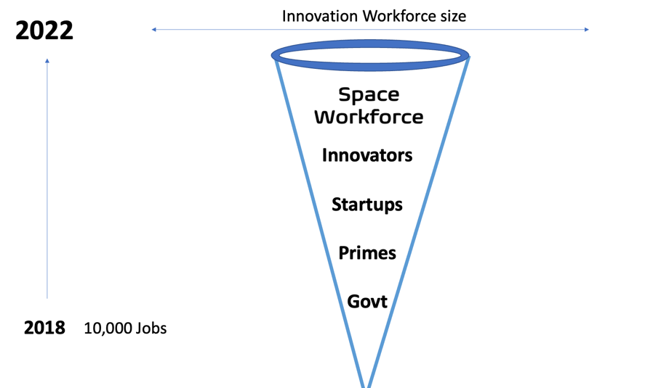

Fig 6. The space workforce, dubbed the ‘innovation’ workforce.

The Space workforce (which again, is dual purpose with Defence) is at a critical needs point. There simply are not enough skilled hands to create the workforce that is needed for an ecosystem of any global relevance. The Innovation workforce are making deep investments in the aerospace industry, however the grand majority of people who will perform work for a space company won’t need to make that same investment.

Coupled with this, the universities cannot provide the larger scope of what Defence and Aerospace need. This is partially because the students are locked away in their courses, and aren’t able to work a skilled job while studying. But the major reason is that the need for skilled hands isn’t met by universities, and caps on enrolment prevent it in any case.

The Space industry must focus on retrainees and companies spinning into Space as an industry. To do this, we must develop training short training packages that can be used to translate existing skills into Space.

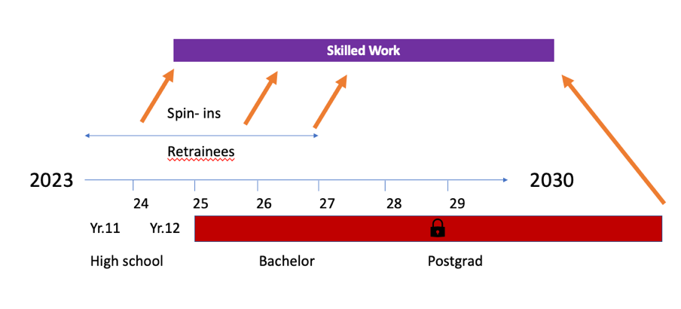

Fig. 7: literature suggests that in order to properly attract young people to an industry, the presentation has to be made early. This graph shows the work beginning to interest high school kids in year 11, in the current TE system. The students is inaccessible for skilled work before they finish their course. The graph shows the period between 2023 and 2027 being the key years to attract retrainees to Space.

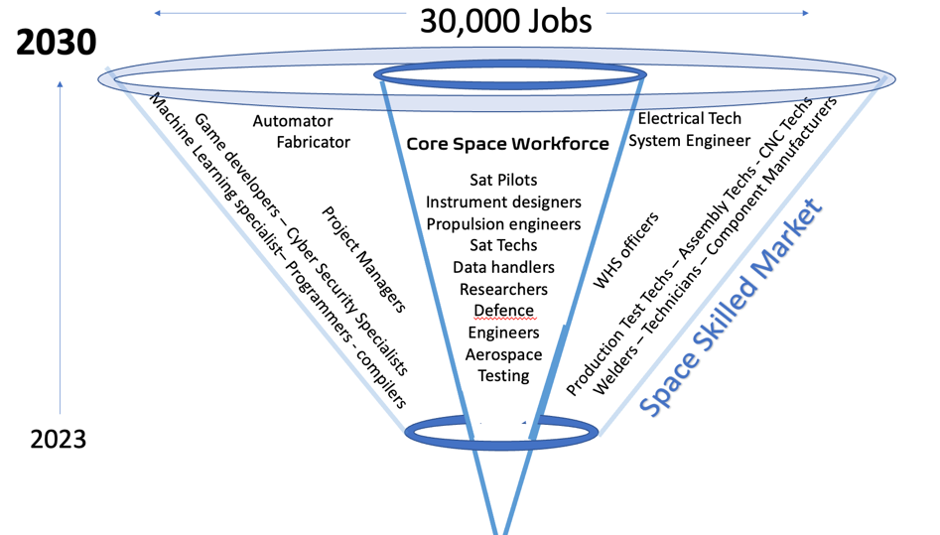

Fig. 8: The space workforce, representing the ‘innovation’ workforce, which is at the core, but the majority are the technicians that may work in the industry. Most importantly - the technicians are not Space specialists.

In order to create the Space industry, general industry must be built, and available for contract. The ‘Space Skill Set’ referred to in the suggestions above are mostly generalised skills that are and will be taught at TAFE – Advanced Manufacturing and Cyber skills.

The Space Industry will overlap considerably with the Information, Cyber and Data industry and the Advanced Manufacturing industry. The graph below shows that the Space, Cyber and AM industries do not currently overlap, but that by 2030 they will grow together.

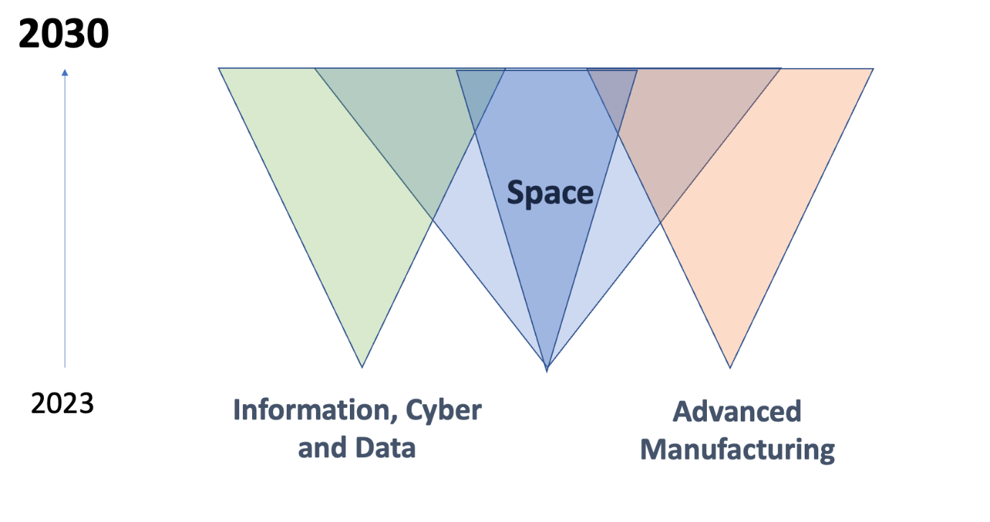

Fig 9: A graphic illustrating the growth of the Space, Cyber and Advanced Manufacturing industries growing together over the coming years.

Space is a nascent industry. However, Cyber is also a fledgling capability in Australia. To build on this, the Advanced Manufacturing capability in Australia will become far greater in Australia over the coming years, in large part because of the Federal Government’s push to reconstruct this capability.   
  
The crux of this message is that Cyber and Data will be the core of modernity in 2030, and advanced manufacturing will be an increasingly large presence and resource in Australia in the next decade. While Space is a critical industry, *it can be used interchangeably with many other industries in this graph.*

Fig 10: A graph showing the times at which a student may be able to start skilled work with TAFE installed into the system.

If TAFE and Skills are installed early on in some cohesive, nationwide fashion, the opportunities for students at University to enter skilled work multiply dramatically.

**Conclusion**

The TAFE system is one of Australia’s most important assets. The Market Design trend has caused it to atrophy into the form it takes today – not only having shrunk dramatically, but also having taken the reputational tarnish of the past decades of decline.

Australia’s Universities, our centres of innovation, have been hobbled by a global pandemic that is seemingly ever-present, and more to the worse, repeatable.

The opportunity to partner between TAFEs and universities is a lifeline to the entire Higher Education system, and a way of turning its individual weaknesses into collective strength. Additionally, it is an opportunity to uplift Australia’s TE system to be on par with those of Scandinavia, Spain, Chile and other labour-enriched countries.

It is true of Australian industry as it is true of our Higher Education system - the destructive has cleared way for the constructive. COVID has highlighted and dismantled our over-reliance on International students.

Moreover, it has given the Australia the desire to work and the will to elect a government that will bid us do so. That in this time our Universities have the ability to move more freely is a considerable gift.

We have the impetus. We are only needful of the apparatus.   
  
I thank you for the opportunity to present my suggestions.

My gratitude to the Panel,

David Reynolds

1. Haralampiev, K., & Naidenov, G. (2010). Waves of the Change and Change of the Waves. *Sociological*

   *Problems*.
2. Devezas, T. C. (Ed.). (2006). *Kondratieff waves, warfare and world security* (Vol. 5). Ios Press.
3. Goldstein, J. S. (1985). Kondratieff waves as war cycles. *International Studies Quarterly*, *29*(4), 411-444.
4. As described by Prof. Iain Martin at a CEDA Victorian Vice-Chancellors event in 2021 – referenced here: https://www.ceda.com.au/NewsAndResources/News/Education/International-student-numbers-won%E2%80%99t-recover-until
5. https://www.pc.gov.au/inquiries/current/productivity/interim5-learning
6. Pilcher, S., & Torii, K. (2018). Crunching the number: Exploring the use and usefulness of the Australian Tertiary Admission Rank (ATAR).
7. Leadbeater, C. (2016). The Problem Solvers: The teachers, the students and the radically disruptive nuns who are leading a global learning movement