**State of Victoria submission to the Commonwealth**

**Government’s Quality Initial Teacher Education**

**Review**

**Executive Summary**

Teaching is a rewarding career which provides an opportunity to make a powerful difference to the lives of our next generation. The best way to lift student outcomes is to support the quality of teachers’ classroom practice at all stages of their career.

The Victorian Government’s ambitious Education State agenda relies on attracting, retaining and developing a high quality teacher workforce. Victoria has implemented a range of nation-leading initial teacher education (ITE) reforms to support teachers at the start of their professional journey. These reforms balance the dual imperatives of increasing teacher supply and supporting teacher quality, and include:

* introducing a multi-year *Teach the Future* campaign to attract the best and brightest to the teaching profession
* establishing the Victorian Selection Framework, including an ATAR threshold of 70 for school leavers, to quality assure entry into ITE
* reforming legislation to enhance quality assurance of Victorian ITE programs and extend the quality assurance framework for entry to ITE to include pathway programs into ITE
* partnerships with ITE providers to develop innovative ITE programs that fast track high-achieving career changers into the classrooms that need them most
* a Memorandum of Understanding between the Victorian Department of Education and Training (DET) and Victorian ITE providers to improve access to high quality pre-service teacher (PST) placements in Victorian government schools, and
* *Transforming the First Years of the Teaching Career*: a pilot program to accelerate graduate teachers’ professional development and transition from university to the classroom.

Victoria’s experience in developing ITE initiatives has highlighted the importance of productive collaboration between government, ITE providers, the Victorian Institute of Teaching (VIT) and schools to achieve effective reform.

There are opportunities for the Commonwealth Government to partner with state and territory governments to raise the status of the teaching profession, highlight the rewards a career in teaching can provide, and make teaching a career of choice.

There is also more the Commonwealth Government can do to increase the supply of high quality teachers by making teaching programs more accessible and attractive to school leavers, university graduates and career changers.

The Victorian Government welcomes this review of ITE and looks forward to working with the Commonwealth Government to strengthen the supply of high quality teachers to our nation’s classrooms.

Page **1** of **11**

**1. Victoria’s Education State Agenda**

Since 2014, the Victorian Government has invested more than $10 billion to build an education system that provides every student with the skills that industry needs and employers expect, and the knowledge, capabilities and attributes to thrive throughout their lives.

The Education State agenda aims to improve outcomes for children, young people and adult learners across the state by providing learning for life, developing happy, healthy and resilient students, breaking the link between disadvantage and student outcomes, and building pride and confidence in Victorian schools.

**Raising the status of the teaching profession**

Raising the status of teaching in Australian culture is vital for success in attracting more high quality entrants to the teaching profession. All governments have a role to play in achieving this cultural change. Collaboration between governments is likely to multiply the effectiveness of any single initiative in this area. Victoria encourages the Commonwealth Government to consider national measures that would raise the status of the teaching profession and would welcome joint initiatives.

The Victorian Government has implemented a range of initiatives focused on raising the status of the teaching profession, including a major communication and recruitment campaign: *Teach the Future*. The *Teach the Future* campaign provides information on the opportunities and remuneration available in a teaching career, communicates the job satisfaction inherent in teaching, and demonstrates Victorian teachers’ significant community contribution.

**The importance of balancing quality and supply imperatives**

In designing and developing initiatives to strengthen ITE, Victoria prioritizes achieving a sustainable supply of teachers, as well as supporting teacher quality. As the Quality ITE Review’s Discussion Paper notes, teaching quality is the most significant in-school influence on student educational outcomes. Maximising the positive influence of teachers on student educational outcomes depends not only on supporting the quality of teachers, but also on enabling student access to teachers, including those with relevant specialist expertise.

There are opportunities to support teachers’ quality throughout their professional journey. For example:

* measures to attract and select high achieving people from diverse backgrounds, with a passion for teaching, to enter ITE
* resourcing providers to deliver quality ITE, including diverse and well supported placement experiences, and
* enabling teachers’ access to high quality professional development throughout their career.

Inadequate teacher supply can significantly affect student educational outcomes. The 2018 Victorian Teacher Supply and Demand Report forecasts that the supply of new teachers in Victoria between 2018 and 2024 would not keep pace with the projected increase in demand for new teachers. In particular, Victorian modelling forecasts increasing teacher supply challenges in the early childhood and secondary school sectors, rural and regional geographic areas, and existing hard-to-staff subjects, such as IT, STEM subjects, languages, inclusive education and applied learning.

Schools seek to address persistent supply challenges by engaging short term and relief staff, which interrupts continuity of learning for students, reducing subject offerings, or timetabling teachers with additional capacity to teach subjects that are outside their fields of expertise. Due to the comparative

Page **2** of **11**

average school size, rural and regional students are more likely to be affected by these interventions than their metropolitan peers. Experience of these interventions is linked to lower educational outcomes.

Measures that can increase teacher supply include:

* increasing the attractiveness of the teaching profession, by raising its community status
* facilitating entry to the profession, by reducing the costs of studying ITE, and
* offering financial incentives to attract high demand subject specialists and connect ITE students with areas of forecast workforce shortage.

**Increasing diversity in the teaching profession**

The Victorian Government welcomes recognition in the Discussion Paper that it is important for teacher workforces to reflect the diversity of our school students.

Programs that provide pathways into ITE play an important role in making ITE accessible to people from diverse backgrounds. This is recognised in Victoria’s recent legislative reforms, which grant the VIT new powers to benchmark and accredit quality pathway programs. Quality pathway programs can provide valuable scaffolding and support to candidates who have not achieved the minimum ATAR for direct entry to an ITE program, supporting them to develop the skills they need for entry to an ITE program.

The Victorian Government is committed to increasing the diversity of our teaching workforce to better represent the students they teach. DET is focused on building diversity in the workforce across a number of domains, including disability, gender, age, culture and LGBTIQ+, and has developed a number of Plans and Strategies to lead the way forward. For example, the Aboriginal Employment Plan (2020-2026) sets out high expectations for inclusion and cultural safety for Koorie1 teachers across the State. The Plan sets a 2% Koorie employment target and outlines significant actions across the teacher lifecycle to attract, retain, develop and support Koorie teachers in Victorian government schools.

Similarly, the positioning of the Literacy and Numeracy Test for Initial Teacher Education (LANTITE) as an ITE graduation requirement (rather than an entry requirement), helps make ITE accessible to students from diverse backgrounds. With LANTITE as a graduation requirement, ITE students benefit from the valuable support of their ITE provider in preparing for LANTITE.

Victoria encourages the review panel to consider initiatives and opportunities available to the Commonwealth that promote teacher quality and a sustainable, diverse workforce supply.

**2. Recent Victorian ITE reforms**

The ITE reforms implemented in Victoria in recent years have been designed to support both the quality and supply of Victoria’s teaching profession. Reforms target each stage of the new teacher journey, from people considering a teaching career and entry to ITE, through PST placements in schools, to the graduate teacher years in the classroom. A brief description of these reforms is provided below.

1 *Koorie refers to Aboriginal and Torres Strait Island Peoples in the State of Victoria*

Page **3** of **11**

**a) Quality assurance of ITE entrants – the Victorian Selection Framework**

The academic capability and personal attributes of a candidate for ITE are a strong predictor of the quality of teacher they become. High performing international education systems select the candidates for ITE from among their top academic achievers. As the Discussion Paper notes, students entering ITE with higher ATARs have a lower attrition rate from ITE programs. In 2018, the Victorian Government and Victorian ITE providers introduced a new set of criteria for applicants to ITE: the Victorian Selection Framework (VSF).

Under the VSF, candidates must pass a personality assessment that tests for the attributes most suitable for teaching, and demonstrate their academic capability and performance, for example by achieving an Australian Tertiary Admission Rank (ATAR) of 70 or above if entering following school.

**Diagram 1** sets out the principles that underpin the VSF.
  
**Diagram 1: The Victorian Selection Framework**

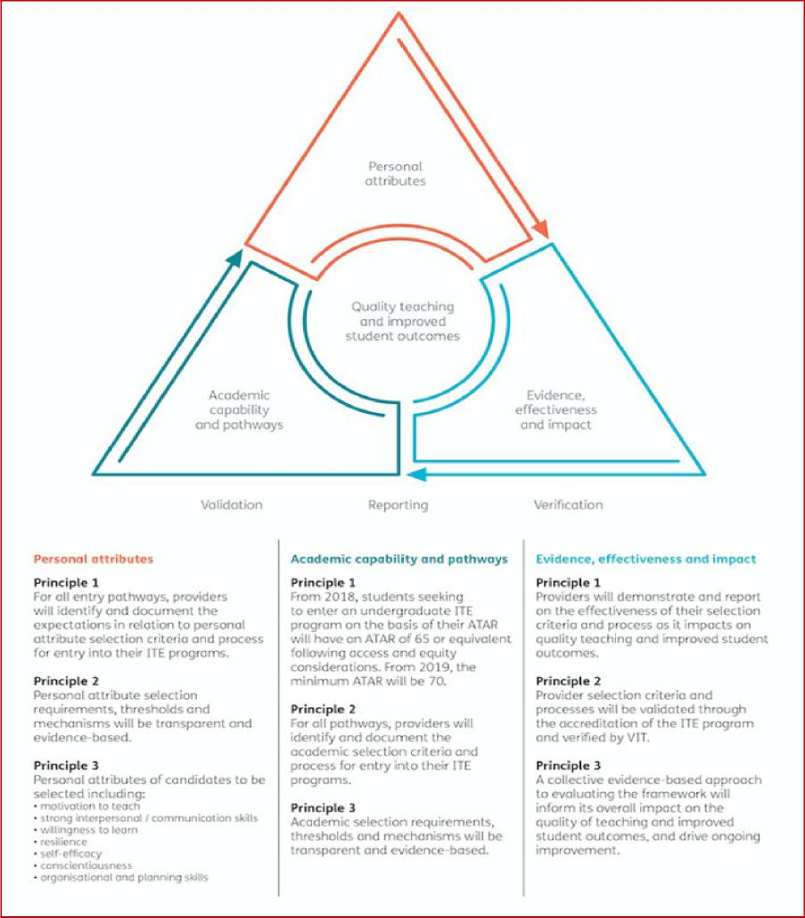

Page **4** of **11**

1. **Quality assurance of ITE programs and pathway programs to ITE**

In March 2021, Victoria amended the *Education and Training Reform Act 2006* (the Act), to complement and reinforce the entry requirements of the VSF. The new legislation clarifies and enhances the VIT’s powers to regulate ITE programs. It also introduces new powers for the VIT to regulate programs or courses of study that are identified or marketed as pathways to entry into an approved ITE program. These powers extend the VIT’s quality assurance of entrants to ITE programs to include those entering from pathway programs.

The legislative reforms also provide students and ITE providers with confidence that VIT-accredited pathway programs prepare their participants to study a bachelor-level ITE program effectively.

1. **Attracting high achievers to the profession and schools that need them most**

The time and cost of undertaking an ITE program are key barriers to potential career changers entering teaching. Victorian employment-based and innovative ITE programs reduce those barriers by providing students with the opportunity to work in a school as a paraprofessional while they complete their ITE program.

By early 2020, the Victorian Government had invested in three postgraduate employment-based ITE programs: Teach for Australia with Australian Catholic University, La Trobe University’s Nexus program, and the University of Melbourne’s Master of Teaching (Secondary) Internship program. These employment-based ITE programs all prepare participants for secondary teaching. Each has a unique program structure and focus. These include targeting high-achieving graduates, selecting specialists in high demand subject areas, working with disadvantaged schools and selecting applicants with a commitment to social justice.

In late 2020, the Victorian Government entered partnerships with four additional ITE providers to develop innovative ITE programs that would attract high achievers, meet all national quality standards, provide financial support for participants, and fast-track students’ entry into secondary classrooms that needed them most.

The innovative ITE programs include:

* *Employment-based Programs* – participants are employed to work as paraprofessionals in classrooms in their host school while completing a Master of Teaching online, across 18-24-months. Participants earn up to $47,000 per year. Deakin University, Monash University and the University of Melbourne offer employment-based innovative ITE programs.

**Rose van Rooy, BSc, participant in employment-based teacher education program**

*While Rose was studying a Bachelor of Science she supported herself working part time as a teacher’s aid in a local primary school. The experience inspired her to consider teaching as a career. Rose saw the new employment-based teacher education programs advertised and thought they looked perfect: a chance to maintain an income by doing work she enjoyed, that would be relevant to her teaching studies. Now a BSci graduate and part way through her employment-based teaching program, Rose is finding that working part time in Koo Wee Rup Secondary College during her degree not only helps her to support herself financially, but also demonstrates the relevance of her academic studies to the classroom. Rose enjoys the chance to apply the techniques she is learning, and is delighted to have the opportunity to do this continuously alongside her studies. Rose commented: “*It’s such a great opportunity and I feel so immersed in my career path already"

Page **5** of **11**

* *Hybrid Accelerated Programs* **–** participants receive a scholarship of $15,000 for the first 12 months of intensive study (including placements at their host school). They then work as paraprofessionals in classrooms for six to 12 months, while completing the final units of a Master of Teaching. The Australian Catholic University (ACU) and Federation University offer hybrid accelerated innovative ITE programs

**Surani Sachindra BSc, participant in hybrid-accelerated teacher education program**

*After graduating from a Bachelor of Physical Sciences, Surani worked for a range of businesses, leading process re-engineering to achieve lean manufacturing. Nearly a decade later, Surani felt like a career change. Surani learnt of the high demand for teachers with tertiary maths qualifications, which she had gained in her undergraduate degree. Surani researched the various pathways into teaching, and was attracted to the structure of the hybrid accelerated model. For example, the opportunity for consistent experience in classrooms during the program’s second year was reassuring, given teaching would be completely new to her. Living in Wallan, Surani also liked the program’s regional and rural focus, while the scholarship offered in first year would provide financial support during her intensive study period out of the workforce. Now part way through the degree, Surani is very happy with her decision.*

“The course is great, and I am so keen to tell other people about it, so that they can have this opportunity too.”

The employment-based and hybrid accelerated ITE programs reduce cost barriers to ITE for people who have the qualities to make a great teacher but could not otherwise afford to spend the time out of the workforce to obtain a teaching qualification. The earlier employment-based and subsequent innovative ITE programs have been well subscribed, with providers receiving strong interest in the programs.

**d) Expanding pre-service teachers’ access to high quality professional placements**

Professional practice placements provide a crucial setting for ITE students to link academic theory to classroom practice, developing their autonomy and capacity to realise their full potential as graduate teachers.

Connections built between ITE students and schools during placements can also enhance ITE students’ future employment opportunities. Access to high quality mentors during placement, and experience of diverse school contexts during ITE, helps graduate teachers to enter their first classroom with confidence, prepared for their professional role and at less risk of early career attrition

Page **6** of **11**

**Collaboration between schools and ITE providers: Online placements during remote learning**

*When River Gum Primary School moved to remote and flexible learning for the start of Term 2, second year Master of Education student Talia* was just a few weeks into her placement. With the support of the school, Talia was not only able to continue her placement but also became an important resource for her school during the transition. Victorian schools reported that ITE students have been able to use their strong digital skills to create learning materials, instructional videos and other useful tools to support teachers and students. For her Primary School Principal, there was value in continuing with ITE student placements through the period of remote learning:*

'The intensive learning pre-service teachers [ITE students on placement] have had during remote learning has been substantial. It’s a huge benefit for schools and you are helping build the future workforce’.

*\*Not the student’s real name.*

In 2020-21, DET and ITE providers developed a Memorandum of Understanding (MOU) to strengthen Victorian government schools’ capacity to host high quality PST placements, by:

* streamlining the administration of placements, for example by establishing designated placement booking windows in Terms 2 and 4 to facilitate schools’ planning
* introducing one standard placement assessment template for all ITE students, used by all ITE providers
* clarifying the roles and responsibilities of schools, ITE providers and ITE students during placement, so each party knows what to expect, and ITE students receive the support they need, and
* supporting schools and ITE providers to build new relationships, particularly in areas of high forecast workforce demand.

The MOU also includes a commitment that DET and Victorian ITE providers will continue to work together to increase the support and recognition of mentor teachers and strengthen the strategic distribution of placements. The MOU will be implemented from Term 3, 2021.

**e) Supporting continuous improvement of ITE programs through Teaching Academies of Professional Practice**

A Teaching Academies of Professional Practice (TAPP) is a partnership between a cluster of schools and one or more universities for the purpose of improving initial teacher education. Membership includes government, Catholic and Independent schools. DET has assisted with setting up the TAPPs.

The TAPP initiative aims to deliver an immersive preparation experience for ITE students, test innovative approaches to ITE, and strengthen the links between theory, research and practice to enhance ITE effectiveness. Participating principals and teaching staff have reported increased professional learning opportunities, with teachers identifying strengthened mentoring skills. The initiative has also enabled universities to draw on the experience of schools to enhance ITE program delivery.

Page **7** of **11**

**Continuous improvement of ITE programs: the Horsham-Wimmera multi-provider TAPP**

In 2021, the Victorian Government provided a grant to a multi-provider TAPP in Victoria’s Horsham region that will place ITE students from three universities in government and Catholic schools. Members of the TAPP will share a site director, who will support professional experience and mentor development for schools and each of the universities. The site director will bring efficiencies in employment, communications and administration, economies of scale in terms of support for multiple placements at different times of the school year, and a strong community of practice for improvements to ITE.

1. **Accelerating the professional development of early career teachers**

To support the transition of graduate teachers from ITE into the workforce, and accelerate their professional development, the Victorian Government has funded a pilot program during 2021-23: *Transforming the First Years of the Teaching Career* (the pilot).

The pilot provides graduate teachers with an allocated mentor, one day a week of time release, and additional professional learning, networking and wellbeing supports, over their first two years in the profession. In addition, pilot graduate teachers join their peers in state-wide graduate teacher conferences.

The pilot is operating in three local government areas (North East Melbourne, Western Melbourne, and Inner Gippsland) through newly established alliances of schools. The alliances connect graduates and their mentors, enabling collaborative learning and the sharing of expertise across the system.

1. **Supporting the existing teacher workforce to upskill, particularly in STEM teaching**

Victoria has introduced the Secondary Mathematics and Science Initiative (SMSI) to support out-of-field teachers to build the knowledge and classroom skills necessary to teach mathematics and science subjects to level 10 through a Graduate Certificate in their chosen field. Candidates do not incur any out-of-pocket expenses.

Participating schools receive 0.2 full-time equivalent time release for each participating teacher to complete assessments and study: the equivalent of 20 days of professional learning. The initiative also provides local networking opportunities for participants and offers financial support to cover rural and regional participants’ travel costs of participation.

1. **Connecting ITE students with strong and well supported future employment prospects**

Some schools experience greater challenges in recruiting staff than others. A series of recent Victorian initiatives is designed to connect ITE students with these schools, to increase the ITE student’s employment prospects on graduation, and meet an identified workforce need. For example, through the Memorandum of Understanding on Placements, DET supports the development of new relationships between ITE providers (and their students) and schools with high forecast workforce demand. Victoria’s employment-based and innovative ITE programs prioritise matching their students with hard-to-staff host schools.

To facilitate hard-to-staff schools’ recruitment of a balanced staff profile – i.e. including a range of experience, and capacity to mentor more junior teachers - the Victorian Government attaches financial incentives to hard-to-staff positions for registered teachers. A successful applicant receives an initial gross payment of $9,000 - $50,000, and annual (gross) payments of $9,000 at the conclusion

Page **8** of **11**

of the second, third and fourth year of employment. Relocation costs for regional and rural positions are also available.

**i) Providing quality professional learning through the Victorian Academy of Teaching and Leadership to drive improved teaching and learning**

The creation of the new Victorian Academy of Teaching and Leadership (the Academy) will provide high quality professional development opportunities for teachers to raise the status and impact of the profession.

The objectives of the Academy are—

* to improve outcomes for school students through the provision of specialised teaching and leadership excellence programs for exceptional teachers and school leaders;
* to increase equity of access to professional learning to lift the quality of teaching across Victoria;
* to provide a dedicated pathway for established exceptional teachers to contribute to school and system improvement;
* to improve the quality of school leadership; and
* to raise public awareness of the capability and status of school leaders and teachers in the science and practice of teaching.

Set to begin in 2022, the Academy will deliver advanced professional learning for teachers in the government, Catholic and Independent sectors through its flagship Teaching Excellence Program (TEP). The TEP is designed for highly skilled classroom teachers to advance professional practice, disciplinary knowledge and deeper understanding of the science of learning. TEP graduates will be empowered to influence and advance teacher practice in their area of specialisation and share their expertise and knowledge into new cross sectoral networks and within their school communities.

The Academy’s professional learning opportunities for highly skilled teachers will support their career pathways while the enhanced public profile of the Academy will also raise the status of the teaching profession and support attraction and retention of highly skilled teachers.

**3. Opportunities for the Victorian and Commonwealth Governments to work together**

Victoria welcomes the opportunity to work with the Commonwealth Government on strategies to improve the quality and supply of teachers. In particular, Victoria is ready to work with the Commonwealth on initiatives that raise the status of the teaching profession, and expand access to innovative ITE programs.

Raising the status of the teaching profession is vital for success in attracting high quality candidates to the teaching profession. Commonwealth-state collaboration on initiatives that publicly recognise and communicate teachers’ important contribution to future generations would expand the reach of these messages across the community.

Victoria would welcome the opportunity to work with the Commonwealth Government to further expand access to high quality, innovative ITE programs. This could include:

* Co-funding regional universities to develop innovative bachelor-level ITE programs for local students with existing community connections. Increasing regional students’ access to

Page **9** of **11**

undergraduate ITE programs would support local communities of practice and generate a local workforce for regional and rural schools.

* The Commonwealth increasing its contribution to employment-based ITE programs (Teach for Australia and LaTrobe Nexus) that it co-funds with Victoria.
* The Commonwealth joining the Victorian Government in funding the University of Melbourne’s Master of Teaching (Secondary) Internship ITE program, and Victoria’s suite of recent innovative ITE programs.

**4. Unique opportunities for the Commonwealth Government to increase the supply of high quality teachers**

While states and territories manage teacher workforces and education systems across Australia, the Commonwealth Government is responsible for the funding and policy settings for ITE providers. Victoria encourages the review panel to consider the levers uniquely available to the Commonwealth Government to contribute to the national pipeline of high quality teachers.

There are two key areas where the Commonwealth Government could play an increased role.

**1. Expanding access to ITE programs, in particular for high achievers in priority subject areas**

The Commonwealth must ensure that universities are funded to provide enough places to meet student and workforce demands, that each place is funded sufficiently, and that those places are effectively prioritised to meet the needs of the future workforce. Victoria recommends that the review panel encourage the Commonwealth Government to:

* review the impact of the Job-ready Graduates Package reforms to ensure that they provide sufficient resources to a range of providers to deliver high quality ITE programs
* ensure that resourcing of ITE programs enables closer collaboration between ITE providers and schools. For example, allocating resources for ITE providers to deliver wrap-around support of their ITE students during placements, and to establish roles focused on sharing best practice and evidence between leading teachers and educational researchers
* allocate additional Commonwealth Supported Places (CSPs) to ITE programs, enabling providers to educate more future teachers, and
* fund additional scholarships to incentivise high achieving school leavers with expertise in areas of high workforce demand (e.g. STEM, languages, applied learning) to enter ITE.

**2. Sharing timely and more granular ITE pipeline data**

The Commonwealth Government collects data on the number of people undertaking ITE and their course specialisations.

Victoria has sought the Commonwealth Government’ timely provision of ITE data over a number of years. However, to date, the Commonwealth Government has not been able to provide comprehensive, granular ITE data more promptly than 18 months after university enrolment dates. Timely access to this information would enhance state and territory education system managers’ capacity to forecast workforce supply and demand, and better tailor policy and program initiatives to meet emerging workforce challenges.

Victoria recommends that the review panel encourage the Commonwealth Government to provide states and territories with more timely access to granular ITE data.

Page **10** of **11**

**5. Conclusion**

Victoria welcomes the Quality Initial Teacher Education Review, and an increased national focus on improving ITE. This submission highlights a range of Victorian initiatives to increase the equitable access of all Victorian students to excellent teachers. Victoria encourages the review panel to consider the range of reforms and initiatives in Victoria, and how learnings from these reforms and initiatives could inform approaches in other parts of Australia.

The Victorian Government has focused on the dual imperatives to improve teacher quality and increase teacher supply, guided by the importance of both in raising student educational outcomes. Victoria recommends that considerations of both supply and quality guide any proposed national ITE reforms.

Victoria’s experience illustrates the benefits of productive collaboration between government, schools, ITE providers and the profession’s regulator. Victoria encourages the Commonwealth to develop and implement proposed ITE initiatives in partnership with key education system stakeholders.

There are opportunities for the Victorian and Commonwealth Governments to work together to improve ITE. Victoria welcomes the opportunity to collaborate with the Commonwealth on raising the status of the teaching profession and increasing access for high quality candidates from diverse backgrounds to the teaching profession.

In addition to areas of joint responsibility, the Commonwealth Government has a unique role in funding and regulating ITE providers. There are a number of ways that the Commonwealth could strengthen ITE providers’ capacity to deliver quality ITE to an increased number of participants, including in areas of high workforce demand. Victoria encourages the review panel to consider opportunities available to the Commonwealth to enhance the access of all Australian students to the high quality teachers they deserve.

Page **11** of **11**