Quality Initial Teacher
  
Education Review
  
Submission

|  |  |  |
| --- | --- | --- |
|  |  | 5 |

**Quality Initial Teacher Education Review**

**The problem we’re trying to solve**

* Part A - Attracting and selecting high-quality candidates into the teaching profession
* Part B - Preparing ITE Students to be effective teachers

**Our key challenges**

**Improving workforce supply**

*Increasing the number of quality teachers entering our workforce in specialist areas where workforce shortages exist.*

* Pathways and entry requirements into specialist areas of teaching are limited and lack flexibility.
* We lack successful methods for attracting mid and late career professionals to transition into the profession and become quality specialist teachers.
* Since the introduction of the longer post-graduate courses there has not been any noticeable increase in teacher quality or student performance. What is observable is a decline in high achieving students choosing to study teaching, a drop of nearly one third from 2006 – 2019.

**Increasing attractiveness of the teaching profession.**

*Strengthening interest in the profession to attract a high performing, motivated and diverse future workforce.*

* Teaching is not a highly desirable profession: Grattan Institute have found high achieving young Australians perceive teaching to fall well short of the intellectual challenge and pay offered by other careers.
* Teaching is not deeply understood; understanding is based on memory of lived school experience as a student. There are outdated views and misconceptions detracting people from entering the profession.
* We need to promote the profession: bring light to the diversity, inclusion, clear career paths, team teaching environment, professional autonomy, lifelong learning opportunities, and the ability to ‘make a difference’. A diverse cohort may be more attracted to teaching when they are introduced to the contemporary school environment.
* The need to forgo salary for 2 years provides a financial barrier that prevents some interested professionals from transitioning into teaching.
* Alternative entry pathways are required: shorter duration of ITE qualifications and increased recognition of prior learning. Focus on quality of applicants rather than time spent in ITE.

1

**Improving ITE completion rates.**

|  |  |  |
| --- | --- | --- |
|  |  | 2 |

*Improving completion rates through focused attraction strategies.*

* Completion rates have dropped, which is inconsistent with all other fields of study.
* Evidence that higher ATAR scores translate to higher completion rates.
* Overall high achievers are not choosing teaching.
* Increasing completion can be influenced by attracting the ‘right’ candidates, with the ‘right’ motivations and the ‘right’ capabilities (including interpersonal skills / emotional intelligence, LANTITE – set requirements for entry)

**Preparing ITE students for the profession.**

*Increased time and connection with schools and practice-focused mentors to better*

*prepare graduate teachers for the profession.*

* Pre-service teachers feel that time in schools is the best preparation for the career. The data on page 20 of the Discussion Paper suggests graduate teachers are better prepared in deeper ongoing professional knowledge and less prepared in immediate day to day, face-to-face teaching strategies that are immediately usable (and required).
* Professional experience needs to be longer and more substantial. More time in schools, with teachers, being mentored in a focused way has been found to provide better preparation for beginning teachers.
* Stronger/tighter partnerships between universities and schools can co-lead high quality learning in ITE.
* Greater emphasis is required on the importance of professional experience and the role of the mentor teacher. Value must be formally assigned to the importance of the mentor work.
* Content micro-credentialing is needed to prepare teachers for teaching ‘out of area’ and can develop and recognise mentoring and development options from both employer/ITE provider. Portfolio of evidence for attainment reflects contemporary practice. Also addresses Q4 – workforce supply in some subject areas.
* We need to increase supported engagements between ITE academic staff and classroom teachers, focusing on curriculum, research projects and a shared understanding of the modern school classroom environment and the learning needs of students.

**Our current state**

|  |  |  |
| --- | --- | --- |
|  |  | 3 |

The Department of Education (DoE) and the University of Tasmania (UTAS) values their collaborative partnership. UTAS and DoE is deeply committed to the mission of improving educational attainment in Tasmania and leveraging high quality and impactful ITE programs as a key mechanism for delivering the future Tasmanian teaching workforce. We believe success is best achieved through close partnership between ITE providers (UTAS) and State Government (DoE), allowing for holistic thinking and practice specifically directed at building and sustaining a high-quality teaching workforce suited to the needs of Tasmania.

In 2018 the Education Workforce Roundtable created the More Teachers Quality Teaching (MTQT) Action Plan. In response, the partnership established a range of strategies to attract people with the right professional and personal aptitude to the profession, and to support their successful transition from study into practice. A key resulting action under the MTQT Action Plan is our **internship program**, the Teacher Intern Placement Program (TIPP), which was initiated to transition quality ITE graduates from UTAS into Tasmania’s Government education system. In collaboration DoE and UTAS designed and have been successfully operating the TIPP for the past 5 years. Through the TIPP, 4-year undergraduate and 2-year postgraduate UTAS ITE students complete their final year of study while based full-time in a DoE School, working alongside a practice-focused mentor (experienced teacher) while completing coursework and placements. We see opportunities to build on this success, expanding internship options to include alternative and shorter career pathways and to enhance the relationship between theory, research and practice.

We recognise that preparing prospective teachers for a teaching career requires a holistic approach that reaches more broadly than ITE study. In response we have developed **The Experience**; a concept which recognises ITE as an ongoing and collaborative partnership between the employer (DoE) and ITE provider (UTAS), which spans over an extended period of time, from ITE application through to full registration. The Experience guides our approach to supporting and developing DoE’s early career teachers.

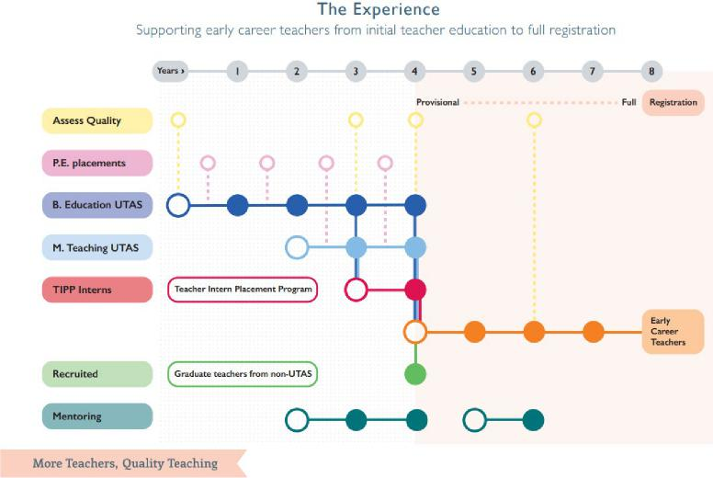

An additional initiative resulting from the MTQT Action Plan is the **Tasmanian Teacher Profile (TTP).** The TTP was developed to define what we understand to be a ‘quality teacher.’ We now define quality teachers has having the right knowledge, experiences, skills and capabilities and personal attributes and motivations. The key change is an additional focus on personal attributes and motivations; ensuring we are attracting people into our workforce who have personal beliefs and purpose that align to teaching in Tasmania’s public education system. The TTP will inform how we train, attract, recruit and develop teachers in Tasmanian Government schools and inform the UTAS process of admission and placement activities. The TTP was utilised in our most recent recruitment process for our 2021 TIPP cohort, where prospective interns were assessed against the elements in the profile to be awarded entry into the program.

|  |  |  |
| --- | --- | --- |
|  |  | 4 |

Recognising the importance of the postgraduate pathway for attracting career change professionals and teachers in specialist areas, UTAS has approved two new ITE offerings for introduction in 2022. These are a **fast-tracked MTeach degree**, where students can undertake their post-graduate teaching qualifications over a condensed delivery period of 18-months, and a **Vertical Double Undergraduate/Master of Teaching** where students are able to accelerate their completion of a combined degree in a reduced 4-year period. We see opportunities to build and expand this approach with additional fast-tracked, accelerated, and double degree pathways.

**Our Recommendation**

|  |  |  |
| --- | --- | --- |
|  |  | 5 |

The challenges being addressed in the Quality Initial Teacher Education Review are complex and diverse. DoE and UTAS have developed a recommended approach, where employers and ITE providers work in collaboration to create additional pathways into the profession.

DoE and UTAS have already been working successfully in partnership for the past five years to deliver our existing intern program, TIPP, where UTAS students complete their final year of study based in a Tasmanian government school.

The TIPP was recognised in the [OECD review](http://www.oecdteacherready.org/promising-practice/creating-a-pipeline-to-teaching-in-tasmanian-government-schools-from-the-university-to-hire/?country=australia&parent=1220) as a promising practice. Our recommended partnership model between employers and ITE providers builds on the learnings and success of this collaborative relationship, to design and deliver new immersive education offerings.

**What is needed nationally**

**Shorter career pathways, with additional time in schools and increased focus on mentorship to improve workforce supply, increase the attractiveness of the profession, improve completion rates and prepare ITE students for the profession**

* 12-month immersive professional degree program that incorporates the knowledge, skills and application attained through a combination of coursework and placement, with supported and focused micro-credentialling to build a portfolio that would demonstrate achievement at AQF9.

**Revised entry requirements to improve workforce supply, attracting a strong and diverse teaching workforce**

* Recognition of prior learning broadened to include tertiary (less prescriptive), VET, work experience and life experience.
* Reduced reliance on ATAR score; broader considerations to assess ability.
* Recognition of skills, knowledge and competencies through entry via a portfolio of evidence.
* Non-cognitive measures as a key component of course admission.
* Adopt promising world practices, including psychometric assessments.

**Additional ITE delivery options to better prepare ITE students for the profession and to support the continuous upskilling of our teaching workforce**

* Micro-credentialling and modularised learning: for early career teachers and to support upskilling for teaching ‘out of area’.
* Reimagine methods for delivery of ITE coursework: Learning from global practices, focused on project-based teaching: interdisciplinary, multidisciplinary.

**Increased flexibility to improve workforce supply and increase the attractiveness of the profession for career changers**

|  |  |  |
| --- | --- | --- |
|  |  | 6 |

* Ability for ITE students to undertake paid employment or cadetships in schools while studying, blending education/training/work.
* Ability for ITE students to undertake Professional Experience placements with more flexibility: allowing part-time and modified schedules for placements to accommodate employment in schools.

**Current Challenges with delivering the above**

* Duration of study for entering the profession (4-5 years).
* Micro-credentialling and modularised options not currently available, and if they were to be developed, they would not attract Commonwealth funding. Costs would be borne by the student, DoE or delivered unfunded by the University.
* Limited flexibility in current ITE courses (e.g. semesterisation)
* Limited alternative pathways into ITE from a range of sectors and with a range of experiences and credentials.
* Approval and regulations around conditional registration and appropriate salary levels.
* Current accreditation requirements around length of course, definitions and requirements around professional experience placements.
* Registration requirements.
* Our current understanding of teacher supply and demand lacks the level of granular data and consistency necessary for detailed modelling to project future workforce needs accurately. We require better, more comprehensive, and timely data about teacher supply, including the trends in ITE commencement and completion, career movement, progression, and attrition.

**Solutions to address these challenges**

* Change the culture around ITE, shifting our/the profession’s mindset to see ITE spanning over an extended period of time from admission though to full registration; that is that ITE continues into the first years of employment.
* Revise Commonwealth funding to promote micro-credentialling and modularised options supporting:
* ITE students to upskill and advance their qualifications while they are immersed in a teaching environment, and
* Continued development for mentor teachers
* Support a revised approach to entry requirements, understanding that a one-size-fits-all approach will not deliver workforce strength and diversity. We need to assess suitability based on a suite of entry requirements, utilising a range of assessments (including LANTITE, psychometrics, previous success, prior learning).

|  |  |  |
| --- | --- | --- |
|  |  | 7 |

* Recognise an additional way of ITE may include frontloading to build foundational teaching capability, followed by structured supplementary immersive work to be completed while engaged as an early career teacher. Change the approach to funding to enable us to frontload to a proficient level and then continue to develop over time (with the funding of micro-credentials to reach AQF9).
* Incentivise and continually upskill our current teaching professionals to support mentoring and development of ITE students; the skill and will of mentor teachers is a crucial component of participant success in achieving ITE qualifications in the immersive model. Funding structures would need to shift from being linked solely to coursework, expanding to cover on the job training.
* Have regulatory bodies endorse paid cadetships and internships.
* Revise ITE program standards, including:
* *Standard 3: Program entry*
* *Standard 4: Program structure and content*
* *Standard 5: Professional experience*

**How it could work in practice**

Our conceptual example has two phases, an Immersive MTeach Pilot and an Accelerated Specialist Teacher Pilot, to be approached collectively and piloted across different time horizons. These offerings would attract mid and late career professionals from other fields into the teaching profession in specialist areas aligned to our workforce needs, and would prepare these graduates to be effective teachers through extensive classroom experience and practice focused mentoring.

**Phase 1: Immersive MTeach Pilot**

The delivery of the existing MTeach would be reimagined and redesigned, adapted to fit the immersive nature of this concept. Existing coursework, placement mentoring, assessment, and the requirements of the GTPA would be leveraged to support the development an offering that brings an integrated approach to academic learning, practical application, and formal assessment.

Participating students would receive a part-time salary for the duration of their study, two years of experience in a school environment with dedicated mentoring support, additional professional learning, and successful completion would result in permanent employment.

**Phase 2: Accelerated Specialist Teacher Pilot**

A new accelerated 1-year teaching qualification that achieves the required volume of

learning would be designed. Students would be based full-time in a school for the

duration of their study. This offering would have rigorous entry assessment requirements and would be offered only to those with highly developed skills relating to the teaching profession. Successful completion would result in permanent employment.

**Roles and Responsibilities**

Our conceptual model would see the employer and ITE provider working in

collaboration, with individual accountabilities outlined below.



**Employer**

**ITE Provider**

***Pilot coordination and course design support***

Organising school placements, engaging and training practice-focused mentors, designing and delivering targeted professional learning for participants and mentors, ongoing program co-leadership with ITE provider. Ongoing consultation with ITE provider regarding progress of students and the pilot. Ongoing collaboration and support in the development of Immersive MTeach, Accelerated Specialist Teacher and micro-credentialling offerings.

***Course design***

Reimagining the delivery of the existing MTeach and designing a new Accelerated Specialist Teacher pathway and micro-credentialling; designing offerings that provide an integrated approach to academic learning, practical application, and formal assessment.

***In-school practice-focused development*** Matching each student with a practice focused mentor; an experienced teacher who they would work with throughout their studies. Host schools would be allocated 0.1FTE funded time release to facilitate dedicated mentoring time. Host schools would also receive funding support for mentor teachers to attend targeted professional learning in line with program delivery needs.

***Delivery and academic support***

Dedicated resources to support students undertaking these new offerings, including delivery of academic learning, ongoing academic support to students and the schools where they are based, undertaking formal assessments aligned to their teaching environment, and building and maintaining strong relationships with schools where students are based. Ongoing consultation with the employer about the progress of students and the pilot.

***Employment***

Collaborating to recruit students into the program, providing contract employment throughout the program, and providing permanent employment upon successful completion.

***Employment***

Collaborating to recruit students into the

program.

|  |  |  |
| --- | --- | --- |
|  |  | 8 |

**Design Principles**

|  |  |  |
| --- | --- | --- |
|  |  | 9 |

1. **Immersive, focused, and integrated approach to academic learning, practical application, and formal assessment**

Students undertake an immersive experience in the school environment. They will be taught the academic content, apply this learning, and be assessed on this application, all within the school context. Content will be delivered as ‘project’ modules, building from work and learnings of the Highly Accomplished and Lead Teacher (HALT) pilot, with formal assessment micro-credentialling.

The Graduate Teacher Performance Assessment will be leveraged for student development throughout their study period; to support formative assessments, development plans and assessment of progress over time.

Academic learning will have a particular focus on achieving graduate level proficiency against the following Australian Professional Standards for Teachers:

- Standard 1: Know your students and how they learn

- Standard 2: Know the content and how to teach it

- Standard 3: Plan for and implement effective teaching and learning

- Standard 4: Create and maintain supportive and safe learning environments

- Standard 5: Assess, provide feedback and report on student learning

1. **Learning communities**

Bringing together students, university staff, and teaching staff to create learning communities that focus on:

- Supporting, inducting, mentoring, and collaborating to develop professional identities and expertise of ITE students, and

- The continued development of university and teaching staff.

1. **Reciprocal relationships**

Reciprocal relationship between the employer and ITE provider that is interdependent in building the workforce. Collaboratively developing and delivering professional learning, micro-credentialling for ITE students and mentor teachers, and continuous evaluation and improvement of the program.

1. **Admission requirements recognise prior experience**

A revised approach to admission requirements, assessing and recognising ability gained from prior experience as well as tertiary education.

1. **Paid employment while studying**

Students will be offered part-time contract employment while completing their degree, paid as an Education Support Specialist for their in-class days.

1. **Time allocation for coursework and study**

Students will have dedicated study time to complete university coursework requirements.

1. **Practice-focused mentoring**

The employer will match each student with a practice focused mentor (an experienced teacher). This mentoring arrangement will be supported with 0.1FTE funded time release for mentoring activities. Mentors would also participate in additional professional learning days, upskilling to continually improve their practice and their mentoring ability to support the immersive program delivery needs.

**Admission Requirements**

**Eligibility**

To gain entry prospective students must demonstrate content knowledge relevant to

their specialist area, and/or advanced aptitude for the teaching profession. This may be

demonstrated through:

1. Formal qualification in a relevant area
2. Employment history in a profession where human/child development is core to their everyday work
3. Entry assessments testing content knowledge and aptitude for the teaching profession

Applicants will also need to satisfy standard employment requirements, including Working with Vulnerable People and National Police Clearance.

**Recruitment**

Applicants who meet the eligibility requirements would be invited to participate in a recruitment process to enter the program. The employer and ITE provider would collaboratively lead this process.

Successful applicants would be offered a position in the pilot, which includes contract employment for the duration of their study, and a permanent teaching position upon successful completion.

10



**Appendix 1**

11

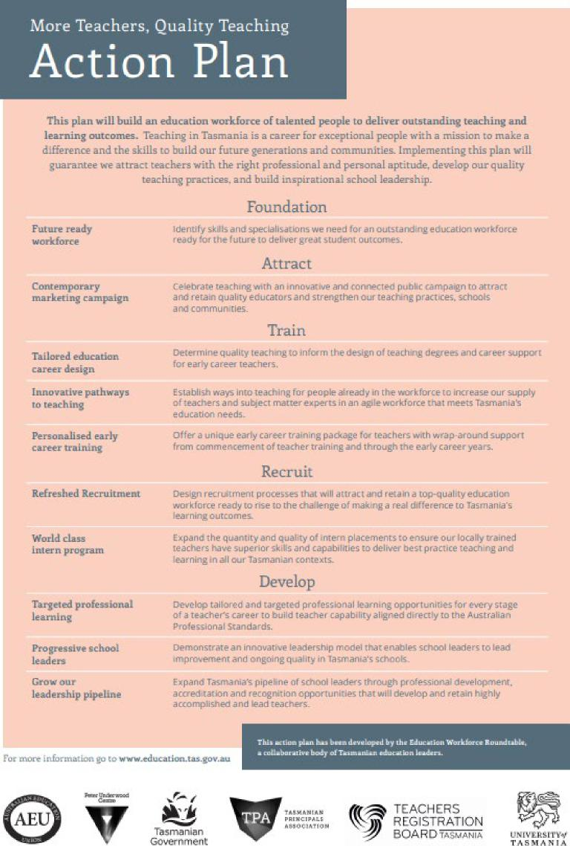

identify skills and specialisauons we need lot an (bonsai-ding education workforce ready for the future to deliver great stud:ern ousioornes.

Future ready workforce

Refreshed Recruitment

World class intern program

Design reriatment processes-that wdl attract and retain a sop-quakry ecfocadan workforce ready so rise to the challenge of making a teat difference **EU** Tasmania's learning.ourcomes_

Expand the qoarrusy and quaky of i mem placements to ensure our locally trained teachers have superior skills and capabil *hies* so. deliver best practice teaching ancE learning in all cur Tasmanian contexts.

**KM1IMIRI. PRI Nein.**

**HMO.**

ToismANIA

tiff ***I***

Tasmariar [.over einent

**TEACHERS** R**EGISTRATION BOA RD** 1.4SbAsonA

**imr[ran-ma cr.**

More Teachers, Quality Teaching

**Action Plan**

This plan will build an education workforce of talented people to deliver outstanding teaching and
  
learning outcorrom. Teaching in Tasmania is a career *for* exceptional people with a mission to make a
  
difference and the skills to build our future generations and communities. Implementing this plan will
  
guarantee we at tract teachers with the right professional and personal. aptitude, develop our quality

teaching practices, and build inspirational school leadersh ip.

Foundation

Attract

Contemporary celebrate ieachi ng with an innovar we and connected public cu mpaign ro amen

marketing campaign and retain quality educators and strengthen our teat/ling practices. schools and communities.

Train

Tailored education career design

Innovative pathways to teaching

Personalised early career training

Determine quality Leazhidg. so Inform the design of teaching degrees and career suppert for early career Leachers.

Establish ways Into-teaching for people al ready in Ow wcirkforce **40** increase our supply of teachers and sale-a mercer experrs in an agile workforce rhos meets Tasmania's education needs.

Offer a unique early career [raining package for Leachers emil wra p-around support from commencement *of* reacher ualning and through. she early career yearn.

Recruit

Develop

*Develop* tailored and targeted professional learning opporwnisies for *every* stage of a teacher's career to build teacher capabiliry aligned directly to die Australia n Professional Standards.

Dernonsuate a n innoirantie leadership *moue)* roarerraaies school leaders Lei lead improNenbenr and ongoing quanLy in Tasmania's schools.

Expand Tasrna nias pipeline cif school leaders through professional clevelepment, acuediration and recognitionopporrunities that will develop and retain highly accompelshed and lead Leachers.

.O11111.1

**For more inforeraTiara I713 Iplidhr_aiuraliormia.3Altrle.au**

rlus **diLiCn plan h :arm daalupcd by Thu EduChfli0n Warktoroc Eautsailm, a cuLlatpurairr hcayeiTanaid.ra reln.aiDn laAn.**

Targeted professional learning

Progressive school leaders

Crow our

leadership pipeline

|  |  |  |
| --- | --- | --- |
| **UNIVERSITYof**  **TASMANIA** |  | Tasmanian Government |