**Quality Initial Teacher Education Review - Terms of Reference**

Teachers and school leaders are the largest in-school influence on student outcomes.

With the development of the Australian Professional Standards for Teachers; the [Accreditation of Initial Teacher Education Programs in Australia: Standards and Procedures;](https://www.aitsl.edu.au/docs/default-source/initial-teacher-education-resources/eag-operational-principles.pdf?sfvrsn=b90cfd3c_12) and reforms arising from recommendations made by the Teacher Education Ministerial Advisory Group, the last decade has been a time of significant positive reform in initial teacher education (ITE).

A key goal of the reforms to ITE has been to ensure that graduate teachers start their teaching career with the necessary knowledge, skills and dispositions to be successful teachers in any Australian school. This review will build on the significant progress to date and inform the next evolution of reforms to continue to improve our capacity to attract high-quality candidates into teaching and equip them to become highly effective teachers.

The Review will consider the following questions and other important matters that may arise during the Expert Panel’s deliberations.

**PART A - Attracting and selecting high-quality candidates into the teaching profession**

1. How can we further encourage high performing and highly motivated school leavers to enter ITE and choose teaching as a career?



1. What changes to admissions and degree requirements, including recognition of prior experience, would better attract and support suitable mid- and late-career professionals from other fields transition into the profession and become quality teachers?
2. How can we increase ITE completion rates so that quality ITE students graduate and pursue careers as quality teachers?



1. What more can be done to address issues with workforce supply in some subject areas (particularly mathematics) and schools?
2. How can we attract a more diverse cohort into ITE so that teachers better mirror the diversity in school students and society?

**PART B – Preparing ITE students to be effective teachers**

1. What more can we do to ensure that ITE curriculum is evidence based and all future teachers are equipped to implement evidence-based teaching practices?
2. What more can ITE providers and employers do to ensure ITE students are getting the practical experience they need before they start their teaching careers?



1. How can Teaching Performance Assessment arrangements be strengthened to ensure graduate teachers are well-prepared for the classroom?
2. How can leading teachers, principals and schools play a greater role in supporting the development of ITE students?
3. Can ITE providers play a stronger role in ongoing professional development and support of teachers?

Names of member contributors:
  
**Associate Professor Michelle J. Eady**

*1. How can we further encourage high performing and highly motivated school leavers to enter ITE and choose teaching as a career?*

As a university educator, I am a conduit for young aspiring teachers to become conscious of their ability to influence and make a difference in the lives of children and in our society. Particularly, I endeavour to shape the way that my students become active and capable influencers in their own classrooms and beyond. My approach is founded in life experiences that I bring to share with my students. A qualified New South Wales primary school teacher since 1995, my teaching experiences have been unique and exciting both in Australia and abroad and include a variety of leadership positions in various educational contexts.

A constructive way of ensuring we are encouraging high performing and highly motivated school leavers to enter ITE and choose teaching as a career is through the integration and uptake of ‘taster’ sessions for these groups of interested students. These opportunities for high school students could be facilitated through university/school partnerships and delivered as gallery walks (Ramsaroop & Petersen) for high school students on universities campus. My institution, the University of Wollongong, regularly conducts these, and the feedback received is always of high value. For example, one unsolicited email I received stated, “*Thank you for your time, energy and professionalism in your session today. It was very engaging and my son wasn’t sure what he wanted to do at university until he attended your session...it looks like we will have a teacher in our family”* (email, 2016). Moreover, to further this notion of increasing high school interest, it would be advantageous to create a co-op placement for these attracted students. These students could attend local schools and observe teachers, read to the students, and facilitate small groups. A possible way of incorporating this could be during Education Week where students would have an opportunity to go into a school and observe, while volunteering themselves for appropriate tasks the teacher deems suitable. Often, as an educator of teachers, I see so many students entering the degree who come from a strong teaching family background which a foundational understanding of how schools operate however, we also want to encourage others who may still be undecided or not confident in choosing a career path that leads to teaching.

I strongly believe that collaborating with the community brings opportunities for success through authentic learning environment experiences. I rely heavily on situated learning theory (Lave & Wenger, 1991) which defines learning as a social construct (Vygotsky, 1978) within an authentic context with a Community of Practice (CoP). My students are given opportunities to collaborate with each other, school teachers, as well as with me, to learn and gain expertise about school pedagogy. I believe in being an approachable, team player who engages students in real, meaningful, supportive, and innovative ways that support their learning about pedagogy and guides them in the development of their own teaching philosophy and practice. I believe that strengthening the partnership between high school career advisors and universities could open opportunities for students to have these conversations at a younger age. Ensuring a meaningful role creating a third space partnership (Zeicher, 2010) between the university and school career advisors would allow many different ways of motivating and inspiring young students.

*3. How can we increase ITE completion rates so that quality ITE students graduate and pursue careers as quality teachers?*

In recent years, there has been a strong focus towards a shift in sustainable education, focussing on integrating theory and practice (Lozano et al., 2017). More specifically, there has been a focus in many areas such as e-learning, utilising active learning methods, and the creation and sustainment of partnerships with industry and community (Lozano et al., 2017). Integrating theory and practice within initial teacher education (ITE) is not only an effective way to incorporate real world experience for students, but it has been seen to increase student engagement (Cattaneo, 2017).

I strong believe that it is imperative that students are also gaining the relevant skills and experience needed when entering ITE, through Work Integrated Learning (WIL). I created a new subject, EDPD100 Introduction to the Profession, a subject that connects students who come into our degree with three Band 5 HSC results, including one in English, with local community schools, giving them the opportunity to have WIL experiences. This subject involved an introduction to and an exploration of schools and school environments. Students were engaged in learning within a partnership school and other educational settings and work on a project related to education. Skills in project planning, developing a research plan, library research and critical analysis of selected educational literature was also developed. In allowing students to gain this early experience, they are developing their passion and skills from the very beginning of the degree, which in turn creates the motivation for the students (Solomon et al., 2017).

Over a decade ago, I established a collaborative school-university partnership with a local school. As part of this partnership, pre-service teachers enrolled in my subject would visit the school for three hours once a fortnight throughout the semester. During their visits, PSTs participated in a one-hour lecture and a one-hour tutorial in the school setting and also spent one hour in classrooms connecting theory to practice through observations and teaching school students themselves. The school-based tutorials and lectures gave PSTs a valuable opportunity to connect what they have been learning through their ITE degree to what they see in classrooms, thereby meaningfully integrating theory with practice. Further capitalising on the school-based learning opportunities, some of the assessment tasks in EDPD202 were aligned to PSTs’ classroom visits. These assessment tasks were discussed with the teachers at the school where they were asked for input and ideas from the professional perspective. This was an important step to the partnership between the school and the university. Some unsolicited comments received by students include, “Having the opportunity to spend some time in a school and teach a lesson was something I really enjoyed and found helpful (*PST in 2018 cohort.)” and “Learning the content and being able to witness, experience, and use it in the classroom (PST in 2018 cohort.)”* Further, it is important to listen to these students and allow them to experience the school setting.

*7. What more can ITE providers and employers do to ensure ITE students are getting the practical experience they need before they start their teaching careers?*

I believe that the work that I do as a teacher, researcher, leader, and influencer of education is both an important and meaningful life purpose however, I am most proud of the reciprocal relationships that I have created with all of my students over the years. My goal is to guide my students in their journey to becoming the best teachers and role models that they can be, and to inspire and encourage my peers and colleagues to do the same.

One of the most significant areas of focus in today’s tertiary education settings is learner-centred pedagogies and the concern of fostering both employable and civic prepared graduates. Learning must recognize the concept of “the essential integration of personal development and learning” (Keeling, 2004, p. 5) in the disciplines. Goldstein and Otte (2016) note that change is occurring in pedagogy due to the science of learning research. Current research in learning suggests networks and connections need to be made across contexts and retrieved over time for effective learning (David & Naidoo, 2018). In addition, learners fare better when they believe that ability is cultivated, rather than innate, and nurtured by a growth mindset (Dweck, 2006). This is illustrated in a model created by my research team.

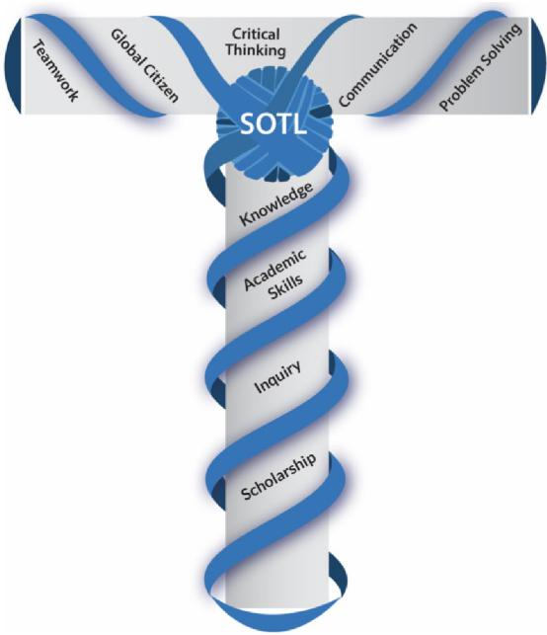

(Eady et al., 2021)

By considering students holistically, we can provide them with opportunities to take ownership of their own learning, and further develop problem-solving mindsets. HE is concerned with the preparation of students from an academic perspective however, little is done to prepare students for life’s challenges.

**References**

Cattaneo, K. H. (2017). Telling active learning pedagogies apart: From theory to practice. *Journal of New Approaches in Educational Research (NAER Journal)*, *6*(2), 144-152.

David, M., & Naidoo, R. (2018). *The sociology of higher education: Reproduction, transformation and change in a global era*. Routledge.

Dweck, C. S. (2006). *Mindset: The new psychology of success*. Random House.

Eady, M. J., Abrahamson, E., Green, C. A., Arcellana-Panlilio, M., Hatfield, L., & Namaste, N. (2021). Re-

positioning SoTL toward the T-shaped Community. *Teaching & Learning Inquiry, 9*(1), 262-278. <https://doi.org/10.20343/teachlearninqu.9.1.18>

Goldstein, M., & Otte, G. (2016). *Change We Must: Deciding the future of Higher Education*. Rosetta Books. Keeling, R. P. (2004). *Learning reconsidered: A campus-wide focus on the student experience*. Student Affairs Adminstrators in Higher Education.

Lave, J. & Wenger, E. (1991). *Situated learning: Legitimate peripheral participation*. Cambridge University Press.

Lozano, R., Merrill, M. Y., Sammalisto, K., Ceulemans, K., & Lozano, F. J. (2017). Connecting competences and pedagogical approaches for sustainable development in higher education: A literature review and framework proposal. *Sustainability*, *9*(10), 1889.

Ramsaroop, S., & Petersen, N.(2020). Building professional competencies through a service learning ‘Gallery Walk’ in primary school teacher education*. Journal of University Teaching & Learning Practice, 17*(4).

Solomon, Y., Eriksen, E., Smestad, B., Rodal, C., & Bjerke, A. H. (2017). Prospective teachers navigating

intersecting communities of practice: early school placement. *Journal of Mathematics Teacher Education*, *20*(2), 141-158.

Vygotsky, L. S. (1978). *Mind in society: The development of higher psychological processes*. Harvard university press.