

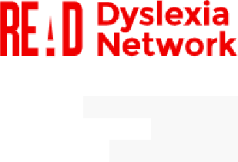

ABN: 69 621 888 122

PO Box 493 Curtin, ACT, 2605

17/07/2021

**Submission to The Quality Initial Teacher Education Review**

Code Read welcomes the opportunity to make this submission to The Quality Initial Teacher Education Review.

**About Code Read**

Code Read is a not-for-profit advocacy network founded to improve the outcomes for children and families with dyslexia. The organisation remains inclusive of parents, carers, educators, health professionals and people with dyslexia.

**Our Vision:** For all people with dyslexia to be understood, acknowledged, empowered and to have equal access to opportunity.

**Our Mission:** We will raise awareness about dyslexia. We will support and empower those with dyslexia and their families. We will work with government and other decision makers to improve the education system and workplaces for those with dyslexia. We will work to enhance the everyday experience of people with dyslexia.

**Our Aims:**

* Raise awareness of dyslexia and its impact on children and families.
* Ensure families with dyslexic children are able to advocate effectively for their children.
* Mandate national early testing in every school.
* Ensure national implementation of best practice teaching methodologies and approaches for dyslexia.
* Educators that are knowledgeable about dyslexia and how to identify it.
* Educators using current evidence-based teaching practices.
* Effective evidence-based literacy instruction (explicit systematic synthetic phonics) in schools and high expectation for all students.
* Schools and teachers to be dyslexia aware and give all students equitable access to the curriculum.
* Dyslexia to be de-stigmatised in the community.
* Action to alleviate the potentially devastating outcome of undiagnosed or unsupported dyslexia.

**About Dyslexia**



Dyslexia is a specific learning disability that is neurological in origin. It is characterised by difficulties with accurate and/or fluent word recognition and by poor spelling and decoding abilities. These difficulties typically result from a deficit in the phonological (sound system) component of language that is often unexpected in relation to other cognitive abilities and the provision of effective classroom instruction. Secondary consequences may include problems in reading comprehension and reduced reading experience that can impede the growth of vocabulary and background knowledge.

Dyslexia is a learning difficulty that primarily affects the skills involved in accurate and fluent word reading and spelling. Characteristic features of dyslexia are difficulties in the awareness of individual sounds in a word (ability to identify and manipulate separate sounds within words), verbal memory and verbal processing speed.

Dyslexia occurs across the range of intellectual abilities an affects an estimated 10-20% of the population1. Children with dyslexia are constantly confronted with situations of failure and frustration in school settings. When mastery of skills falls short of peers then it can have a significant impact on self-esteem. Children with dyslexia are at higher risk for intense feelings of sorrow and pain and suffer anxiety and depression. As many as 70% of children with learning difficulties suffer from poor self-esteem.2

Dyslexic children suffer learned failure and have poorer school outcomes than children without dyslexia. Therefore, the provision of reading instruction based on scientific evidence about how children learn to read and how to teach them is crucial for improving their educational and emotional outcomes. Significant research into the science of reading and most effective evidence-based teaching methodologies for literacy show that explicit literacy instruction is essential for all students, especially those with dyslexia.

Teaching children using systematic synthetic phonics has been proven to increase literacy success. *“The evidence is clear that the teaching of systematic synthetic phonics is the most effective way of teaching young children to read, particularly those at risk of having problems with reading.”* Rose review, England (2006).

Effective literacy Instruction includes the five essential areas as identified by research:

1. Phonemic awareness
2. Phonics
3. Fluency
4. Vocabulary

1 In other English speaking countries (first language) the figures are estimated to be up to 20% (UK, Canada, UK). <https://dyslexiaassociation.org.au/dyslexia-in-australia/>

2 An article by Great Schools refers to research conducted by Dr. Kenneth Kavale and Dr. Steven R. Forness.

5. Reading comprehension



Dyslexic children should receive this evidence-based instruction from teachers who have been given a thorough understanding of dyslexia and its learning challenges. It is essential that Australian teachers be instructed in the science of reading and how to teach it within their Initial Teacher Education training (ITE).

**National Inquiry into the Teaching of Literacy, 2005**

Australia’s falling literacy standards continue to have lifelong impacts on Australia’s children, especially those with dyslexia who struggle to learn to read. The National Inquiry into the Teaching of Literacy (NITL) (Rowe Report) in 2005 made 20 recommendations. The following two recommendations are relevant to this submission:

1.Teachers be equipped with teaching strategies based on findings from rigorous, evidence-based research that are shown to be effective in enhancing the literacy development of all children.

2. Teachers provide systematic, direct and explicit phonics instruction so that children master the essential alphabetic code-breaking skills required for foundational reading proficiency.

Since the 2005 NITL report, 18-19% of students have failed to read at a proficient standard in grade four. Australia’s failure to teach them effectively negatively impacts about 50,000 Australian children each year. Since 2005 this has become a cost that 700,000 of our children now bear.

**Initial Teacher Education and Dyslexia**

Australia’s response to literacy in ITE training falls short of the needs of students, especially those with dyslexia. This can be seen in Australia’s falling OECD PISA results that highlight 41% of 15-year-olds in Australia did not meet National Proficiency Standards in Reading and 46% of 15-year-olds did not meet National Proficiency Standards in Mathematics. In 2017, UNICEF rated Australia 39th out of 41 high and middle-income countries in achieving quality education.

Research by Maxwell comparing ITE in the UK and Australia recommended that training should include explicit teaching to meet the needs of students with specific learning needs (including dyslexia) across all abilities and include strategies to support inclusive student participation and engagement in classroom activities. This includes ensuring new graduating teachers have a specific understanding of dyslexia. “*Unfortunately, according to the extremely limited research available, teachers in Australia are insufficiently equipped to support students with dyslexia.”* (2019, p. 4)

Other research supports the findings that Australian teachers receive limited information about how they can support dyslexic students during their ITE.

*Only 60% of early career primary teachers said they found their ITE course to be helpful, or very helpful, in developing strategies for teaching literacy. Principals who participated in the SiAS survey also lacked confidence in the abilities of new teachers, with only 33% saying that they thought that recent graduates were well, or very well, prepared to develop strategies for teaching literacy.* (Buckingham & Meek, 2019, p. 3)



If teachers are given insufficient knowledge and training in their ITE to support children with dyslexia, then they will be unable to meet the Australian Teaching Standards and provide effective individual support in their classrooms. It is also likely that many graduate teachers will be unable to respond to children with sufficient understanding and empathy in relation to their learning difficulties.

Australia’s basic literacy instruction is caught in ideological paradigms and policies rather than evidence-based, best practice instruction. This is a major contributing factor to the reading failure of dyslexic students. Australia’s teaching of reading is still heavily linked to a whole language philosophy where immersing children in oral and written language is expected to result in them learning to read. This conflicts with the efficacy of the science of reading, where the correlation between the spoken sound, the letter name and the letter shape are explicitly taught.

A whole language approach to reading was contraindicated in the NITL report (2005) that recommended, *“teachers provide systematic, direct and explicit phonics instruction so that children master the essential alphabetic code-breaking skills required for foundational reading proficiency.” (Rowe, 2005)*

*The National Inquiry into the Teaching of Literacy (Rowe Report) identified that there was a dichotomy between educators who advocate for the traditional practice of whole language or analytic phonics, and cognitive scientists who relied on research to assert that SSP would be a more effective and efficient way to teach Australian school children (Australian Government Department of Education Science and Training, 2005).* (Leslie, 2020)

Australia’s experience and rates of literacy are similar to other countries where the whole language, balanced literacy approach to literacy has been implemented. Australia is failing to give a large proportion of children vital literacy skills and our student teachers continue to enter schools without the requisite knowledge and skills to effectively teach reading/literacy by applying a proven science-based approach. For Australian students, this results in ongoing failure among those who struggle to learn to read.

In Australia and other western countries, a sizeable proportion of children do not learn to read well. In the UK, schools that implemented synthetic phonics had better outcomes and used a Year One Phonics Check (Y1PC) to determine if students had met phonic decoding benchmarks. However, Australia has not yet established a nationally consistent approach to teaching phonics. In many schools, the implementation of whole word readings and other programs may be selected by the

school. These programs may not be backed by scientific research but are still being taught to students. Their implementation has a significant influence on the ongoing professional development of graduate teachers and what approaches they learn are acceptable to use.



Buckingham and Meek’s research (2019, p.20) highlights how little advancement has been made since the National Inquiry into the Teaching of Literacy (NITL) (Rowe, 2005),

*The NITL report recommended that “the key objective of primary teacher education courses be to prepare student teachers to teach reading, and that the content of course-work in primary literacy education should focus on contemporary understandings of: evidence-based findings and an integrated approach to the teaching of reading, including instruction on how to teach phonemic awareness, phonics, fluency, vocabulary knowledge and text comprehension; child and adolescent development; and inclusive approaches to literacy teaching.*

*Subsequent reviews of ITE made almost identical recommendations. This review of ITE literacy courses indicates that the recommendations with respect to a focus on beginning reading, the prioritisation of evidence-based practice and the five essential elements of reading instruction, have not been widely adopted.*

It is not enough for the Australian Graduate Teacher Standards to set out requirements for understanding and implementing effective teaching strategies that state teachers should know and understand literacy and numeracy teaching strategies and their application in learning areas. Course requirements should mandate the inclusion of evidence-based systematic synthetic phonics, including the ‘what’ and ‘how’ aspects, be included in teacher training as is the case in the UK. In addition, individual schools should not be able to implement programs for literacy that are not evidence-based simply because they have been ‘sold’ to the school.

**The Impact of Failed Literacy Ideologies on Teachers**

Teachers are professionals who want to help their students achieve their best. Leaving teachers insufficiently prepared to support struggling students and those with dyslexia undermines the foundation of their professional role. This includes providing them with poor literacy teaching methodologies, insufficient training to teach literacy effectively or support student’s specific learning needs.

*The Australian Professional Standards for Teachers (AITSL, 2011, p2), “are a public statement of what constitutes teacher quality. They define the work of teachers and make explicit elements of high-quality, effective teaching in 21st century schools that will improve educational outcomes for students.” (Maxwell, 2019, p 3).*

While ITE providers claim to afford teachers the skills they need to enter the classroom, most teachers report they have been given neither the knowledge or the skills to support dyslexic

students. Despite this shortfall, teachers are continually called upon to be the solution to Australia’s falling educational standards. Hardy notes in his research that,



*The shift to a knowledge economy has brought unparalleled attention to the quality of education systems, and in particular to teacher education providers and teachers, who are presumed to be the generators of knowledge workers for the new economy. (Cochran-Smith, 2016, p. xii)”... “when teacher education is constructed as a policy problem, the focus is almost always on pupil achievement, defined as test score.* (p 203).

The continual focus on test scores and performance outcomes for school students clouds the issues underpinning poor reading outcomes for dyslexic students and struggling readers in Australia.

Maxwell (2019) similarly notes, *“It appears teachers are still not receiving adequate education regarding dyslexia.”* 71.8% of teachers said that dyslexia was not covered well in the ITE making at odds with the Australian Professional Standards for Teachers that requires teachers to differentiate their teaching to meeting the specific learning needs of students.

With a government policy to engage parents in their child’s education, there is significant disconnection between the inconsistent understanding teachers have of dyslexia and the needs of dyslexic children and their parents and carers. Australian research into the experience of parents of children with dyslexia reveals that parents also experience significant stress and poorer mental health as a result of their child’s school experience. The following parent experiences highlight the extent of this:

*In my work it’s frustrating because I’m trying to work with these kids and coming up against colleagues that I work with who have little understanding. It kills me when they tell me these kids are lazy. I just want to kill them. We need a lot more education on these kinds of issues. [parent teacher]...*

*It’s very hard. That’s quite rare to find someone. I really feel two teachers have had the ability to see the picture, and to understand and to be able to talk on a certain level with that knowledge, but most teachers have no idea (Mother, interview no. 9). [parent]...*

*I feel that at the start of every year you have to go [to the school] and introduce everything again, absolutely everything. There are different levels of understanding of dyslexia. Some people understand a lot and others understand nothing. It’s like we’re educating them. [parent]*

Additional information about parent experiences come from a 2016 Parent Survey on the Education of Students with Dyslexia in Australia.3 The national survey was completed by 1,720 participants and aimed to convey the experiences of parents about the education of their children with dyslexia from

3 Compiled by Tanya Forbes, Founder of the Gold Coast Dyslexia Support Group and Dyslexia QLD Support Group.

Prep/Kindergarten through to Year 12. The following charts identify significant gaps in teacher understanding of children’s learning needs and adequate training to support dyslexia.



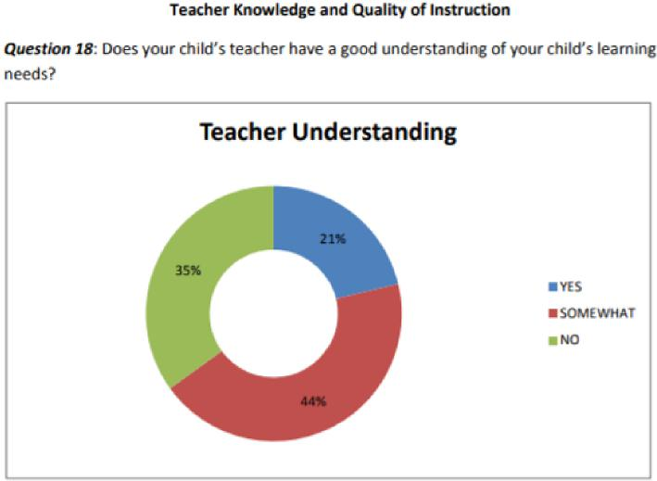

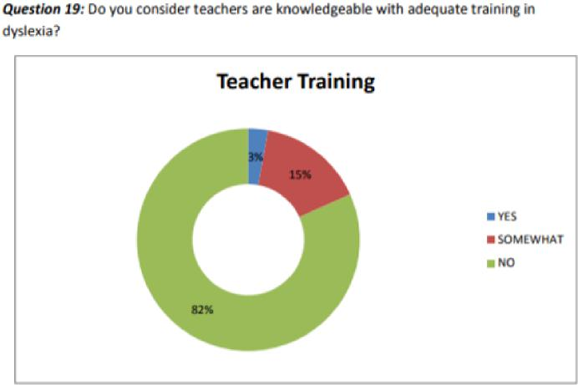

With graduate teachers reporting they feel less prepared to manage classrooms and engage with parents, improving their ability to support dyslexic students is likely to improve these factors. With a sound understanding of the issues facing dyslexic students, teachers may have better classroom

management skills and be more able to engage with parents to discuss their children’s learning issues. Improving graduate teacher understanding and skills is also like to enhance their confidence in their own ability and perceptions of their value to parents of struggling children is also likely to improve.



**Conclusion**

The number of children failing reading in Australia is not a small group of children and it is especially evident among the 10-20% of children who have dyslexia. The total reading failure among Australian children is roughly 50,000 students a year (700,000 Australians) despite the recommendations of the Rowe report in 2005. The research efficacy for teaching evidence-based literacy is incontrovertible yet Australia remains unable to make a political and moral decision to mandate this for all students. All Australian children should receive explicit evidence-based literacy instruction in systematic synthetic phonics and the teaching of evidence-based literacy should not be confounded by contradictory methods enabled by individual school decisions.

Despite ITE providers claiming to provide adequate instruction for student teachers in explicit evidence-based teaching of literacy, recent Australian research has identified this falls far short of what is required. In addition, both teachers and parents agree that teachers have a low level of understanding of dyslexia and how to support dyslexic students.

Australia cannot continue to exclude dyslexic and struggling readers from the basic human right to literacy attainment. To continue to do so is not only imprudent but it is also inadvertent. In the face of mounting evidence Australian governments, schools and ITE providers hedge towards an ever more well-informed level of negligence.

**Recommendations**

Australia is being left behind in its response to the issue of dyslexia/specific learning disabilities. It needs to implement the recommendation made in the National Dyslexia Action Agenda (Firth, 2010 p10) and significantly improve the information and training provided to teachers in ITE. For graduate teachers to be effective in supporting dyslexic students they must have an improved understanding of dyslexia, its impact on students, and the knowledge and skills to provide differentiated support in line with teaching standards. Graduate teachers also need to effectively teach evidence-based explicit instruction in systematic synthetic phonics and understand the science of reading.

Code Read recommends that the Australian Teaching Standards mandate ITE providers deliver the following nationally consistent level and depth of knowledge and skills training within their ITE courses:

* explicit ‘what’ and ‘how to’ training similar to the UK standards so graduate teachers are able to effectively teach Systematic Synthetic Phonics or multisensory, phonetically based, systematic, incremental instructional programs to Australian children.
* teaching of the science of reading.



* a thorough understanding of dyslexia and specific learning differences, including how to effectively support students that is developed by, or approved by an Australian Dyslexic Support Association.

In addition, individual schools should not be able to run literacy programs or interventions that are not based on the science of reading or systematic synthetic phonics. This requirement should be a requirement across all state jurisdictions.



Dr Sandra Marshall

BMBS FRACGP Dip Child Health

Chairperson

Code Read Dyslexia Network

**References**



Buckingham, J & Meeks, L (2019). Short-Changed: Preparation To Teach Reading In Initial Teacher Education, Five from Five, Macquarie Park. <https://www.researchgate.net/publication/336019904_Short-Changed_Preparation_To_Teach_Reading_In_Initial_Teacher_Education>

Firth, N. (2010). A Resilient Response to Dyslexia/Specific Learning Disabilities: International Best Practice Environments and Programs. *Australian Journal of Dyslexia and Other Learning Difficulties*, 5, 3–11.<https://search-informit-org.ezproxy.lib.swin.edu.au/doi/10.3316/informit.568008477448989>

GreatSchools Staff (2016). Learning Disabilities and Psychological Problems: An Overview. <https://www.greatschools.org/gk/articles/learning-disabilities-and-psychological-problems/>

Harding, I. Chapter 14. Practice, Theory and Policy: Redesigning ‘Quality’ Teacher Education in Australia. C. Edwards-Groves et al. (eds), Education in an Era of Schooling, htpps://[doi.org/10.1007/978-981-14-2053-8_14](http://doi.org/10.1007/978-981-14-2053-8_14)

Leslie, R. (2020). An interpretative phenomenological analysis of the experiences of parents of children with dyslexia in Australia. Masters thesis, University of Southern Queensland.

Levi, K (2017). The Experiences of Parents of Children who have Dyslexia in Victoria, Australia: A social justice perspective. PhD thesis, The University of Melbourne

Maxwell, C. (2019). Teacher Education on Dyslexia: An Analysis of Policy and Practice in Australia and England, *Education Research and Perspectives*, Vol 46, p 1-19.

Rose, J (2006), Independent Revie of the Teaching of Early Reading, Final Report, Department of Education and Skills, UK