

**AUSTRALiA**

**THE 2020 REVIEW OF THE DISABILITY STANDARDS FOR EDUCATION 2005**

SUBMISSION

September 2020

Reimagine Australia acknowledge the traditional custodians of the land across this nation on which we work and pay our respects to their Elders, past and present and to the children and young people of today, who are the Elders of tomorrow.

We acknowledge our gratitude in sharing this land today, our sorrow for some of the costs of that sharing, and our hope and belief that we can move to a place of equity, justice and partnership together, recognising that we walk in harmony with our First Nations brothers and sisters in creating a more just Australian society.

Reimagine Australia Level 5, 4 Columbia Court, Norwest NSW 2155 ABN: 94 083 927 317

2

Reimagine Australia

Table of Contents

1. **Executive summary 3**

1.1 Background on Reimagine Australia 3

1.2 Submission purpose 3 1.3 The National Action Plan for Children with Developmental Delay and Disability

1. **The Role of the Disability Standards for Education 2005 4**

2.1 Broaden the criteria 4

2.2 Human Rights Alignment 6

1. **Apply Standards to all Education Environments 7**

3.1 Extend to childcare 7

1. **Embed Standards in everyday practice 8**

4.1 Embed the standards in the Early Years Learning Framework 8

4.2 Embed the standards across the National Quality Standard 8

4.3 Support for guiding inclusive practice 8

1. **Quality and Consistency of Support for Children 9**

5.1 Workforce support around ‘Reasonable Adjustment’ 9

5.2 A Trauma Informed Approach for Children 9

5.3 Complaints and accountability 10

1. **Conclusion 10**

**Attachment A - Reimagine Early Childhood National Action Plan Priority Areas 11**

**Attachment B - Case Study 11**

3

Reimagine Australia

1. Executive Summary

**1.1 Background on Reimagine Australia**

Reimagine Australia, formerly known as Early Childhood Intervention Australia (ECIA), has been the leading Australian body for early childhood outcomes for young children with a developmental delay or a disability and their families, since 1986.

As the singular national organisation that works with families, government, service providers, and mainstream support services to obtain the very best outcomes for children with developmental delay or disability and their families, Reimagine Australia has been leading the early childhood sector in embedding best practice and inclusive systems design for over 35 years.

Reimagine Australia’s purpose is to ensure that children with disability and/or developmental delay, and their families, have every opportunity to reach their potential in life. We do this by supporting families and practitioners, whilst reimagining communities in which we live, work and play through strategic and inclusive design.

**1.2 Submission purpose**

Reimagine Australia welcomes the opportunity to contribute to this year’s review of the Disability Standards for Education 2005, to highlight the rights of children with disability or developmental delay and their families. Our submission highlights several areas of interest of concern and recommendations of Reimagine Australia which are:

* Broaden the criteria - to support the actual number of children with additional needs who require legislative protection
* Apply Standards to all education environments - extend to childcare
* Embed the Standards in everyday practice through the Early Years Learning Framework and the National Quality Standards
* Provide support for guiding inclusive practice
* Sector support for ‘Reasonable Adjustment’
* Improving complaints process for families and accountability for education providers

4

Reimagine Australia

**1.3 The National Action Plan for Children with Developmental Delay and Disability**

In March 2019 the Hon. Paul Fletcher, Minister for Families and Social Services, commissioned Reimagine Australia to design and deliver the first national Action Plan (National Blueprint Project) for children with disability and/or developmental delay and their families.

The Action Plan provides a 10-year strategy for the government, in partnership with stakeholders across the early childhood development sector, to iteratively deliver the vision of ensuring every child has every opportunity to reach their full potential.

The Action Plan is led by a governing recommendation, which is underpinned by 6 recommendations that fall into 6 Key Priority Areas (see attachment A for Priority Areas).

Actions proposed through the Action Plan are considered to be the first, important steps to deliver a stronger, more collaborative and quality early childhood development sector. Further actions can build from these first steps and other existing work underway across government and the sector, to be implemented.

2. The Role of the Disability Standards

for Education 2005

**2.1 Broaden the criteria**

Reimagine Australia is concerned the Disability Standards are not currently supporting the actual number of children with additional needs who require legislative protection.

Reimagine Australia is concerned that the requirement for a diagnosed disability, in order to be protected by the Disability Standards, does not reflect the accurate number of children requiring support. The Disability Standards review, states that four per cent of children aged from birth to four years of age have a disability, however evidence suggests this is not a true reflection of need.

5

Reimagine Australia

Around 56 per cent of children in Early Childhood Early Intervention (ECEI) under the NDIS are without a diagnosis yet are receiving disability funding to access the additional support they require to learn and develop. This means over half of the children in the early years who require additional support do not have a diagnosis. It can take many years for children to receive a diagnosis, if at all and Reimagine Australia is concerned the diagnosis mandate of the Standards is leaving many children without the adjustments and tailored support they require.

Reimagine Australia strongly recommends the Standards adopt the access criteria for early childhood from the NDIS legislation. This would ensure all who require specialised developmental support are protected by the Standards and the Disability Discrimination Act.

For the purposes of the NDIS Act, developmental delay means a delay in the development of a child under six years of age that meets all of the following criteria:

is attributable to a mental or physical impairment or a combination of mental and physical impairments; and results in substantial reduction in functional capacity in one or more of the following areas of major life activity:

1. self care;
2. receptive and expressive language;
3. cognitive development;
4. motor development; and

results in the need for a combination and sequence of special interdisciplinary or generic care, treatment or other services that are of extended duration and are individually planned and coordinated (section 9).

Reimagine Australia recommends that if the diagnosis mandate is removed and protection extended to children with developmental delay, the age should be extended beyond six years of age for all children (see attached case study).

We recognise that children with additional needs require support regardless of whether they have a diagnosis of disability and we are concerned a narrow interpretation of

6

Reimagine Australia

eligibility is preventing many children from getting the tailored support they require in their education settings.

In addition, we agree with the access criteria for the NDIS and also call for the inclusion of another area of major life activity - social context - to accompany self care, receptive and expressive language, cognitive development and motor development.

The addition of social context is a crucial element for the development of children to acknowledge their emotional and social wellbeing in environments such as playgrounds and in the classroom.

**2.2 Human Rights Alignment**

The expansion of eligibility beyond a diagnosis of disability aligns with the international Convention of the Rights of Persons with Disabilities, specifically the social model and would assist in moving the education system away from a deficit based medical model of disability to a social model of disability. Furthermore, the requirement for a diagnosed disability for reasonable adjustments to be made does not reflect the complex system of navigating diagnosis and assessment evenly.

We strongly advocate for the sector to recognise the social model of disability and focus on the strengths of children and alleviating disabling factors. The addition of ‘social context’ as a major life activity will assist in the shift toward the social model of disability as it broadens thinking and application beyond the individual into the larger environment for children and their families.

Reimagine Australia believes the medical model, which the standards currently align with, inadvertently results in limitations on the response and support for all children in the education system that have diverse needs.

7

Reimagine Australia



|  |  |
| --- | --- |
| **Medical model thinking**  “Disability is the problem located in the individual” | **Social model thinking**  “Disability as a social construct located not in the individual but in the environmental barriers and discriminatory practices of society” |
| Child is faulty | Child is valued |
| Diagnosis from a professional | Strength and Needs identified by self and parents |
| Labelling | Identify barriers and develop solutions |
| Impairments becomes focus of attention | Outcome based program design |
| Assessment, monitoring, programs of therapy imposed | Resources are made available  universally to all |
| Segregation and alternative services | Training for parents and professionals |
| Ordinary needs put on hold | Relationships nurtured |
| Re-entry if normal enough or Permanent Exclusion | Diversity welcomed Child is included |
| Society remains unchanged | Society evolves |

Adapted from M. Mason 1994, R.Rieser 2000

3. Apply Standards to all Education

Environments



**3.1 Extend to childcare**

All early childhood education and care (ECEC) and school age education services must comply with the Disability Discrimination Act 1992 and it is unlawful to discriminate against a person with a disability, however the Disability Standards do not have the same application. Preschools, kindergartens, government and private schools must apply the Standards, but childcare providers are not included.

Reimagine Australia strongly recommends all education and care services are included in adhering to the Standards, especially childcare providers including centre based day

8

Reimagine Australia



care, family day care, in home care, outside school hours care and any other services involving children.

The majority of childcare services provide a kindergarten education program of which children with developmental delay and/or disability would be accessing and requiring support to meaningfully engage. We acknowledge that when the Standards were developed childcare played a different role, however, we recommend the Standards align with the current education and care model.

4. Embed Standards in everyday

practice





**4.1 Embed the standards in the Early Years Learning Framework**

Reimagine Australia strongly recommends the Standards are woven into the Early Years Learning Framework (EYLF) to embed these protections for children in everyday practice.

As the EYLF is the guiding document for the teaching sector, we believe there is still work to be done to embed the Standards in the document. Currently the EYLF does not make reference to the Standards and Reimagine Australia would like to see the protection of children with disability embedded more clearly in the national approved learning frameworks.

Based on the national law, all education services are required to base their program on the EYLF to address developmental needs, experiences of each child, while taking into account individual differences1 however there is no direct reference to the Standards.

1 <https://www.acecqa.gov.au/nqf/national-law-regulations/approved-learning-frameworks>

9

Reimagine Australia

**4.2 Embed the standards across the National Quality Standard**

The National Quality Standard (NQS) is the national benchmark for early childhood and care and includes seven quality areas that are important outcomes for children. We believe the Standards need to be embedded into the NQS to protect children with disability as providers are given ratings based on the quality areas, of which disability and/or developmental delay needs to be included.

5. Quality and Consistency of





Support for Children



**5.1 Workforce support around ‘Reasonable Adjustment’**

Educators are required to make reasonable adjustments to assist children with disability to engage in education on the same basis as other students2. Drawing from the findings of the Royal Commission into Violence, Abuse, Neglect and Exploitation of People with Disability, we support that capable and skilled educators are crucial to providing students with a quality and inclusive education. However, many teachers do not receive appropriate training to provide reasonable adjustments for inclusive education3.

We believe that educators don’t always have the professional knowledge or time during their working hours to provide these reasonable adjustments. Furthermore, a lack of individualised supports and planning contributes to children missing out on learning.

We support the development of guidance documents4 to support educators to implement reasonable adjustments in practical ways for children.

2 <https://disability.royalcommission.gov.au/system/files/2020-07/Issues-paper-Education-Learning.pdf>

3 <https://disability.royalcommission.gov.au/system/files/2020-07/Issues-paper-Education-Learning.pdf>

4 <https://disability.royalcommission.gov.au/system/files/2020-07/Issues-paper-Education-Learning.pdf>

10

Reimagine Australia

**5.2 A Trauma Informed Approach for Children**

Reimagine Australia also emphasises the need of educators to provide a holistic, preventative and trauma informed model for children with disability to inform how they implement reasonable adjustments.

We believe a trauma informed practice is integral to build workforce capability to fully support children. The sector would be greatly enhanced if educators are trained to view their interactions with a trauma-informed lens for the wellbeing of children with disability. Trauma-informed models in education settings have reduced anxiety and depression and have also reduced stress in educators when supporting children who have experienced trauma5.

**5.3 Complaints and accountability**

We believe education centres need to be accountable to protect the rights of the children when the Standards aren’t upheld. Furthermore, we believe the awareness of the Standards needs to improve as most families don’t know they exist and instead of raising a complaint, they move to another education provider. Based on feedback from the sector, we hear many families are overwhelmed when their child is refused education or care based on needing support. Instead of resolving this issue with education providers, parents find another provider until their child is accepted.

We believe accountability needs to be embedded when Standards aren’t being upheld, beyond a complaints process. We would like to see a review of the education’s inclusion practice and recommendations to be implemented with training and support for staff.

Reimagine Australia would like to see the investment of advocacy funding through the Department of Education to support families to act on behalf of their children.

5 <https://www.monash.edu/education/teachspace/articles/five-approaches-for-creating-trauma-informed-classrooms>

11

Reimagine Australia

Conclusion

Reimagine Australia believes the Disability Standards need to protect students with disability so they can access and participate in education on the same basis as students without disability. To protect the rights of all children, we believe the Standards need to broaden the criteria for children with disability and/or developmental delay and to apply the Standards to all education environments. To uphold the rights and obligations under the Disability Discrimination Act, the Standards need to be embedded in everyday practice through the Early Years Learning Framework and the National Quality Standard. We recommend professional support for inclusive practice to be provided for the sector. Education providers need support around reasonable adjustment and education providers need greater accountability when families are acting on behalf of their children.

12

Reimagine Australia

Attachment A

**6 Key Priority Areas**

The Reimagine Early Childhood National Action Plan is led by a governing recommendation, which is underpinned by 6 recommendations that fall into 6 Key Priority Areas. Each Priority Area is supported by a set of succinct action items.

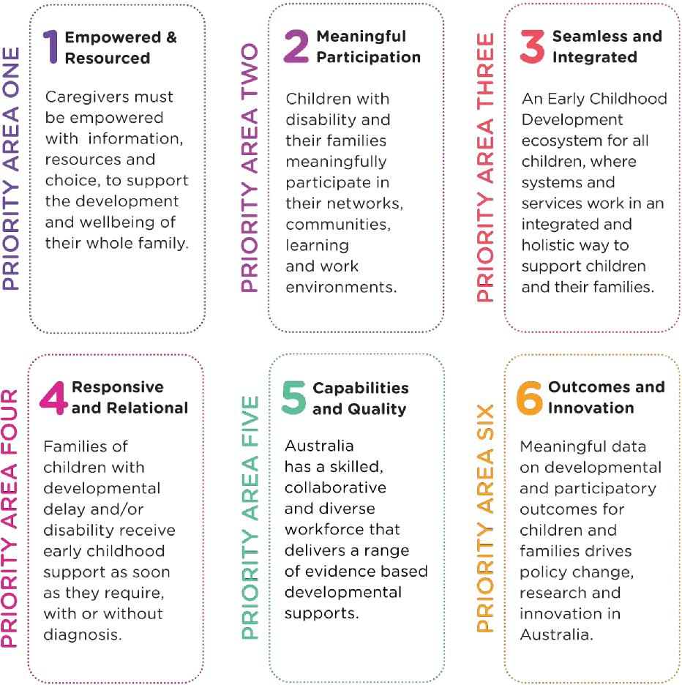

The Reimagine Early Childhood Action Plan to 2030 makes recommendations for a 10-year pathway for governments, communities and the sector to optimise service system efficacy, realise social and economic benefits for the nation and, importantly, better support families of children with additional needs to participate meaningfully in society.

13

Reimagine Australia

Attachment B

**Case Study - Charlie**

Charlie is a bright and vibrant 9 year old girl who has sensory needs and does not have a diagnosis. Charlie experiences heightened sensory discomfort, which includes constant itching and a burning sensation, when wearing socks, tights and/or enclosed shoes. In her life outside of school, Charlie does not wear socks, tights or enclosed shoes.

Charlie is in Year 4, and every morning since Kindergarten she and her family have battled the 30 minute ritual of putting her socks and shoes on in the most precise way, so as to cause her the least discomfort. Despite being minimised, the sense of discomfort remains a distraction to Charlie throughout her school day.

Charlie’s school has a strict uniform code, and all students must wear socks that can only be purchased through the school uniform shop. This year the China-based supplier of the school socks has supplied incorrectly sized socks. The result was that the smallest size of the girls’ formal school socks are so large that they would comfortably fit a high school student. Charlie is very small for her age and the formal socks are enormous on her, sitting all the way up to her knees, rather than just above ankle height.

COVID-19 has interrupted the fresh supply of socks to the school, with the supplier advising that they are unable to supply correctly sized socks until Term One of 2021.

Charlie’s parents, in witnessing her increasing distress and ongoing discomfort, reach out to school staff to ask if an adjustment could be made for her, such as allowing her to wear the school sports socks in place of the formal socks, and to do so without receiving a demerit for being “out of uniform”.

The appeal for adjustment was met with a request from the school for a formal diagnosis, even though Charlie’s parents had advised the school that they did not wish to seek a diagnosis for their daughter as they felt the label would likely be more disabling for Charlie than her sensory discomfort was.

14

Reimagine Australia

The school then instructed the manager of the uniform shop to call Charlie’s parents about the socks. This conversation culminated in a request from the manager for Charlie to attend the uniform shop wearing the socks so she could see for herself, despite being told that wearing the socks would cause Charlie emotional distress and physical discomfort. Charlie’s parents felt that their testimony wasn’t valued by the school, and that socks themselves were a higher priority to the school than their daughter’s well­being and ability to thrive in her school environment.

In desperation, Charlie’s parents wrote to the School Principal to outline the three weeks of communications they had with the school over the request for an adjustment, without resolution. During this period, Charlie had been attending school wearing her sports socks and had received several demerits for being out of uniform, which was adding to her emotional distress.

With the matter raised to the level of School Principal, 4 weeks after the initial request to the school for an adjustment Charlie was granted permission to wear sports socks to school in place of the formal socks.

Despite Charlie’s parents possessing excellent advocacy skills in seeking what they thought would be a very straight forward adjustment for their child, they felt extremely challenged and frustrated by the way the school responded.

Reimagine Australia believes the medical model of disability, which the standards currently align with, inadvertently results in limitations to the response and support for all children in the education system that have diverse needs.

Charlie’s example of a child with sensory needs who does not have a diagnosis and who is denied reasonable adjustments on the basis that she does not have a diagnosis, has been mapped in the table on the next page to succinctly illustrate how the medical model of disability differs in approach and potential outcomes to the social model of disability.

15

Reimagine Australia

**Table: Medical Model vs Social Model of Disability for Charlie**

|  |  |
| --- | --- |
| **Medical model thinking**  **“Disability is the problem located in the individual”**  Charlie needs a diagnosis as she is the problem | **Social model thinking**  **“Disability as a social construct located not in the individual but in the environmental barriers and discriminatory practices of society”**  The school does not have adequate supports and understanding to alleviate environmental factors that are disabling for Charlie. |
| **Child is faulty**  Charlie is the problem | **Child is valued**  Charlie is a valued member of our school community and we want to ensure the environment is enabling for her to thrive. |
| **Diagnosis from a professional**  We believe that professionals and labels will prove that Charlie is disabled and has a problem. | **Strength and Needs identified by self and parents**  We trust the voice of Charlie and her parents who know her best and we are responsive to her individual needs. We do not need 'expert' advice on how to respond to what support she requires to feel like she can learn and grow here. |
| **Labelling**  Charlie needs a label so we can then justify the adjustments that 'do not fit with our business as usual' | **Identify barriers and develop solutions**  Let's work together with the needs Charlie has today so that the environment can support her and other children. |
| **Impairments becomes focus of attention**  Charlie needs a diagnosis | **Outcome based program design**  Charlie has needs that require an outcome for her so she can learn and thrive at school, let's work together to make this happen as soon as possible. |
| **Assessment, monitoring, programs of therapy imposed**  Charlie needs a diagnosis, an assessment and an expert and therapy to fit the mould of the school, that all children have to fit in to. | **Resources are made available universally to all**  Let's support Charlie and see if any other children are feeling this way with sensory needs. |
| **Segregation and alternative services**  Charlie is to report to the uniform officer and is punished with a demerit for her different needs. | **Training for parents and professionals**  What training and professional development does the school staff require to support Charlie's needs. |
| **Ordinary needs put on hold**  No compassionate response to her actual needs with focus on her not complying. | **Relationships nurtured**  How can we build a relationship and trust with Charlie, so she is able to express her needs and reach an outcome? |
| **Re-entry if normal enough or permanent exclusion**  Demerits for Charlie until she is suspended or until she 'follows the rules like all the 'normal' & 'good' kids' | **Diversity welcomed Child is included**  Charlie has gifts that are to be celebrated and needs that require support to ensure she belongs and is thriving at our school. |
| **Society remains unchanged**  School system churns out compliant, cookie cutter children and we continue to see declining outcomes for children in Australia. | **Society evolves**  Our society evolves from diverse children of today who are diverse leaders of tomorrow and all people grow up feeling they belong and are celebrated for their individual gifts. |

16

Reimagine Australia

PAGE INTENTIONALLY LEFT BLANK

17

Reimagine Australia



[www.re-imagine.com.au](http://www.re-imagine.com.au)

l