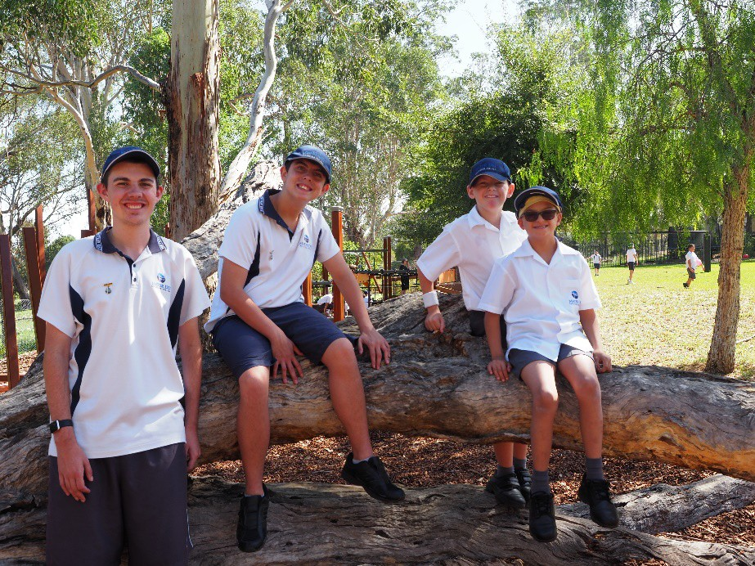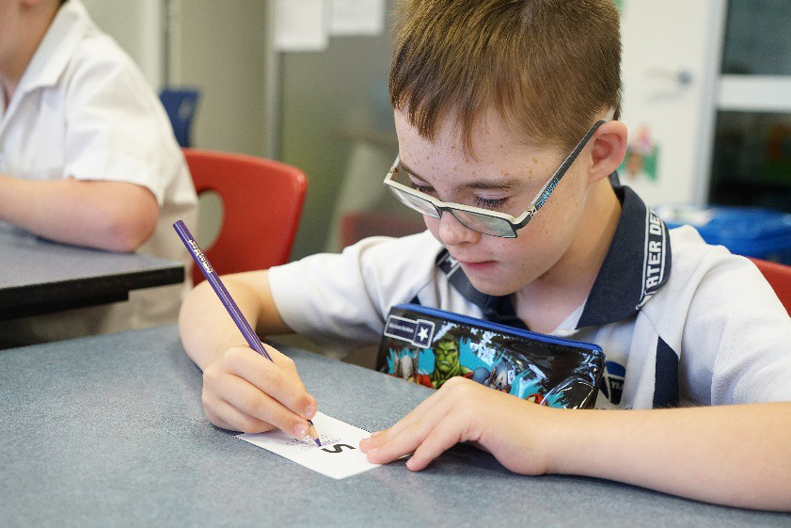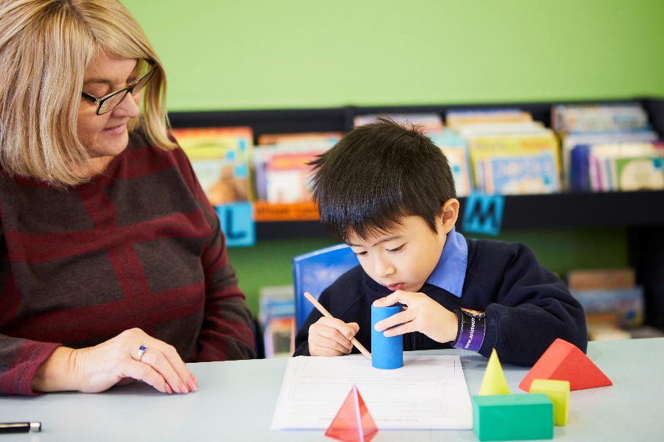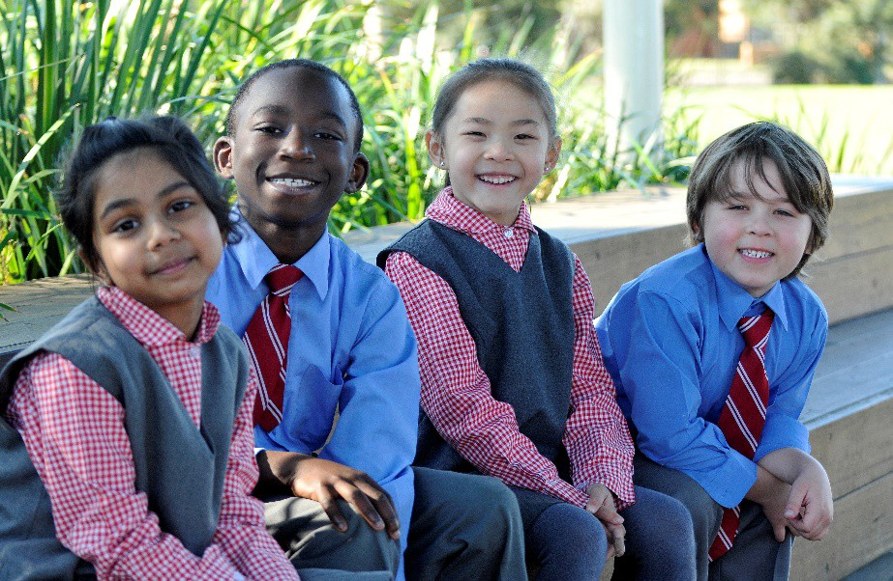

Catholic Schools NSW

Submission

# 2020 Review of the Disability Standards for Education

September 2020

Table of Contents

2020 Review of the Disability Standards for Education 3

Catholic Schools NSW 3

CSNSW Submission 3

Are the DSE making a positive difference? 3

Recommendations 4

Enhancing and expanding DSE support materials 5

Implementing the DSE 5

Funding for Students with Disability 7

The Importance of Early Learning and Learning Transitions 7

Aboriginal and Torres Strait Islander Students with a Disability 8

What should be done to improve awareness of the DSE? 9

Supporting schools through professional learning 9

2020 Review of the Disability Standards for Education

## Catholic Schools NSW

1. Catholic Schools NSW (CSNSW) is the representative body for Catholic schools and systems in NSW, providing expert policy advice, fostering collaboration and advocating on their behalf. CSNSW is also the approved system authority for funding purposes and ensures compliance with respect to both the Commonwealth and NSW Education Acts.
2. Catholic schools have been an integral part of Australia’s education landscape for 200 years. Today, Catholic schools educate one in five children. There are 598 Catholic schools in NSW, which employ 30,000 staff and enrol 258,000 students across Kindergarten to Year 12, including 43,842 students with disability. Catholic education is broader than just its schools and covers the continuum of learning with its Catholic early learning centres, Out-of-School- Hours Care facilities and Catholic tertiary institutions, including two universities.
3. CSNSW supports an inclusive approach to providing education services to students with additional needs, ensuring that learning pathways for all students enable them to progress through their education to become members of a community where their contribution is both valued and welcomed.

## CSNSW Submission

1. CSNSW welcomes the opportunity to make this submission to the 2020 Review of the Disability Standards for Education (DSE). This written submission is complemented by a number of video links, which highlight how the DSE are making a positive difference and point to opportunities for improvement.
2. This submission is informed by feedback from diocesan Catholic school systems, members of the Federation of Religious Institute and Ministerial PJP School Authorities NSW/ACT (Catholic ‘independent’ schools), and the Council of Catholic School Parents NSW/ACT. CSNSW notes that some of these bodies may also choose to provide their own submission to the review. The CSNSW submission also supports the key themes of the National Catholic Education Commission submission to the review.
3. CSNSW (formerly Catholic Education Commission NSW) also participated in the two previous reviews of the DSE in 2010–11 and 2015.

## Are the DSE making a positive difference?

1. The DSE are a sound framework for students with disability to access education and training opportunities on the same basis as students without disability. By raising the expectations of students, their families and the wider community in relation to making reasonable adjustments, the DSE have made school leaders and teachers more accountable in ensuring participation is available to all students on the same basis. There is also a growing awareness of the many barriers students with a disability may experience and a desire to remove such barriers to ensure equity across all school community experiences.
2. The DSE provide an opportunity for educators to firstly examine the quality of their instruction and adjustments provided for the student to achieve success in outcomes, before relying on success criteria linked to measures of the student’s own deficits or incapability. Some

examples of how the DSE are making a positive difference can be seen in the following videos from the Catholic Education Office, Diocese of Armidale: [Grace’s story,](https://youtu.be/8nA24IH8qDw) [Clementine’s story,](https://youtu.be/880xJqJbtKQ) [Charlie’s story](https://youtu.be/3qj1IIce8YY) and the [story of Chelsea and Maeve](https://youtu.be/4GSU6NqpqOI).

1. When accessed by students with disabilities and their families, the DSE also provides guidance to parents around each educational setting’s obligation to provide reasonable adjustments and can be an important advocacy tool. An example of how this works in practice, in collaboration with educators, can be seen in the following video from Catholic Education, Diocese of Parramatta [here.](https://youtu.be/fXhf9_B0lmY)
2. However, there are opportunities to further improve the awareness and implementation of the DSE. Moreover, while the DSE currently apply to preschools and kindergartens, they should also apply to other early learning contexts, such as childcare providers.

## Recommendations

1. CSNSW recommends the Commonwealth Government:
   * Enhance and expand the existing suite of resources so that they are accessible to a wider audience and easier to understand, support early career teachers, target wellbeing and mental health, and address the complexity of behavioural disorders.
   * Develop further support materials for implementing the DSE that clarify key terms, support the consultation process, assist schools with managing complex disorders and provide the option of an online decision tree.
   * Create a new, dedicated DSE website where all these resources and support materials can be accessible to different users (parents, educators, school leaders) and categorized according to different contexts (including schools in rural and remote areas, and transitions from early learning into school or from secondary school to post-school options).
   * Apply the DSE across all early learning settings—childcare, preschool and formal schooling—so that the DSE become a more consistent framework across the continuum of learning.
   * Acknowledge the importance of transitions for students with disability at different points on the learning continuum: from early childhood to school, from primary from secondary, from Stage 5 to Stage 6, and from secondary to VET and other post-school options.
   * Explore options to improve the access to and cultural appropriateness of services for Aboriginal and Torres Strait Islander students with disability. This should include improving the cultural competency of educators and school leaders so that they can develop a deeper understanding of their Aboriginal and Torres Strait Islander students and how disability adds to complexity of the challenges some of these students face.
   * Play a role in raising community awareness of DSE through the new DSE website recommended above and through effective use of social media channels.
   * Support the ongoing and targeted professional learning of teachers and school leaders through a more coordinated and strategic approach to DSE professional learning, beginning with university teacher education. The approach should also consider various aspects of professional learning, including how best practice can be embedded, the role of external mentors and how the learning can respond to specific DSE contexts.

## Enhancing and expanding DSE support materials

1. While a range of DSE support materials have been developed in response to the two previous reviews of the DSE, including fact sheets and exemplars of practice, these resources could be further enhanced.
2. Parents and students would benefit from resources that are easier to understand and available in languages other than English, including Aboriginal English and other Aboriginal languages. The online practical guide to the DSE is a good start but is difficult to navigate because it is a suite of resources spread across numerous webpages. Families and communities would benefit from a single document in plain language that introduces them to the key elements of the DSE.
3. Expanding the limited audiovisual resources currently available, including by making them available in languages other than English and making hard copies available for families without access to the internet, would make them more accessible for families and the community.
4. Similarly, a targeted suite of resources for new or early career teachers would foster a greater cultural sensitivity around disability and cultivate a better awareness of the DSE.
5. The summer bushfires and COVID-19 have created an extraordinary set of circumstances for our schools to navigate. Catholic schools have found new and innovative ways to respond to these challenges, however, such events also pose significant challenges, especially when students have complex needs. While technology can assist schools to be agile and overcome these unprecedented events, schools would benefit from DSE support materials that assist with responding to pandemics and natural disasters. The Royal Commission into Violence, Abuse, Neglect and Exploitation of People with Disability’s *Statement of Concern* has a particular focus on how emergency planning and response should be highlighted across all areas of society, including education. A particular focus within the DSE support materials regarding wellbeing and mental health, as well as online digital literacy skills, should be a priority.
6. Another set of resources that develop a deeper level of understanding of the significant growth of behavioural disorders in children would be valuable. These resources would help staff recognise when the behaviour is a manifestation of a disability. These resources could include culturally appropriate information relating to behaviours associated with trauma, which is also often misdiagnosed due to lack of understanding.

## Implementing the DSE

1. While the DSE provide a good framework for supporting educational access and participation, the practical implications of implementing the DSE within a school setting are significant. Whether it is interpreting and applying the DSE, gathering evidence and data, meeting the needs of students with appropriate adjustments, liaising with support services, complying with reporting requirements—many more examples could be given—the work schools do to make the DSE a reality in the lives of students is multifaceted and overwhelming. A more sustainable model to assist schools in implementing the DSE effectively, while overseeing all aspects of the delivery of meaningful and inclusive learning, would be a significant benefit to schools.
2. While the general understanding of terms such as ‘consultation’, ‘unjustifiable hardship’,

‘reasonable adjustment’ and ‘on the same basis as’ is improving, especially given the current set of resources to support the DSE, there is still some uncertainty around the interpretation and application of these terms. Further practical examples to support consistent interpretation and application—what do they mean and what do they look like in practice— would be helpful.

1. School authorities are required to navigate their way through the provisions of the DDA and DSE, assessing a range of competing factors and then making adjustment judgements. The difficulty of this task is particularly acute when the disability manifests itself in a student exhibiting behaviour that requires special management. For example, from time to time, a school will enroll a child who has significant behavioural issues that result in the child harming themselves or other students, and sometimes, staff. If these actions arise out of a neurological or psychological disability, the school will have certain obligations under the Disability Discrimination Act and Disability Standards for Education. However, the school also has obligations to staff and students under Workplace Health and Safety legislation and under its general legal obligation under Common and Statute law to exercise a duty of care. In addition, in NSW, special obligations to manage students who pose a risk of violence by reason of their behavior arise under Part 5A of the NSW Education Act. School decision makers may also be required to take regard of adjustment advice provided by parents and/or allied health specialists. These overlying pieces of legislation and multiple considerations often means that all parties involved can find themselves participating in a complex decision-making matrix.
2. An online decision tree, conceptually similar to the NSW Mandatory Reporter Guide decision tree, would be a valuable resource that could help practitioners interpret the DSE and map their application. This tool would enable schools to assess in advance their response and consider all available options while ensuring they meet DSE requirements. It could also point to how the DSE intersect with other legislative obligations and national standards.
3. An improved understanding of key DSE terms would be particularly helpful during the consultation process, which is not always well understood by all the key stakeholders and is an important step in determining the adjustment. The DSE fact sheet on ‘Effective Consultation’ is a good start, but the general principles in this resource could be unpacked for each of the stakeholders and the roles they play in the consultation process.
4. Given an important element of the DSE is assisting students with disability to participate in education on the same basis as students without a disability, schools would benefit from resources that build the independence of students with a disability and pave the way to post- school study, training or other endeavours. While there are some resources available, they are not readily accessible. If these resources were available on a dedicated DSE website (as this submission recommends below at 43–44), then it would be easier for parents and students to access them and plan transitions to adulthood and post-school life.
5. While the consultation process often includes medical reports that describe the disability of the student, the complexities arising from a disability in a school context, particularly in the social, emotional and sensory categories, are not always apparent to teachers and school leaders. Autism Spectrum Disorder, Fetal Alcohol Spectrum Disorder, Obsessive Compulsive Disorder and Attention Deficit Disorder might be defined in a medical report, but how each of these unfolds in an educational setting, together with a range of complex comorbidities, requires a nuanced approach from teachers, counsellors and school leaders. Schools would benefit from evidence-based material that sheds light on the educational implications of specific disorders, helping them navigate the complexities of these disorders.
6. The DSE note that disability can include a disorder or malfunction that results in the person learning differently from a person without the disorder or malfunction. However, there are occasions when ambiguity over what constitutes a disability that affects learning might arise. For example, a student with a cultural or linguistic barrier to learning may also struggle with their intellectual ability. While schools strive to differentiate between a learning difficulty and an intellectual disability, they would benefit from greater clarity around what constitutes a disorder or malfunction under the DSE, as opposed to a complex need or an array of needs.
7. Applying the DSE and making reasonable adjustments is particularly challenging in rural and remote areas. In these settings, waiting times for—and access to—specialist assessment and support services for students with disabilities are far longer than those in the Sydney metropolitan area. The lack of early intervention and difficulties ensuring ongoing therapy during school often leads to Catholic schools pursuing these services for the student, shouldering responsibility both logistically and financially of ongoing health support in schools. Indeed, the very definition of ‘reasonable adjustment’ is more complex in rural and remote areas. Examples that show what ‘reasonable adjustments’ in rural and remote communities might look like and how they can be achieved would be particularly helpful for schools in these settings. These resources should be readily accessible and include examples of best practice for teachers and school leaders.
8. Catholic schools in the Diocese of Wagga Wagga, for example, use Royal Far West, which is a telehealth service that supports students in remote areas where access to allied health is difficult to access and which schools often struggle to provide in-house. Students engage very well with this service through Zoom, accessing speech pathology, occupational therapy and psychology services.

## Funding for Students with Disability

1. While this submission acknowledges that the 2020 review of the DSE does not intend to canvass the issue of funding for students with disability, it is important to emphasise that funding plays a significant role in the educational access and participation of a student with disability on the same basis as a student without disability. This is particularly the case if substantial or extensive adjustments are made, or where other barriers to equity may also be present, as might be the case with, for example, an Aboriginal student with disability, a student with disability from a low socioeconomic background, or a student with disability in a rural or remote part of NSW.

## The Importance of Early Learning and Learning Transitions

1. Children with additional needs benefit greatly from attending quality early learning services that support and enhance their learning, skills, experiences and development. Research has shown that quality early learning has profound personal, social and economic benefits. As Professor James J. Heckman has shown, investing time and resources in children’s early learning leads to lifelong benefits for them and the whole community (see [here](https://heckmanequation.org/resource/invest-in-early-childhood-development-reduce-deficits-strengthen-the-economy/)). Moreover, the Australian Government [Early Years Learning Framework](https://docs.education.gov.au/node/2632) calls on all children to be active participants in their learning.
2. Childcare services are increasingly offering preschool programs for children. Currently preschools are obliged to implement the DSE. However, childcare services only have

obligations under the *Disability Discrimination Act 1992* (Cth).

1. Childcare services represent a crucial stage in the learning of all children. They are an entry point for developing friendships and creating a sense of legitimate participation in education. Applying the DSE across all early learning settings—childcare, preschool and formal schooling—creates a more consistent and robust framework that acknowledges the continuum of learning.
2. This notion of a continuum of learning should be underpinned by successful learning transitions that happen through a collaborative approach between various stakeholders. While this process can be a smooth and positive one for some children, families of children with a disability require additional thought, time and planning to ensure the transition is successful. The childcare service plays an important role in facilitating this transition.
3. A well facilitated transition to school happens in partnership with the child’s family. Planning should be timely, transparent and clear. This contributes to successful child-centred outcomes, especially for children with disability.
4. However, the transition in the early stage of a child’s learning journey is by no means the only transition that matters. Transitions for students with disability are important at all points across the learning continuum: from early childhood to school, from primary from secondary, from Stage 5 to Stage 6, and from secondary to VET and other post-school options.
5. One of our Catholic school parents highlighted how her advocacy improved the transition process for students with disability from Stage 5 to Stage 6. As part of this transition, it is important for schools, parents and students to work together in applying for any special examination provisions that might be appropriate.

## Aboriginal and Torres Strait Islander Students with a Disability

1. While Aboriginal and Torres Strait Islander people have higher rates of disability than non- Indigenous people across all age groups, they access disability services at a lower rate. There needs to be a greater focus on how to best support Aboriginal and Torres Strait Islander families and communities to access these services.
2. To some extent, Indigenous perceptions of disability can be a barrier to accessing disability services. As noted in the Australian Human Rights Commission *Social Justice and Native Title Report 2015* (p. 109), there is no equivalent word for ‘disability’ in many Aboriginal and Torres Strait Islander languages and this absence of the very concept of disability in Indigenous thought results in underreporting of disability and underutilisation of disability services.
3. There is more to be learnt and more support required before these barriers can be removed. Culturally appropriate services for Aboriginal and Torres Strait Islander students with a disability require a combination of supports and processes to be in place within a school community.
4. Deepening cultural competency in understanding Aboriginal and Torres Strait Islander students—the language, culture and protocols—gives teachers an understanding of their students and how disability adds to the complexity of the challenges some of these students face. There is an opportunity for qualitative data collated from the perspective of Aboriginal students with disability to inform the DSE regarding issues preventing full participation and how to remove cultural barriers. Culturally appropriate resources supporting the DSE could

see the cultural identity of a student disability become a vehicle for improving learning capacity by creating a sense of belonging.

1. The Aboriginal Education Consultative Group model is also an option worth exploring to support collaboration between teachers, elders, community members to understand the needs of Aboriginal students with disability within their own local communities, listen to their voices to both advocate for their needs and understand their needs from their cultural perspective.
2. An Aboriginal Education Worker plays an important role in supporting the access to, and participation in, schooling of an Aboriginal student with a disability. Often the Aboriginal Education Worker becomes the spokesperson for families that may find it hard to express their expectations or may not even be aware of the DSE. Language barriers may occur when talking about adjustments and technical jargon can be difficult to understand. They can also assist in ensuring collaborative planning processes with families are culturally sensitive, appropriate and effectively meet the needs of these students.

## What should be done to improve awareness of the DSE?

1. Improving awareness of the DSE for parents, teachers and school leaders is an important step in the process that leads to students with disability accessing and participating in education on the same basis as students without disability.
2. While there are some resources already available on the Commonwealth Department of Education website and in the NCCD national portal, a dedicated website for the DSE could gather all these resources—and any new resources—into a single, purpose-built hub. In a similar way to how, for example, the Australian Government eSafety Commissioner website functions, the DSE website landing page could categorise resources according to the user, offering portals that lead to dedicated resources for parents, educators and school leaders.
3. There could also be sections of the website with dedicated resources for a range of users and settings, including:
   * schools in rural and remote areas (or other relevant contexts);
   * schools/parents supporting Aboriginal and Torres Strait Islander students with disability;
   * parents/students (whose child is) transitioning from early childhood into school or from secondary school to post-school options.
4. The Commonwealth Government can also play a role in raising community awareness of DSE. While advertising and promoting the standards through television or radio has cost implications, social media channels are excellent tools for raising community awareness of the DSE and starting conversations that provoke further inquiry into and learning about the DSE.

## Supporting schools through professional learning

1. Related to awareness of the DSE is the ongoing and targeted professional learning of teachers and school leaders. Beyond the government resources that support the implementation of the DSE and the learning modules that Catholic school systems might provide to teachers and school leaders, there is an opportunity to develop a more coordinated and strategic approach to DSE professional learning. This should begin with university teacher education that

prepares graduates to teach students with disability and continue with ongoing professional learning that incorporates best practice and responds to specific DSE contexts. It should also include improved DSE collaboration and professional learning between school communities so that schools learn from each other. As part of this strategic approach, there is an opportunity for the new National Evidence Institute, in collaboration with tertiary institutions, to embed DSE best practice in teacher education and professional learning.

1. Even a teacher or school leader who might be familiar with the DSE and confident in how they are applied would benefit from the kind of professional learning that enhances their expertise and/or improves early identification of student need. This could also enable them to play a role as a leader or mentor in the application of the DSE, both within their school and as a critical friend for other schools. In a similar fashion to Highly Accomplished and Lead Teachers, there could be an opportunity for teachers to become Leaders of Diversity. However, this expertise would need to be recognised and credentialed.
2. While teachers and school leaders would benefit from ongoing and targeted professional learning which they can access from a learning institute external to the school, much of the professional learning should be *in situ* and respond to the local context of the school community.

Catholic Schools NSW

02 9287 1555

PO Box 20768

World Square NSW 2002

Level 10, Polding Centre 133 Liverpool Street Sydney

[www.csnsw.catholic.edu.au](http://www.csnsw.catholic.edu.au/)