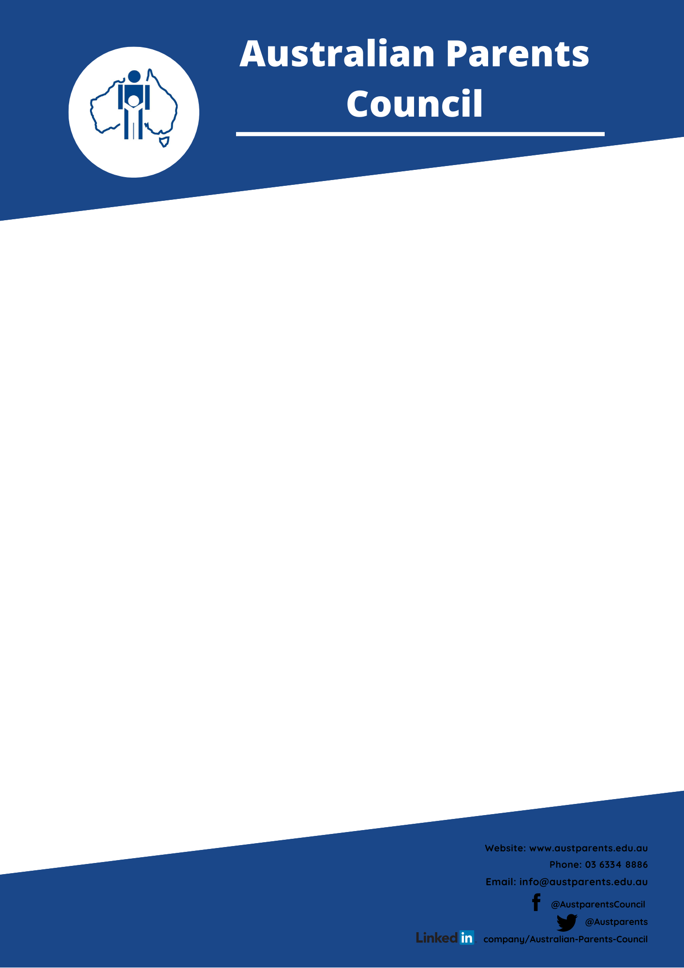

**Submission to the 2020 Review on the Disability Standards 2005.**

**The Australian Parents Council thanks the panel for the opportunity to participate in this review and puts forth the following perspectives.**

* **Parents and carers are a student’s lifelong advocate for accessing their education however they are not referred to at all in the standards. Parents and carers are the link between medical and educational information. The role parents play needs to be formally recognised, promoted and protected, and a communication framework established.**
* **A transition to include strength-based adjustments rather than a focus on meeting deficits. Disability Standards should promote children reaching their potential.**
* **A framework for best practise be established to guide schools on the best ways to allows students with additional needs to access their education, and how to collaborate and communicate with parents and carers to ensure this happens.**
* **The importance of adaption of provisions to cultural background and family circumstances of each child needs to be formally recognised, promoted and protected. No child is an island.**

The Australian Parents Council has provided parents and governments with a trustworthy voice in education policy for over 55 years. We are a non-denominational, non-party political organisation that advocates for parents with children in non-government schools (Catholic and Independent) and for Australian parents more generally. We are an independent, diverse and inclusive organisation of parents from all states and territories of Australia. Our interests and activities extend down to early learning and up to post-school transitions.

The work of the Australian Parents Council over many years, and of Parents Australia Incorporated more recently, has contributed to the improvement of children’s educational experiences and outcomes, progressive reforms in schooling, and building the social capital of school communities throughout Australia.

We welcome this opportunity to contribute our views on the review into Disability Standards from the parent perspective.

Kind regards,  
Jennifer Rickard   
Chair, Australian Parents Council

1. **Enrolment and access: What has been your experience when accessing education? What was the process like to enrol in school or other education and were you happy with the outcome?**

Whilst the school’s enrolment process is fine, we are hearing that parents are still fearful that their application will be rejected because of their child additional needs and the school saying they do not have the ability to support them. This may result in parents understating their child’s disability and need during the process. This says to us that parents still do not have full awareness of the standards and their rights when enrolling their child into a non-government school.

1. **Participation: Has your education provider/s made reasonable adjustments to ensure you or your child can participate in education? This includes participating in courses and programs, the curriculum, and using facilities. How did your education provider consult with you? Were you happy with the outcome?**

This is perhaps the area of greatest concern for parents. The formal process to discuss reasonable adjustments is different not only across states and sectors but also school to school. The biggest concern for parents is that schools often take a deficit approach to considering reasonable adjustments. That is, they are making reasonable adjustments for the student’s weaknesses rather than working to address a student’s strengths and enable them to reach their full potential. An example is the Individual Learning Plan, which may address reasonable adjustments for behavioural deficiencies (sensory time out), but not address the student’s strengths and build their capacity in the education setting (capitalise on an area of special interest). We would argue that by taking the strength-based approach you may in part negate the need to have reasonable adjustments for the behavioural issue.

Consultation is another area of concerns for many parents. Schools are busy places and often the need to meet with parents to discuss learning adjustments, goals and plans can get lost or be tokenistic. Authentic engagement where parents have an equal say in what strengths need to be addressed would be welcomed.

Finally, documents used to record and measure the adjustments are often filled with education jargon that are difficult for many parents to comprehend. Teachers and administrators should be mindful of communicating adjustments in a language that is easily understandable not only for the student but also the parents/carers.

1. **Harassment or victimisation: If you or your child experienced harassment or victimisation in an education setting, what happened? What steps did your / their education provider take to address this?**

There is evidence that this can occur, although it would be the exception rather than the rule. But Families who have experienced victimisation face further difficulties accessing a pathway to resolution. A fully mapped process for complaints resolution would be beneficial, starting from internal school contact to escalation points and where advocacy services exist to support families and students.

1. **Compliance: If you considered that an education provider was not meeting their obligations, how was it dealt with? Did you know how to make a complaint? What happened?**

This is a particular area of difficulty for parents with students in the Independent school sector. Schools are accountable to themselves and their governing board. When compliance issues arise, for example not following their published compliant procedure, there are few options for compliance checks beyond legal options, which are expensive for families, or contacting the Human Rights Commission, which can be overwhelming for families. Parents value and treasure the independence of their schools but accessing fair and just compliance measures can be difficult.

1. **Transition: Tell us about your or your child’s experience in accessing education opportunities and being supported as they transitioned from one education sector to another e.g. from school to further education.**

Parents tell us that transitioning can be difficult, not just between institutions but also from year to year within the same school. Information sharing does not seem to be a priority in some schools making transition difficult. Often parents are relied upon to pass along vital information, which requires them repeating themselves over and over. Parents also find themselves in the role of having to educate and inform teachers of not only their child’s disability, but also the usual adjustments. Parents often tell us there is little connectivity between education institutions and enrolling at a new school means starting the process from scratch. Even if files have been sent in advance, they are often not thoroughly understood before the child enrols.

1. **Aboriginal and Torres Strait Islander students with disability: Tell us about your or your child’s experiences accessing and participating in education.**

APC is concerned about instances where there is a lack of engagement between Aboriginal and Torres Strait Islander families, parents and carers and schools that is culturally approriate. There are many instances of schools successfully reaching out to Aboriginal and Torres Strait Islander families, parents and carers, via community groups, community sessions, and informal meetings that have led to positive engagement. To engage families, parents and carers, there should be an emphasis on actively ‘reaching out’ and not just passively ‘inviting in’, and best practice needs to be better highlighted and supported .A lack of access to extra equipment and technology at home has also been highlighted as a problem.

1. **COVID-19: Has COVID-19 impacted your or your child’s experience in participating in education? Have your experiences ever been impacted by other major events, such as natural disasters?**

We have heard from parents that Covid-19 has certainly had an impact, both positively and negatively. Some students have previously fought to have access to assistance technology and been denied because it was perceived to disadvantage other students. The pandemic has seen a rapid expansion into using technology for education and has allowed students to use these technologies more widely, and often we are hearing it has been to the betterment of the whole student body. We have also heard from a range of parents with children with diverse additional needs that the remote learning model has benefited their child and they have been given the opportunity to access their education free of bullying, anxiety and have found the experience to be much more inclusive. Adversely it must be mentioned that the pandemic has had a huge impact upon the mental health of many students and the impact of student enrolling into further study options remains to be seen. In addition, we have heard that many students with additional needs have struggled to adapt to remote learning and have not been able to engage with online education. No child should be left behind in remote learning. Most importantly, the Standards need to be updated so that there are contingency plans for remote learning in students Individual Learning Plans, and a recognition of the need and right of students to access extra teaching resources in extraordinary circumstances.