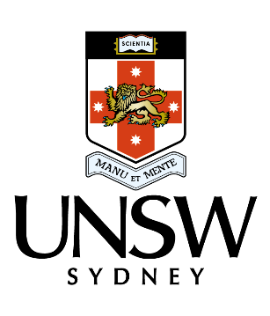

31 August 2017

Emeritus Professor John Halsey

Chair, Independent Review into Regional, Rural and Remote Education

[IRRRRESecretariat@education.gov.au](http://rcs.med.unsw.edu.au/rcs-coffs-harbour-campus)

# UNSW Submission To The Independent Review Into Regional, Rural And Remote Education

UNSW, Sydney welcomes the opportunity to make a submission to this important review and to provide comment in response to the Discussion Paper.

We applaud and support the objectives of the government and this review, to support improved access and achievement of students in regional, rural and remote Australia and their transition to further study, training and employment.

UNSW has a longstanding commitment to improving outcomes in regional, rural and remote Australia through our education, research and community engagement. The extent of that broad engagement is outlined in the attached report *UNSW Australia Meeting the Needs of Regional Australia*.

## UNSW’s impact on education for regional, rural and remote Australia

The extent of UNSW’s education programs and impact from pre-school to post graduate education, is outlined in Attachment 1 to this submission, but in summary, it includes:

* Students and alumni - over 2,900 regional/rural students are enrolled at UNSW and over 53,000 UNSW alumni are working across regional Australia;
* Support for UNSW regional students - through scholarships, accommodation and pathway programs;
* Health disciplines education – UNSW has an expansive Rural Medical School, with five campuses across regional NSW (Port Macquarie, Albury, Coffs Harbour, Griffith and Wagga Wagga) as well as sub campuses at Grafton and Kempsey. Student clinical placements occur at over 70 regional NSW locations. UNSW is the first university to offer a full six-year medical degree located in a regional area (Port Macquarie). In addition, our programs in social work, optometry, psychology, and physiotherapy include regional and rural clinical placements and employment outcomes.
* Teacher education and research – UNSW’s School of Education trains teachers of the future and undertakes research relevant to improving outcomes for regional education.
* Our ASPIRE Regional program - an educational outreach program working with teachers and students from Kindergarten to Year 12 - in thirty schools across regional NSW. It has over 6900 engagements with students each year through workshops, residentials, homework clubs, literacy support, other events and online resources. Evaluations by students, parents, and teachers reveal significant impact. The number of ASPIRE students offered a place at UNSW has increased by 65% (2010-2016) while many other participants have enrolled in other universities.
* The UNSW Indigenous programs including Winter School, road shows, pre-university preparation and pathways have also been very successful in increasing regional participation.
* Research – UNSW undertakes extensive research addressing major issues affecting regional Australia – rural health issues, water, photovoltaics and renewable energy, fruit fly eradication, agricultural waste, algal blooms, technology innovations for farming. These research connections also contribute to educational aspiration and outcomes.
* Regional Alliance – UNSW has entered an alliance, with the University of Newcastle, and University of Wollongong - NUW - aimed at improving outcomes across our significant regions.
* UNSW regional community engagement – UNSW has a range of programs that engage broadly and deeply with regional communities. One example is a long-standing engagement with Walgett. UNSW is working to expand that partnership with Dharriwaa Elders and community to improve educational, employment and other outcomes.

## Some key points and recommendations we would like to make are:

1. Recognise the impact universities have on regional education

UNSW and other universities all make significant contributions to improving educational and employment outcomes for regional, rural and remote Australia.

We believe that this current impact and immense potential is not recognised in the Discussion Paper but should be reflected in the Review report.

* UNSW and other universities have an expansive range of engagement programs we lead, working in collaboration with pre-school, school, VET sector, community and industry which are achieving great outcomes for educational and employment outcomes for regional, rural and remote Australia. These programs are aimed at pre-university to improve educational attainment, aspiration, and awareness of educational options. Other programs are aimed at improving success for regional and remote students while at university and towards graduate outcomes.
* Universities also have extensive influence in future education and teacher skills through our education courses delivering future teachers and principals across the nation.
* Universities also have extensive influence in health education through our medical and other health degrees and programs
* Universities also have an expansive reach in to regional and rural Australia through the presence of some campuses, many sub campuses or sites, clinical and work placement areas for our students and our research sites and endeavours.

The Review team and Commonwealth government can improve education and employment outcomes for regional, rural and remote Australia by engaging with universities and supporting the continuation and expansion of our proven programs and utilising our innovation and research strengths.

1. The Higher Education Participation and Partnership Program (HEPPP) has been a particularly effective and cost-effective program and model for improving outcomes for regional, rural and remote Australia. It should be protected, expanded (from the current $205M p.a.) and include an additional targeted program where funds are used for programs and collaborations aimed at benefitting regional, rural and remote Australia.
2. Indigenous programs - The current Commonwealth funding schemes for university Indigenous programs and support are inadequate to address current student need for outreach, pathways, pastoral and academic support and scholarships.
3. Student financial support - The cost of attending university (travel, accommodation, set up costs, tuition, and cost of living) are barriers to potential and current students from regional, rural and remote Australia. More support is important to address this issue. Current government support, university and philanthropic funded scholarships and schemes are not adequate.
4. Evaluation of programs - The ability to evaluate the effectiveness of programs and the impact on improving regional, rural and remote Australia educational outcomes, would be enhance through the implementation of a unique student identifier number which would apply across pre-school, school, VET sector and university. It is currently almost impossible to track young people involved in university programs which span pre-school onwards, to see the impact in their later access to higher education.
5. Accommodation - The ability of universities to provide affordable student accommodation could be enhanced through a capital works fund; favourable capital loan schemes or the National Rental Affordability Scheme being reinstated and made available to universities. This support could come with a requirement to provide a defined number of places for students from regional, rural and remote Australia.
6. Health programs

* A key area of support for regional health education outcomes is to improve staff specialist positions and training in regional areas, rather than the pipeline of undergraduate places.
* Expansion of the recent Rural Health Hubs program will be important.
* Financial support and funding for support programs is important for regional/rural, Indigenous, and low SES medical and health students.

1. Higher Education funding package – there are a number of elements in the government’s package of reform that will impact negatively on regional students. For this reason UNSW seeks withdrawal of that proposal:

* The overall funding cut of $2.8 billion to university funding nationally, will inevitably lead to a reduction in programs that universities are able to offer in regional schools and communities, as well as the closure of some campuses and sites.
* Changes to the student fees and loan scheme, will act as a particular deterrent to regional students, where there is a stronger aversion to debt and where cost is already a deterrent.
* Changes to the Enabling courses to impose fees, will be a barrier

1. Funded university places – The current demand-driven funding for Commonwealth Supported under graduate places should continue, to ensure that regional students can access university places. If any capped places model is reinstated, then the first students to miss out, will be regional students as those students with higher educational attainment (ATARs) will inevitably be selected first by universities. The uncapped system has enabled the number of regional and remote students to increase by over 30% since 2008. At the very least, there needs to be no cap on the number of regional, rural or remote students who enrol.

**The UNSW contact person relevant to this submission is:**

Name: Professor Eileen Baldry, Deputy Vice Chancellor Inclusion and Diversity

Email: [e.baldry@unsw.edu.au](http://rcs.med.unsw.edu.au/rcs-wagga-wagga-campus)

Phone: (02) 9385 1878

## APPENDIX 1

**UNSW Programs**

**Improving Educational Outcomes In Regional, Rural And Remote Australia**

**ASPIRE (Regional)**

The UNSW ASPIRE program is an award-winning program, which aims to give students from disadvantaged backgrounds a better chance of going to university by:

* creating more awareness about university
* raising student aspirations about their future
* giving students a purpose to stay motivated at school and want to achieve.

The Regional ASPIRE program currently works with 27 partner schools [across regional NSW](http://rcs.med.unsw.edu.au/rcs-griffith-campus), including: 11 central schools,  5 high schools, 11 primary schools:

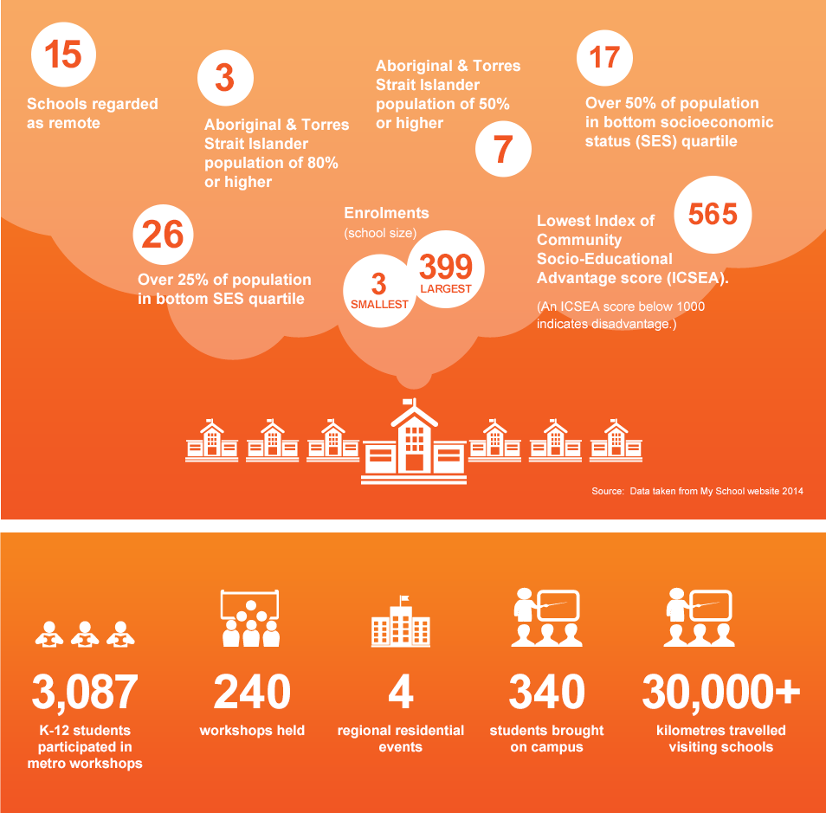

Regional ASPIRE program works with teachers and students from Kindergarten to Year 12 - in 27 schools across regional NSW. It has over 6,900 engagements with students each year through in-school workshops, on campus residentials, homework clubs, literacy support, [Year 9 Taster Day, Dubbo](http://www.aspire.unsw.edu.au/ourwork/regional-aspire/year-9-taster-day-dubbo), [Parent and Carer engagement](mailto:IRRRRESecretariat@education.gov.au), [Academic assistance](http://rcs.med.unsw.edu.au/application-process-1), other events and online resources.

Evaluations by students, parents, and teachers reveal significant impact. The number of ASPIRE students offered a place at UNSW has increased by 65% (2010-2016) while many other participants have enrolled in other universities.

*Regional ASPIRE Reach*

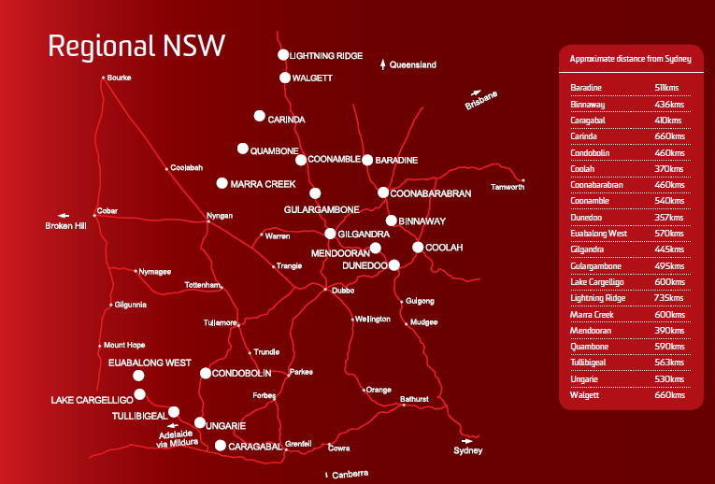

Regional and remote students face unique issues with regard to pursuing higher education. They can miss out on vital resources and information about university because of where they live.  At 17, it’s hard to think about going to university when you are over 500 kilometres from the nearest one.

Some of the educational disadvantages regional ASPIRE students face are:

* Limited or non-existent interaction with universities
* Lack of contact with role models who have degrees
* Low self-esteem and confidence in own academic potential
* Lack of knowledge about the range of courses and universities available
* Distance from university means considerable upheaval to relocate
* Psychological barrier of travelling outside geographic area
* Lack of information about financial support available to assist with university costs
* A misguided belief that ‘people like us’ don’t go to university
* Long term unemployment and transient population
* Poor internet connections restricting access to information
* Hardship and stress caused by extreme conditions, such as long term drought, that have a significant impact on the quality of life within the community, at home and on the family’s livelihood.

Impact

The number of university offers made to students from regional schools has continued to increase, indicating the longitudinal effect of ASPIRE. The increase in offers between 2010 (when Regional ASPIRE began) and 2016 was 65%. In 2010, offers were made to students at 10 ASPIRE schools. In 2016 offers were made to students at 14 ASPIRE schools. 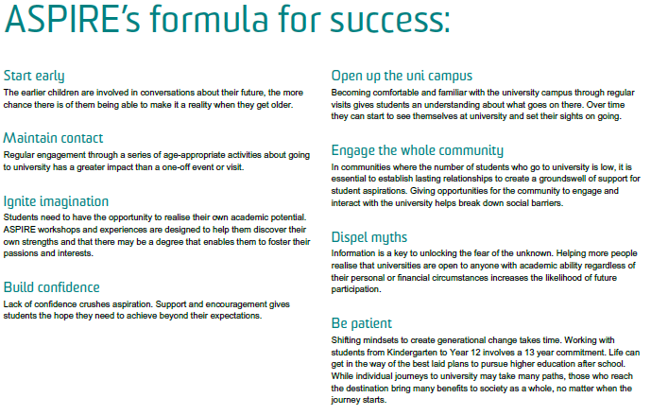

## INDIGENOUS PROGRAMS

UNSW Indigenous students and completions

UNSW has steadily increased our enrolment numbers towards the UNSW target of 500 students. An increase of 7.5% (from 348 to 374) of Indigenous enrolments was experienced from 2015 to 2016

UNSW Indigenous programs which particularly attract regional students include:

| **Program Name** | **Target audience** | **Outline of Program** | **Outcome (2016)** |
| --- | --- | --- | --- |
| Pre-Programs | Indigenous applicants in the areas of Law, Medicine,  Social Work, Business and  Education (Secondary). | Pre-Program is a three to four week intensive program designed for students seeking  admission to undergraduate degrees  or enabling programs. | 53 participants .  42 participants accepted offers to study at UNSW. |
| UNSW Indigenous  Admissions  Scheme. | Indigenous applicants for all Faculties excluding ADFA and Pre-Program cohorts | Flexible entry pathway for students  who may not have acquired the ATAR  or high school education for standard  admission. | 50 offers resulting in 42  acceptances into UNSW  degree programs. |
| Enabling Programs | Law, Arts and Social  Sciences, Science and  Engineering. | One year program for students not  academically ready for admission to  undergraduate studies. | More than 100 students (around 15 p.a..) have enrolled in Nura Gili enabling programs since 2008. |
| UNSW Indigenous  Winter School | Indigenous School students across Australia in years 10, 11 and 12. | Winter School is a 5-6 day tertiary  aspiration program consisting of 11  faculty groups. Students live on  campus and receive a personalised  experience of academic learning in  their areas of interests. | 106 high school students  participated in the program. Approximately 20 % of the UNSW Indigenous cohort had attended Winter School in the past. |
| Nura Gili  Recruitment and  Outreach Program  (School, TAFE,  community visits  and expos). | Potential applicants,  school and TAFE students,  community members. | Roadshows, site visits, expos and  market stalls promoting Nura Gili  programs and university studies. | Communications to  potential students,  communities, and key contacts in schools and TAFEs to maintain and further develop  relationships with key  partners. |
| Nura Gili Student  Ambassador  Program. | Current students and past  students. | To provide students with workplace  transferrable skills in delivering  programs alongside experienced Nura  Gili support staff | Professional Development for UNSW Indigenous students. |

*UNSW Indigenous Pre-Programs*

The UNSW Indigenous Preparatory Programs (Pre-Programs) is a three to four week intensive residential program for Indigenous students and is jointly delivered by Nura Gili and the faculties. The program acts as the admissions pathway for Indigenous entry into undergraduate programs for Business, Law, Medicine, Social Work and Education. The program provides diagnostic information where students are consistently assessed by Faculty and Nura Gili staff over the course of the program on a range of criteria including the ability to participate academically in the discipline area, commitment to study and their attitude and aptitude for university studies. The program runs at no cost to the participants, and all travel, accommodation, meals and study materials are coordinated by Nura Gili. The program is a highly successful transition strategy that allows students to better understand the academic expectations of the disciplines they have chosen to study.

*Enabling Programs*

The UNSW Enabling Programs have been delivered for consecutive years since 2008 and provides Indigenous students with pathways into related undergraduate programs. This program is specifically for students that have potential, but lack the academic skills required. Students usually undertake 2 academic skills courses and 2 courses from their preferred degree program. This allows them to improve their academic skills and attempt to complete degree courses that students undertake for the degree program. Potential students are identified by Nura Gili and UNSW faculty staff during the Pre-Programs exit interviews, or Admissions Scheme interviews.

*UNSW Indigenous Winter School*

Winter School is a program designed to encourage Indigenous students in years 10, 11 and 12 to consider further studies beyond high school. The annual UNSW Winter School was delivered for the 15th consecutive time in 2016 with a total of 106 secondary students from across Australia participating. Historically, the program was sponsored by the UBS Foundation. It is currently funded by Nura Gili and UNSW, while a new sponsor is sought. The week long residential program is designed to provide students with an opportunity to experience university life.

Students are engaged through participation in academic lectures and tutorials, presentations, study sessions, team building activities, cultural activities, interaction with university staff and peer engagement with current students and fellow attendees. The selection process for Winter School focuses on student’s areas of interests and their aptitude toward their school studies as expressed by their school Principal in a supportive reference letter.

Accommodation is provided in the colleges on campus at no cost to students. The program areas offered are Business, Engineering, Medicine, Indigenous Studies, Law, Performing Arts, Visual Arts, Science, Social work and the Built Environment (Architecture, Construction and Design).

An average 20% of participants transition from Winter School in to formal UNSW degree programs. This transition increases to 35% as students near the end of their high school education. The success of the Winter School Program has been consistent for the past 5 years.

Repeat attendance at Winter School across the years, increases the likelihood for participants to study at UNSW. 47% of students who attended more than one Winter School program between the years 2012 - 2016, enrolled in UNSW degrees.

*Nura Gili Recruitment and Outreach Programs*

Nura Gili’s recruitment and outreach programs continues to reach Indigenous communities in regional New South Wales - with more than 50 communities, over 60 schools and nine careers expos. Road trips included Moree, Armidale, Tamworth, Newcastle, Hunter Valley, Mudgee, Wellington, Dubbo, Parkes, Forbes, Condobolin, Orange, Bathurst, Griffith, Wagga Wagga, Albury, Northern Rivers, Mid North Coast, Port Macquarie, Taree, Far South Coast, Nowra, Bega and Canberra.

*UNSW Scholarships* for Indigenous students, continue to increase, with 67 scholarships that were either provided by UNSW and/or private/corporate sponsors.

## HEALTH EDUCATION

Medical

UNSW Medicine's Rural Clinical School brings world-class medical education to rural Australia. The school has campuses across New South Wales including [Albury](http://rcs.med.unsw.edu.au/rcs-albury-wodonga-campus#.VBkG3vmSzzg), [Coffs Harbour](mailto:e.baldry@unsw.edu.au#.VBkG__mSzzg), [Griffith](http://rcs.med.unsw.edu.au/indigenous-entry-medicine#.VBkHF_mSzzg), [Port Macquarie,](http://rcs.med.unsw.edu.au/rcs-port-macquarie-campus#.VBkHN_mSzzg) [Sydney](http://www.aspire.unsw.edu.au/ourwork/regional-aspire/parent-and-carer-engagement) and [Wagga Wagga](http://www.aspire.unsw.edu.au/ourwork/regional-aspire/academic-assistance#.VBkHS_mSzzg). Since our launch in 2000 we have had great success training the next generation of [rural](http://aboutus/where-we-work#.VBkGQvmSzzg) and [Indigenous](https://rcs.med.unsw.edu.au/rcs-sydney-campus#.VBkGp_mSzzg) doctors.

In 2017, UNSW introduced the first Australian medical program that offers the full six-year course in a regional site - Port Macquarie. This program enables 205 UNSW medical students to undertake clinical studies in a rural campus with a pipeline to grow to 305 students, or over 25% of the total commonwealth funded medical students enrolled at UNSW.

Rural Clinical School students have been winners of the UNSW University Medal on numerous occasions. UNSW Rural Clinical School has the largest cohort of Indigenous students of any Australian Medical School – 52 students in 2017.

*UNSW Rural Clinical School Teaching Sites:*

UNSW Rural Clinical School teaching sites

Campuses/Sub-campuses:

| * Albury-Wodonga * Coffs Harbour * Griffith * Port Macquarie * Sydney * Wagga Wagga | * Grafton * Kempsey |
| --- | --- |

Clinical Training Placement sites:

| * Barraba * Batemans Bay * Beechworth (Victoria) * Bellingen * Bingara * Bomaderry * Bowral * Bowraville * Broken Hill * Buladelah * Byron Bay * Cobram (Victoria) * Coonabarabran * Cootamundra * Corowa * Corryong (Victoria) * Deniliquin * Dorrigo * Dunedoo * Dungog * Goulburn * Gundagai * Gunnedah * Hay * Hillston * Holbrook * Lake Cathie * Lake Cargelligo * Laureiton * Lismore * Lockhart | * Macksville * Maclean * Manilla * Mittagong * Molong * Moss Vale * Mount Beauty (Victoria) * Murwillumbah * Nambucca Heads * Orange * Quirindi * Sanctuary Point * Scone * Shoalhaven * Swan Hill (Victoria) * Tallangatta (Victoria) * Tamworth * Taree * Temora * Toormina * Trangie * Tumut * Tuncurry * Uladulla * Urunga * Walgett * Walwa (Victoria) * Wauchope * Werris Creek * Woolgoolga * Yarrawonga (Victoria) |
| --- | --- |

Other Regional UNSW Health Programs

* UNSW Optometry program includes a two week rural placement scheme for stage four students

UNSW Regional Health Research

* UNSW Psychology developed an online treatment for depression and anxiety which is particularly beneficial for people living in **rural** and remote areas
* Research on health areas most relevant to regional/rural Australia, including that undertaken in our School of Public Health and Community Medicine, Centre for Social Research in Health; HIV Research group; mental health; and our collaborations with leading Medical Research Institutes
* A new UNSW partnership with the George Institute for Global Health, enables UNSW to collaborate around their world-leading health research relating to socio-economic disadvantage and living in resource-poor settings. One of many collaboration areas for our research will include Indigenous health.

**Newcastle UNSW and Wollongong universities (NUW) Alliance**

The formation of the Newcastle UNSW and Wollongong universities (NUW) Alliance to enable greater collaboration across our efforts in those regions will also benefit health collaborations in regional Australia.

## STORIES

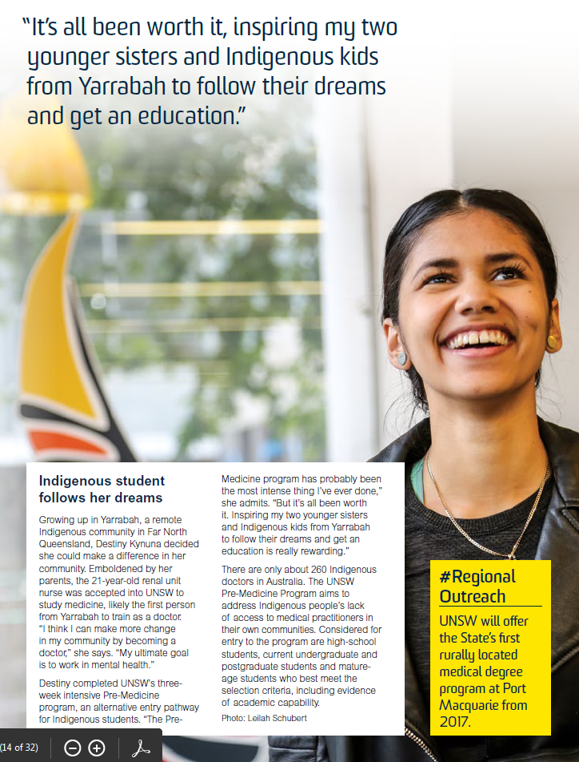

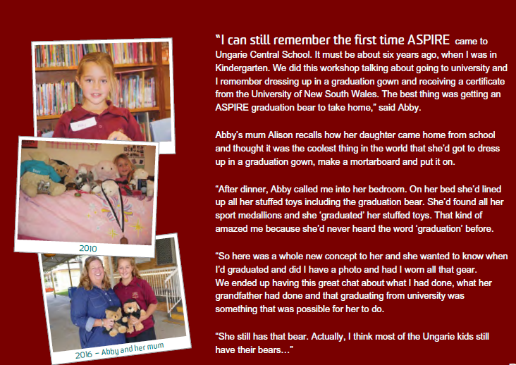

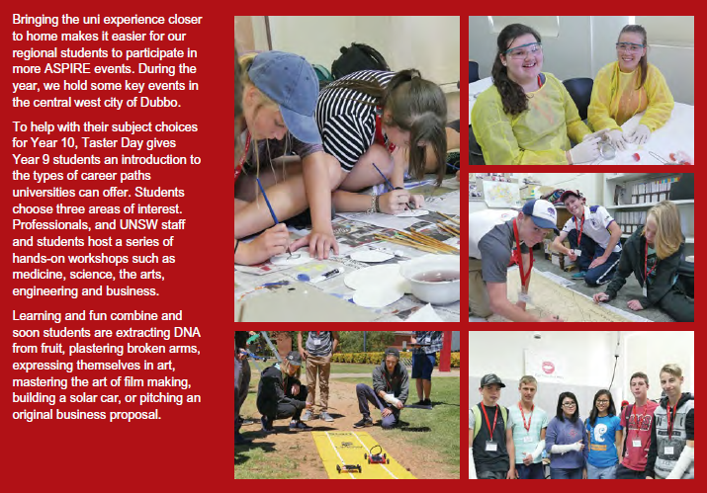

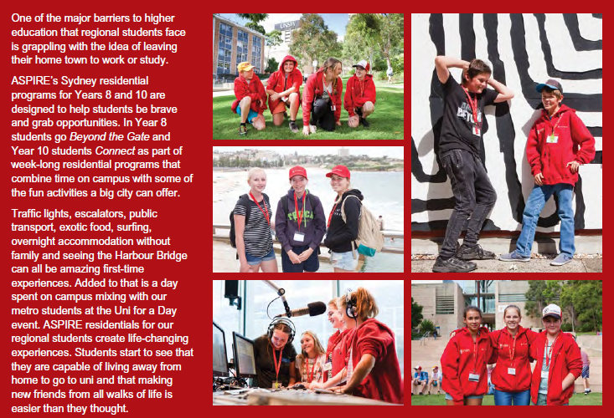

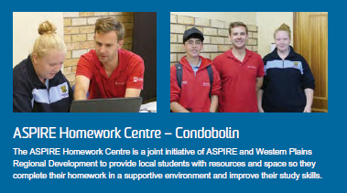

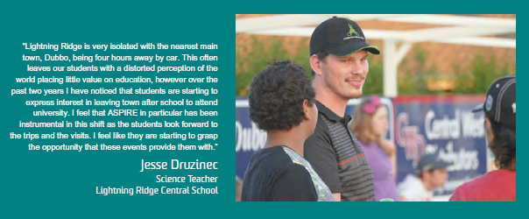

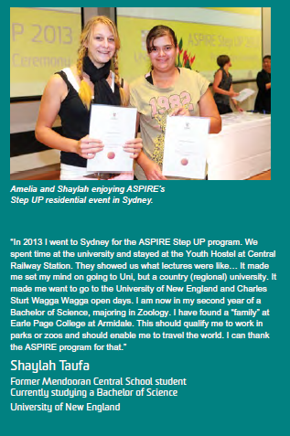

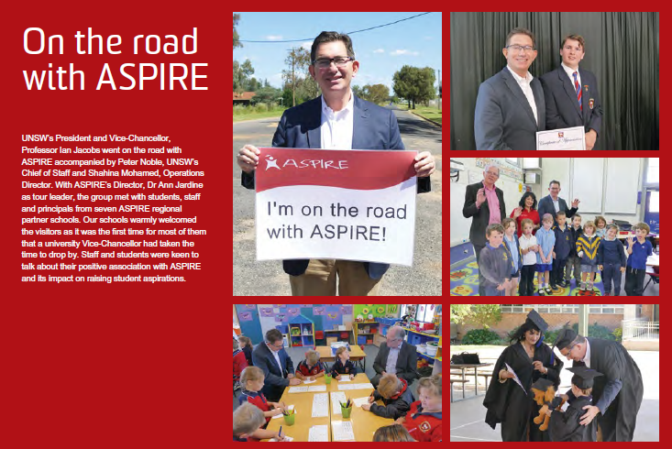

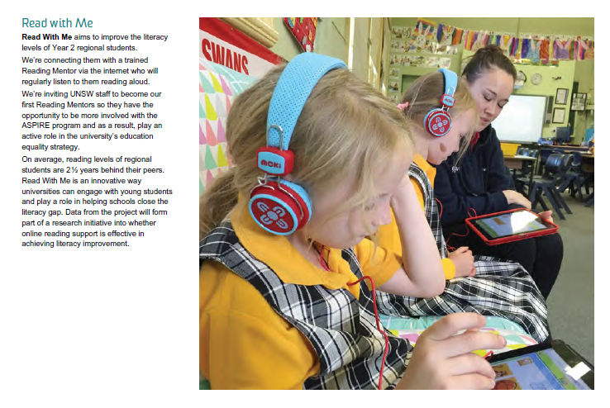

* Ends -