# 

# The Australasian Society for Classical Studies

An Association Incorporated in the State of Victoria

###### President

Assoc. Prof. Tom Stevenson

Classics and Ancient History: School of Historical and Philosophical Inquiry

University of Queensland, St Lucia, Brisbane, 4072

Australia

[t.stevenson@uq.edu.au](mailto:t.stevenson@uq.edu.au)

17 August 2020

Att. Hon. Dan Tehan

Minister for Education

Dear Minister,

I am writing to you as President of the Australasian Society for Classical Studies (ASCS) in response to the Job-ready Graduates Package that is currently being considered in its draft form.

The members of ASCS consist of university lecturers, school teachers, students at all levels, and members of the public who have a passion for teaching, researching, and passing on the great debt we all owe to our Graeco-Roman heritage, including its reception in religion (notably Christianity), politics, literature, and culture more broadly. We are, as such, great supporters of education in the humanities and social sciences and, naturally, are concerned about several aspects of the draft legislation. In general, we support the statements made by the Council for Humanities and Social Sciences (CHASS), especially concerning the impact that the proposed changes would have on access to tertiary education among women and people from lower socio-economic backgrounds. In what follows, I want to make some remarks under three headings: (i) societal decision-making and the humanities; (ii) the acquisition of core skills by humanities students; and (iii) the apparent political perspective.

1. *Societal decision-making and the humanities*

Universities have always offered education for life in all its complexity. They are meant to do much more than prepare students for particular vocations, especially in a world in which employment opportunities are evolving as rapidly and profoundly as the draft legislation rightly recognises. It is more than simply providing models for human achievement or ways to contemplate positive roles for individuals, families, groups, societies, and governments. It is really about helping students to improve their capacity for excellent decision-making in all areas of their lives, including those related to their current employment. It is plain, of course, that their jobs will never be divorced from their lives more generally or from the lives of others in their communities. All decision-making, then, is inter-related and will be enhanced by access to humanities education that is as broad as possible. In the fields of Classical Studies, for instance, we consider questions every day about the value of life, about individual rights and responsibilities, and about understanding the perspectives of others. We do this carefully and in detail. We do it using reason rather than dogma or prejudice. We produce graduates of breadth and vision, who are typically more tolerant, articulate, and diplomatic than the norm. Decision-making by such graduates benefits us all.

1. *The acquisition of core skills by humanities graduates*

Skills of thinking, reading, writing, and speaking are primary business for teachers and students of the humanities. Our graduates are more adaptable, flexible, and critical (in the thoughtful sense) than others. They know the backgrounds and value of the most important ideas of western traditions, such as individual worth, democracy, egalitarianism, and freedom. Their employment opportunities are enhanced rather than limited by this kind of knowledge. They end up everywhere because they have skills that are useful everywhere. This, in turn, is because we are all human beings underneath the titles and roles we might have at any particular time. It is hardly surprising to learn about the number of members of the Government who have taken humanities courses.

1. *The apparent political perspective*

What is surprising, however, is that the draft legislation comes from people who have had the benefit of such an education. The differential increase in fees for humanities (and other) courses seems difficult to follow. The inconsistency seems stark and hugely dispiriting. I can only think that there is an idea prevalent somewhere among our decision-makers that universities are something other than I know them to be – and I have worked in universities (USydney, UAuckland, UQueensland) since the 1980s. They are not hotbeds of sedition or subversion, especially in the Arts and Humanities. They are not dominated by communist thought (I have never worked alongside anyone who identifies as such) and they seek to do good rather than to undermine. There seems to be a basic misunderstanding which can only lead to an impoverishment of spirit for Australia in the future.

Thank you for the opportunity to make this submission.

Yours,

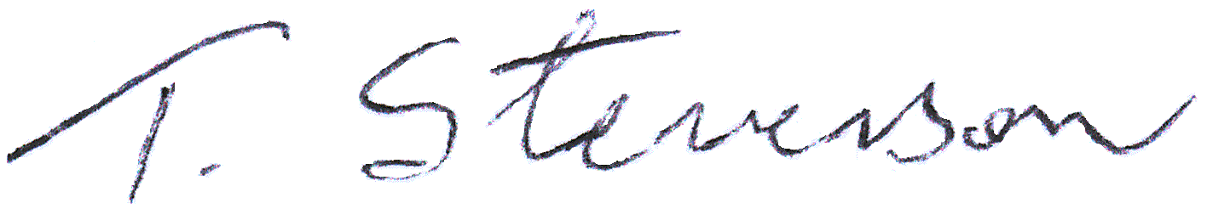

Assoc. Prof. Tom Stevenson,

Room 527 Michie Building,

School of Historical and Philosophical Inquiry,

University of Queensland,

St. Lucia, Brisbane. 4072.

Queensland.

Ph.: 61-7-3365 3143 (w.)

Email: [t.stevenson@uq.edu.au](mailto:t.stevenson@uq.edu.au)

CRICOS Provider No. 00025B