Group of Eight logo


# Group of Eight Submission: Independent Review into Regional, Rural and Remote Education

This submission sets out, at a high level, the position of the Group of Eight providing an overview of the significant contribution we make to rural, regional and remote education and communities along with key recommendations. The Go8 welcomes this review and the opportunity to highlight the wealth of programs and initiatives being taken by our universities to support access to world-leading educational opportunities for all. Our footprint in regional areas is significant, contributing greatly to regional economic development and improving the quality of life of regional Australians. Our cutting-edge research delivers innovative solutions to a wide range of issues affecting regional communities.

## The key recommendations of the Go8 submission are:

* That the Senate block the current Higher Education Reform Bill as this puts at risk a broad range of university capacity-building, including highly successful equity programs.
* That the Federal Government ensure that policies to support higher educational outcomes for regional students are well-designed, and adequately and consistently funded.
* To ensure Australia’s medical workforce is adequate to meet regional needs, the Federal and State governments should work together to support medical graduates to complete specialist training in regional locations.
* The Federal Government continue to invest in equity programs over the long-term to support regional and remote students, including by increasing the value of the Higher Education Participation and Partnerships Program (HEPPP) to $205.1 million per year (as forecast in the 2012/13 budget for 2015/16 year).
* The Federal Government review eligibility criteria for Youth Allowance and other linked student income support programs to ensure that they provide an appropriate level of support for students from regional areas. Experience from Go8 suggests a key factor deterring disadvantaged students from attending university is not course costs, but up front living costs while studying, such as rent and food.
* That the Federal Government reverse its decision to abolish the Education Investment Fund to provide greater headroom for universities to make new capital investments, in rural, regional and remote areas.
* That the Federal Government provide incentives that encourage an adequate supply of purpose built student accommodation for rural, regional and remote students.

# Executive Summary

Group of Eight universities make a significant national contribution to the education of regional and remote students across Australia. Our universities are particularly strong in fields that are of importance to regional and remote Australia. We invest substantially in outreach to regional communities to inspire more young Australians to pursue post-secondary education.

Once regional students come to our universities, they are more likely to stay and complete their course. Retention rates for regional, remote and Indigenous students at Group of Eight universities are significantly higher than the national average. Once they complete their studies, many of our graduates return to rural areas to generate wealth and contribute to the well-being of their communities.

Our education is informed by the high-quality research that we undertake. Group of Eight universities are dominant in research fields that are of importance in regional and remote Australia. We deliver research that solves real-world problems in regional, rural and remote areas, with deep partnerships with industries and communities.

While there are a number of Federal Government programs that provide targeted support for regional and remote students to attend university, regular review of these policy settings is required to ensure that interventions to support educational outcomes for regional students are well-designed and adequately funded. Regional and remote students face many challenges accessing and succeeding at university.

Since 2011, while overall numbers of students from regional and remote areas have increased, there has been a slow but steady decline in the proportion of rural and remote students at university – down from

20.3% in 2011 to 19.8% today. Such students need all the support they can get from government.

In this submission, the Group of Eight makes seven recommendations directed at ensuring greater support for qualified regional students to access university education and an appropriate level of support for Australian universities to help regional students succeed.

In particular, the Go8 calls on the Senate to block the current Higher Education Reform Bill as this puts at risk a broad range of university capacity-building. Cuts to university funding will force universities to make difficult choices about the allocation of resources across teaching, student support, and research with serious impacts on access, choice, quality, and, most importantly, equity.

The Go8 urges the Federal Governmentto continue to invest in equity programs to support regional and remote students to aspire to university and to receive the additional study and social support they need. The Government has the capacity to improve education and employment outcomes for regional, rural and remote Australia by engaging with universities and supporting the continuation and expansion of our proven educational aspiration and attainment programs (spanning pre-school, school, TAFE, community and industry) and utilising our innovation and research strengths.

|  |
| --- |
| **The Group of Eight’s contribution to meeting regional higher education needs: Key Facts**   * **25,000+ regional and remote students study at Group of Eight Universities every year.** * **1 in 8 Australian university students from regional or remote areas are studying at a Group of Eight university.** * **1 in 2 students of agriculture, environmental and related studies learn at a Group of Eight university.** * **60% of veterinary students in Australia are educated at a Group of Eight university.** * **First university group to establish a Rural Clinical School for medical training - a model now embraced across Australia.** * **3%+ higher rates of student retention for regional, remote and Indigenous students than the national averages.** * **Group of Eight universities spend a far greater proportion of their HEPPP funding on outreach to regional and remote schools and communities than any other university grouping.** |

# The Group of Eight and Rural, Regional and Remote Australia

The Group of Eight (Go8) are Australia’s world-leading universities educating more than one-quarter of Australia’s undergraduate students, and delivering 92,000 quality graduates each year. The strength of our performance in global ranking systems means that one in three international students who choose to go to university in Australia do so at a Group of Eight university. This makes the Go8 a significant contributor to Australia’s $25 billion education export sector. In research, we account for two-thirds of all research funding to universities, and each year spend some $6 billion on research, of which only $2.5 billion is funded by Government. Ninety-nine per cent of Go8 research is assessed by Government as world class or above.

Rural, regional and remote students deserve the chance to study at the highest levels at Australia’s leading universities. To this end, the Go8 has a strong commitment to ensuring such students are well-supported through a wide range of innovative programs and targeted outreach that improve the transition from school, to university, to employment. While other university networks do an invaluable job as higher education providers in rural areas, the fact remains that they do not shoulder that care, nor geographical space on their own. The Go8 is very active in regional Australia and has an enviable equity platform for regional and rural students wishing to access a world-class education, for raising the aspirations of school age students, and for medical, agricultural, and veterinary training in rural areas.

This inquiry poses a number of significant questions around the following:

* innovative course delivery using new technologies
* strategies for developing a high-quality and skilled workforce that will benefit rural communities (eg health professionals)
* strategies for raising the aspirations of rural communities and improving quality of life
* strategies for innovative models of accommodation delivery that could benefit regional, rural and remote tertiary students studying away from home
* strategies for addressing the directional flow of regional, rural and remote students moving to cities for further education and/or training

None of these issues can be addressed without consistent, coherent policy and funding certainty. The current Higher Education Reform Bill puts at risk a broad range of university capacity-building. Cuts to university funding will force universities to make difficult choices about the allocation of resources across teaching, student support, and research with serious impacts on access, choice, quality, and thus, equity.

Government can improve education and employment outcomes for regional, rural and remote Australia by engaging with universities and supporting the continuation and expansion of our proven educational aspiration and attainment programs (spanning pre-school, school, TAFE, community and industry) and utilising our innovation and research strengths.

**Recommendation: That the Senate block the current Higher Education Reform Bill as this puts at risk a broad range of university capacity-building, including highly successful equity programs**

# Our commitment to regional Australia

While Go8 members are headquartered in metropolitan Australia, we make a substantial contribution to education and research outcomes both in and for regional and remote Australia. This is a reflection both of our history and our vision for the future.

Historically, a Go8 university was the first to be established in each Australian mainland State and in the Australian Capital Territory. Since Go8 universities were founded, students from regional and remote parts of Australia have always travelled to join us to acquire knowledge from some of Australia’s most eminent scholars. Likewise, from their beginnings, Go8 universities have worked as partners of choice with regional industries and communities to tackle research problems of relevance to regional Australia.

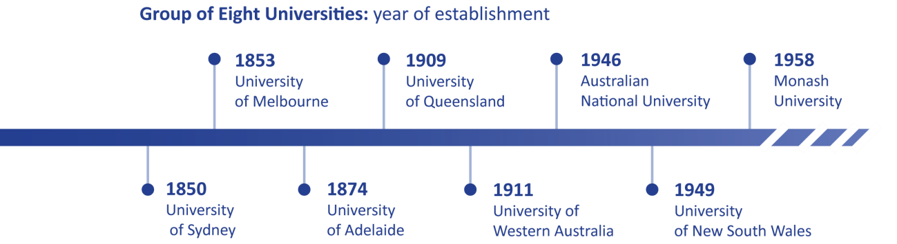

Looking forward, we know that Australia’s continued economic success and social development depends on the prosperity of Australia’s regions.

Regional Australia makes an enormous contribution to Australia’s progress across multiple sectors and industries. Its success depends in part on university graduates being able to apply their knowledge and capabilities to drive economic progress and create healthy communities.

Our universities provide the doctors and other health professionals, engineers, vets, business leaders, technology professionals, scientists, teachers, entrepreneurs and other professionals needed to create wealth and well-being in regional communities throughout Australia.

By providing the skills and capabilities that regional communities need and by driving strong, meaningful and productive connections in the heartland of regional Australia, Go8 universities continue to transform our nation.

# Addressing regional disadvantage

Regional and remote students still face many challenges accessing and succeeding at university compared to metropolitan students. While the Review of the Demand-Driven System (DDS) conducted in 2013 by David Kemp and Andrew Norton found that the DDS and associated reforms had increased higher education opportunities for people from regional and remote areas, recent changes in the patterns of participation by regional students present a more concerning picture.

Since 2011, while overall numbers of students from regional and remote areas have increased, there has been a slow but steady decline in the proportion of regional and remote students at university – down from 20.3% in 2011 to 19.6% in 2016.

Distance and costs remain significant barriers for many students who wish to access a university education. While there are a number of federal government programs that provide targeted support for regional and remote students to attend university, regular review of these policy settings is required to ensure that interventions to support educational outcomes for regional students are well-designed and adequately funded.

**Recommendation: That government ensure that policies to support higher educational outcomes for regional students are well-designed, and adequately and consistently funded.**

# Our contribution to the education of students from regional and remote areas

Every year, of the 200,000 students from regional and remote areas that study at Australian universities, more than 25,000 are studying at Go8 Universities.[1]

For those students who commence a university education but do not complete it, there can be substantial social costs including higher individual debt with reduced capacity to repay and reduced relative social mobility. It is for these reasons that Go8 universities place a high premium on retention and completion by students from regional and remote areas, as well as Indigenous students.

Regional, remote and Indigenous students of Go8 universities experience rates of retention that are significantly higher than average for the higher education sector. [2]

* **Regional students:** The retention rate forregional students at Go8 universities is 80.7% (national average: 76.8%).
* **Remote students:** The retention rate for remote students at Go8 universities is 77.4% (national average: 74.1%).
* I**ndigenous students**: The retention rate for indigenous students at Go8 universities is 74.8% (national average: 71.2%).

Go8 universities are comprehensive in the education on offer, but especially strong in fields that are of vital importance to regional and remote Australia, including medical education, agricultural education and veterinary science education.

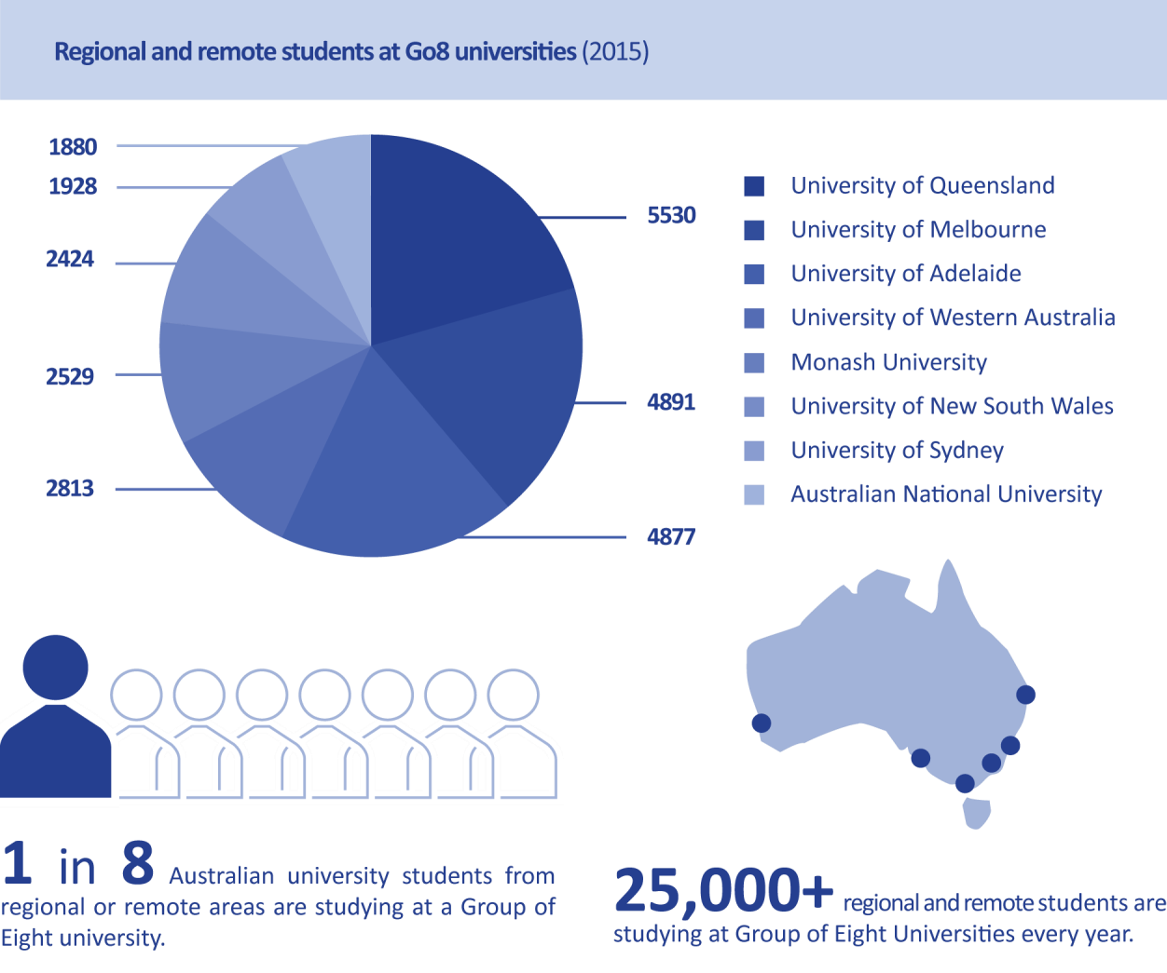

# Medical education

Our universities train the vast majority of doctors working to deliver improved health outcomes in regional and remote areas.

Go8 universities were among the first universities in Australia to establish Rural Clinical Schools to bring world-class medical education to rural Australia. They play a major role in developing Australia’s rural medical workforce.

Our universities have made significant staffing and financial investments in rural clinical schools. Each school offers integrated rural placements providing medical students with opportunities over the course of their degree to practice their medical skills and to experience life in regional areas. Go8 universities have made significant staffing and financial investments in rural clinical schools with most schools offering longitudinal integrated rural placements or block rotations providing students with multiple opportunities to practice skills and experience rural life.

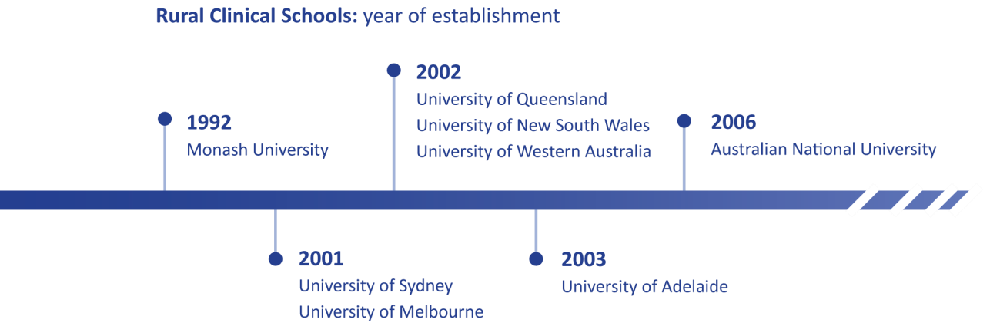

Rural clinical schools have brought new health infrastructure and expanded the rural clinical workforce. There has been growth in the number of students from a rural background and increased opportunities for students to experience a rural placement as part of their medical education. In 2003, 20% of domestic students had a rural background and in 2016, the proportion of commencing rural students had risen to 28% of total domestic students (*Please refer to the Appendix 10 for a map showing the breadth and scope of Go8 Medical and Health Placement Locations throughout much of regional Australia*).

In addition to providing positive experiences for medical students, rural clinical schools have had positive impacts on regional and rural communities with teaching facilities bringing new infrastructure and an expanded clinical workforce. Rural clinical schools provide new opportunities for education and research for rural clinicians, which reduces professional isolation, improves the quality of care and may assist in retaining clinicians in regional areas.[3] (*See* ***Case Study 1*** *in the appendix for an overview of the challenges and rewards of medical practice in rural communities*).

Studies have shown that students who have positive experiences in rural clinical placement settings are more likely to choose to work in these settings following graduation.[4]

While the establishment of Rural Clinical Schools within Australian universities has been effective in producing an appropriate number of medical graduates to serve Australia’s needs, regional areas continue to experience shortages of medical practitioners.

According to the Department of Health, only 13% of non-GP accredited specialist training positions are outside the major metropolitan areas. Many young doctors are still moving back to the city for specialist training, often never to return to rural areas.

The current lack of specialist training capacity in rural settings is a major problem that needs to be addressed so that graduates with intentions to practice in regional areas can continue their training in these settings. The solution to getting more doctors in rural areas is not the creation of further medical schools or the redistribution of medical school places, but the establishment of viable regional postgraduate training programs that allow medical graduates to complete specialist training in regional locations.

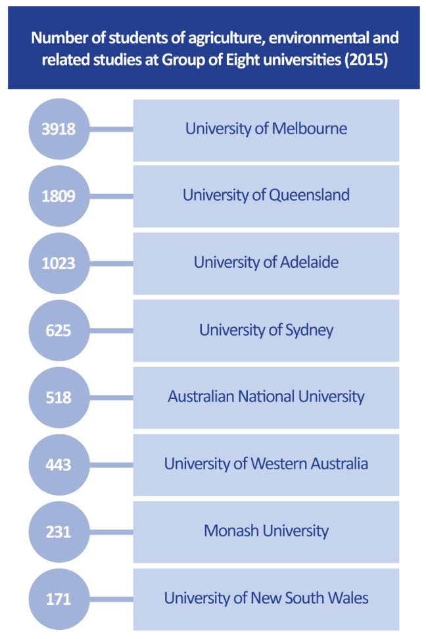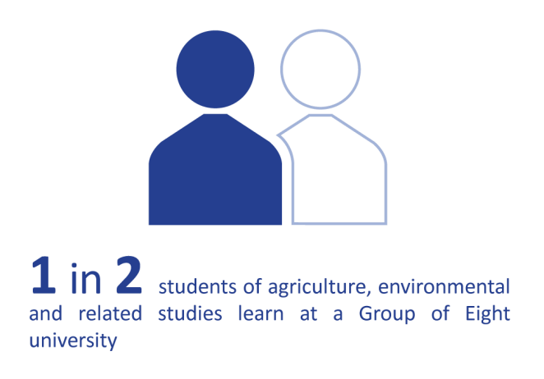

For a further discussion of the issues associated with postgraduate medical training, please see the joint submission by the Medical Deans Australia and New Zealand and the Go8 Deans of Medical Faculties Group to the Assessment of the Distribution of Medical School Places in Australia (February 2017).

**Recommendation: To ensure that Australia’s medical workforce is adequate to meet regional needs, the Federal and State governments should work together to support medical graduates to complete specialist training in regional locations.**

# Agricultural education

Agriculture is a major industry in regional Australia and a significant and critical component of the overall Australian economy, contributing 2.3% of Australia’s GDP. Agriculture is the biggest employer in rural and regional communities, and provides employment through a range of affiliated food and fibre industries for more than 1.6 million Australians.

One in every two students studying agriculture, environmental or related areas in Australia do so at a Go8 university. Three of the five largest providers of agriculture studies in Australia are Go8 universities.[5]

As Australia’s largest provider of education in agriculture, the University of Melbourne offers its Bachelor of Agriculture students an opportunity to undertake a semester of practical learning at Dookie, the University’s working farm and science hub 180 kilometres north-east of Melbourne.

The largest farm campus in the southern hemisphere, Dookie is situated on 2240 hectares and has a high-technology robotic dairy, broad acre farming crops and 5000 merino sheep.

# Veterinary science education

Veterinary science is vital for rural and regional communities who depend on animal health to grow and sustain livestock-based industries.

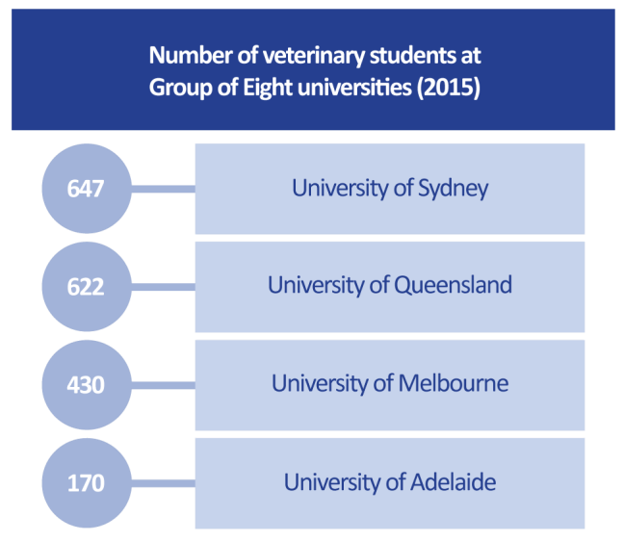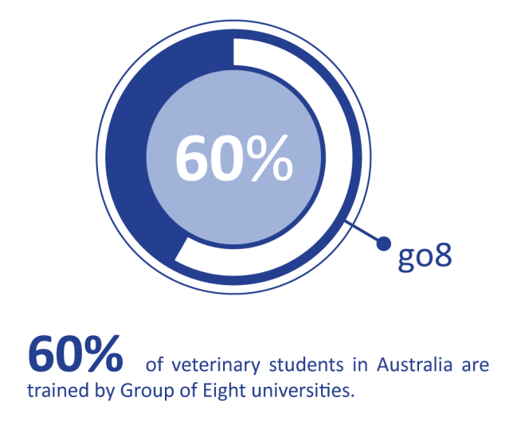

The Go8’s veterinary schools serve the livestock industries of Australia through provision of veterinary services and training and by advancing knowledge through research into issues affecting animal production health and welfare.

60% of all veterinary students in Australia are trained by Go8 universities.[6] Of the seven university veterinary programs in Australia, four are run by Go8 universities.

Go8 veterinary facilities with a focus on regional and rural needs include University of Queensland’s Equine Specialist Hospital at Gatton, University of Adelaide’s Production Animal Health Centre at Roseworthy, the University of Sydney’s Livestock Veterinary Teaching and Research Unit at Camden and the University of Melbourne’s Equine Centre at Werribee.

# Raising aspiration and helping students overcome barriers to success

Go8 universities take seriously their responsibility to raise aspirations for university-level study among regional and remote students. In the period from 2010-2015, Go8 universities spent a greater proportion on outreach to regional and remote schools and communities than any other university grouping[7] *(See* ***Case Studies 2 & 3*** *in the appendix, as they highlight the effectiveness of Go8 aspirational programs and outreach on regional school-age students’ lives).*

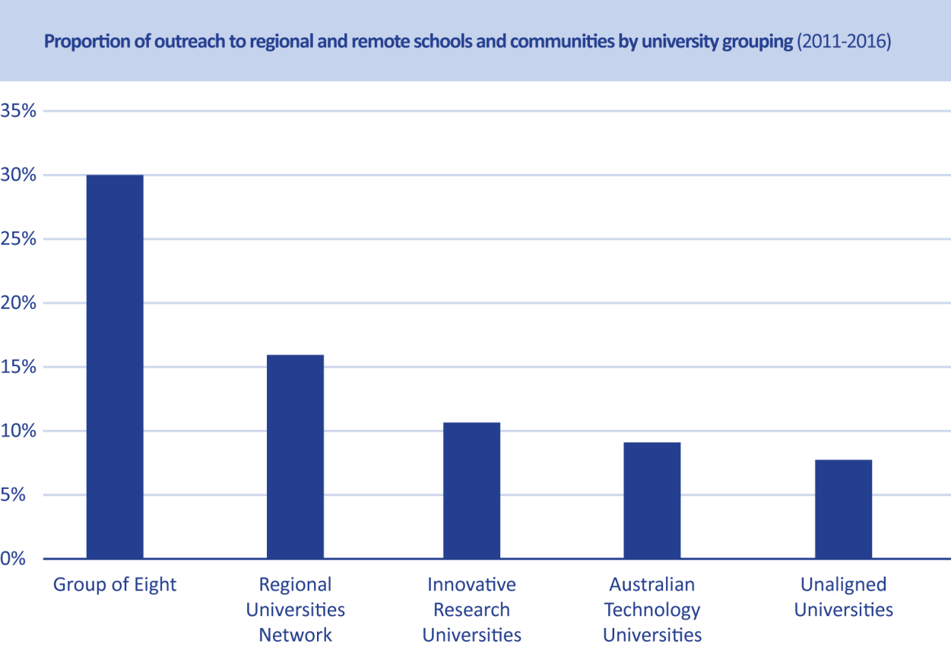

There are many programs run by Go8 universities that encourage regional and remote students to consider university study and the Go8 believes that a university education should be accessible to all qualified people who choose it regardless of background or circumstance.

* The University of New South Wales’ *ASPIRE* program is an educational outreach program working with teachers and students from Kindergarten to Year 12 in 30 schools across regional NSW. It has over 6,900 engagements each year through workshops, residentials, homework clubs, literacy support, other events and online resources. It addresses a critical need for young people in these areas, breaking down barriers to further study by helping students overcome fears and misconceptions and giving them confidence in their own capabilities. Evaluations reveal significant impact, including the number of *ASPIRE* students offered a place at UNSW increasing 65% (2010-2016). The *UNSW Indigenous programs* including Winter School, road shows, preuniversity preparation and pathways have also been very successful in increasing regional participation.
* The University of Sydney’s *Regional Hub* program targets remote indigenous schools with programs to develop strong study habits, workshops on campus and a volunteer program that sees University of Sydney students involved with year 10 literacy programs.
* The Australian National University’s *SetUp for Success* program provides transition support to increase the retention rate of students, including from regional and remote areas. Identified students are contacted at the start of the semester and offered campus information, individual appointments and the support of a project officer.
* Monash University and the University of Melbourne jointly run the *Strengthening Engagement and Achievement in Maths and Science* (SEAMS) program to improve student attainment in the areas of Maths and Science. Participants attend 2 residential camps a year over Year 11 and 12 to assist them to gain entry to STEM university Courses. In 2017, 38% of participants were from regional schools.
* The University of Queensland’s *Young Achievers Program* is a tertiary aspiration building program for low SES students from state secondary schools in the Ipswich, Logan, Brisbane South, Toowoomba, the Darling Downs, and the South West, Wide Bay and Bundaberg regions of Queensland. Students are nominated for the Program while they in Year 10 by their School Principals and chosen by a selection committee.
* The University of Adelaide works with schools across 11 regional areas in South Australia and border regions to help shape students’ decisions to increase university participation. Students undertake a combination of presentations, workshops and advising sessions throughout the year as part of the outreach program. University staff also attend field day events and deliver subject specific outreach programs. They also partner with the Children’s University Australia (CUA) Program that engages with schools across South Australia, enabling member schools to offer their student’s access to a unique reward based program recognising participation in extra-curricular activity, and celebrated in an annual graduation ceremony at the University of Adelaide.
* Since 2000, the University of Western Australia’s Aspire Program has been supporting rural students through the challenging process of applying for medicine or dentistry. It now achieves its ambitious target of 25 per cent of places for rural students in each intake of medical students and 10% of dental students. Students from a rural background are three times more likely to practice medicine in a regional area than those from an urban background, addressing a critical skills shortage in regional Australia.

While the DDS has been highly successful in growing participation, it has been less successful delivering one of its original policy priorities of equity. The DDS has had only limited success in increasing participation from students from a low socio-economic background, Indigenous students and those from regional and remote areas.

Students from regional and remote areas have greater barriers to overcome in accessing and succeeding at university than many other Australians. Since 2009, the Higher Education Participation and Partnerships Program (HEPPP) has supported universities to create programs of outreach to regional and remote students as well as to provide additional study and social support for regional students who attend university.

Supported by HEPPP funding, the Go8’s focus is on raising aspiration to attend university, expanding levels of participation and supporting students to complete their degrees. Collaborative outreach work to groups that are under-represented at university – especially regional, remote and Indigenous students – is a priority.

However, successive governments have withdrawn funding for HEPPP over time, jeopardising the significant support for regional and remote students that universities are able to offer.

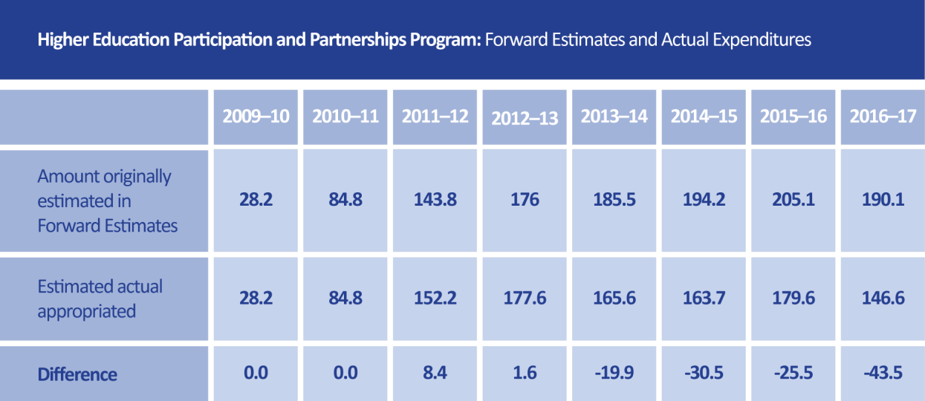

To support improved outcomes for regional and remote students, the Go8 strongly recommends that the Federal Government restores funding for the Higher Education Participation and Partnerships Program.

**Recommendation: The Federal Government continue to invest in equity programs to support regional and remote students, including by increasing the value of the Higher Education Participation and Partnerships Program (HEPPP) to $205.1 million per year.**

While many university students experience financial challenges while at university, these challenges are often greater for students who choose to relocate from regional areas. The cost of living for students living away from home can stretch family finances. In many cases, it is the difference whether a young Australian takes up post-secondary education opportunities.

Current student income support policy acknowledges this to some degree by providing eligible students with access to a relocation scholarship, a once-a-year payment for those who need to move from a regional or remote area for higher education study. The amount of the benefit ranges from $4,376 in the first year that students need to live away from home to study to $1,094 per year in the later years of their degrees.

This is welcome recognition by the Australian government of the additional financial pressures that regional students face. Students may also eligible to apply for and receive a Student Start-up Loan, a voluntary payment of $1035 that is available twice per year and is repayable through the HELP system.

However, current rules prevent many students from accessing the government’s student income support programs unless they can prove to have been living independently for 14 months. This causes many students in regional areas to defer higher education study. According to the National Centre for Student Equity in Higher Education, 15 per cent of regional students undertake a gap year compared to just 5 per cent of metropolitan students.

For these reasons, the Federal Government should review eligibility criteria for Youth Allowance and other linked student income support programs to ensure that they provide an appropriate level of assistance for students from regional areas (*See* ***Case Study 4*** *in the appendix on the financial pressure faced by regional students*).

**Recommendation: The Federal Government review eligibility criteria for Youth Allowance and other linked student income support programs to ensure that they provide an appropriate level of assistance for students from regional areas.**

# Capital funding pressures and the shortage of purpose-built student accommodation

Students from regional and remote areas attending university benefit from living close to campus, yet there is a national shortage of affordable purpose-built student accommodation to accommodate student demand.[8] For those students who are unable to find affordable accommodation on or close to campus, this provides additional challenges which may well interfere with their ability to succeed at university, including additional financial pressure and the requirements to travel long distances from accommodation they can afford. *(For a detailed map of Go8 regional campuses please refer to Appendix 11).*

To attempt to meet demand in the absence of government policy intervention, universities have entered into innovative financing arrangements with private sector accommodation providers to build new forms of accommodation. Universities have also made capital investments of their own to create supply and to renovate and upgrade existing stock to meet student expectations.

The ability of universities to provide affordable student accommodation could be enhanced through incentives such as a capital works fund; favourable capital loan schemes, or the National Rental Affordability Scheme being reinstated and made available to universities. This support could come with a requirement to provide a defined number of places for students from regional, rural and remote Australia.

Disappointingly, the Federal Government has placed additional pressure on universities’ ability to make capital investments in affordable purpose-built student accommodation stock through its decision to abolish the $3.9 billion Education Investment Fund.

The Education Investment Fund (EIF) facilitated the creation and development of infrastructure in the areas of higher education, research, vocational education and training. It provides a vital source of capital with which universities can renew ageing infrastructure and make new investments to meet future educational and research needs.

The decision to abolish the Education Investment Fund was taken in 2014 in the context of its now defunct proposal to deregulate student fees. With the abandonment of that policy, the proposal to abolish the Education Investment Fund cannot be justified as it will place additional pressure on universities to meet capital investment needs by diverting funds from teaching and research.

**Recommendation: That the Federal Government provide incentives that encourage an adequate supply of purpose-built student accommodation for rural, regional and remote students.**

**Recommendation: That the Federal Government reverse its decision to abolish the Education Investment Fund to provide greater headroom for universities to make new capital investments in rural, regional and remote areas.**

# Research that creates value for regional and remote Australia

While the focus of this inquiry is education, it is important to note that discoveries made by Go8 universities and the real-life applications of that research is making an enormous difference to the lives of people in regional and remote areas across Australia. Not only does our research inform the approach that we take to teaching but it also underpins deep and abiding partnerships with regional communities.

The pioneering work conducted in and about Australia’s rural and regional communities is at the leading edge the Go8’s research endeavours. Our research interests bind Go8 universities to regional communities as researchers work in partnership with local industry and community organisations. Our work makes a material difference to the lives of people in rural and regional communities while creating new industries for regional and remote communities (*See* ***Case Study 5*** *in the appendix on research that has the potential to transform energy solutions and create new industries in regional areas*).

Go8 research is also shedding light on the forgotten contribution made to rural communities by hardworking farming women of Australia’s regional and remote areas (*See* ***Case Study 6*** *in the appendix into the forgotten women of Australia’s farms*).

Australia’s dry and arid rural landscape is particularly vulnerable to the impact of natural disasters such as fire. The long-term impact upon rural communities cannot be overestimated. Essential work to mitigate the impact of bushfires is being undertaken by Co-operative Research Centres such as the Bushfire and Natural Hazards Co-operative Research Centre (*See* ***Case Study 7*** *in the appendix*).

In major research areas that benefit regional and remote communities, Go8 universities produce high quality research that is recognised by the Australian Government as meeting or exceeding world standards through its Excellence in Research Australia (ERA) evaluation framework.[9]

* **Environmental sciences:** All eight Go8 universities at above world standard – University of Western Australia, University of Melbourne, University of Queensland, Australian National University (ERA 5), Monash University, University of New South Wales, University of Adelaide, University of Sydney (ERA 4).
* **Resources Engineering and Extractive Metallurgy:** Four Go8 universities produce research at world standard or above – the University of Adelaide, University of New South Wales (ERA 4), University of Melbourne and University of Queensland (ERA 3)
* **Earth sciences:** All eight Go8 universities produce research at or above world standard – University of New South Wales (ERA 5), University of Adelaide, University of Sydney, University of Western Australia, University of Melbourne, University of Queensland, Australian National University (ERA 4), Monash University (ERA 3)
* **Soil sciences:** Five Go8 universities produce research above world standard – the University of

Adelaide, University of Sydney, University of Western Australia (ERA 5), University of Melbourne, University of Queensland (ERA 4)

* **Agriculture and veterinary sciences:** Six Go8 universities produce research above world standard – University of Western Australia, University of Melbourne, University of Queensland,

Australian National University, University of Adelaide, University of Sydney (ERA 4)

* **Tourism:** The University of Queensland is Australia’s only university in Australia with research at well above world standard (ERA 5).

All Go8 universities produce earth sciences research at or above world standard, benefiting Australia’s mining industries.

Research that is produced by Group of Eight universities is finding solutions to problems affecting regional and remote industries and communities, as this snapshot of research projects awarded competitive funding by the Australian Research Council in 2015-2016 shows.

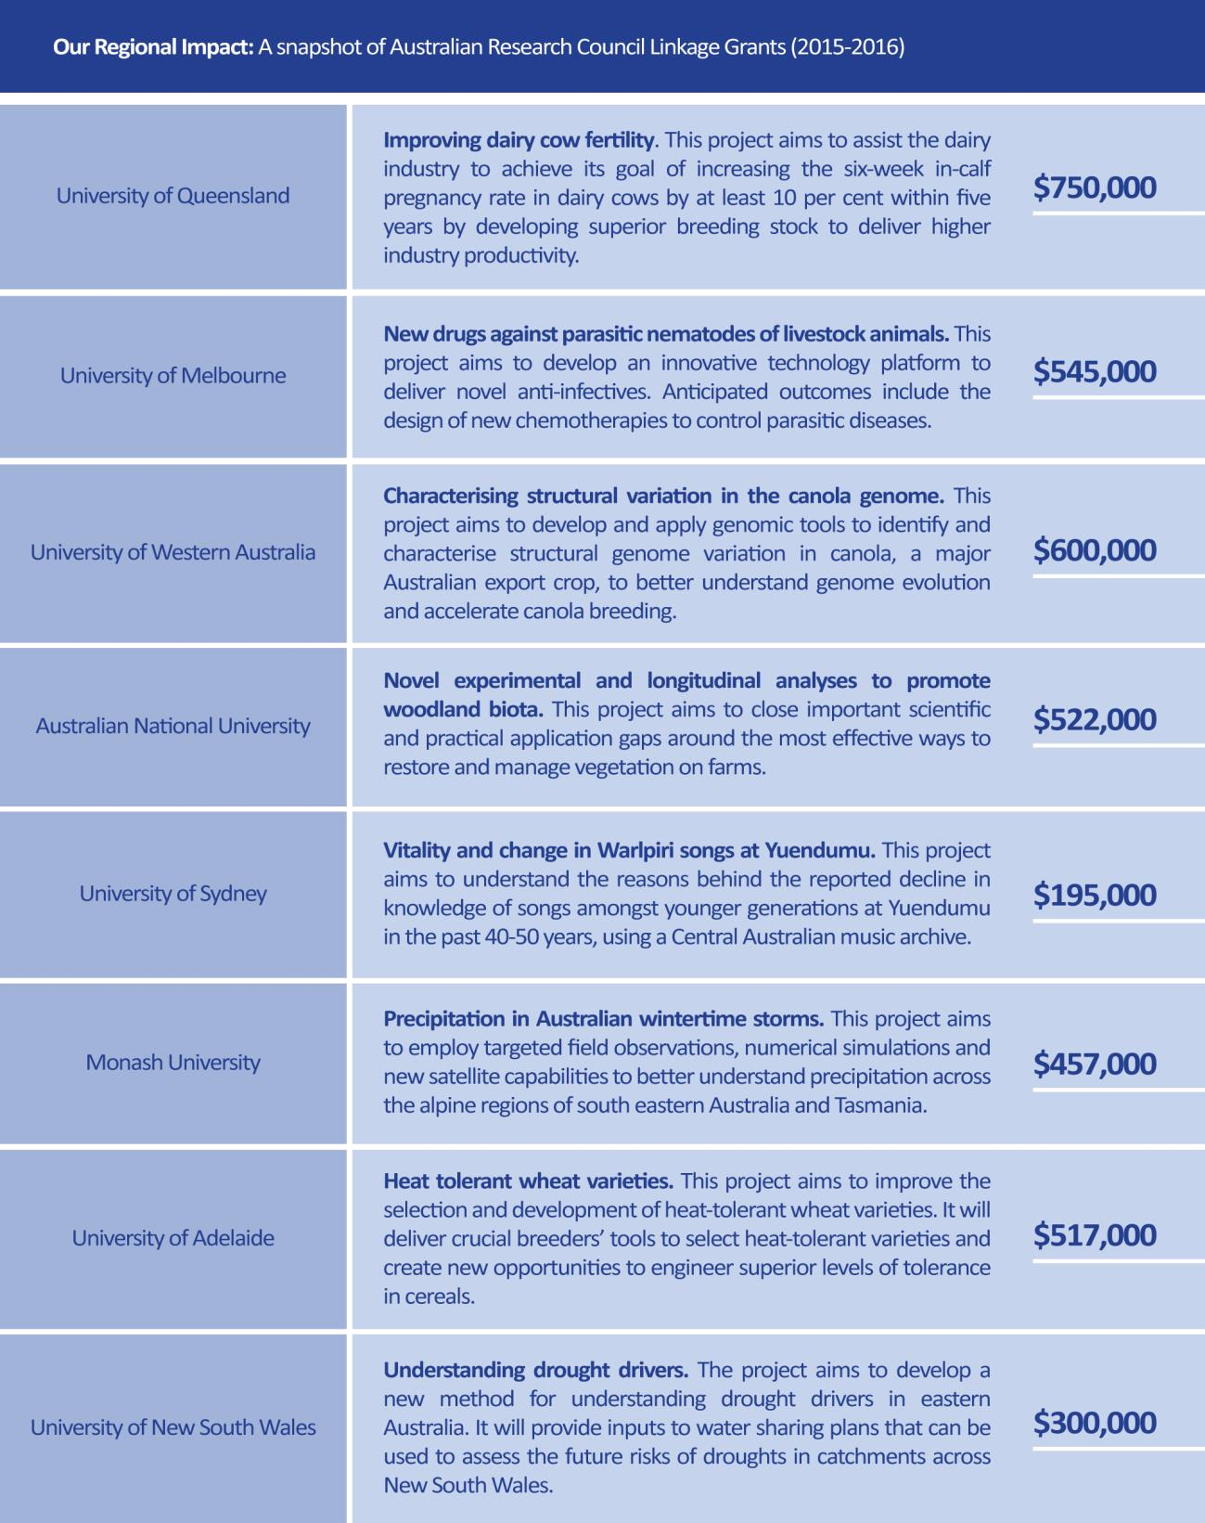

# Our Commitment to Indigenous Communities

Go8 universities are also helping us to better understand Australia’s indigenous heritage and applying indigenous knowledge. Research centres and initiatives with specific Indigenous research objectives include:

* The **National Centre for Indigenous Studies** at the Australian National University (ANU)
* The University of Sydney’s **Centre for Research Excellence: Indigenous Health and Alcohol**
* Established in 1981, **the Indigenous Law Centre** at the University of New South Wales is the only Indigenous law research centre in Australia.
* The **Monash** **Indigenous Studies Centre** supports an active research program
* The University of Melbourne’s **Indigenous Research Initiative** seeks to increase the engagement with and impact of its research in Indigenous studies
* **Wirltu Yarlu** at the University of Adelaide brings together support for research quality, with the achievement of research outcomes in areas of societal need.
* The research focus of the **School of Indigenous Studies** at University of Western Australia is to ensure that Indigenous oral traditions and cultural expressions are supported and valued

Since 2014, Go8 universities have won half of the Indigenous-specific competitive research grants offered by the Australian Research Council, with a total value of $6.9 million.

Two case studies highlight the significant interaction between Go8 universities and Indigenous communities. (*See* ***Case Study 8*** *in the appendix that takes an innovative approach to food science using the Kakadu plum while engaging Indigenous communities.* ***Case Study 9*** *highlights the substantial benefits to Indigenous communities by highly-trained Indigenous health workers returning to work in their local communities*).

When it comes to education, it should be noted that current Commonwealth funding schemes for university Indigenous programs and support are inadequate to address current student need for outreach, pathways, pastoral and academic support and scholarships.

# Conclusion

As has been amply demonstrated in this submission, the Go8 is making a substantial contribution to Australia’s rural, regional and remote communities. The Go8 recognises the importance of regional Australia to the national economy and is working with regional centres to enable them to reach their full potential.

The Go8 provide initiatives that promote equitable access to high-quality educational experiences within the regions. We raise aspirations and hopes for a better future through targeted and dynamic programs for school-age students and we provide ongoing support for regional students so that they may access world-leading university study. We also provide highly-qualified health professionals to support the wellbeing, both physical and mental, of local communities. Much of our research addresses issues of direct concern to regional populations with our strong and vigorous focus on agriculture, veterinary sciences, and ecology, while also creating new regional business, industries and partnerships. All this takes significant resources and energy.

For the Go8 to continue high-level outreach into rural, regional and remote areas long-term, adequate and reliable university funding is crucial. As mentioned in the first recommendation of this submission, the current Higher Education Reform Bill puts at risk many of the excellent outreach and support programs that are changing lives for the better. The Bill will also impact negatively upon research programs of relevance to the regions by reducing the overall capacity of universities.

Cuts to university funding will force universities to make very difficult choices. With sustainable and adequate funding, these very difficult choices will not have to be made.

# Appendix: Case studies

## Case Study 1: Roisin Kinsella, Monash University

*As a General Practitioner working now in the town she grew up in, Roisin knows both the challenges and the rewards of practicing medicine in a regional community such as Lakes Entrance.*

Roisin Kinsella grew up on a farm 10 minutes from Lakes Entrance in eastern Victoria. Her mother, a former nurse is a farmer off a family property near Albury. Her father is the local GP and has been for 35 years.

Now in working in Bairnsdale after studying medicine with Monash University and in the final six months of her GP training, Kinsella never really liked the hospital environment and enjoys the continuity of care in the country – and hearing people’s stories.

“This may be a generalisation but people in the country tend to come to the doctor later and they tend to come sicker, especially the farmers,” she says. “The discussions with specialists and the level of medicine that you are doing is a lot more interesting because you’re a lot more involved,” she says.

Initially, Kinsella was slightly put off medicine by her dad. He always said it was tough and big commitment. But she saw him as a great role model and valued the work-life balance he managed to achieve.

After originally being offered a Rural Medical Bonded Scholarship, Kinsella won an excellence and equity scholarship at Monash. While she studied, Kinsella did stints working in the regional Victorian centre of Geelong and did a six-months obstetrics residency in Alice Springs.

Kinsella believes the barriers for regional students studying in the city are high, even for a student like herself who came from a strong family financial background.

She worked throughout first and second year in Melbourne and came home to ‘Lakes’ every summer and held down three jobs.

“Not being close to family and not having the financial support, the social support. And the city kids had all of the social connections, they were very well connected, it was pretty lonely the first few months,’’ Kinsella recalls.

Lakes Entrance has had a shortage of GPs for three decades. People come and stay for six months and then they go. It’s part of a much broader issue, she says.

“We need to try to get more country kids into medicine – they are more likely to come back to the country.”

And Kinsella loves the work, doing ward rounds at the GP run Bairnsdale hospital in the morning, ordering tests and doing more of the procedural work, such as skin cancers.

“And as soon as you leave work, you can be at the beach in 10 minutes,” Kinsella adds.



Brody Hannan from Cowra in New South Wales won a Tuckwell Scholarship to attend the Australian National University. Image: ANU[.](http://www.uq.edu.au/research/impact/stories/the-tree-of-shelf-life/media/holding_plum-hr_t429jbc.jpg) [Link to source.](http://www.anu.edu.au/study/choose-anu/brody-hannan)

## Case Study 2: Brody Hannan, Australian National University

*Students from regional areas face many challenges as they make decisions about postsecondary study. This is the story of how Go8 aspirational programs and outreach can have lifechanging and significant lasting effects on young regional school-age students’ lives.*

Growing up I had heard of ‘university’, but never had any real ambitions to go there – after all, no one in my family had ever been before, and most of my friend’s parents were family farmers.

The ANU was the first, and the only university that I visited when I was in high school. My journey to higher education began when I was 14. After seeing posters up around my school in Cowra, NSW, promoting the various residential science programs for high school students, I attended The Science Experience in Year 9, and the National Youth Science Forum in Year 12. Both programs were held at the ANU in Canberra.

It was these outreach education programs that really gave me the dream of one day going to university. I never had considered being an academic, scientist, engineer or entrepreneur not because they didn’t interest me, but because I never knew anyone in those fields, let alone how to even get there.

I saw studying at university, particularly the ANU, as a place where dreams are made and horizons broadened.

But when I got to Year 12, I had become increasingly pragmatic. My single-mum was continually reminding me of the financial pressures of moving away from home for university, and made it clear that I’d have to support myself through my studies. I considered joining the Australian Defence Force Academy, because at least then I could study at a ‘university’ without the financial burden. And I began looking for scholarships.

After a long application process, I was awarded the Tuckwell Scholarship in July 2014, which gave up to $100,000 to its recipients. I got lucky. At the time, very few people knew about the scholarship that looked favourably upon volunteering, community service and sporting commitments.

The next four months of Year 12 were an interesting time for me at Cowra High School. Knowing I had the Tuckwell behind me gave me a lot more confidence and certainty in picking degrees, residential colleges, and arranging future part time work.

I arrived at my residential college at the ANU in February 2015. I won’t lie – those first few months of university were extremely challenging. Whilst studying at the ANU was always my dream, I never could have imagined the isolation and loneliness I would feel from the 20,000 other students at the ANU, most of whom were from Sydney and Melbourne, and heavily supported by their parents.

Fast forward a few years and I’m now in my third year of my undergraduate science degree. I now hold the most senior student leadership position at my residential college where I organise events, manage a team of 20 residential advisors, and help in providing pastoral college to our college of 360 undergraduate and postgraduate residents.

The ANU has provided me with some pretty amazing opportunities. I’ve worked in the Office of the Chief Scientist, British High Commission and the Australian Research Council in their science policy teams and I have recently returned from a course at the University of Oxford in Global Challenges of the 21st Century. I now run The Science Experience, the same forum that first introduced me to the ANU.

There’s no doubt that my university experience has been an exception that has completely changed my life trajectory. But right throughout my time at university, I meet so many students who are from regional areas, self-supported, and struggle to pay the living fees associated with living away from home. Working 25 hours or more a week, these students don’t have the chance to take up the amazing opportunities that university provides that helps them flourish academically and socially.

I’m not sure what I’ll do after university. After all, there is no way that high-school me could have ever imagined half the things I’ve been able to do thanks to the ANU. I am however, passionate about education and am considering a career in government or public policy. I know that my experiences will continue to drive me towards a career that can have a deep and genuine impact upon solving the inequity that exists in regional and rural education.

*Brody Hannan*

## Case study 3: Andrew Muggeridge, University of Western Australia

*The University of Western Australia’s Aspire Program raises aspiration for university study among students in regional areas and helps students like Andrew thrive and succeed once they are there.*

Andrew Muggeridge’s home of Denmark in southern Western Australia has a population of 2280. The student population of the University of Western Australia, where Muggeridge is studying for his Bachelor of Arts, numbers more than 50,000.

It’s one illustration of the challenges experienced by regional and rural students when they decide to study at a metropolitan university.

Students such as Andrew are among those helped by the University of Western Australia’s Aspire program which seeks to make going to university ‘the expectation rather than the exception’ by repeated engagement with the institution’s researchers, teachers and student ambassadors.

The program, which is run in partnership with the schools and local communities, offers study skills sessions, mentoring, campus visits via the Faculty of Medicine, Dentistry and Health Sciences and The School of Indigenous Studies.

In 2015, the university engaged over 10,000 students through school visits, camps and on-campus events. The program has expanded since its foundation year in 2009, from 25 schools to 63 last year. Forty-one of these schools are in regional and rural Western Australia.

Reflecting on his first year of study, Andrew says he has gone from being confused simply getting around campus to studying until the early hours and making friends.

Andrew’s favourite aspect of university is the atmosphere – the lecturers, the tutors, enjoying the learning environment such as debating his teachers.

He also credits the help of the university’s mentor program.

“I wasn’t prepared for it when I first started, but I have embraced the challenges,” he says.

“All of the online resources and everything are tailored to one purpose, which is to help you advance yourself and your career goals. It just feels really good to be part of that.”

Aspire UWA is funded by The University of Western Australia and Australian Government: Department of Education. Its supporters include Alcoa, BHP, Mineral Resources, Water Corporation and kind individuals who want to make a difference for students like Andrew

## Case Study 4: Grace Chapman, University of Adelaide

*Like many students, Grace Chapman needed to take a gap year to qualify for Youth Allowance and works through her holidays to make ends meet. The financial pressure faced by regional students is a significant constraint on access to educational opportunity.*

Like many of her peers, Grace Chapman took a gap year after she finished school. Unlike her peers, she didn’t just travel the world or volunteer abroad – though the US and Mexico were on her itinerary. Instead she worked at Bakers Delight and Kmart to earn enough money to be eligible for Youth Allowance while studying for a Veterinary Bioscience degree at the University of Adelaide.

Grace Chapman, 24, has always worked. She grew-up in the small South Australian town of Orroroo on a farming property with sheep, cattle and cropping. At school, Grace had a part time job at Bakers Delight to ensure her financial independence.

One of the biggest barriers for regional and rural students studying at university – particularly if they relocate to the city – is the financial cost of supporting themselves often far from home, family and social networks.

Grace is now living at the university’s Roseworthy Campus, doing the second year of her doctorate in Veterinary Medicine having finished her degree in 2015. But the financial pressures remain. She has been employed as a senior resident of the college for the past three years and also relies on Youth Allowance and rent assistance to enable her to live away from home and pay for her accommodation and study.

“For me to continue studying, I require income from harvest work over my holidays, through my job at the Barossa Veterinary Clinic as well as being a student representative for Hills Pet Nutrition for the past three years,” Grace says.

Grace is currently working as a veterinary nurse near her partner’s property and hopes to run her own mixed animal Veterinary Clinic and specialise in the areas of radiology or pathology.

“I still really enjoy work on the farm and it’s the only lifestyle I know. Both sides of my family are farmers and is the reason I decided to become a Veterinarian in the first place,” she says.

“I am a person who chooses to not close any doors and will take up any opportunity that comes my way, even if it’s not something I saw myself doing.”

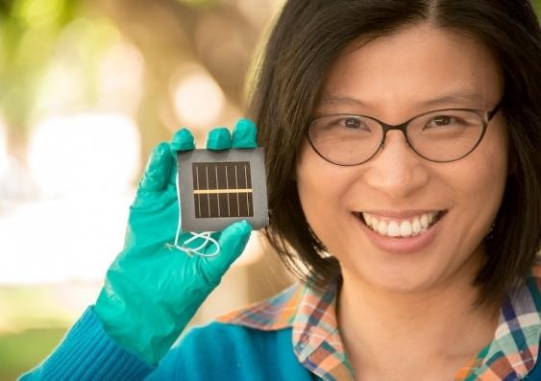

The University of New South Wales’ Dr Anita Ho-Baillie with the world-leading perovskite solar cell. Image: University of New South Wales.

## Case study 5: Dr Anita Ho-Baillie, the University of New South Wales

*Ground breaking research that is making solar cells more efficient has the potential to transform energy solutions and create new industries for regional and remote communities.*

The world records keep on coming.

University of New South Wales engineers hold the world record for the efficiency of a perovskite solar cell. Anita Ho-Baille’s team at the Australian Centre for Advanced Photovoltaics achieved the highest efficiency rating of 12.1% for the solar cell, with the results independently tested and verified in the United States.

UNSW has held the world record for solar cell efficiency for 30 of the last 32 years. And by next year, over

60 per cent of the world’s solar cells will use technology developed by Australian researchers.

“This is a very hot area of research, with many teams competing to advance photovoltaic design,” says Ho-Baillie.

“Perovskites came out of nowhere in 2009, with an efficiency rating of 3.8%, and have since grown in leaps and bounds. These results place UNSW among the best groups in the world producing state-of-theart high-performance perovskite solar cells. And I think we can get to 24% within a year or so.” Perovskite is a structured compound, where a material acts as the light-harvesting active layer. Its appeal comes from its low production and manufacturing costs.

“The versatility of solution deposition of perovskite makes it possible to spray-coat, print or paint on solar cells,” says Ho-Baillie. “We hope one day to be able to spray it on any building fabric, device or even cars.”

The research is part of a collaboration backed by $3.6 million in funding through the Australian Renewable Energy Agency’s solar excellence initiative.

The Australian Centre for Advanced Photovoltaics is a national research collaboration based at UNSW, whose partners are the University of Queensland, Monash University, the Australian National University, the University of Melbourne and the CSIRO Manufacturing Flagship.

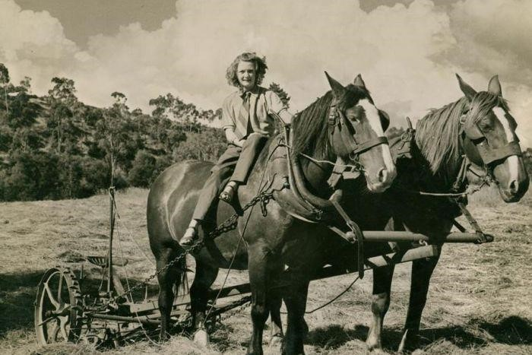

[An Australian woman](http://www.anu.edu.au/study/choose-anu/brody-hannan) [riding a hay mower, circa 1944. Image: Museum Victoria/ H.V. McKay Massey Harris Collection.](http://www.abc.net.au/radionational/programs/drawingroom/6484096) [Link to](http://www.abc.net.au/radionational/programs/drawingroom/6484096)[source.](http://www.abc.net.au/radionational/programs/drawingroom/the-forgotten-history-of-australian-country-women/6483744)

## Case Study 6: Joy Damousi, University of Melbourne

*Research into the forgotten women of Australia’s farms is helping to shed new light on the contribution that farm women have made to rural industries and communities throughout Australian history.*

They are invisible twice over. Having been written out of history by the great Australian myth of the ‘man on the land’ and largely sidelined by a city centric women’s movement - the women of the nation’s farms are now the subject of a $380,000 Australian Research Council grant to the University of Melbourne.

The national project is the first national history of farm women and will explore how gender inequality prevails in rural communities as well as how women have organised and their relationship to the land.

“The history of rural Australia is predominantly about man on the land in male dominated industries and women’s contributions are not as immediately prominent,” the University of Melbourne’s chief investigator Joy Damousi explains. “The project is about getting women’s voices and stories on the record.”

Partnerships are crucial to the linkage grant with the Museum of Victoria, the ABC, the Victorian government as well as rural communities and cultural groups also involved in the three-year project. There is also funding for two PhD students in the grant.

To date, a call from the ABC for the women’s stories has seen hundreds of responses, with the broadcaster airing the numerous stories and the project and now looking to put together a documentary on women the land. Museum Victoria have undertaken a huge social media and online campaign calling for stories and developed the website The Invisible Farmer project.

Professor Damousi said the impact of the research on rural communities was crucial, from the feeding back the stories gathered to the communities they came from to using the findings to help the state government develop policy on the needs of women in rural communities and industry to help them become more inclusive.

Just six months into the project, Professor Damousi has been surprised by the sheer scale of the reaction to the project.

“We’ve had a great response across Australia of how many women want to tell their stories and help us unearth a whole new perspective on Australian history and the land,” she said.

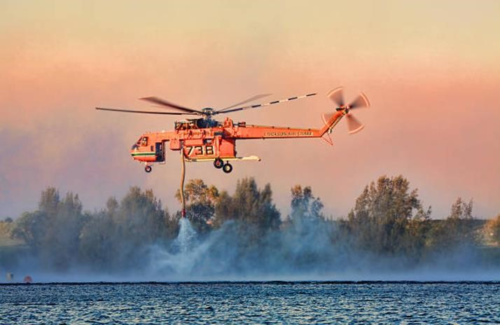

Victoria’s Bushfires Royal Commission estimated the cost of the Black Saturday bushfires alone at $4.4 billion. [iStock](http://www.istockphoto.com/au/photo/air-crane-fighting-extreme-bush-fires-gm458552811-28848410)[image.](http://www.istockphoto.com/au/photo/air-crane-fighting-extreme-bush-fires-gm458552811-28848410)

## Case Study 7: The Bushfire and Natural Hazards Co-operative Research Centre

*Group of Eight universities across Australia are coming together to tackle one of the most significant and growing problems that affect regional communities – to make better predictions that will make Australians safer and to inform better responses to natural disasters when they occur.*

The scales of measuring natural disasters are moving. Rapidly.

What used to be a one in 1000-year event might become a one in 500-year event. A one in 100-year event might become a one in 20-year event.

The Bushfire and Natural Hazards Co-operative Research Centre (CRC) is working to understand the impacts of these natural disasters.

“We’re seeing changes to length of fire seasons and the return intervals for major flood events,” the CRC’s chief executive Dr Richard Thornton explains.

Created in 2013 with $47 million in Australian government funding, the Cooperative Research Centre’s mission is to better predict, warn of and understand the impact of natural hazards, and how communities work together to address them.

Seven of the Group of Eight’s member institutions are involved in the CRC, partnering with the Federal Attorney-General’s Department, the Bureau of Meteorology, Geoscience Australia and a number of other Australian universities.

Group of Eight universities are involved in a suite of research projects, many driven by the impact of climate change, including:

* Bushfire predictive services: University of Melbourne, University of NSW and The Australian National University
* Flood and Coastal Management: The University of Western Australia and Monash University
* Economics and urban planning: The University of Adelaide, The University of Western Australia and The University of Melbourne
* Prescribed burning: The University of Sydney

As part of its work for the CRC, the University of Adelaide is modelling a number of ‘what if’ scenarios for Adelaide, Melbourne and Tasmania. Modelling will include scenarios for flooding, coastal inundation, earthquake, bushfire, heatwave and land-use allocation.

The research is based on the premise that to reduce both the risk and cost of natural disasters, an integrated approach is needed to consider multiple hazards and a range of mitigation options.

“Taking into account future changes in demographics, land use, economics and climate, the modelling will be able to analyse areas of risk both now and into the future, test risk reduction options and identify mitigation,” research leader Professor Holger Maier explains.

The CRC’s work also has a big impact on regional and rural communities who feel the brunt of bushfires and natural disasters resulting in close work with fire and land management agencies.

“The ultimate test is whether we end up with better and safer communities, which has to be underpinned by the best science,” Professor Thorton says.

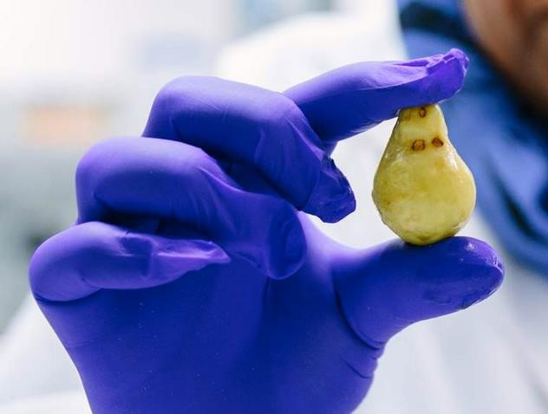

Researchers at the University of Queensland are commercialising the use of Kakadu plums to extend the shelf life of frozen foods. Image: University of Queensland[.](http://www.istockphoto.com/au/photo/air-crane-fighting-extreme-bush-fires-gm458552811-28848410) Link to source.

## Case study 8: Yasmina Sultanbawa, University of Queensland

*By taking a novel approach to food science using the Kakadu plum, an ingredient that Indigenous people have harvested for thousands of years, researchers are extending the shelf life of a major fisheries export.*

A fresh prawn has a shelf life of three or four days. But add the antimicrobial properties of the Kakadu Plum and its shelf life can be extended to 14 days.

The plum fix is used by 15% of Queensland’s aquaculture industry, worth about $80 million annually to the economy.

At the[Q](http://www.abc.net.au/radionational/programs/drawingroom/the-forgotten-history-of-australian-country-women/6483744)ueensland Alliance for Agriculture and Food Innovation, a UQ institute jointly supported by the Queensland Government, researcher Dr Yasmina Sultanbawa set out with the goal of finding a way to commercialise native plants in a way that engaged Indigenous communities.

Kakadu plum – a small green fruit the size of an olive – has potential in numerous sectors with a chemical profile that allows many and varied applications in the food ingredients, cosmetic and nutraceutical industries. When the extract is added to pre-prepared frozen meals, freezer life can be extended to a year.

Commercial production of ready-to-eat meals opens new markets and encourages Indigenous communities to expand wild harvesting.

Dr Sultanbawa is pleased that the health, economic, and employment benefits are flowing back to Indigenous communities. She also has high hopes that the industry can be replicated elsewhere.

“We hope to engage more Indigenous communities in the Northern Territory through regional hubs and have other native foods added to the value chain,” Dr Sultanbawa said. “Australian native plant foods are currently under-valued and thus present an enormous opportunity.”

The Queensland Alliance for Agriculture and Food Innovation aims to improve the competitiveness and sustainability of Queensland’s agriculture and food sectors through high impact science and creating direct links with agriculture and industry.

UNSW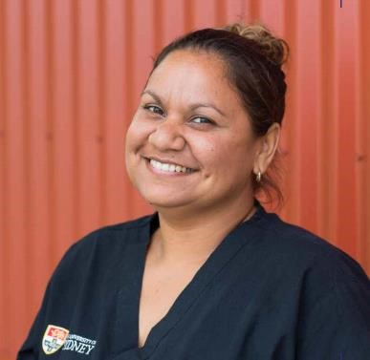

The University of Sydney’s Norma Binge. Image: University of Sydney.

## Case Study 9: Norma Binge, University of Sydney

*Working with the University of Sydney’s Poche Centre for Indigenous Health, Norma Binge is changing people’s lives in remote NSW communities through oral health.*

Norma Binge I can remember when there wasn’t a dental service in the Boggabilla northern NSW where she grew up. She couldn’t see a dentist 10 minutes by car in Queensland because of a border issue.

“I would have to travel to Moree in NSW which is over 100kms away, not knowing if there was road works or any other thing that could stop you from being on time. If you weren’t there on time, you would be turned away,” Binge recalls.

Now the Goomeroi woman works in oral health after applying for a job advertised for the University of Sydney’s Poche Centre for Indigenous Health in dental oral health for the Boggabilla, Toomelah, Mungindi and Moree communities.

Founded in 2008, the University of Sydney’s Poche Centre is predicated on working in collaboration with communities, consulting closely to understand community needs and develop mutual goals. The aim is to then develop sustainable, long-term improvements in health services and health outcomes for the people and communities.

Binge says the opportunity has changed her life dramatically. She has now finished a Certificate III in Dental Assisting, and Certificate IV in Oral Health Promotion. She is now studying ATSI Primary Health Care Practice through the Poche Centre Scholarship Program.

“Being hands on with patients and helping them change their lives through oral health has been very rewarding for me and I think also the people in these communities,’’ she says.

**Appendix 10:**

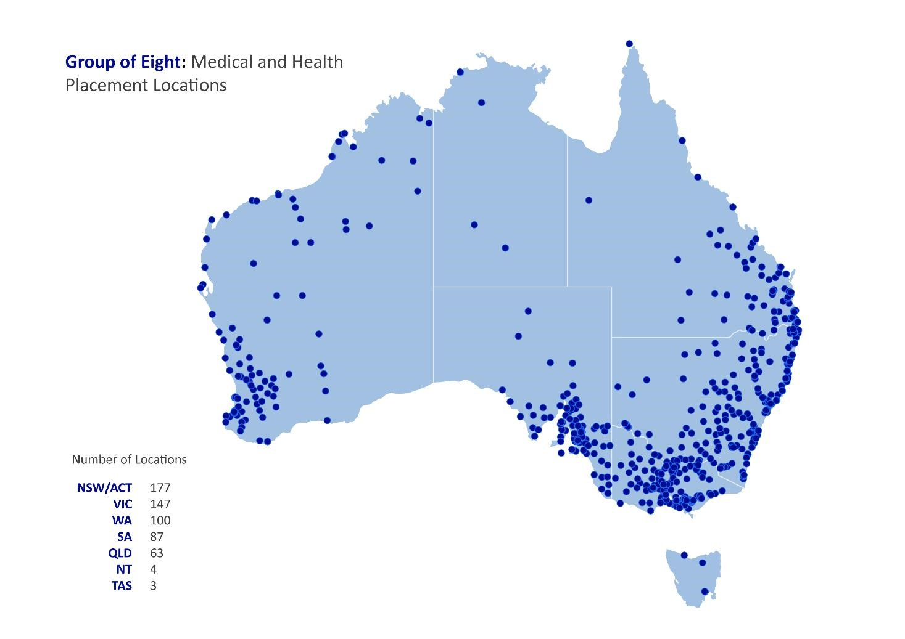

**Appendix 11:**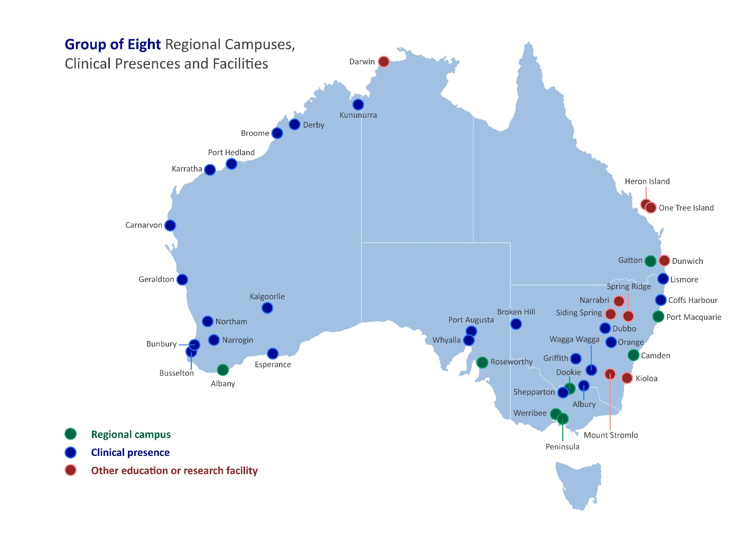

1. Department of Education, Selected Higher Education Statistics – 2015 Student Data
2. Department of Education, Selected Higher Education Statistics – 2015 Student Data
3. Greenhill, J. A., J. Walker, and D. Playford. "Outcomes of Australian rural clinical schools: a decade of success building the rural medical workforce through the education and training continuum." Rural & Remote Health 15.3 (2015).
4. Herd, Marie S., et al. "Preferred practice location at medical school commencement strongly determines graduates' rural preferences and work locations." Australian Journal of Rural Health 25.1 (2017): 15-21.
5. Department of Education, Selected Higher Education Statistics – 2015 Student Data
6. Department of Education, Selected Higher Education Statistics – 2015 Student Data
7. ACIL Allen, Evaluation of the HEPPP: Higher Education Participation and Partnership Program for the Australian Department of Education, 2016, (see Appendices, Figure D.5)
8. See *Australian Student Accommodation Market Update 2015*, “JLL’s analysis of the existing supply of PBSA…indicates that in all the major Australian metropolitan locations apart from Canberra, there is currently less than one bedroom of purpose built accommodation for every 10 students.” p. 9.
9. Excellence in Research Australia 2015[, http://www.arc.gov.au/era-outcomes-2015,](http://www.arc.gov.au/era-outcomes-2015) accessed 24 August 2017.