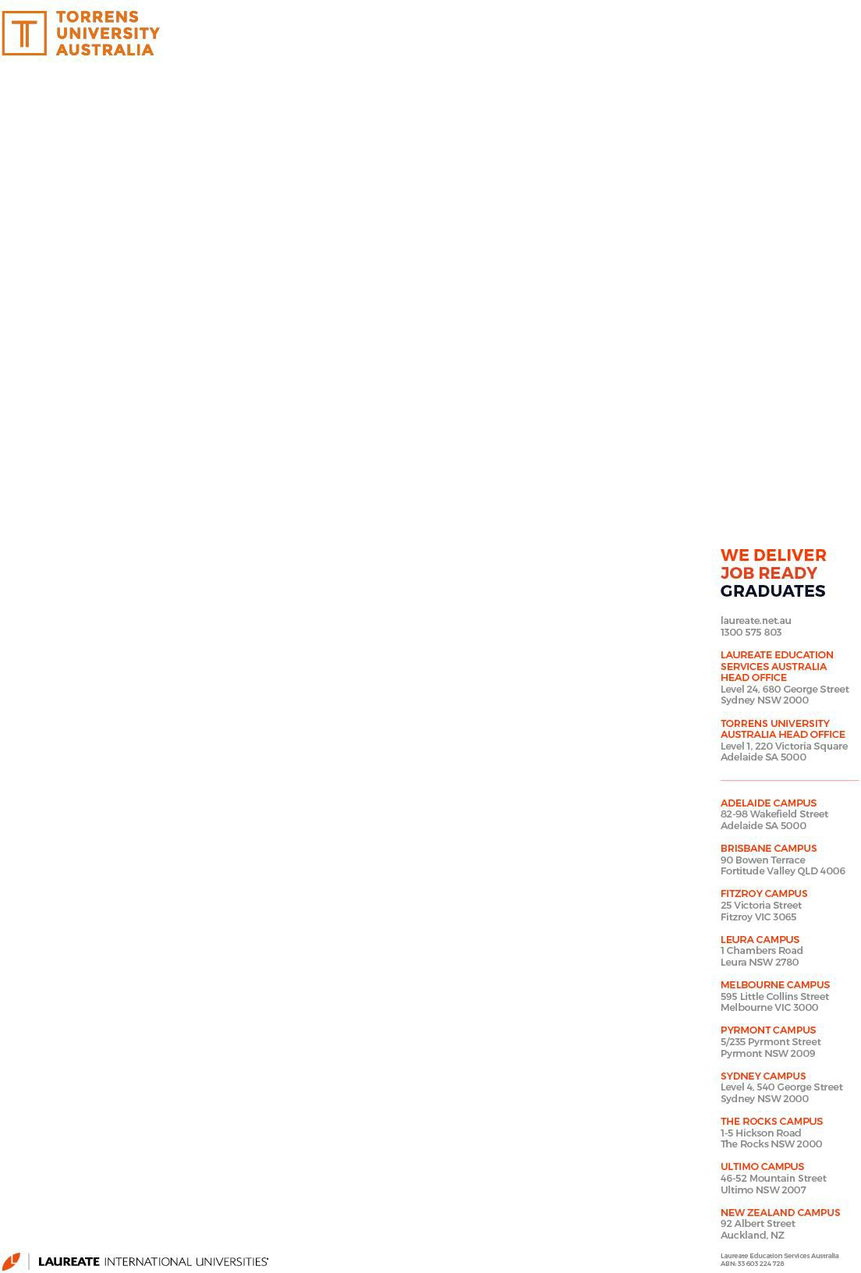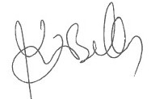

February 21, 2019

Professor Justin Beilby Vice Chancellor Torrens University

82-98 Wakefield Street

Adelaide SA 5000

Dear Mr. French,

I refer to your letter of 8 February 2019 in relation to the proposed Draft Model Code. Torrens University Australia has been monitoring your independent review of Freedom of Speech in Higher Education Providers and as such I have reviewed both your letter and the draft with interest.

We support the principles based approach reflected in the Model Code. We consider that the Model Code addresses matters of current relevance and, as you say, adds some clarity to the distinction between freedom of speech and academic freedom. We consider that academic freedom is something to be enjoyed by all the Torrens University community. We value and support the freedom of those teaching for and studying with us to speak and write without undue restriction to further legitimate intellectual and professional debates. We look forward to reviewing your final report together with any Model Code, which may be part of it.

Yours sincerely

Justin Beilby Vice Chancellor

Torrens University Australia