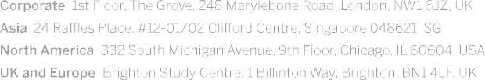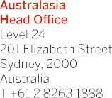



22 February 2019

To: The Hon Robert S French AC Suite 2, Level 13 Allendale Square

77 St George's Terrace Perth WA 6000

via: The Secretariat for Review of Freedom of Speech Quality and Access Branch, Higher Education Group Australian Department of Education and Training

*E:* [*freedomofspeechreview@education.gov.au*](mailto:freedomofspeechreview@education.gov.au)

Your Honour,

Thank you for your correspondence of 8 February 2019 inviting comment on the recommended draft Model Code that has been prepared in the course of the Independent Review of Freedom of Speech in Higher Education Providers.

Study Group Australia Pty Limited (SGA)1 believes a globally connected, diverse and innovative public and private education sector is vital to Australia’s future prosperity, intellectual capital and social cohesion. Accordingly, SGA welcomes this opportunity to provide comment on the draft Model Code. Our comment is brief and is presented in the following bullet points:

* SGA notes the draft Model Code’s applicability is currently limited to universities. Our comment herein is presented in the context that it is intended that the Model Code, in its next variant, be capable of application across all Australian registered higher education providers;
* SGA supports the intent of the draft Model Code, or some variant. This includes the principles enunciated in the definitions of ‘academic freedom’ and ‘the duty to foster the wellbeing of staff and students’. It also includes the ‘Principles of the Code’ set out on pages 4 – 6. A broadening of these principles with consideration of the diverse operational and educational models in the higher education sector would be required if they are to serve as umbrella principles that could create a framework for sector-wide sharing of experience and consistent application in practice; and
* Similarly, the proposed ‘Operation of the Model Code’ on pages 3 - 4 requires broadening to accommodate the diversity of sector operating models if the Model Code is to be reasonably capable of application across the sector.

SGA would be interested in and looks forward to the next reiteration of the Model Code and the related details of its intended implementation process, including timeframes, once this becomes available.

SGA has no objection to this response being published on the departmental website after publication of the final Report.

Yours sincerely,

Alex Chevrolle

Chief Operating Officer, ANZ

1 Study Group Australia Pty Limited (SGA) is a private Australian education institution providing pre-university, foundation, English language and higher education courses in partnership with a number of Australian universities and through SGA’s own Colleges. SGA is part of the global education provider, Study Group which has 85 campuses across the USA, Canada, the UK, Europe, Australia and New Zealand. Study Group educates students from every corner of the globe enabling them to realise their potential through a transformational learning experience. Approximately 60,000 students from 150 countries chose Study Group to provide them with life-changing learning experiences last year.