

The Hon Robert Fr ench AC Suit e 2, Leve l 13
Allendale Squa re
77 St George's Terr ace Pert h WA 6000

Dear Mr Fr ench

Thank you fo r your letter of 8 February regar ding the Draft Model Code ar isi ng from your Review of Freedom of Speech in Hig her Educat ion Providers.

At this stage Char les Dar win Unive rsity has no part icu la r commen t to make rega rding changes or furt her considerations in relation to the Draft Model Code, however we will be int erest ed to pa rt icipa t e in the Uni versit ies Australia (U A) plenary session on t his subject at the annual UA conference in early March and to hear the views of other universit ies and the peak bod y on what the code might mean in practice. I under st and UA will be providing feedback on t his matter to you after this conference . If the UA discussion raises issues that need further clarifi cat ion from Charles Dar win Univer sit y' s perspect ive, I wi ll fo llow up with you in early M ar ch.

Yours sincere ly

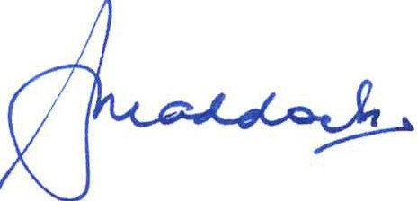

Professor Simon Maddock s
Vice-Cha ncello r and Presi dent 20 February 2019
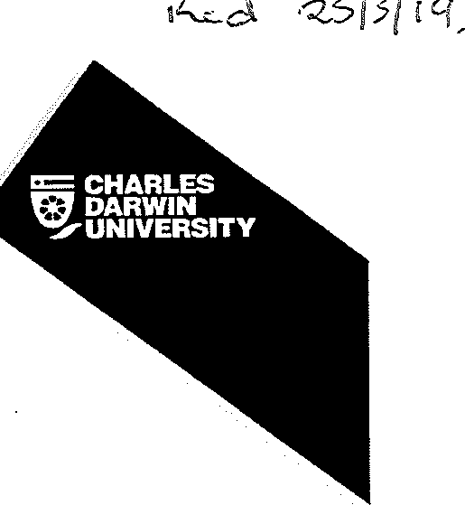

The Hon Robert French AC Suite 2, Level 13
Allendale Square
77 St George's Terrace Perth WA 6000

Dear Mr French

Further to my earlier letter to you regarding the Draft Model Code arising from your Review of Freedom of Speech in Higher Education Providers, I write to advise that following discussion at the Universities Australia meeting in February, Charles Darwin University supports the points made in the Universities Australia submission to you on this matter. We will not, therefore, be making a separate submission on the Draft Model Code.

Yours sincerely

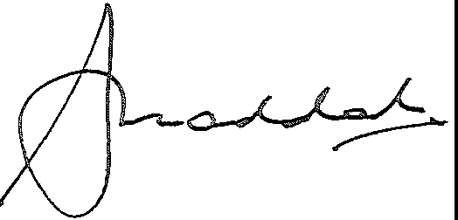

Professor Simon Maddocks
Vice-Chancellor and President 20 March 2019

