**Australian Government**

# Tertiary Education Quality and Standards Agency

GPO Box 1672

Melbourne VIC 3001 **teqsa.gov.au**

Level 14, 530 Collins Street [**enquiries@teqsa.gov.au**](mailto:enquiries@teqsa.gov.au)

Melbourne VIC 3000 **1300 739 585**

The Hon Mr Robert S French AC Suite 2, Level 13

Allendale Square

77 St George's Terrace PERTH WA 6000

Email: C/- [sulcsj@bigpond.com](mailto:sulcsj@bigpond.com)

Dear Mr French ,

# Subject: Independent Review of Freedom of Speech in Higher Education Providers - Draft Model Code

Thank you for your letter of 8 February 2019 providing a copy of a Draft Model Code. I have had an opportunity to discuss your letter, and the Draft Model Code, with my fellow commissioners, and this letter reflects our views.

In particular, we:

1. note your view that you have not been persuaded of the existence of a 'free speech crisis'
2. welcome the Draft Model Code's clarification of the distinction between freedom of speech and academic freedom;
3. welcome the proposed use of the Draft Model Code as an optional resource to support institutional approaches to these matters, while preserving institutional autonomy to deal with these matters in the context of institutions' relevant legal obligations.

Subject to a further opportunity to review any proposed amendments to the Higher Education Standards Framework and the *Higher Education Support Act 2003,* and to individual institutions having an opportunity to consider the application of the Code in the context of their own governance and operations, we do not anticipate that the Draft Model Code will raise substantial difficulties for TEQSA in performing its functions.

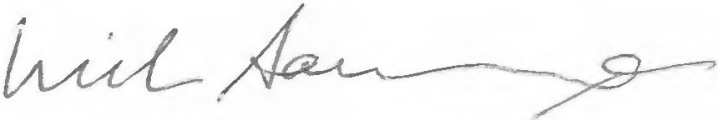I confirm that we are content for my correspondence to you to be published on the Department's website. Yours sincerely,

# Professor Nicholas Saunders AO Chief Commissioner

20 February 2019

**TEQSA**