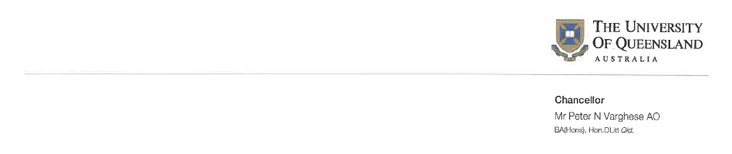

12 March 2019

The Hon Robert S French AC Suite 2, Level 13

Allendale Square

77 St George's Terrace Perth WA 6000

Email: [sulcsj@bigpond.com](mailto:sulcsj@bigpond.com)



The University of Queensland (UQ) appreciates the opportunity to comment on a draft voluntary Model Code to provide guidance on freedom of speech at universities. We acknowledge and appreciate the consultative and respectful approach that has been taken with this review. We agree with your observations that there is no 'free speech crisis'. The principles of Freedom of Speech are highly valued and core to the functions of universities in Australia.

We note the Universities Australia, University Chancellors Council and Go8 responses and agree that there are many complexities in respect of Federal, State and institution-specific legislation. We do, however, retain a less closed mind on a voluntary code.

The University's consideration of the proposed voluntary Code follows and is informed by earlier discussions about the broader concept of freedom of speech held with the University's Academic Board in 2018. The response below is a reflection of the views formed by the Senate, as discussed at its meeting on 25 February 2019.

It is apparent that the development of the voluntary Code has taken into account some of the specific elements of the higher education context. Our consideration of the proposed document has focused on the University's ability to implement the specific elements of the voluntary Code as a guide for decision-making. In this context, we offer the following comments.

Being cognisant of the intrinsic role of universities to encourage questioning, curiosity and diversity of thought, it is important that utmost care be exercised when considering guidelines for freedom of speech. While the voluntary Code aims to provide guidance on decision-making principles, it would be beneficial to introduce a preamble to articulate an overarching commitment to the importance of preserving freedom of speech as fundamental to the purpose of universities. Otherwise, why single out Universities as benefitting from a voluntary code on freedom of speech?

The voluntary Code provides a basis from which to work and we appreciate that the voluntary nature of the document would allow for variation to reflect institution-specific contexts. The University would need to consider the adoption of a voluntary Code in the context of the Enterprise Agreement, institutional policies and relevant legislative instruments. We recognise that the Human Rights Bill1 recently passed by Queensland Parliament will include provisions for freedom of thought, conscience and expression.

1 [https://www.parliament.qld.qov.au/DocumentsrrableOfficerrabledPapers/2018/5618T1767](http://www.parliament.qld.qov.au/DocumentsrrableOfficerrabledPapers/2018/5618T1767) pdf

Office of the Chancellor The University of Queensland Brisbane Old 4072 Australia

T +61 7 3365 1304

F +61 7 3365 1266

E [chancellor@uq.edu.au](mailto:chancellor@uq.edu.au) W [www.uq.edu.au](http://www.uq.edu.au/)

CAICOS PROVIDER NUMBER 000258

# Comments on Definitions:

We note the distinction drawn between freedom of speech and academic freedom and that the draft voluntary Code limits application of academic freedom provisions to academic staff. This does raise the issue of whether recognised subject matter experts hired into non-academic positions should have similar terms accorded to them. For example, should a Lecturer in Finance be given the right to exercise 'academic freedom' in matters relating to finance but the Chief Financial Officer be barred from doing so? The incoming UQ Enterprise Agreement2 (currently with Fair Work Australia) acknowledges that non-academic staff also have the right to comment and engage in debates as a recognised expert or as a person with recognised specialist knowledge.

We acknowledge that the definition of *'the duty to foster the wellbeing of staff and students'* expresses a principle that speech should not be intended to insult or humiliate and that the voluntary Code is not in place to protect people from feeling offended. However, there is a risk that the clause outlining the duty that a university;

*'supports reasonable and proportionate measures to prevent any person from using lawful speech which is intended to insult, humiliate or intimidate other persons and which* a *reasonable person would regard, in the circumstances, as likely to have one or more of those effects',*

could rely on subjective judgements that may be at odds with the clause noting that the duty to foster wellbeing;

*'does not extend to* a *duty to protect any person from feeling offended or shocked or insulted by the lawful speech of another.'*

The Senate strongly supported the latter but there was a widespread view that the former, whilst well intended, would be difficult to operationalise because of the judgement required to determine what may constitute humiliation, intimidation or insult.

# Comments on Section 5:

The University notes the distinction between internal and external speakers.

Section 5 helpfully provides universities with the ability to determine the terms and conditions that would apply to invited and external visitors. The ability to apply such terms to visitors would assist with operationalising the clauses relating to the duty to foster the wellbeing of staff and students; and may contribute to safeguarding the reputation of universities in terms of perceived endorsement of a speaker's content.

With reference to Section 5(d), we note that the matter of payment for security for controversial speakers has attracted significant public interest. The University encourages freedom of speech and in support of this position, believes it is appropriate to provide a reasonable level of security to enable events to proceed. However, the University is pleased to see that the draft voluntary Code provides the option to charge for security, which may be legitimate in cases where the required security would be beyond what reasonably could be expected to be provided, or where activities may put at risk our ability to deliver our core teaching and research functions. The 2014 speech by President Barack Obama at UQ serves as an example of an event where the University clearly was not in a position to provide the necessary security and cover the cost thereof.

Section 5(c) notes that the university may ... *'refuse permission to any invited visitor or external visitor to speak on university land or at university facilities where the content of the speech is or is likely to:*

*(iii) involve the advancement of theories or propositions which do not meet scholarly standards to such an extent as to be detrimental to the university's character as an institution of higher learning.'*

2 https://staff.ug.edu.au/files/13889/enter prise-aqreement-2018-2021-proposed.pdf

In discussing the proposed clause, Senate noted that the requirement to make a judgement about whether the topic being discussed by visitors meets scholarly standards would be difficult to operationalise and questioned whether making such judgements indeed could be counter to exercising the freedom of speech.

We thank you for the opportunity to provide comment on the draft voluntary Code.

Yours sincerely



Mr Peter N Varghese AO

# Chancellor

Professor Peter H0j AC

# Vice-Chancellor and President

Copies: Chair, Go8

Chair, Universities Australia

Convenor, University Chancellors Council Secretariat for Review of Freedom of Speech

*D19/15096-19*