

VCD19/76

11 March 2019

The Honourable Robert S French, AC Suite 2 Level 13 Allendale Square

77 George’s Terrace

Perth WA 6000

by email: [sulcsj@bigpond.com](mailto:sulcsj@bigpond.com)

**Office of the Vice-Chancellor** University of New England Armidale NSW 2351

Australia

**Phone** +61 2 6773 2004

[**vcadministration@une.edu.au**](mailto:vcadministration@une.edu.au)[**www.une.edu.au**](http://www.une.edu.au/)

Dear Mr French,

**RE: Response to Draft Model Code on Freedom of Speech in higher education institutions**

Thank you for your invitation to comment on the draft model code.

The University of New England takes pride in our commitment to freedom of speech and we note that you have found that there is not a crisis in this area at any Australian university.

As you are aware, the Universities Australia Plenary meeting last week considered the model code. I participated in that discussion and have little else to add. It would be regrettable if a proposed model code over-rode the policies which have been developed over many years and have served us well.

Yours sincerely,

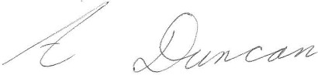

***Professor Annabelle Duncan Vice Chancellor and CEO University of New England***