

-

Minister for Health and Wellbeing Minister for Higher Education

Minister for Medical and Health Research Minister for Transport

Minister for Vocational Education and Skills

Member for Yerrabi

Mr Robert French AC Suite 2, Level 13 Allendale Square

77 St George's Terrace PERTH WA 6000

[sulcsj@bigpond.com](mailto:sulcsj@bigpond.com)

Dear Mr French

Thank you for your letter of 8 February 2019 inviting the ACT Government's comments on the Draft Model Code (the Draft) for higher education providers concerning freedom of speech and academic freedom.

Freedom of speech, expression, and intellectual inquiry of all persons are fundamental principles of any democratic society that should be safeguarded.

As I outlined in my response of 7 January 2019, the ACT has in place a number of legislative instruments that, in our view, provide significant protections for freedom of speech and academic inquiry. Those legislative provisions apply to everyone, regardless of their association with an institution of higher education.

Given that the adoption or modification of any codes of conduct is principally at the discretion of higher education providers, and based on our understanding that you are already in contact with Canberra's higher education providers as part of your review, we will refer to their views on the Draft at this time.

Thank you for providing me with an update on the progress of your review, and I look forward to hearing further in due course including final recommendations as the review reaches its conclusion.

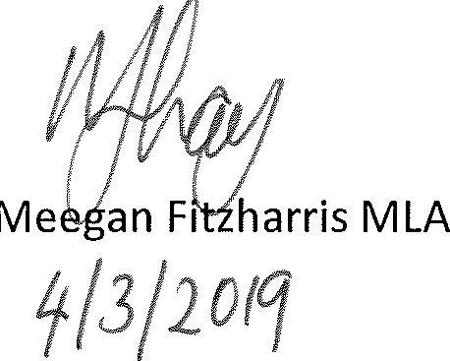Yours sincerely

**ACT Legislative Assembly**

London Circuit, Canberra ACT 2601, Australia GPO Box 1020, Canberra ACT 2601, Australia

**Phone** +61 2 6205 0051 **Email** [fitzharris@act.gov.au](mailto:fitzharris@act.gov.au)



@MeeganFitzMLA MeeganFitzharrisMLA **CANBERRA**