**Mr James Harris HonDUniv (NE) FRSN**

8 February 2019

The Hon Robert S French AC

**Chancellor**

University of New England Armidale NSW 2351 AUSTRALIA

**Phone** +61 2 6773 3445

[**chancellor@une.edu.au**](mailto:chancellor@une.edu.au)[**www.une.edu.au**](http://www.une.edu.au/)

By email: And to:

[freedomofspeechreview@education.gov.au](mailto:freedomofspeechreview@education.gov.au) [sulcsj@bigpond.com](mailto:sulcsj@bigpond.com)

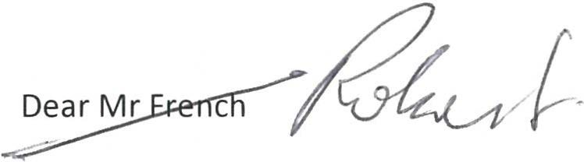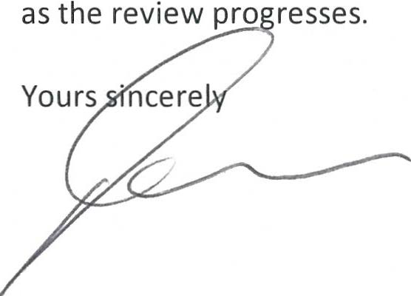

# Review of freedom of speech in higher education - University of New England

Thank you for your invitation to contribute to this review. The University of New England (UNE) has noted the contents of your letter dated 29 November 2018 to Mr Stephen Gerlach AM, the Chair of the University Chancellor's Council.

UNE does not have any specific matters to raise at this stage.

UNE is looking forward to receiving any observations you may make on the Higher Education Standards Framework and the draft Model Code. I note that universities will have the opportunity to respond to these.

In the meantime, set out below are some of the UNE policies and other instruments that may be relevant to your review:

l. UNE Intellectual Freedom Statement (https://policies.une.edu.au/document/view- current.php?id=283)

1. UNE Code of Conduct for Staff (https://policies.une.edu.au/document/view-current.php?id=140)
2. UNE Code of Conduct for Research (https://policies.une.edu.au/document/view-current.php?id=l06)
3. UNE Media Policy (https://policies.une.edu.au/document/view-current.php?id=91)
4. UNE Social Media Policy (https://policies.une.edu.au/document/view-current.php?id=166)
5. UNE Code of Ethics for UNE Council (https://policies.une.edu.au/document/view-current.php?id=83)
6. UNE academic staff collective agreement, which applies to the employment of academic employees ([https://www.une.edu.au/documents/hr/une-academic-and-elc-teaching-staff-collective-agreement-](http://www.une.edu.au/documents/hr/une-academic-and-elc-teaching-staff-collective-agreement-) 2014-2017, noting in particular clause 9)

I trust that these documents are of assistance. I look forward to receiving a further communication from you

# James Harris Chancellor