T H E U N IV E RS IT Y OF
@
-
NOTRE DAME
A U S T R A L I A

Office of the Vice Chancellor

20 December 2018
287-l SL

The Hon Robert S French AC Chancellor
The University of Western Australia

By email: freedomofspeechreview@education.gov.au

Dear Chancellor

I refer to your letter dated 19 November 2018 with respect to the independent Review of Freedom of Speech in Higher Education which you have been asked to undertake by the Commonwealth Minister for Education.

We appreciate the collaborative spirit with which you hope you to conduct the Review and are very happy to provide you with the materials you request. Please find attached to this letter a document containing hyperlinks to publicly available information and copies of relevant information which may not be in the public domain. In relation to the latter, we are providing it on a confidential basis for the purposes of your consideration of existing principles and practices and would request a further discussion with you should you seek to make any of this publicly available.

We are pleased to note in your letter that in undertaking this review the focus will be on "institutional measures consistent with the need to respect the legitimate institutional autonomy of universities". We also note your understanding that there is a "distinction and degree of overlap between general concepts of freedom of expressive conduct and academic freedom" and your stated hope of addressing this distinction in the Review. We are of the view that a clear analysis and statement regarding the nature of each of these two concepts individually and the relationship between them is most urgent, and strongly encourage you to include it. We would suggest that some of the following issues might also be worth considering:

- The nature and extent of the institutional autonomy of universities in Australia today with particular reference to the nature and extent of what is often called "institutional academic freedom", (i.e. the right of the University to determine, on academic grounds, who may teach, what may be taught, and who may be admitted to study);
- The intersection between the institutional academic freedom/ institutional autonom y referred to above and individual academic freedom; the situations in which they conflict, and the articulation of general principles which may be used to guide resolution of these conflicts;
- The identification and articulation of the responsibilities (if any) which sit alongside both the concepts of institutional autonomy and individual academic freedom;
- The nature of the relationship between the university and its students and the rights, duties and responsibilities of both; and

HH::M:ili N:ii+i::11Hi:19
19 Mouat Street (PO Box 1225) Fremantle WA 6959 u
T +6' 8 9433 0850 F +61 8 9433 0855 vc@nd.edu.au
notredame.edu.a

r I rov,d c 0'032f Broome Campus R8 Guy Street (PO Box ?287) Brome WA r72 Sydney Campus 140 Bra, Jway (PO Bex 944) NSW 2007

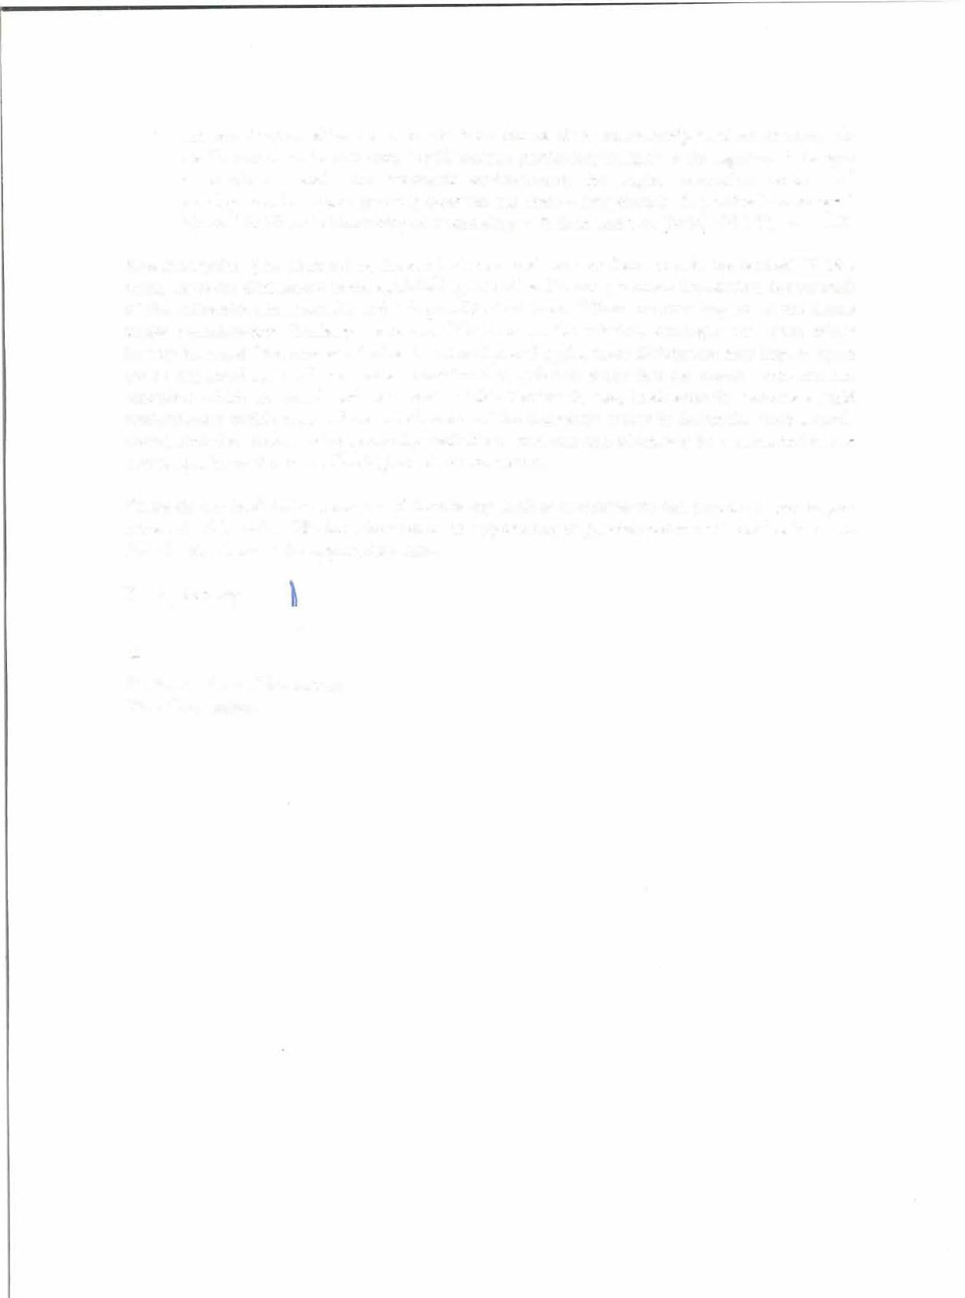
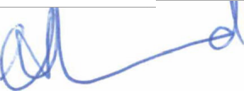
- An examination of the extent to which the nature of the relationship between an academic staff member and a university is still 'unique' particularly in light of the significant changes to academic work, the academic environment, the higher education sector and employment law more generally over the last three - four decades (a point acknowledged, Nettle Jin Victoria University of Technology v Wilson and Ors [2004] VSC 33, para 148).

As a final point, (and as noted by the original court and the appellate court in the case of UWA v Grqy,) there are differences in the establishing acts of parliament (or other foundation documents) of the universities in Australia and it is possible that these differences may impact on the issues under consideration. Similarly, there are differences in the mission, strategies and what might loosely be called "the character' of each university, and again, these differences may impact upon (or be impacted by) the issues under consideration. It is important that the Model Code and the resources which are developed as a result of this Review do not, inadvertently, become a rigid straightjacket which undermines the diversity of the university sector in Australia. Such a result would limit the choice and opportunity available to students and ultimately be detrimental to the overall quality of the Australian higher education sector.

Please do not hesitate to contact us if there is any further assistance we can provide to you as you undertake this review. We look forward to an opportunity to provide comment/ feedback on the draft Model Code at the appropriate time.

Yours sincerely

Professor Celia Hammond Vice Chancellor

