

The Hon Mr Robert S French AC Suite 2, Level 13

Allendale Square

77 St George’s Terrace PERTH WA 6000

Email: C/- [sulcsj@bigpond.com](mailto:sulcsj@bigpond.com)

GPO Box 1672

Melbourne VIC 3001

Level 14, 530 Collins Street

Melbourne VIC 3000

**teqsa.gov.au** [**enquiries@teqsa.gov.au**](mailto:enquiries@teqsa.gov.au) **1300 739 585**



Dear Mr French,

# Subject: Independent review of policies supporting freedom of expression and intellectual enquiry in Australian higher education

Thank you for your request for information regarding the practical operation of the provisions of the *Higher Education Standards Framework (Threshold Standards) 2015* (HES Framework) that are relevant to your independent review.

As you would be aware, the HES Framework includes the following specific requirements in relation to freedom of expression and intellectual enquiry:

1. the governing body of each provider takes steps to ’…develop and maintain an institutional environment in which freedom of intellectual inquiry is upheld and protected…’ (Standard 6.1.4),
2. Higher Education Providers have ’a clearly articulated higher education purpose that includes a commitment to and support for free intellectual inquiry in its academic endeavours.’ (Provider Category Criterion B1.1.2).

TEQSA is aware of very few cases in which these issues have been raised as complaints or concerns. The only regulatory decision which has been made in relation to these issues involved the imposition of a condition in June 2014 on the initial registration of a provider of theological studies. The details of the condition and the basis of the decision can be found on the [National Register of Higher Education](https://www.teqsa.gov.au/national-register/condition-decision/initial-registration-10-jun-2014-1) [Providers](https://www.teqsa.gov.au/national-register/condition-decision/initial-registration-10-jun-2014-1) (National Register) entry for Sheridan College Inc. The condition was revoked in November 2014 when TEQSA was satisfied that the condition had been met and this subsequent decision can also be found on the [National Register.](https://www.teqsa.gov.au/national-register/condition-decision/revoke-registration-conditions-13-nov-2014-1)

As mentioned at the Supplementary Senate Estimates in October 2018, TEQSA is seeking information from the University of Sydney (the University) about the incident reported in the media on 25 September 2018, concerning Bettina Arndt’s speaking engagement at the University. The University has advised that the outcome of an external investigation will be reported to TEQSA in 2019.

TEQSA raised the issue of freedom of expression with TEQSA’s Student Expert Advisory Group, whose members comprise student leaders of national bodies at undergraduate and postgraduate levels from public and private higher education providers of the sector. Members of the group advised that in their experience freedom of expression did not seem to be under threat and was not a major issue for them.

TEQSA is part of an international network of quality assurance agencies that could be drawn on to inform a comparative international approach. I would be very happy to assist you with making contact with other agencies whose work may be of interest to you.

A key challenge will be reconciling an overall commitment to freedom of speech with the wording of certain institutional policies, such as policies on equity and diversity, anti-bullying, and codes of conduct. The aforementioned requirements in the HES Framework and [TEQSA’s guidance note on diversity and](https://www.teqsa.gov.au/latest-news/publications/guidance-note-diversity-and-equity) [equity in higher education](https://www.teqsa.gov.au/latest-news/publications/guidance-note-diversity-and-equity) both acknowledge the need for providers to meet their responsibilities for safeguarding freedom of intellectual enquiry in the context of other duties and responsibilities.

Please do not hesitate to contact me if you would like to meet to discuss the above information. Yours sincerely,

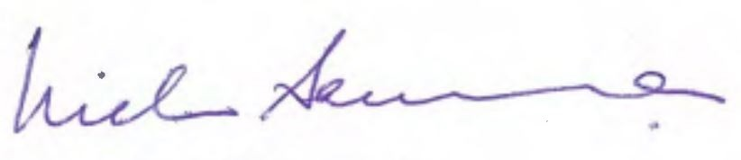

# Professor Nicholas Saunders AO Chief Commissioner

19 December 2018