

**Queensland**

Government

Office of the

Minister for Education and Minister for Industrial Relations

**2,9 JAN 2019**

The Honourable Robert French AC

Email: [freedomofspeechreview@education.gov.au](mailto:freedomofspeechreview@education.gov.au)

1 William Street Brisbane 4000 PO Box 15033 City East Queensland 4002 Australia

Telephone +61737197110

Email: [education@ministerial.qld.gov.au](mailto:education@ministerial.qld.gov.au)

Email: [industrialrelations@ministerial.qld.gov.au](mailto:industrialrelations@ministerial.qld.gov.au)

Dear Mr French

Thank you for your letter dated 4 December 2018 seeking advice on any state legislation, administrative policies or principles that may be of relevance to the Review of Freedom of Speech in Australian Higher Education. I have been asked to respond on the Minister's behalf, and I apologise for the delay in responding.

A copy of your request, together with the Terms of Reference for the review, has been circulated across Queensland Government portfolios. An indicative list of relevant legislation is as follows:

* *Anti-Discrimination Act 1991;*
* *Defamation Act 2005;*
* *Multicultural Recognition Act 2016;* and
* *Public Sector Ethics Act 1994.*

In addition, the *Human Rights Bill 2018* (the Bill) was introduced into the Queensland Parliament on 31 October 2018. I am advised that, if passed, the legislation will impose an obligation on public entities, as defined, to act and make decisions in a way that is compatible with human rights. The human rights protected under the Bill currently include the right to freedom of expression. The Bill and Explanatory Notes can be accessed online at [www.legislation.qld.gov.au/view/html/billf.irst/bill-2018-076.](http://www.legislation.qld.gov.au/view/html/billf.irst/bill-2018-076)

No additional Queensland Government administrative polices or principles have been identified as relevant to the review. This is consistent with the Queensland Government's limited regulatory functions in relation to higher education providers, which generally relate to their broader status as public sector entities and statutory bodies.

If you require further information or assistance, please contact Ms Pia St Clair, Assistant Director-General, Strategic Policy and Intergovernmental Relations, by email at [pia.stclair@qed.qld.gov.au](mailto:pia.stclair@qed.qld.gov.au) or on (07) 3034 5905.

I trust this information will be of assistance in the review process. Yours sincerely

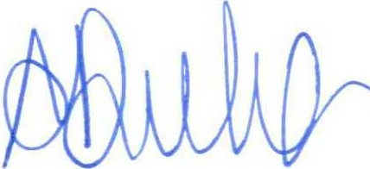

**SHARON DURHAM**

**Chief of Staff**

**Office of the Hon Grace Grace MP Minister for Education and Minister for Industrial Relations**

Ref: 18/19814