**OFFICE OF THE VICE - CHANCELLOR**

**Professor S Bruce Dowton**

MB BS MD FACMG FRACP

Vice -Chancellor and Pre ident

**MACQUARIE**

University

SYD NEV· AUSTRALIA

14 December 2018

The Hon Robert S French AC Suite 2, Level 13

Allendale Square

77 St George's Terrace Perth WA 6000

Emaii: [fr eedomofs peechreview @education. gov.au](mailto:freedomofspeechreview@education.gov.au)

Dear Mr French,

**Review of Freedom of Speech in Higher Education**

Thank you for your letter of 29 November 2018 on the review of freedom of expression and intellectual inquiry.

I am writing to advise that your Review Secretariat will be able to locate all of the relevant material from Macquarie University on our website, starting with the *Academic Senate Statement on Academic Freedom* and with related documents linked to our *Academic Integrity Policy.* There are no relevant non-confidential reviews which the University has undertaken in this area.

The Macquarie University Academic Senate has resolved to undertake an inquiry into academic freedom as a special project in 2019.

You will see from the *Academic Senate Statement on Academic Freedom* that academic freedom 'is fundamental to the values that Macquarie University upholds and strives to cultivate in the wider society'. With that in mind, I have recently joined other Australian Vice-Chancellors in restating 'our enduring commitment to academic freedom and intellectual inquiry [as well as] our enduring commitment to freedom of expression on our campuses and among our staff and students'.

I wish you well with your Review and would of course be happy to provide any further information you might need.

Yours sincerely,

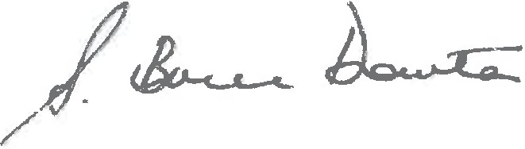

S Bruce Dowton

Vice-Chancellor and President

Macquarie University NSW 2109 Australia

T: +612 9850 7440

**E:** [vc@mq.edu.au](mailto:vc@mq.edu.au) mq.edu.au

ABN 90 952 Bol 237

CRICOSProvider0 000 2J