

**DEAKIN**

The Hon Robert S French AC

Review of Freedom of Speech in Higher Education

By email [<freedomofspeechreview@education.gov.au>](mailto:freedomofspeechreview@education.gov.au)

14 December 2018

Dear The Hon Robert French AC

Thank you for the opportunity to provide input to the Review of freedom of speech in higher education.

Deakin University believes that free intellectual inquiry in learning, teaching and research is the cornerstone of Australian universities. Academic freedom is a *raison d'etre* of public funding as described in the objects of the *Higher Education Support Act 2003.*

Your request has catalysed internal analysis of policy and procedures relating to academic freedom, and will serve as useful preparation for cyclical review of Deakin's *Academic Freedom policy* already scheduled for 2019.

The policy frameworks governing Deakin's approach to academic freedom and freedom of expression are attached. These are publicly accessible in Deakin's Legislation and Policy Library , but some additional internal documents have been identified, and are also attached.

In auditing Deakin's policies, internal stakeholders were asked to identify instances where issues relating to freedom of expression and academic freedom arose during 2018. Two instances were identified that involved freedom of expression, but also the manner in which views were expressed:

* A staff member's social media post
* A student's contributions to a subject discussion board.

Acaden:1ic freedom and freedom of expression are important issues but, as is evident at Deakin where there is clear policy guidance given to staff and students, it is rare that these issues emerge and require attention. This allows Deakin to direct focus and attention to substantive issues of providing students with an outstanding education and undertaking world class research.

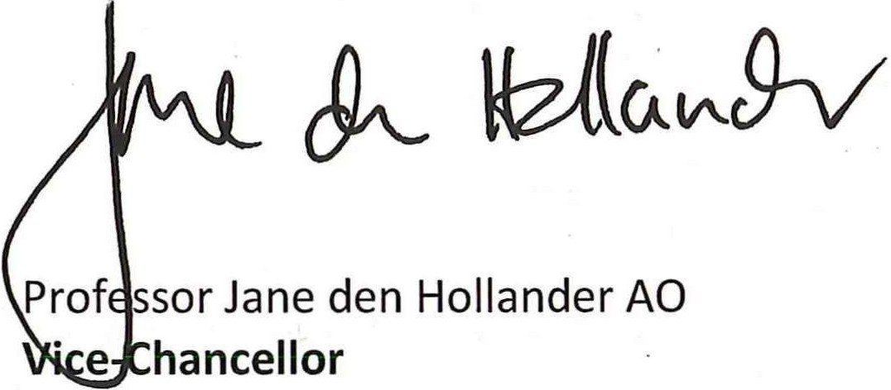I would be happy to discuss the factors contributing to Deakin's successful management of these issues. Yours sincerely



Deakin Univers i t y CRICOS Provider Code: 00113B

**Deakin University Legislation and Policy Relating to Academic Freedom**

All policies listed can be found in Deakin's Legislation and Policy Library, except the Enterprise Agreement for which an additional hyperlink is provided.

<http://www.deakin.edu.au/about-deakin/leadership-and-governance/legislation-and-policy-library>

**The Deakin University Act** includes the following as one of the University's objects (noting the objects of all Victorian universities are uniform):

1. *to serve the Victorian, Australian and international communities and the public interest by­*
   1. *enriching cultural and community life;*
   2. *elevating public awareness of educational, scientific and artistic developments;*
   3. *promoting critical and free enquiry, informed intellectual discourse and public debate within the University and in the wider society;*

**Academic freedom policy**

1. *The University recognises and values the right to academic freedom as central to its endeavours in scholarship, teaching and research and is committed to its promotion and protection within the University. It supports the right of its scholars to engage in critical inquiry and robust and unfettered*· *critical debate. It recognises and promotes a diversity of opinion and the right to express that opinion freely.*
2. *The University recognises that in the exercise of t_he right to academic freedom there is a duty and obligation on Academic staff to act responsibly and in good faith.*
3. *Academic freedom includes the rights of all Academic staff, within their area of expertise, to:*
   1. *exercise the right of academic freedom without fear of harassment, bullying, intimidation or unfair treatment and/or*
   2. *speak, write and publish, or perform, create and exhibit, without being subject to University sanction, censorship or discipline.*
4. *In addition, staff can make other comments provided they do so solely in their private capacity. A comment will not be in a private capacity if the person is identified as (or reasonably identifiable as) making the comment as a Deakin staff member or using Deakin technology and equipment.*

{8} Clauses {6} and {7} include expression of unpopular or controversial views, but does not provide any right to harass, vilify, defame or intimidate other persons or to demean alternate points of view.

(9) By recognising, promoting and supporting the right to academic freedom the University does not imply endorsement of particular views expressed by Academic staff The views expressed are the views of the Academic staff even though an affiliation with the University is indicated. Views on behalf of the University can only be expressed by officials and executives because of the position they hold or by other University staff if specifically authorised to do so.

{10} Academic freedom is not a defence for acting unlawfully or for poor behaviour or disrespectful treatment of others and in their exercise of academic freedom Academic staff will at all times also observe the University's Code of Conduct.



Deakin Unil tersity CRICOS Pro vider Code : 00113B

**Deakin University Enterprise Agreement 2017**

[**http://www.deakin.edu.au/**](http://www.deakin.edu.au/) **data/assets/pdf file/0003/1062966/EA-2017.pdf**

Intellectual Freedom

5.1 The Parties to this Agreement are committed to act in a manner consistent with the protection and promotion of intellectual freedom within the University.

. 5.2.The Parties to this Agreement recognise that the University has a policy that enables a staff member to make public comments on a topic within their area of expertise and also to make other comments as Jong as the staff member does so in their private capacity and does not claim to represent the University when making these comments. This will include the expression of unpopular or controversial views provided that they do not harass vilif y defame or intimidate. Further details are set out in the policy and associated documents.

5.3 The University undertakes to consult staff members and the NTEU on any proposed changes to the relevant policy which might otherwise affect the freedom of staff members to provide public comment on community affairs as individual members of the community or to provide public comment in their particular area of expertise.

**Relevant policies**

Academic Integrity Policy

Admission Criteria and Selection (Higher Education Courses) Policy Assessment (Higher Education Courses) Procedure

Media Policy

Research Conduct Policy (and related research integrity suite) Social Media Policy

Statute 9.1 and Regulation 9.1.1 - Intellectual Property Student Code of Conduct

Student Complaints Resolution policy Student Complaints Resolution procedure

**Relevant University property regulations and policy**

Regulation 6.1.2 (3)

Event and Visitor Protocol Procedure Critical Incident Management Policy Security Procedure

**Relevant internal Guidelines**

Unit guide available to students on rights and responsibilities (attached) Event Management Workflow (attached)

Commercial Events - Venue Work Hire Instructions (attached) Event Risk Management Assessment Form (attached)

Deakin Venue Hire Agreement - Terms and Conditions (attached).