

**Independent Review into Regional,**

**Rural and Remote Education**

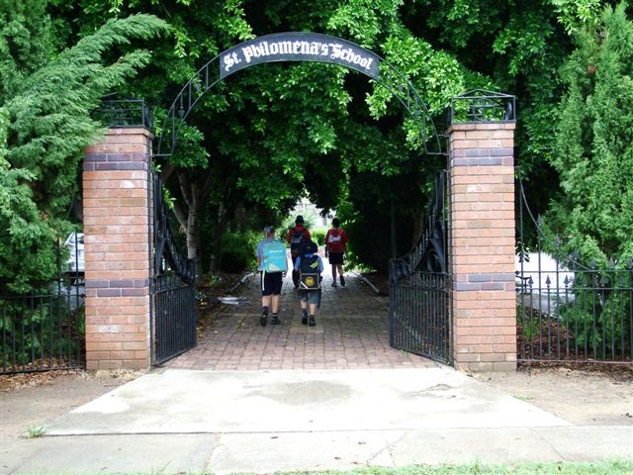

St Philomena’s School, Moree (Founded 1898)

Submission from Catholic Education Commission, NSW

# September 2017

# 

## Contents

Page

**Foreword** ........................................................................................................................... 3

1. **Recommendations** ...................................................................................................... 4
2. **New South Wales Catholic Education** ......................................................................... 6
3. **Raising Achievement** ................................................................................................ 10
   1. Improving Funding – What the Evidence Shows .................................................. 11
   2. Addressing Cross-Sector Co-operation – Greater Efficiency and Effectiveness .... 13
   3. Early Childhood Education and Transition to School ........................................... 15
   4. Recruiting and Developing Quality Teachers and Leaders ................................... 18
   5. Teacher Housing and Improved Buildings ........................................................... 22
   6. Information Communication and Technology ..................................................... 24
   7. Boarding Schools – Keeping in Touch with Community ....................................... 26
   8. Transition between Schools and Beyond Schooling – Planning with Data ........... 29
4. **Conclusion**  ................................................................................................................ 34
5. **Contact**  ..................................................................................................................... 34

## Foreword

Catholic Education Commission, NSW (CECNSW), which represents 256,000 students in some590 schools welcomes the opportunity to provide a submission to the Independent Review into Regional, Rural and Remote Education. CECNSW’s monitoring of the increasing educational disparity between metropolitan and non-metropolitan schools and communities in NSW, and indeed Australia, has been of significant and increasing concern for NSW Catholic education. CECNSW is encouraged by the appointment of Emeritus Professor Halsey to Chair this review. The Catholic Education Commission, NSW wishes to acknowledge from the outset that educational disadvantages for non-metropolitan schools, students and communities are unique, long-standing, and transcend state and sector jurisdictions. Statistics in this submission highlight that inequalities in non-metropolitan NSW and Australia are more nuanced than a simplistic urban/rural divide, and that issues and barriers to equitable educational opportunity differ for schools in coastal and inland communities, and for schools in large and small towns. CECNSW knows that schools are important in local communities; and many Catholic schools in non-metropolitan NSW positively influence postschool life trajectories of non-metropolitan students.

For consistency and national comparability, school locations are classified to the ABS 2011 Australian Geographical Standard Remoteness Structure. Metropolitan schools are those located in the Major Cities geography, and non-metropolitan schools are located in Inner Regional, Outer Regional, Remote and Very Remote NSW.

CECNSW is committed to improving opportunity and educational outcomes for non-metropolitan Catholic schools and students. CECNSW firmly believes that nuances and diversity in non-metropolitan schools and communities can only be identified and contextualised by exploring data at school-level granularity. CECNSW is committed to this review, and offers the Review Committee access to our extensive national longitudinal educational and population datasets, together with support from the Catholic Education Commission’s staff to provide the review panel with comprehensive sectoral and jurisdictional-neutral,, school-level data.

CECNSW believes that recommendations in this submission will benefit the majority of schools and communities in regional, rural and remote Australia.

## A. Recommendations

The Catholic Education Commission NSW makes the following recommendations, after consulting our dioceses and schools in relation to themes in Professor Halsey’s stimulus paper:

1. Amend the *Australian Education Act* to better align national funding practices and requirements with objective need by increasing the location loading for schools.
2. Facilitate funding arrangements across sectors for two or more schools operated by different school proprietors that enable: (i) the employment of specialist teachers as a shared resource; (ii) the sharing of educational facilities; and/or (iii) the joint governance of one viable school (whether government or non-government) where each school lacks viability.
3. Revise the criteria for use of school funding to permit the conduct of extended Transition to School Programs for students prior to kindergarten commencement, in disadvantaged rural communities where the national (COAG) commitment to provide one year of pre-school education cannot otherwise be met.
4. Invest in the recruitment and development of quality teachers and leaders to work in rural and remote regions including primary teachers and secondary teachers in core and specialist areas as well as suitably qualified school-based VET teachers.
   1. Fund the development of early career principals to succeed in the complex role of leadership in rural and regional areas.
   2. Build partnerships between education, government and industry to recruit quality graduates through teacher scholarships, financial incentives, teacher exchange programs, locum arrangements across states and systems, as well as the provision of teacher incentives including housing, relocation expenses, schooling for children and spouse employment.
   3. Fund in-school professional development strategies to better form the skills of inexperienced teachers who disproportionally staff schools in remote and regional areas.
5. Provide capital funding to meet nationally accepted standards in relation to both teacher housing and access to schools for people with disabilities in rural areas.
   1. Provide funding to build and maintain safe, secure, quality housing for teachers serving schools in disadvantaged isolated school communities.
   2. Provide funding to modernise all rural school buildings to meet Access Standards under the Disability Discrimination Act.
6. Complementary to the NBN initiative, invest in Information Communication and Technology (ICT) in disadvantaged rural communities.
   1. Provide ICT access to all disadvantaged regional and remote schools and communities, comparable to metropolitan services.
   2. Provide all disadvantaged rural students K-12 with up-to-date ICT devices, including adaptive technologies, with appropriate security and maintenance.
   3. Expand opportunities for disadvantaged rural students to enrol in distance education to provide a breadth of subject choice in the senior secondary years of schooling, while also extending this support to the middle years of high school.
7. Promote boarding programs that better maintain links with families and communities.
   1. Promote the development of weekly boarding schools (4 nights at school, 3 nights at home) in regional hubs where students board within 3 hours of home).
   2. Improve transport support for disadvantaged boarding students from remote areas by including air travel subsidies and subsidising mid-term travel.
8. Develop cross-sectoral and cross-state data collection and sharing to improve transitions between schools and post schooling education and training providers, particularly for Aboriginal and Torres Strait Islander students especially in the areas of Vocational Education and Training (VET), career education and Transition Support services.
   1. Adopt a more cross-sectoral approach, in relation to data-sharing and delivery, for students who move between rural schools, regions, sectors and across state borders. In this context CECNSW acknowledges the greater mobility of Aboriginal families and seeks to work with other agencies to better support educational choices for Aboriginal families while promoting school attendance and retention.
   2. Increase funding to support a national approach to identifying the post-school destinations of all students, to better provide regional and remote students with Vocational Education and Training, Career education and Transition Support services.

## B. New South Wales Catholic Education

Catholic Education Commission, NSW is the Australian Education Act Approved System Authority and Representative Body for Catholic schools in NSW, providing leadership in Catholic education, through service to Dioceses, Religious Institutes and Parents. CECNSW functions through consultation with Diocesan Directors of Catholic Education, Religious Institutes, Principal and Parent associations. The majority of NSW Catholic schools are administered by eleven Diocesan Catholic Schools Offices (CSO), with 46 schools administered by Religious Congregations.

Eight of the eleven dioceses – Armidale, Bathurst, Canberra & Goulburn, Lismore, Maitland-Newcastle, Wagga Wagga, Wilcannia-Forbes and Wollongong have schools in non-metropolitan NSW (Figure 1), and this submission draws on the expertise from these dioceses and Principals from Congregational boarding schools and regional and remote Catholic schools as they best understand the unique issues for non-metropolitan Catholic schools in NSW.

**Figure 1**: NSW Catholic Dioceses

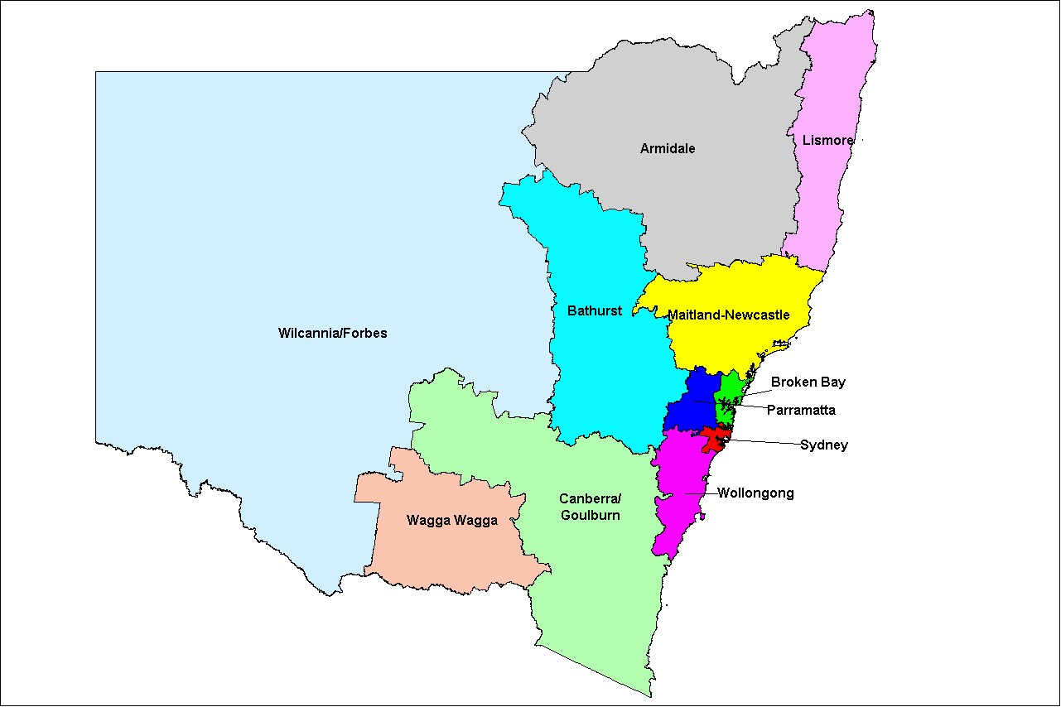

In 2016, the NSW Catholic sector educated 255,775 students and employed more than 30,000 people in 588 schools. The NSW Catholic sector is the fifth largest education system in Australia, behind the New South Wales, Victorian, Queensland and Western Australian government school systems (*ABS Schools Australia 2016*). It is Australia’s largest non-government provider of school education, comprising one-third of Australia’s Catholic school students.

204 NSW Catholic schools, or 35% of Catholic schools in NSW are located outside of the ABS NSW major cities geography (as Figure 1 shows), including 12 schools in remote NSW and 4 in very remote NSW). Regional, rural and remote NSW Catholic schools educate 26% of primary students and 21% of secondary students, as well as 23% of our Students with a Disability and 49% of our Aboriginal and Torres Strait Islander students.

**Figure 2**: Non-metropolitan Catholic schools (blue diamonds) overlayed on ABS Remoteness areas

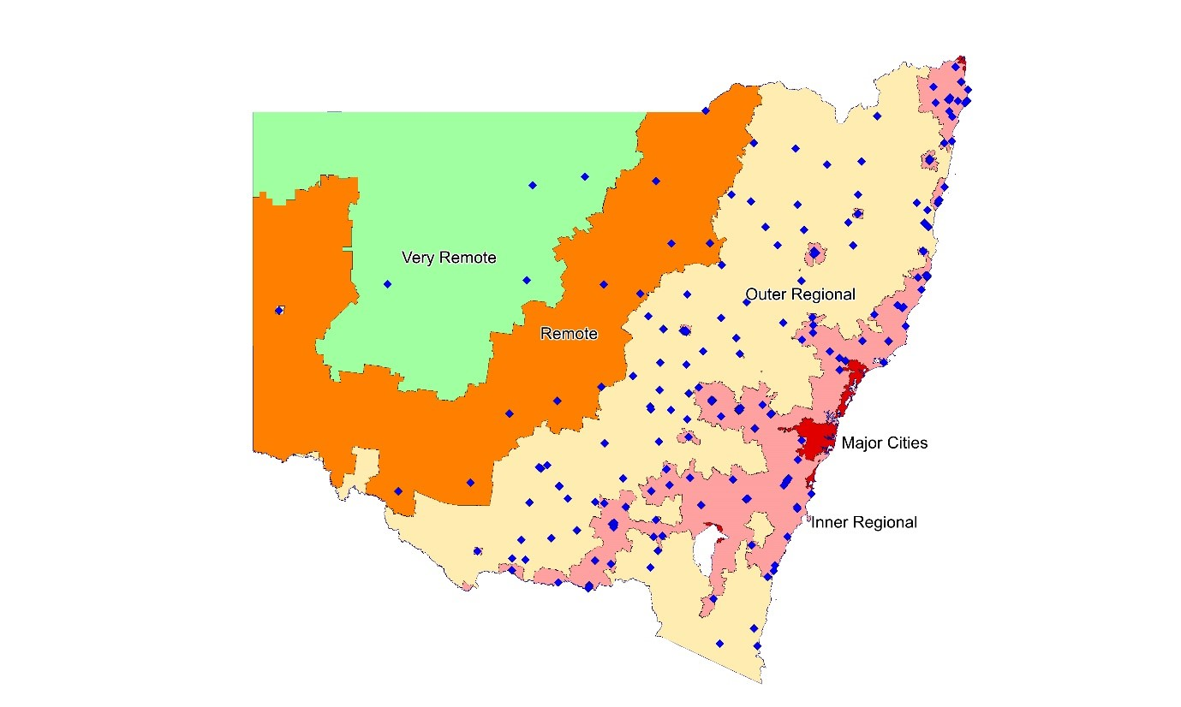

Catholic schools in regional, rural and remote NSW are predominately primary schools, and entirely so in remote and very remote NSW. There is significant diversity in Catholic schools in each of the geographical categories, but Catholic schools in regional, rural and remote NSW are generally less advantaged than metropolitan Catholic schools. They are generally smaller, educate students from less socio-economically advantaged communities, have higher proportions of Aboriginal and Torres Strait Islander students, have less experienced teachers and greater difficulty attracting and retaining teachers and principals, require higher levels of funding, have lower educational outcomes, and are often educating in towns with declining populations.

The ’tyranny of distance’ provides challenges that are unique to remote and very remote schools and systems supporting these schools. Wilcannia-Forbes for example, which covers half of NSW and is the size of France, supports Catholic schools from the Queensland to Victorian borders and as far west as Broken Hill. The distance from Sacred Heart Parish Primary School, Broken Hill to the Catholic Education Office located in Forbes is greater than the distance from Sydney to Melbourne (Figure 3). Bringing principals or staff from different schools together for professional development is challenging, and significantly more expensive than for metropolitan schools, as the distance requires even one day’s face-to-face training to expand to three days away from the school because of travel.

**Figure 3**: Location of Wilcannia-Forbes CSO & Sacred Heart Parish Primary School, Broken Hill

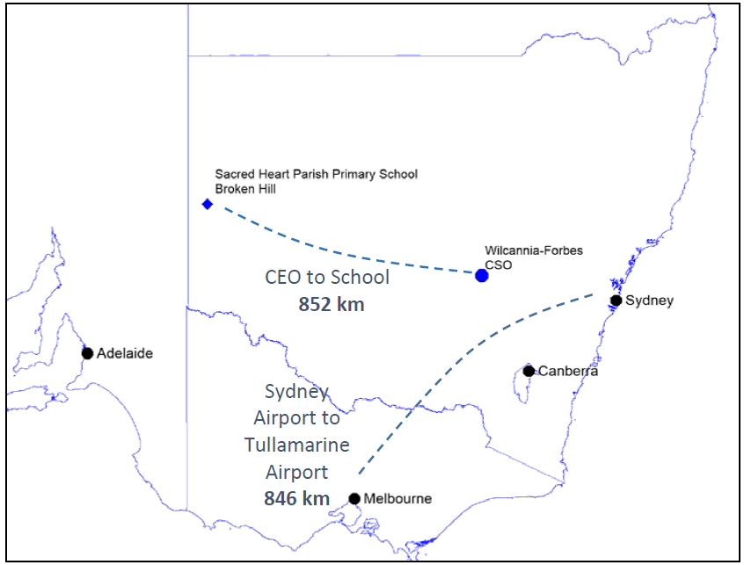

Figure 4 summarises some of the key characteristics of the differences between NSW Catholic schools in the major cities, inner regional, outer regional and remote/very remote geographies. The graphs highlight that differences between metropolitan and nonmetropolitan Catholic schools and communities are more nuanced than an urban/rural divide.

**Figure 4**: NSW Catholic School Averages by Remoteness, 2016

### Primary students Socio-Economic Status (1)

49

%

54

%

68

%

100

%

0

%

25

%

%

50

75

%

100

%

Major City

Inner

Regional

Outer

Regional

Remote/

Very

Remote

104

95

91

85

70

80

90

100

110

Major City

Inner

Regional

Outer

Regional

Remote/

Very

Remote

(1) Socio-Economic Status is the student weighted average using *Australian Education Act* Socio-Economic Status (SES) Score for non-government schools. SES is based on an average of 100 and is calculated from all students’ addresses.

**Figure 4 (Cont.)**: Selected NSW Catholic School Averages by Remoteness, 2016

### Indigenous Students Students with a Disability

%

2

6

%

%

9

%

29

0

%

%

10

%

20

%

30

40

%

Major City

Inner

Regional

Outer

Regional

Remote/

Very

Remote

%

5

%

5

6

%

%

8

0

%

2

%

%

4

%

6

%

8

10

%

Major City

Inner

Regional

Outer

Regional

Remote/

Very

Remote

| **Change in Enrolments, 1985-2016** | **Average Students per Primary School** |
| --- | --- |

37,171

11,094

-1,382

-287

-10,000

0

10,000

20,000

30,000

40,000

Major City

Inner

Regional

Outer

Regional

Remote/

Very

Remote

350

261

108

90

0

100

200

300

400

Major City

Inner

Regional

Outer

Regional

Remote/

Very

Remote

| **Teachers as % of all staff** | **1st and 2nd Year Teachers** |
| --- | --- |

%

80

75

%

72

%

64

%

50

%

60

%

70

%

80

%

90

%

Major City

Inner

Regional

Outer

Regional

Remote/

Very

Remote

7

%

%

8

%

8

18

%

%

0

%

5

%

10

%

15

%

20

Major City

Inner

Regional

Outer

Regional

Remote/

Very

Remote

| **NAPLAN: Grade 5 Reading** | **Cost Per Student (Primary Schools), 2015** |
| --- | --- |

Schools Above or Substantially Above National Average

53

%

36

%

%

21

0

%

0

%

20

%

40

%

60

%

Major City

Inner

Regional

Outer

Regional

Remote/

Very

Remote

$11,133

$11,550

$14,337

$17,017

$10,000

$12,000

$14,000

$16,000

$18,000

Major City

Inner

Regional

Outer

Regional

Remote/

Very

Remote

## Raising Our Achievement

Catholic Education Commission, NSW supports the approach that Professor Halsey has taken in preparing the Discussion Paper (July 2017) that informs the Independent Review into Regional, Rural and Remote Education. The five convictions that frame the paper (p.7) found solid support when presented to educators in Catholic dioceses and schools in regional and remote NSW. CECNSW agrees that vibrant rural communities are integral to Australia’s sustainability and prosperity; we accept that the state of education in rural areas is problematic; and we agree that a positive approach is required to effectively address this challenge.

CECNSW began this response by consulting educators in the rural and regional dioceses and schools, using the Halsey paper’s nine themes as a stimulus for discussion and further research.

Two of these themes resounded most strongly: 6.2: Teachers and teaching and 6.3 Leaders and leadership in rural schools – recruiting staff, guiding their formation into quality professionals, and keeping them working constructively in rural NSW. As we consulted, another theme emerged. We realised that, while solutions focused on the secondary years, and transition to work and further training, the problems were evident at the very beginning of schooling. If we could increase the focus on the early years of schooling with Early Childhood Education (ECE) and Transition to School, there might be a chance of addressing problems before they became entrenched. We could build better relationships with families and communities and commence early intervention where special needs are identified.

Many of our recommendations are asking for very little – for rural children to have entitlements that should be the norm for every child in the nation. We ask, for example, that all rural children are prepared when they begin school, if necessary with extended transition to school. The commitment to a year of pre-school is well progressed in metropolitan areas, but this is not the case in those remote areas which experience the most serious socio-economic disadvantage.

The discussion paper provides clear evidence of deficits in regional and remote education, and our paper further quantifies the scale and urgency of the disadvantage. CECNSW accepts that it is not possible to solve all problems identified by simply allocating more resources without supporting strategies for the additional funding. We identify strategies and provide intervention examples in this submission to evidence those actions that dioceses and schools are taking to address disadvantage: affordable solutions such as weekly boarding schools in regional hubs; an online distance education school in Lismore; and a collaborative pathway in agricultural studies from school through to VET Colleges and University.

Some of the solutions we present do require more funding. Our modelling shows that substantial funds are needed to place quality teachers in rural classrooms. To provide quality education requires dedication, professionalism and goodwill – and we must nurture our dedicated professionals with adequate funding support.

### C.1. Improving Funding – What the Evidence Shows

#### Recommendation 1

Amend the *Australian Education Act* to better align national funding practices and requirements with objective need by increasing the location loading for schools.

The *Australian Education Act* provides Commonwealth recurrent funding for non-government schools through per student ‘base’ funding and loadings. Loadings include student-centred loading for Aboriginal and Torres Strait Islander students, low socioeconomic status, low English proficiency, and students with disability funding; as well as school-centred loadings for small schools and location (weighted by relative remoteness). Other than location, loadings aren’t specifically targeted to regional and remote schools and students – although these other factors do attract funding where they occur in regional and remote schools.

School systems – including the Catholic Education Commission, NSW – recognise that schools outside of the major cities are disadvantaged when compared to metropolitan schools overall, and provide financial support above that which the location loading provides, by redirecting funding from within the system. Using the most recent publicly available data from *MySchool*, the average funding per student (Net Recurrent Income Per Student, or NRIPS) for NSW systemic Catholic primary schools in 2015 (the most recent year available) was $11,122 per student in major cities, increasing through each remoteness category to $28,033 per student in Very Remote NSW. Figure 5 shows the average funding per student for students in Catholic primary schools in NSW, as well as the national average for students in all sectors combined across Australia’s primary schools.

**Figure 5**: Average Net Recurrent Income Per Student (NRIPS) in Primary Schools by Remoteness, 2015

|  | **NSW Catholic Primary Schools** | **All Australian Primary Schools** |
| --- | --- | --- |
| Major Cities of Australia | $11,122 | $10,918 |
| Inner Regional Australia | $11,550 | $11,857 |
| Outer Regional Australia | $14,337 | $13,627 |
| Remote Australia | $14,901 | $18,588 |
| Very Remote Australia | $28,033 | $24,267 |

The evidence from *MySchool* is clear that Catholic education is not alone in supporting non-metropolitan schools, and there are clear differences between the averages for the remoteness categories. For NSW Catholic primary schools, students are funded at 2.5 times that of students in metropolitan Catholic primary schools; and overall, students in Australia’s primary schools are funded at 2.2 times the level of funding for students in the primary schools in Australia’s major cities.

The Australian Parliament, recognises that inequity between schools in different locations is not acceptable in the *Australian Education Act*. It states that:

* All students in all schools are entitled to an excellent education, allowing each student to reach his or her full potential so that he or she can succeed, achieve his or her aspirations, and contribute fully to his or her community, now and in the future.
* The quality of a student’s education should not be limited by where the student lives, the income of his or her family, the school he or she attends, or his or her personal circumstances.
* The quality of education should not be limited by a school’s location, particularly those schools in regional Australia.

However, as figure 4 shows, and as is repeatedly articulated in the Discussion Paper, students and schools in non-metropolitan Australia are disadvantaged compared to metropolitan schools. And this is despite the additional funding already targeted towards regional and remote schools (Figure 5).

In recognition of the significant disadvantages that schools and students in regional and remote schools have; acknowledgement of existing funding support by Australia’s school systems; and acceptance that recommendations in this submission will require increased funding, CECNSW recommends that the *Australian Education Act* better align national funding practices and requirements with objective need by increasing the location loading for schools. CECNSW recognises that additional funding alone cannot ameliorate inequity but recognises that additional funding is a necessary but not sufficient condition for improved educational outcomes.

### C.2. Addressing Cross-Sector Co-operation – Greater Efficiency and Effectiveness

#### Recommendation 2

Facilitate funding arrangements across sectors for two or more schools operated by different school proprietors that enable: (i) the employment of specialist teachers as a shared resource; (ii) the sharing of educational facilities; and/or (iii) the joint governance of one viable school (whether government or non-government) where each school lacks viability.

Supporting and resourcing small schools – whether Catholic, Government or Independent – in towns with decreasing populations is problematic. In Wagga Wagga Diocese for example, one-quarter of Catholic schools have fewer than 25 students, and half the schools have fewer than 100 students. However, in these towns especially, the school provides not just education, but continuity, community and hope in increasingly difficult circumstances.

In many towns, two or more schools have long been operating, but with declining school-aged population and decreasing births, options other than retaining current arrangements might offer better education, teachers and opportunity than currently exists with two or more schools in the town. For towns with two small schools such as a government primary and a Catholic primary school, opportunities for collaboration and sharing of specialist staff, or for sharing educational or sporting facilities might be one way forward.

CECNSW recognizes that the circumstances in each town will be different, and doesn’t advocate one solution. Rather, barriers to innovative solutions need to be addressed. CECNSW suggests that a number of governance and operational models currently exist – such as Sole Provider, Joint-Governance, Co-located, and Connected Community schools – which might offer opportunity for improved funding, governance, education and teaching opportunities to ensure schools in these towns remain viable.

**Sole Provider Schools:** Sole-provider schools as defined in *the Australian Education Act 2013* are schools in Remote or Very Remote Australia, with the distance between the [school](https://aeaguide.education.gov.au/content/f2-glossary#glossary-school-1081) and another [school](https://aeaguide.education.gov.au/content/f2-glossary#glossary-school-1081) being more than 25 km. Eight Catholic schools in Western Australia’s Kimberley Region operate as sole-provider schools, including Luurnpa Catholic School, Balgo Hills (112 students), Ngalangangpum Catholic School, Warman, (119 students) and Sacred Heart School, Beagle Bay (119 students).

**Joint Governance Schools:** St Columba’s College, Andrews Farm is an initiative of the Anglican and Catholic Dioceses of Adelaide. The College receives Commonwealth funding through the Catholic school stystem, but is clearly a combined Anglican/Catholic College. The College has operated since 1997, and has grown to be an R-12 school with 1,400 students. Such a model could be developed in regional and remote communities between Catholic and Government schools.

**Co-Located Schools:** Co-location of schools on one site allows access to resources across three sectors. At Golden Grove in Adelaide, Pedare Christian College, Gleeson Catholic College and Golden Grove High School share common grounds and facilities, including playing fields, halls, teacher facilities and other resources. This example of government and non-government cooperation in a metropolitan area could be extended to enable sharing of teachers between sectors to maximise efficiency, while still offering parent choice in regional and rural areas.

### C.3. Early Childhood Education and Transition to School

#### Recommendation 3

Revise the criteria for use of school funding to permit the conduct of extended Transition to School Programs for students prior to kindergarten commencement, in disadvantaged rural communities where the national (COAG) commitment to provide one year of pre-school education cannot otherwise be met.

##### Differential disadvantage at school commencement

Catholic School education systems across New South Wales are committed to providing all children with the best possible start to school. Universally, it has been established that a successful start to school is linked to later positive educational and social outcomes.

Indicators of disadvantage, available for all students at school commencement through the Australian Early Development Census (AEDC), reveal that students in remote schools are already disadvantaged before they start school, when compared with metropolitan children. CECNSW’s analysis of NSW Catholic schools AEDC data shows significant difference between students starting NSW Catholic schools in the Major Cities compared to Remote and Very Remote NSW. 18% of students starting school in Major Cities were disadvantaged on one or more domains, whereas more than double (40%) of students from Remote and Very Remote schools were disadvantaged. For students with disadvantage in two or more domains in NSW Catholic schools, the difference is even more telling – 8% in major cities compared to 28% in Very Remote Catholic schools. Figure 6 shows that the incidence of students at risk or vulnerable becomes greater as the schools become more remote – and this has remained unchanged from the first collection in 2009.

Significantly, children that are not ‘on track’ varies across domains, with 52% of students in very remote Catholic schools not on track in the Physical, Social and Communications, as well as the General Knowledge domains (compared with around 20% in the major cities). The Language and Cognitive (the school-based domain) and Emotional domains still have differences between metropolitan and remote NSW, but these domains are not as significantly different.

**Figure 6**: Children ‘not on track’ in NSW Catholic schools by AEDC Domain and Remoteness, 2015

| **Children not on track (at risk or vulnerable)** | | **Physical** | **Social** | **Communications**  **& General knowledge** | **Emotional** | **Language**  **&**  **Cognitive** | |
| --- | --- | --- | --- | --- | --- | --- | --- |
| Major Cities | 19% | 22% | 21% | 20% | 10% |
| Inner Regional | 17% | 21% | 18% | 19% | 10% |
| Outer Regional | 16% | 22% | 19% | 24% | 12% |
| Remote | 28% | 30% | 27% | 22% | 18% |
| Very Remote | 52% | 52% | 52% | 32% | 28% |

##### Strategies in overcoming disadvantage at school commencement

Children’s preparation for school is very different across the more remote regions. AEDC shows that 63% of children commencing their formal education in NSW Catholic schools in major cities had attended preschool; compared to 33% in very remote NSW. This is despite the national commitment to pre-school education for all children in the year before school. More children were cared for by grandparents (15%) and other relatives (18%) in remote schools than in metropolitan schools (7% and 4% respectively). Remote children’s experiences of transition to school remain very different from those of metropolitan students.

Catholic schools accept that transition is a process of ‘getting the school ready for the child’[1], as much as it is getting the child ready for school. Transition to Kindergarten is a process that is most successful when carefully planned over the entire year prior to, and during, the Kindergarten year (NSW’s first compulsory year of schooling). Where children are from communities of greatest need, a school immersion program during the year prior to school may commence with visits to school with a parent or guardian, and culminate in attendance at school as a supernumerary member of the Kindergarten class one day a week for a term or more. The school will use this period to build relationships with the child, their parents, and the community. Those children without family support or access to regular pre-school services should not, however, be further disadvantaged. They should be able to access this extended transition to school program unaccompanied by a parent or guardian.

The NSW Department of Education has identified five models for Extended Transition to Schools[2], including a weekly Transition to School program to provide opportunity for sustained early childhood experience at school. Four year olds who are not enrolled students, attend a Kindergarten class unaccompanied by parents. Such programs are not intended to replace attendance at a pre-school program. Rather, they complement attendance at local early childhood services, though in very remote areas, such services might not be available.

Extended Transition to Schools programs meet an urgent community need, filling a gap for the most vulnerable children. The costs of these programs are substantial. The NSW Department of Education estimated program costs ranging between $6,500 for one session a week for two terms, to $18,000 for one day a week for three terms. Schools are advised that funding for such services must be managed separately from school funding.

In very remote communities, where need is greatest, neither parents nor the broader community are able to make significant a financial contribution. Consequently, CECNSW recommends that special arrangements be made for these most needy communities. In particular governments need to revise the criteria for school funding for designated rural schools so as to permit the enrolment of four-year old children at school in the year prior to kindergarten for up to two days a week, without affecting their entitlement to school funding in their kindergarten year.

Early intervention programs in rural schools.

NSW Catholic schools are committed to transition practices that have a direct link with five AEDC domains of childhood development and include early intervention plans for children with disabilities. School educators need professional development provision to prepare effective transition programs. Families of children in regional and remote areas also require support in accessing the services of allied health professionals and other services.

| **Health in Outback Schools Program:** Sacred  Heart Primary School, Broken Hill and Saint Therese’s Community School, Wilcannia, along with many government schools have been involved since 2009 in a partnership with the University of Sydney’s Broken Hill Department of Rural Health.  The access to allied health services has been a key issue for preschool and primary schools and impacts on the academic achievement of students in Broken Hill and the surrounding region. In 2009 the the Broken Hill University Department of Rural Health, in collaboration with the local primary schools and Far West Local Health District responded to this need through the implementation of a recurring service-learning speech pathology student placement. Due to the overwhelming success of these placements the program was expanded and now includes occupational therapy, social work, dietetics, audiology and exercise physiology. |
| --- |

An audit of the preparation of rural schools for the transition of their kindergarten students, and the availability and involvement of health professionals and other support services is recommended.

Remote area health services have responded to the shortage of health professionals by forming partnerships with schools and making use of graduate students from metropolitan Universities undertaking their final practicums. Students are accompanied by their clinical supervisors for clinical placements in very remote areas. These student practitioners work with children under the supervision of trained professionals who are also able to provide support to teachers and families. Allied health students may go on to employment in hard-to-fill vacancies in remote area health services.

### C.4. Recruiting and Developing Quality Teachers and Leaders

#### Recommendation 4

Invest in the recruitment and development of quality teachers and leaders to work in rural and remote regions including primary teachers and secondary teachers in core and specialist areas as well as suitably qualified school-based VET teachers.

4.1 Fund the development of early career principals to succeed in the complex role of leadership in rural and regional areas.

4.2 Build partnerships between education, government and industry to recruit quality graduates through teacher scholarships, financial incentives, teacher exchange programs, locum arrangements across states and systems, as well as the provision of teacher incentives including housing, relocation expenses, schooling for children and spouse employment.

4.3 Fund in-school professional development strategies to better form the skills of inexperienced teachers who disproportionally staff schools in remote and regional areas.

##### 4.1. Leaders and Leadership – Funding Early Career Principals

According to the Director of School for the diocese of Wagga Wagga ‘the further west you go, the harder it is to attract teachers. The eastern seaboard has a greater pool; the west looks at employing teachers who have missed out on their first and second choices, who've had to go west. The diocese compensates by putting effort into the formation of these staff. There are costs in training, but the longer-term costs of not doing it are greater.’

The critical issue of leadership is very real. Catholic school principals have historically had the authority to make their own staffing appointments. However, their greater authority for local decision-making extends much further, due to the Catholic Church’s social teaching in relation to ‘subsidiarity’, which holds that decisions are best made as close as possible to those who will be affected by the outcome of a decision. In isolated schools, the role of the Principal has expanded - ‘part Lord Mayor, part priest, and 50% of them have a teaching role’ says one Director.

There is also a gender issue – the teaching force in rural and regional areas becomes more female with remoteness. While female teachers make up 73% of teachers in major cities, they comprise 84% in remote and 93% in very remote areas. In remote and very remote NSW Catholic schools, there are only 8 male teachers, and 1 male Principal. The number of principals who are male is proportionally larger in regional and remote schools.

Principals moving to a rural or regional school must consider the physical costs, employment for their spouses, schooling for their children and housing (See 3.1). The Dioceses identify schools that are 'hard to staff' and provide incentives appropriately. For example:

##### Armidale Diocese

* The Enterprise Agreement states (Clause 13.7) that where an employer has difficulties in recruiting a principal to a school because of the remote location an employer may pay an additional loading not greater than 10% of the applicable standard salary.
* Accommodation is provided for principals and staff in remote locations.
* A location loading of $2 600 is paid to teaching staff in remote locations.
* Staff may access personal leave to attend doctors, accountants, etc.

##### Wilcannia Forbes Diocese

* An additional 4 days of discretionary leave is granted.
* Access to a house in Broken Hill has been provided for teachers and their families from the very disadvantaged Catholic school in Wilcannia, ‘so that they can lead a normal life on weekends’.
* Spousal employment has been offered to attract Principal recruitment.
* Staff wellbeing is a very real issue in remote schools. Psychological support beyond the standard employee assistance provided, and exercise facilities are essential to maintain mental health.

Supporting early career leaders is required, but possible solutions can send contradictory messages. Common incentives include: programs to attract pre-service teachers to rural schools for their practicums; and arrangements with metropolitan dioceses so that teachers can be seconded to country schools for a period without losing benefits. However, strategies such as ‘return to the coast’, or promotional opportunity can create a perception that ‘time served in the country’ is just a transient step to a better place elsewhere. Closer engagement with family and community are central to successfully attracting and sustaining early career leaders including Principals.

##### 4.2. Partnerships between Education, Government and Industry

Rural educational leaders form partnerships to recruit quality graduates. Strategies include teacher scholarships, financial incentives, teacher exchange programs, locum arrangements across states and systems, and incentives for families including housing, relocation expenses, schooling and partner employment.

Contributions from local business and industry to rural education are not well documented. Schools report on the personal support received through Church and school based fundraising and alumni organisations. The change to drive-in/drive-out mining and modern mechanised agricultural methods has diminished the personal links between companies and local rural schools. Schools and businesses form mutual partnerships to train VET students for the future. However, there is an apparent deficit in partnerships between businesses at the corporate level – mining companies, agribusinesses and equipment suppliers who might be encouraged to do more to support education in the community where they derive their incomes.

Catholic educators who contributed to this paper tended to describe partnerships with other educational organizations. Lismore diocese for example, described why it goes beyond building good local university relationships. ‘All universities have their specialty subject areas.

| **Sydney Research Mentor Program for Science Research:** Three students from St Matthews Catholic School, Mudgee, a K-12 school in the Bathurst diocese, are involved in a partnership program with the University of Sydney The students submitted an abstract for inclusion in the Radiological Society of North America Scientific Conference. The abstract was based on their research that examined the performance of radiologists in South East Asia as compared to Australian radiologists, with support from university mentors. The abstract has been accepted and Professor Brennan will present their research at one of the biggest scientific conferences in the world. The students are currently fundraising to support their attendance at the Conference. |
| --- |

Regional dioceses must be outward looking, particularly with respect to Science, Technology, Engineering and Mathematics (STEM) strategies says a Lismore representative. ‘Lismore has partnered with Melbourne University for Mathematics support’.

The regional Lismore diocese is able to build partnerships for teacher education much like those in metropolitan dioceses. The Lismore Catholic Schools Office manages a Ready to Teach Program. It offers selected 4th year university students completing an education qualification the opportunity to participate in a mentor based program designed to provide the best possible preparation immediately prior to teaching. Selected student teachers will teach for a three-week period alongside the classroom teacher specifically tasked to prepare the student teacher for imminent employment in the workforce. Student teachers and Accredited teachers are together, working closely, with the student teacher learning on the job and completing many of the normal duties of the classroom teacher. These student teachers are drawn from Universities in NSW and Queensland. Many of the student teachers are employed by their host diocese upon completion of the program.

The submission by the Director of the Wilcannia Forbes Diocese, Anthony Morgan, to the Senate Select Committee on School Funding (2016) entitled [*Postcode Cannot Mean Destiny*](https://www.google.com.au/url?sa=t&rct=j&q=&esrc=s&source=web&cd=1&ved=0ahUKEwjuyvLC8drVAhWFnZQKHVGmApIQFggoMAA&url=http%3A%2F%2Fwww.aph.gov.au%2FDocumentStore.ashx%3Fid%3D6ad914be-b9e7-4dd3-b05e-85c88d331063%26subId%3D411005&usg=AFQjCNGGx6A5dFH0iAblMGlujeqE5YFJNg) makes it clear that it is much harder for a very remote diocese to form this kind of beneficial partnership with universities. He writes:

* The lack of links between this remote diocese and universities are issues, so that it is unable to influence university policy.
* Student practicum placements in remote regions are hampered by practicalities. Students typically need to maintain their part-time work and rental obligations, which makes spending time on a remote placement difficult. They are unable to earn on a remote practicum, and suitable mentor teachers and secure short-term accommodation are not always available.
* Wilcannia Forbes diocese does use partnership strategies for recruitment, including targetting applicants from other shortlists, partnering with recruitment companies, participating in university fairs and in arranging secondments from urban Catholic Education Offices.

Partnership issues also arise for regional dioceses that are contiguous with State borders. Lismore diocese believes that the further implementation of the Australian Curriculum will be a significant advantage in overcoming substantial barriers in cross-border education and partnerships, and in planning transitions for their students and teachers.

##### 4.3. Professional Development

There are difficulties in relation to professional development that are specific to rural and remote schools. These schools predominately rely on inexperienced teachers to staff schools in remote and regional areas and the least equipped dioceses and schools are tasked with the formation and NESA Accreditation of new graduate teachers.

Wilcannia Forbes Diocese has outlined some of the challenges associated with providing professional development (PD) to remote schools across a region ‘the size of France’. For teachers from remote schools to gather for PD for one day, they need to be absent from school for three days, with a day of travel each way, two nights in a motel, up to 7 meal allowances and, for the most remote school, an 830k drive each way to be compensated. Costs can exceed $2000 per day for teacher PD. There is often no possibility of teacher relief, so teacher absences from the classroom impact on learning. The Diocese has adopted an individualised model where Education Officers travel across the Diocese, planning, modelling and reflecting within individual teachers’ classrooms. While still expensive, this method is more effective, but is a very different method for PD than for city-based teachers.

CECNSW recommends that targeted funding is required to support in-school professional development strategies to better form the skills of inexperienced teachers who disproportionally staff schools in remote and regional areas.

### C.5. Teacher Housing and Improved Buildings

#### Recommendation 5

Provide capital funding to meet nationally accepted standards in relation to both teacher housing and access to schools for people with disabilities in rural areas.

5.1 Provide funding to build and maintain safe, secure, quality housing for teachers serving schools in disadvantaged isolated school communities.

5.2 Provide funding to modernise all rural school buildings to meet Access Standards under the Disability Discrimination Act.

##### 5.1. Teacher Housing

Directors of schools from rural dioceses have identified teacher housing as a major area of need for Catholic Schools. Lismore, Wagga Wagga and Wilcannia Forbes dioceses offer housing to attract and maintain principals and teachers to isolated schools. In recent years, Australian Government capital grant funding has been allocated to build quality teacher housing in the very disadvantaged communities of Brewarrina and Bourke.

| **The Need for Teacher Housing:** New teachers in remote areas are predominately single females in their twenties, who cannot be accommodated safely in mixed-gender share housing. “Robberies of teacher accommodation and vandalism of teacher cars are commonplace in towns where ‘ice is rampant“. In many of these towns, there is no private rental market or those properties that are available, are substandard. The safety and security of our employees is a matter of grave concern, and the diocese is seeking to provide a stock of suitable accommodation units for our staff. It is anticipated that to deliver this, in the more remote locations will average around $300,000 per teacher.  Wilcannia-Forbes Diocese |
| --- |

Armidale Diocese has not accessed Commonwealth Capital funding, but estimates the costs for the purchase, and maintenance, of housing over the past 5 years would be close to $2 million. It has built a 6-unit accommodation block, and 5 houses in isolated and hard-to-staff towns. For these small schools, the per student cost is estimated at $5,500 over the 5 years.

The NSW Department of Education maintains a stock of high quality residences in remote towns at substantial expense. NSW government schools’ teacher housing has been made available to Catholic staff, when surplus to the government’s requirements. However, reliable and assured access to housing is a necessary condition of staffing regional and remote schools.

##### 5.2. Meeting Access Standards

| **St Joseph’s Primary School Nyngan:**  St Joseph’s, Nyngan (founded in 1884), in Wilcannia-Forbes Diocese has 145 students, of which six students have a disability. Upgrading of the administration building and associated facilities was recently required for a new student enrolling, as these buildings were not wheelchair accessible, and ad-hoc emergency arrangements threatened the function of the air-conditioning system. $250,000 was required to provide wheelchair access to the school buildings without compromising the school facilities. |
| --- |

Capital funding is needed to modernise rural school buildings to meet Access Standards under the *Disability Discrimination Act* and to provide an acceptable standard of facilities for all schools as a matter of equity.

An audit and upgrade of school buildings in remote areas is needed to forestall the need for emergency solutions. It should make use of better information as to the population of students with disabilities in the rural and remote communities.

CECNSW believes that there is clear need for ALL rural schools serving disadvantaged communities across Australia to be modernised to meet access standards

under the *Disability Discrimination Act* to make schools accessible for all students, staff, parents (including parents with prams) and grandparents, and other visitors to the school; and that the standard of modernisation be of the same standard for schools in metropolitan, regional, rural and remote schools. With smaller schools, many remote schools are disadvantaged financially when upgrading to standards taken for granted in large metropolitan schools.

### C.6. Information Communication and Technology

#### Recommendation 6

Complementary to the NBN initiative, invest in Information Communication and Technology (ICT) in disadvantaged rural communities.

6.1 Provide ICT access to all disadvantaged regional and remote schools and communities, comparable to metropolitan services.

6.2 Provide all disadvantaged rural students K-12 with up-to-date ICT devices, including adaptive technologies, with appropriate security and maintenance.

6.3 Expand opportunities for disadvantaged rural students to enrol in distance education to provide a breadth of subject choice in the senior secondary years of schooling, while also extending this support to the middle years of high school.

##### 6.1. ICT Infrastructure

Information Communication and Technology is one of the essential assets for rural and remote dioceses. Alan Bowyer, Director of the Catholic Schools Office Wagga Wagga noted that ‘the diocese has made a big investment in ICT infrastructure, and schools can communicate with each other and across the world. Fibre installation, even to small schools – which need it more – has served them well. Good ICT is essential for teaching of science and maths across the diocese’.

Lismore Diocese has also invested in cross-school connections. It has videoconferencing in all secondary schools, and most primary schools are also connected. Connectivity tends to add value to cultural aspects of education that are not otherwise available to regional students. Wagga Wagga Diocese, for example, has an isolated student studying the cello online with their tutor living in Auckland.

Good upload and download speeds should be a given for all schools, especially in rural schools, whether by broadband or satellite in more remote areas. Connectivity should not stop at the school gate. Yet, access to computers and other technologies at home and school, and the skills and resources to maintain and service them can still be problematic. Indigenous educators cite access to communication technologies as barriers to full participation in schooling. Even telephone coverage can be unreliable in rural and remote communities. Online access to government health and social services, school curriculum and assessment taken for granted in metropolitan Australia are often not available to many schools and communities outside of the cities. This is creating and reinforcing an equity and access chasm between rural and metropolitan students and teachers.

##### 6.2. Access to ICT Devices

Schools in rural towns may not have the capacity to source technical applications at affordable prices. The smaller scale in a market economy inevitably means that these devices are more expensive to purchase than in urban areas.

Nevertheless, in many low socio-economic and remote communities, students do have digital devises to assist with their education. In the remote diocese of Wilcannia-Forbes each student from Kindergarten has their own digital device, funded by parent levies, with technical support from the Catholic Education Office. The move to NAPLAN online has, however, revealed problems with the maintenance of devices across the state. Apple has announced that it will no longer be supporting the older first-generation iPads, which remain the mainstay of some diocesan programs. Without the ability to provide security, they will not be suitable for a critical online assessment. This emerging problem has revealed potential issues and costs to support rural and remote students.

##### 6.3. Distance Education

| **The On-Line Education School, Coffs**  **Harbour:** The Online Education School  (OES) is an initiative of the Diocese of Lismore. It supports students in Catholic high schools and colleges across NSW to study a variety of NSW Preliminary and Higher School Certificate courses that may not be otherwise available to them at their home school.  The OES is NESA Registered as a campus of John Paul College, Coffs Harbour, offering a choice of 8 more specialised HSC subjects (including Engineering Science and Aboriginal Studies) to stage 6 students in every diocese in NSW. There are 150 students in Year 11 and 150 in Year 12 taught by highly qualified teachers employed by OES. Lismore is considering expanding the service to Year 10 students. |
| --- |

The introduction of the Australian Curriculum has provided consistency across the country in core areas of English and Mathematics. However, it is difficult to provide content beyond the core with depth and breadth. For Wilcannia-Forbes Diocese, Key Learning Areas that suffer most are foreign languages, Music/Arts, Physical Education and Science (STEM) subjects. They are at risk because of teachers’ lack of confidence, unavailability of specialist support, and difficulties in providing professional support.

Breadth of curriculum provision is an issue in rural areas, where teachers are less experienced and may not have developed the skills to teach across a range of abilities. In small schools, with composite classes, the skill demands on teachers are higher. Distance education has the capacity to enrich and broaden rural students’ choices.

CECNSW believes that online distance education can offer disadvantaged rural students support in the middle years of high school, and provide a breadth of subject choice in the senior secondary years which will never be able to be provided at the students’ school.

### C.7. Boarding Schools – Keeping in Touch with Community

#### Recommendation 7

Promote boarding programs that better maintain links with families and communities.

7.1 Promote the development of weekly boarding schools (4 nights at school, 3 nights at home) in regional hubs where students board within 3 hours of home).

7.2 Improve transport support for disadvantaged boarding students from remote areas by including air travel subsidies and subsidising mid-term travel.

|  |  |  |  |  |  |  |  |  |  |  |  |  |
| --- | --- | --- | --- | --- | --- | --- | --- | --- | --- | --- | --- | --- |
| **St Scolastica’s College, Glebe:** St  Scholastica’s College, Glebe is a Catholic Girls schools with 1,000 students, of which there are 94 students boarding from regional and remote NSW and other states. The College has 62 Indigenous students, of which 30 are boarders.   | HSC | Aboriginal Studies Major Projects are | | | --- | --- | --- | | selected for permanent display as part of the NSW State Library Digital Collection. In | | | | 2016, all five students selected were | | | | students from St Scholastica’s College. | |  |   Each year, five outstanding works from the |

There are nearly 2,200 Boarding students enrolled across 17 NSW Catholic boarding schools. Catholic Boarding Schools provide innovative and nurturing approaches to support improved access and achievement for remote students and provide better transitions to further study, training and employment. Boarding schools – whether in Sydney metropolitan area or other parts of NSW – aren’t for all students or families, but they can offer important support for rural families including Indigenous students, and can provide these students with opportunities not otherwise available.

Connectedness with home and family is recognised as a major challenge for students at boarding school, as the Discussion Paper makes clear. Boarding schools can break the cycle of disadvantage for Aboriginal and Torres Strait Islander students, allowing students from rural areas to complete their secondary education IN NSW Catholic education. There are twice as many male boarders as there are female boarders in NSW Catholic education.

##### 7.1. Weekly Boarding Schools

| **School Captains:** The two school captains of  St Francis De Sales last year were boarders. Thomas Dore shared his experience of being a boarder at their Open Day: ‘I grew up in Urana, which for any of you who may not know, is about 100 k’s that way. I attended the Catholic primary school in the town along with about 20 other students, so the prospect of coming to St Francis was daunting, but predominantly exciting…mainly because I’d have a few more people to kick the footy with’. Thomas did more than kick the footy as he gained an ATAR over 90 and is at University in Melbourne this year.  Co-captain, Mary Sandral, described the feeling of coming from Oaklands, 150 km from the school, and ‘glancing around the sheer immensity of the college’, until she made the school ‘a home away from home’. Mary gained an ATAR in the mid-90s and is studying  Osteopathy in Melbourne |
| --- |

Weekly boarding in regional NSW has been a successful strategy that helps maintain close links with community and family. Wagga Wagga Diocese runs two large regional boarding schools – Mount Erin College, Wagga Wagga (564 students including 27 boarders), and St Francis de Sales Regional College, Leeton (699 students including 194 boarders). Weekly boarding has the advantage that it maintains links with family and community, offers co-educational boarding that meets the needs of regional girls as well as boys, keeps fees affordable, promotes attendance, and provides choice to remote and regional families.

St Francis De Sales Regional College is a Catholic Co-educational school of 649 students, of whom 194 are weekly boarders from Leeton, Narrandera and surrounding rural areas in the Riverina, including Jerilderie,

Coleambally, Darlington Point, Hay,

Weethallee, Binya, Lake Cargelligo, Rankin Springs and Urana. The College provides a comprehensive education across Years 7-12. It boasts good academic results, with 44% of students undertaking VET during their senior years of schooling and 100% attaining an HSC or equivalent VET qualification. 11 students gained ATAR rankings over 90 in 2016, with the top student gaining 98.50.

Boarding students - equal numbers of boys and girls - are bussed home each weekend. Students travel home for up to three hours on three or four private bus runs on Friday nights and return early on Monday mornings. Under this model, where students can board for 4 nights and spend 3 nights at home, students can still access rural and isolated children’s allowances and Abstudy grants. What is most valuable is that they maintain their connections with their families, their sporting teams, and their community and culture – particularly important for the ten Aboriginal boarders. Students are busy and engaged in educational pursuits in their four days in residence. The school provides a range of boarding scholarships to make the experience accessible.

CECNSW recommends that expanding weekly boarding options can improve educational opportunities and outcomes for students, while allowing them to remain connected with their family and community. NSW with its large number of regional towns could offer a model for weekly boarding, with students who live within 3 hours of the school boarding 4 nights at school and living 3 nights at home.

##### 7.2. Subsidised Transport

Seventy percent of boarding students in NSW Catholic schools are in boarding schools in the metropolitan Sydney. The majority of these students are from towns located in either remote outer regional or remote locations. Currently in NSW, students in Boarding schools are provided with free train and long distance buses at the start and end of term under the NSW School Student Transport Scheme. Air travel is not provided or subsidised for students. This is clearly a policy from a previous era when rail travel was the primary form of travel to and from regional Australia.

The distances that boarding students travel from outer regional, remote and very remote NSW and other States is significant. While many of these students are not from wealthy families, they are unable to access subsidised air travel through programs such as the Indigenous Youth Leadership Program or the Isolated Student programs. As already noted these students are not from wealthy families, and non-subsidised air travel remains a barrier for family visits. This is particularly so for mid-term travel such as on long weekends, resulting in students being unable to return home. This is particularly difficult for younger students in their first years of boarding.

CECNSW recognises the difficulties for disadvantaged, remote students and their families, and the sacrifices made to improve their children’s education through boarding. CECNSW recommends that improving transport support for disadvantaged boarding students from remote areas by including air travel subsidies and subsidising mid-term travel will provide significant benefit – socially, emotionally and educationally – for students and their families in regional and remote NSW and Australia.

### C.8. Transition between Schools and Beyond Schooling – Planning with Data

#### Recommendation 8

Develop cross-sectoral and cross-state data collection and sharing to improve transitions between schools and post schooling education and training providers, particularly for Aboriginal and Torres Strait Islander students especially in the areas of Vocational Education and Training (VET), career education and Transition Support services.

8.1 Adopt a more cross-sectoral approach, in relation to data-sharing and delivery, for students who move between rural schools, regions, sectors and across state borders. In this context CECNSW acknowledges the greater mobility of Aboriginal families and seeks to work with other agencies to better support educational choices for Aboriginal families while promoting school attendance and retention.

8.2 Increase funding to support a national approach to identifying the post-school destinations of all students, to better provide regional and remote students with Vocational Education and Training, Career education and Transition Support services.

Data offers an important foundation for identifying and anticipating issues and trends, and to inform, contextualise and facilitate effective and productive planning in regional, rural and remote schools. However, the potential for data collection and sharing is too often unrealised in education because it is either inconsistent in its intent and collection, or because custodians are either unwilling or unable to collaborate on sharing data and analysis. Despite enormous advances over the past decade with data comparability and availability (*MySchool* for example), the collaborative use of educational data still needs to be improved for the purpose of supporting students and schools, particularly in regional, rural and remote Australia.

CECNSW believes that improving data consistency and improving cross-sectoral data collection and the sharing data analysis must be advanced as a strategy to improve rural and remote education. CECNSW has identified a number of data opportunities (a number of CECNSW staff represent Catholic education or the non-government schools sector on national, cross-sectoral data committees). Rather than open the entirety of the data environment, this submission focuses on two specific data opportunities – Indigenous student data and Vocational Education and Training (VET) data , as these are particularly pertinent to regional, rural and remote schools, and data collaboration in these fields has strong potential to be realised.

##### 8.1. Indigenous Mobility – Cross-sectoral Data Collaboration

In 2003, Dr Andrew Refshauge, NSW Minister for Education and Training initiated a review of Aboriginal Education. Central to the submission of CECNSW to this Review was the recommendation that “the Government and non-Government sectors work jointly to share and analyse data related to Indigenous education and provided the Minister with a full dataset of Indigenous and non-Indigenous enrolments across all NSW schools by gender and grade”. More than a decade later, CECNSW makes this same recommendation to the Independent Review into Regional, Rural and Remote Education.

The 2003 CECNSW submission proposed the sharing of combined Indigenous data for Catholic and Government schools across defined regions together with TAFE enrolments and subject choice for all Indigenous students. A particular data use advocated in 2013 was the tracking of Indigenous student mobility between secondary schools and TAFE, as well as between Catholic and Government schools. It was argued that this would assist in answering questions relevant to Indigenous choices about school participation, including an exploration of the extent to which Indigenous families are constrained by geographic location of schools and the effect of school location on both participation and retention.

CECNSW’s proposal was – and remains – more than the sharing of aggregate data. As the Commission’s submission showed (see Figure 7), within-year movement of Indigenous students was predictable when identified in a cultural and familial context; but when students moved between schools and towns, or from ‘city to country’ there was little sharing of data for the purpose of ensuring the continuity of each student’s education. Despite the passage of time since the 2003 review, cross-sectoral and cross-state student-focused data sharing still has significant potential for improving the educational continuity and outcomes for Indigenous students, and especially for those moving between urban and rural schools. Consequently, CECNSW again recommends that improving cross-sectoral and cross-state data sharing will benefit students, particularly for Indigenous students at risk.

**Figure 7**: Extract from CECNSW Submission to NSW Review of Aboriginal Education (2004)

Geographical factors in Indigenous student movement

The Commission is interested to test some of the hypotheses regarding Indigenous participation in schools. For example, the smaller populations of Indigenous students in Catholic secondary schools outside Sydney in **Graphs 3 to 13** may be explained by the small number of Catholic schools in the country areas with larger Indigenous populations. The following map of the Lismore Diocese illustrates student movement by Indigenous students might have a significant regional component, which may link geographically distanced areas (such as Macleay Region (Northern NSW coast) linked to Moree (inland some 400km). **Map 3: Identified Indigenous ‘Community Catchments’ in Lismore Diocese**

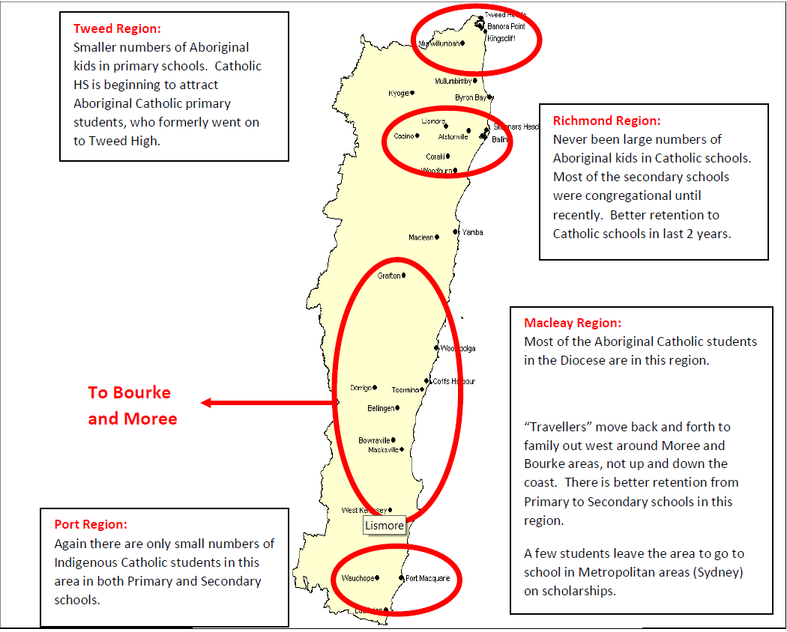The ‘community catchments’ highlighted in **Map 3** were identified with the help of the Lismore Diocese’s Aboriginal Education Officer, Ms Doreen Flanders. She identified four regions within the diocese within which the ‘travellers’ typically move. As this map demonstrates, there is little movement between communities ‘up and down’ the coast but there may be movement ‘back home’ (typically to Central Western NSW), or to join relatives who have moved out of the area to the capital cities of Sydney and Brisbane. Consequently, an Indigenous student may move between the Government and Catholic sectors when moving between regions. Necessarily, cross-sectoral sharing of data will be a critical aspect of the analysis of Indigenous students.

In an extended research project, it would be interesting to explore the combined data for Catholic and Government schools in Indigenous defined regions together with TAFE enrolments and subject choice for Indigenous students’ data to test whether Indigenous students move between secondary schools and TAFE, as well as between Catholic and Government schools.

##### 8.2. Nationally Consistent Data Collection and Sharing

CECNSW values its ability to monitor and examine trends in, and correlation of post-school education, training and employment destinations among secondary school students. Data analysis is an important tool to support all students, but in particular students within regional and remote areas.

Every State and Territory approaches data collection, analysis and dissemination differently. For example an annual, cross-sectoral *Post-School Expectation and Destination Survey* is published in NSW, while Victoria uses its *On Track Collection* and Queensland the *Next Step* and *Early School Leavers Surveys.* However, while each of these is cross-sectoral within the state, they are ‘similar but different’ with limited comparison between states, or sharing of data between states and territories. Some, but not all States and Territories have incorporated longitudinal studies to provide additional information to stakeholders. However, information collected and reported varies and the ability for a national comparison is limited.

In NSW, the three school sectors work collaboratively with the NSW Department of Education’s Centre for Education Statistics and Evaluation *(*CESE*).* CECNSW is able to analyse data for early school leavers and Year 12 completers from Catholic schools to extrapolate trends and identify differences in outcomes. As an example, Figure 8 shows differences in post-school destinations of students from NSW Catholic schools. The figure shows significant differences between early leavers and those students completing the Higher School Certificate (HSC), and also differences between students in the different geographies (students in inner regional and outer regional less likely to undertake a bachelor degree and more likely to undertake an employment pathway (full and part time).

**Figure 8**: Destination Early leavers and HSC Completers in NSW Catholic schools by Remoteness, 2016

|  | **Major Cities** | | **Inner Regional** | | **Outer Regional** | |
| --- | --- | --- | --- | --- | --- | --- |
| **Destination** | **Early Leaver** | **HSC Completers** | **Early Leaver** | **HSC Completers** | **Early Leaver** | **HSC Completers** |
| Bachelor degree | 2% | 61% | 1% | 55% | 1% | 43% |
| VET Cert IV+ | 12% | 7% | 10% | 6% | 9% | 3% |
| VET Cert I-III | 10% | 3% | 14% | 3% | 11% | 3% |
| Apprenticeship | 43% | 6% | 41% | 7% | 46% | 8% |
| Traineeship | 6% | 3% | 6% | 5% | 7% | 7% |
| F/T Work | 8% | 6% | 9% | 9% | 12% | 20% |
| P/T Work | 10% | 9% | 10% | 11% | 7% | 15% |
| Looking for work | 7% | 3% | 7% | 3% | 5% | 2% |
| NILFET | 2% | 2% | 2% | 2% | 2% | 0% |

| **Agribusiness Careers and Professions**  **Program:** AGCAP was established in the  Armidale area to address the unsustainable loss of young people from rural areas. It was developed through a unique collaboration between the Make It Work Foundation (Narrabri Chamber of Commerce), Training Services NSW and the NSW Department of Education. It is open to students in Catholic schools, and two students from Armidale O’Connor Catholic College have been accepted into the first round of the program.  AGCAP is a series of linked stages starting with an SBAT in an agricultural related vocation at school, which includes at least 100 days on the job training. The pathway continues through post school Vocational Educational Training (VET) at Tocal College to the University of New England.  A shortened pathway to university gives AGCAP students the opportunity to gain a high-level qualification while spending a minimum amount of time away from their home town or work commitments. AGCAP addresses the skills shortage in rural areas and offers students an achievable pathway to a career in agriculture or related industries. |
| --- |

Data is available to CECNSW at school and student level, and analysis by gender, grade and Indigenous status are possible. Further analysis of destination based on courses undertaken at school (i.e. English, Mathematic, Vocational Education and Training) and NAPLAN results are also available. The data provides insight into students’ aspirations for the future, which can assist in providing focussed career advice provision and transition planning. However, this data currently remains limited in its dissemination, and for cross-state collaboration. CECNSW would encourage the sharing of data under agreed protocols. The information is collected by CESE in NSW on behalf of all the school sectors, but it is not analysed and reported to its full potential. Collaborative planning of transitions and pathways from school, to post-school study to university are a feature of the vocational education sector, and educational and employment programs can be enhanced by an evidence-based approach to planning to meet student and industry needs.

A tangible example of how this data has positively impacted on NSW Catholic students is the Agribusiness

Careers and Professions (AGCAP) Program. The program was a direct outcome of need, identified by the data obtained through targeted transition planning data.

CECNSW uses Vocational and Educational Training data to assist students in regional, rural and remote schools. CECNSW recognises the potential that this data will have if the data were to be consistent in its collection and sharing across all States and Territories.

## D. Conclusion

There is significant educational disparity between schools and students in metropolitan Australia and those in regional, rural and Australia, and this disparity is increasing. Despite the requirements of the Australian Education Act that “The quality of education should not be limited by a school’s location, particularly those schools in regional Australia”, the reality is very different. The data presented in this submission is unambiguous.

This submission from the Catholic Education Commission NSW offers a number of recommendations. These recommendations have been informed by the experiences of educational leaders in NSW Catholic Dioceses and schools, as well as by CECNSW’s research.

As cited above CECNSW makes eight recommendations to this review. These recommendations cannot end all inequality between metropolitan and non-metropolitan Australia, but taken together they have the potential to make significant improvement if adopted.

These recommendations focus on identifying tangible strategies that are achievable and appropriate for NSW Catholic schools and beyond. CECNSW strongly supports this Independent Review into Regional, Rural and Remote Education, and offers the Review Panel the opportunity to discuss our submission further.

## E. Contact

Mr Crichton Smith

Principal Research Officer – Executive Director’s Officer

Phone: (02) 9287 1553

Mobile: 0410 544 157

Email: crichton.smith@cecnsw.catholic.edu.au

1. Sue Dockett and Bob Perry, ‘Who's Ready for What? Young Children Starting School’, *Contemporary Issues in Early Childhood*, Volume 3, Number 1, 2002.
2. Extended Transition to School Programs: Strong partnerships, strong transitions, NSW Department of Education and Communities, 2011.