Community attitudes to education in the

Colac Otway Shire

Research commissioned by Beyond the Bell Colac Otway Local

Action Group, supported by Regional Development Victoria and the Colac Otway Shire

George Myconos Angela McKenna

With Stephanie Yung, Rachel Wood and Cara Bradley

February 2017 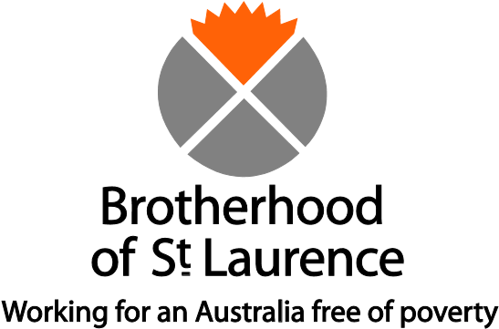

The Brotherhood of St Laurence is a nongovernment, community-based organisation concerned with social justice. Based in Melbourne, but with programs and services throughout Australia, the Brotherhood is working for a better deal for disadvantaged people. It undertakes research, service development and delivery, and advocacy, with the objective of addressing unmet needs and translating learning into new policies, programs and practices for implementation by government and others. For more information, visit <[www.bsl.org.au>](http://www.bsl.org.au/).

George Myconos is a Research Fellow in the Inclusive Education team at the Brotherhood’s Research and Policy Centre.

Angela McKenna is an educator with experience in English language teaching, curriculum and materials development, across community, higher education and vocational training sectors.

## Acknowledgements

Our thanks go to those at Beyond the Bell Colac Otway Local Action Group who promoted the research and gave valuable feedback on draft versions of this report. We are also grateful for the assistance and hospitality provided by Rachel Wood and her colleagues at the Colac Community Hub. Similarly, thanks go to Deborah Patterson, Shelley Mallett and Eric Dommers for their feedback and assistance. We express our gratitude to the people of Colac Otway Shire who responded with such enthusiasm and insight through surveys and discussions.

Lastly we acknowledge the approval to conduct this research from the Department of Education and Training and the Catholic Diocese of Ballarat (Education).

Published by

Brotherhood of St Laurence

67 Brunswick Street

Fitzroy, Victoria 3065

Australia

ABN 24 603 467 024

Ph: (03) 9483 1183 [www.bsl.org.au](http://www.bsl.org.au/)

© Brotherhood of St Laurence 2017

Apart from fair dealing for the purpose of private study, research, criticism, or review, as permitted under the *Copyright Act 1968*, no part of this paper may be reproduced by any process without written permission. Enquiries should be addressed to the publisher.

**Contents**

Acknowledgements 2

**Summary** **5**

**Introduction** **10**

**Section 1: Background** **13**

The Colac Otway Shire 13

Insights from existing research 15

**Section 2: Method** **24**

**Section 3: Attitudes to education** **29**

How participants regard the Colac Otway Shire 29

Attitudes to education: some opening remarks 32

Relevance: the role of education in future planning 33

Priorities: how education ranked against contending priorities 35

Benefits: what motivates people to undertake education 38

Quality, range and accessibility 40

Attitudes to education: summing up 48

**Section 4: Initiatives** **50**

How challenges to education are perceived 50

Suggested community-wide initiatives 51

Suggested school-based initiatives 55

Initiatives: summing up 57

**Conclusion** **58**

**Appendices** **59**

Appendix A: Survey 59

Appendix B: Interview participants 70

Appendix C: Population profile 74

Appendix D: Employment profile 75

Appendix E: Education providers 76

**References** **77**

**Figures**

| Figure 1.1 | Colac Otway Shire and surrounds 13 |
| --- | --- |
| Figure 1.2 | Are your views fairly typical of people across the community? 28 |
| Figure 1.3 | Is education highly valued across the Colac Otway Shire? 32 |
| Figure 1.4 | Under 18 year olds on whether education is valued across the Shire 32 |
| Figure 1.5 | Is education relevant to your future plans? 33 |
| Figure 1.6 | Under 18 year olds on the relevance of education 34 |
| Figure 1.7 | All things considered, is education among your highest priorities? 36 |
| Figure 1.8 | When I think of the benefits of education, I think of … 38 |
| Figure 1.9 | Under 18 year olds’ views on the benefits of education 39 |
| Figure 1.10 | From my experience, the following are of high quality in the Shire 41 |
| Figure 1.11 | Under 18 year olds’ views on quality of various education sectors 41 |
| Figure 1.12 | Schools and other providers I need/have needed, are/were, easy to reach 46 |
| Figure 1.13 | Are schools in the Shire positive and rewarding places for young people? 48 |
| Figure 1.14 | Problems such as poor attendance and completion rates are linked mostly to … 50 |
| Figure 1.15 | Community-wide changes to improve education standards across the Shire 52 |
| Figure 1.16 | When making decisions or judgements about schools/providers I refer to … 55 |
| Figure 1.17 | School-based changes key to improving education standards 56 |
| **Tables**  Table 1.1 Education and participation profile, with Victorian comparisons, 2011 15  Table 1.2 Survey respondent profile 25  Table 1.3 Occupations 26  Table 1.4 Interviewees and modes of engagement 26  Table 1.5 Local factors identified as contributing to educational underachievement 51 | |

# 

# Summary

This research was commissioned by the Colac Otway Local Action Group, one of six such groups within ‘Beyond the Bell’, an initiative dedicated to improving educational outcomes across six local government areas of Victoria’s Great South Coast. With the support of Regional Development Victoria and the Colac Otway Shire, and as part of its strategic review, the Local Action Group engaged the Brotherhood of St Laurence to undertake research into local community attitudes to education. Specifically, the Brotherhood was engaged to:

* assess the extent to which education is valued in the Colac Otway Shire
* convey community views on how education is delivered and experienced
* glean what changes participants believe might lead to enhanced outcomes.

Concern was prompted by formal measures such as Year 12 or equivalent attainment rates and Year 7–12 retention rates that lag behind the state average. In contemplating a range of causal factors, the Local Action Group focused on community attitudes to education and the role they might play in shaping outcomes. In effect, the research was to test an assumption that education is not highly valued in the community.

While the Local Action Group’s immediate concerns were with secondary school indicators, the research task was to consider the broader educational experience, through primary, secondary, and beyond. Views were canvassed from those directly engaged in education – learners and educators – as well as from a cross-section of the community.

Over a limited period (between mid-September and mid November 2016), more than 420 people shared their views on education. Most contributed through a communitywide survey (337, with 135 under 18 years), while 85 took part in semistructured interviews and focus groups.

### Attitudes to education: key points

#### Education is valued, but is sometimes not the most important consideration

* Participants were well informed about the barriers to educational engagement and transitions to work faced by young people and educators in the Shire, making strong links between the barriers and larger social and civic concerns.
* For most people, education is one of many priorities, and one that the most disadvantaged are sometimes compelled to relegate in the face of pressing financial and health challenges.
* The availability of local entry-level jobs to young people comes at a cost, with many choosing to end their education prematurely for short-term financial gain.
* Participants indicated that education is strongly linked to short and long-term benefits. While it is not always linked solely to monetary gain, there is still an emphasis on gaining employment and the skills to enhance employability.

#### The range of educational and wellbeing support options is too limited

* There is a shortage of well-resourced educational and wellbeing support options, in the form of a wide range of vocational training and alternative education programs, or more and better social services.
* Commitment to education is undermined by the lack of clear post-secondary school pathways, and this is exacerbated by the absence in the Colac Otway Shire of a TAFE institution or a university campus.

#### There is a need for whole-of-community effort to link up and collaborate

* Participants pointed to the need to enhance the capacity of all educational and civic stakeholders to make connections, collaborate and prepare young people to take the ‘next step’ on their journey through education.
* People are frustrated by what they perceive as unproductive and debilitating competition between the secondary schools in Colac.
* People learn about the education system mainly through word of mouth and from family and acquaintances, and much less from government, nongovernment agencies and schools.
* Many believe that the accomplishments of schools, and of educators in general, are hidden from view.
* Participants believe that the responsibility to assist parents to engage more effectively with schools, and assist young people to maximise post-secondary school options, should not be borne solely by school management and staff.

#### Education providers are under pressure and there are concerns with quality and accessibility

* The region’s schools, vocational training organisations and alternative education programs are under scrutiny, with many people frustrated by lack of choice, lack of resources, and inadequate learning and wellbeing support for students.
* People are concerned about lack of accessibility, related not only to long distances and travel times to schools and services, but also to parents’ estrangement from, and confusion with, education providers.

#### The kids are alright

* Notwithstanding the relatively small sample (135), survey respondents under 18 years seemed often to express a more positive outlook than older cohorts.
* For the young survey respondents, education is considered very relevant to their future, and a high priority.
* Young people believe that through education it is likely they will be held in higher regard by parents and peers.
* Those aged under 18 were in agreement with older participants on the importance of helping young people overcome personal difficulties such as anxiety, depression, substance abuse, as well as helping families to overcome serious hardship.

### Recommendations

#### Local and state government

##### Improve access

* Obstacles posed by remoteness must be addressed through improved services. These include better public transport, shuttle buses, facilitated online learning with TAFEs or universities, and other outreach arrangements with institutions situated outside the Shire.
* Funding should be sought to establish well-resourced alternative education programs that have strong formal and informal links with secondary schools, vocational training organisations and existing programs for second-chance learners.
* Commercial and community-based vocational training organisations should be encouraged to establish operations in the Shire, with particular reference to the aspirations of young women.

##### Improve collaboration

* Local and state government, as well as the Department of Education and Training, should adopt more effective ways of conveying information to the community about education. Methods should span social media and direct, face-to-face and printed communication.
* The Colac Otway Shire should facilitate young person-led interschool gatherings that foster pride in the Shire and that celebrate education. This would showcase the achievements of young people, while extending a welcome to Aboriginal families, and ethnic minorities.

##### Build capacity

• Ethnic minorities must be embraced as they make their homes in the Shire. Scoping should take place on the existing or future need for ESL assistance, tailored homework support and mentoring programs.

#### Education authorities

##### Improve access

• Support providers of second-chance courses for early school leavers who might otherwise leave the Shire, be unemployed or be in insecure work. Options might include non-accredited or foundation level courses (e.g. Certificate in General Education for Adults) or the Victorian Certificate of Applied Learning, provided in non-school settings.

#### Leaders across education and training

##### Improve collaboration

* Educational opportunities should be promoted through greater collaboration with universities and TAFEs, particularly with Deakin University, the Gordon Institute, Federation University and South West TAFE. These institutions should be encouraged to play an active role, with open days, tours and facilitated online programs considered.
* School and community leaders should put in place innovative orientation programs for young parents whose children will soon be entering secondary school.
* School leaders should enter into joint initiatives and reciprocal arrangements that lead to mutually beneficial activities such as social events, grounds beautification, fundraising and parent involvement.

##### Build capacity

* Professional development should be provided to attune teachers and staff to the issues facing young people beyond the school setting. This should be accompanied by strengthened internal school processes linking teaching, careers guidance and wellbeing support staff.
* An interschool student wellbeing and support consultation framework should be established in Colac. This would ensure that schools as a whole have improved knowledge of young people’s needs, as well as improved access to community support services. This is important in the context of rising homelessness, anxiety, depression, and drug and alcohol abuse.
* School leaders should make every effort to vary the curriculum in ways that utilise settings beyond the school, and that engage with the broader community.

##### Enhance guidance

* Careers guidance in secondary schools should be enhanced to ensure that young people gain a thorough understanding of post-secondary education, employment and training pathways beyond the Shire.
* School–employer links should be strengthened to ensure young people understand the range of current and future occupations and career paths offered by local small, medium and large businesses.

#### Employers, sporting clubs, and community sector and civic organisations

##### Engage with education

* Leaders of peak bodies, small, medium and large enterprises, and community groups should initiate productive and supportive relationships with schools and encourage affiliates to do likewise.
* Leaders of sporting clubs should play an active role in building closer relationships with schools by jointly hosting social and recreational activities.

#### Conclusion

Doubtless there is a degree of indifference towards education in sections of the community across the Colac Otway Shire. However, it is likely that what is often observed is reticence and an inability on the part of some to navigate complex education and community support systems. This research shows that it is difficult to disentangle problems with, and concerns for, education and the community at large, where symptoms and remedies are entwined. Participants consistently confirmed that difficulties with education can only be addressed effectively through a community-wide response. Lastly, if the responses from those under 18 years are indicative of young people across the Shire, then there is cause for optimism.

# 

# Introduction

This report is the product of research commissioned by the Colac Otway Local Action

Group of the ‘Beyond the Bell Great South Coast’ initiative1, in association with Regional Development Victoria and the Colac Otway Shire. It is a necessary step in the Group’s strategy for improving educational outcomes in the region. Beyond the Bell spans six local government areas (LGAs) across the Great South Coast (Colac Otway, Corangamite, Glenelg, Moyne, Southern Grampians and the City of Warrnambool) and is a whole-of community undertaking to improve educational outcomes for 0–19 year olds. Supported by the Colac Otway Shire, the Local Action Group comprises representatives from local government, education, community and business organisations and provides input to the local priorities of Beyond the Bell.

The Brotherhood of St Laurence was engaged to:

* assess the extent to which education is valued in the Colac Otway Shire
* convey community views on how education is delivered and experienced
* glean from participants what changes they believe might lead to enhanced outcomes.

There are very good reasons to examine these issues. A series of formal indicators suggest that all is not well across the Shire’s educational landscape, with, for example, relatively low Year 12 or equivalent attainment and retention rates prompting concern. Thus, for those concerned with the opportunities available for young people, and for the Shire’s future prospects in general, education is one aspect of life in need of attention. Moreover, ‘attitudes’ act as determining and interpreting functions in any given state of affairs –as cause, symptom or reaction to circumstances – and their importance in shaping educational outcomes cannot be overstated.

This is an instructive, though limited, exercise, particularly when assessment is based on quite brief consultations through surveys and interviews, conducted over a two-month period with a small proportion of a geographically dispersed community. In addition, the bases of the assessments are perceptions, sentiments, and opinions which are not judged against ‘hard data’ or through critical analysis weighing the veracity of claims.

1

The Colac Otway Local Action Group comprises the following active members: Children’s

Services Colac Otway Area Health, Colac Otway Shire, Colac Primary Schools, Colac Secondary

Colleges and P12s, Department of Education, and South West Local Learning & Employment Network. Regional plans for Beyond the Bell and the Colac Otway Local Action Group are at [<http://www.greatsouthcoast.com.au/images/Beyond_the_Bell/Beyond_the_Bell__Regional_Pla n_Final_16_March_2015.pdf>](http://www.greatsouthcoast.com.au/images/Beyond_the_Bell/Beyond_the_Bell__Regional_Plan_Final_16_March_2015.pdf) and

[<http://www.greatsouthcoast.com.au/images/Beyond_the_Bell/Beyond_the_Bell_Colac_Otway _Community_Action_Plan_Dec_2014.pdf>](http://www.greatsouthcoast.com.au/images/Beyond_the_Bell/Beyond_the_Bell_Colac_Otway_Community_Action_Plan_Dec_2014.pdf)

Ultimately, this research acknowledges the importance of attitudes in the education related decisions of individuals in the Shire, and also the importance of the community in shaping those attitudes. Hence, ours is a socioecological approach that recognises the interdependence of the individual and their environment.

### Definitions

#### Attitudes

In this research ‘attitudes’ refers to what people believe and feel about particular issues – that is, whether they view an issue in a favourable or an unfavourable light. Attitudes develop as a result of a complex interplay of factors, and a person’s attitudes to one issue are inevitably linked to a value system that helps make sense of broader circumstances. At a conscious and unconscious level, attitudes contribute strongly to people’s preferences and choices, including their decisions about whether to engage in particular activities.

#### Education

We use the term ‘education’ to mean the process and experience of imparting and acquiring knowledge as this plays out across formal, institutional settings. Our view of education attunes us to the interconnectedness of settings, and invites consideration of a range of community-wide initiatives. Such usage also helps to avoid unwarranted scrutiny of specific providers: be they under government auspice, Catholic, independent or commercial enterprises. We limit the term to formalised learning with educational providers that provide accredited or unaccredited courses.

#### Community

In line with the Local Action Group’s requirements, ‘community’ is defined to accord with the LGA of the Colac Otway Shire. However, while focusing mainly on residents of the Shire, it also brings into view those who make use of services in the Shire and who live outside its boundaries. We adopt this usage while recognising that community comes in many guises: community of interests; ethnic or cultural communities or those bound by identities of various kinds; groupings in close proximity, or those separated by vast distances (diasporas, or virtual communities).

### Structure of the report

Section 1 sets out the context with a brief community profile and the lessons found in existing research into attitudes to education.

Section 2 explains the research method. It outlines the practices and principles guiding the research, and explains practical and conceptual parameters of the research, as well as its limitations.

Section 3, the main section of the report, conveys findings about community attitudes to education (initially with reference to survey data, and then to the views of interviewees).

Section 4 considers participants’ views on the factors leading to underachievement in education, before focusing on what they consider to be much needed community and school-based initiatives.

In concluding remarks we reflect on the important messages received from the community, before emphasising some implications of the findings.

# Section 1: Background

## The Colac Otway Shire

We provide here a short profile of the Colac Otway Shire[1]. It provides a glimpse of the demographic, socioeconomic and educational indicators that have given rise to concerns, and that have prompted this research (see Table 1.1).

#### **Figure 1.1 Colac Otway Shire and surrounds**

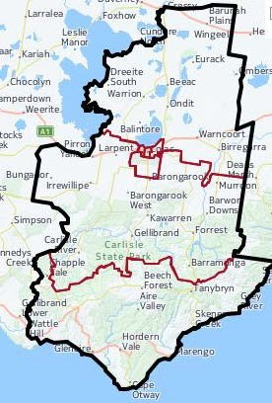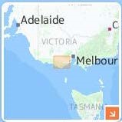

Source: <http://profile.id.com.au/colac-otway>

#### Location, population, economy

The Colac Otway Shire is located in south-western Victoria, 160 km from Melbourne, 100 km south of Ballarat and 75 km west of Geelong. The region comprises rugged coastal areas, rainforest hinterland and open plains in the north.

Its population of 20,343 (with almost 12,000 in the largest town, Colac) is predominantly Australian-born (87.7%), and with median age 40 years, older than the Victorian average. The population is growing, but more slowly than most other shires in regional Victoria. Of particular concern is the decreasing number of 15–19 year olds (a fall of 9% between 2006 and 2011), with projected decreases of 15–24 year olds in coming years (G21 Geelong Region Alliance 2014, pp.12–13).

Though traditionally a rural economy, there have been declines in employment in sectors such as agriculture, forestry and fishing, with increases in health care and social assistance, administrative support, and professional and technical services.

Its SEIFA[2] ranking (19 of 80) places the Colac Otway Shire among the most disadvantaged regions in the state, with a higher proportion of one-parent families with children under 15 years, and higher rates of young people ‘not in employment, education or training’ aged 15–19 years and 20–24 years, than the state average.

#### Education providers

The Shire is served by 12 primary and four secondary or P–12 schools. Nine primary and three secondary schools are government run, and the remainder are Catholic schools. In addition there are five providers of specialist programs for young people who have particular needs not met by other schools. The primary schools are mostly in or fairly close to Colac, with others dispersed across the Shire. Of the secondary schools, two are in Colac and the others in the much smaller townships of Apollo Bay and Lavers Hill (see Appendix E: Education providers). The four secondary schools are part of the Colac Otway Vocational Education Cluster, the centrepiece of which is the Trade Training Centre (providing training in Construction, Automotive and Hospitality.

#### School retention

School retention and attainment rates lag behind the state average. The Year 7–12 retention rate (2007–12) was 69 per cent (state average: 83%); and the Year 12 or equivalent attainment rate of 57 per cent for 20–24 year olds in 2011 was also lower than the state average (74.4%). With no tertiary institution in the Shire, the rates of those undertaking university education are modest (11% compared to 34% across the state). While the gap is much smaller for TAFE and other vocational training, the local participation rate still lags behind the state average. Table 1.1 presents key education and participation data for the Colac Otway Shire and for Victoria.

##### Table 1.1 Education and participation profile, with Victorian comparisons, 2011

| **Indicator** | **Colac Otway Shire Victoria** | | | |
| --- | --- | --- | --- | --- |
|  | **No.** | **%** | **No.** | **%** |
| **School retention and attainment**  Year 7–12 retention rate (2007–2012)1 | - | 69.1 | - | 83.2 |
| Year 12 or equivalent attainment rate for 20–24 year olds1,2 | - | 57.2 | - | 74.4 |
| **Young people not in employment, education or training (NEET) and not in the labour force (NILF)** 15–19 years | 88 | 6.5 | 18,418 | 5.3 |
| 20–24 years | 172 | 16.7 | 39,843 | 10.6 |
| **Attending post-school educational institution, 15–24 years**  Technical or further education institution | 375 | 15.8 | 117,953 | 16.4 |
| University or other tertiary institution | 259 | 10.9 | 246,550 | 34.2 |
| Other type of educational institution | 142 | 6.0 | 502,669 | 69.8 |
| **Highest level of schooling completed, 15+ years (excluding school students)**  Year 12 or equivalent (defined as Certificate II) | 5,208 | 33.2 2,152,436 | | 51.7 |
| Less than Year 12 or equivalent | 9,201 | 58.6 1,667,429 | | 40.2 |
| Not stated | 1,300 | 8.3 339,472 | | 8.2 |

1. 2011 data, <http://www.greatsouthcoast.com.au/projects/education-attainment-project>
2. Year 12 equivalent defined as Certificate II or above

Source: ABS Census of Population and Housing 2011, except where noted

## Insights from existing research

This section is an abridged version of a literature review which supported this study, and which places emphasis on education in rural and regional contexts.[3] We focus here on three themes:

* attitudes to education, educational choices and outcomes
* the range of attitudes to education
* effective strategies for promoting successful educational outcomes

We find in this literature confirmation that the attitudes of today bear significantly on the educational outcomes of tomorrow, and that much can be done to shape attitudes in ways that are beneficial to education. The literature makes clear that what happens in educational institutions is vital, and that pedagogy, support, appropriate curricula, guidance and information are key ingredients for success. Importantly, it also affirms the importance of factors beyond the educational setting that are key determinants of educational outcomes, and that this is particularly the case for those living in regional and rural areas.

#### Attitudes to education, educational choices and outcomes

##### Parental, peer and personal aspirations influence educational outcomes

Numerous studies have shown that the educational, occupational and wider aspirations of young people, their parents and peers have a major impact on educational attainment, participation in post-compulsory education and later life outcomes (Cabinet Office 2008; Homel et al. 2012; Mansfield 2010; Neunschwander et al. 2007; Nguyen & Blomberg 2014).

A parent’s aspirations for their child also have an important effect on the child’s academic self-efficacy (Neunschwander et al. 2007). A child’s academic achievement is also influenced by their parents’ level of satisfaction with their child’s school (HampdenThompson & Galindo 2016). Young people’s perceptions of their own academic ability are also major determinants of their educational aspirations and outcomes (Homel et al. 2012). Indeed, there is strong evidence that school-related factors have a relatively small effect on academic outcomes compared with non-school factors (Emerson et al. 2012).

##### Student attitudes to school influence motivation to study

Research shows that student attitudes towards their school have a strong influence on their motivation to undertake further study. Attitudes to school include whether students view relationships with teachers as supportive, and their level of interest and valuing of learning and its applications outside of school (Hillman 2010). Conversely, disengagement in the early secondary years, or earlier (Stehlik 2013), can result in longterm feelings of alienation from school or school-like environments (Finn 1989).

##### Early career planning has lasting positive employment benefits

The research also indicates that young people who have a specific career plan during secondary school are more likely to have positive employment outcomes by age 25, even where the plan is not achieved or is unrealistic. The converse is true for students without a clear plan (Sikora & Saha 2011; Thomson & Hillman 2010). Various forms of parental engagement and assistance with planning are also shown to have a positive impact on educational achievement and employment prospects (Emerson et al. 2012; Jeynes 2012; Jeynes 2005; 2007; Sellars 2016).

##### Teachers’ attitudes have a positive influence

The attitudes, beliefs and behaviours of secondary teachers have been shown to have a positive influence on young people’s transitions upon leaving school (Abbott-Chapman & Kilpatrick 2001). Teachers and the school leadership also shape a school’s ability to improve, innovate and respond to diverse learning needs, in particular, through a school culture of questioning and experimentation by staff (Carrington & Elkins 2002; Rosenholtz 1989). School-related factors that can be mitigated by teachers and that impact negatively on educational achievement or post-compulsory participation include bullying (Haywood et al. 2009), high rates of problem behaviour among students (Homel et al. 2012) and smaller school size (CESE 2013).

##### The impact of socioeconomic status and living in rural communities

Many rural areas are affected by economic decline, which is associated with lowered educational aspirations and reduced employment opportunities for young people

(Alloway & Dalley-Trim 2009; Cabinet Office 2008; DEECD 2014; Sullivan, Perry & McConney 2013). Lower educational outcomes in rural and regional areas are driven primarily by socioeconomic disadvantage, and particularly the concentration of disadvantage in some schools (DEECD 2014; Firth & Huntley 2014; NOUS 2011), which in some cases is also driven by residualisation in the public school system (Cranston et al. 2016; NOUS 2011). Parents with low SES tend to form lower educational aspirations for their children, partly due to competing financial and other priorities (Neunschwander et al. 2007). However, this should not be overstated: ‘teachers and other professionals may underestimate the aspirations of socio-economically disadvantaged children and parents and not appreciate the importance with which school is viewed’ (Cummings et al. 2012, p. 4).

Living in a rural area often exacerbates the effects of socioeconomic disadvantage on young people’s and their parents’ educational aspirations, particularly where further study requires relocation (Alloway & Dalley-Trim 2009; CESE 2013; Freeman, Klatt & Polesel 2014; Lamb et al. 2015). Rural location also affects the quality, range and accessibility of services, including health and support services, alternative education programs and further education (DEECD 2014). Rural and regional areas face particular difficulty in attracting and retaining highly qualified teaching staff and leaders, for both schools and vocational training providers (CESE 2013; Cranston et al. 2016). This in turn leads to fewer subject and course offerings which can limit young people’s educational opportunities and aspirations (CESE 2013; Cranston et al. 2016). Small communities are more likely to suffer from a scarcity of teaching materials, technological resources and applied learning opportunities such as work placements (Campbell, Faulkner & Pridham 2010; CESE 2013; Rothman 2004; Sullivan, Perry & McConney 2013).

##### The role of social capital and social norms

Social capital refers to the attributes and qualities of the family, social and community networks that facilitate cooperation between individuals and communities. It is widely recognised as a causal mechanism that shapes young people’s educational aspirations and participation, having positive effects over and above that of family and structural factors (Cabinet Office 2008; Semo 2011; Semo & Karmel 2011). Small communities with high levels of social bonding within them but low levels of social bridging capital connecting them to networks beyond their community are associated with low aspiration and fewer opportunities (Cabinet Office 2008).

Young people’s attitudes are shaped by their communities, including through the effects of social capital (Semo 2011). While young people living in small, isolated communities may have limited access to extracurricular activities (Alloway & Dalley-Trim 2009); there is scope for them to develop social capital through broader social interactions (Chesters & Smith 2015). Attitudes are also shaped by social norms, which may be transmitted through family, peers and others in the community. In a study of rural, regional and disadvantaged communities in Tasmania, Cranston et al. (2016) found evidence of entrenched cultural views among some parents, teachers and community members that education, particularly beyond Year 10, was neither necessary nor desirable; and staying at school beyond Year 10 was still seen as the exception rather than the norm. These views appeared to be gradually shifting due to decreased local employment in low skilled industries.

While broadly optimistic about their educational and occupational prospects, many young people living in rural and regional Australia are strongly aware of the potential obstacles to achieving them (Alloway & Dalley-Trim 2009). Much of their understanding of these barriers is based on direct observation and experience, as well as hearing about the experiences of other people in or from their community (Alloway & Dalley-Trim 2009).

#### The range of attitudes towards education

##### The importance of parental and peer influences

Attitudes are shaped by the individual and their immediate social environment as well as through exposure to community influences. Parents and peers tend to have the strongest impact on educational and occupational aspirations and outcomes. According to data from the Longitudinal Surveys of Australian Youth, parental and peer influences have the strongest effect on a student’s intention to complete Year 12, followed by the student’s perceptions of school, which are themselves influenced by parental and peer attitudes (Nguyen & Blomberg 2014). Aspirations to go to university are also most strongly impacted on by parent and peer influences, and occupational aspirations by parental expectations (Gemici et al. 2014).

##### The role of self-efficacy and academic resilience/persistence

At the individual level, self-efficacy and resilience in the context of learning are key determinants of a young person’s attitudes to education (Martin & Marsh 2008). Selfefficacy in educational and non-educational settings, and related to this, self-esteem, impact positively on a range of educational outcomes (Barón 2009; Cabinet Office 2008; Lamb & Rice 2008). Promoting confidence can also motivate engagement in further study, as is the case for many Indigenous learners in vocational training (Miller 2005). Self-efficacy and motivation are strongly influenced by the family environment, with one Australian study finding that home resources and parenting style are key predictors of children’s academic motivation and engagement (Mansour & Martin 2009).

##### Attitudes to school

As discussed, student attitudes to school are a major influence on school completion and participation in further study (Finn 1989; Hillman 2010). The quality of student– teacher relationships and engagement with school-related extracurricular activities are two factors that enhance student attitudes towards school and learning (Hillman 2010). Students’ and parents’ attitude towards the school are also influenced by their perception of the school’s ability to cater for the student’s learning needs. Some parents whose children fall short of having a recognised disability find that the public system does not cater adequately for these children (Firth & Huntley 2014). The support needs of gifted and talented children must also be considered, as these children are at risk of disengagement if their learning needs are not met (Koshy et al. 2013).

Parents and carers of Aboriginal students generally have a high regard for their schools and the teaching that takes place in them (Milgate 2014). Aboriginal parents and carers value principals who are seen in the community, teachers who are culturally sensitive and aware, and a curriculum that incorporates local cultural history and heritage (Milgate 2014).

Student and parental attitudes towards particular school subjects also influence educational and occupational choices (Boon 2011). An Australian study found that Year 10 school science is enjoyed significantly less in small rural and remote areas than elsewhere, raising questions about the relevance and quality of the science education in those areas (Lyons & Quinn 2012).

A 2007 study found that, in general, Victorians ‘value and support the endeavours of teachers and show strong support for the increased resourcing of education’, and that ‘support amongst the general community for both education and teachers is very high’ (Andrews 2007). However, many Australians have concerns about the public school system, even those who strongly support it. These concerns include the standard of teaching, the ability of public schools to cater for individual needs and the quality of the social environment in public schools (Firth & Huntley 2014). Many Australians believe that private schools perform better in these areas, although the quality of both public and private schools varies greatly (Firth & Huntley 2014). Public opinion remains divided on whether public or private schooling influences career success (Firth & Huntley 2014; Randles 2014).

Alternative learning programs can assist young people and their parents to develop more positive attitudes towards education, and are playing an increasing role in reaffirming a commitment to education (Stehlik 2013; te Riele 2011). Attitudes towards these programs are shifting: as the programs’ transformative effects become more apparent, less stigma is now associated with them (Myconos 2014; Myconos et al. 2016). The attitudes of other community members towards alternative schools and their students can also be favourably influenced, as discussed below.

##### Attitudes towards vocational training

Some of the factors affecting attitudes towards further education were discussed earlier. A large European study found that people’s decisions to undertake vocational training were most strongly influenced by having a personal interest in a specific vocational area and a positive perception of employment prospects (TNS Opinion & Social 2011). Female and younger respondents were also likely to place importance on travel distance, cost and image of the training institution when deciding whether to undertake a course (TNS Opinion & Social 2011). Entrenched beliefs that vocational training is inferior to university and is for lower achieving students are prevalent in Australia, including among those providing career advice to rural young people. Consequently, some rural young people are encouraged into vocational training without university even being discussed as an option, thus reinforcing low educational aspirations (CESE 2013; Webb et al. 2015).

##### Attitudes towards various occupations

Occupational aspirations begin to form around the age of 9 years and remain relatively stable after the age of 15 years (Cabinet Office 2008; Gottfredson 2002; Nguyen & Blomberg 2014). The process begins with children eliminating occupational choices based on perceived attainability and social acceptability (Gottfredson 2002; RPAC 2013). A major Australian study found that even where schools encouraged young people to consider university, social influences outside school often appeared to be stronger, leading to young people (especially young men) ‘adapting their aspirations in ways that were gendered and which replicated family and local traditions’ (Webb et al. 2015, p.8). Rural young people seem to be affected by gendered stereotypes to a greater extent than those living in urban areas, possibly due to rural communities being smaller and in some cases more socially conservative (Alloway & Dalley-Trim 2009; Webb et al. 2015). There is also evidence that Australian teachers and students have differential expectations of the academic performance of different cultural and racial groups (Dandy et al. 2015).

##### The role of information sources

Family and friends are the sources of information that individuals most commonly rely on when choosing between vocational training and other educational pathways (TNS Opinion & Social 2011), and when choosing between public and private schooling for their child (Firth & Huntley 2014). However, many young people access information about educational pathways from multiple sources, including online (TNS Opinion & Social 2011). Many people with lower educational attainment and/or lower socioeconomic status appear not to have received guidance about educational pathways from any source, including family members, and are also less likely to believe in the benefits of vocational training (TNS Opinion & Social 2011).

##### Attitudes towards relocation and education

Several geographic and social factors deter many young people from undertaking further study, especially where this would involve relocation. These deterrents include lack of transport, travel distance and costs, and a limited range of programs within commuting distance. The prospect of relocation is daunting and anxiety-inducing for many young people and their parents, particularly given that social bonds are strong in rural communities (Alloway & Dalley-Trim 2009). Both the financial and the social impacts of relocation act as major barriers to university aspirations for rural and regional young people and their parents (Alloway & Dalley-Trim 2009). Financial and travel barriers are felt most keenly in the first two years out of school, indicating the need for additional support and advice during this period (Freeman, Klatt & Polesel 2014).

##### The role of social capital in shaping attitudes

Attitudes can change in response to new experiences and influences, although little is known about how quickly the attitudes of whole communities can change (Webb et al. 2015). Many rural young people report that they lack exposure to role models for further education; instead, it is common for them to know of neighbours who have moved away to undertake further study, only to return due to missing family and friends (Alloway & Dalley-Trim 2009). They also report that they see only a limited range of career choices, as well as a lack of career opportunities in their community. Some rural students are also disadvantaged by the lack of academic competition from their peers (Alloway & Dalley-Trim 2009).

Effective strategies for promoting successful educational outcomes A clear message from the literature is that to improve school retention:

structural solutions alone are not sufficient. Responses will also need to address curriculum issues as well as deeply held cultural views and practices evident across various sectors of society, including families, communities and educators.’ (Cranston et al. 2016, p.2).

Successful interventions for promoting school retention tend to be multifaceted, coordinated and long-term in outlook (Cranston et al. 2016; RPAC 2013; Watson et al.

2015). They take into account young people’s social development and wellbeing (Emerson et al. 2012; Lamb & Rice 2008). Indigenous or other cultural needs should also be addressed in promoting student engagement, as indicated by research into vocational training (Miller 2005).

To be effective in improving educational outcomes, a whole-of-community response must be innovative and locally tailored (Cabinet Office 2008; Cranston et al. 2016). The role of school leaders, especially principals, is crucial for driving a school culture of innovation and for building strong relationships with parents and other community stakeholders (Carrington & Elkins 2002; Carrington & Robinson 2006; Cranston et al. 2016; What Works 2012). There is a need for early intervention in the formation of educational aspirations and programs that target young people who have left the school system (Nguyen & Blomberg 2014; RPAC 2013). The value of engaging students as citizens in school reform has also been highlighted (Carrington & Robinson 2006).

##### School-based strategies

Research also indicates that effective school-based strategies for enhancing attitudes to school among young people include fostering high expectations for all students (Lamb & Rice 2008). This is challenging if the local community’s attitudes and priorities do not favour high educational aspirations. Attempts to foster high expectations may be undermined by factors common in rural and regional communities, such as a lack of suitably qualified teachers, a lack of varied and challenging school subjects, and lack of diverse occupational role models (CESE 2013). However, a lack of competition from peers, which is perceived as demotivating by many rural students, may be counteracted by encouraging them to reflect on where they stand in relation to state or national benchmarks (Alloway & Dalley-Trim 2009).

##### Careers education and advice

The literature on careers education highlights the importance of actively increasing young people’s awareness of a wide variety of careers and challenging stereotypes, particularly in relation to careers that students may not have seen in their local community (CESE 2013; Gorton 2015). A study by Webb et al. found that ‘[b]y encountering educational cultures different from their own, young people are more likely to make life choices divergent from those they “inherit”’, thus ‘disrupting the strong ties of the familiar’ (2015).

Careers advice appears to increase the likelihood of Year 12 completion, particularly for young people who are originally undecided about whether to complete Year 12

(Rothman 2008). Many of the career development services available to young people in Australia are underutilised, respond only to certain needs, and provide insufficient support with the career decision making process (Rainey 2008). More comprehensive approaches include advice that is relevant to the developmental age of the audience, strategies to enhance self-knowledge and early intervention (Polvere & Lim 2015).

##### Parent engagement

Parent–school engagement strategies that assist parents to become involved in their child’s learning in stage-appropriate ways can greatly enhance the student’s attitudes to education (Emerson et al. 2012; Flynn 2007). Parent involvement in students’ educational and career decision-making processes is important – in both negative and positive respects – given the strong influence of parental attitudes in broadening or restricting a young person’s aspirations (Gemici et al. 2014). Well informed and, hence, effective parent engagement requires specific attitudes and skills, the availability of resources and leadership at the institutional and systemic levels, as well as a relationship built on genuine collaboration, including collaboration with the young person (Emerson et al. 2012; Maury 2014; Murray 2012; Porter 2008; Victory 2010).

##### Community engagement

Meaningful involvement by community members from outside the school, including leaders from business, cultural, sporting or community organisations, can have a very positive effect on student attitudes to education (Horton & Heggart 2015; Klatt et al. 2016; te Riele 2011; Ward 2007; Watson et al. 2015). This can also improve the attitudes of the community members towards the students, including those sometimes viewed as ‘problem youth’ (te Riele 2011). Unfortunately, school–community partnerships are underutilised, as they require the building of mutual trust and understanding (Cripps Clark, Tytler & Symington 2014; Flowers & Chodkiewicz 2009; Gamage 2006; Jones 2010; Watson et al. 2015). In Australia and the United States, schools are generally regarded as responsible for cultivating school–community partnerships (Gamage 2006; Klatt et al. 2016; Public Agenda & Kettering Foundation 2014). A simpler strategy found to foster positive community attitudes towards a particular educational institution is the public celebration of success stories (te Riele 2011, p.223).

# Section 2: Method

### The research design

Education in this research is considered principally from the viewpoint of the Colac Otway Shire community. We employed a mixed method approach, drawing on both quantitative and qualitative analysis in more or less equal measure. A community survey enabled quantitative analysis, while interviews and focus groups – via a combination of ‘chain’ and ‘purposive’ sampling – provided qualitative data.

### Survey development, recruitment and collection

The survey (see Appendix A) was designed for age groups ranging from early teenage to older adults (ultimately, 337 people responded). Data collection was via an online platform accessible through a link provided in emails and promotional fliers. Fliers were distributed in cafes, retail outlets, neighbourhood houses and charity shops, and to large employers. Distribution of the invitation via email commenced in mid September and ceased in mid November. Among those who helped promote the survey were secondary and primary schools, youth and family health services, employers, the South West Local Learning and Employment Network and the local government. Thus, the survey was distributed widely to school community and parent networks, employees of large firms, government agencies and their clients, church groups and youth networks. Hard copies of the survey were distributed by agencies with regular contact with people who lack reliable access to the internet.

The survey comprised 25 questions on participants’ past and current experiences in education, their attitudes and views on education, the challenges they and their communities faced, and the community-wide and school-based initiatives they feel are necessary. Though the design of the survey (and of the interview framework) was informed by a broad literature review, particular use was made of an approach taken by the Directorate-General Education and Culture of the European Commission in its ‘Attitudes towards vocational education and training’ (TNS Opinion & Social 2011). The Commission viewed attitudes from a number of vantage points[4], four of which we adapt for our purposes: the *relevance* of education to the future plans; the *status* of education against contending priorities; its perceived *benefits*; and the *quality, range and accessibility* of provision.

#### Survey respondents

Table 1.2 provides data from survey questions about backgrounds and circumstances. Some categories have been abridged for simplicity.

##### Table 1.2 Survey respondent profile

| **Characteristics** | **Total** | **%** | ***LGA population***  ***Total %*** | |
| --- | --- | --- | --- | --- |
| Gender Female | 253 | 75 | *10,204* | *49.8* |
| Male | 79 | 23.4 | *10,139* | *50.9* |
| Other | 5 | 1.5 | *20,343* |  |
| Under 18 years | 134 | 40.1 | *6,439* | *30.9* |
| Male | 46 | 13.6 |  |  |
| Female | 87 | 25.8 |  |  |
| Other | 1 | 0.8 |  |  |
| Australian-born1 | 304 | 90 | *19,074* | *93.8* |
| Residing in Rural North | 39 | 12.3 |  |  |
| Colac (West, Central, East) | 178 | 56.5 |  |  |
| Elliminyt | 26 | 8.2 |  |  |
| Rural South | 38 | 12 |  |  |
| Great Ocean Road – Otways | 13 | 4.1 |  |  |
| Beyond Colac Otway | 21 | 6.6 |  |  |
| Length of residence Less than 2 years | 29 | 8.6 |  |  |
| 2–6 years | 64 | 19 |  |  |
| More than 8 years | 243 | 72.3 |  |  |
| Highest level of education to date University degree | 82 | 37 |  |  |
| Vocational qualification | 64 | 28.8 |  |  |
| Year 12 | 33 | 14.9 |  |  |
| Less than Year 12 | 41 | 18.5 |  |  |
| Parents | 142 | 42 |  |  |
| Employment status  ‘Very’ or ‘reasonably secure’ | 166 | 77.5 |  |  |
| ‘Very’ or ‘quite insecure’ | 28 | 13 |  |  |
| ‘Unemployed and looking for work’ | 6 | 2.8 |  |  |
| Financial status  ‘Very’ or ‘reasonably comfortable’ | 219 | 67.5 |  |  |
| ‘Just getting by’ | 82 | 25.3 |  |  |
| ‘Finding it tough’ or ‘extremely tough’ | 23 | 7 |  |  |

(n=337)

Notes: 1. Others were born in the United Kingdom (4), New Zealand (3) and the Philippines (2), and individuals from Zambia, Russia, Hungary, Papua New Guinea and Easter Island. Source of LGA data: <[http://profile.id.com.au/colac-otway/population>](http://profile.id.com.au/colac-otway/population)

The table shows a strong response rate from those aged under 18 years, females, those born in Australia, the relatively well educated, long-term residents, and parents. This may reflect the demographics most concerned with education, and/or selection bias (see Limitations, p. 27). It may also reflect the prominent role schools played in distributing the survey to young people.

As the respondents used many occupation descriptors, we have grouped them in the categories shown in Table 1.3.

##### Table 1.3 Occupations

| **Occupation** | **Number** |
| --- | --- |
| Education, principals, teaching, education aides | 55 |
| Administration/office | 26 |
| Community development/local government/support | 26 |
| Nursing/health care/support | 15 |
| Management/finance | 14 |
| Retail and sales | 13 |
| Home duties | 9 |
| Farming | 7 |
| Self-employed/trades | 6 |
| Tourism and hospitality | 6 |
| Information technology | 4 |
| Employment | 2 |
| Meat processing | 2 |
| Technicians | 2 |
| Police | 1 |
| Sport | 1 |

(n=189, Q8)

### Fieldwork: meeting and speaking with participants

The fieldwork component – involving interviews, focus groups and other consultations – was designed to access a broad sample of the community. While many participants belong to multiple categories, they are listed in Table 1.4 according to their principal role, as outlined in the selection framework (see Appendix B: Interview participants). The table indicates the representation of selected groups. It also shows the methods used to engage them.

#### **Table 1.4 Interviewees and modes of engagement**

| **Participant category** | **Face-to-face interview** | **Focus groups** | **Phone interview** | **Total** |
| --- | --- | --- | --- | --- |
| Senior educator (principal, assistant principal, coordinator, RTO manager) | 4 |  | 1 | 5 |
| Educator (teacher, trainer, aides) | 5 | 11 | 1 | 17 |
| Community support, service provider | 5 | 4 | 10 | 19 |
| Employment support service provider |  |  | 4 | 4 |
| Employers (large/small) | 4 |  | 1 | 5 |
| Layperson (parents, guardians, other) | 7 |  | 4 | 12 |
| Children (school age) | 2 | 18 |  | 20 |
| Young adults (in training, with/without employment) |  | 3 |  | 3 |
| **Total** |  |  |  | **85** |

To identify suitable participants we relied initially on guidance from members of the Local Action Group. They helped identify and access a larger number of interviewees who, in turn, provided contact with more community members. ‘Chain sampling’ of this kind makes use of local knowledge, and is suited to those research contexts in which it may be difficult to locate enough subjects in a short period of time.

Mindful of chain sampling’s limitations – that is, the risk of privileging the views of those known to a group of insiders – we incorporated a degree of purposive sampling. This involved a selection framework that identified target groups, without whom no fair representation of the community would be possible.[5] Lastly, the research was promoted through newspaper reports and a radio interview with the lead researcher.

In summary, the survey and fieldwork enabled 422 people to participate in the research between mid September and mid November 2016. They provided the raw material from which we derive our assessments about the overall ‘worth’ ascribed to education in the Shire.

### Ethics

The ethical considerations and precautions needed for this research were outlined in the project’s application for approval from the Brotherhood of St Laurence Human Research Ethics Committee, accredited by the National Health and Medical Research Council. This approval was granted (2 August), as was approval from the Victorian Department of Education and Training (6 October) and the Catholic Diocese of Ballarat (25 July). Incorporated in the project methods – particularly in relation to interviewees, focus group participants and survey respondents – were plain language information forms and consent forms, each stating the possible risks to participants, as well as their right to withdraw and to review the findings.

### Limitations

We undertook to gauge how education is valued in the absence of a universally accepted measure and, consequently, without data enabling comparisons with other regions. In addition, the research provides a snapshot only of the attitudes of participants during a period of just two months.

We acknowledge the effect of selection bias: it is to be expected that those most open to contributing would be more likely to place a higher value on education than would non-participants.

Conspicuous for its absence is the voice of ethnic minorities – the small Sudanese community in particular, as well as the Chinese, Filipino and Vietnamese. In spite of efforts to recruit participants through church groups, leafleting and employers, we obtained just one interview and a handful of survey responses. This difficulty, we conclude, is partly due to the weak connections such communities have to date with services and schools (there are no ESL programs), both of which played important referral roles in our sampling.

Other factors hindered data collection: notably, flooding that severed roads and limited access; and council elections that limited local government agencies’ and some service providers’ capacity to engage. Indeed, the elections placed restrictions on the Shire’s capacity to promote the survey.

Lastly, given that the research enquired into participants’ own experiences and circumstances, it is worth considering the extent to which their views can be thought representative of the broader community. On this point we sought guidance from the participants themselves. Figure 1.2 shows an inconclusive result, with just over half (over 54%) venturing that their views were typical. This reminds us that assessments about community-wide attitudes must be tempered.

**Figure 1.2 Are your views fairly typical of people across the community?**

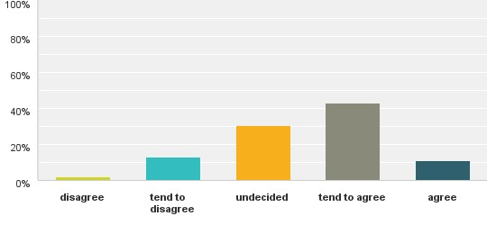

(n=280, Q 18)

# Section 3: Attitudes to education

## How participants regard the Colac Otway Shire

Vignettes from interviewees help us understand how they perceive the area in which educational services are provided. Colac Otway Shire is perceived as comprising diverse communities. Interviewees made it clear that townships differed greatly in terms of economics, appearance, demography and geography, which gave each a distinct identity.

When describing their communities, many spoke of the transformation from dependence on farming and other rural sectors such as forestry, to greater reliance on health care and social assistance, retail, hospitality and tourism. While this trend is well documented[6] it is interesting to note the aspects of change that are uppermost in the minds of interviewees.

#### The impact of change in employment and population trends

Many spoke of how the shift from farming reduced the number of ‘family farms’ that in earlier times had employed young people, and help them to grow into adulthood with purpose and support. Other interviewees speculated on the impact of these changes on the motivation of young people from farming families who are forced to stay in school:

I suppose kids who would have gone back on farms … when they were younger, all of a sudden were forced to stay in school and there just wasn’t the family aspiration around education generally. (Employment Youth Services worker, Geelong)

Interviewees spoke of a transitional phase in which many from self-reliant farming communities were reticent to call on community services when in need. They noted that such reticence often impacted negatively on the capacity of children and young people to realise their educational potential. Interviewees in the rural south and Great Ocean Road – Otways regions, where forestry had ceased to be a defining feature, spoke of the rising numbers of tourists and a decline in local communities living close to schools.

The majority of children who come to this school are travelling by bus from Barwon Downs, Yeodene. The cohort that actually live in the township of Forrest is shrinking from being 75% of the student population to now more like 20–25%. (Educator, Forrest)

Another interviewee believed that in spite of dwindling numbers, diminished school funding meant that student–teacher ratios continued to increase, and teachers were struggling to cope. Their troubles were exacerbated by the number of students with learning disabilities (Educator, Alvie).

#### Growing division between ‘haves’ and ‘have-nots’

Others spoke of the increased tourist activity and new residents seeking a ‘tree change’ which had created the appearance of growing affluence but said that this only masked the reality. The segregation within the region was characterised by one interviewee:

Just within Colac there’s lots of differences. Yeah you got Housing Commission, which is always referred to – I hate it – as the Bronx … I grew up down there, but even people who live there refer to it as the Bronx … so you’ve got a few of those Housing Commission areas around the place, and you’ve got the wealthy areas. You’ve got the farming areas, which often – you know, there’s the wealthy and not wealthy farming areas. (Community Worker, Colac)

Several interviewees mentioned a divide between Apollo Bay and Colac, with some services described as ‘Colac-centric’ and Apollo Bay described as holding itself apart from the rest of the Shire. All such impressions suggest that idealised notions of rural togetherness should be tempered.

#### Positive initiatives for Aboriginal communities

We learned from one community worker that there had been a growing awareness that services are lacking for Aboriginal people, and that a range of new initiatives are helping (a co-op, a health service, Colac Community hub providing tailored programs for Aboriginal people). This change is welcome:

It is exciting, and it’s much needed. Because you find in Colac a lot of Aboriginal people sort of go – not under the radar – but don’t necessarily identify openly … [and] opportunities for identification … are quite limited. (Community support worker)

#### Ethnic minorities – under the radar

Another change noted by interviewees was the number of migrants now settling in the area, particularly from the Sudanese community, but also including Russian, Iranian, Filipino and Indian families along with previously settled Vietnamese and Chinese families. However, there is very little evidence from the interviews relating to the impact of these migrant groups on education in the Shire. One interviewee mentioned that some African families have successfully accessed HIPPY, an early intervention program literacy development in families (Community services worker, Colac). However, the impression gained from interviewees, and particularly from those working in the community sector, was that newly arrived communities are yet to establish strong links to services.

#### Entry-level employment: a mixed blessing

Interviewees felt that the area, and particularly Colac, offered entry-level employment opportunities, particularly for the young. These opportunities were available through large employers based in the timber, dairy and meat processing plants, located near the town centre. From the perspective of one local employer, Colac compares favourably in this regard to other regional towns:

We’re lucky a lucky town because a lot of towns have one big employer and if that goes bust, the town dies … here we’ve got a couple of good timber mills, CMTP, we’ve got the hospital, we’ve got ALC, and Bulla as well. So … very, very lucky town. (Employer, Colac)

At the same time, many interviewees regarded the lure of such work to teenagers yet to complete secondary school as a mixed blessing.

For their part, employers spoke of changing expectations of new employees – expectations that would reduce the opportunities for those lacking basic literacy and numeracy. Others commented on a decreased demand for unskilled labour: ‘Like most manufacturing places, they don’t need as many hands anymore, they do things more efficiently’ (Resident, Birregurra).

Some interviewees also commented on the poor demeanour of those young people wishing to gain employment: ‘The way they dress and talk, they’re certainly not prepared for the workforce’ (Employer, Colac). This, in turn, is exacerbated by computer application processes, as described by one interviewee:

The thing is, when you look for jobs – to apply for jobs like Woolworths, Coles and

Bunnings – all the applications are now read by computer. So if they don’t match the Cert. II or something like that, your resume is not even going to get in the hands of a human being. (Employment services, Colac)

#### Colac: too big, too small; too near, too far

Another common view was that Colac has attracted many new residents from larger regional centres where housing costs have become prohibitive, but that it lacks the transport and services to cater for these new residents. Some interviewees mentioned a sharp increase in poverty, welfare dependency and a hardening of divisions between those included and those excluded from all that the region has to offer.

Look, there’s still a group – pockets in the community – who … experience generational unemployment and generational low education … there’s a real geographical isolation with that group as well … a community within a community. That community has existed for maybe five or six generations. (Community worker, Geelong)

Others spoke of Colac’s geographical disadvantage compared with regional centres such as Geelong and Warrnambool. Some service providers opted to locate in these larger towns, using as justification economies of scale, and Colac’s residents were deemed to be within reach of these neighbouring centres.

Other interviewees commented that proximity to Geelong made it difficult for educational and support services to attract sustained funding for essential local services

(Employment services, Geelong; Community worker, Colac, Educator, Colac). The everyday limitations for Geelong-based services responding to educational needs in areas like Colac were highlighted by this comment:

[We’ve got] some education support officers, and … I know they travel to Colac, but as I said, it takes a bit longer to get up there than it does here. They’ll say, ‘Oh yeah, we can come tomorrow’. Whereas [for] Colac, they’ll go, ‘Oh yeah, I’ll be there next week’. (Community worker, Geelong)

## Attitudes to education: some opening remarks

We asked: is education highly valued across the Colac Otway Shire? Figure 1.3 shows that just 49 per cent tended towards an affirmative response, with over 25 per cent undecided. Deeper analysis of these aggregate figures shows that respondents under 18 years were more inclined (64%) to show agreement (Figure 1.4).

**Figure 1.3 Is education highly valued across the Colac Otway Shire?**

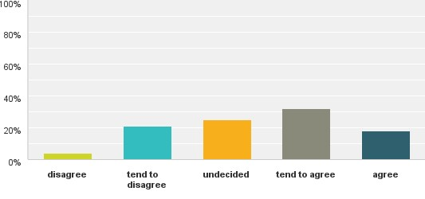

(n=263, Q 24)

#### **Figure 1.4 Under 18 year olds on whether education is valued across the Shire**

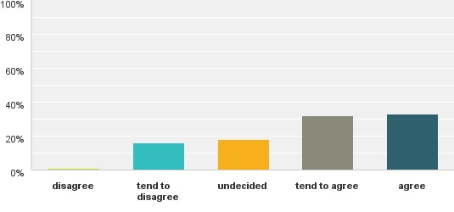

(n=88)

All this prompts us to consider a range of factors that might shape attitudes. When contemplating the same question, interviewees conveyed at least one clear message: it is very difficult to disentangle attitudes and behaviours in relation to education from wider societal factors. For these interviewees, educational outcomes cannot be attributed solely to what is or is not delivered in schools. Instead, they depend on factors such as support, health, security, confidence, wellbeing and motivation, all of which are enhanced by broader positive experiences and relationships, within or beyond a learning institution.

In what follows we explore how participants regard education, with reference to our four vantage points: *relevance*, *status*, *benefits and motivations*, and *quality, range and accessibility*. Throughout, we first convey relevant survey findings before referring to the views of interviewees.

## Relevance: the role of education in future planning

The survey asked whether education was relevant to participants’ future: that is, to their plans for making the most of the circumstances they see now, or that may present at some future time (Figure 1.5).

**Figure 1.5 Is education relevant to your future plans?**

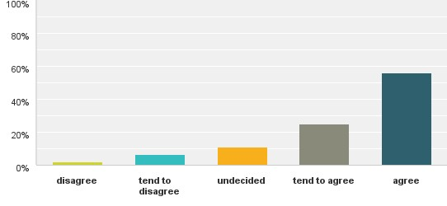

(n=281, Q 13)

The responses – with over 80 per cent showing a level of agreement with the proposition that education was relevant – indicate a widespread regard for education and the important role it plays in how people shape their future.

Figure 1.6 shows that those under 18 years indicated much stronger support, with 95 per cent inclined to agree.

#### **Figure 1.6 Under 18 year olds on the relevance of education**

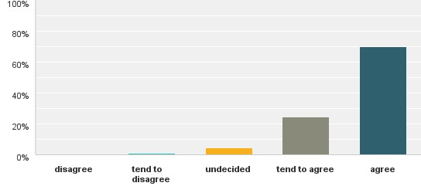

(n=94)

Yet, more can be gleaned from our interviewees on this question, with some feedback prompting a less sanguine view.

#### Barriers to realising plans

A common viewpoint expressed in interviews was that even though education is indeed relevant, the capacity to act on or realise plans is often limited for reasons including pressures relating to finance, family, and physical and mental health. One clear message was that those who regard education as relevant to their future are often discouraged when there is no clear line of sight to the next stage or setting of education provision. It seems the experience of this young interviewee was not uncommon:

When I finished school I was still only 17. I wanted to go to Ballarat Uni but because I was 17 it was going to be difficult to get there. A lot of places wouldn’t rent to someone who was 17 years old, so I ended up getting a couple of part-time jobs and then a fulltime job. I think at one stage I was working four or five jobs (Resident, Colac).

#### Entry-level jobs can undermine commitment to education

Several interviewees mentioned a kind of comfort zone for some students that curtailed their aspirations. An account of two talented students being encouraged to consider university is instructive:

We mentioned uni to her. She’s: ‘Oh there’s no way I could go to uni’! Well she’s way beyond talented enough, but her social circle don’t enhance that dream … Another girl had been offered [an opportunity] in Melbourne to do a program there and now she’s working in a small shop. She said to me not long ago: ‘I wish I had followed my dream though’ … To go to Melbourne is an enormous thing for these kids. (Educators, Colac)

One interviewee (an employer) was concerned that community members, particularly the young, were less able to appreciate the long-term future of education, and that this was in part due to the disjunction between the various educational sectors.

Frequent reference was made to the apparent ease with which young people in the past gained manual handling or processing work in the Colac surrounds, and how this took precedence over planning for education beyond senior secondary level. As one recently employed student commented:

I don’t really want to go too far ahead. Like just make a bit of money to live really. I don’t really want a career life. I just want to make some money to live. (Student, Colac)

Others, however, affirmed the relevance education, and literacy skills in particular, regardless of the type of employment:

Just because you want to be a labourer doesn’t mean you don’t need education. You want to be a garbage collector? ...you’re still going to have to learn how to drive a truck. (Parent, Colac)

Others speculated on how the availability of employment over many years – whether through farming or businesses in town – had fostered a transgenerational indifference towards education. One person commented on how the low aspirations of many young people that she knew had been accepted:

From a young age I liked school, but the plan was always to finish up school as fast as I could. I don't actually know really why: for ages that was just the plan – as soon as I hit the right age I was leaving and working … I was probably 15 or something. Year 12 didn’t loom large in my mind. For me it was always to get out working and do something I guess … a lot of my friends were [thinking the same]. A lot of us didn’t actually leave until Year 12 but a lot always planned to get a trade or to do some sort of traineeship, apprenticeship or some sort of office job you didn’t really need [a qualification] for. (Resident, Colac)

## Priorities: how education ranked against contending priorities

In contrast to the previous question focusing on relevance to future plans – this question aimed to show where education was situated as a current priority. Survey respondents were asked where education ranked alongside other commitments, be they to family, employment, health, recreation or other lifestyle choices. Figure 1.7 shows that 82 per cent of all respondents regarded education to be among their highest priorities. This is another indication that education is valued (deeper analysis shows almost 95 per cent of those under 18 years supported the proposition).

**Figure 1.7 All things considered, is education among your highest priorities?**

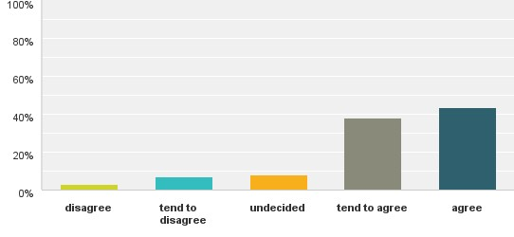

(n=288, Q 14)

Those interviewed shed light not on only the contending priorities, but also on how some commitments impact on families’ and individuals’ approach to education.

Commitments range from what might seem trivial to the critically important. Unsurprisingly, the former included what parent interviewees regarded as distractions from education for young people such as travel, sport and other recreational activities. More often mentioned, however, were financial and physical and mental health concerns. Interviewees described how these and their commitment to education could come into conflict.

#### Relocation can be expensive and challenging

Some spoke of how prioritising education can lead to familial disruption and financial hardship. This was often the case when families across the region – particularly in the rural north and rural south – contemplated the sacrifices needed to send their teenage children to post-secondary school education or to pursue interests not available in the

Shire. Residing some distance from universities or vocational training institutions such as TAFEs in Geelong, Warrnambool and beyond, families weighed the travel, accommodation and general living costs they and young people would incur. They also weighed the dislocation and the disruption to the family (these implications would not be lost on younger siblings who were privy to discussions that might shape transgenerational attitudes to education).

For these reasons many young people opt for relatively unskilled, entry-level employment, rather than pursuing a difficult progression to further education. For one resident this move was understandable, yet self-defeating:

I think a lot of people think that it’s okay to be a dropout and not to finish school and work at Macca’s for their whole life, even though you will struggle when you have a family and need to pay for things. Also their kids will think it’s okay to be a dropout and live with their family forever (Resident, Colac; survey text response)

#### Sometimes there are more important concerns

Some interviewees spoke of being drawn away from formal education by a change in life circumstances, such as an unplanned pregnancy or the need to care for family members. One single mother of 22 said she was now returning to school to finish Year 12 because she ‘wants life to be better for her children and things like that – settle down pretty much’ (Parent and student, Colac).

Other life circumstances also made it impossible for some young people to engage fully in education. This seems to be the case in Colac especially, where issues related to homelessness, including couch-surfing, the need for kinship care, and parental drug abuse were not uncommon. Many interviewees mentioned drug abuse for students and their parents as a serious threat to educational advancement. One interviewee – employed in a program for disengaged young people – relayed a story revealing some of the hardships that might go unnoticed:

This student was living in a caravan, and we started talking about the paranoia that he had about his personal safety, and he said ’I’m going to take you for a drive’. He took me for a drive for three hours around Colac and he was able to show me every alley, every escape route, who was sitting in ‘that car’, why they’re there, people who are on corners … it helped me understand that, yes, everything is ‘nice and dandy’ here [in our program] – we offer them six hours of safe time. But this is the world … that these young people are dealing with. We need to know, we need to understand that. (Community educator, Colac)

An additional consideration was the need to navigate community services whose capacity to respond was limited. Interviewees spoke of the complexities of gaining referrals and consultations with specialised health services based outside the Shire, many of which provide limited outreach services. Others spoke of the difficulty teachers had in tracking services support for students. One interviewee commented on the problems brought about by competitive funding models for services:

There is a real disconnect between providers of services. There seems to be a lot of ownership about their groups – [and this] creates barriers for progress – especially for recruitment (Educator, Colac).

The needs of both parents and children were at issue here, and it was evident that navigating through the service landscape was time-consuming and confusing, and frequently impacted on school attendance. For example, one primary educator commented that students were sometimes taken out of school for government-funded therapeutic services that were also provided within the school.

The interviews pointed to a myriad disincentives and hindrances that potentially eroded people’s commitment to education. Furthermore, we learned that those most likely to ‘demote’ education included those experiencing disadvantage, hardship and the cumulative effect of multiple difficulties.

One resident in a lower socioeconomic area reflected on the impact of poverty on parental aspirations:

Watching that lower demographic … I think it comes down to the parents’ headspace, where they’re at with their life. But generally through the years I think [education] is just not a priority for people anymore. (Parent, Colac)

In addition to these challenges, educators spoke of those who justified their children’s non-attendance for questionable reasons. For example, we heard about a tendency among some families to take advantage of ‘off-peak’ budget holiday offers, even during school terms.

## Benefits: what motivates people to undertake education

Participants were asked about their interpretation of the benefits that education conferred, and about what motivates them to undertake study or to encourage others to do so. This is important as it explores the extent to which education is valued beyond practical considerations or a means to an end.

Through the survey we enquired into the extent to which education was associated with increased income, improved employment outcomes, gaining life skills, a sense of accomplishment, and increased respect from family, peers or the wider community. Figure 1.8 indicates a strong association between education and both monetary and non-monetary benefits. A high proportion of respondents indicated that education was future focused, to the extent that it would enhance employment prospects, and the acquisition of skills for and beyond the workplace. Interestingly, there was also a strong link between education and a feeling of personal achievement.

#### **Figure 1.8 When I think of the benefits of education, I think of** …

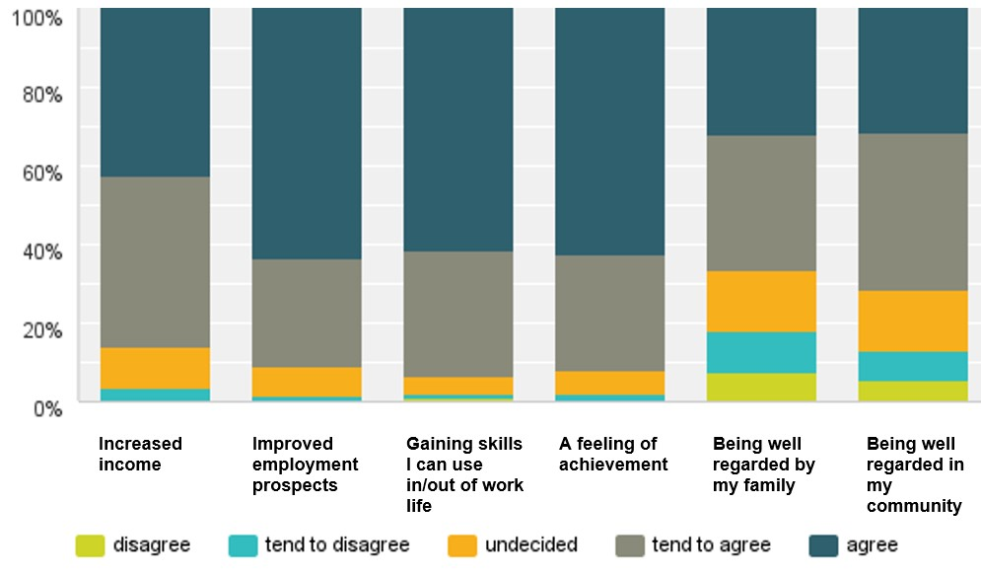

(n= 287, Q 17)

The corresponding data for those under 18 years in Figure 1.9 shows similar results, except that the younger respondents were less concerned with education for the purpose of increased future income, and more concerned about gaining respect from family and the community.

#### **Figure 1.9 Under 18 year olds’ views on the benefits of education**

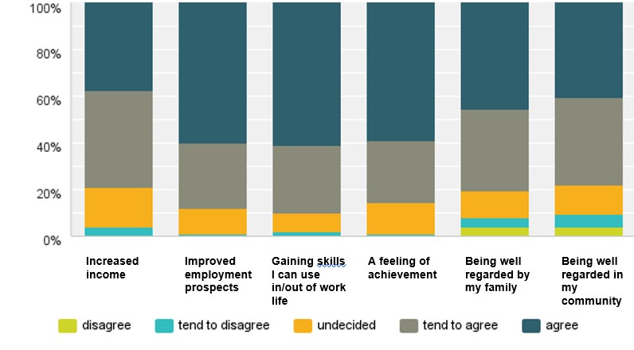

(n=100, Q17)

Interview responses resonated with survey findings. Among the benefits, vocational education and training figured prominently. Interviewees generally regarded training and upskilling as necessary to better situate themselves in the labour market and gain improved income. As expected, if interviewees valued education, they also spoke about their children valuing it and a love of learning being fostered in the family.

#### Doubts about the worth of university education

One interviewee believed there was a shift under way in young people’s attitudes to education. By this account, young people were questioning society’s fixation on tertiary education, and this undermined their commitment to attaining Year 12. This is illustrated by a current student:

I’ve been to a few Arts lectures at Melbourne Uni, been to the open day and stuff, yeah … but when it comes to the Arts field … I don’t want to end up doing a degree like that. I’m sure philosophy’s all good-and-well to learn but I’m not sure that it would get me a job – just a 20-grand debt. (Student, Apollo Bay)

However, another interviewee mentioned a lack of academic mentors for some young people as an issue affecting the perceived benefits of education:

I don't think they have the mentors to speak to. I don’t think they see the positive parts of university and I don’t think they hear at home that it’s great, that it’s empowering, that it’s fun. (Parent)

#### Vocational training is favoured by many

For some young people, taking the place of aspirations for a university degree are vocational training qualifications that promise easier access to employment, as well as a sense of achievement, self-worth and personal improvement. One student who had tried to re-engage at school told of how undertaking VCAL[7] had extended his skills but also given him the chance to work out what vocational path he wanted to take:

I finished Year 9 and started Year 10 for about a month and that was when I dropped out. I thought back then you needed at least a Year 10 pass to get any job – and then I went back to school [to a VCAL provider] and [there] it’s not about the year level any more – it’s about the certificates you complete within that year, or within your schooling time. I did that many certificates…It was very, very beneficial. (Recently employed student, Colac)

#### Education for esteem and relationship building

Many older interviewees commented on the formative value of education, as it had initiated positive changes in their lives. One said: ‘I think it’s the desire to keep learning, and change and develop, that sort of thing’ (Parent, Colac). Another stated that ‘I really think it’s the bridge out of poverty … Also improving heath and [well]being – feeling connected, that sort of thing’ (Parent, Colac).

Other interviewees commented that one benefit from education was that it ‘gives your mind something to do’ and was ‘a kind of validation of your experience’ (Parent, Colac). For that interviewee, further education also gave older and younger people a chance to mix in a shared endeavour:

It’s the ability to be able to communicate with those younger ones where they may see you as ‘Oh, just some old chook’. But if you can talk to them and react with them on their level – if I can do that – like I’m getting something that benefits me … but also, that I can give back to others, is how I see it in later life. (Resident, Colac)

Another benefit of education was that it promoted intergenerational aspirations:

I’ve got this idea that I’m going to run courses for parents, but not parenting courses – parents are too intimidated to come because they think they’re being judged as bad parents when they get there – but [various certificate courses] … with little graduations that let the kids see that the parents value education … I think parents would jump at it. (Educator, Colac)

## Quality, range and accessibility

Participants were asked to comment on how they regarded the educational institutions in the Shire, including primary, secondary, vocational, alternative or non-accredited training institutions. Figure 1.10 shows survey respondents’ impressions of quality.

#### **Figure 1.10 From my experience, the following are of high quality in the Shire**

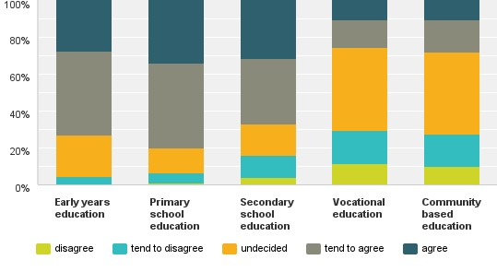

(n= 285, Q 15)

The survey results indicate that many respondents have a high regard for the quality of early years education providers and primary schools: the former received 73 per cent, and the latter 80 per cent, of responses expressing satisfaction[8]. The responses were less positive for secondary schooling (67%), with fewer still indicating they had a high regard for providers of vocational training (26%).

A slightly different story emerges if those under 18 years are considered in isolation. Figure 1.11 shows that young people have a higher regard secondary school education than do older people (80%).

#### **Figure 1.11 Under 18 year olds’ views on quality of various education sectors**

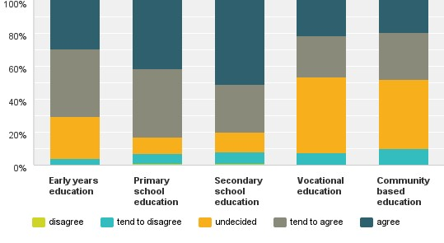

(n=100)

#### Limited options

Interviewees held strong views about the educational landscape across the Shire. Many spoke of how a lack of choice affected parents of both primary and secondary school aged children – for example, those who would like to have multiple secular options or who face the prospect of incurring costs associated with private schooling. One parent, commenting on the difficulties for many parents of children with learning disabilities, said this about her own situation with a child who had disengaged from school:

[the children] have lost interest and they’ve lost interest for a long time. The thing is, with having one school you don’t get the option to say, ‘Well look, they’re not happy here’, so let’s go there – unless you’ve got big money of course, but there’s no option. We have no options unless we travel. I’ve got a couple of kids [in primary and secondary school] and one child with a disability and I can’t travel because I have to think of the other children. The options are gone. (Parent, Colac)

Another interviewee – a community educator – found this a familiar predicament.

I’m just sort of finding that once kids leave for an extended period it’s damned hard to get them back. When the choice of schools is limited … like two schools – one’s a Catholic school that the parents can’t afford to go to, so it’s really only one – and if there is a major social issue there, that limits their chances. (Community educator, Colac)

Interviewees also noted the difficult transition from primary school for children who travelled a long way from small rural schools but who had little choice about where to go to secondary school. (Educator, Forrest; Support services, Colac)

Several interviewees noted that without alternative education providers it is very difficult for students to re-engage in schooling (Community educator, School educator, Colac). A common perception was that while alternative community programs providing VCAL have been successfully implemented, the overwhelming demand across the region cannot be met given current funding and organisational arrangements. (Community educators, Community services, Colac)

#### Residual effects of school merger in Colac

A recurring theme was the detrimental effect of the merging in 2010 of two government schools (Colac High School and Colac Technical School) to form Colac Secondary College. Indeed, a majority of interviewees referred to the merger as a watershed moment in secondary education in Colac and surrounding area, with some even suggesting that the current completion rates may be a result of shock waves from that merger. One newcomer to Colac commented:

I reckon it [poor attainment] probably stems back to when the schools amalgamated and there was quite a bit of turmoil. I’ve only been working in Colac for two years but the trauma of that amalgamation is still deep (Resident, Colac)

Of all the issues raised in relation to the merger – for example, unease among staff, relocation and construction challenges, as well as other teething problems – the most frequently mentioned was the limits it placed on choice. Indeed, many looked upon the merger not as the emergence of a larger and better equipped school, but as the removal of a well-regarded alternative.

One parent explained the bewilderment of many local people about the closure:

The big knot in everybody’s head is that high school getting dumped … they never wanted the two public schools to merge. We don’t ever understand why the government done that because they didn’t ‘forward think’ to the ‘baby-boom era’ … where [politicians] said ‘have one [baby] for your country and one for yourself and we’ll give you $5,000’. They didn’t forward think that those kids have got to go to school some day, and there’s a very high chance they’re not going to leave Colac. So when it happened the school was already full and then you’ve got all these up and coming kids. There’s heaps of primary schools but only two high schools – why would you shut down a third high school and merge it? We just couldn’t get it. (Parent, Colac)

The same parent did not believe the closure had changed people’s attitude towards education, saying ‘I think it was more the fact that [people believed] education was going to suffer because of it’.

In numerous interviews, the merger was perceived as placing considerable pressure on the newly formed school:

When there was the closure of the two secondary schools a number of families went across to the Catholic education system, leaving a base of low socioeconomic families. I think that has … posed some challenges for the [public education] system. (Community worker, Colac)

One former student remarked that the merger created problems in terms of class size for some students. He contended that more students with various needs created a pressure-cooker effect for all involved:

Because it’s so big. Like obviously the teachers like teaching but it’s pretty full on for them too. Not just us students. Like, the teachers would have a hard time and probably got frustrated, which probably made their teaching hard as well, which made our learning hard. It all impacted on everyone, not just us students. Some can just put up with it, and I just wasn’t one of those people. (Student, Colac)

Another former student commented on the immediate impact:

There was a lot stuff going on at the school at the time, which made it quite hard to focus on your schoolwork … that was a massive distraction at the time, that was my Year 11 and 12 which probably didn’t help. In Year 12 they cut back some of the [courses] because there wasn’t the two schools … because we’re in a regional area there’s not as much opportunity. (Resident, Colac)

However, some educators reported that after a difficult transition, an engagement framework (now in its second year at the school) was proving effective. This is part of an ongoing improvement:

When the schools first amalgamated, it was about finding the right temperament or culture … to push forward with, and it was about making sure that culture enveloped everybody in our system, not just one particular status. (Educator, Colac)

#### Increased competition between school sectors

Another effect of the merger is evident in perceptions of the relative quality of schools in the region. Many spoke of the increased competition between the two remaining schools, and of how that competition worked to the advantage of the Catholic school system which could be selective in its enrolments. Since the merger, several interviewees reported that kindergartens were referring children to Catholic primary schools to improve chances of securing a place in the Catholic secondary school (about which interviewed parents commented positively).

Interviewees’ responses suggest that the enduring reputations of both schools were shaped by the merger, with the Catholic school’s reputation enhanced, and the government school’s reputation diminished. One educator commented that the negative perception of the secondary school is ‘out of skew, it is totally out of skew. It’s been the perception – the perception and not the reality is what’s done the damage’.

Many interviewees – parents and former students, and educators – recalled a time when all three schools provided a shared curriculum which extended study options and made the best use of resources for the benefit of students. One interviewee said:

The shared campus arrangement, that was absolutely fantastic … There was the tech, the high and Trinity all working together and offering comprehensive subjects across VCE, and we saw it first-hand … [And] as well as that, outside of school those young people were uniting with each other because they’d come across each other – and so there wasn’t this competitive element. (Parent, Forrest)

Some reflected on the challenges for both schools as a result of enrolment fluctuations, shifting demographics and the learning needs of students. For one Pirron Valley resident,

Having one public high school and one private high school only in Colac creates a cultural and economic divide between the 'haves' and 'have-nots'. (Admin worker, survey text response)

#### Limited options beyond secondary school

The concern with limited options extended beyond the secondary schools. Particular mention was made of the paucity of options for young women. Concerns were also frequently raised about the limited range of non-TAFE vocational training organisations, as well as of flexible learning options designed for those who had disengaged from mainstream schooling.

Several interviewees also mentioned the lack of suitable provision for older students, many of whom were now parents, who were ready to complete their secondary education after a period of disengagement. They spoke of the effect of the closure of the Otway Community College in Colac, with people denied the opportunity to take accredited or non-accredited courses outside a highly competitive mainstream context.

#### Limited capacity to respond

The capacity of schools to meet the needs of young people was a recurring theme in discussions. Interviewees referred to the growing pressure society placed on schools to achieve improved educational attainments, as well as to an unrealistic expectation that they would easily adapt to the changing socioeconomic complexion of the Shire. Many believed that the existing schools and training providers were falling behind in efforts to cope with the growing number of students and families with complex financial, social, physical and psychological needs.

However, these views were not universally shared, with some students, staff and parents speaking highly of the schools with which they were associated. At Apollo Bay students commented on friendly and supportive relations between peers, small classes and lack of bullying as motivating factors. The following collection of responses from across the Shire shows that the efforts of educational providers are appreciated:

I think the staff and students that I know … and the principals that I know of – they are really conscientious and doing a really good job in a really hard situation. (Support services, Birregurra)

I do know that our college … is working really hard with disengaged kids. (Parent, Colac)

Lavers Hill [K–12 College] was a fantastic school when I was there, very community minded, all the teachers were great. (Resident, Apollo Bay)

If anyone wants a good place to be for school, enrol here [alternative program], like [there’s] a little bit of waiting list I think because there’s lots of people who want to come here … I chose this place and I think I’ve come a long way. (Student, Colac)

Nevertheless, many participants believed that the school system was under resourced, with wellbeing support and career guidance lagging behind demand. While the importance of a small number of re-engagement programs was acknowledged, they too were thought to be under resourced, and remedial.

Views were also expressed about the demands on teachers in the Shire, and about the capacity of some to stay abreast of the skills needed to teach effectively. Importantly, a number of participants were quick to remind us that the community’s fears and anxieties sometimes seem to be placed at the feet of the teaching profession. For one student, however, there is much need for improvement:

…the teaching staff of these mainstream schools need to take into consideration their students’ insecurities and issues at home before lashing out at them in a class atmosphere in front of their peers. This has a negative effect on the student and from my own experience makes it very difficult to actively want to come to school each day. (Student, Colac; survey text response)

With some exceptions, the vocational training providers were not highly regarded, with the limited selection of qualifications a concern. There were indications also that local training providers suffer from the broader perception that vocational training is inherently inferior to ‘higher education’, and that on the other hand it does little to cater for the learning and wellbeing needs of a growing number of young early school leavers.

#### Accessibility

Given that the Shire is large and its communities dispersed, a question was posed about accessibility of education. Figure 1.12 shows that many respondents are untroubled by the distances they travelled.

##### Figure 1.12 Schools and other providers I need/have needed, are/were, easy to reach

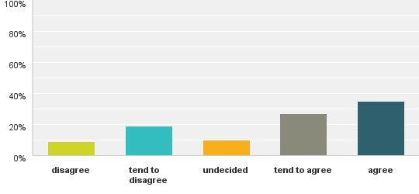

(n= 283, Q 16)

It is likely that some who experienced difficulties may be referring to the distant postsecondary school education providers, and perhaps to accessing the secondary schools in the Shire, particularly given that two of the four are situated in Colac, with others in smaller townships (Lavers Hill and Apollo Bay). It is unclear whether the same concerns apply to primary schools, which are in greater number (though, again, concentrated around Colac). Frequent references were also made to the large distance to the nearest TAFE and university, with campuses located in Geelong and Warrnambool.

###### Distance is a barrier

An educator in Alvie in the rural north noted that students from that area were forced to travel long distances to secondary schools, and also that that their transition from primary school was made more difficult because they were used to much smaller school communities.

Concerns were raised about public transport. Some interviewees spoke of the inflexibility of the public bus system, and of how funding cuts had impacted on its capacity to serve the community. Similarly, concerns were raised about the rail system, which provided only three services to Geelong each day, and those at times that did not align with TAFE and university teaching times:

So, going to Geelong, you’re either there at 8 o’clock in the morning, okay, or you’re there at 2.30 in the afternoon. There is a bus that comes around 5.30 or 6 o’clock. If not, you have to wait until the 8.30 or 9 o’clock train at night. (Employment support, Colac)

Many interviewees spoke of the upgrade under way of the highway linking Colac to Geelong as a positive development that would allow easier transport to more learning and employment opportunities.

###### Weak relationships and estrangement are barriers

Geography was not the only barrier to access. A recurring theme in interviews was the difficulty schools and parents faced in building relationships. Some parents of children proceeding to secondary school experience the new setting as intense and complex, and feel their presence may not be welcomed by their children. In addition, engagement with schools was thought to be difficult for those parents whose own experience of education had been negative. Where such parents’ children were experiencing difficulties, education had long ago come to be synonymous with ‘bad news’. One parent commented on how personal troubles impacted on her capacity to communicate:

I had stuff going on too, and so I probably wasn’t dealing with things the best as well. I was only young and – yeah – [many parents] feel like the principals and teachers have power over things … probably feels a little bit daunting to go see them. (Parent, Colac)

For parents who themselves had little positive experience with schooling, it is often difficult to support their own children as they negotiate secondary schooling. This is nowhere more important than for Aboriginal children whose parents experienced difficulties at school.

having at home family members who haven’t gone through their own education, so they don’t necessarily know what the process is … so the kids haven’t got that go-to person at home either. So that understanding of the process is only at school, it’s not at home. (Community worker)

The schools’ responses to Aboriginal communities are uneven, with tentative and intermittent interest shown by a number of schools. There remains much to be done, with one community worker reflecting on why progress is slow:

I think also a lot of [schools] don’t see the need for creating a culturally safe environment if they have, say, three Aboriginal students, so they see it as such a minor cohort that [change] doesn’t actually need to happen. (Community Worker)

For their part, educators spoke of difficulties in engaging parents who worked long and irregular hours, or were preoccupied with personal and family difficulties. Educators also expressed frustration with some parents’ complacency, and apparent lack of regard for their children’s education. For some, a consequence of this parent–school estrangement and lack of investment in a child’s educational experience was an indifference to postsecondary and higher education. Unsurprisingly, interviewees believed that relative affluence plays a major role in determining the capacity of parents to engage. It seemed those that participated in parent programs were those least in need of the engagement.

## Attitudes to education: summing up

A summary question in the survey invited participants to share views on the extent to which schools were positive, rewarding and welcoming to young people. The results in Figure 1.13 suggest that schools in the Shire are considered positive and welcoming by many people – with almost 67 per cent inclined to towards agreement – though we might have expected higher overall support (disaggregated results for those under 18 years were lower still, with 64% in support).

**Figure 1.13 Are schools in the Shire positive and rewarding places for young people?**

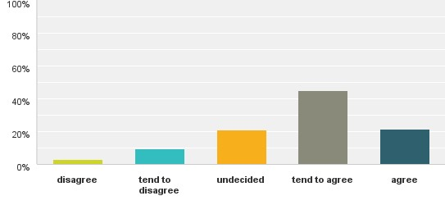

(n=262, Q 23)

What conclusions can be offered about attitudes to education in general? We have seen that while most considered education to be very relevant, the educational pathway is often blocked. We have also seen that for many people education is one of many priorities, and one that they are compelled at times to relegate, particularly if the family is unstable or facing hardship. Education is strongly linked to short and long-term benefits, not all of which are monetary. The institutions and methods through which education is delivered are also under considerable scrutiny, with many people concerned with the level of choice, competence and accessibility.

In response to the assertion that people in the Colac Otway Shire in general do not value education, we can offer this qualified response: while many people suspect there is entrenched apathy in sections of the community, it is likely that what is often being observed is bewilderment and uncertainty with a complex and/or limited system. Such ambivalence about education – perhaps best illustrated in low parent–school engagement – is hardened to the extent that people must grapple with pressing personal, social, financial concerns.

# Section 4: Initiatives

## How challenges to education are perceived

Participants in this research were asked what they believed were the main obstacles to better educational outcomes. Figure 1.14 shows that survey respondents were concerned with barriers linked to personal issues (85%) and home life (90%). A smaller proportion (58%) pointed to employment and economic factors. The extent to which survey respondents believe tradition and culture plays a role is uncertain, with a significant proportion undecided, or tending towards disagreement. The results were largely mirrored in results from the 90 respondents under 18 years.

#### **Figure 1.14 Problems such as poor attendance and completion rates are linked mostly to**

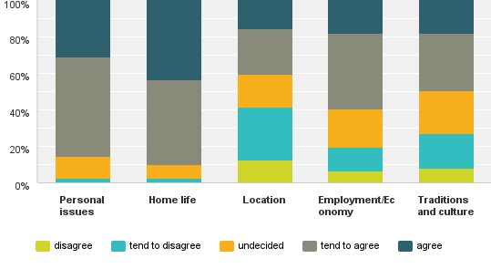

(n=270, Q 20)

While these categories sufficed for the survey, a more nuanced approach is needed. To capture the entire range of challenges raised in surveys and interviews we provide Table 1.5, which brings into view a wide range of concerns, including factors within the education system.

#### **Table 1.5 Local factors participants identified as contributing to educational underachievement**

| Personal issues | Home life | Location | Employment and economy | Tradition and culture | Specific to education |
| --- | --- | --- | --- | --- | --- |
| Anxiety & mental health issues  Poor nutrition  Fear of violence & bullying Drug & alcohol abuse  Boredom | Instability or family dysfunction  Parents’ reticence to engage with school  Parent ambivalence and wariness re social media and IT  Caring & other responsibilities | Difficulty accessing school or provider  Public transport issues  Complex & inadequate community support services | Financial hardship  Assumed access to entry-level employment  Transition from forestry, dairy etc. to the unfamiliar.  Intergenerational poverty  Costs associated with accessing distant options | Reputation  Familial connection to the land  Persistent negative impressions  Indifference to education born of intergenerational poverty  Sense of exclusion from mainstream culture | Bullying & strained relationships  Lack of choice  Residualisation  Inflexible & uninspiring curricula  Few or low quality post-secondary options  Inadequate career advice  No clear line of sight to work, further education or training |

Such lists are familiar reading for those concerned with supporting young people as they transition through school. However, one issue resonated throughout the Colac Otway community: a narrowing of choice and unproductive competition between schools. Some interviewees were of the belief that the inevitable loser in such competition is the government secondary school, as it has less scope to exercise selective enrolment, and so has to cater for relatively more high needs children, while it is expected to increase attainments.

From this point, we focus on the initiatives participants believed would meet these challenges. We consider firstly the community-wide responses they believe are necessary, before turning to responses that schools – and by implication, education authorities – should consider.

## Suggested community-wide initiatives

Survey respondents were presented with a selection of community-wide measures that, according to the literature, were likely lead to improved educational outcomes. Figure 1.15 shows that respondents offered support for all, with least support for an enhanced role of sporting clubs. The strongest backing was for parent support (86%). This preference was followed by housing and family support (83%), enhanced school– community links (81%), more vocational training (76%), crisis assistance (75%), healthy living and fitness programs (74%) and better transport and mobility (71 %). The ranking of transport seems low in the light of interviewees’ comments, but may be linked to adults’ access to cars.

#### **Figure 1.15 Community-wide changes that are keys to improving education standards across the Shire**

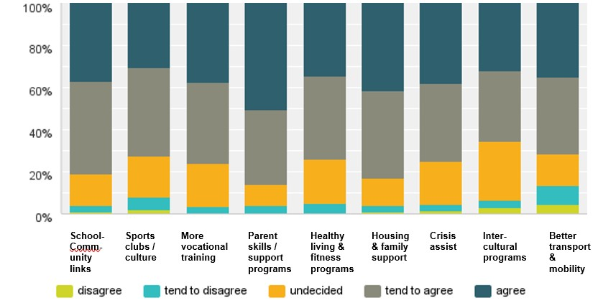

(n=268, Q 21)

Disaggregated analysis focusing on the 90 respondents under 18 years shows some variance, with marginally more concern for healthy living and fitness programs (80%), crisis assistance (77%, compared with 75%), and less for school–community links (69%, and 80%), vocational training (61%, and 76%), and housing and family support (78%, and 83%). Initiatives that improve transport and mobility received greater support from this younger cohort (85%, 72%).

#### Holistic integrated support

A refrain in many interviews was that improvements in educational outcomes required a community effort, and this involved change in the broader social context. In the context of Colac, for example, there was a view that resources, innovation and energy should be harnessed to enhance and promote the town’s many assets. Promotion of art, music and beautification were all part of improving civic pride and countering persistent negative impressions of the town. Interviewees also felt that to persuade more young adults to remain in Colac it was necessary to make it a more interesting and vibrant town, and to ensure that it is a safe, secure and healthy place to live.

Stability and security are particularly important for Aboriginal children, where development of identity is so vital. A community worker engaging with Aboriginal families commented on this issue:

If you can be proud about who you are, then you’re more likely to aspire for other things. So, if you’re not given the opportunity to be proud of your identity and to have that celebrated, then you’re not going to feel safe, you’re not going to feel like you belong, and stemming from there you’re more likely to not ask for help if you need it because you don’t have that confidence about yourself … If the environment’s not conducive to that positive identity, then you’re not going to want to be there. (Community worker)

To do all this called for specific measures. Interviewees referred to the need to improve services to families and young people, housing and mental health support. This may require new services, as well as stronger connections between existing services and specialist support workers wherever they are located. To illustrate, one interviewee reflected on the introduction of the National Disability Insurance Scheme. While the NDIS was considered an important service, doubts were raised about its capacity to bring those in need into contact with health professionals not based in the Shire.

#### A broader learning community

Improvements were also called for in the range of learning options. This would include not only alternative settings for young people unsuited to mainstream school environments – two such programs exist and are highly regarded – but also promotion of wider vocational training opportunities. Interviewees saw the need to promote the benefits of practical, hands on learning, and to match this with access to more training providers and/or a greater choice of qualifications. This was articulated in a survey text response:

I think we need a clear path for students in the trades like we once had with tech[nical] schools … In towns like Colac there is a definite need to have a trade school where students that are not interested in a VCE-type education can find a … course to keep them in school and help them become a valuable member of the community. (Farmer, Barongarook)

An employer affirmed the need for stronger pathways between school and work:

I think there should be more emphasis put into the transition from education to employment, like school-based apprenticeships. Also more education on realistic goals and employment opportunities. (Employer, Colac; survey text response)

Researchers witnessed first-hand the enthusiasm young women trainees expressed for one small training organisation, recently located in Colac and providing qualifications in hair and beauty. During interviews the value of this opportunity was made even more apparent when students recounted past attempts to access similar training in faraway Geelong using trains or buses. The lesson here was that new, accessible training is possible and, from a business perspective, commercially viable.

A related concern – the lack of a TAFE or university – is not so easily overcome. However, interviewees spoke of how better public transport links, facilitated online course delivery, and assistance to young people to gain their driver’s licence would all ease many of the difficulties with access to further education. The following contribution affirmed the need for stronger pathways between school and work:

I think there should be more emphasis put into the transition from education to employment, like school-based apprenticeships. Also more education on realistic goals and employment opportunities. (Employer, Colac; survey text response)

Implicit in all such responses was a call for the creation of a learning community that extends beyond the confines of schools. Participants saw the need for a network of collaborating agencies – across educational and service settings – that were more attuned to the needs of both learners and their families. Such collaborations would facilitate understanding of, and transitions through, the educational landscape, be it through improved counselling, career advice, after-school programs, mentoring, tutoring, homework groups or innovation in program delivery.

#### Bridge-building: schools, parents, the community

Interviewees also dwelt on the need to improve parents’ capacity to engage with schools and education in general. Despite a degree of frustration with apparent indifference, many interviewees believed engagement could be achieved. To do so, they suggested proceeding with the assumption that most ‘disengaged’ parents would likely respond, were it not for compelling challenges.

Thus, one key to enhancing parents’ willingness and capacity to engage is assisting them to deal with instability and difficulties of the kind featured in Table 1.5. Another interviewee made a case for providing opportunities for parents to socialise: such events – sporting, cultural and/or celebratory – would build rapport and a regard for the importance of learning and for educational institutions themselves. This is all the more important given the belief among others that many parents are loath to engage where conventional formal interactions are associated with implied judgements of their parenting.

Speaking in relation to Aboriginal communities, one community worker believed this socialising approach ought not to be limited to parents:

I think there needs to be more positive use engagement activities … So bringing them into an environment where the kids are appreciated and they are learning in an informal capacity. So, it could be … like the youth coming together and creating a meal for people in need or something like that, so they’re learning their life skills as well as helping community, helping the elders, helping people in need. Also … having a youth-focused area where the kids know they can go to for help outside of school, so like a tutoring group or a homework group where there’s someone there they can approach. (Community Worker, Colac)

Interviewees were under no illusion as to the difficulty in improving parent–school– community relations. Relationships between parents and education providers are complex, and may change as children transition from one setting to another. Interviewees pointed to the need to not only enhance parents’ opportunities for interaction, but also their skills to talk with educators across the education and training landscape. In practice, this entails improved communication, information and parent friendly scheduling.

Survey respondents provided some insight into what might be needed for bridge building of this kind when they indicated their preferred sources of information about schools and education in general. Figure 1.16 points to opportunities, as well as to sobering lessons.

##### Figure 1.16 When making decisions or judgements about schools/providers I refer to …

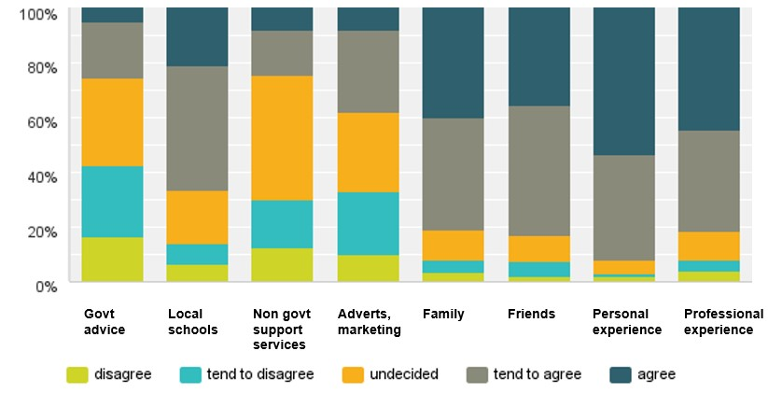

(n= 287, Q 19)

The responses show that there is much scope for improved communication from government, with only 26 per cent of respondents indicating that government is a preferred source of information. Nongovernment agencies fared worse, with barely 24 per cent support. While there is reliance on schools, they too might consider ways of improving communicating with the community. In contrast we find that most respondents rely heavily on personal experience (92%) and the views of friends (83%) or family (80%). If this result is representative, the importance of personal contact between residents and education providers is apparent.

## Suggested school-based initiatives

Attention turns to how schools – whether primary or secondary – might achieve better outcomes. Figure 1.7 shows that survey respondents placed greatest emphasis on the quality of teaching (93%). Given that support and wellbeing also features (89%), it appears that workforce skills in general – across wellbeing and career counselling – are highly valued.

Among other initiatives supported were creating engaging and welcoming settings, and providing a range of relevant options. Two closely related themes of parental engagement and attendance programs were pronounced (84% and 81% respectively receiving strong support).

#### **Figure 1.17 School-based changes key to improving education standards**

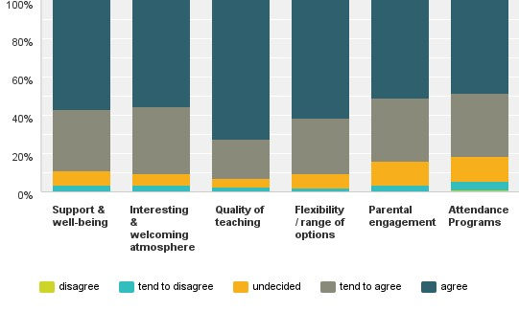

(n=270, Q 22)

Those under 18 years showed the same strong support for changes that make schools more interesting and welcoming settings (90% support). Most of their other responses are in line with the total respondent results, excepting for less support for parent engagement (73%) and attendance programs (77%).

Interviewees added that early intervention in literacy and basic skills at primary school was necessary so that students were better able to deal with demands of secondary school, especially the critical Year 9–10 stage. Many also suggested careers education should begin well before senior secondary school, even at primary level, so that students were attuned to a wide range of options.

#### Collaboration, outreach and adaptability

Interviewees called for greater collaboration between the Shire’s senior secondary schools, harking back to a time when they felt there was far less competition and emphasis on protecting or enhancing ‘brands’. Beyond providing more options, interviewees suggested that much work was needed to strengthen the image of all schools, and to dispel often misleading perceptions about quality. To this end, calls were made for schools to ‘reach out’, and to showcase to parents and the community the very best of their endeavours.

Interviewees also echoed many of the survey findings relating to parent engagement. While it seemed the capacity of schools to change parent attitudes has its limits, interviewees believed that more outreach, more welcoming gestures and activities, as well as more efficient and responsive feedback would prove beneficial. Certainly, interviewees thought an overhaul of the existing parent–teacher interview regime is long overdue.

Many believed that greater resourcing for careers counselling and wellbeing support staff was key to enhancing the image of schools in the community. Putting aside the obvious and substantive benefits to students – that is, to their mental and physical wellbeing, decision-making and planning – enhancing the role of these staff would also prompt a rethink of what constitutes progress and advancement in education. This is thought particularly important in the context of intense pressure on young people, and schools, to reach prescribed performance indicators.

Interviewees spoke highly of teachers who adapted to current social circumstances and were attuned to student needs and learning styles. They saw the value of high quality teacher training and ongoing professional development. In this context, the value of a staff member was gauged not only by their technical skills and knowledge, but also by their capacity to engage and motivate students.

Adaptability was also called for at an institutional and programmatic level, with interviewees applauding the schools that offered engaging and interesting curricular and non-curricular activities (surfing is an elective at Apollo Bay P–12 College). They also applauded collaborations between schools that promoted alternative education programs, and those that created better pathways to innovative vocational training opportunities.

## Initiatives: summing up

Participants in this research seemed well apprised of the challenges faced by young people and educators in the Shire. A theme common to most of the suggested initiatives – from within or from beyond school boundaries – was the need to enable all those associated education to make connections, collaborate, and prepare the young for the ‘next step’. This was as true for teachers, careers counselling and wellbeing staff assisting young people to imagine the full array of post-secondary options, as it was for school management assisting parents to engage more effectively with schools. While the theme of linkages and collaboration resonated, another essential element is a wider range of educational and support options; be they in the form of more diverse vocational training and alternative education programs, or more and better social services.

# Conclusion

The findings of this research – derived from the views of participants – resonate strongly with the findings of the literature on attitudes to education and on effective strategies to promote improved educational outcomes. That more than four hundred people chose to participate in research lasting barely ten weeks indicates that education is an issue close to the hearts of many across the Colac Otway Shire. Further, if the response is representative, then we might assume that education itself is of real importance for the residents in the region. This is not to say that indifference to education should not be a concern. Indeed, sufficient participants spoke of that concern for it to have some credence. Yet issues pertaining to education were often linked to developments and decisions ‘made from afar’ that shape the entire region, and not solely to local school management, resource allocation or teaching practices. That participants dwelt on such factors – such as the effects of the transition away from farming towards processing, a changing socioeconomic profile and a location that limits access to services and options – suggests that to improve educational attainment in the region initiatives must not be confined to the education sector, but be wide-ranging and all-encompassing.

# Appendices

## Appendix A: Survey

See following pages for survey preamble and questions

Community attitudes to education in the Colac Otway Shire

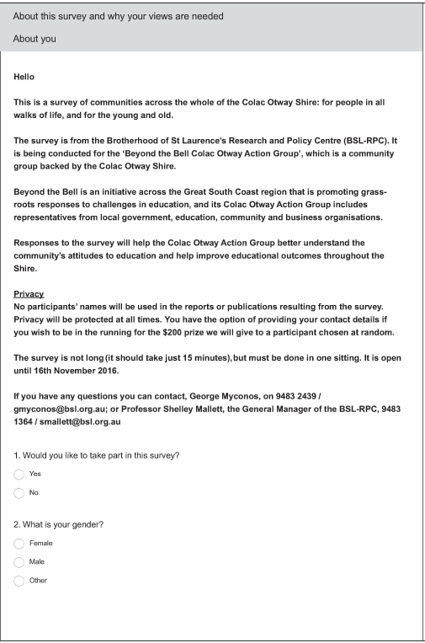





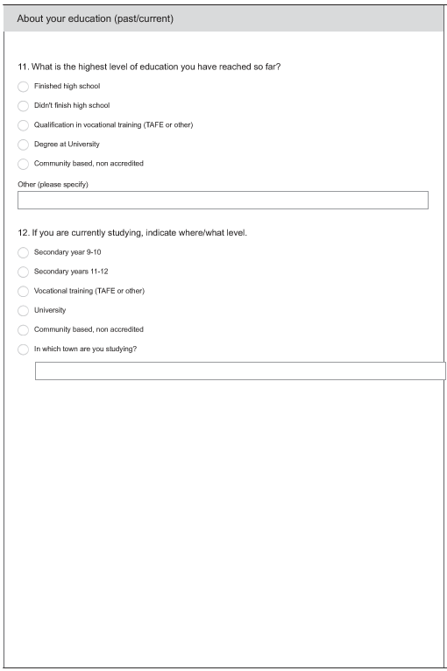

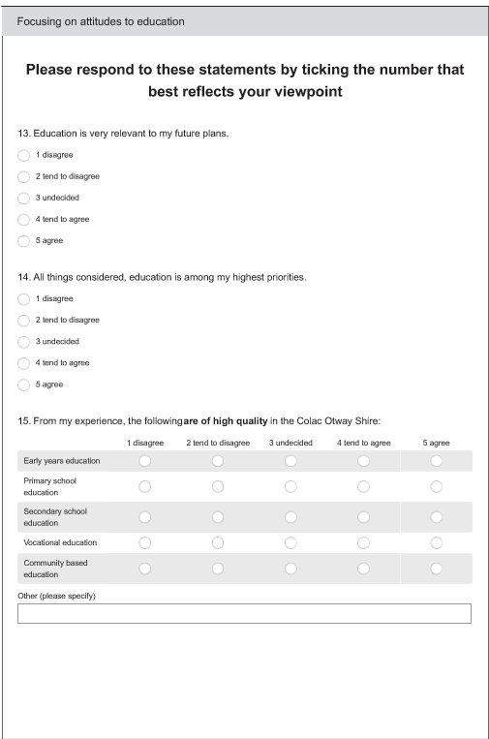

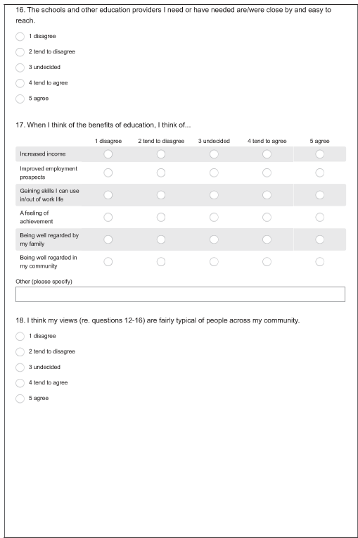

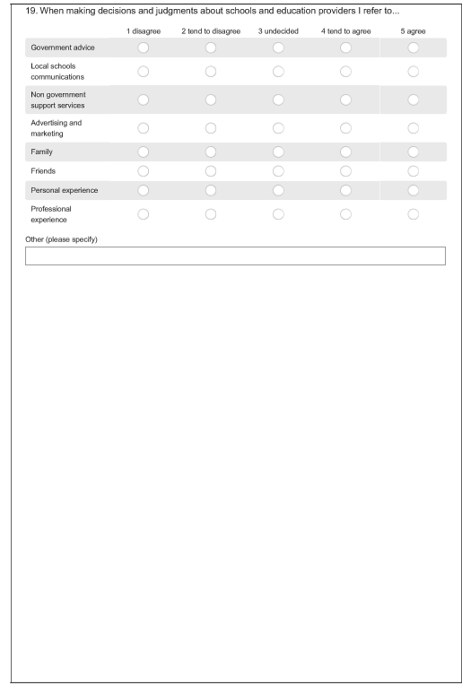

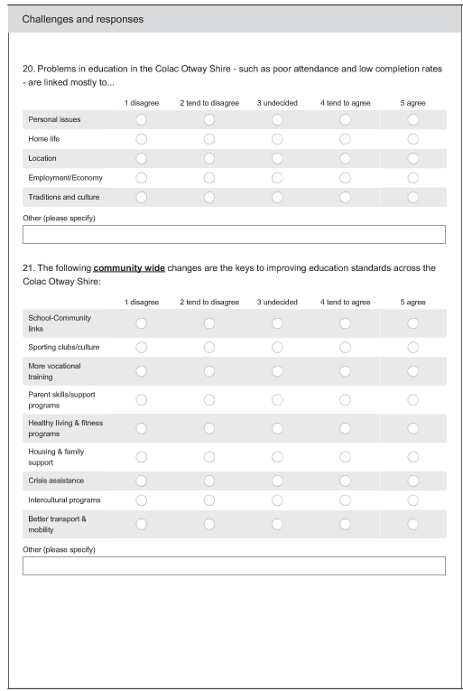



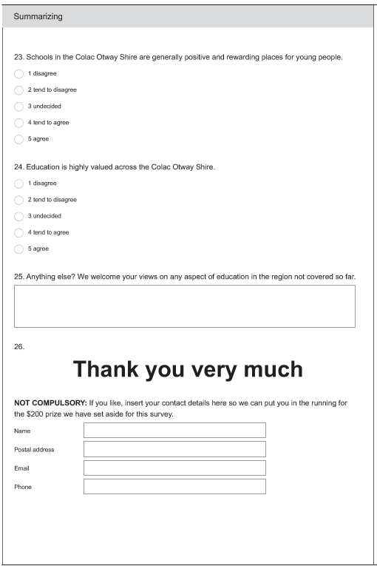

Community attitudes to education in the Colac Otway Shire Appendix A

## Appendix B: Interview participants

Blank cells denote no information available

**STUDENTS**

| **Role** | **Resides in …** | **For how long?** | **Educated in shire?** | **Children at school in shire?** | **Date interviewed** | **Type of interview** |
| --- | --- | --- | --- | --- | --- | --- |
| Student TP | Colac | Born | Yes |  | 20.10.16 | F-to-F G/A |
| Student TP | Barongarook | Born | Yes |  | 20.10.16 | F-to-F G |
| Student Mentor | Colac/Irrewarra | 2 yrs/Born | Yes |  | 20.10.16 | F-to-F A |
| Student TP | Colac |  | Yes |  | 20.10.16 | F-to-F Group G/A |
| Student TP | Colac |  | Yes |  |
| Student TP | Winchelsea | Born | Yes |  |
| Student TP | Colac |  | Yes |  | 20.10.16 | F-to-FG/A |
| Student AB Y11 | Apollo Bay | Born | Yes |  | 21.10.16 | F-to-F Group G |
| Student AB Y11 | Apollo Bay | Born | Yes |  |
| Student AB Y11 | Apollo Bay | Born | Yes |  |
| Student AB Y9 | Apollo Bay |  | Yes |  | 21.10.16 | F-to-F Group G |
| Student AB Y9 | Apollo Bay |  | Yes |  |
| Student AB Y9 | Apollo Bay |  | Yes |  |
| Student AB Y9 | Apollo Bay |  | Yes |  |
| Student CSC Y7 |  |  | Yes |  | 26.10.16 | F-to-F Group G/A |
| Student CSC Y7 |  |  | Yes |  |
| Student CSC Y8 |  |  | Yes |  |
| Student CSC Y10 |  |  | Yes |  |
| Student CSC Y10 |  |  | Yes |  |
| Student CSC Y10 |  |  | Yes |  |
| Student COEX |  |  | Yes |  | 26.10.16 | F-to-F Group G/A |
| Student COEX |  |  | Yes |  |
| Student COEX |  |  | Yes |  |

**EDUCATORS**

| **Role** | **Resides in …** | **For how long?** | **Educated in shire?** | **Children at school in shire?** | **Date interviewed** | **Type of interview** |
| --- | --- | --- | --- | --- | --- | --- |
| Teacher CSC/IP | Colac | Born | Yes | Yes Y 9 | 19.10.16 | F-to-F A |
| Teacher CSC/IP | Colac | Born | Yes |  | 19.10.16 | F-to-F A |
| Principal Special School | Colac | 10 Years | No-Werribee |  | 19.10.16 | F-to-F G |
| Teacher AB |  |  |  |  | 21.10.16 | F-to-F G |
| Teacher AB |  |  |  |  |
| Teacher AB |  |  |  |  |
| Teacher CSC | Colac |  | Yes | Yes | 26.10.16 | F-to-F G/A |
| Teacher CSC | Colac |  | Yes | Yes |
| Teacher CSC | Colac |  | Yes | Yes |
| Principal CSC | Colac |  | Yes | Yes | 26.10.16 | F-to-F G |
| Coordinator TP | Apollo Bay | Born | Yes |  | 05.10.16 | F-to-F A |
| CEO COEX |  |  | No | No | 26.10.16 | F-to-F G/A |
| CDW Diversitat | Colac | 20 yrs+ | No | Yes in past | 04.10.16 | Phone C |
| Teacher TP | Apollo Bay |  | No | Yes | 20.10.16 | F-to-F A |
| Trainer 20 Squared | Colac | 35 years | No |  | 18.10.16 | F-to-F A |
| Teacher Trinity |  |  |  |  | 01.11.16 | F-to-F Group A |
| Teacher Trinity |  |  |  |  |
| Teacher Trinity |  |  |  |  |
| Teacher Trinity |  |  |  |  |
| Teacher Trinity |  |  |  |  |
| Coordinator Trinity |  |  |  |  |

71

**COMMUNITY SUPPORT SERVICES**

| **Role** | **Resides in …** | **For how long?** | **Educated in shire?** | **Children at school in shire?** | **Date interviewed** | **Type of interview** |
| --- | --- | --- | --- | --- | --- | --- |
| Worker-Geelong BF |  |  |  |  | 13.10.16 | F-to-F Group G/C |
| Worker-Geelong BF |  |  |  |  |
| Worker-Geelong BF |  |  |  |  |
| Worker-Geelong BF |  |  |  |  |
| Rural Access | Colac | 10 yrs | No |  | 18.10.16 | F-to-F A |
| Engagement Officer-KESO | Geelong |  | No | No | 24.10.16 | Phone C |
| Worker BCYH | Barwon Downs | 11 yrs | No | Yes 2 | 03.10.16 | F-to-F G |
| Worker BCYH | Camperdown | 30 yrs | No |  |
| Worker BCYH | Geelong |  | No |  |
| Worker BCYH | Barwon Downs | 11 yrs | No | Yes 2 | 19.10.16 | F-to-F A |
| Researcher | St Leonards |  |  |  |
| Youth Lawyer | Terang | 5 yrs | No |  | 24.10.16 | Phone C |
| Youth Dev Worker YHH | Barongarook | Born | Yes |  | 24.10.16 | Phone C |
| Worker | Camperdown | 30 yrs | Yes | Yes in past | 06.10.16 | F-to-F A |
| Worker – Wathaurong | Geelong | 20 yrs | No | No | 06.10.16 | Phone C |
| Exec-Manager St Laurence | Colac | Born | Yes | Yes in past | 05.10.16 | Phone C |
| Worker Otway H | Apollo Bay |  |  | Yes 2 | 04.10.16 | Phone C |
| Minister Salvos | Colac | 5 yrs | No |  |  |  |
| Leader Hub | Colac | Born | Yes | Yes | 09.09.16 | F-to-F G/A |

**RESIDENTS AND PARENTS**

| **Role** | **Resides in …** | **For how long?** | **Educated in shire?** | **Children at school in shire?** | **Date interviewed** | **Type of interview** |
| --- | --- | --- | --- | --- | --- | --- |
| Parent and trainer | Colac | 35 yrs | Yes | Yes | 08.09.16 | F-to-F A |
| Resident/ Ex-student | Colac | Born | Yes |  | 05.10.16 | Phone A |
| Resident | Colac | 5 yrs | Yes | No | 11.10.16 | Phone C |
| Young resident | Apollo Bay | 10 yrs | Yes | No | 12.10.16 | Phone C |
| Parent | Colac | 50 yrs | Yes | Yes in past | 13.10.16 | F-to-F A |
| Guardian | Colac |  | No | Yes |
| Young resident | Colac | Born | Yes | No | 18.10.16 | F-to-F A |
| Parent/Trainer | Apollo Bay | Born | Yes | Yes | 18.10.16 | F-to-F A |
| Young parent/Student | Colac | Born | Yes | Yes | 18.10.16 | F-to-F A |
| Parent | Colac | 12 yrs | Yes | Yes |
| Parent/Resident Action | Colac | 24 yrs | No | Yes | 19.10.16 | F-to-F A |
| Parent/Teacher | Forest | 15 yrs | No | Yes | 21.10.16 | F-to-F G |
| Parent/Community worker | Birregurra | 22 yrs | No | Yes | 21.10.16 | Phone C |
| Guardian | Colac | 15 yrs | No | Yes | 19.10.16 | Phone A |

**EMPLOYERS AND EMPLOYMENT AGENCIES**

| **Role** | **Resides in …** | **For how long?** | **Educated in shire?** | **Children at school in shire?** | **Date interviewed** | **Type of interview** |
| --- | --- | --- | --- | --- | --- | --- |
| Agency – Vic. GT | Colac/Geelong | Born | Yes |  | 03.10.16 | Phone C |
| Agency – WDEA | Colac | Born | Yes |  | 04.10.16 | Phone C |
| Agency – Matchworks | Geelong | 24 yrs | No |  | 10.10.16 | Phone C |
| Agency – St Laurence | Colac | Born | Yes |  | 19.10 16 | Phone A |
| Employer ALC | Colac | Born | Yes | Yes | 26.09.16 | F-to-F G |
| Employer CMTP | Colac | 15 yrs | Yes | Yes | 26.09.16 | F-to-F G |
| Employer | Colac | Born | Yes | No | 26.09.16 | F-to-F G |
| Employer Ex CoC | Colac | Born | Yes | Yes | 26.09.16 | F-to-F G/A |
| Small business | Colac | 22 yrs | Yes | Yes | 24.10.16 | F-to-F G |

## Appendix C: Population profile

| **Indicator** | **Colac Otway Shire** | | **Victoria** | |
| --- | --- | --- | --- | --- |
|  | **No.** | **%** | **No.** | **%** |
| **Resident population** | **20,343** |  | **5,354,042** |  |
| Male | 10,139 | 49.8 | 2,632,619 | 49.2 |
| Female | 10,204 | 50.9 | 2,721,423 | 50.8 |
| Aged under 18 years | 6,439 | 31.6 | 1,204,648 | 22.4 |
| Australian-born | 17,848 | 87.7 | 3,670,934 | 68.5 |
| Aboriginal and Torres Strait Islander | 184 | 0.9 | 37,911 | 0.7 |
| Aboriginal and Torres Strait Islander, under  18 years | 68 | 0.3 | 15,860 | 0.3 |
| Overseas arrivals (Jan 2006–Aug 2011) | 237 | 1.2 | 318,242 | 5.9 |
| Homeless persons (estimated) | 57 | 0.3 | 22,773 | 0.4 |
| One parent families with children under 15 years | 432 | 8.1 | 106,257 | 7.5 |
| SEIFA Index of Relative Socioeconomic Advantage and Disadvantage (IRSAD), score and percentile ranking within Australia1 | 946 | 39.0 | n/a | n/a |
| SEIFA ranking out of 80 LGAs in Victoria1 | 19 | n/a | n/a | n/a |

1. ABS 2013, Census of Population and Housing: Socio-Economic Indexes for Areas (SEIFA), Australia, 2011, Cat. no. 2033.0.55.001

Source: ABS Census of Population and Housing 2011, except as noted

## Appendix D: Employment profile

|  | **Residents employed** | | **Change in residents employed, by**  **industry, 2006–**  **2011** | |
| --- | --- | --- | --- | --- |
|  | **No.** | **%** | **No.** | **%** |
| **Industry sector of employment** Manufacturing | 1,204 | 12.7 | 193 | 19.1 |
| Health care and social assistance | 1,197 | 12.6 | 188 | 18.6 |
| Agriculture, forestry and fishing | 1,134 | 12.0 | –188 | –14.2 |
| Retail trade | 992 | 10.5 | –33 | –3.2 |
| Accommodation and food services | 807 | 8.5 | 59 | 7.9 |
| Construction | 712 | 7.5 | 40 | 6.0 |
| Education and training | 568 | 6.0 | 10 | 1.8 |
| Administrative and support services | 463 | 4.9 | 51 | 12.4 |
| Public administration and safety | 460 | 4.8 | –65 | –12.4 |
| Transport, postal and warehousing | 399 | 4.2 | –7 | –1.7 |
| Other services | 302 | 3.2 | –10 | –3.2 |
| Professional, scientific and technical services | 279 | 2.9 | 57 | 25.7 |
| Wholesale trade | 239 | 2.5 | –156 | –39.5 |
| Inadequately described or not stated | 187 | 2.0 | –54 | –22.4 |
| Financial and insurance services | 130 | 1.4 | 20 | 18.2 |
| Arts and recreation services | 107 | 1.1 | 8 | 8.1 |
| Electricity, gas, water and waste services | 93 | 1.0 | 15 | 19.2 |
| Information, media and telecommunications | 92 | 1.0 | –16 | –14.8 |
| Rental, hiring and real estate services | 82 | 0.9 | –9 | –9.9 |
| Mining | 38 | 0.4 | 17 | 81.0 |
| **Occupational categories** Managers | 1,752 | 18.5 | –68 | –3.7 |
| Labourers | 1,670 | 17.6 | –64 | –3.7 |
| Technicians and trades workers | 1,300 | 13.7 | 19 | 1.5 |
| Professionals | 1,169 | 12.3 | 14 | 1.2 |
| Community and personal service workers | 1,040 | 11.0 | 164 | 18.7 |
| Sales workers | 862 | 9.1 | 31 | 3.7 |
| Clerical and administrative workers | 841 | 8.9 | 10 | 1.2 |
| Machinery operators and drivers | 688 | 7.3 | 22 | 3.3 |
| Inadequately described | 162 | 1.7 | –10 | –5.8 |
| **Residents' place of work** Within the Shire | 7,468 | 78.8 |  |  |
| Outside of the Shire | 733 | 7.7 |  |  |
| Unknown | 1,276 | 13.5 |  |  |
| **Total** | 9,477 | 100.0 |  |  |
| **Local employers**  **No. staff employed1**  Less than 20 | 736 | 94.5 |  |  |
| 20 to 199 | 43 | 5.5 |  |  |
| 200 or more | 0 | 0.0 |  |  |
| **Total** | 779 | 100.0 |  |  |

1. June 2015 data, ABS *Counts of Australian businesses*, Cat. no. 8165.0

Source: ABS Census2011, compiled by profile.id, except as noted

## Appendix E: Education providers

| **Education providers** |
| --- |
| **Primary schools – Government**  Alvie Consolidated Primary School  Beeac Primary School  Birregurra Primary School  Carlisle River Primary School  Colac Primary School  Colac South West Primary School  Colac West Primary School  Elliminyt Primary School  Forrest Primary School  **Primary schools – Catholic**  Sacred Heart Primary School, Elliminyt  St Brendan's Primary School, Coragulac  St Mary's Primary School, Colac  **P–12 schools – Government**  Apollo Bay P–12 College  Lavers Hill K–12 College  **Secondary school – Government**  Colac Secondary College  **Secondary school – Catholic**  Trinity College Colac  **Special school**  Colac Specialist School  **Engagement programs**  Turning Point Ignition Point  **Learn Local provider (non-accredited training)** Community Hub Inc. |

# 

# References

Abbott-Chapman, J & Kilpatrick, S 2001, 'Improving post-school outcomes for rural school leavers', *Australian Journal of Education (ACER Press)*, vol. 45, no. 1, pp. 35–47.

Alloway, N & Dalley-Trim, L 2009, ''High and dry' in rural Australia: obstacles to student aspirations and expectations', *Rural Society*, vol. 19, no. 1, pp. 49–59.

Andrews, M 2007, 'Education for the community', *Teacher Learning Network*, vol. 14, no. 3, pp. 17–18.

Barón, J 2009, *Exploring the factors associated with youths’ educational outcomes: the role of locus of control and parental socio-economic background*, Discussion Paper 598, Centre for Economic Policy Research, Australian National University, Canberra.

Boon, H 2011, 'Regional Queensland parents' views of science education: some unexpected perceptions', *Australian Educational Researcher (Springer Science & Business Media BV)*, vol. 39, no. 1, pp. 17–43.

Cabinet Office 2008, Aspiration and attainment amongst young people in deprived communities: analysis and discussion paper, Social Exclusion Task Force, Cabinet Office (UK), London.

Campbell, C, Faulkner, M & Pridham, B 2010, 'Supporting adolescent learning and development using applied learning pedagogies in a regional secondary school: an evaluation of a pilot program', *High School Journal*, vol. 94, no. 1, pp. 15–27.

Carrington, S & Elkins, J 2002, 'Comparison of a traditional and an inclusive secondary school culture', *International Journal of Inclusive Education*, vol. 6, no. 1, pp. 1–16.

Carrington, S & Robinson, R 2006, 'Inclusive school community: why is it so complex?', *International Journal of Inclusive Education*, vol. 10, no. 4/5, pp. 323–34.

CESE 2013, *Rural and remote education: literature review*, Centre for Education Statistics and Evaluation (NSW), Sydney.

Chesters, J & Smith, J 2015, 'Social capital and aspirations for educational attainment: a crossnational comparison of Australia and Germany', *Journal of Youth Studies*, vol. 18, no. 7, pp. 932–49.

Cranston, N, Watson, J, Allen, J, Wright, S, Hay, I, Beswick, K, Smith, C, Roberts, W & Kameniar, B 2016, 'Overcoming the challenges of keeping young people in education: a wicked problem with implications for leadership, policy and practice', *Leading & Managing*, vol. 22, no. 1, pp. 1–18.

Cripps Clark, J, Tytler, R & Symington, D 2014, 'School-community collaborations: bringing authentic science into schools', *Teaching Science*, vol. 60, no. 3, pp. 28–34.

Cummings, C, Laing, K, Law, J, McLaughlin, J, Papps, I, Todd, L & Woolner, P 2012, *Can changing aspirations and attitudes impact on educational attainment?*, Joseph Rowntree Foundation, York, UK.

Dandy, J, Durkin, K, Barber, BL & Houghton, S 2015, 'Academic expectations of Australian students from Aboriginal, Asian and Anglo backgrounds: perspectives of teachers, traineeteachers and students', *International Journal of Disability, Development & Education*, vol. 62, no. 1, pp. 60–82.

DEECD 2014, Aspiring learners, thriving communities: a long-term approach to improving rural and regional learning outcomes, Department of Education and Early Childhood Development (Vic.), Melbourne.

Emerson, L, Fear, J, Fox, S & Sanders, E 2012, *Parental engagement in learning and schooling: lessons from research*, A report by the Australian Research Alliance for Children and Youth (ARACY) for the Family-School and Community Partnerships Bureau (FSCPB), FSCPB, Canberra.

Finn, J 1989, 'Withdrawing from school', *Review of Educational Research*, vol. 59, no. 2, pp. 117–

42.

Firth, V & Huntley, R 2014, Who's afraid of a public school? Public perceptions of education in Australia, Per Capita, Sydney/Melbourne.

Flowers, R & Chodkiewicz, A 2009, 'Local communities and schools tackling sustainability and climate change', *Australian Journal of Environmental Education*, vol. 25, pp. 71–81.

Flynn, GV 2007, 'Increasing parental involvement in our schools: the need to overcome obstacles, promote critical behaviors, and provide teacher training', *Journal of College Teaching & Learning*, vol. 4, no. 2, pp. 23–30.

Freeman, B, Klatt, M & Polesel, J 2014, *Deferring a university offer in regional Victoria: final report*, Youth Affairs Council of Victoria, Melbourne.

G21 Geelong Region Alliance 2014, *Colac Otway region profile Ocotber 2014*, G21 Geelong Region Alliance, viewed 28 November 2016,

[<http://www.g21.com.au/sites/default/files/resources/141104_region_profile_colac_otway_we b.pdf>](http://www.g21.com.au/sites/default/files/resources/141104_region_profile_colac_otway_web.pdf).

Gamage, D 2006, 'School-based management: shared responsibility and quality in education', *Education & Society*, vol. 24, no. 1, pp. 27–43.

Gemici, S, Bednarz, A, Karmel, T & Lim, P 2014, *The factors affecting the educational and occupational aspirations of young Australians*, Longitudinal Surveys of Australian Youth Research Report 66, National Centre for Vocational Education Research, Adelaide.

Gorton, S 2015, 'Who paints the picture? Images of health professions in rural and remote student resources', *Rural and Remote Health*, vol. 15, no. 3423.

Gottfredson, L 2002, 'Gottfredson's theory of circumscription, compromise, and self creation', in D Brown (ed), *Career choice and development*, Jossey-Bass, San Francisco.

Hampden-Thompson, G & Galindo, C 2016, 'School-family relationships, school satisfaction and the academic achievement of young people', *Educational Review*, vol. DOI:

10.1080/00131911.2016.1207613, pp. 1–18.

Haywood, N, Walker, S, O’Toole, G, Hewitson, C, Pugh, E & Sundaram, P 2009, *Engaging all young people in meaningful learning after 16: a review*, Research Report 25, Equality and Human Rights Commission, Manchester, UK.

Hillman, K 2010, 'Attitudes, intentions and participation in education: Year 12 and beyond', *Longitudinal Surveys of Australian Youth Briefing Reports* no. 20.

Homel, J, Mavisakalyan, A, Nguyen, H & Ryan, C 2012, *School completion: what we learn from different measures of family background*, Social Policy Evaluation, Analysis and Research Centre, Australian National University, National Centre for Vocational Education Research, Adelaide.

Horton, A & Heggart, K 2015, 'Engaging the community through a creative curriculum: a hip-hop case study', *Australian Educational Leader*, vol. 37, no. 3, pp. 66–9.

Jeynes, W 2005, 'Effects of parental involvement and family structure on the academic achievement of adolescents', *Marriage & Family Review*, vol. 37, no. 3, pp. 99–116.

—— 2007, 'The relationship between parental involvement and urban secondary school student academic achievement: a meta-analysis', *Urban Education*, vol. 42, no. 1, pp. 82–110.

—— 2012, 'A meta-analysis of the efficacy of different types of parental involvement programs for urban students', *Urban Education*, vol. 47, no. 4, pp. 706–42.

Jones, CM 2010, 'Growing community partnerships through shared success', *Australasian Journal of University-Community Engagement*, vol. 5, no. 2, pp. 1–25.

Klatt, M, Polesel, J, Dulfer, N, Starr, K & Blake, D 2016, *Innovative partnerships for youth engagement in education and work*, Centre for Vocational Education Policy, University of Melbourne, Melbourne.

Koshy, V, Brown, J, Jones, D & Portman Smith, C 2013, 'Exploring the views of parents of high ability children living in relative poverty', *Educational Research*, vol. 55, no. 3, pp. 304–20.

Lamb, S, Jackson, J, Walstab, A & Huo, S 2015, *Educational opportunity in Australia 2015: who succeeds and who misses out*, Centre for International Research on Education Systems for the Mitchell Institute, Melbourne.

Lamb, S & Rice, S 2008, *Effectiveness strategies to increase school completion report*, Report to the Victorian Department of Education and Early Childhood Development, University of Melbourne, Melbourne.

Lyons, T & Quinn, F 2012, 'Rural high school students' attitudes towards school science', *Australian & International Journal of Rural Education*, vol. 22, no. 2, pp. 21–9.

Mansfield, CF 2010, 'Motivating adolescents: Goals for Australian students in secondary schools', *Australian Journal of Educational & Developmental Psychology*, vol. 10, pp. 44–55.

Mansour, M & Martin, AJ 2009, 'Home, parents, and achievement motivation: a study of key home and parental factors that predict student motivation and engagement', *Australian Educational and Developmental Psychologist*, vol. 26, no. 2, pp. 111–26.

Martin, AJ & Marsh, HW 2008, 'Academic buoyancy: towards an understanding of students' everyday academic resilience', *Journal of School Psychology*, vol. 46, no. 1, pp. 53–83.

Maury, S 2014, *Uplift: an empowerment approach to parent engagement in schools*, Good Shepherd Youth & Family Service, North Collingwood, Vic.

Milgate, G 2014, *Listening to the school community*, Research Developments, ACER, [<http://rd.acer.edu.au/article/listening-to-the-school-community>](http://rd.acer.edu.au/article/listening-to-the-school-community).

Miller, C 2005, Aspects of training that meet Indigenous Australians' aspirations: a systematic review of research, National Centre for Vocational Education Research, Adelaide.

Murray, S 2012, 'The boundaries of home and school', *Principal Matters*, no. 90, pp. 46–8.

Myconos, G, 2014, *Lessons from a flexible learning program: the Brotherhood of St Laurence,*

*Community VCAL education program for young people 2010–2013*, Brotherhood of St Laurence,

Fitzroy, Vic.,

[<http://www.bsl.org.au/fileadmin/user_upload/files/research/reports/Myconos_Lessons_from_ a_flexible_learning_program_2010-2013CVCAL_evaluation_2014.pdf>](http://www.bsl.org.au/fileadmin/user_upload/files/research/reports/Myconos_Lessons_from_a_flexible_learning_program_2010-2013CVCAL_evaluation_2014.pdf).

Myconos, G, Thomas, J, Wilson, K, te Riele, K & Swain, L 2016, ‘Educational re-engagement as social inclusion: the role of flexible learning options in alternative provision in Australia’, *Forum*, vol. 58, no. 3, pp. 345–54.

Neunschwander, M, Vida, M, Garrett, J & Eccles, J 2007, 'Parents’ expectations and students’ achievement in two western nations', *International Journal of Behavioral Development*, vol. 31, no. 6, pp. 594–602.

Nguyen, N & Blomberg, D 2014, *The role of aspirations in the educational and occupational choices of young people*, Longitudinal Surveys of Australian Youth Briefing Paper 29, National Centre for Vocational Education Research, Adelaide.

NOUS 2011, Schooling challenges and opportunities: a report for the Review of Funding for Schooling Panel, NOUS Group, Melbourne.

Polvere, RA &, Lim, P 2015, *Career development supporting young Australians: a literature review*, NCVER and Brotherhood of St Laurence, Fitzroy, Vic.

Porter, L 2008, 'Collaboration with parents', *Educating Young Children*, vol. 14, no. 2, pp. 25–7.

Public Agenda & Kettering Foundation 2014, *In theory, yes: how educators of educators discuss the roles and responsibilities of communities in education*, Public Agenda, New York.

Rainey, L, Simons, M, Pudney, V & Hughes, E 2008, *What choice? An evaluation of career development services for young people*, National Centre for Vocational Education Research, Adelaide.

Randles, J 2014, '"Who's afraid of a public school?": Social responsibility and schooling choices', *Ethics Quarterly* no. 96, pp. 22–4.

Rosenholtz, S 1989, Teachers' workplace: the social organization of schools, Longman, New York.

Rothman, S 2004, 'Staying longer at school and absenteeism: evidence from Australian research and the Longitudinal Surveys of Australian Youth', *International Education Journal*, vol. 5, no. 1, pp. 113–23.

Rothman, S & Hillman, K 2008, *Career advice in Australian secondary schools: use and usefulness*, Longitudinal Surveys of Australian Youth Research Report 53, National Centre for Vocational Education Research, Adelaide.

RPAC 2013, Research into education aspiration for regional Victoria: full report, Regional Policy Advisory Committee, Melbourne.

Sellars, E 2016, 'Rethinking the power of parent engagement: the role of school leaders', *Prime Number*, vol. 31, no. 1, pp. 15–7.

Semo, R 2011, *Social capital and young people*, Longitudinal Surveys of Australian Youth Briefing Paper 26, National Centre for Vocational Education Research, Adelaide.

Semo, R & Karmel, T 2011, Social capital and youth transitions: do young people's networks improve their participation in education and training?, National Centre for Vocational Education Research, Adelaide.

Sikora, J & Saha, L 2011, *Lost talent? The occupational ambitions and attainments of young Australians*, National Centre for Vocational Education Research, Adelaide.

Stehlik, T 2013, 'Addressing disengagement from schooling through community action networks', *Journal of Educational Enquiry*, vol. 12, no. 1, pp. 15–24.

Sullivan, K, Perry, L & McConney, A 2013, 'How do school resources and academic performance differ across Australia's rural, regional and metropolitan communities?', *Australian Educational Researcher (Springer Science & Business Media BV)*, vol. 40, no. 3, pp. 353–72.

te Riele, K 2011, 'Breaking down the sense of "us and them" in a regional town', in D Bottrell & S Goodwin (eds), *Schools, communities and social inclusion*, Palgrave Macmillan, South Yarra, Vic.

Thomson, S & Hillman, K 2010, *Against the odds: influences on the post-school success of 'low performers'*, National Centre for Vocational Education Research, Adelaide.

TNS Opinion & Social 2011, *Attitudes towards vocational education and training*, Special Eurobarometer 369, European Commission, Brussels.

Victory, M 2010, 'Beyond the classroom: beginning teachers' communication with parents', *Professional Voice*, vol. 8, no. 2, pp. 39–46.

Ward, J 2007, 'POSM: project-oriented school mentoring', *Boys in Schools Bulletin*, vol. 10, no. 3, pp. 1–14.

Watson, J, Wright, S, Allen, J, Hay, I, Cranston, N & Beswick, K 2015, *The community voice on education and students' school completion*, University of Tasmania & Tasmanian Department of Education, Hobart.

Webb, S, Black, R, Morton, R, Plowright, S & Roy, R 2015, *Geographical and place dimensions of post-school participation in education and work*, National Centre for Vocational Education Research, Adelaide.

What Works 2012, *Success in remote schools: a research study of eleven improving remote schools*, The Work Program: improving outcomes for Indigenous students, National Curriculum

Services, Abbotsford, Vic., viewed 28 November 2016,

[<http://www.whatworks.edu.au/upload/1341805220784_file_SuccessinRemoteSchools2012.pdf](http://www.whatworks.edu.au/upload/1341805220784_file_SuccessinRemoteSchools2012.pdf)

>.

1. Sources for data in this profile, except as noted, are shown in Appendix C.
2. Socio-Economic Indexes for Areas (SEIFA) area measure used by the Australian Bureau of Statistics to rank areas according to relative socio-economic advantage and disadvantage.
3. We reviewed some 220 Australian and international journal articles and research reports, including scholarly and grey literature. The literature review aimed to provide an overview of key findings on community attitudes to formal education options for children and young people, particularly in rural and regional areas. Contact the authors for details.
4. The Commission set out to identify community perceptions of the relevance of vocational training provision for the labour market and learners’ needs; the quality of training provision; the status of vocational occupations; and the impact of vocational education and training in society.
5. A key reference while compiling this purposive selection framework was the South West Local

   Learning and Employment Network’s Environmental Scan and its lists of key community partners.
6. Profile.ID Community Profile for Colac Otway Shire at [http://economy.id.com.au/colacotway/employment-census](http://economy.id.com.au/colac-otway/employment-census) 
7. The Victorian Certificate in Applied Learning, a Year 11–12 course provided by a great many secondary schools.
8. Survey respondents included slightly more parents of primary school aged children than parents of secondary school aged children.