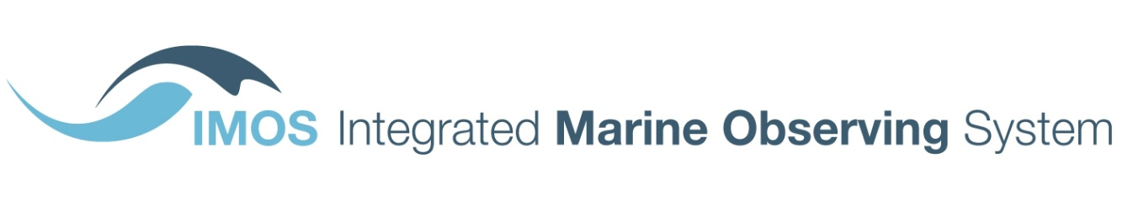

University of Tasmania

Private Bag 110

Hobart TAS 7001

Australia

T +61 3 6226 7505

F +61 3 6226 2107

[www.imos.org.au](http://www.imos.org.au)

28 November, 2014

Department of Education  
GPO Box 9880  
Canberra ACT 2601

**RE: Boosting the commercial returns from research**

Thank you for the opportunity to provide comment on the paper entitled *‘Boosting the commercial returns from research’*. The Integrated Marine Observing System (IMOS) is a foundation NCRIS capability, and our comments on the proposals in the paper are provided from that perspective.

# Creating stronger incentives for research-industry collaboration

Opportunities identified under this proposal are focused on the research to industry interface e.g. competitive research grants recognising industry experience, research block grant arrangements supporting greater industry engagement, and collaboration between publicly funded research agencies and industry.

Australian Government, and State and Territory Governments, often play a significant role at the research to industry interface. This can manifest through government roles as a regulator, and though government funding of research through other portfolios such as Defence, Environment, Agriculture, and Foreign Affairs and Trade. There would be considerable value in thinking about research-**government**-industry collaboration is some areas, particularly in terms of lowering cost and reducing regulation. For example, very expensive environmental impact assessments and compliance monitoring for the offshore oil and gas industry are currently undertaken on a project by project basis. Investment in research-government-industry collaboration focused on developing regional baselines and regional monitoring programs with open access to all data would deliver significant net economic benefit at the industry sector level.

# Supporting research infrastructure

The proposals to strengthen the focus of NCRIS on outreach to researchers and industry, to reassess existing research infrastructure provision and requirements, and to develop a roadmap for long-term research infrastructure investment are strongly supported. Some specific issues warranting consideration include the following:

* In the ‘information age’, open access to publicly funded research data provides a competitive edge for research and business. It makes economic sense to treat research data as an infrastructure that can be used and reused for research, and valued-added to deliver products and services through research-industry collaboration where appropriate. A number of NCRIS capabilities, including IMOS, have set a new benchmark in open access to research data over the last decade. They are recognised globally as world-leading, and if they are closed down as a result of funding discontinuity the opportunity cost to Australia will be considerable.
* Related to the above, Australian Government research investments positioned within international programs can deliver massive leverage for research and business. The value of global datasets, data products, and research outputs delivered far exceeds the relatively modest levels of domestic investment. Prominent examples in marine observing include provision of calibration and validation data to international public good satellite missions, and contribution to the global autonomous profiling float array (called Argo – see <http://imos.org.au/argo.html>).
* NCRIS was designed to provide funding for national research infrastructure, and ‘market failure’ should be one of the tests applied to prioritising investment. In some cases, it is obvious that no single institution, jurisdiction or business has the resources, capability or mandate to own and operate the national research infrastructure required to address Australia’s grand challenges. There is a clear role for government investment in research infrastructure. In other cases, there will be viable alternatives which should be considered, including use of commercial providers.
* When NCRIS was established in 2006-7, the scope was well articulated in a national strategy. There were sixteen priority capability areas of which twelve were funded in the first stage. Through subsequent iterations, including the Education Investment Fund investments of 2009-13, the scope was widened to the twenty-seven projects currently in scope for NCRIS 2015-16 funding. It will be important to re-establish a well-articulated scope for next stage NCRIS investment. Current work on evaluation and review is also welcome, as it will be important to objectively assess where and how the NCRIS model has been implemented most successfully.
* Research infrastructure is often ‘one step removed’ from industry impact. We need well-targeted research funding programs to use the national research infrastructure in order to deliver greater industry impact. Opportunities under the *‘Supporting research infrastructure’* proposal therefore need to be considered in tandem with opportunities under the ‘*Creating stronger incentives for research-industry collaboration’* proposal.

# Providing better access to research

National research infrastructure should be accessible to industry researchers as well as to publicly funded researchers. As noted above, a number of NCRIS capabilities have set a new benchmark for open access to research data that has removed traditional barriers for industry researchers. This should be supported on an ongoing basis.

# Increasing industry relevant research training

Opportunities identified under this proposal are focused at the post graduate level, which is very important. However student choices being made at the under graduate level are strongly influenced by business imperatives within the University sector, and these choices are skewing the talent pool available for post graduate training. This is also very important. In the case of marine science, we are simply not producing anywhere near enough graduates with sufficient quantitative skills to be able to train as a research workforce that is industry relevant. Significant focus has been placed on this issue in recent years, but our post graduate quantitative marine science courses are still dominated by foreign students due to their superior undergraduate training. The Australian Government’s new STEM agenda is addressing this issue, and is strongly supported.

One final point to note. The 2014-15 Budget commitment of $150 million to NCRIS for 2015-16 is very welcome. However the $150 million committed in May is yet to be allocated to NCRIS capabilities and its value in addressing the ‘stop-start funding’ problem is rapidly diminishing. Immediate allocation of the committed funding would send a very positive signal into the research and business communities.

IMOS is a national collaborative research infrastructure, supported by Australian Government.

It is led by University of Tasmania in partnership with the Australian marine and climate science community.