

Council of Australian Postgraduate Associations (CAPA)

Response to the Discussion Paper on Performance-Based Funding for the Commonwealth Grant Scheme

February 2019



Compiled with the assistance of the staff and office bearers   
of the Council of Australian Postgraduate Associations (CAPA)   
and its affiliated member organisations.

Prepared by Natasha Abrahams (President), Owen Myles (Policy and Research Advisor), and Lara McKenzie (Research Officer)  
Level 1, 120 Clarendon Street, Southbank, VIC, 3006  
0430 076 993  
**www.capa.edu.au**

**Foreword**

The Council of Australian Postgraduate Associations (CAPA) is the peak body representing the interests of the over 425,000 postgraduate students in Australia. We represent coursework and research, as well as domestic and international, postgraduates. We are comprised of 28 university and campus based postgraduate associations, as well as the National Aboriginal and Torres Strait Islander Postgraduate Association (NATSIPA).

CAPA carries out its mission through policy, research, and activism, communicating the interests and issues of postgraduate students to higher education stakeholders as well as Federal and State Governments, Opposition parties, and minor parties.

We welcome this opportunity to contribute our perspective on the performance-based allocation of Commonwealth funding. The provided consultation paper lists a total of seven major consultation questions. The following submission does not seek to answer all of these questions, but will provide CAPA’s perspective on those that would most directly affect the students of Australian universities. We discuss several of the proposed performance measures, drawing attention to pitfalls which must be considered and mitigated prior to implementation. We believe that, for the funding scheme to achieve its objective of promoting quality education, universities should be assessed against benchmarks or targets rather than in a competitive fashion.

We agree with the mission of Performance-Based Funding (PBF) to promote quality in universities, as set out in the Department of Education and Training’s Discussion Paper. This scheme has the potential to be an incentive for improving student outcomes, used in conjunction with legislative instruments which enforce minimum standards. However, such a large change to how funding is distributed must be carefully considered to ensure the outcome matches the intention, and particularly to ensure that disadvantaged groups of students are not further marginalised.

**The current funding environment**

We preface our feedback on the Discussion Paper by noting that universities have increasingly been asked to do more with less. Universities have been subjected to successive funding cuts, particularly the $2.1 billion cut to the Commonwealth Grants Scheme and the Higher Education Loan Programme in December 2017, followed by the the $328.5 million cut to research funding announced in December 2018. These cuts were motivated by the Government’s desire to deliver short-term budget savings, with disastrous long-term consequences for the education attainment of Australians, as well as for national research output (CAPA, 2018). We also note that current funding levels are insufficient to support the number of students in postgraduate study. This is discussed in our response to the Consultation Paper on the reallocation of Commonwealth supported places for enabling, sub-bachelor and postgraduate courses. There is an urgent need to fund universities at an appropriate level, in addition to examining how that funding should be distributed.

We believe that the introduction of performance-based funding must coincide with restoring funding from the 2017 and 2018 cuts, in order to enable universities to achieve quality teaching and research.

A performance-based funding scheme would have no impact on full-fee postgraduate places. It is unclear if the scheme would apply to postgraduate Commonwealth Supported Places, or if it will only apply to Bachelor level degrees in the first instance. The postgraduate reallocation principles suggested in the associated Consultation Paper are rather different to those in the PBF discussion paper, reflecting the dire funding environment for postgraduate places.

As argued elsewhere (CAPA, 2019), we support a regulated fee environment for postgraduate coursework degrees. It is our hope that the Government takes steps towards high-quality and affordable higher education, including at a postgraduate level.

**Performance measures**

The student’s experience cannot be wholly quantified using metrics which can be compared and ranked across universities. Moreover, the benefits of a higher education are not always immediately obvious, yet a lifetime-long timeline is not practicable for a PBF scheme. We recognise the need for the performance measures to be quantitative, relatively easy to collect, and have a limited lag time. There is also a need to have a variety of performance measures in order to lessen the impact of risks associated with any one performance measure.

The PBF scheme must be cautious not to inadvertently implement perverse incentives in its performance measures. Measures we are concerned about include attrition/retention, student satisfaction, and full-time further study. We are not opposed to the inclusion of these metrics, however, they must be implemented carefully and in conjunction with other measures to ensure effectiveness and reduce the likelihood of unintended consequences.

The privileging of an attrition or retention metric will create incentives for universities to pressure unsure students into remaining in their course. Furthermore, not all drop-outs are undesirable. For example, a student may find full-time work in their field, and find that the knowledge they have gained in their degree so far is sufficient. As the Grattan Institute survey found, many of those who have withdrawn from their course found it to be an interesting and valuable learning experience (Norton & Cherastidtham, 2018).

Student satisfaction is a challenging metric as this measure does not always indicate relative quality. This is largely because most undergraduate students, having attended a single institution, do not have a point of reference to which they can compare their university’s conditions. Anecdotally, we hear feedback from students who were pleased with improvements made at their university - until they realise that their university remains behind others in that area. As satisfaction tracks with expectations (Athiyaman, 1997), further investigation into determinants of student expectations is needed. For example, student expectations may correlate to socioeconomic status and the type of high school attended. If this is the case, a university could hypothetically be rewarded for meeting the low expectations of underprivileged students, while delivering a service of lower quality than other universities.

Finally, full-time further study can be both a desirable and an undesirable outcome, depending on the student’s circumstances. Under the “Melbourne model” of education, progressing onto further study is the intended and desired outcome of a completing a generalist undergraduate degree, as this is the point at which the student specialises for their profession. However, for students who have undertaken a Bachelor degree with the intention of moving directly into the workforce afterwards, enrolling in further study can be an outcome of them being unable to find work upon graduation. A metric based on enrolment in further study would need to take into account the student’s motivation for undertaking an additional course.

**Designing and setting the PBF scheme**

In Appendix 2 of Discussion Paper, three example PBF scheme formulae are outlined. The first of these utilised each institution’s internal performance on these metrics are a benchmark for success. The second uses the national average, with each university receiving their score based upon their weighted performance (taking into consideration cohort demographics, location and other factors. The final provided alternative uses regression analysis to determine the weighted performance of each university, and compares this to an established benchmark.

We are opposed to the use of average long-term internal performance as a benchmark for universities (Scheme A). This method would disadvantage those universities that have previously succeeded in improving performance, and would make it easier for poorly performing universities to receive PBF based on performance that would be considered to be sub-par at a similar institution. Additionally, while this may initially assist underperforming universities to improve (by allowing them to direct performance-based funding to programs that target the selected performance measures), in the long-term, such a system would provide greater support to those universities that make marginal improvements in these measures, while punishing those who are more successful at improving in the selected measures more rapidly.

Figure 1 provides a hypothetical example of this issue, using attrition rate as the example metric. In this example, University C, despite being the worst performer and only improving at a very slow rate would receive the greatest amount of PBF (never not receiving it), due to their constant improvement on their own average (albeit, a small one), while University B, who starts as a high performer and improves rapidly would receive PBF only initially, failing to receive PBF in later years despite being the best performer.

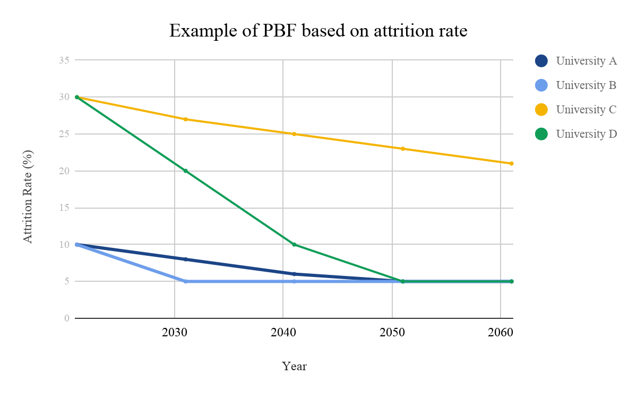

Figure 1: Hypothetical example university performance on attrition rates under PBF

We support a model which would reward universities based on meeting an absolute target or stretch target, rather than ranking against own previous performance or the performance of other universities. A PBF scheme which, for example, requires universities to be ranked in the top 50% of at least one measure, as posited in the Discussion Paper, will do little to inspire quality teaching in universities. Rather than using a percentile ranking of performance measures to distribute funding and hoping that competition between universities achieves the desired outcomes, one possible alternative approach is that the Government could set performance measures which can be graded. Thus, if all universities are high-performing, they should all be able to access additional funding. A percentile ranking approach, however, requires that some universities are deemed to have poor performance.

**Conclusion**

We support the Government’s goal to improve quality of Australian university degrees. However, the method of doing so must be carefully considered. A risk of performance-based funding is that there may be unintended consequences. In CAPA’s response, we have outlined some of the risks we perceive of particular suggestions made in the Discussion Paper, noting that a fair distribution of funding should be based on universities meeting targets rather than being ranked against other universities or their own past performance. We look forward to providing further feedback on a more developed model of performance-based funding.

**References**

Athiyaman, A 1997, Linking student satisfaction and service quality perceptions: the case of university education, *European Journal of Marketing*, vol. 31, no. 7, pp. 528 - 540

Council of Australian Postgraduate Associations [CAPA] 2018, More pain for Australian research in brutal MYEFO cuts, retrieved from http://www.capa.edu.au/media-release-pain-australian-research-brutal-myefo-cuts/

Council of Australian Postgraduate Associations [CAPA] 2019, 2019-20 Pre-Budget Submission, retrieved from http://www.capa.edu.au/wp-content/uploads/2019/01/Pre-budget-submission.docx

Norton, A, and Cherastidtham, I 2018, Dropping out: the benefits and costs of trying university, retrieved from https://grattan.edu.au/report/dropping-out/