

|  |
| --- |
| PERFORMANCE-BASED FUNDING FOR THE COMMONWEALTH GRANT SCHEME  Response to Discussion Paper  February 2019 |

about uac

The Universities Admissions Centre (NSW & ACT) Pty Ltd (UAC) was established in 1995 and is the largest tertiary admissions centre in Australia. Owned by universities in NSW and the ACT, our mission is to provide excellence in admissions services and promote equity of access to tertiary education. Central to that mission is a strong culture of servicing the needs of all our stakeholders, in particular our institutions and applicants.

UAC has a trusted and valued position in the higher education sector. Applicants, in particular Year 12 students, turn to UAC for unbiased and authoritative information about university admissions and courses and for an easy interface with which to apply. Institutions rely upon UAC services to handle the bulk of the admissions process, allowing them to focus on their core capabilities of learning and teaching, research and community engagement. Institutions and government can turn to UAC as a central repository of student data and an expert in managing and analysing that data. Parents, schools, the media and the general public know UAC as their first point of reference for university admissions in NSW and the ACT.

UAC is a member of the Australasian Conference of Tertiary Admission Centres (ACTAC), the group that facilitates communication and co‑operation between tertiary admissions centres in Australia and New Zealand. UAC’s Managing Director is the current Chair of ACTAC.

OUR submission

UAC welcomes the opportunity to provide a response to the Discussion Paper on the Performance-based funding for the Commonwealth Grant Scheme.

Our mission is to provide equity of access to higher education, and we value equally students and the universities they aspire to attend.

As a not-for-profit working in the broad interests of the education sector, UAC is well-placed to provide objective and neutral advice to government.

Our expertise in student data management and analysis developed over 30 years of experience in university admissions puts us in a unique position to provide data insights to institutions and policy makers.

While the scope of the Discussion Paper is very broad, our interest and expertise is in the aspect of attrition as a potential performance measure.

With that in mind, UAC provides the following response for consideration.

# 1. ATTRITION IS A REFLECTION OF STUDENT COHORT

UAC and government data show that the attrition rates of universities is influenced heavily by the nature of the student cohort. The following table shows that the University of Tasmania has the highest attrition rate and the University of Melbourne the lowest.

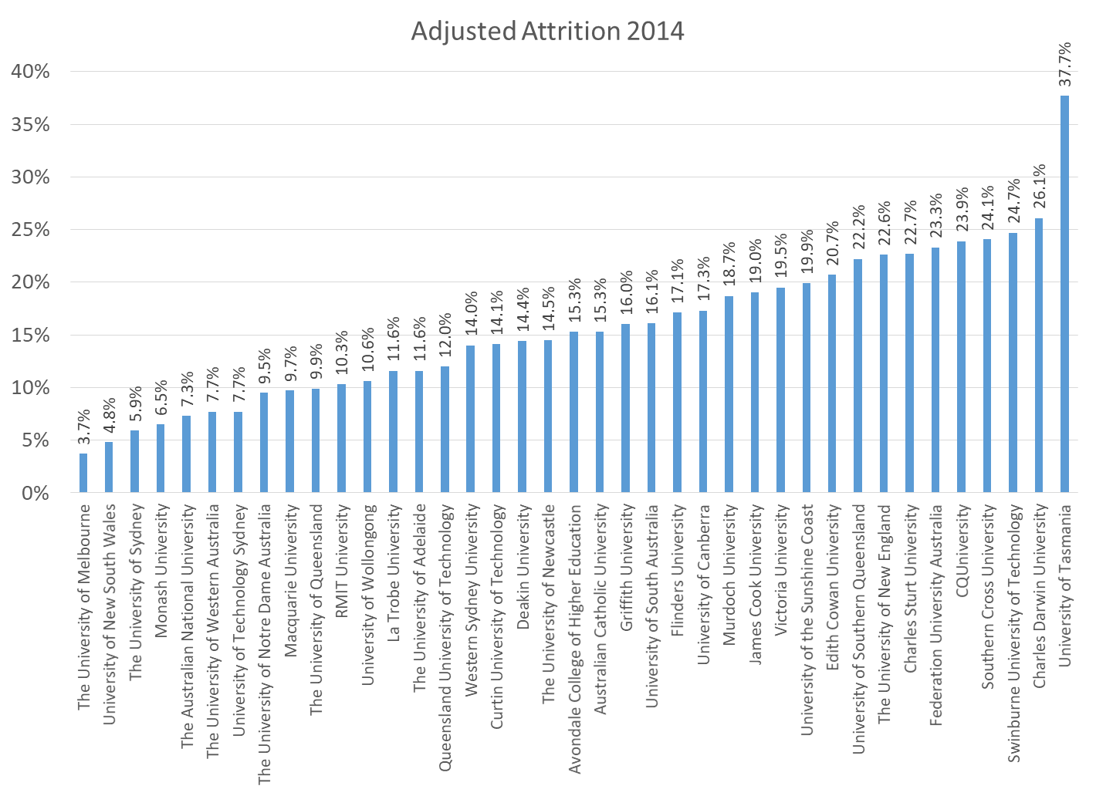

Factors that strongly influence attrition include:

* part-time/full-time
* internal/external
* age
* basis of admission.

The University of Tasmania has 11% of its students as part-time, external, 40+ and admitted on “other” basis, with the resultant 60% attrition rate. The University of Melbourne has no students fitting this profile. The University of Melbourne has half of its students full-time, internal, aged 19 and admitted on the basis of recent secondary education (another 60% of which achieved ATARs over 80), all of which contribute to a lower attrition rate.

It is not surprising that a university with a highly qualified student cohort will be more likely to retain and graduate students than a university with a student cohort of mixed abilities and backgrounds and who have higher levels of external “distractions” from their studies.

# **2. USING ATTRITION DATA ALONE IS UNFAIR**

Given the above, linking university funding to attrition data alone would result in gross inequities in the system. The universities that need funds to better support students less prepared for higher education will be precisely those universities for which funding could potentially be reduced, and universities whose students do not require the same level of support might be overfunded.

# 3. ANY USE OF ATTRITION DATA NEEDS TO BE MODIFIED

The Discussion Paper notes that potential options for the use of attrition data could be to weight attrition rates using benchmarks. UAC would support any option that would produce fairer results not only for individual institutions but also for students, government, the sector and the community as a whole.

**UAC thanks the Department of Education and Training for the opportunity to provide this response to the Discussion Paper on Performance-based funding for the Commonwealth Grant Scheme and looks forward to continued work with government, the education sector and the broader community to deliver greater success in tertiary education.**