

|  |
| --- |
| Data Analysis: THE IMPACT OF senior secondary study choices ON SUCCESS AT UNIVERSITY  Anthony Manny, Helen Tam, Robert Lipka and Zhizhou Yin |

Table of contents

1 Executive Summary 2

2 Introduction 3

2.1 Definitions and background 3

2.1.1 Defining success 3

2.1.2 The HSC 4

2.1.3 The ATAR 4

2.2 Pathways to university 5

2.3 HSC Subjects and Key Learning Area trends 7

2.4 First-year university Field of Study trends 14

3 Analysis 15

3.1 The relationship between HSC subjects, KLAs and the ATAR 16

3.2 The relationship between HSC study patterns and FOS at university 19

3.2.1 Participation in Mathematics 19

3.2.2 Participation in STEM 20

3.2.3 Participation in higher level mathematics and English 21

3.3 The relationship between subject choices and university success 22

3.3.1 ATAR and first-year GPA 22

3.3.2 ATAR, highest level of mathematics and English and university success 24

3.3.3 ATAR, number of science subjects (Physics, Chemistry, Biology) at school and university success: Natural and Physical Sciences students 27

3.3.4 ATAR, highest level of mathematics at school and university success: Engineering and Related Technologies students 29

3.3.5 Regression analysis 31

3.3.6 ATAR as a singular measure that summarises academic achievements across different areas 33

3.3.7 Other factors 34

3.4 The effect of a broader HSC on GPA 34

3.5 Student self-selection 36

3.6 The Gap Year 38

4 Conclusions 39

5 Appendix 40

5.1 Methodology for HSC subject to ATAR correlation analysis 40

5.2 Methodology for ATAR to GPA correlation analysis 40

5.3 HSC subject selection and ATAR 41

5.4 Summary of the machine learning model 43

5.5 Miscellaneous Tables 44

# Executive Summary

Recent media reports have suggested that, due to HSC subject selection, students are entering university ill-prepared and greater emphasis should be placed on course prerequisites[1]. Over the last decade in NSW, more students overall are going on to complete Year 12 and a higher proportion are also ATAR-eligible. More HSC students are studying a science subject but are studying lower levels of mathematics and English. Many pathways are available to students transitioning between school and university, which are dependent on senior secondary study choices. This report investigates various effects of HSC subject selection on first-year university success concerning GPA, fail rate and non-completion. The HSC years 2013–2017 and subsequent university commencement years 2014–2018 are this report’s focus.

There are strong links between HSC subjects selected and a student’s ATAR (ie higher ATAR students tend to study certain HSC subjects). The ATAR is also the most accurate indicator of high first-year university GPA (accounting for 21.5% of GPA variance) and first-year completion. However, once the ATAR’s effect has been allowed for, there are smaller but significant effects on success by studying certain HSC subjects (less than 1%) as preparation for certain university Fields of Study (FOS).

Although there is no ideal pattern of HSC study for all senior secondary students, there are some instances in which HSC subject selection can improve first-year university success (in particular, first-year completion with GPA ≥ 4). For example, the level of HSC mathematics studied improved the chances of first-year success for students undertaking a course in the Engineering and Related Technologies FOS as did studying HSC science subjects for the Physical and Natural Sciences FOS.

Generally, students select HSC subjects that are appropriate for future university study; however, there is evidence that the introduction of prerequisites may be beneficial for degrees in Engineering and Related Technologies and Natural and Physical Sciences.

# Introduction

Success at university, and indeed lack of success, affects all education stakeholders in many ways – from effective resource deployment and university and government funding, through to the burden of student debt and unrealised personal goals. It is therefore a worthy endeavor to investigate what factors can lead to university success. However, it is important to remember that every student is an individual with circumstances that define their experience and personal measures of success – one size does not fit all.

Recent media reports have suggested that, due to their senior secondary subject choices, students are entering university ill-prepared and greater emphasis should be placed on course prerequisites for university entry[2]. This report investigates the link between senior secondary study choices and success at university for domestic NSW Higher School Certificate (HSC) students who applied for, received an offer to, and subsequently enrolled in a bachelor degree at a university in NSW or ACT through the Universities Admissions Centre (UAC).

We looked at study choices for which data was available, and how these choices affected first-year university success. The HSC years 2013–2017 and associated university intake years 2014–2018 are this report’s focus.

All data quoted is UAC data unless otherwise indicated by an asterisk (*). More detail on the methodology can be found in the Appendix.

## Definitions and background

### Defining success

Success at university can be defined in many ways. First-year university results are a useful way to define success due to the timeliness and availability of the associated data and have been found to correlate with degree completion rates[3]. Many factors influence results in later years of university ranging from personal life circumstances to subject specialisation, which are less related to secondary study choices. For the purposes of this report, first-year success was primarily measured by first-year grade point average[4] (GPA) and defined by four outcomes:

* incomplete first year – achieving a GPA of zero with a non-zero study load (recording a fail for all subjects)
* GPA under 4 – the student has failed one or more subjects
* completed first year with fails – recording a non-zero GPA but failing at least one subject
* completed first year with no fails – achieved a pass grade or better in all subjects.

### The HSC

The Higher School Certificate (HSC) is administered by the New South Wales Education Standards Authority (NESA)[5]. The official term used by NESA for subjects offered in the HSC is ‘HSC courses’; however, in this report these will be referred to as ‘HSC subjects’ to avoid confusion with courses students undertake at university level.

‘Standards setting’ is used to align HSC exam marks to course achievement standards and a standards-based reporting scale allows marks and performance to be compared over different years[6].

### The ATAR

The Australian Tertiary Admission Rank (ATAR) is a rank between 0.00 and 99.95 with intervals of 0.05. Students in NSW are not informed of their precise ranking if it is below 30.00. In NSW, UAC calculates the ATAR on behalf of its member universities using HSC results for all eligible HSC students, not just UAC applicants. The ATAR’s only function is for university admission and is transferrable across jurisdictions in Australia – therefore an ATAR has the same value regardless of the state or territory in which it was issued.

Underlying the ATAR are aggregates of scaled marks achieved by each student in their best 10 units of subjects; a student’s 10 units must:

* include at least 2 units of English
* consist of at least four different subject areas (eg Mathematics, Physics, Biology, French Continuers and Japanese Extension are from different subject areas)
* not include more than 2 units of Category B courses (Category B courses are primarily VET-oriented courses such as Hospitality (Examination) and Construction (Examination)).

The aggregate of scaled marks is calculated for each student. The students with the highest aggregates are assigned the top ATAR of 99.95, the next group of students are assigned the next band of 99.90, and so on. The number of students assigned to each ATAR is determined by a cubic-spline model[7] which is dependent on the percentage of the 16 to 20-year-old population in NSW who are eligible for an ATAR. This model assumes that all the students who would achieve the highest academic level (ie 99.95) would continue through to Year 12 and be ATAR-eligible. However, the proportion of students meeting the necessary requirements for an ATAR would gradually decrease along with the ATAR bands as these students are less likely to complete year 12 and be ATAR-eligible.

Each student’s aggregate is comprised of scaled marks. HSC subject marks are scaled to ensure students are neither advantaged nor disadvantaged by choosing one subject over another. Since students can choose from approximately 120 subjects which could contribute to their ATAR, each subject would have a unique candidature with varying levels of academic ability. The scaled mark is an estimate of the student’s performance in a subject, if all students had completed that subject. Therefore, the purpose of scaling is to remove the differences in the strength of academic ability between subject candidatures and to put marks from different subjects on the same scale, thus allowing them to be aggregated. In this way, the ATAR is a singular measure indicating a student’s general academic ability. As a singular measure, however, it does not give specific information concerning a student’s strength in individual subject areas.

## Pathways to university

University enrolment can be achieved via many pathways. The most common pathway for UAC applicants is with a senior secondary qualification – just over half of all domestic undergraduate applicants are HSC students[8].

Each year, approximately 72,000 students complete at least one HSC subject, 55,000 HSC students receive an ATAR, and 43,000 HSC students apply to UAC. Through a competitive process, offers are made to university using the ATAR (in most cases) as the primary rank for UAC applicants[9].

The apparently straight-forward pathway from high school to university is complicated by the definition of ‘recent school leaver’ and rules for ATAR-eligibility – approximately 8% of HSC students undertake ATAR-eligible subjects over more than one year (students can undertake ATAR-eligible HSC subjects over a period of up to five years) and approximately 7% of HSC students who enrol in a bachelor degree take a ‘gap year’ before enrolling. Approximately 21% of HSC applicants reapply to UAC in the following year, regardless of the enrolment outcome of their prior application. Of these returning applicants, students with ATARs above 60 were slightly more likely to reapply (22-23%) than those with ATARs below 60 (19-20% reapply).

The transition from secondary school to university starts with the student’s decision to continue school past Year 10 and selecting Year 11 and 12 subjects which determine ATAR-eligibility.

Over the last decade, the NSW Year 10 to Year 12 retention rate has increased; however, from 2014 to 2017, has been relatively stable at 79% (Figure 1).

Figure 1: NSW Year 12 retention rate (*ABS data).

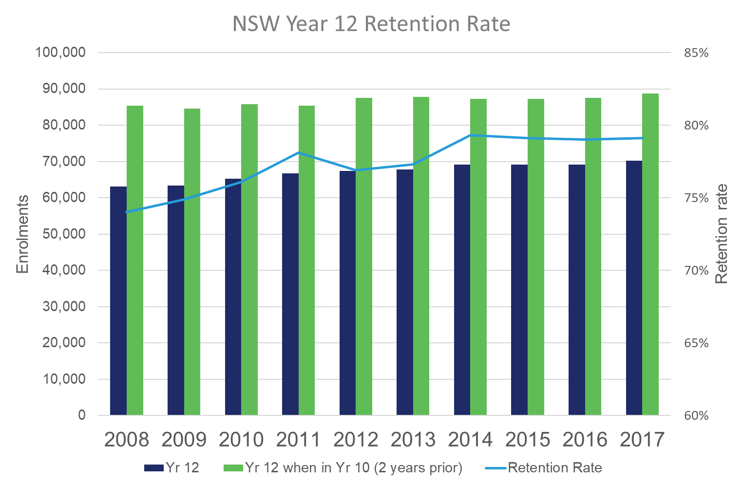

Over the last decade, the proportion of HSC students who are ATAR-eligible in their final HSC year has also increased slightly from 82.6% to 84.4% (Figure 2).

Figure 2: HSC ATAR attainment rate (last year enrolled for HSC).

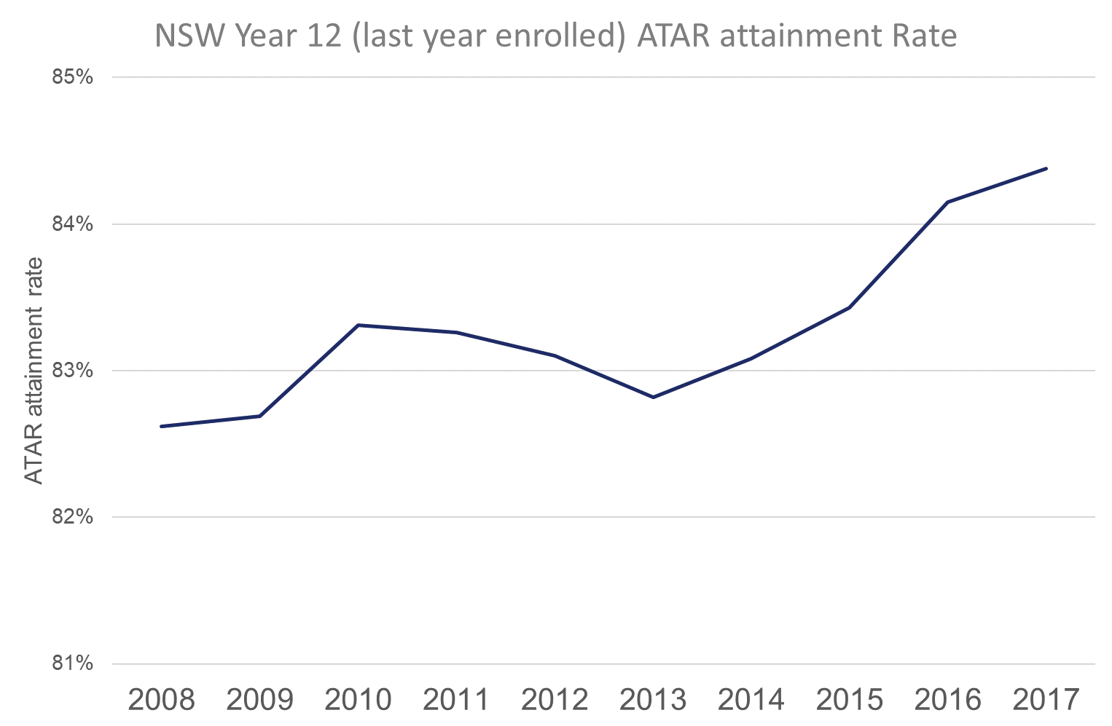

Application rates vary greatly according to ATAR – students who achieve a higher ATAR apply and enrol in significantly higher proportions than students who achieve lower ATARs (Figure 3).

Figure 3: 2013–2017 HSC student – UAC application rates by ATAR.

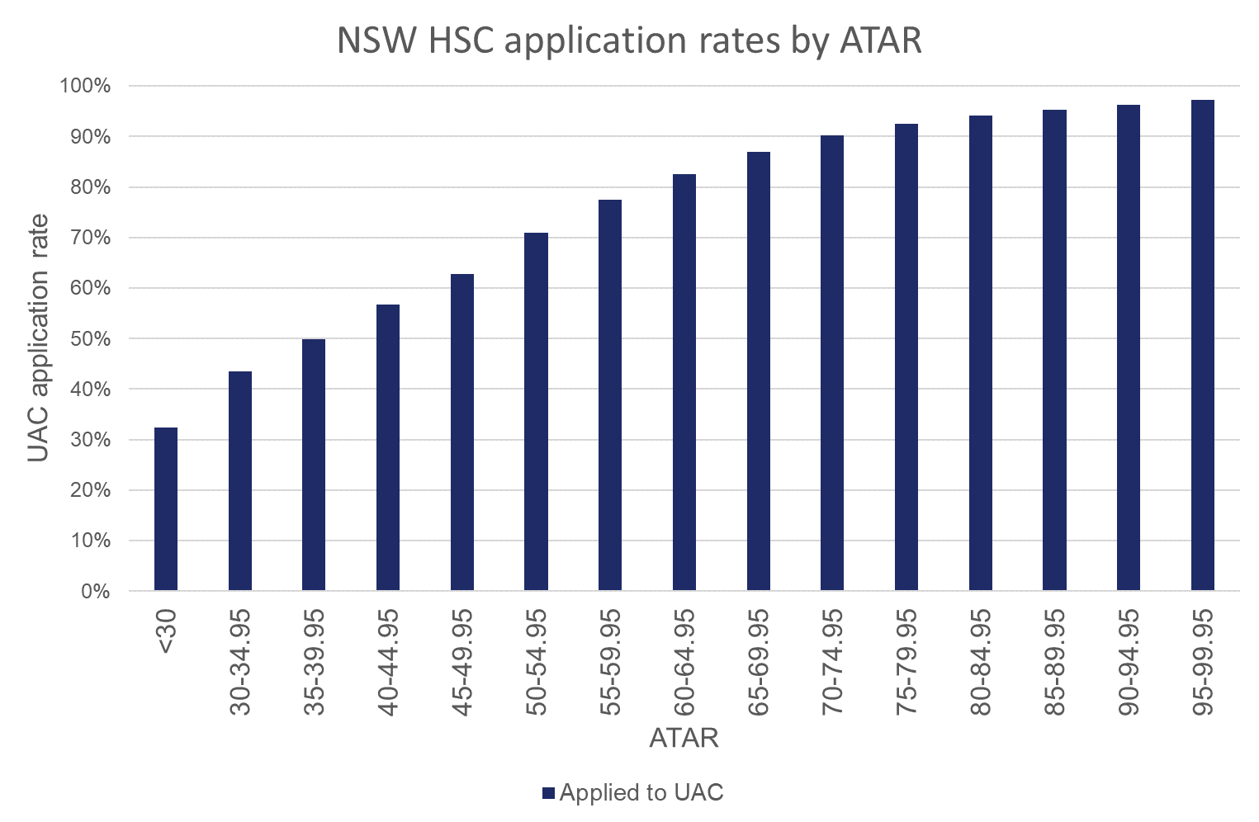

## HSC Subjects and Key Learning Area trends

HSC subjects are organised into nine Key Learning Areas (KLAs)[10]:

* English
* Mathematics
* Science
* Technologies
* Human Society and Its Environment (HSIE)
* Creative Arts
* Personal Development, Health and Physical Education (PDHPE)
* Languages
* Vocational Education and Training (VET).

Over the last decade there have been changes in the proportion of ATAR-eligible HSC students studying each KLA (Figure 4). English is currently the only compulsory KLA for an HSC student to be ATAR-eligible, hence the 100% study rate. Over the last decade, the Mathematics KLA declined slightly, but has started to recover in the last two years. The study rate for PDHPE and Science KLAs has increased over the last decade, while HSIE, Technologies, Creative Arts and Languages have all slightly declined. Until 2013, the study rate for VET subjects increased but has since declined.

Figure 4: ATAR-eligible HSC students – Key Learning Areas’ rates of study.

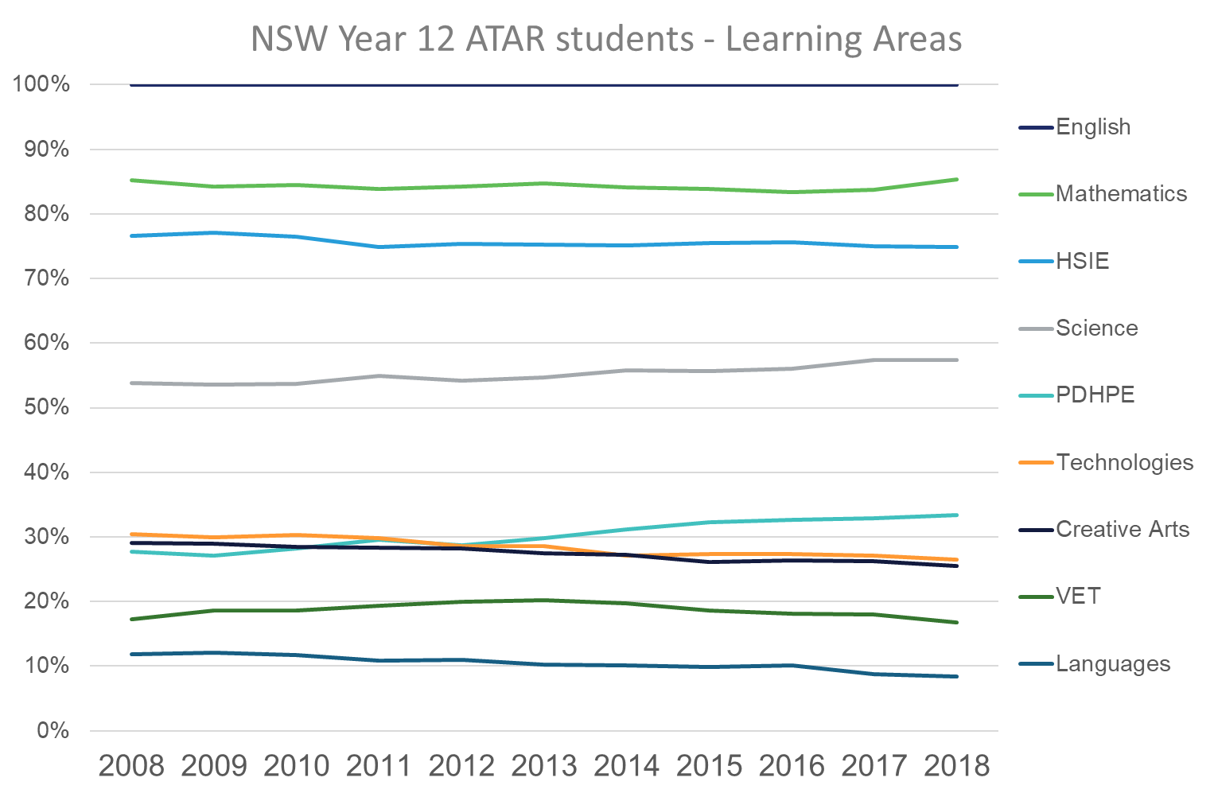

As Figures 5a and 5b show, the average number of units undertaken in each KLA has changed over the last decade – PDHPE and VET have increased, Languages, Creative Arts and English have declined slightly, and the other KLAs have remained stable.

Figure 5a: ATAR-eligible HSC students – Average units studied per KLA.

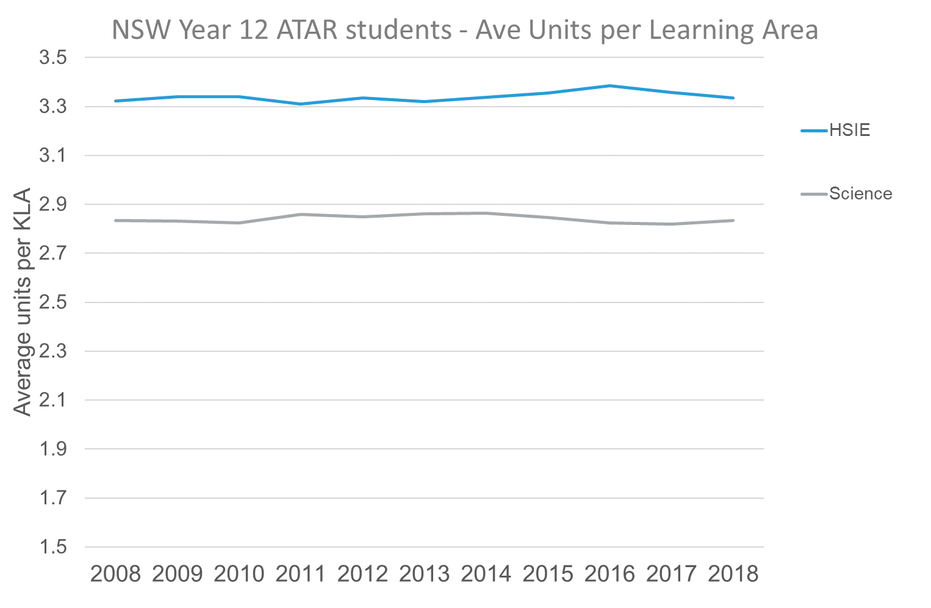

Figure 5b: ATAR-eligible HSC students – Average units studied per KLA.

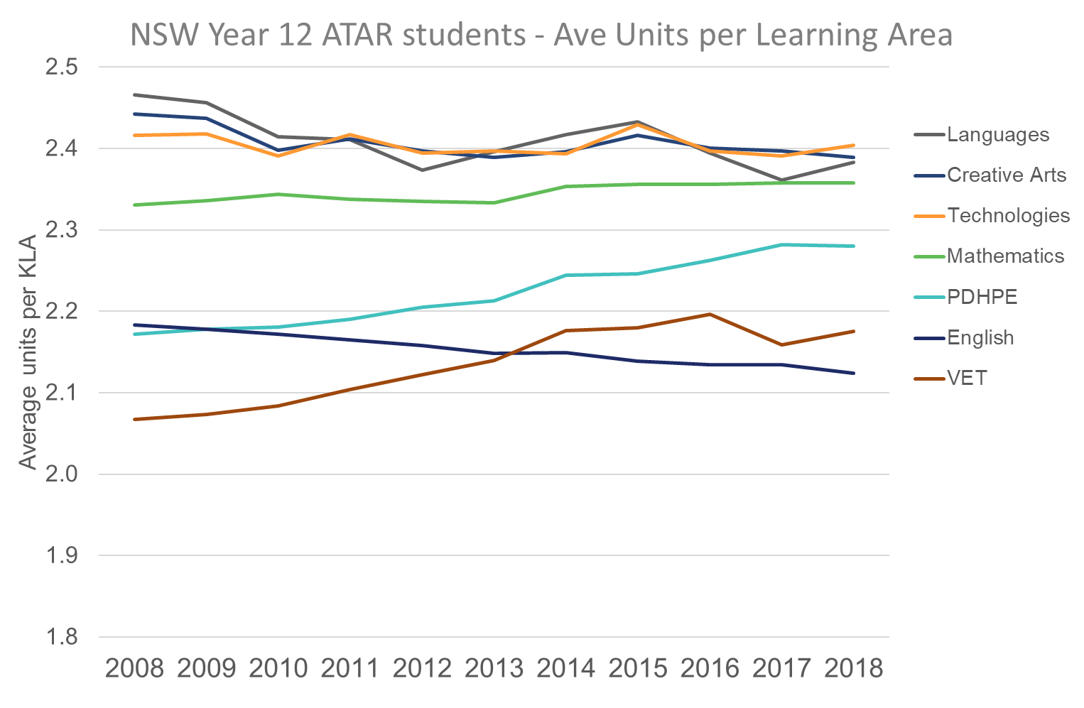

HSC students who achieve higher ATARs study subjects across fewer KLAs – a distinct trend shown in Figure 6. Students with higher ATARs tend to study subjects from three or four KLAs whereas students with lower ATARs tend to study subjects from four or five KLAs. This may be because students with higher ATARs are more likely to study extension subjects that belong to the same KLA as the base subject. The effect on HSC and ATAR results of the number of KLAs from which HSC subjects are selected is unclear. It is also unclear whether students who specialise achieve a higher ATAR.

Figure 6: ATAR-eligible HSC students by number of KLAs and ATAR.

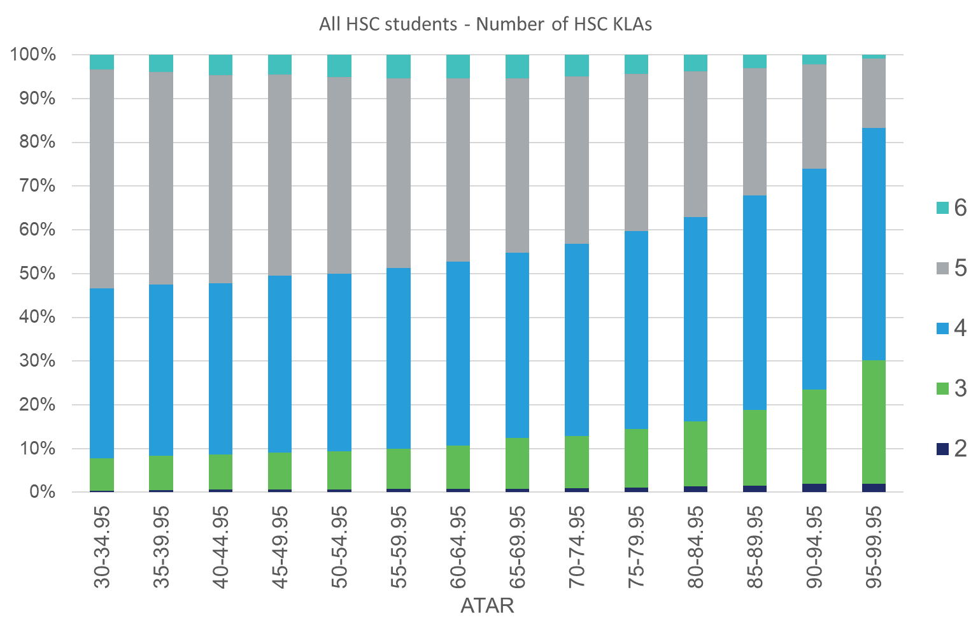

Individual subjects are important in determining what drives KLA trends of ATAR-eligible HSC students.

As mentioned, the English KLA is compulsory for ATAR-eligibility so its participation rate is 100%; however, the rate of study for individual English subjects has changed dramatically over the last decade (Figure 7). English Standard has increased while the higher-level English Advanced and the English Extension options have decreased. This explains the decrease in the average number of English units undertaken by ATAR-eligible HSC students over the last decade. (Note: To undertake an English Extension option a student must also undertake English Advanced).

Figure 7: ATAR-eligible HSC students – English subjects' rates of study.

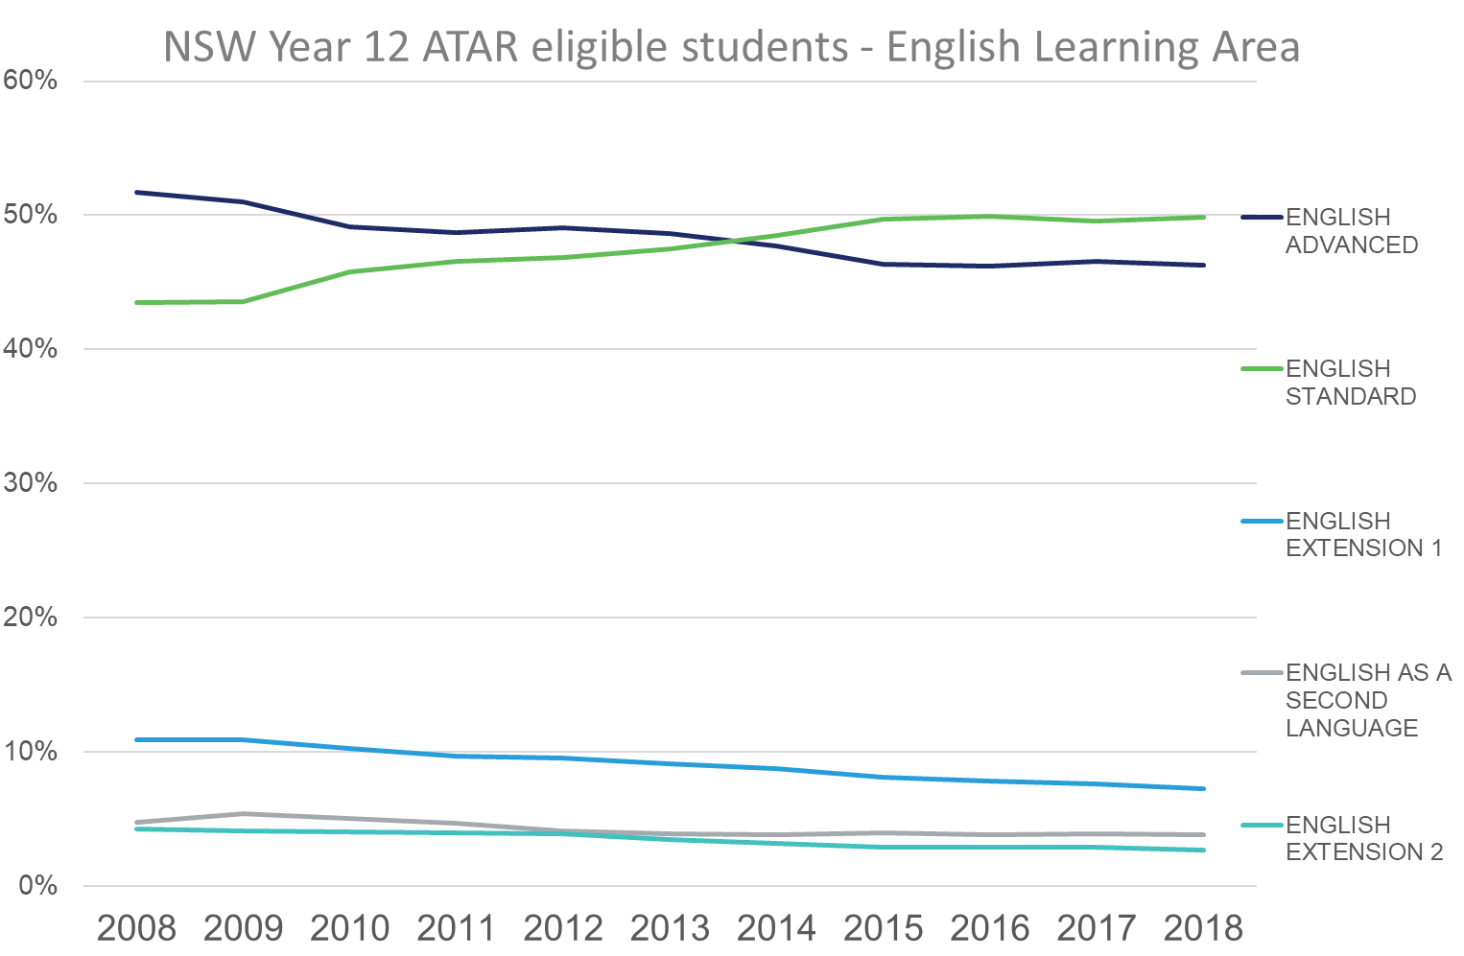

Over the last decade, the rate of study for Mathematics General has increased while the higher-level Mathematics has decreased; however, since 2016 this trend has reversed (Figure 8). The recent increase in the rate of study of higher-level mathematics may be due to its introduction as a prerequisite for entry by some universities. This change may have also increased the rate of students studying any mathematics subject.

The decline in the rate of study of Mathematics Extension 1 was comparatively less than that of Mathematics and has reversed since 2016. The rate of study of Mathematics Extension 2 has been steady since 2008. (Note: To undertake Mathematics Extension 1 a student must also undertake Mathematics. A student who chooses Mathematics Extension 2 must also undertake Mathematics Extension 1, but not Mathematics in addition. If a student undertakes Mathematics General, they cannot choose an Extension option.)

Figure 8: ATAR-eligible HSC students – Mathematics subjects' rates of study.

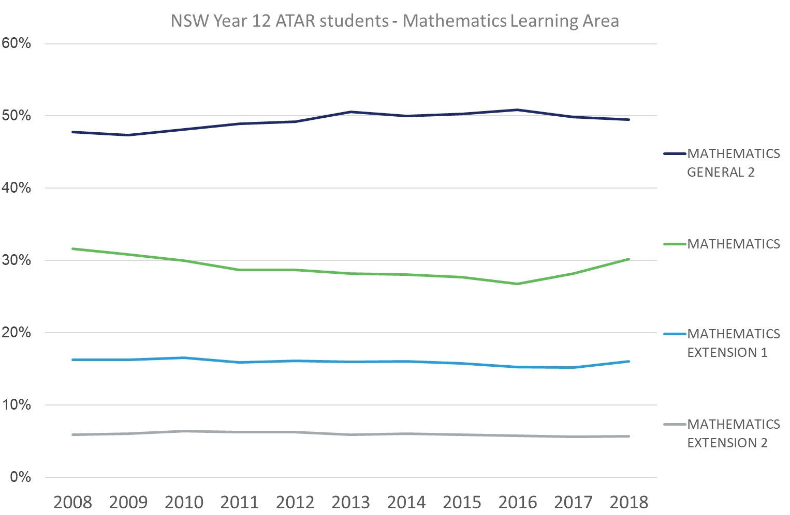

The popularity of the Human Society and Its Environment (HSIE) KLA among ATAR-eligible HSC students is evident by its study rate percentage and average number of units studied. Its relatively high rate of study is largely driven by the number of HSIE subjects available and each subject’s popularity. Figure 9 shows study rate trends for HSIE subjects over the past decade.

The rate of study of Business Studies declined sharply until 2011 and has recovered strongly since. Economics experienced a similar variation in rate of study until 2011 and has since stabilised. Legal Studies has seen strong growth, Ancient History has declined, and Modern History has increased slightly. The rate of study of History Extension has slightly declined.

The increase in rate of study of the 2 unit Studies of Religion II has grown strongly, while 1 unit Studies of Religion has decreased – therefore students are increasingly opting for the 2 unit version of the subject. Geography, Society and Culture, and Aboriginal Studies have remained relatively steady. In general, while slightly fewer students are undertaking HSIE subjects, they continue to undertake the same number of units.

Figure 9**:** ATAR-eligible HSC students – HSIE subjects' rates of study.

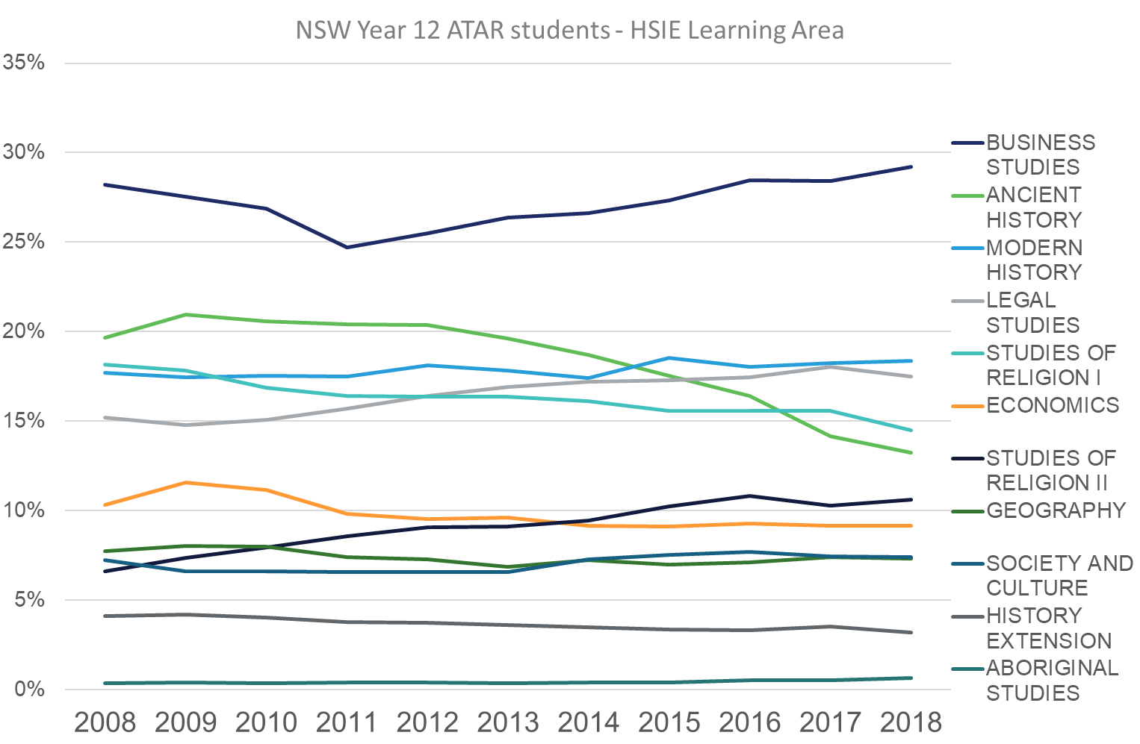

Over the past decade, an increase in the rate of study of Biology and Senior Science has driven growth in the rate of study of the Science KLA. Chemistry, Physics and Earth and Environmental Science have remained relatively stable (Figure 10). As Figure 5a shows, students are studying the same number of units in Science, which indicates more students are electing to study Science subjects (ie Biology and Senior Science) as opposed to individual students electing to study more Science subjects.

Figure 10**:** ATAR-eligible HSC students – Science subjects' rates of study.

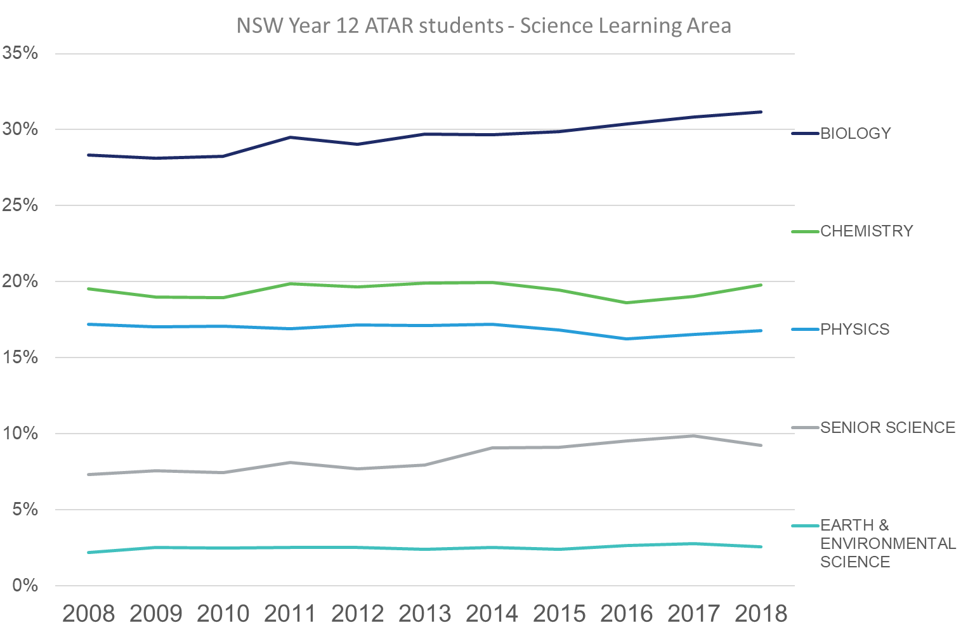

The study rate (Figure 4) and units studied per student (Figure 5b) of the Personal Development, Health and Physical Education (PDHPE) KLA have both increased; this is because students are choosing to study PDHPE subjects both individually and concurrently (Figure 11).

Figure 11**:** ATAR-eligible HSC students – PDHPE subjects' rates of study.

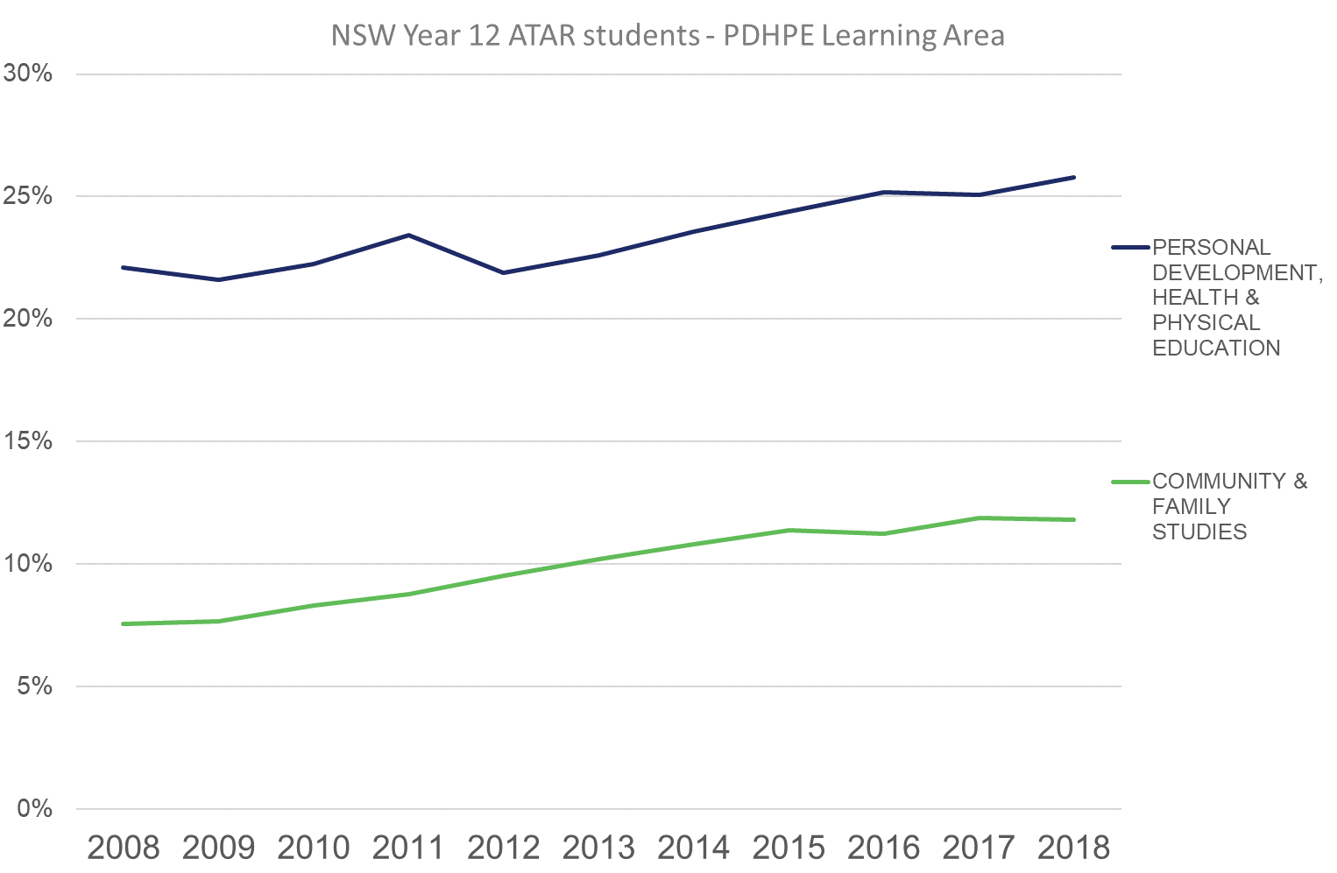

Since 2008, there have been significant shifts in study rates of subjects in the Technologies KLA (Figure 12). The decline in the study of Information Processes and Technology has been mostly offset by an increase in the study of Industrial Technology – a shift for which curriculum changes are possibly responsible. The overall decline in the rate of study of the Technologies KLA is reflected in a decline in its subjects – except for Engineering Studies and Agriculture, both of which have remained steady.

Figure 12**:** ATAR-eligible HSC students – Technologies subjects' rates of study.

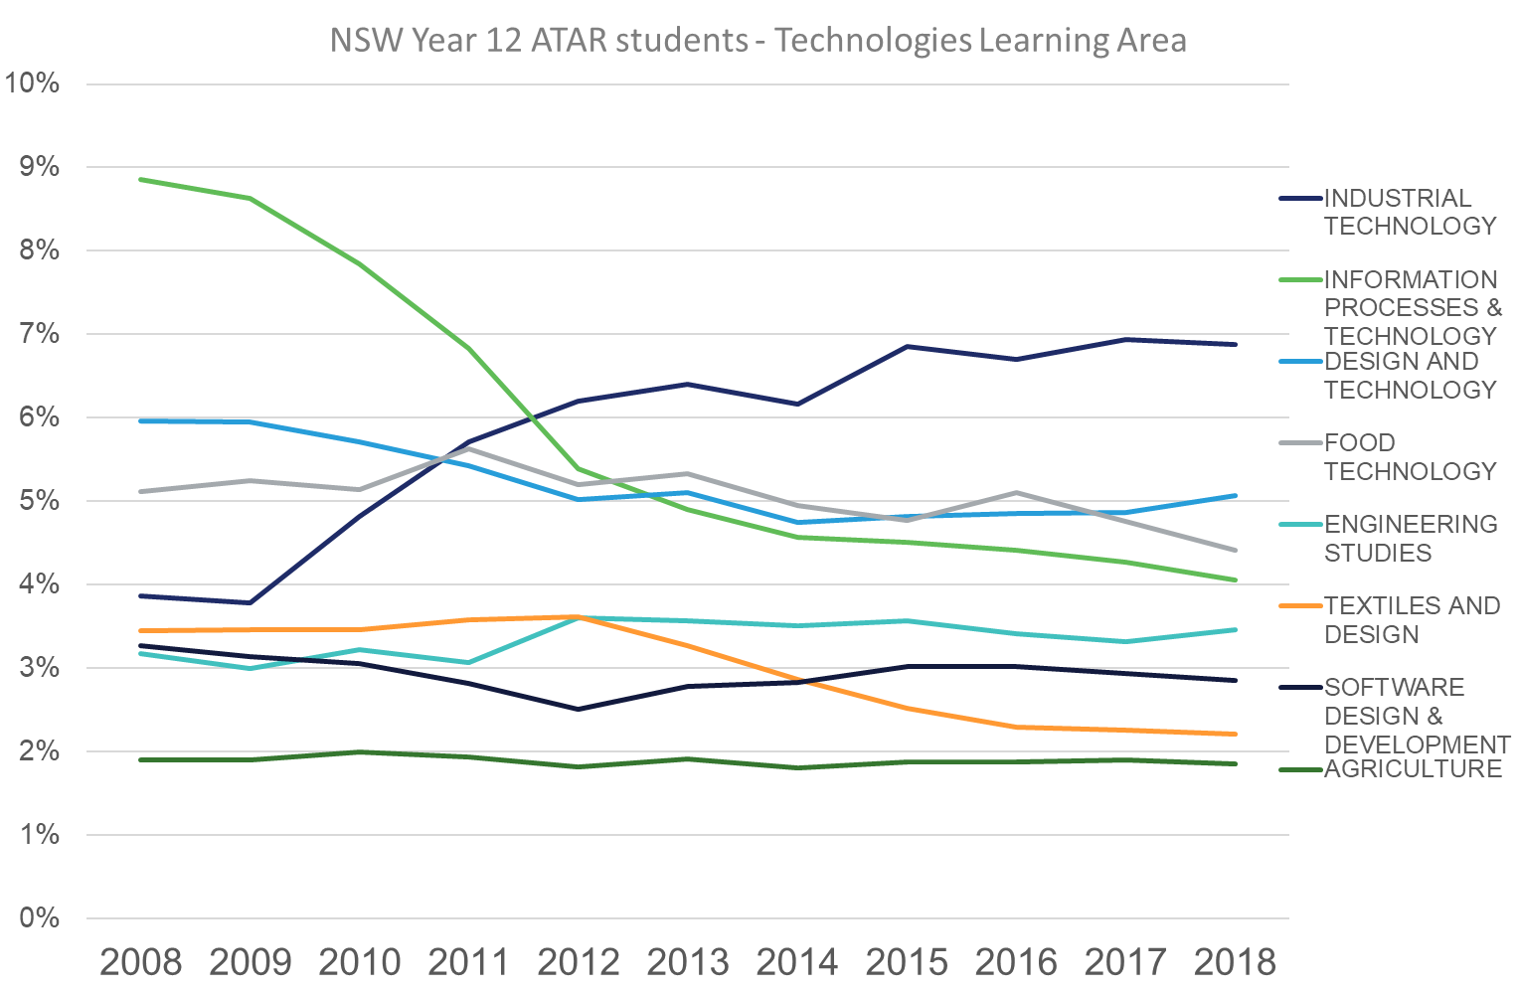

Rates of study of Visual Arts, Drama and Music 1 have experienced a similar decline, while Music 2, Dance and Music Extension have remained steady (Figure 13).

Figure 13**:** ATAR-eligible HSC students – Creative Arts subjects' rates of study.

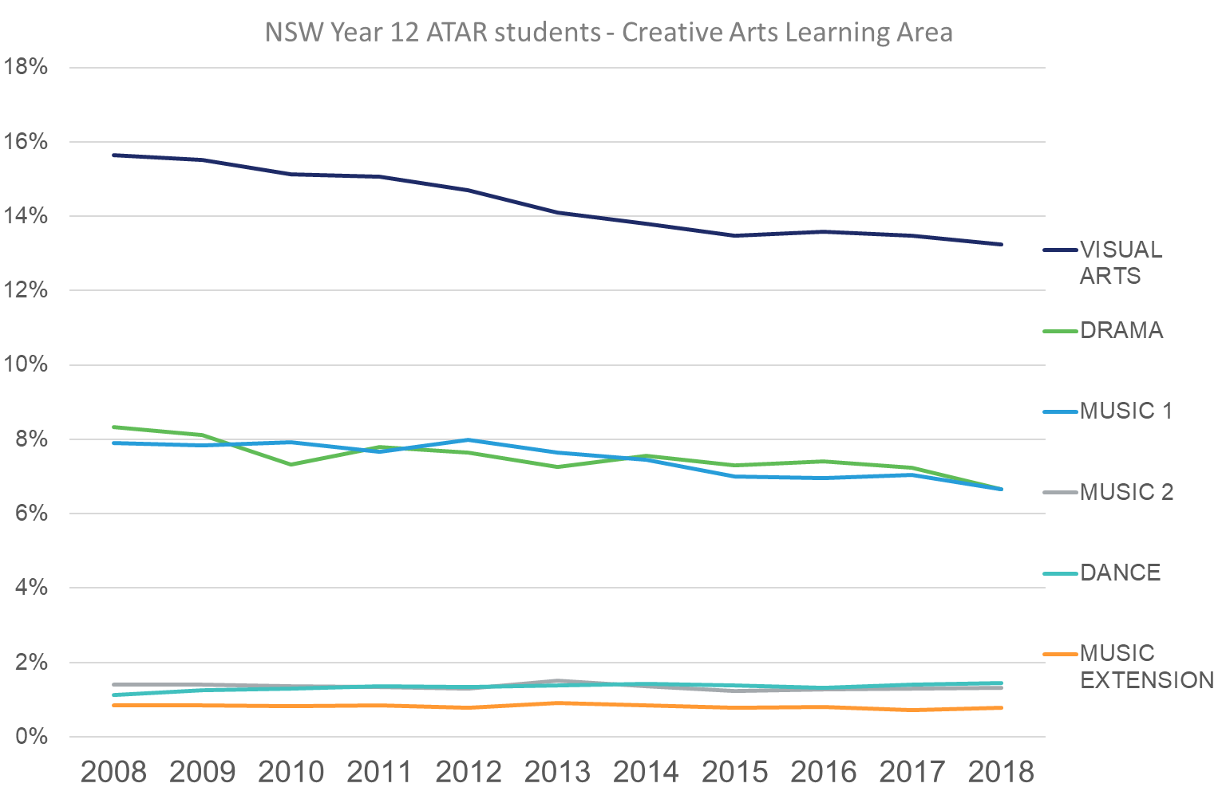

The Vocational Education and Training (VET) and Languages KLAs have significant rates of study by ATAR-eligible HSC students (Figure 4); however, they are comprised of many subjects with mostly low rates of study, so these are not considered in this analysis. Over the past decade, the number of students studying VET subjects has decreased, however VET students are studying more units within this KLA. Similarly, fewer students are studying languages; however, the average number of language units studied remains high at 2.4 units per student (Figure 5b). A significant number of students who study a language elect to study more than one language subject or a language extension subject.

## First-year university Field of Study trends

A direct connection cannot be easily made between rates of study of most HSC KLAs and a university Field of Study[11] (FOS) as multiple KLAs are contained both within, and across, multiple university FOS. Two exceptions are Science, which is steadily increasing, and Creative Arts which is declining at a similar rate of study at both HSC and university levels (Figure 14). HSIE and Society and Culture are both experiencing a decline in rates of study.

Some HSC subjects’ rates of study align with university FOS. For example, rates of study for both HSC Biology and university-level Health have increased, although neither is associated exclusively with the other. The study rate of HSC Engineering Studies and university-level Engineering and Related Technologies is relatively flat; however, the former is significantly less popular.

Less clear is the trend between Management and Commerce at HSC and university levels. This university FOS experienced growth up to 2016 but has since declined (Figure 14), while the HSC subject Business Studies, initially declined but is now growing.

At university level, the Information Technology FOS has seen steady growth, despite changes in the related HSC subjects as shown in Figure 12. It is worth noting that the HSC subjects are studied at a much higher rate than the university FOS.

Among school leavers, the rate of study of university-level Education has generally declined over the past decade. Furthermore, it is impossible to match any trends between the Education FOS with related HSC subjects, since Education is comprised of such a broad range of KLAs.

Similarly, Architecture and Building has experienced growth at a university FOS level, but has no direct links with HSC KLAs.

Agriculture has a low study rate at both university FOS and HSC subject levels. Over the past decade, it has experienced a slight decline in rate of study at university-level but has remained consistent at HSC subject level.

Figure 14: UAC HSC students – Commencing bachelor degree FOS.

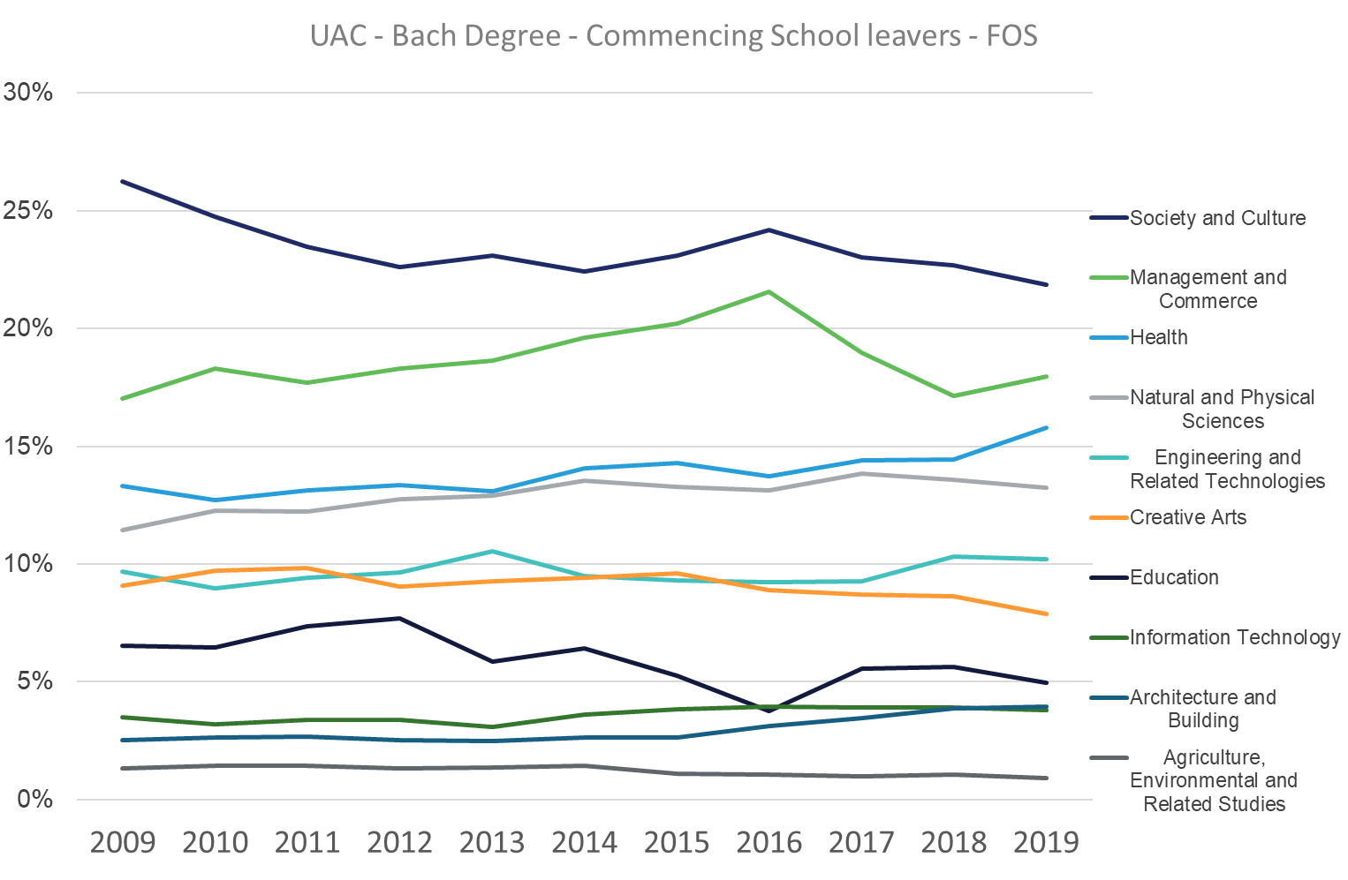

# Analysis

A summary of first-year university outcomes (as defined in section 2.1.1 above) is shown in Figure 15 below for HSC students (2013–2017) enrolling through UAC in a bachelor degree (2014–2018). On average, over half of the students with an ATAR of 60 or above, pass all subjects in first year. This is reflected in the first-year GPA, which has a moderately strong correlation to ATAR and will be discussed further in section 3.3 below. Overall, there is a clear relationship between the student’s ATAR and their preparedness for university – both first year GPA and the likelihood of completing first year with no fails increases with ATAR. Of course, it is possible for students with lower ATARs to succeed at university, but these students face a greater risk than students with higher ATARs of failing one or more of their subjects. The consequence of this would be an increase in completion times and student debt.

Figure 15: First-year outcomes of HSC students 2013–2017.

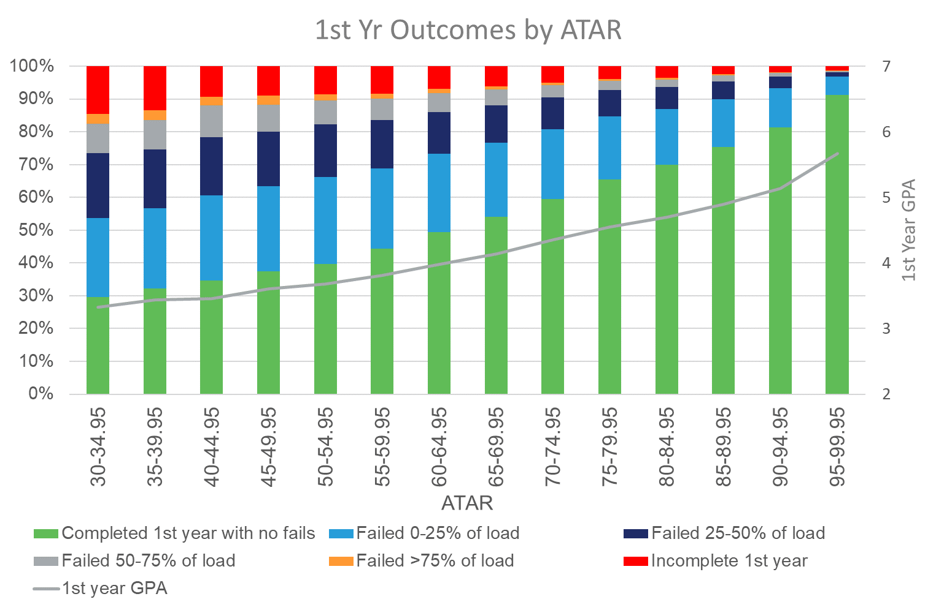

## The relationship between HSC subjects, KLAs and the ATAR

Standard Pearson correlation coefficients were calculated between HSC subject marks from the various KLAs for the same year and for the same ATAR-eligible (2013–2017) HSC student (Table 1 below; see Appendix section 5.1 for a more detailed methodology).

Correlations of HSC subject marks between KLAs range from 0.39 for Mathematics with Creative Arts, to 0.90 for Mathematics with Mathematics; these are medium and large effect sizes, respectively. These correlations confirm that, on average, student performance in HSC subjects and across KLAs is uneven – and strong performance in one area is associated with similar performance more strongly in some areas than others; however, this association is always at or above medium effect size. Furthermore, as shown in Table 1, the patterns of strongest correlations are different for each KLA.

This result reinforces the importance of HSC subject selection and specialising in areas that fit the student’s demonstrated strengths because, overall, results are affected by the combination of subjects; however, there is no single optimal set of subjects for all students. Whether students who study subjects from more closely correlated KLAs achieve better overall results is one potential area for further research.

Table 1: Correlations between HSC subject marks from Key Learning Areas 2013–2017.



Figure 16 shows the distribution of correlations between all HSC subject marks and the ATAR for the same student in the same year. This result confirms that most HSC subject marks correlate closely to the student’s ATAR and is unsurprising since ATAR calculation is based on the marks students have achieved in their HSC subjects. High correlation between HSC subject marks shows that students’ achievement levels are similar across their subjects. Therefore, students who are academically strong (with high HSC subject marks) receive higher ATARs than those who are academically weaker (with low HSC subject marks).

Figure 16: Distribution of correlations between ATAR and HSC subject marks 2013–2017.

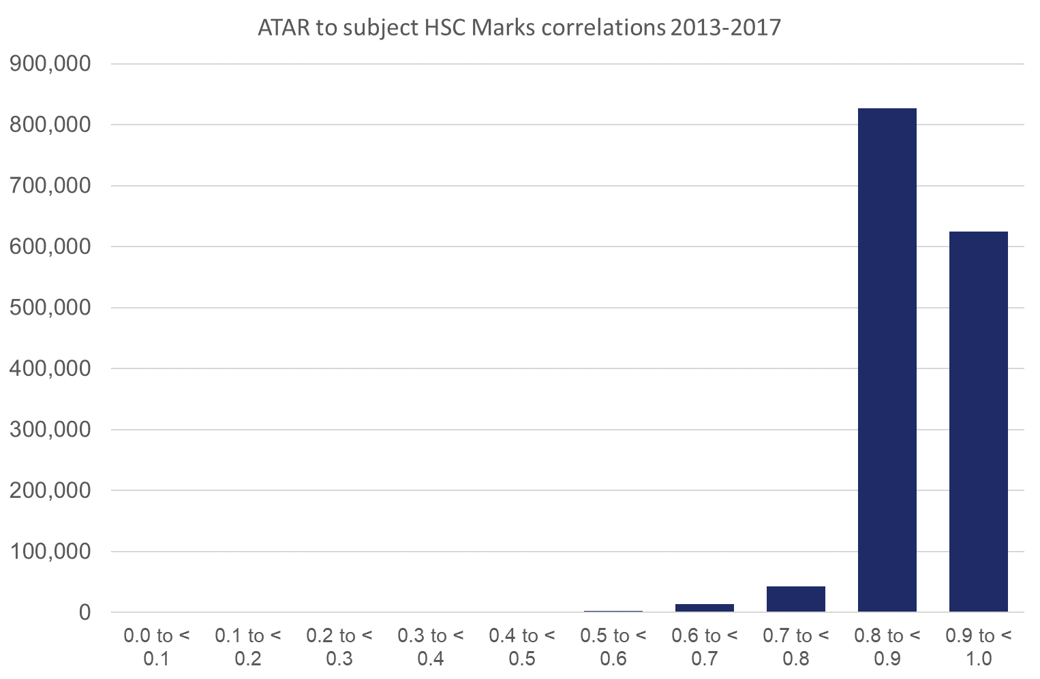

In contrast, the correlations between two HSC subject marks for the same student in the same year are shown in Figure 17. This result shows that most HSC subject marks still correlate well with other HSC subject marks; however, HSC subjects and the student’s ATAR are more highly correlated. Most ATAR to HSC subject correlations are greater than 0.8, while only a minority of HSC subject to HSC subject correlations are in this range.

It is also worth noting, as outlined in sections 2.1.2 and 2.1.3 above, that HSC subject marks are aligned to course achievement standards[12], whereas the ATAR calculation process is based on the students’ raw marks. Therefore, compared with HSC marks, scaled marks have an even stronger correlation to the ATAR, and furthermore, a stronger correlation to other scaled marks of the same student.

Further information on the highest matched HSC subject-to-subject correlations can be found in section 5.5 in the Appendix.

Figure 17: Distribution of correlations between HSC subject marks 2013–2017.

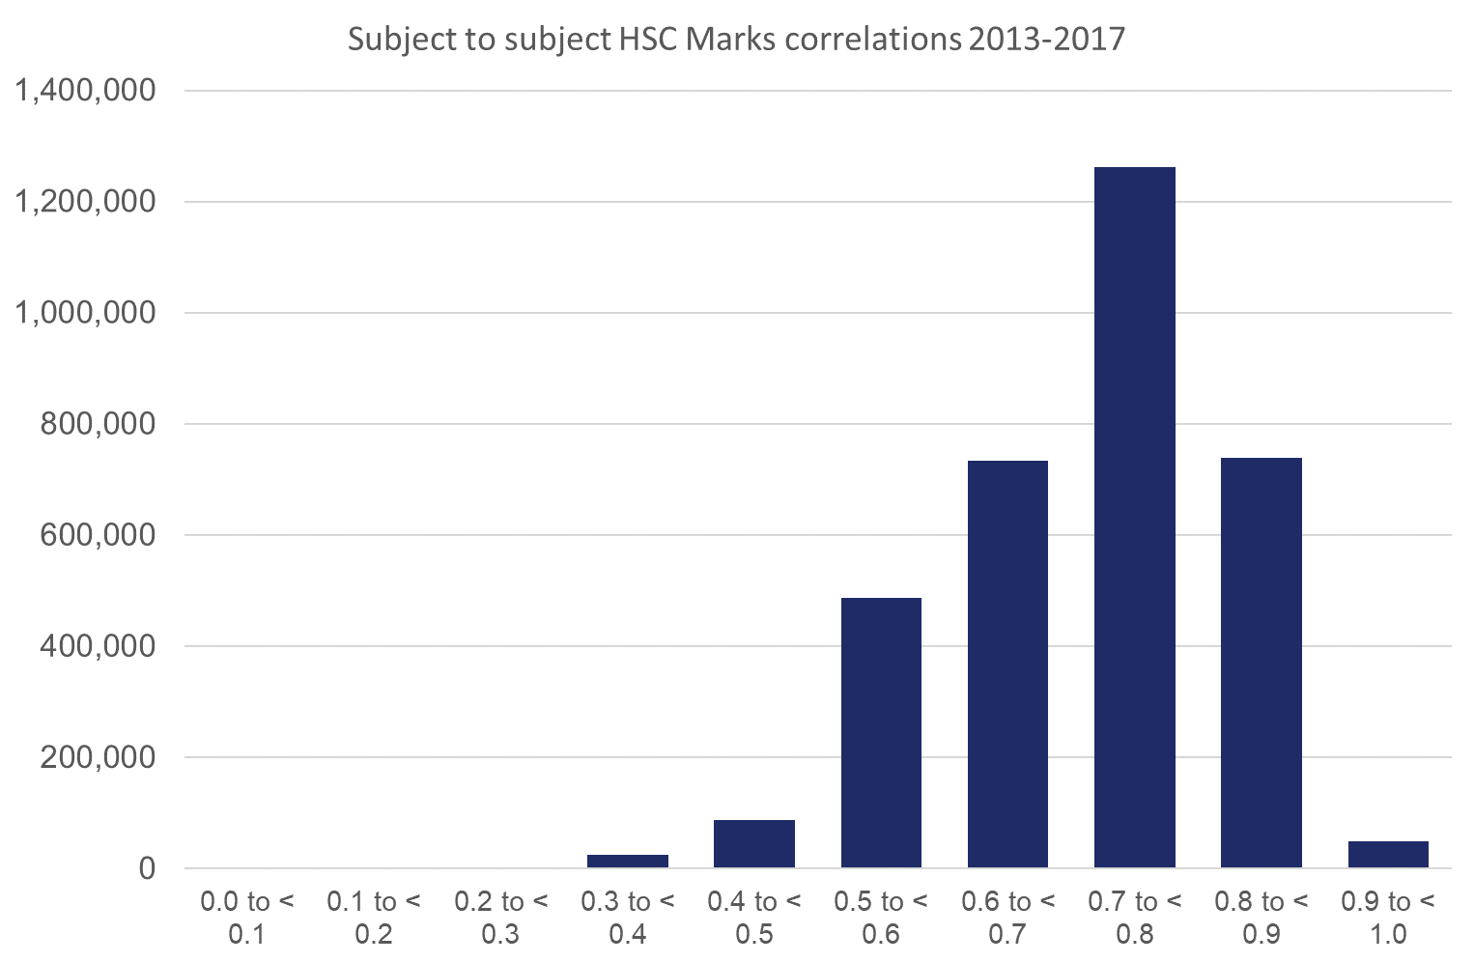

## The relationship between HSC study patterns and FOS at university

Between 2013 and 2017, students could choose to study Mathematics at four levels. From lowest to highest, these were: General Mathematics, Mathematics, Mathematics Extension 1, and Mathematics Extension 2.

Students are introduced to calculus in Mathematics, with more in-depth study in this and other areas in Mathematics Extension 1 and Mathematics Extension 2. Further information on each subject’s syllabus is available on the NESA website[13]. Mathematics is not compulsory, so students may choose not to study mathematics whatsoever.

### Participation in Mathematics

Typically, UAC participating institutions only recommend that students study STEM subjects, and in particular, mathematics, if they are planning to enrol in engineering and science courses. In the period 2013–2017, there were no prerequisites per se, however some universities have introduced prerequisites since.

Figure 18 shows the percentage of students by the highest level of mathematics they had undertaken for their HSC in the following FOS: Natural and Physical Sciences, Information Technology, Engineering and Related Technologies, Health, and Education. The first four FOS were chosen because mathematics tends to be a recommended HSC subject for these fields, while Education is included due to the attention it has attracted in recent years.

Our data shows that almost all students in the Engineering and Related Technologies FOS have undertaken some level of mathematics. Specifically, 93% have taken Mathematics or higher (Extension 1 or 2), and 7% have undertaken Mathematics General. However, it may be that Mathematics General is inadequate in preparing students for some engineering courses. This problem could be countered by institutions imposing the appropriate course prerequisites.

Figure 18: Percentage of students in each FOS by their highest level of HSC mathematics.

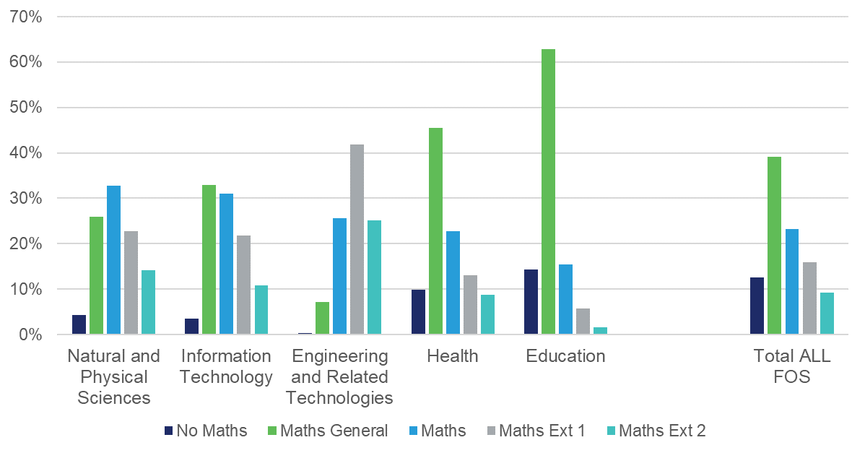

In the Natural and Physical Sciences, Information Technology and Health FOS, most students have studied an HSC-level mathematics subject. A sizeable proportion of students have undertaken a higher level of mathematics in these FOS, however this is not the case among students in Education where Mathematics General is most popular. Indeed, less than a quarter of Education students (23%) chose a calculus-based mathematics subject (Mathematics, or Extension 1 or 2) in high school.

### Participation in STEM

Figure 19 shows, by university-level FOS, the percentage of students who did not take any science or mathematics subject (or both) in high school. (Note: In Figure 19, ‘Science’ includes Biology, Chemistry, Physics, Earth and Environmental Science and Senior Science; and ‘Maths’ refers to any level of mathematics.) In this analysis, technology-related subjects are not included as part of STEM.

It is perhaps unsurprising that a large proportion of students in Society and Culture, and Creative Arts did not take any science subjects, or indeed any STEM (mathematics or science) subjects at school. In contrast, most students undertaking STEM-oriented degrees (Natural and Physical Sciences, Information Technology, Engineering and Related Technologies, Health) have studied STEM subjects at school.

It may be of concern to educators and policy-makers that more than half of Education students (53%) have not undertaken any science subjects at school. In fact, around 10% of these students did not study mathematics or science for their HSC.

Figure 19: Percentage of students in each FOS who have undertaken no Mathematics, no Science, or neither for their HSC.

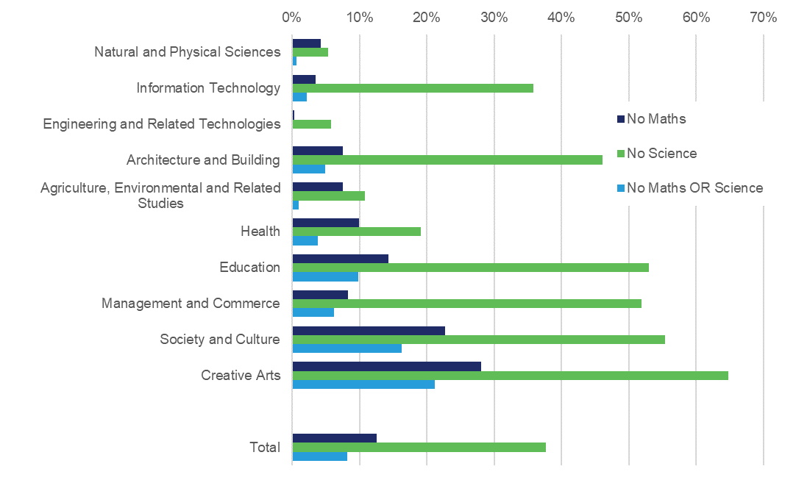

### Participation in higher level mathematics and English

Figure 20 shows the percentage of students in each FOS who have studied higher levels of English and Mathematics. Higher levels of English include English Advanced, English Extension 1 and English Extension 2, and higher levels of mathematics include Mathematics, Mathematics Extension 1 and Mathematics Extension 2.

As expected, a greater proportion of students have studied higher levels of mathematics in STEM-oriented FOS than in other FOS such as Society and Culture and Creative Arts. However, a high proportion of students (over 60%) in Natural and Physical Sciences, Engineering and Related Technologies, and Health, have also studied English Advanced or higher at school.

It is worth noting that of all FOS, Education has the lowest proportion of students who studied English Advanced or higher at school (47%), as well as the lowest proportion of students who have studied Mathematics or higher (23%).

Figure 20: Percentage of students in each FOS who have taken English Advanced or higher, and Mathematics or higher for their HSC.

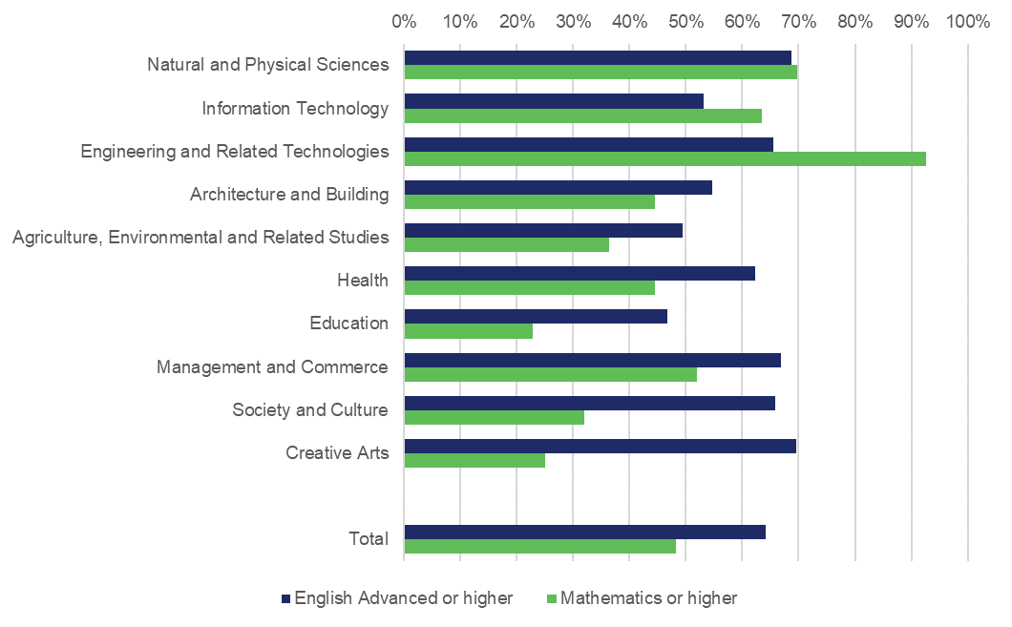

## The relationship between subject choices and university success

This section describes the analyses carried out to explore any relationship between subject choices and university success. Here, the measurement for university success is indicated by the student’s grade point average (GPA) in their first year at university.

The analysis includes a series of hierarchical regressions which ascertain the relationship between subject selection and first-year GPA, while controlling for the ATAR, which is taken as a singular measure summarising a student’s senior secondary schooling achievement. In a hierarchical regression, therefore, we could control for the general academic ability of the student, as measured by the ATAR. Any additional variance explained could then be attributed to the specific subject selected by the student. Further information can be found in section 5.2 in the Appendix.

For reference a summary of the proportion of the top 50 HSC subjects studied by FOS can be found in Table 6 in the Appendix.

### ATAR and first-year GPA

The average ATAR of our sample of 118,362 recent school-leavers who embarked on their university degree between 2014 and 2018 was 78.61 (SD = 14.80). The average of their first-year GPA was 4.48 (SD = 1.52). The correlation between their ATAR and first-year GPA was 0.464. This is slightly under the common finding in existing literature, which shows a correlation of around 0.5 between previous academic performance and first-year GPA[14].

The mean ATAR, mean first-year GPA, and the strength of the correlation between these two measures vary across FOS. Table 2 shows that students in Natural and Physical Sciences, Engineering and Related Technologies, and Management and Commerce, on average, achieved higher ATARs than students from other FOS. There is also variation in the average first-year GPA between students from different FOS, with students studying Creative Arts, and Architecture and Building achieving, on average, higher first-year GPAs than students studying other FOS.

The correlation between ATAR and first-year GPA appears to be stronger for STEM-oriented degrees, as well as Management and Commerce. The correlation is weaker for Society and Culture, and Creative Arts. It may be that there is a more direct mapping between content of study between HSC subjects for STEM and Management and Commerce, than for humanities and the arts. In other words, the ATAR might have captured the abilities required for STEM and management-related fields to a better extent than for the arts.

For Society and Culture, it is more difficult to surmise which HSC subjects would benefit university studies given the diverse nature of this FOS. For some courses in this FOS, there is probably an overlap in content between the 11 HSC subjects under the KLA of HSIE (Human Society and its Environment) and university studies. As for Creative Arts, the ATAR might not have sufficiently captured the potential in these students. Therefore, it could be argued that it is necessary for the institutions to use auditions as part of the basis for admission to degrees in the performing arts (eg music, visual arts, and drama).

Table 2: Mean and SD of ATAR, first-year GPA and correlation between ATAR and first-year GPA by FOS.

|  |  |  |  |  |
| --- | --- | --- | --- | --- |
| FOS | ATAR mean (SD) | GPA mean (SD) | Correlation between ATAR and GPA | N |
| Natural and Physical Sciences | 81.73 (12.86) | 4.52 (1.58) | 0.474 | 16,609 |
| Information Technology | 75.64 (14.39) | 4.35 (1.65) | 0.503 | 4,781 |
| Engineering and Related Technologies | 84.30 (11.46) | 4.54 (1.49) | 0.502 | 10,334 |
| Architecture and Building | 76.56 (13.99) | 4.73 (1.28) | 0.459 | 3,805 |
| Agriculture, Environmental and Related Studies | 73.14 (13.26) | 4.16 (1.56) | 0.491 | 952 |
| Health | 78.88 (14.64) | 4.59 (1.45) | 0.496 | 16,329 |
| Education | 71.41 (13.10) | 4.46 (1.34) | 0.467 | 6,547 |
| Management and Commerce | 81.20 (15.80) | 4.41 (1.54) | 0.594 | 20,038 |
| Society and Culture | 76.19 (15.27) | 4.31 (1.59) | 0.405 | 29,023 |
| Creative Arts | 76.36 (15.00) | 4.80 (1.30) | 0.389 | 9,937 |
|  |  |  |  |  |
| **Total** | **78.61 (14.80)** | **4.48 (1.52)** | **0.464** | **118,362** |

### ATAR, highest level of mathematics and English and university success

The percentage of students who have achieved a GPA < 4 provides another way of looking at the relationship between the ATAR and university success. (Note: A GPA ≥ 4 indicates that, on average, the student has passed all degree modules. A GPA < 4 indicates the student has failed one or more degree modules.)

As shown in Figure 21, the likelihood of achieving a first-year GPA < 4 decreases as the student’s ATAR increases, regardless of the level of HSC mathematics studied. (Note: In Figures 21–28, data points are not shown if there were fewer than 20 students in that subject group and in that ATAR range – eg in Figure 21, fewer than 20 students undertook Mathematics Extension 2 and achieved an ATAR below 50.)

Figure 21: Percentage of students with first-year GPA < 4, by ATAR and the highest level of mathematics taken for their HSC.

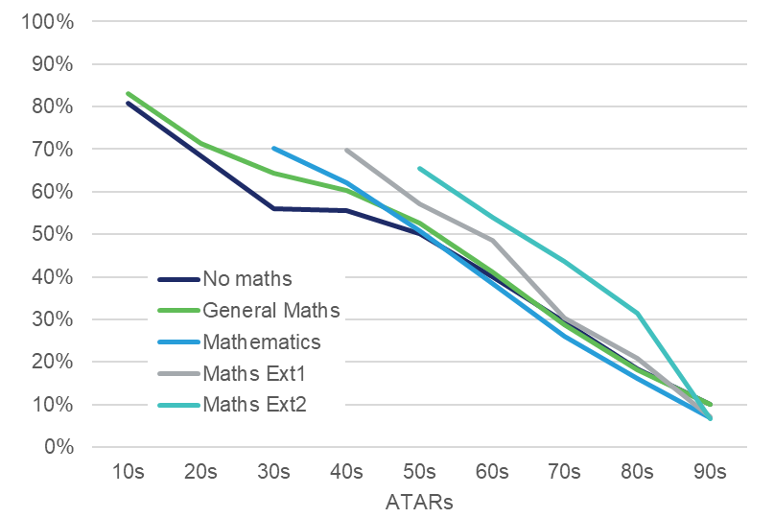

Conversely, the mean GPA in first-year study increased as students’ ATARs increased – a trend evident regardless of the highest level of HSC mathematics studied (Figure 22). Indeed, there appears to be a significant disadvantage for students who studied Mathematics Extension 2 at school if their ATARs were below 90 and a lesser disadvantage for Mathematics Extension 1 students if their ATARs were below 70. This result is reflected in Figure 21, which shows that the percentage of students with a first-year GPA < 4 was higher for Mathematics Extension 1 and 2 students with lower ATARs.

It is unusual for a student to be disadvantaged by completing a higher level of prior study. The two groups[15] of students mentioned above were investigated further. These students were more likely to have also studied English Advanced, Physics and Chemistry than students with the same level of Extension Mathematics and ATAR who achieved a GPA > 4. As discussed in section 3.3.5 below, English Advanced, Physics and Chemistry are usually studied by students who achieve higher ATARs. These two student groups were also more likely to study Engineering and Related Technologies or Natural and Physical Sciences degrees than similar students who achieved a GPA > 4. It is unclear why these students made these subject choices; it is possible, due to bad choices or advice, they had an expectation that studying higher-level subjects would produce a higher ATAR – an expectation that possibly continued into first-year university.

These groups represent only a small proportion and most students study appropriate levels of subjects; however, it does highlight the need to ensure that students select subjects that are appropriate for them. Further research is needed to examine the effects of studying subjects at a level higher than the student’s capabilities.

Figure 22: **Mean first-year GPA, by ATAR and the highest level of mathematics taken for HSC.**

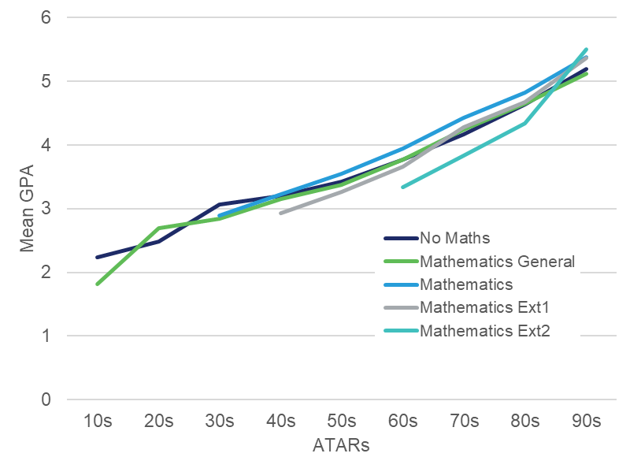

Students with low GPAs are less likely to complete their course[16]. In this way, our results here are in the same vein as those from the Grattan Institute[17] and the Higher Education Standards Panel[18]. Norton et al. (2018) found that after controlling for various characteristics, the risk of course non-completion among students with ATARs above 90 was low (below 20%) and among students with ATARs below 60 was high (40%).

The researchers argued that the ATAR measures both ability and effort. Unlike an ability test which only assesses aptitude (eg in numeracy or literacy), the ATAR is based on academic achievement – the student’s knowledge and skill, and other factors such as motivation and attitude towards learning. Both ability and effort have an impact on the individual’s performance at university, so it is no surprise that there is a link between the ATAR, GPA and likelihood of course completion.

Similar analyses were carried out to show the relationship between the highest level of HSC English and university success, as measured by the percentage of students with a failing GPA (Figure 23) or first-year GPA (Figure 24). Both figures show that the ATAR underpins university success – as the ATAR increases, the likelihood of a failing GPA decreases and the mean GPA increases. It appears that the level of English studied at school had little impact on these measures, except for ESL students who had a slightly poorer outcome compared with students who studied other HSC English subjects.

Figure 23: Percentage of students with first-year GPA < 4, by ATAR and the highest level of English taken for their HSC.

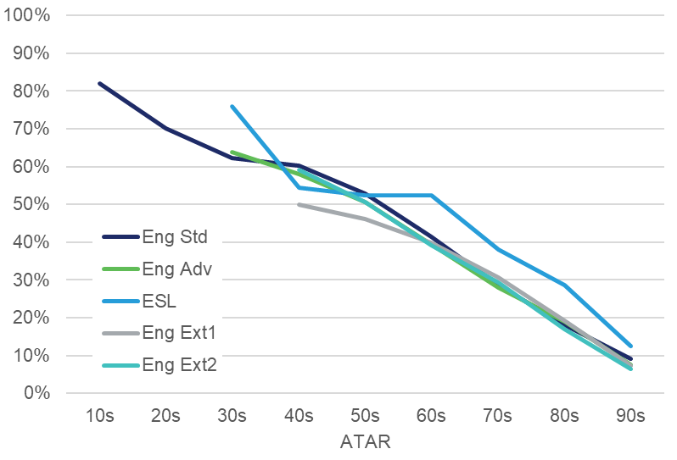

Figure 24: **Mean first-year GPA, by ATAR and the highest level of English taken for HSC.**

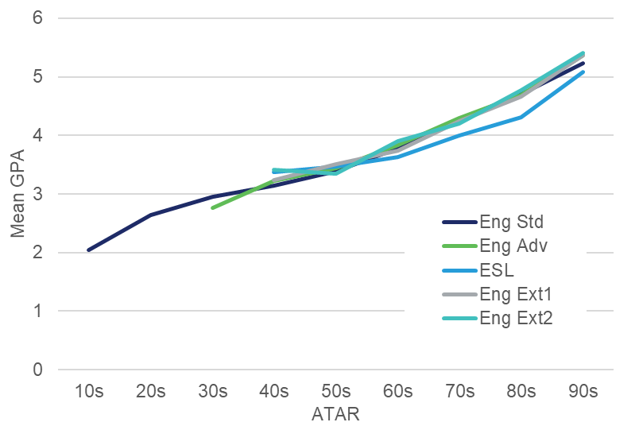

### ATAR, number of science subjects (Physics, Chemistry, Biology) at school and university success: Natural and Physical Sciences students

The above analysis was repeated for students in a Natural and Physical Sciences degree who attained a GPA for first-year study. Figure 25 shows the percentage of students who have a GPA < 4 and Figure 26 shows the mean first-year GPA – both by ATAR and number of HSC science subjects studied (from Physics, Chemistry, Biology). Few students studied Senior Science, and Earth and Environmental Science so these subjects were not considered.

Figure 25: **Percentage of Natural and Physical Sciences students with first-year GPA < 4, by ATAR** **and the number of science subjects studied (from Physics, Chemistry and Biology) in their HSC.**

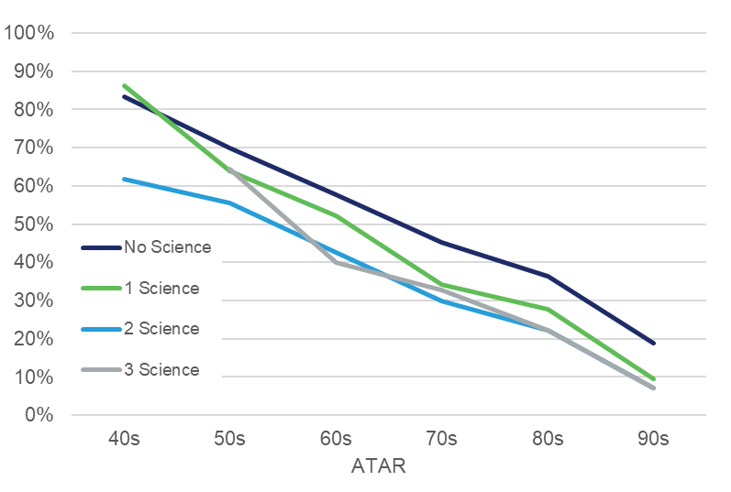

As we have consistently found, the ATAR is the primary factor underpinning the likelihood of a failing GPA (Figures 25 and 26). Students with higher ATARs are less likely to fail in at least one module and achieve a higher GPA in the first year of their Natural and Physical Sciences degree. However, studying at least one HSC subject from Physics, Chemistry and Biology is evidently associated with a lower rate of a failing first-year GPA. Students (with an ATAR of 50 and above) who did not study an HSC science subject are more likely to achieve a GPA < 4 than those who studied at least one.

Similarly, there is evidence (Figure 26) that studying HSC science subjects (Physics, Chemistry and Biology) generally results in a higher GPA for first-year Natural and Physical Sciences FOS students. Students who studied at least one of Physics, Chemistry and Biology performed better than those who did not. And students who studied two or three science subjects from Physics, Chemistry and Biology performed better than those who studied only one. This pattern is seen consistently with ATARs in the 60s and above.

Figure 26: **Mean first-year GPA of Natural and Physical Sciences students, by ATAR and the number of science subjects studied (from Physics, Chemistry and Biology) in their HSC.**

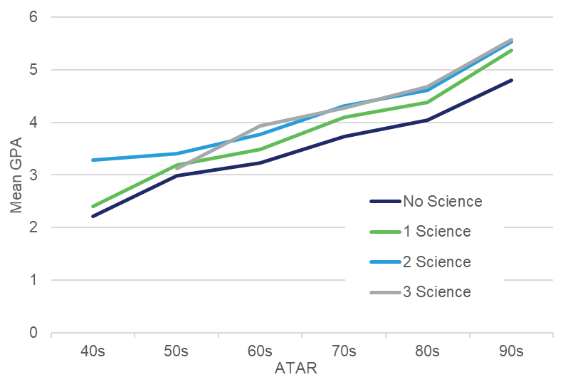

Overall, 44% of Natural and Physical Sciences students who studied none of HSC Physics, Chemistry and Biology had a failing GPA in the first year, compared with 26% who studied at least one of these three HSC subjects. However, it should be noted that the majority of Natural and Physical Sciences students sensibly selected a university course based on what they studied for their HSC. In this analysis, 92% of students have studied at least one of HSC Physics, Chemistry and Biology. The remaining 8% of students did not study any of these HSC subjects and, in comparison, did not perform as well in the first year of their science degree.

Given that 92% of Natural and Physical Sciences university students studied at least one science subject in Year 12, serious consideration should be given to introducing a science prerequisite for Natural and Physical Sciences degrees due to the clear benefit provided by studying one or more science subjects at HSC level.

### ATAR, highest level of mathematics at school and university success: Engineering and Related Technologies students

As mentioned in section 3.2.1, most students in this FOS (93%) have studied a calculus-based HSC mathematics subject; that is, Mathematics, Mathematics Extension 1 or Mathematics Extension 2. The remaining 7% studied General Mathematics, which does not have a calculus component; and only a negligible number of students studied no mathematics subjects whatsoever.

As Figure 27 shows, Engineering and Related Technologies students who studied General Mathematics in their HSC were more likely to have a failing GPA than those who studied higher levels of mathematics. Students who studied General Mathematics in their HSC also achieved, on average, lower GPAs in an Engineering and Related Technologies degree than their peers who studied a higher level of mathematics (Figure 28). Overall, the likelihood of achieving a passing first-year GPA, and also the student’s GPA itself, were again driven primarily by the ATAR.

Clearly, studying a calculus-based mathematics HSC subject is beneficial for a student planning to study an Engineering and Related Technologies degree at university. It is less clear whether studying a higher level of HSC mathematics contributes to university success. For students with an ATAR below 90, studying the highest level of HSC mathematics (Mathematics Extension 2) is not obviously beneficial for Engineering and Related Technologies degree students. As discussed in section 3.3.2 above this may be due to bad HSC subject choices or advice that possibly continued into first-year university. However, for students with an ATAR in the 90s, university success (ie mean GPA and likelihood of a failing GPA) aligns with the level of HSC mathematics studied. That is, students who studied Mathematics Extension 2 performed better than Mathematics Extension 1 students; Mathematics Extension 1 students performed better than Mathematics students, who, in turn, performed better than General Mathematics students

It is worth reiterating that students who studied higher levels of HSC mathematics were more likely to achieve ATARs in the 90s. The number of students who studied Mathematics Extension 2 and with an ATAR of less than 60, and those who studied Mathematics Extension 1 with an ATAR less than 50, were too small to be shown in Figures 27 and 28. The opposite is true for students studying lower levels of mathematics (Mathematics and General Mathematics) – they were more likely to achieve lower ATARs.

Introducing a mathematics prerequisite for Engineering and Related Technologies degrees should be given serious consideration as studying an HSC mathematics subject with a calculus component is clearly beneficial.

Figure 27: **Percentage of Engineering and Related Technologies students with first-year GPA < 4, by ATAR and the highest level of mathematics in their HSC.**

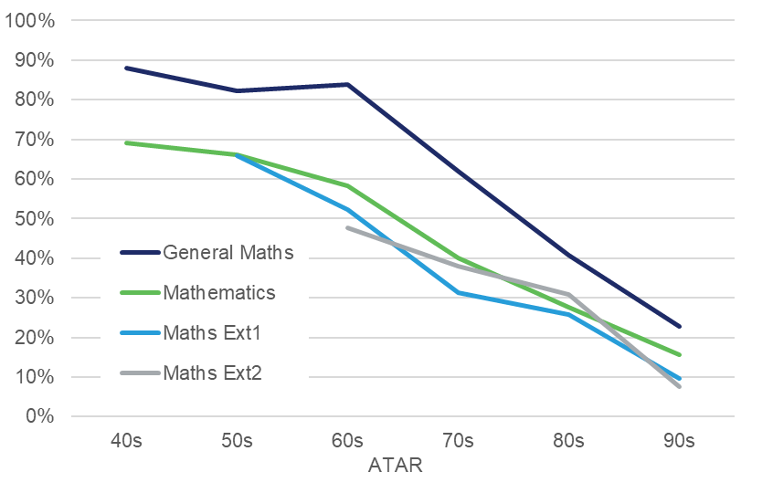

Figure 28: **Mean first-year GPA of Engineering and Related Technologies students, by ATAR and the highest level of mathematics in their HSC.**

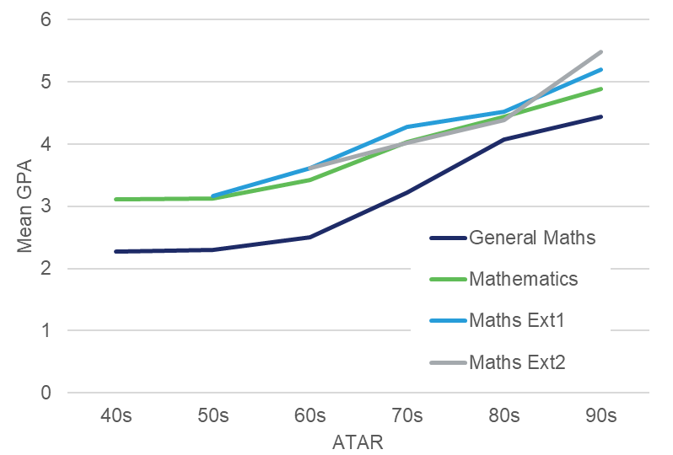

### Regression analysis

Sections 3.3.2 to 3.3.4 clearly show that subject selection had an impact on university success (eg for FOS such as Natural and Physical Sciences, and Engineering and Related Technologies). Additionally, there is a link between subject selection and the ATAR – for example, students who undertook higher levels of mathematics generally achieved a higher ATAR.

A question, therefore, remains: After accounting for the ATAR, does subject selection affect university success? To answer this question, several hierarchical regressions were carried out to predict first-year GPA. In each, the students’ ATARs were entered in the first step of the model, and in the second step, the subject choice of interest was entered. The size of R2 change in the second step would show the additional amount of variance in first-year GPA which could be uniquely explained by the subject choice in question (Table 3).

For example, the first regression focused on whether the highest level of mathematics taken by students would affect their first-year GPA. When ATAR was entered first into the model, it explained around 21.5% of the variance in GPA. Entering the highest level of mathematics done by the students in the second step hardly explained any further variance in their GPA.

Even when the analysis was restricted to an FOS where the level of mathematics might be more important for university success (eg Engineering and Related Technologies), the amount of variance in GPA which was explained by the level of mathematics undertaken at school was minimal, at less than 1%. This result may appear to contradict Figure 24 in the previous section, where evidence showed that students who studied General Mathematics, rather than higher levels of mathematics for their HSC, had a greater chance of a failing GPA. The regression model shows that there is both a relationship between the ATAR and first-year GPA, and between the ATAR and the level of mathematics studied in the HSC. The level of mathematics studied had little impact on GPA after the ATAR has been accounted for. This is because students taking higher levels of mathematics also tend to achieve higher ATARs.

The regression was also run to predict GPA for students in the Natural and Physical Sciences FOS. Again, the ATAR accounted for most of the variance in the GPA, and the number of science subjects (Physics, Chemistry, Biology) done in the HSC accounted for roughly an additional 1% of variance in the GPA after ATAR has been controlled for. As seen in section 3.3.3, there is some evidence that taking these three science subjects in the HSC may be beneficial to students in the first year of their Natural and Physical Sciences degrees, irrespective of their ATAR. The regression here could be seen in support of that finding.

Finally, after controlling for ATAR, we found little evidence that the GPA of Society and Culture FOS students was affected by the level of English studied. This may be partly due to the diverse nature of this FOS, and that the overlap between HSC English and this FOS may be less straightforward than it is for Natural and Physical Sciences.

Table 3: Regression analysis of ATAR and subject effect on first-year GPA.

|  |  |  |  |
| --- | --- | --- | --- |
| Model | All FOS | R2 | R2 change |
| 1 | ATAR | 0.215 | 0.215 |
| 2 | ATAR, highest level of mathematics | 0.216 | 0.000 |

|  |  |  |  |
| --- | --- | --- | --- |
| Model | FOS = Engineering and Related Technologies | R2 | R2 change |
| 1 | ATAR | 0.252 | 0.252 |
| 2 | ATAR, highest level of mathematics | 0.253 | 0.001 |

|  |  |  |  |
| --- | --- | --- | --- |
| Model | FOS = Natural and Physical Sciences | R2 | R2 change |
| 1 | ATAR | 0.225 | 0.225 |
| 2 | ATAR, number HSC subjects from Physics, Chemistry, Biology | 0.234 | 0.009 |

|  |  |  |  |
| --- | --- | --- | --- |
| Model | FOS = Society and Culture | R2 | R2 change |
| 1 | ATAR | 0.164 | 0.164 |
| 2 | ATAR, highest level of English | 0.165 | 0.000 |

Using hierarchical regressions, we found no evidence that the level of mathematics or English studied by HSC students would have an impact on their first-year GPA, after accounting for their overall academic ability. Here, the student’s overall academic ability was measured by their ATAR. There is some evidence that studying at least one subject from Physics, Chemistry and Biology in the HSC benefits students who undertake a Natural and Physical Sciences degree. However, we found that, overwhelmingly, the ATAR tends to explain most of the variance in first-year GPA, leaving little additional variance to be accounted for by the specific subjects studied in the HSC.

Furthermore, it is unclear how the advantage of studying a specific HSC subject relates to other first-year modules within an FOS. It could be assumed that studying HSC Chemistry would be advantageous for studying Chemistry in first-year university; however, first-year Chemistry is only one of multiple first-year modules undertaken and very few degrees consist of only one subject area, particularly at first-year level.

In general, the simple explanation of the null results lies in the intercorrelations between various subjects and the ATAR. As described in section 3.1, the correlation between HSC subject marks and the ATAR is generally high for all subjects, but the correlation between these two measures is stronger for some subjects than others. Put simply, certain subjects are associated with higher ATARs. Given the relationship between ATARs and first-year GPA, once the ATAR has been entered into a regression model, there is little variance left to explain by specific subject choices.

If there were no intercorrelations between subjects and the ATAR, then subject choice might have an impact on first-year GPA. Traditionally, certain HSC subjects tend to attract students with higher academic ability. This is shown in the annual report produced by UAC on the scaling of each year’s HSC results[19]. Higher levels of mathematics and English; sciences such as Chemistry and Physics; Economics; and languages such as Classical Greek, Classical Hebrew, Latin, French, German and Japanese tend to have higher scaled means than other HSC subjects. This reflects that the students choosing these subjects on average did very well in all their other subjects, and that the general academic ability of these students tend to be higher than those taking other subjects which have lower scaled means.

In turn, because the aggregate underlying the ATAR is made up of the scaled marks from the student’s best 10 units of subjects, higher scaled marks would therefore inevitably lead to higher ATARs. In other words, there is a clear relationship between certain subjects and ATARs (examples of this are shown in section 5.3 in the appendix). Similar findings have been reported in Victoria where it was shown that Victorian students taking mathematics and languages (other than English) tended to achieve higher tertiary entry scores than students taking other combinations of subjects[20].

However, this relationship between subject combinations and ATAR success should not be construed by the public to mean that taking certain subjects will certainly lead to higher ATARs. This finding simply reflects how students of higher academic ability tend to choose certain subjects. Moreover, subject scaling is done yearly, as the average academic ability of a particular subject’s candidature may change, therefore affecting the subjects’ scaled mean.

### ATAR as a singular measure that summarises academic achievements across different areas

One common criticism of the ATAR is that it is a singular number, and that it assumes the students’ academic ability is unidimensional, as marks from subjects with unrelated contents (eg Physics and Drama) can be scaled and then aggregated. An alternative is that separate ATARs could be calculated using results from STEM subjects alone, or from English and HSIE subjects, and these ATARs could be better predictors of university performance for STEM or humanities courses respectively, compared with a unidimensional ATAR based on all subjects.

Cooney (2001)[21] noted that there has been little research done to show that a subject-area-specific ATAR has greater predictive validity than a general ATAR. His research did not show that a STEM-based ATAR (or a humanities-based ATAR) was a better predictor of first-year university performance in a science degree (or a humanities degree). Findings from the current analysis in part support this. Specific subject choice (eg number of STEM subjects) improved the prediction of GPA performance in a Natural and Physical science degree by a small margin after the ATAR has been accounted for. A possible explanation is because students can choose their own subjects (only English is compulsory), they have already streamed themselves in certain FOS for their HSC, and that there is a reasonable consistency between their HSC ‘stream’ and the FOS of their chosen tertiary degree. For example, two students with an ATAR of 90 could have taken entirely different sets of subjects (eg one could be STEM-oriented, while the other humanities-oriented). Their ATAR of 90 suggests that they have equal academic ability, or equal chances of success at university, but that their areas of strength are different. It is also unlikely that the STEM-oriented high school student would choose a humanities degree, and the humanities-oriented student would choose a STEM degree. This is examined further in section 3.5 below.

Thus, the student’s area of strength is already inherent in the subjects they have chosen, whereas the ATAR indicates their academic potential. The best way to ensure that there is rationality in university course selection is for institutions to impose prerequisites to guide their students to the right path.

### Other factors

The focus of this analysis was on subject selection and its impact on university success. We found that this relationship was mediated by the ATAR, which is the measurement summarising a student’s secondary scholastic achievements. Prior achievement therefore accounted for roughly 20–25% of the variance in first-year GPA.

Thus, there is as much as 80% of variance in first-year GPA which could not be explained by the ATAR. In her literature review, Evans (2000)[22] outlined some of the factors influencing students’ transition from secondary to tertiary education. Apart from students’ prior performance (which could be measured by the ATAR), factors included:

1. students’ demographic characteristics (eg age, gender, socio-economic status, type of secondary school attended)
2. students’ psychological characteristics (eg learning strategies, study skills, goals)
3. social factors (eg family and financial support)
4. institutional factors (eg students’ engagement and integration with other students and the university).

Some of these factors have been implicated as factors underlying retention by the Higher Education Standards Panel[23], and it is expected that some, if not all, of these factors will contribute to students’ success at university.

## The effect of a broader HSC on GPA

To examine the effect of a broader HSC on first-year GPA, Figure 29 shows the mean first-year GPA by the number of KLA that comprised the students’ set of subjects taken for their HSC.

It appears to be advantageous for the student to study more KLAs at the HSC level – this generally produces a higher mean first-year GPA at university (Figure 29). However, it is not clear if students who study more KLAs overperform at first-year GPA or underperform at HSC/ATAR. In other words, it is unclear whether the student pays a penalty at HSC/ATAR level for not specialising, or if they gain an advantage in first year for having a broader education base.

Similarly, an HSC student who has studied subjects from more KLAs is less likely to ‘drop out’ of university (Figure 30) and pass all first-year subjects (Figure 31).

For first-year university students, having a broader HSC education base may be advantageous, as very few degrees are highly specialised and often cover many subjects in the first year. This may relate to the limited effect of a single HSC subject on first-year results as discussed in section 3.3.6 above.

Figure 29: First-year GPA by ATAR of HSC students enrolled in a bachelor degree by number of KLAs.

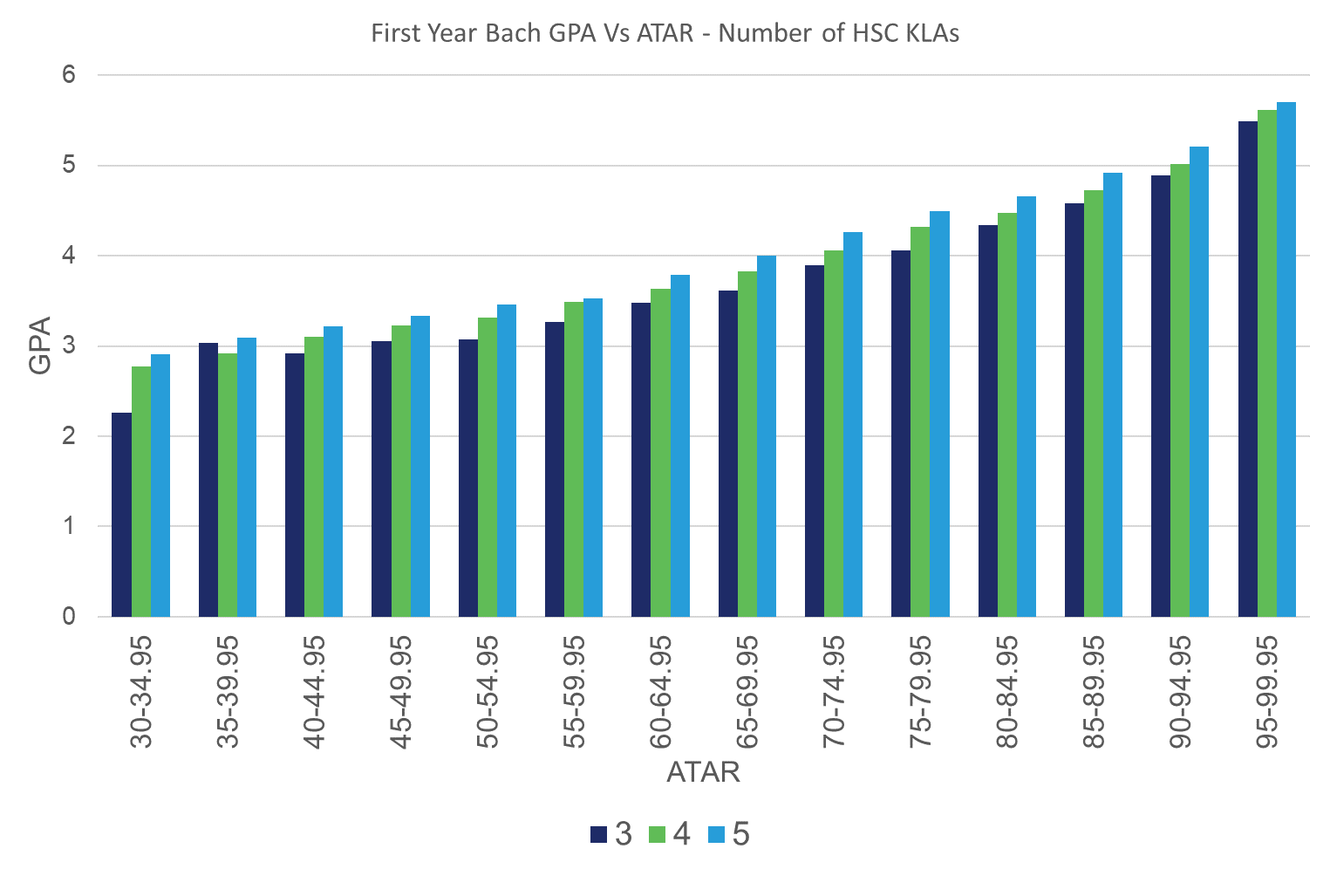

Figure 30: First-year non completion rate by ATAR of HSC students enrolled in a bachelor degree by number of KLAs.

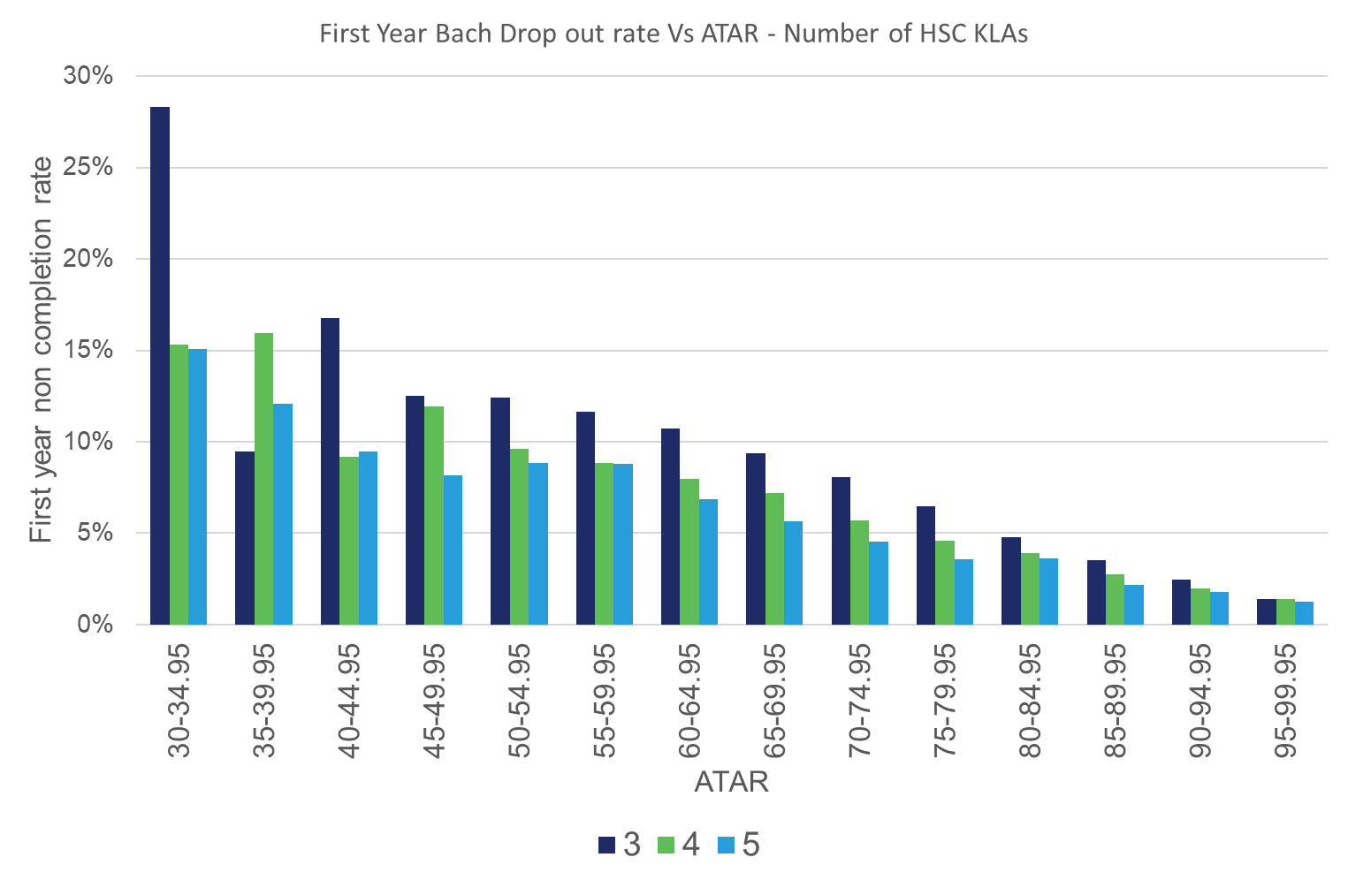

Figure 31: First-year pass everything rate by ATAR of HSC students enrolled in a bachelor degree by number of KLAs.

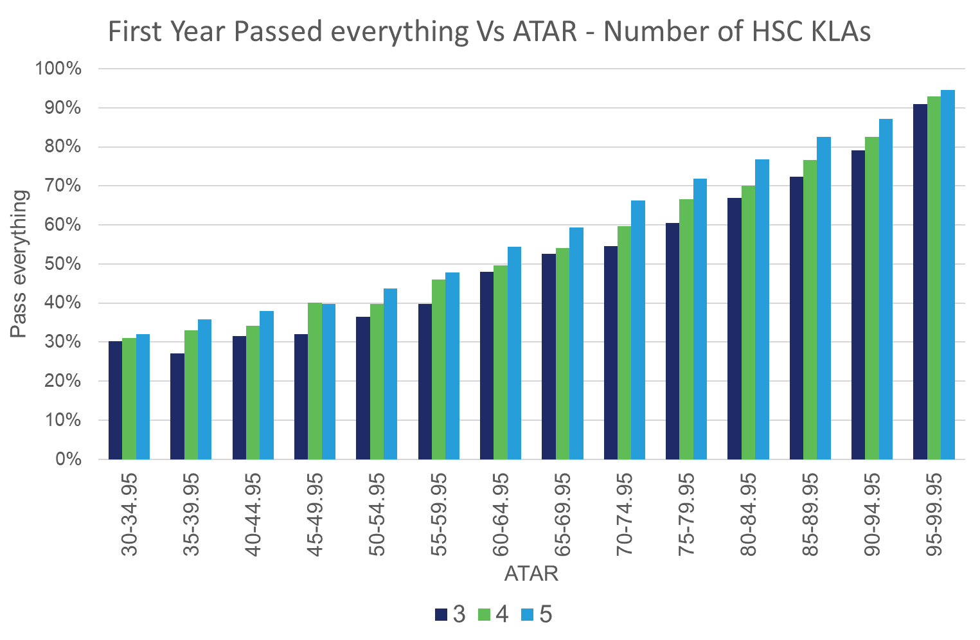

## Student self-selection

As discussed earlier in section 3.3.6, it appears many students tend to self-select a suitable university FOS based on the HSC subjects they studied, ie they study what they are good at or are interested in at both levels (A summary of the proportion of the top 50 HSC subjects studied by FOS can be found in Table 6 in the Appendix). Using this assumption, we were able to use machine learning techniques to identify several suitable university FOS (Focus FOS) that could be ‘recommended’ for a student based on their results and pattern of study undertaken for the HSC. As there are almost as many unique ATAR and HSC subject result combinations as there are HSC students, and many subjects are relevant for many university FOS, it is impossible to determine clear relationships between these variables without using machine learning. A more in-depth summary of the machine learning model and a list of the Focus FOS can be found in section 5.4 in the Appendix.

The machine learning model was able to make a recommendation of one of the Focus FOS to 36% of ATAR-eligible students after data cleansing. The Focus FOS covers 47.6% of all HSC students who enrolled at university from 2014–2018, which represents a significant coverage. Of the students who were able to be given a recommendation, 62.9% enrolled in the recommended FOS. The students who were able to be given a recommendation made up 41.3% of all HSC students who enrolled in the Focus FOS.

We found that HSC students who followed the machine learning recommendation had a slightly higher GPA than those who didn’t (Figure 32). The major difference in a student’s GPA is still explained by the ATAR, which is consistent with earlier findings. There was however a more significant benefit for those who followed the recommendation in terms of first-year completion (Figure 33). Students with lower ATARs were still more likely to leave university during their first year; in addition, students who enrolled in the Focus FOS without a machine learning recommendation were 42% more likely to ‘drop out’ of first-year university than those with a recommendation.

Figure 32: First-year GPA by ATAR of HSC students who did and didn't follow the FOS recommendation (Recommended FOS only included).

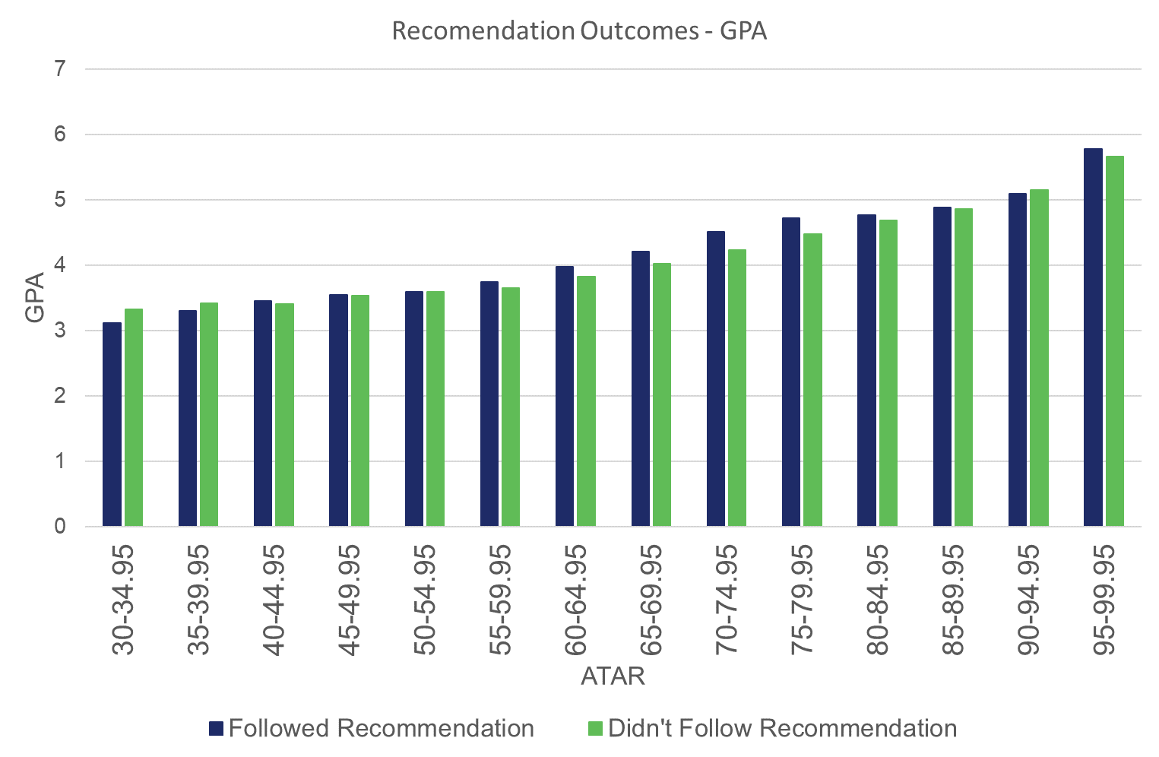

Figure 33: First-year non completion rate by ATAR of HSC students who did and didn't follow the FOS recommendation (recommended FOS only included).

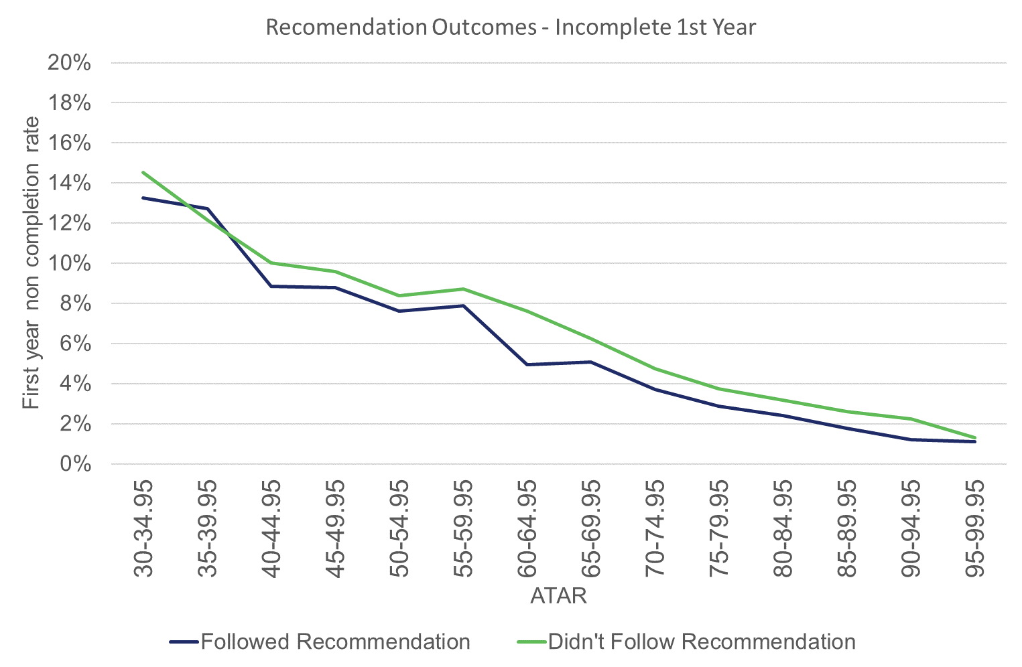

## The Gap Year

Whether to take a gap year between the HSC and university is very much a student’s personal decision and is often influenced by circumstances out of the student’s control. Unfortunately, the reasons for taking a gap year are not recorded for later analysis.

When comparing the first-year performance of HSC students from 2013–2016 who took a gap year before enrolling in a bachelor degree, compared with those who went straight on to university, there was a slight advantage in GPA for students who took a gap year across the ATAR bands (Figure 34). (Note: First-year results are not yet available for 2017 HSC gap year students.) Furthermore, the GPA was dependent on the ATAR even after a gap year, which is consistent with section 3.3 above. Students who took a gap year were slightly less likely to complete first year, particularly if they achieved higher ATARs (Figure 35).

It is impossible to say whether taking a gap year has a positive or negative effect for the student as other unknown circumstances may contribute to the student’s decision.

Figure 34: First-year GPA by ATAR of HSC students enrolled in a bachelor degree who took a gap year.

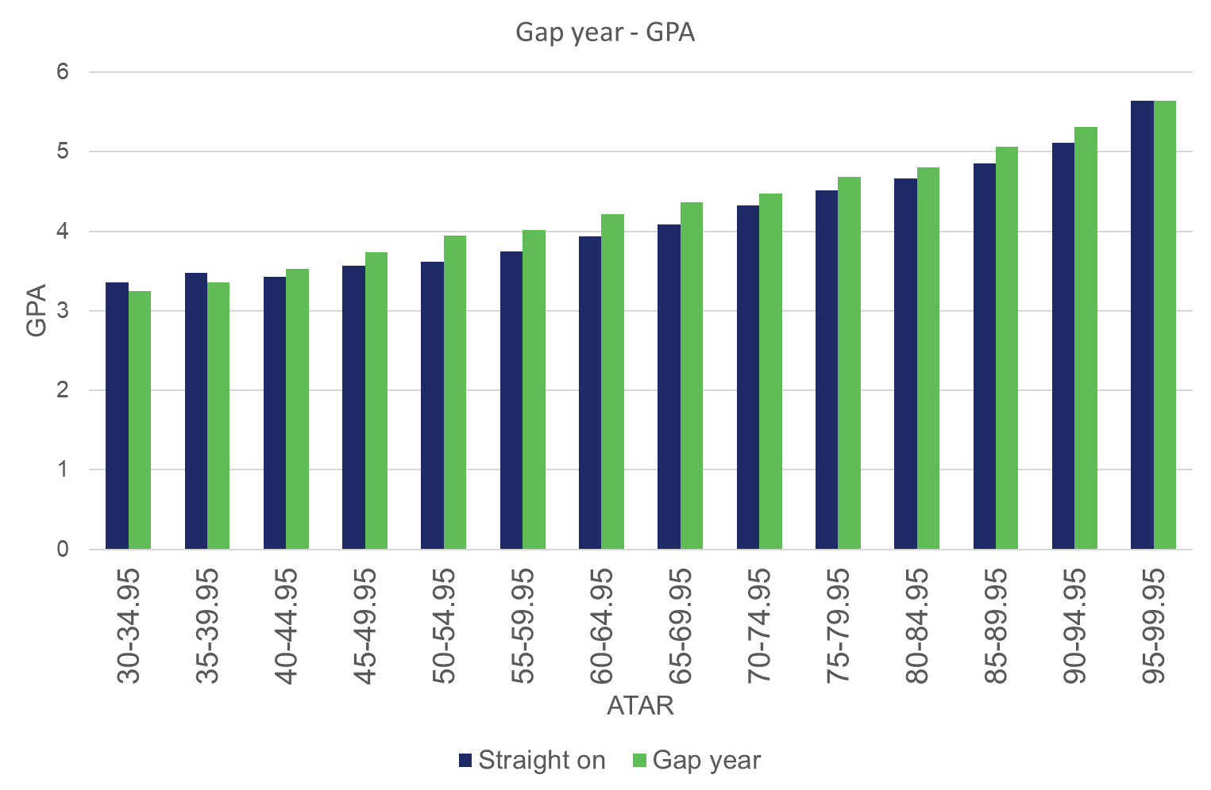

Figure 35: Incomplete first-year rate by ATAR of HSC students enrolled in a bachelor degree who took a gap year.

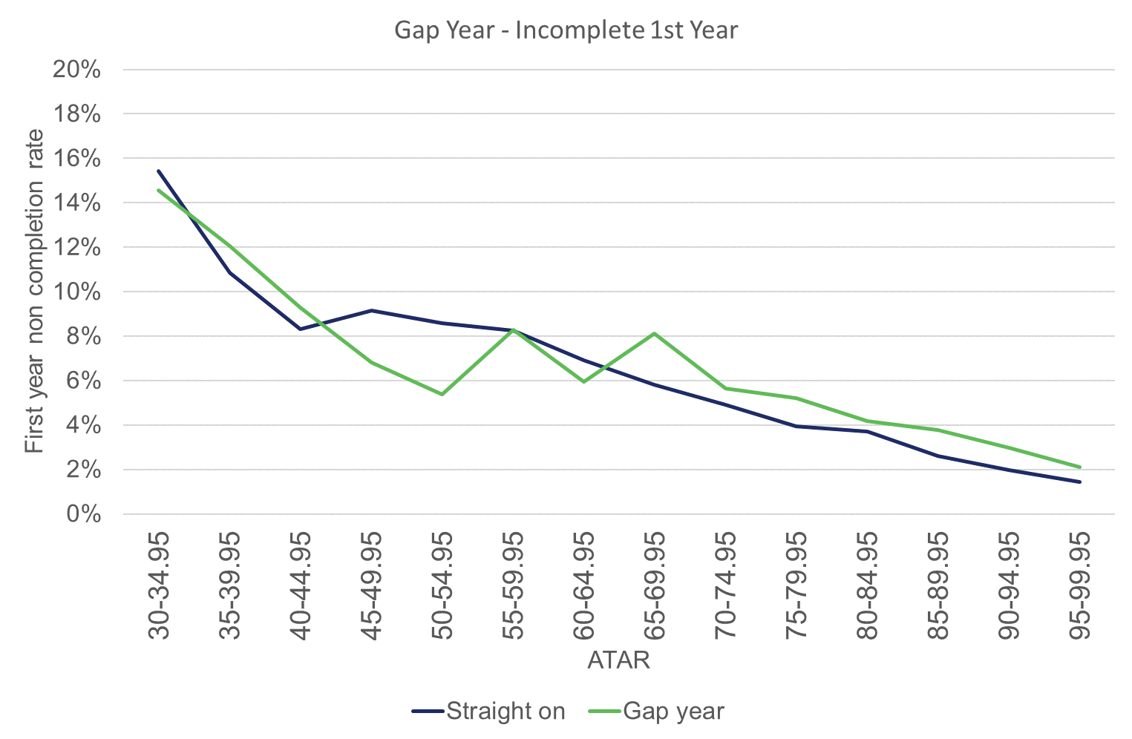

# Conclusions

Most HSC students tend to select subjects that align with their interests and academic ability, which generally provide appropriate preparation for university. While it is important to recognise that each student is unique, some senior secondary subject choices provide better preparation for certain tertiary Fields of Study (FOS) and for overall university success.

The ATAR is the most accurate available indicator of first-year university GPA and first-year non-completion. The ATAR was found to account for 21.5% of GPA variance. There are strong relationships between the ATAR achieved and certain HSC subjects due largely to student subject selection (ie high-ATAR students tend to select particular HSC subjects). Generally, once the ATAR has been accounted for there was only a small effect on GPA (less than 1%) attributable to subject selection.

The Natural and Physical Sciences and Engineering and Related Technologies FOS were found to have evidence of positive HSC subject selection effects.

We discovered that studying an HSC science subject reduced the chances of a (failing) GPA < 4, and slightly increased the average GPA, in first-year Natural and Physical Sciences degrees when compared to studying no HSC sciences subjects. These effects increased slightly if two or three HSC science subjects were studied.

Studying a mathematics subject with a calculus component reduced the chances of a failing GPA in first-year Engineering and Related Technologies degrees, and slightly increased the average GPA when compared with a student who studied HSC Mathematics without a calculus component (General Mathematics). We found no further advantage to studying higher levels of HSC mathematics.

In addition, we believe introducing a science prerequisite for Natural and Physical Sciences degrees and a prerequisite of mathematics with a calculus component for Engineering and Related Technologies degrees should be seriously considered.

Studying HSC subjects from a broad range of Key Learning Areas (KLAs) appears to be somewhat advantageous for a student’s first-year university GPA and first-year completion. We found that students with a higher ATAR tended to specialise, ie study subjects across a narrower range of HSC KLAs. It is unclear whether specialising results in a higher ATAR or studying HSC subjects across more KLAs results in a higher first-year university GPA.

Using machine learning, it was possible to recommend particular university FOS for many students based on HSC study pattern assuming that most students make appropriate study choices at HSC- and university-level. Students who followed this recommendation (ie selected an appropriate FOS for their HSC study pattern) achieved a slightly higher GPA but more significantly were less likely to ‘drop out’. We also found that students who select a level of mathematics beyond their capabilities, and choose university FOS unwisely, are more likely to receive a lower GPA and are at greater risk of ‘dropping out’ of university before completing their first year. These findings emphasise the importance of ensuring students select HSC subjects and university FOS that are complementary of each other and appropriate for them.

Students who took a gap year before enrolling in a bachelor degree were slightly less likely to complete first-year university, compared to students who went straight on to university. Furthermore, it is unclear whether the reasons for which students take a gap year (eg financial, medical or ‘to find yourself’) are, by first-year university, resolved, or persist and therefore contribute to non-completion. Finally, a student’s ATAR remains the dominant factor underlying first-year university GPA; however, students who took a gap year and ultimately completed first-year university, did so with a slightly higher GPA.

# Appendix

## Methodology for HSC subject to ATAR correlation analysis

Standard Pearson correlation coefficients were calculated in this section. These correlations are calculated for two sets of one-to-one result pairs occurring at the same time and indicate the strength of the linear relationship between them. In other words, a correlation of 1 means that given a value in one set, the corresponding value in the second set can be derived exactly. In turn, a correlation of 0 means that there is no linear relationship between values in the two sets.

It follows that these correlations are calculated between two groups of results. To ensure reliable results, correlations were not calculated for groups smaller than 50 results.

Final Year 12 results from ATAR-eligible students between 2013–2017 were selected and grouped at various levels for correlation calculations. Result pairing in these calculations occurred at the student level. If results belonging to specified groups were obtained by the same student in the same year, they were paired and used.

## Methodology for ATAR to GPA correlation analysis

The data used in this correlation analysis came from the HSC results of ATAR students from years 2013–2017 and their first-year GPA in a university bachelor degree course. Not all Year 12 students achieve an ATAR, and not all would continue to university in the year following Year 12. Therefore, the data only includes students who achieved an ATAR and went on to undertake a bachelor-level course at university in the year following Year 12 (ie from intake years 2014–2018), and for whom we have obtained GPA data for their first year of study in a university bachelor course.

Furthermore, the data only includes students who have enrolled in only one course during their first year at university and who have not withdrawn from the course (withdrawal is indicated by a zero value in study load). Students may enrol in more than one course during their first year at university, most likely because they decide to change their degree at some point during their first year. Each year, around 5% of students for which we have obtained GPA data belong in this category. These students have been removed from the dataset in our analyses, as it would not be possible to associate each GPA result with a single degree, and therefore single FOS (of that degree).

The final dataset consists of 118,362 recent school-leavers from intake years 2014–2018. The breakdown of sample size by intake year is shown in Table 4. All analyses in section 3.3 are based on this set of students.

Table 4: Descriptive statistics of students from each intake year, 2014–2018.

|  |  |  |  |  |  |  |
| --- | --- | --- | --- | --- | --- | --- |
|  | 2014 | 2015 | 2016 | 2017 | 2018 | Total |
| n | 24,415 | 25,861 | 23,525 | 21,678 | 22,883 | 118,362 |
| Mean ATAR | 78.53 | 78.25 | 77.69 | 79.02 | 79.66 | 78.61 |
| SD ATAR | 14.86 | 14.72 | 15.53 | 14.47 | 14.26 | 14.80 |
| Mean GPA | 4.39 | 4.46 | 4.45 | 4.52 | 4.59 | 4.48 |
| SD GPA | 1.48 | 1.49 | 1.53 | 1.55 | 1.53 | 1.52 |
| Pearson’s r (correlation between ATAR and GPA) | 0.454 | 0.474 | 0.435 | 0.467 | 0.492 | 0.464 |

## HSC subject selection and ATAR

As shown in Figures 36–38 below, there is a relationship between the ATAR, subject choices and the level of subjects studied. Figure 36 shows that students with higher ATARs tended to study higher levels of maths; 68% of students in the 95-99.95 ATAR range studied Mathematics Extension 1 or 2 compared to less than 10% of students with an ATAR below 75.

The public should not assume that taking certain subjects will lead to higher ATARs. This finding simply reflects that students of higher academic ability tend to choose certain subjects and choose to do higher levels of the subject.

Figure 36: Highest level of HSC mathematics studied by ATAR.

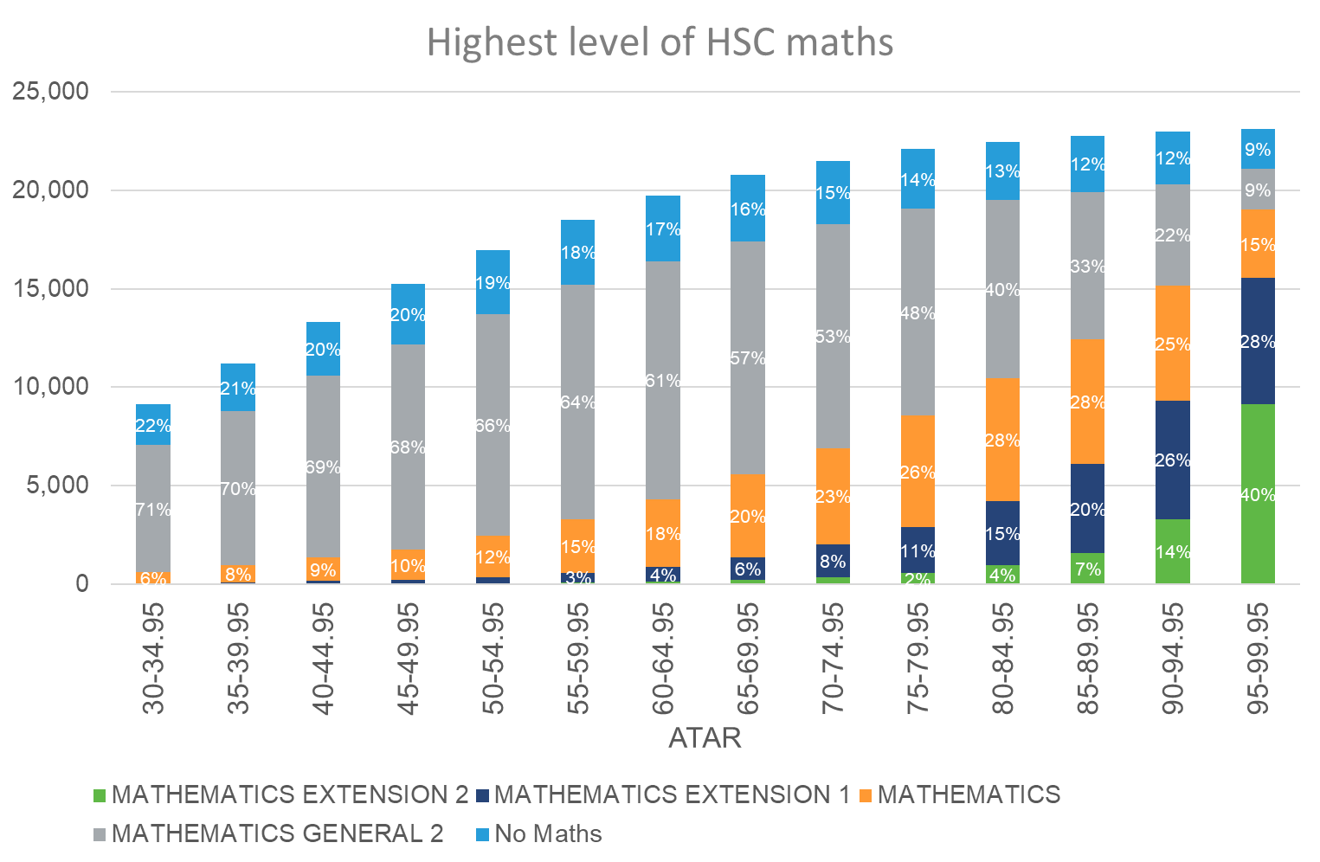

Figure 37 shows that students who achieved higher ATARs preferred to study higher levels of mathematics. HSC students who study Mathematics General 2 do not study any higher levels of mathematics whereas students who study Mathematics can choose to study Mathematics Extension 1 concurrently. As a result, Mathematics will include any student studying Mathematics Extension 1 as their highest level of maths.

Figure 37: Proportion of HSC students who study Mathematics vs Mathematics General 2 by ATAR.

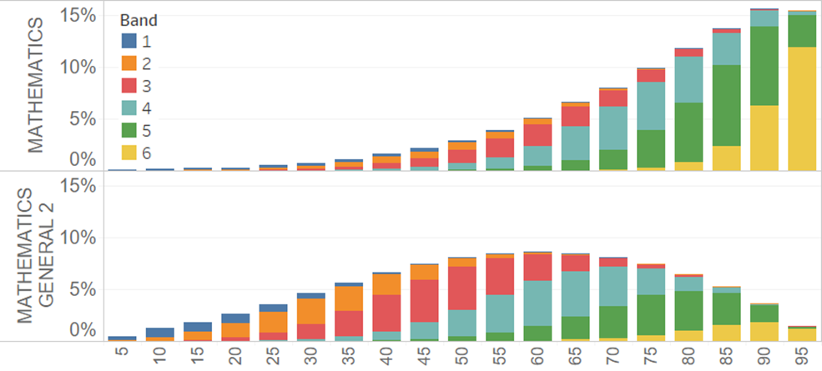

Similarly, Figure 38 shows that students who attained a higher ATAR also preferred to study higher levels of english – in this case English Advanced over its lower-level equivalent, English Standard.

Figure 38: Proportion of HSC students who study English Advanced vs English Standard by ATAR.

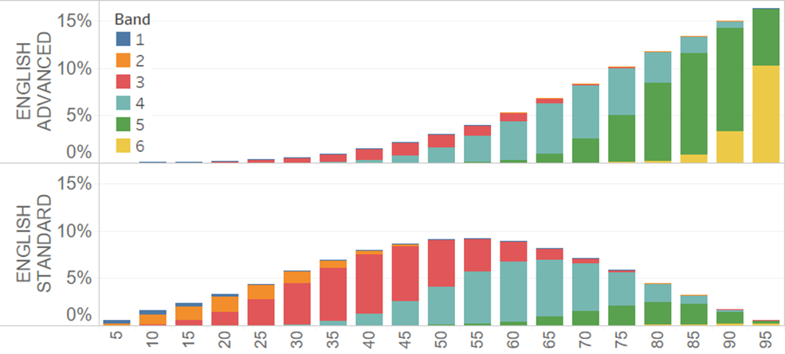

## Summary of the machine learning model

The model is built using machine learning technique, more specifically, an Artificial Neural Network (ANN) based on the five years of Year 12 students’ data (2013–2017).

The model considers the following parameters from an HSC student:

* HSC subjects studied
* scores of individual HSC subjects
* ATAR.

Considering the limitation of the data available, the characteristics of different FOS, and the performance of the model, the system was defined to suggest one or more FOS from the following Focus FOS (FOS code):

* Biological Sciences (109)
* Medical Science (19901)
* Information Technology (2)
* Engineering and Related Technologies (3)
* Architecture and Building (4)
* Agriculture, Environmental and Related Studies (5)
* General Nursing (60301)
* Human Movement (69903)
* Business and Management (803)
* Law (909)
* Economics (91901)
* Creative Arts (10)
* Communication and Media Studies (1007).

Some FOS had to be excluded from the model as no clear pattern of HSC study could be linked to the choice of that FOS due to its general nature. Education, for example, encompasses multiple other FOS under the one FOS (teachers may specialise in one area of teaching).

In our study, we use the actual offer received by the students as the label of the input during the training approach. The assumption behind this setting is that most students will make a reasonable choice on their preference of university courses according to their situation. On the other hand, the institutions make offers to students based on similar logic in the recent five-year period. The decision was made to train the model on offers rather than enrolments, as offers gave a broader base of parameters because not all students enrolled.

Once the data was loaded, it was split into two parts – 90% of the data was used for training the model, while the other 10% was kept for testing purpose. The sample size varied greatly across the different FOS data, and for this reason, some cases had to be removed or repeated to balance the sample size of all FOS.

The training process uses a classical three-layers ANN model. The inputs of the model are the features generated from the original dataset, whereas the output layer contains the same number of neurons as the number of FOS we are going to predict. The training process is done by Keras package with Tensorflow at the backend.

The model was evaluated on the 2015 HSC student data and their first-year (2016) GPA data, which consisted of 11,242 student records. In this, the GPA and completion rate were compared between two groups of students, the ‘same’ and ‘different’ groups. The ‘same’ group were students who studied a course which was recommended by the model (either as top 1, 2, or 3 of its recommendations), and the ‘different’ group were those who studied a course not recommended by the model. Here, the ‘same’ group outperformed the ‘different’ group students by around 3% to 6% on average GPA and first-year completion rate.

There is still some limitation on this model. Firstly, it only recommends 13 specific FOS. Some major FOS, such as Psychology and Education are not covered by the current model. Institution information is not considered during the recommendation approach; hence, the model is only able to recommend FOS rather than actual courses. Future work could improve the model to handle university information to allow recommendations for specific courses. Due to the limitation of the data, we only used students’ HSC study performance for the recommendation. Some important factors, such as personal interests, were also not considered in this model.

## Miscellaneous Tables

Correlations shown in Table 5 are calculated for the same result pairs as described for Figure 17. In Table 5, subjects are matched to those with which its HSC subject marks have the highest correlation; this is called ‘Strongest Correlation’. ‘Potential Matches’ is the count of subjects for which correlations were evaluated to find the Closest Match; subjects with less than five Potential Matches were excluded from the table. ‘Correlation’ is the correlation for the Closest Match. ‘Student with both results’ is the count of result pairs used to derive correlation for the Closest Match. The range of correlations for Closest Match is 0.55 to 0.92.

Matches from Table 1 could be used for suggesting additional subject choice, although this may lead to student specialisation. Students who are aware of their strengths in one or more subjects could consider doing an additional subject in which results most closely correlate with these strengths. This approach to subject choice would tend to optimise overall results for each student. There are three potential opportunities for further research on this point:

* expand Table 1 to show two or more most strongly correlated matches
* design an algorithm for clustering subjects by how strongly their results correlate for suggesting subject choices within these clusters
* correlations offer on-average subject suggestions, but this approach may not be appropriate for all students, especially those performing at the top of subject. Explore other methods to augment subject suggestions by considering the actual level of student performance in their areas of strength.

Table 5: HSC subject matches by highest correlation 2013–2017.



Table 5 continued: HSC subject matches by highest correlation 2013–2017.



Table 5 continued: HSC subject matches by highest correlation 2013–2017.



The proportion of the top 50 HSC subjects studied (2013–2017) by FOS (2014–2018) are shown below in Table 6. The difference in the rate of HSC subjects studied by students who go on to enrol in a bachelor degree by FOS verses all ATAR-eligible HSC students highlights the large variation in the patterns of study of HSC students, even within a given FOS.

Table 6: The proportion of the top 50 HSC subject (2013–2017) studied by FOS.



Table 6 continued: The proportion of the top 50 HSC subject (2013–2017) studied by FOS.



DATA ANALYSIS: THE IMPACT OF SENIOR SECONDARY STUDY CHOICES ON SUCCESS AT UNIVERSITY

© 2019 Universities Admissions Centre (NSW & ACT) Pty Ltd  
UAC is the owner of the copyright in this document.

Apart from any fair dealing for the purpose of private study, criticism or review, or otherwise as permitted under the Copyright Act, no part may be reproduced by any process without UAC’s written permission. Enquiries should be addressed to the Managing Director, UAC.

1. <https://www.theage.com.au/national/victoria/chief-scientist-says-obsession-with-atar-is-leading-students-astray-20190812-p52gda.html>
2. <https://www.theage.com.au/national/victoria/chief-scientist-says-obsession-with-atar-is-leading-students-astray-20190812-p52gda.html>
3. <https://grattan.edu.au/wp-content/uploads/2018/04/904-dropping-out-the-benefits-and-costs-of-trying-university.pdf>
4. <https://www.uac.edu.au/future-applicants/admission-criteria/tertiary-qualifications>
5. [https://educationstandards.nsw.edu.au](https://educationstandards.nsw.edu.au/)
6. <https://educationstandards.nsw.edu.au/wps/portal/nesa/11-12/hsc/about-HSC/determining-HSC-results>
7. Harrison, K.J., & Hyndman, R.J. (2015). Modelling the participation function with a one-parameter family of cubic splines.
8. <https://www.uac.edu.au/media-centre/statistics>
9. <https://www.uac.edu.au/future-applicants/admission-criteria>
10. <https://educationstandards.nsw.edu.au/wps/portal/nesa/11-12/stage-6-learning-areas>
11. ASCED definition <https://heimshelp.education.gov.au/resources/field-of-education-types>
12. <https://educationstandards.nsw.edu.au/wps/portal/nesa/11-12/hsc/about-HSC/determining-HSC-results>
13. <https://www.educationstandards.nsw.edu.au/wps/portal/nesa/11-12/stage-6-learning-areas/stage-6-mathematics/course-descriptions>
14. McKenzie, K. & Schweitzer, R. (2001). Who Succeeds at University? Factors predicting academic performance in first year Australian university students, Higher Education Research & Development, 20:1, 21-33.
15. Where Group 1 studied Mathematics Extension 2, achieved an ATAR < 90 and a GPA < 4; and Group 2 studied Mathematics Extension 1, achieved an ATAR < 70 and a GPA < 4.
16. Baik, C., Naylor, R. & Arkoudis, S. (2015). The first year experience in Australian universities: Findings from two decades. 1994-2014, Centre for the Study of Higher Education, The University of Melbourne.Baik, C., Naylor, R., Arkoudis, S. & Dabrowski, A. (2019) Examining the experiences of first-year students with low tertiary admission scores in Australian universities, Studies in Higher Education, 44:3, 526-538.
17. Norton, A., Cherastidtham, I., & Mackey, W. (2018). Dropping out: The benefits and costs of trying university. Grattan Institute.
18. Improving retention, completion and success in higher education (2017). Higher Education Standards Panel Discussion Paper.
19. <https://www.uac.edu.au/media-centre/publications/report-on-the-scaling-of-the-2018-nsw-higher-school-certificate>
20. Calderon, A. J., Dobson, I. R., & Wentworth, N. (2000). Recipe for Success: Year 12 Subject Choice and the Transition from School to University. Journal of Institutional Research, 9(1), 111–123.
21. Cooney, G. (2001). The Tertiary Entrance Rank – an Endangered Species?
22. Evans (2000). Planning for the transition to tertiary study: A literature review. Journal of Institutional Research, v.9, no.1, p.1-13.
23. Improving retention, completion and success in higher education. Higher Education Standards Panel Discussion Paper, June 2017.