

|  |
| --- |
| PR-03P How to review and submit a Performance Report |

Use when: You need to review and submit a Performance Report

Menu: [Performance](https://indigo.deewr.gov.au/Controller.aspx) Reporting

|  |
| --- |
| Before You Begin |

You will need Provider ‘Review and Submit’ access in order to review and submit Performance Reports. If you do not have this access and require it, please contact the INDIGO Help Desk (see help desk contact information).

A Performance Report can only be reviewed when all data has been entered and the report status is:

* ‘Ready to Submit to DEEWR’ or
* ‘Ready to Submit to Independent Indigenous Representative’ (IIR) – this only applies for Supplementary Recurrent Assistance (SRA and SRA-VET)

If the Performance Report requires amendment, the report will have to be returned to ‘Draft**’** status by selecting the ‘re-draft’ option when submitting the report.

The Performance Report contains two main sections, ‘Question responses’ and ‘Part Details’:

* **Question responses** – show the responses entered into INDIGO for the Performance Indicators and Evaluation Questions
* **Part Details** – shows the results for that Performance Indicator in the context of the Baseline/Previous Results and the Target for that reporting period.

If you attempt to exit the **Performance Report** the following message will appear:

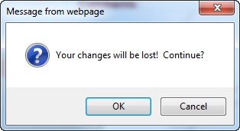

If you have not made any changes since you last saved data, click the  button to go to the **INDIGO** **Home** screen, otherwise click  to return to the **Performance Reporting** pod.

|  |
| --- |
| Process Flow |

1. Open the Performance Report
2. Review the Performance Report
3. Add/Edit a Comment (optional)
4. Submit the Performance Report
   1. Submit for re-draft
   2. Submit to IIR (SRA Only)
   3. Submit to the department

|  |
| --- |
| Open the Performance Report |

1. Open the [INDIGO](https://indigo.deewr.gov.au/) website: <https://indigo.deewr.gov.au/>

**RESULT: INDIGO** website is displayed.

1. Enter your Logon ID and Password and click the  button

**RESULT**: The **INDIGO Home** screendisplayed. The **Performance Reporting** pod will list all of the Performance Reports (that you have access to) that are due within the next year.

**NOTE:** The Performance Reporting pod displays useful information including the Due Date of the Performance Report, Provider Name, Schedule/Initiative Name, Schedule/Initiative ID, Performance Report Status, Programme Element Name and the Action that you can perform.

1. After you have logged into INDIGO successfully, click the link in the Action column for the Performance Report you wish to open (e.g. **Review and Submit to DEEWR** or **Review and Submit to IIR**)

**RESULT**: The **INDIGO Online Performance Reporting** screen is displayed.

**TIP:** If the action available is **Begin**, **Continue** or **View**, the report is not yet 100 % complete

|  |
| --- |
| Review the Performance Report |

* 1. To navigate to a different Outcome Area, click on that Outcome Area’s name

**RESULT**: The selected Outcome Area’s Performance Indicators are displayed and the details of the first Performance Indicator are displayed in the lower half of the screen.

* 1. To navigate to a different Performance Indicator, click on that Performance Indicator’s name

**RESULT:** Details of the selected Performance Indicator are displayed in the **Question responses** section.

**NOTE:** You can navigate between the **Question responses** and **Part Details** tabs

**TIP**: To return to the **INDIGO Home** screen and its **Performance Reporting** pod, click either the **Return** or **Home** link at the top of the page

|  |
| --- |
| Add/Edit a Comment (Optional) |

**NOTE:** If you wish to add a comment, you have the option of selecting whether the comment relates to the report as a whole or to a particular Sector, Outcome Area or Performance Indicator.

**TIP:** If no comments are to be entered, proceed to **Step 4** to submit the report.

* 1. If you wish to comment on a particular aspect of the report, select ‘Sector’, ‘Outcome Area’, or ‘Performance Indicator’ from the Comments dropdown at the top right of the screen and click the  button

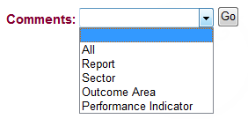

* 1. To add a new comment:

1. Click the  button
2. **RESULT**: A pop-up window will open containing a text editor

**TIP:** The heading section will indicate the context for the comment:

* **Comment Level** – the aspect of the report to which the comment relates e.g. “Outcome Area”
* **User** – your name
* **Date** – the date and time you made/are making this comment
* **Level Name** – name of the selected Sector, Outcome Area or Performance Indicator
* **Role** – the role you are performing when making this comment e.g. “Provider Internal Review”

You can use the text editor functions to format the comment text or include tables of additional data.

1. Enter your comment and click the  button (or click **Close** to cancel without saving)

**RESULT:** The comment is saved and the list of previously entered comments is displayed

* 1. To edit your comment:

1. Click the **more** link next to the text of your comment

**RESULT**: A pop-up window will open containing your comment in the text editor

**NOTE:** Clicking the  button from this screen will create a separate comment for the same Comment Level and Level Name combination as the displayed comment.

1. Edit your comment and click the  button (or to cancel the comment without saving and return to the **Comments** list pop up screen, click the **Close** link)

**RESULT:** The comment is saved and the list of previously entered comments is displayed

**NOTE:** You can change your own comment as long as the status of the Performance Report has not changed since you entered that comment (e.g. status is still **Ready to Submit to DEEWR**). You may not modify another user’s comments.

|  |
| --- |
| Submit the Performance Report |

* 1. To submit the performance report, complete the following:
  2. Click the **Click here to submit to DEEWR or re-draft this report** or **Click here to submit to IIR or re-draft this report** link.

**RESULT**: A new window will open to the ‘Comments’ tab, displaying any previously entered comments.

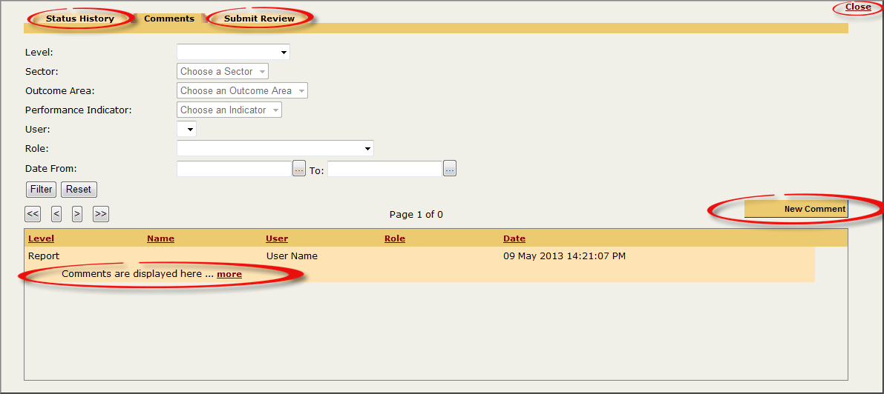

**TIP:** You may enter a comment before submitting the report by clicking the  button (see Step 3). This is not mandatory.

**NOTE:** If any comments have been entered previously, you can view them by clicking the **more** link. You can filter the list of comments by Report Level, Sector, Outcome Area, Performance Indicator, User, Role and Date From/To.

**NOTE:** To view the Performance Report’s status history, click the ‘Status History’ tab.

* 1. Click the **Submit Review** tab at the top of the screen

**RESULT**: The **Submit this report for DEEWR Officer Review** screen (or, for SRA and SRA-VET, the **Submit this report for Independent Indigenous Representative review** screen) will be displayed.

* 1. Choose the submission decision:
  + To **re-draft** the report, go to **Step 4.A**
  + To submit the report to the **Independent Indigenous Representative**, go to **Step 4.B** (SRA and SRA-VET only)
  + To submit to the **department**, go to**Step 4.C**

|  |
| --- |
| 4.A SubMIT FOR RE-DRAFT |

* Enter the details to submit the report for re-drafting:
  + Tick the box  to confirm that you have reviewed the Performance Report
  + Click the Recommendation drop down box and select the 're-draft’ option
  + Click the  button to submit the report (or click **Close** to cancel submitting the report and return to the **INDIGO Online Performance Reporting** screen)

**RESULT**: The Performance Report is successfully submitted and the report’s status changes to ‘**Draft**’. The **INDIGO Home** screen and **Performance Reporting** pod will be displayed.

|  |
| --- |
| 4.b SubMIT to iir (sra only) |

* Enter the details to submit the report to the IIR:
  + Tick the  box to confirm that you have reviewed the Performance Report
  + Click the Recommendation drop down box and select the ‘submit performance report to IIR’ option
  + Click the button to submit the report (or to cancel submitting the report and return to the **INDIGO Online Performance Reporting** screen, click the **Close** link)

**RESULT**: The Performance Report is successfully submitted and the report’s status changes to ‘**Awaiting IIR Review**.’ The **INDIGO Home** screen and **Performance Reporting** pod will be displayed.

**NOTE**: An email notification will be sent to the user(s) with ‘Independent Indigenous Representative Review**’** access for your organisation to alert them that the report is awaiting their review. When the report is reviewed and submitted by the IIR, an email notification will be sent to you (as the Provider user with ‘Provider Review and Submit’ access). The report may be returned with a recommendation of **‘requires further attention’** or ‘**ready to submit’** to the department. If required, the Performance Report can be returned to draft status (Step 4) to amend the report and incorporate any comments made by the IIR.

|  |
| --- |
| 4.c SubMIT to the department |

* To submit the report to the department:
  + Tick the  box to confirm that you have reviewed the Performance Report
  + Click the Recommendation drop down box and select the **‘submit performance report to DEEWR’** option
  + Click the button to submit the report (or click **Close** to cancel submitting the report and return to the **INDIGO Online Performance Reporting** screen)

**RESULT**: The **Performance Report Submit Confirmation** pop up box will open.

* To certify that the information contained in the Performance Report is true, accurate and complete, click the  button. If you disagree, select the  button.

**RESULT**:

* + If ‘I Accept’ was selected, a PDF copy of the ‘Provider’s Declaration’ will be generated for you to print or save. A PDF copy of the ‘All Provider View’ of the report will also be generated in the background. The Performance Report status changes to ‘Awaiting DEEWR Officer Review’. The **INDIGO Home** screen and **Performance Reporting** pod will be displayed.
  + If ‘I Decline’ was selected, you will return to the **Comment** screen.

**NOTE:** A copy of the **Provider’s Declaration** should be signed and saved on file as a record.

**TIP:** You can subsequently access the PDF versions of the report or declaration document from the **INDIGO Online Performance Reporting** screen:

* + From the **Print** drop down list, select the ‘**Submission History**’ option

**RESULT:** The **Submission Historical Listing** pop up box will open.

* + To view the report or declaration, click the **view report** link or **view declaration** link

**RESULT:** A File Download pop up box will open. To save or open the document, or to cancel the file download, click the respective buttons.

|  |
| --- |
| Possible Next Steps |

**PR-04P How to complete the IIR Review of a Performance Report**

|  |
| --- |
| Further Information |

For further assistance contact the INDIGO Help Desk:

Phone: 02 6240 8852

Fax: 02 6123 7995

Email: [indigohelpdesk@deewr.gov.au](mailto:indigohelpdesk@deewr.gov.au)