

|  |
| --- |
| PR-02P How to enter Performance Report data |

Use when: You need to enter Performance Report data

Menu: [Performance](https://indigo.deewr.gov.au/Controller.aspx) Reporting

|  |
| --- |
| Before You Begin |

Data may only be entered into a Performance Report if you have ‘Data Entry’ access and the report is in ‘Draft’ status. If you do not have this access and require it, please contact the INDIGO Help Desk (see help desk contact information).

As data is entered into the Performance Report, a percentage indicator at the top of the screen shows the percentage of the report that has been completed. The report can be submitted for internal review only when it is 100% complete. A banner stating ‘**This report may now be submitted for Provider internal review**’ will be displayed when the report is 100% complete.

If you attempt to exit the **Performance Report** the following message will appear:

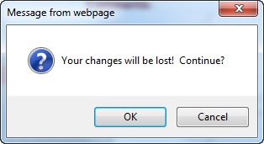

If you have not made any changes since you last saved data, click the  button to go to the **INDIGO** **Home** screen, otherwise click  to return to the **Performance Reporting** pod.

|  |
| --- |
| Path of a Performance Report |

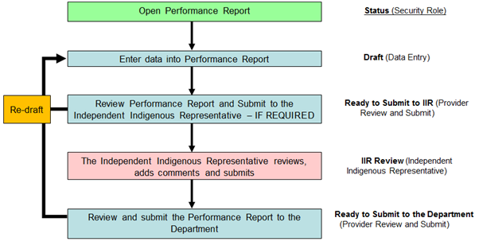

|  |
| --- |
| Process Flow |

1. Open the Performance Report
2. Enter the Performance Report Data
3. Add/Edit a Comment
4. Submit the Performance Report for Internal Review

|  |
| --- |
| Open the Performance Report |

1. Open the [INDIGO](https://indigo.deewr.gov.au/) website: <https://indigo.deewr.gov.au/>

**RESULT: INDIGO** website is displayed.

1. Enter your Logon ID and Password and click the  button

**RESULT**: The **INDIGO Home** screendisplayed. The **Performance Reporting** pod will list all of Performance Reports (that you have access to) that are due within the next twelve months.

**NOTE:** The *Performance Reporting* pod displays useful information including the Due Date of the Performance Report, Provider Name, Schedule/Initiative Name, Schedule/Initiative ID, Performance Report Status, Programme Element Name and the Action that you can perform.

1. After you have logged into INDIGO successfully, click the link in the Action column (e.g. **Begin** or **Resume**)

**RESULT**: The **INDIGO Online Performance Reporting** screen is displayed.

**NOTE**: The action available will be **Begin** if no data has been entered into the Performance Report and **Resume** if some data has been entered previously.

**TIP:** If the status is **‘**Draft’ or ‘Not Started’ but the action available is **View**, you do not have ‘Data Entry’ access and cannot enter data into the Performance Report.

|  |
| --- |
| Enter the Performance Report Data |

* 1. Click on the Outcome Area for which you wish to enter data

**RESULT**: The selected Outcome Area’s Performance Indicator(s) are displayed and the details of the first Performance Indicator appear in in the lower half of the screen.

**NOTE**: The Performance Indicators may require a rating (click on the drop down box and select one of the options available), qualitative responses (i.e. written text) and/or numeric responses.

* 1. To save any information that you have entered, click the  button (at the bottom of the screen)

**RESULT**: The selected Performance Indicator is saved.

* 1. Repeat the above data entry steps for each Outcome Area and Performance Indicator displayed in the Performance Report

**TIP**: To navigate to a different Outcome Area or Performance Indicator, select the Outcome Area or the Performance Indicator by clicking on the Performance Indicator’s name.

**NOTE:** A green tick will appear against the Performance Indicator when all questions are completed. A green tick will appear against the Outcome Area when all Performance Indicators for that Outcome Area is completed. The percentage indicator at the top of the screen also shows what percentage of the report is completed.

* 1. When responses have been entered for each Outcome Area and Performance Indicator, the report is 100% complete and ready to be submitted for internal review

**RESULT:** A banner stating ‘**This report may now be submitted for Provider internal review**’ will be displayed in the middle of the screen.

|  |
| --- |
| Add/Edit a Comment |

**NOTE:** If you wish to add a comment, you have the option of selecting whether the comment relates to the report as a whole or to a particular Sector, Outcome Area or Performance Indicator.

**TIP:** If no comments are to be entered, proceed to **Step 4** to submit the report.

* 1. If you wish to comment on a particular aspect of the report, select ‘Sector’, ‘Outcome Area’, or ‘Performance Indicator’ from the Comments dropdown at the top right of the screen and click the  button:

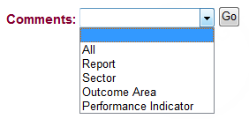

* 1. To add a new comment:

1. Click the  button

**RESULT**: A pop-up window will open containing a text editor

**TIP:** The heading section will indicate the context for the comment:

* **Comment Level** – the aspect of the report to which the comment relates e.g. ‘Outcome Area’
* **User** – your name
* **Date** – the date and time you made/are making this comment
* **Level Name** – name of the selected Sector, Outcome Area or Performance Indicator
* **Role** – the role you are performing when making this comment e.g. ’IIR Review’

You can use the text editor functions to format the comment text or include tables of additional data.

1. Enter your comment and click the  button (or click **Close** to cancel without saving)

**RESULT:** The comment is saved and the list of previously entered comments is displayed

* 1. To edit your comment:

1. Click the **more** link next to the text of your comment

**RESULT**: A pop-up window will open containing your comment in the text editor

**NOTE:** Clicking the  button from this screen will create a separate comment for the same Comment Level and Level Name combination as the displayed comment.

1. Edit your comment and click the  button (or to cancel the comment without saving and return to the **Comments** list pop up screen, click the **Close** link)

**RESULT:** The comment is saved and the list of previously entered comments is displayed

**NOTE:** You can change your own comment as long as the status of the Performance Report has not changed since you entered that comment (e.g. status is still Draft). You cannot modify another user’s comments.

|  |
| --- |
| Submit the Performance Report for Internal Review |

* 1. To submit the performance report for Internal Provider Review, complete the following:
  2. Click the ‘**Click here to submit this report**’ link

**RESULT**: A new window will open to the ‘Comments’ tab, displaying any previously entered comments.

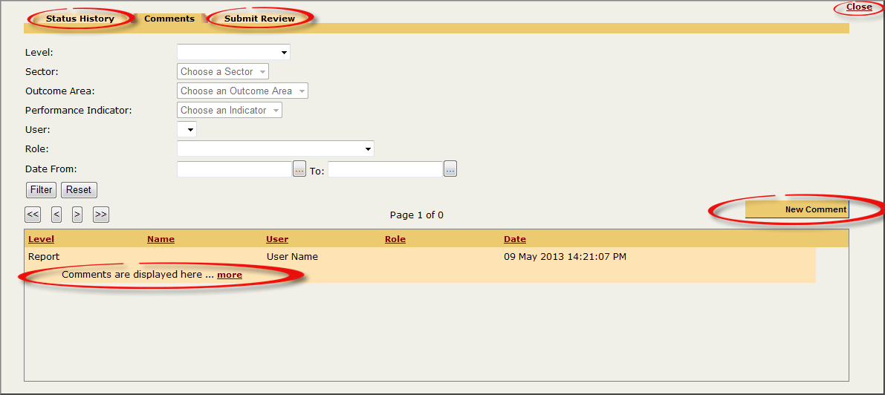

**NOTE:** If any comments have been entered previously, you can view them by clicking the **more** link. You can filter the list of comments by Report Level, Sector, Outcome Area, Performance Indicator, User, Role and Date From/To.

**NOTE:** To view the Performance Report’s status history, click the ‘Status History’ tab.

* 1. Click the **Submit Review** tab at the top of the screen

**RESULT**: The **Submit this report for internal Review** screen will be displayed

* 1. Click the  button to submit the report (or click **Close** to cancel submitting the report and return to the **INDIGO Online Performance Reporting** screen)

**RESULT**: The Performance Report is successfully submitted and the report’s status changes to ‘**Ready to Submit to IIR**’ (only if the IIR step is required) or ‘**Ready to Submit to DEEWR**’. The **Performance Reporting** pod will be displayed.

|  |
| --- |
| Possible Next Steps |

**PR-03P How to review and submit a Performance Report**

|  |
| --- |
| Further Information |

For further assistance contact the INDIGO Help Desk:

Phone: 02 6240 8852

Fax: 02 6123 7995

Email: [indigohelpdesk@deewr.gov.au](mailto:indigohelpdesk@deewr.gov.au)