

|  |
| --- |
| PR-04P How to complete the IIR Review of a Performance Report |

Use when: You need to review a Performance Report as the Independent Indigenous Representative

Menu: [Performance](https://indigo.deewr.gov.au/Controller.aspx) Reporting

|  |
| --- |
| Before You Begin |

Only Performance Reports for the **Supplementary Recurrent Assistance** programmes (SRA and SRA-VET) need to be reviewed by an **Independent Indigenous Representative** (IIR). The report must be at a status of **Awaiting IIR Review**.

You will need **Independent Indigenous Representative Review** access to review the Performance Reports as an IIR Reviewer. If you do not have this access and require it, please contact the INDIGO Help Desk (see help desk contact information).

The Performance Report contains two main sections, **‘Question responses’** and **‘Part Details’**.

* **Question responses** – show the responses entered into INDIGO for the Performance Indicators and Evaluation Questions
* **Part Details** – shows the results for that Performance Indicator in the context of the Baseline/Previous Results and the Target for that reporting period.

If you attempt to exit the **Performance Report** the following message will appear:

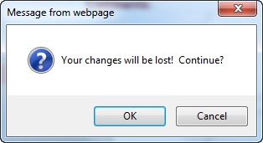

If you have not made any changes since you last saved data, click the  button to return to the **Performance Reporting** pod, otherwise click  to return to the **Performance Reporting** pod.

|  |
| --- |
| Process Flow |

1. Logon to INDIGO
2. Open the Performance Report
3. Review the Performance Report
4. Add/Edit a Comment
5. Submit the Performance Report

|  |
| --- |
| Logon to INDIGO |

1. Open the [INDIGO](https://indigo.deewr.gov.au/) website: <https://indigo.deewr.gov.au/>

**RESULT: INDIGO** webpage is displayed.

1. Enter your Logon ID and Password and click the  button

**RESULT**: The **INDIGO Home** screendisplayed. The **Performance Reporting** pod will list all Performance Reports that you have access to that are due within the twelve months.

**NOTE:** The *Performance Reporting* pod displays useful information including the Due Date of the Performance Report, Provider Name, Schedule/Initiative Name, Schedule/Initiative ID, Performance Report Status, Programme Element Name and the Action that you can perform.

|  |
| --- |
| Open the Performance Report |

1. To open a Performance Report, click the link in the Action column(e.g. **Review**)

**RESULT:** The **INDIGO Online Performance Reporting** screen is displayed.

**TIP:** If the action available is **View**, the report has not been submitted for IIR review or you do not have the required level of access. In this case you will be able to view the report, but cannot progress it further.

Performance Reports are displayed on the Performance Reporting screen in the following three tabs:

* ***Due Now*** – Performance Reports that are either overdue or due within the next 45 days
* ***Due Later*** – Performance Reports that are due between 46 days and one year into the future
* ***Submitted*** – Performance Reports that have been submitted to the Department for consideration or have been accepted by the Department

|  |
| --- |
| Review the Performance Report |

* 1. To navigate to a different Outcome Area, click on that Outcome Area’s name

**RESULT:** The selected Outcome Area’s Performance Indicators are displayed and the details of the first Performance Indicator are displayed in the lower half of the screen.

* 1. To navigate to a different Performance Indicator, click on that Performance Indicator’s name

**RESULT:** Details of the selected Performance Indicator are displayed in the **Question responses** section.

**NOTE:** You can navigate between the **Question responses** and **Part Details** tabs.

**TIP:** To return to the **INDIGO Home** screen and its **Performance Reporting** pod, click either the **Return** or **Home** link at the top of the page

|  |
| --- |
| Add/Edit a Comment |

**NOTE:** If you wish to add a comment, you have the option of selecting whether the comment relates to the report as a whole or to a particular Sector, Outcome Area or Performance Indicator.

* 1. If you wish to comment on a particular aspect of the report, select ‘Sector’, ‘Outcome Area’, or ‘Performance Indicator’ from the Comments dropdown at the top right of the screen and click the  button:

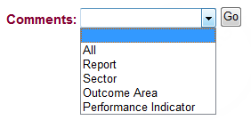

* 1. To add a new comment:

1. Click the  button

**RESULT**: A pop-up window will open containing a text editor

**TIP:** The heading section will indicate the context for the comment:

* **Comment Level** – the aspect of the report to which the comment relates e.g. “Outcome Area”
* **User** – your name
* **Date** – the date and time you made/are making this comment
* **Level Name** – name of the selected Sector, Outcome Area or Performance Indicator
* **Role** – the role you are performing when making this comment e.g. “IIR Review”

You can use the text editor functions to format the comment text or include tables of additional data.

1. Enter your comment and click the  button (or click **Close** to cancel without saving)

**RESULT:** The comment is saved and the list of previously entered comments is displayed

* 1. To edit your comment:

1. Click the **more** link next to the text of your comment

**RESULT**: A pop-up window will open containing your comment in the text editor

**NOTE:** Clicking the  button from this screen will create a separate comment for the same Comment Level and Level Name combination as the displayed comment.

1. Edit your comment and click the  button (or to cancel the comment without saving and return to the **Comments** list pop up screen, click the **Close** link)

**RESULT:** The comment is saved and the list of previously entered comments is displayed

**NOTE:** You can change your own comment as long as the status of the Performance Report has not changed since you entered that comment (e.g. status is still **IIR Review**). You may not modify another user’s comments.

|  |
| --- |
| Submit the Performance Report |

* 1. To submit the performance report to the Provider, complete the following:
  2. Click the **Click here to comment and submit this report to the Provider** link in the middle of the screen

**RESULT**: A new window will open to the ‘Comments’ tab, displaying any previously entered comments.

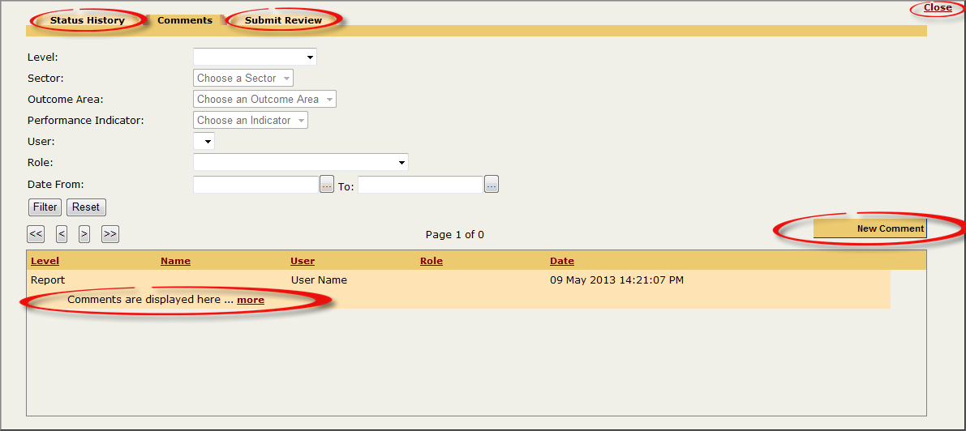

**NOTE**: A Report level (overall) comment must be entered prior to submitting the report.

* 1. To enter a Report level comment:

1. Click the  button:

**RESULT**: A pop-up window will open containing a text editor.

1. Enter your comment and click the  button (or click the **Close** link to cancel without saving and return to the **Comments** list screen)

**RESULT:** The comment is saved and the list of previously entered comments is displayed. Click **more** to view a comment in full, or click **Close** in the top right hand corner to close the window.

* 1. Click the **Submit Review** tab at the top of the screen:

**RESULT**: The **Submit this report for Provider Review** screen will be displayed

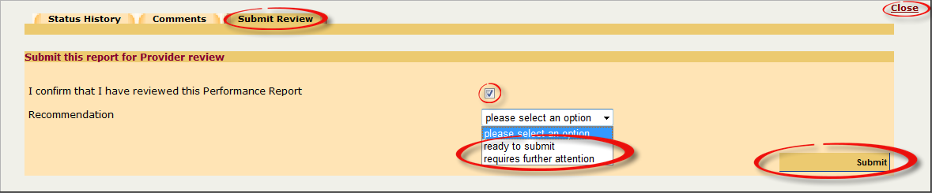

* 1. Enter the submission decision:

1. Tick the box  to confirm that you have reviewed the Performance Report
2. Select ‘ready to submit’or‘requires further attention’ from the Recommendation dropdown
3. Click the  button to submit the report (or click **Close** to cancel submitting the report and return to the Performance Reporting pod)

**RESULT**: The Performance Report is returned to the Provider and the report’s status changes to **Ready to Submit to DEEWR**. The **Performance Reporting** pod is displayed on the **INDIGO Home** screen and an email notification is sent to the Provider’s **Review and Submit** user/s, alerting them that the IIR review has been completed.

**NOTE**: If a Report level comment has not been entered, you will receive the message:

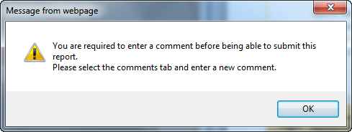

Click the  button and click the ‘Comments’ tab to add a comment before returning to the ‘Submit Review’ tab

|  |
| --- |
| Possible Next Steps |

**PR-03P How to review and submit Performance Reports**

|  |
| --- |
| Further Information |

For further assistance contact the INDIGO Help Desk:

Phone: 02 6240 8852

Fax: 02 6123 7995

Email: [indigohelpdesk@deewr.gov.au](mailto:indigohelpdesk@deewr.gov.au)