



Standing Committee on Education and Employment

Submission from the Department of Education, Skills and Employment to the Senate Standing Committee on Education and Employment

Contents

1. Executive Summary 5

2. Introduction 6

3. Context of reforms 7

3.1. Demand projections 10

3.2. Regional disadvantage 11

3.3. Preparing for the jobs of the future 14

3.4. Skills to build resilience to crisis 15

3.5. Response to the COVID-19 pandemic 16

4. Aims of the reforms 18

4.1. More university places 18

4.2. Job-ready Graduates 20

4.3. Reforms continue to build a better aligned tertiary sector 21

4.4. Capacity where it is needed – including rural, regional, and remote Australia 22

4.5. Simplifying higher education funding 24

4.6. Greater flexibility for universities to provide places where they are needed 27

4.7. Dedicated funds to foster closer industry engagement and improve equity 28

4.8. Working Groups 29

4.9. Improving the cost model 29

5. Consultation 34

5.1. Consultation process 34

5.2. Cost of study 35

5.3. Equity and access 45

5.4. Integrity of the higher education system and university funding 51

6. Conclusion 56

References 59

Table of Figures

Figure 1: Projected change in employment by qualification to 2024 (thousands) 7

Figure 2: Unemployment by educational attainment (thousands) 8

Figure 3: Employment by educational attainment (thousands) 9

Figure 4: Total new jobs projected to be created by 2023 as a proportion of all new jobs 9

Figure 5: Higher education applications among school leavers and labour force participation rates for persons aged 15-19 11

Figure 6: Education attainment rates 12

Figure 7: Attendance rates at university by distance to a university campus (age 22 years) 13

Figure 8: Population growth projections 19

Figure 9: Per centage of population with a Bachelor degree or above (25-34 year-olds, 2019) 20

Figure 10: Map of growth areas- regional, metro high and metro low 23

Figure 11: The reform package provides growth where it is needed 24

Figure 12: 2021 CGS rates (current model) 25

Figure 13: 2021 CGS rates (new model) 26

Figure 14: Commonwealth Grant Scheme (CGS) *funding envelope* 27

Figure 15: Driving growth: a simpler funding model better matched to need 28

Figure 16: Comparison of funding models (current) 31

Figure 17: Comparison of funding models (new system) 32

Figure 18: Share of commencing domestic Bachelor enrolments (2009-2018) 37

Figure 19: Comparative net median lifetime income ($2016 million) by gender 40

Figure 20: Full-time employment three years after graduation (as a proportion of those available for full time work) (%) by gender 42

Figure 21: How HEPPP allocations will better support regional, remote and Indigenous students (from 2021) 48

Figure 22: How Job-ready Graduate Transition Fund Loading will work 53

Figure 23: The effective unemployment rate and headline unemployment rate 63

Table of Tables

Table 1: Employment by skill level for the period February to May 2020 16

Table 2: Net Present Value of a Bachelor degree 41

Appendices

**Appendix A**: Economic Growth and Labour Force needs

Figure 1: The effective unemployment rate and headline unemployment rate

**Appendix B**: Working Groups

**Appendix C**: Summary of Submissions to draft Higher Education Support Amendment (Job‑ready Graduates and Supporting Regional and Remote Students) Bill 2020 exposure draft consultation

**Appendix D**: Summary of correspondence with the Minister

**Appendix E**: Comparison of total funding outcomes   
– current arrangements v Job-ready Graduates package

**Appendix F**: Outstanding HELP debts

Table 1: Summary information for individuals with the 30 highest   
outstanding debts

Table 2: Number of highest 30 HELP debtors enrolled (2005 – 2018)

Standing Committee on Education and Employment

## Executive Summary

The Job-ready Graduates package (the package) will create more university places for Australian students, provide more funding and support to regional students and universities, make it cheaper to study in areas of expected job growth, and strengthen relationships between universities and business to drive workforce participation and productivity.

Based on lessons from previous experience, it is clear demand for higher education increases during economic slowdowns with students seeking job-relevant skills to help them enter or re-enter the workforce.

The focus of the package is to grow the number of university places for domestic students by 100,000 by 2030 and encourage students to consider Job-ready education pathways. This is an integral part of the Australian Government’s (the Government’s) plan to address the COVID-19 recession and will complement increased funding for vocational education and training and additional opportunities to reskill and upskill through an enhanced microcredential offering.

The package will not only make it cheaper for students to study in areas of expected job growth, it will also provide additional funding for partnerships between universities and business that improve workforce participation and productivity.

In particular, the legislation will establish the National Priorities and Industry Linkage Fund (NPILF) – with a strong focus on investment in science, technology, engineering and mathematics (STEM) industries – to support universities to produce job-ready graduates for their local industries and communities.

Importantly, the Job-ready Graduates package also contains new measures to support regional students and regional universities worth an additional $400 million. The Government recognises that more work must be done to close the attainment gap between students from regional Australia and those in metropolitan areas. The measures in the package give effect to recommendations made by The Hon Dr Denis Napthine in the National Regional, Rural and Remote Education Strategy (the Napthine Review). Under the package, the Government’s funding of more than $18 billion in 2020 to fund Australia’s universities will grow to $20 billion by 2024.

## Introduction

The Department of Education, Skills and Employment (the department) welcomes the opportunity to provide the Senate Standing Committee on Education and Employment   
(the Committee) with this submission, as part of the Committee’s inquiry into the   
[Higher Education Support Amendment (Job-Ready Graduates and Supporting Regional and Remote Students) Bill 2020 (the Bill).](https://www.aph.gov.au/Parliamentary_Business/Committees/Senate/Education_and_Employment/JobReadyGraduates)

The Government’s Job-Ready Graduates Package (the package) was announced by the Minister for Education, the Hon Dan Tehan MP, at the National Press Club on 19 June 2020.[1] The package contains measures to:

* increase the number of university places for domestic students;
* direct growth in the higher education sector towards Australia’s regions and national priorities;
* create more opportunities for regional and remote students;
* encourage universities to produce job-ready Graduates; and
* ensure universities are held accountable for the outcomes they deliver for students, industry and the wider community.

This submission outlines:

* the context within which the Bill has been introduced;
* the aim of the Bill; and
* the consultation on the Bill and package and issues raised by stakeholders during the development of the Bill.

## Context of reforms

The *Job-ready Graduates Higher Education Reform Package 2020* *Discussion Paper* demonstrated that a robust and resilient education system is critical to our economic recovery from the COVID-19 pandemic. [2] Education plays an integral role in a country’s immediate recovery response and strengthens long term recovery efforts.

Australia’s economic growth has been affected by the pandemic, and our labour force needs are changing quickly. Existing disparities in education participation and attainment need to be addressed to ensure that all Australians have the job-ready skills and experience that will support them in a challenging labour market. Appendix A sets out the context of economic growth and labour force needs.

The precise impact the COVID-19 pandemic and associated restrictions has on the shape and trajectory of the labour market will only emerge over time, however projections prepared before COVID-19 showed trends that were expected to progress in the labour market over the five years to May 2024, and remain relevant.

Employment growth over the five years to May 2024 was primarily expected in jobs that require some form of tertiary qualification (with 90.7 per cent requiring Certificate II or higher).[3] Of this, almost half of the projected jobs growth would have required Bachelor level or higher qualifications. Even given the extra uncertainties from the COVID-19 pandemic, these projections remain robust.

Figure 1: Projected change in employment by qualification to 2024 (thousands)[4]

Regardless of their level of education, it takes time for workers affected by labour market disruption to recover. Figure 2 shows that higher education can serve as a protective factor against unemployment, at least for the last three major downturns in Australia: the early 1980s recession, the early 1990s recession and the Global Financial Crisis.

Figure 2: Unemployment by educational attainment (thousands)[5]

Persons with bachelor level qualifications tend to have lower unemployment and are less likely to lose their job in a downturn

Tertiary education is also a driver of employment status and income. Graduates enjoy an income premium of around 60 per cent higher than those without tertiary qualifications. Nearly all gains in employment over the last forty years (96 per cent) have been made by people with tertiary qualifications (Certificate III or higher). This trend is expected to continue. In 2019, for the first time workers with a Bachelor degree or higher qualification was the largest category of employment (Figure 3).

Figure 3: Employment by educational attainment (thousands)[6]

Employment of persons with higher education qualifications is increasing fastest

Figure 4: Total new jobs projected to be created by 2023 as a proportion of all new jobs[7]

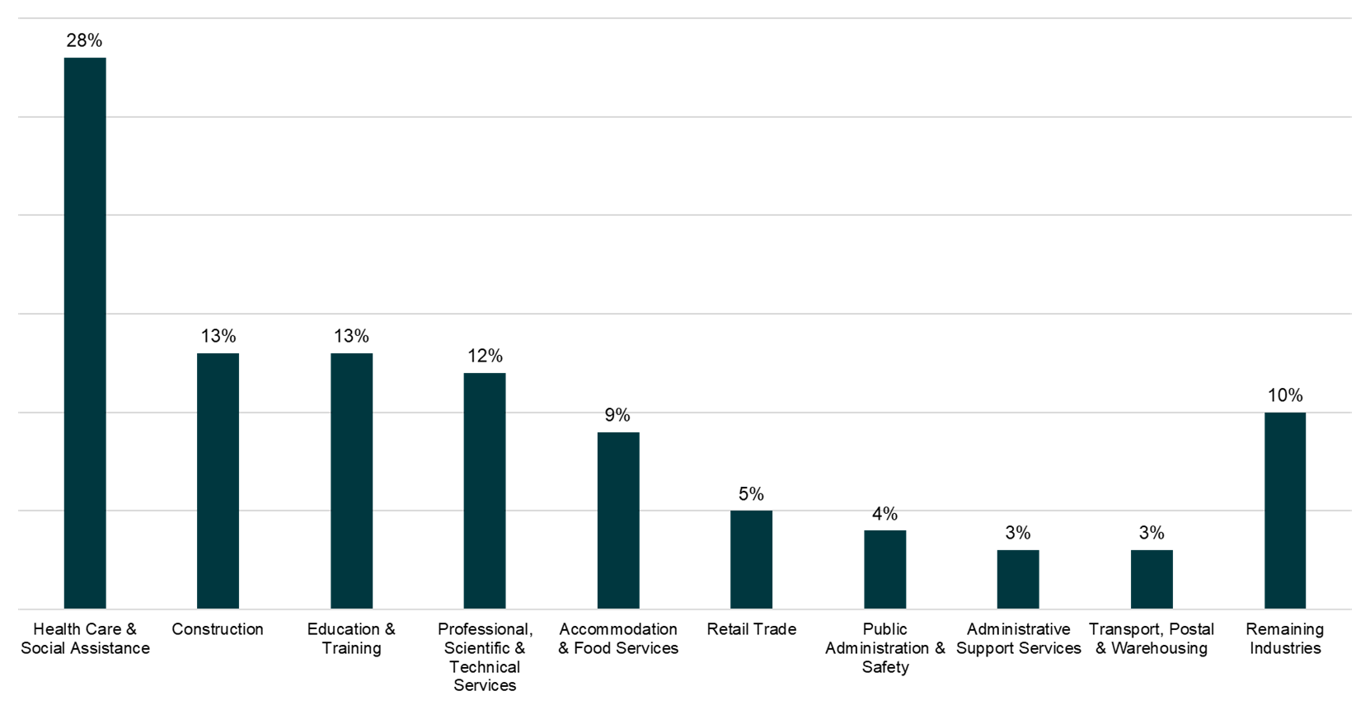

Prior to the pandemic, the health care industry was projected to make the largest contribution to employment growth, followed by professional, scientific and technical services, education and training, and construction (Figure 4). These four industries were projected to provide 62 per cent of total employment growth over the next five years. The department expects these predictions will continue to hold true, and perhaps even strengthen.

Data suggests demand for higher education increases during economic slowdowns, with students seeking job-relevant skills to help them enter or re-enter the workforce. The Government is responding to economic circumstances by ensuring students are ready for the labour market that lies beyond the pandemic.

### Demand projections

The department projects a likely increase in demand for higher education, in terms of the number of undergraduate applications, as a result of changes in the unemployment rate and population bulge. Taking into account the range of potential scenarios for growth in applications from both school leavers and non-school leavers, it expects more than 130,000 additional applications in 2021 due to COVID-19.

Not all applications will seek a Commonwealth supported place (CSP) or a Bachelor degree enrolment, some will choose a short course. In 2013 for example, there were 260,001 unique offers of whom 186,960 or almost 72 per cent commenced an undergraduate course.[8]

Some people looking to higher education for qualifications will require full three years   
(or more) of study to gain the skills they need for the future workforce. Others will be looking to upskill or reskill quickly and re-enter the employment market as soon as possible. People will choose a level of qualification that suits their needs, including the time it takes to gain that qualification.

#### School leaver demand

The youth employment participation rate for 15-19 year-olds was used to model school leaver demand given the traditionally higher propensity for university applications among school leavers. Close to two-thirds of school leavers go on to tertiary education each year, considerably higher than other demographic groups.[9]

Figure 5 below shows an inverse relationship between higher education applications among school leavers and labour force participation rates for 15-19 year-olds from 1985 to 2008 (data period used in regression).

Figure 5: Higher education applications among school leavers and labour force participation rates for persons aged 15-19[10]

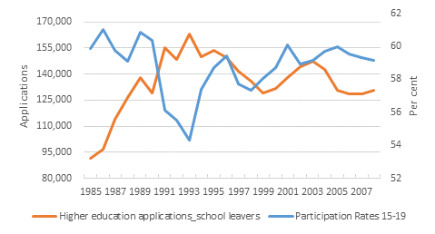

### Regional disadvantage

Beyond general demand, there is a geographical attainment gap that needs to be addressed. The package includes measures to bridge disparities between metropolitan and regional and remote students in tertiary education access and participation. In November 2018, the Minister for Education appointed a Regional Education Expert Advisory Group, chaired by the Hon Dr Denis Napthine, to develop a strategy to improve tertiary education participation and outcomes for students from regional, rural and remote areas. The National Regional, Rural and Remote Tertiary Education Strategy final report (the Napthine Review) was released on 28 August 2019.

The Napthine Review highlighted the significant city ‑ country divide in high-level tertiary education outcomes as there continues to be a significant gap in tertiary education participation and attainment rates between regional/remote and metropolitan areas, with the gap in outcomes most pronounced in higher-level tertiary studies (Certificate IV   
and above) and increasing with distance from metropolitan areas. Regional and remote students had poorer outcomes in higher education, even when they had the same academic potential as metropolitan counterparts, or came from medium–high income families.

Figure 6: Education attainment rates [11]

**Certificate IV and above**

Major Cities

Inner Regional

Outer Regional

Remote

**Bachelor and above**

The Productivity Commission found the demand-driven system, which provided a significant increase in access to higher education, did not improve university participation and outcomes for regional and remote students.[12] Regional and remote students and Indigenous students were the only cohorts who did not benefit from the expansion of access to higher education under the demand-driven system, with the Productivity Commission concluding that there were additional barriers faced by these students in pursuing higher education (such as limited access to education options and substantial relocation costs).

School students in regional or remote areas are much less likely to attend university than students in metropolitan areas. Only part of this difference is explained by lower school achievement and by peer effects. Moreover, there is a growing gap between students of the same background and capability based solely on whether they live in a regional or remote area or in a metropolitan area.

Distance from a campus — with the associated costs of relocation and forgone opportunity to live with family — explains some of the under representation in this group. School students who live more than 40 kilometres from a university campus are considerably less likely to go to university than school students who live in closer proximity; and this gap widened since the introduction of the demand driven system, even for high achieving students (Figure 7).

Figure 7: Attendance rates at university by distance to a university campus (age 22 years)[13]

|  |  |
| --- | --- |
| |  | | --- | |

Improving educational outcomes in regional and remote Australia and boosting the contribution made by regional Australia, including the capacity of education institutions, will help build the nation, increase productivity and promote decentralisation. To boost the contribution of regional Australia, the Napthine Review suggested enhancing the research and development of regional tertiary providers. To support a community’s economy and local industries, including by attracting more international and domestic students and graduates to the regions.[14]

The Napthine Review focused on improving regional and remote tertiary education outcomes. The Government accepted all seven recommendations and considered feedback on the 33 individual actions from the report.  The recommendations focused on the student by improving access to tertiary study options in regional, rural and remote areas, better access to financial support, student support services to address education participation, improving outcomes for equity groups and to build aspiration for regional, rural and remote students.  The recommendations highlighted the need to strengthen the role of tertiary education providers in regional development and to establish mechanisms to support the Strategy.

The Job-ready Graduates regional measures support the recommendations in the Napthine Review to address the disparity between metropolitan and regional and remote students by providing opportunities for regional and remote students to undertake higher-level tertiary study (whether they relocate to study or stay in their local community), and by supporting additional investment in regional universities to boost  regional development.

### Preparing for the jobs of the future

Post-COVID-19, there will be changes to the labour market. It is clear we will need more job-ready graduates in health care, teaching and STEM related fields, including engineering and IT. The higher education sector will need to meet a spike in demand from school leavers, and provide more options for upskilling and reskilling workers who have lost jobs due to COVID-19.

Australia will need more STEM skilled workers as we will have more jobs that rely on STEM professionals. The Australian Academy of Science has predicted Australian workers will spend 77 per cent more time using science and maths skills in the future.[15] Data61 at the Commonwealth Scientific and Industrial Research Organisation (CSIRO) pointed to an increase in automated systems raising task complexity and therefore requiring higher skill levels for entry-level positions.[16] With low-skilled jobs increasingly automated, the bar for skills and education requirements to enter many professions and occupations will continue to rise.

Data61 estimated that STEM knowledge was associated with 75 per cent of the fastest growing occupations, innovations and wage premiums.[17] To enter the labour market of the future, Australians will need to be literate, numerate and digitally literate. These capabilities will be threshold requirements for most jobs. As Data61 highlights, even traditionally labour-intense occupations like nursing or aged care are likely to require an ability to work with computers and operate complex machines. A builder might need to understand and be able to connect the multiple devices and smart systems of future homes.

We have seen this emerging already. STEM-related occupations grew by 20 per cent over the five years to November 2019, or nearly twice the growth rate in non-STEM jobs, with   
74 per cent of STEM occupations requiring a Bachelor degree or higher qualification. These core trends are unlikely to change, and will drive a need for more STEM qualified higher education graduates. Despite this, recent trends show that under current policy settings the proportion of domestic graduates with STEM qualifications has remained stable.[18]

The Job-ready Graduates reforms will assist to rebase funding to align with cost and increase focus on the national interest, incentivise students and universities to focus on work relevant qualifications and support growth in a tertiary qualified workforce.

### Skills to build resilience to crisis

In normal times, higher education graduates have a substantial advantage in the labour market, with lower rates of unemployment and higher earnings than school leavers and vocational education graduates.[19] As highlighted above, this remains the case, even in times of crisis. Australia faces an economic downturn as a result of the pandemic, equipping young Australians with a tertiary education is more important than ever in dealing with the current crisis and building resilience to future labour market disruption.

Departmental analysis using Australian Bureau of Statistics (ABS) Labour Force data suggests those with higher qualifications (Skill level 1, Bachelor or above) have not been as impacted by the COVID-19 pandemic as those with lower level qualifications. Between February and May 2020, employment fell in four of the five Skill Levels (Table 2). Skill Level 1, which includes occupations commensurate with a Bachelor degree or higher qualification was the only skill level that did not have a decrease in employment.[20]

Table 1: Employment by skill level for the period February to May 2020[21]

|  |  |  |  |  |  |
| --- | --- | --- | --- | --- | --- |
| **Skill Level** | **Employed, May-20** | **Quarterly employment change  (Feb-20 to May-20)** | | **Yearly employment change  (May-19 to May‑20)** | |
| **(‘000)** | **(‘000)** | **(%)** | **(‘000)** | **(%)** |
| 1 (occupations commensurate with a Bachelor degree or higher qualification) | 4208.7 | 8.1 | 0.2 | 151.2 | 3.7 |
| 2 (occupations commensurate with Advanced Diploma or Diploma) | 1501.6 | -128.1 | -7.9 | -99.9 | -6.2 |
| 3 (occupations commensurate with a Certificate IV or III, including at least 2 years on the job training) | 1855.3 | -78.6 | -4.1 | -171.7 | -8.5 |
| 4 (occupations commensurate with a Certificate II or III) | 2902.7 | -256.1 | -8.1 | -324.9 | -10.1 |
| 5 (occupations commensurate with a Certificate I or secondary education) | 1749.0 | -282.7 | -13.9 | -251.8 | -12.6 |
| All occupations | 12,184.1 | -811.1 | -6.2 | -690.4 | -5.4 |

### Response to the COVID-19 pandemic

Australia has moved quickly in response to COVID-19, including Australian universities. Most higher education institutions and providers moved to online learning, allowing only essential contact at campuses (mostly infection control, research, and other pandemic responses).

To help Australians upskill, the Higher Education Relief Package provided access to discounted short courses. During COVID-19, universities rolled out microcredential courses to study in areas of national priority and the demand from Australians clearly exceeded our expectations. Fifty-two providers offered 329 courses across eight fields of education.

The Higher Education Relief Package guaranteed Commonwealth Grant Scheme (CGS) payments for all higher education institutions in 2020. This means CGS payments will be paid throughout 2020, regardless of any change in enrolments due to COVID‑19. Similarly, Higher Education Loan Program (HELP) advances will continue to be paid at pre-COVID-19 levels for 2020 with recouping of any excess advances over a deferred and extended period of 2022 to 2029.

The JobKeeper payment will help keep more Australians in jobs and support businesses affected by the significant economic impact of COVID-19.[22] Universities can access JobKeeper when they can demonstrate a loss of 30 per cent or 50 per cent of total revenue, the same rate as other similarly-sized organisations in the economy.

Some 29 Table A[23] universities have made announcements on anticipated revenue reductions for 2020. In many cases there will be reductions against expected 2020 revenues escalated over 2019 actual figures. However, comparing these with 2019 actual revenues, the total reported reductions on average are 14 per cent of 2019 revenues. For individual institutions the reductions range from 4 to 26 per cent of 2019 revenues.

**Context of the Reforms**

* Existing disparities in education participation and attainment need to be addressed to ensure all Australians have the job-ready skills in a challenging labour market. Higher education can serve as a protective factor against unemployment.
* Post-COVID-19 there be changes to the labour market. It is clear we will need more job-ready graduates in health care, teaching and STEM related fields, especially engineering and IT.
* Improving educational outcomes in regional and remote Australia and boosting the contribution made by regional Australia, including the capacity of education institutions, will help build the nation, increase productivity and promote decentralisation.
* To help Australians upskill, the Higher Education Relief Package provided access to discounted short courses.

## Aims of the reforms

The Job-ready Graduates reforms will support increased demand from school leavers and provide more options for upskilling and reskilling workers who have lost jobs due to   
COVID-19. There is a focus on areas of industry and community priority as well as work relevant qualifications to ensure the higher education sector produces job-ready graduates that reflect Australia’s expected economic, industry and employment growth.

The new arrangements encourage prospective students to consider adding skills sought by employers, alongside their own preferences. Higher education providers will work more closely with industry to ensure graduates have the job-ready skills and experience they will need in a challenging labour market.

The CGS funding clusters and student contribution bands are being simplified to make government funding for universities clearer, simpler and more sustainable.

The reforms are timely, as required by any pandemic response, however, consultation was thorough (see Section 5 Consultation) and changes have been made in response to community, sector, and industry feedback in the current Bill.

### More university places

The reforms will grow the number of university places for domestic students by 100,000 by 2030.[24] This will allow more Australian students to study at universities and lead to more tertiary skills in our economy. It will lift the education attainment for students in communities in regional, rural and remote Australia. Left unchanged, the existing funding arrangements cannot respond to emerging demographic trends in domestic student higher education participation and attainment. Put simply — there will not be enough university places for prospective Australian students.

The gap between funding growth and population growth under current settings will not allow the system to develop capacity in pace with future demand. Indexation arrangements for non-designated maximum basic grant amounts (MBGAs) mean overall funding for   
non-medical Bachelor places increases by the projected population growth for   
18-64 year olds. Consumer Price Index (CPI) is normally higher than population growth for 18 to 64 year olds, meaning funding for Bachelor places is falling in real terms, even if universities receive full performance-based funding increases. The current system could not provide enough places to meet the demand of school leavers and the skill requirements of the future (even without the likely increase in demand brought about by the COVID-19 pandemic set out in section 3: Context of the Reforms).

Adding to this problem, the ‘Costello baby boom’ [25]will see a significant increase in the number of school leavers in 2023 and 2024.[26] As shown in Figure 8, a 4.2 per cent increase in the number of 18 year olds is expected in 2023. This compares to 1.2 per cent a year for 18-64 year olds. Based on the department’s analysis, the gap between the number of fully funded commencing students and the number required to maintain an attainment rate of 40 per cent is expected to reach around 50,000 by 2034.

Figure 8: Population growth projections[27]

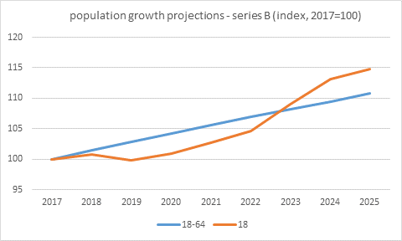

Without these new places, Australia cannot continue to maintain its higher education attainment rates. Australia risks falling down Organisation for Economic Cooperation and Development (OECD) rankings of higher education attainment for 25-34 year olds. In 2006, Australia was ranked sixth in the OECD and by 2019 had slipped to twelfth. To maintain our international competitiveness in the new service and technology economy, this slide must be halted.

Figure 9: Per centage of population with a Bachelor degree or above   
(25-34 year-olds, 2019)[28]

### Job-ready Graduates

The reforms will incentivise students to make more job-relevant choices, that lead to more job-ready graduates, by reducing the student contribution in areas of expected employment growth and demand. This will also help student to receive an education that sets them up for future success – because if graduates succeed, they will support an economic recovery that benefits all Australians.

Importantly, the changes are based at a unit level not a degree level. This means that students studying Arts can still reduce their total student contribution by choosing electives in subjects like mathematics, english, science and IT within their degree. This will encourage students to embrace diversity and allow them to think broadly about their education – it is not just one discipline, it is multidisciplinary. It will also encourage universities to be flexible and innovative in their approach to designing and running their own programs suitable to local conditions.

The current employment challenges will impact most on young Australians and incentivising students to pursue careers in areas of employment need will result in better outcomes for young Australians, and for Australia. Students will always have the freedom to choose what they want to study – and because the Government continues to offer one of the world’s best student loan schemes, no student will be denied a place because they do not have the capacity to pay.

### Reforms continue to build a better aligned tertiary sector

The Government is committed to building a tertiary system that is future-fit and has undertaken a range of studies and reviews to examine the current higher education architecture - how it works for students, employers and the broader community.[29] These reviews have helped Government craft an ambitious tertiary agenda that supports people to make the right choice about their skills and education. Reviews of Vocational Education and Training (VET) and schools are also contributing to the tertiary agenda.[30]

For example, in 2019 the Government made changes to the CGS to implement   
performance-based funding (PBF). While initial implementation has been disrupted by the COVID-19 pandemic, from 2020 the Government has introduced a performance-based funding mechanism determines the allocation of more than $80 million in CGS funding. performance-based funding will continue to grow by around $80 million each year to a total equivalent to 7.5 per cent of funding for domestic, non-medical Bachelor places.

The Government’s response to these reviews builds a coherent tertiary system that is sustainable, future-fit, and focused on building a strong pipeline of work-ready graduates.

Table 1: Next steps in creating job-ready graduates for Australia

|  |
| --- |
| **Next steps** |
| Outcomes of *Expert Review of Australia’s Vocational Education and Training System:*   * Strengthen quality assurance, including regulatory reforms * Speed up qualification development * Simplify funding arrangements and introduce a national approach to skills development * Provide better careers information * Establish clearer secondary school pathways * Provide greater access for disadvantaged Australians |
| Outcomes of *Review of senior secondary pathways into work, further education and training*:   * Ensure students finish school with the skills and knowledge they need, and are aware of pathways and prepared for work, VET or higher education |
| Outcomes of reviews into higher education architecture:   * Simplify category structure and introduce University College, increase requirements for quality and quantity of research * Establish national marketplace for microcredentials, consolidate short course arrangements * Enhance access, outcomes and opportunities for regional, rural and remote participation in post-secondary education |

### Capacity where it is needed – including rural, regional, and remote Australia

The regionally focused measures announced in the package address the disparity between metropolitan and regional and remote students, whether they choose to relocate to study or stay in their local community. These measures are targeted to provide opportunities for regional and remote students to attend university, and to support additional investment in regional universities to boost regional development.

New growth funding will see funding allocated where the nation needs it most. It provides a 3.5 per cent boost to funding for regional campuses to address the gap in attainment. It provides 2.5 per cent additional funding per annum for campuses located in high-growth metropolitan areas and 1 per cent growth funding per annum for other campuses.

Figure 10: Map of growth areas- regional, metro high and metro low

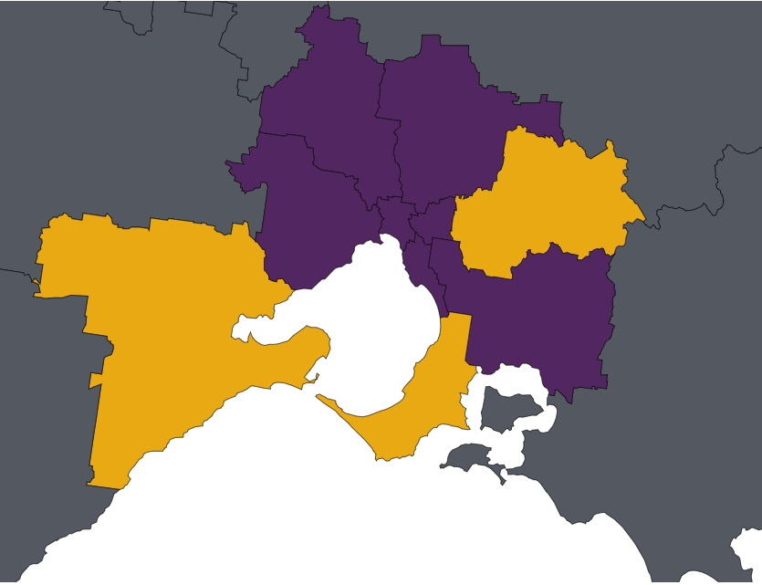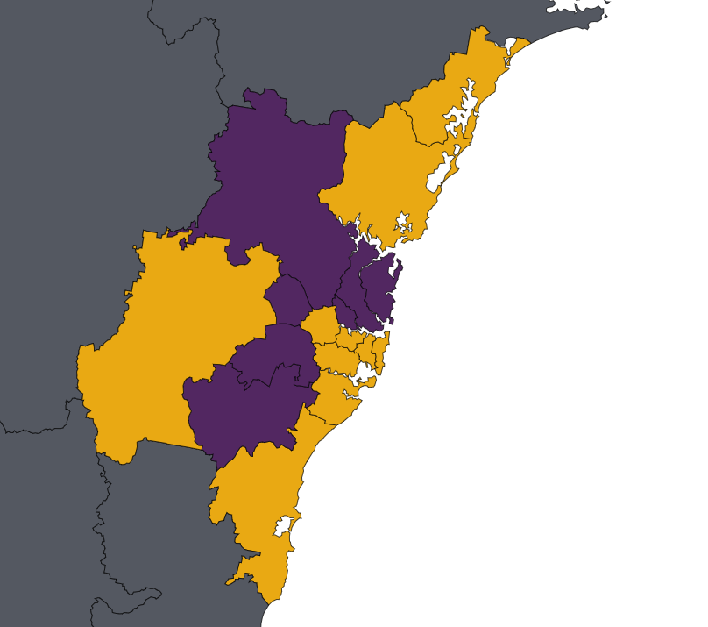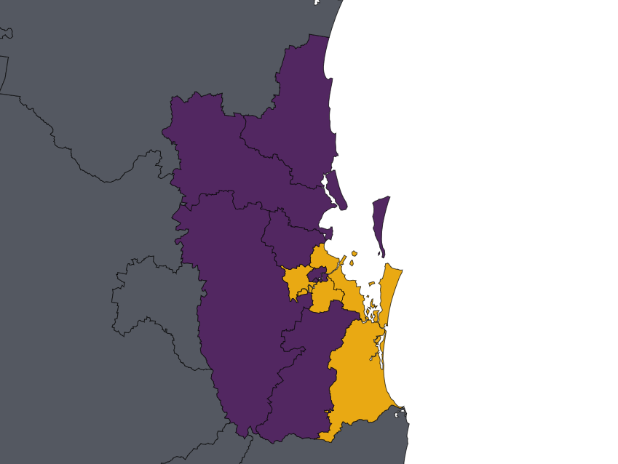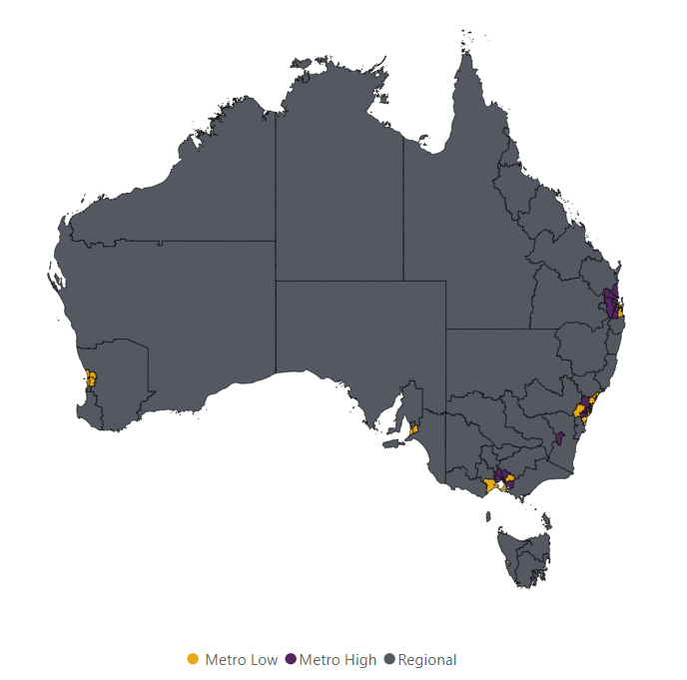

Providing a boost to funding for regional campuses responds to Recommendation 1 of the Napthine Review to ‘improve access to study options for students in rural, regional and remote areas.’ The Napthine Review found regional and remote students had less access to tertiary education options in their local communities, and to increase university participation rates, revision of funding caps for university places would be necessary. Additional places will support the capacity of regional education institutions and, the communities they serve, in line with recommendation 6 to ‘strengthen the role of tertiary education providers in regional development and grow Australia’s regions.’

Figure 11: The reform package provides growth where it is needed

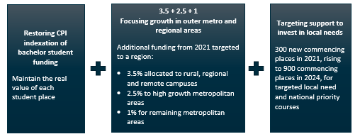

### Simplifying higher education funding

The Bill provides for funding reforms that allow more places, help boost participation and attainment in regional Australia, and provide targeted support for university study in areas of economic need. The Bill simplifies the higher education funding arrangements for providers and students.

For students, the Bill simplifies cluster and band arrangements for CSPs. Under the current CGS funding structure, there are eight Commonwealth Contribution funding clusters and three student contribution bands (Figure 12 below). The Bill simplifies these arrangements to four clusters and four bands (Figure 13 below). The redesigned funding clusters will see Government pay more than half the cost of CSPs overall, while bringing the funding levels into better alignment with the cost of delivery and national employment priorities.

Figure 12: 2021 CGS rates (current model)

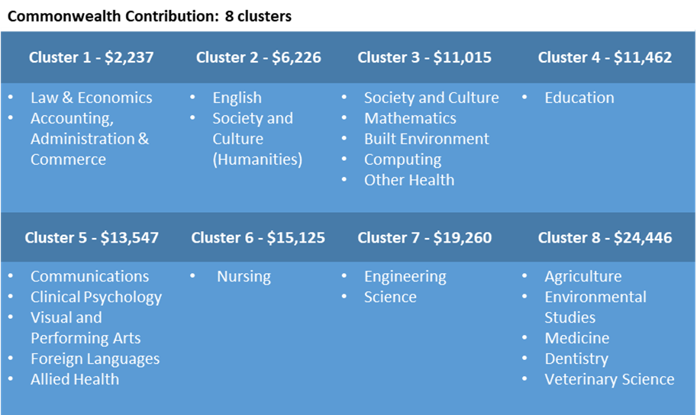

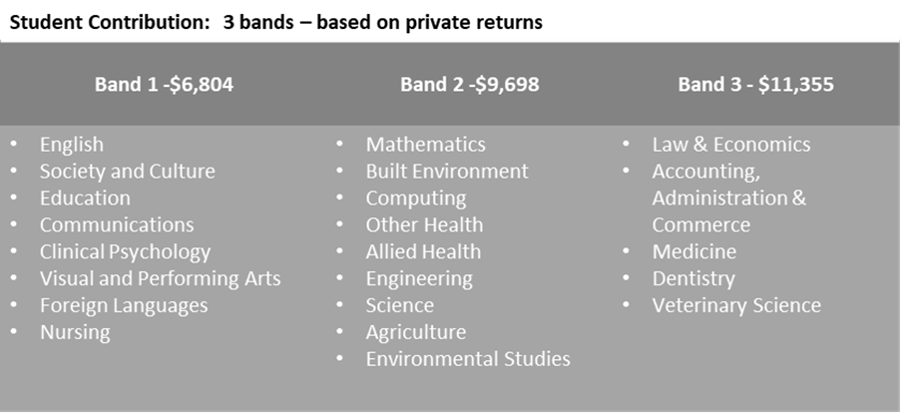

Figure 13: 2021 CGS rates (new model)

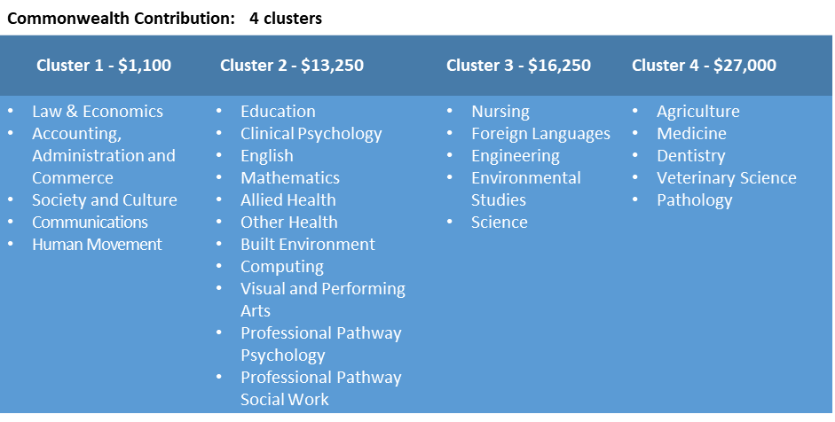

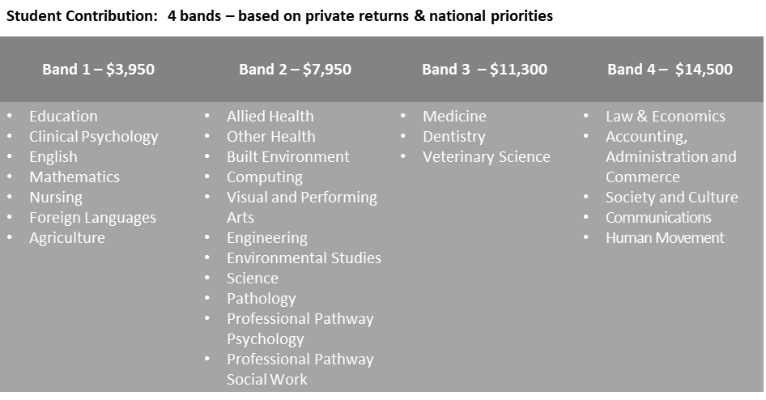

Currently, indexation arrangements for CGS funding for non-medical bachelor CSPs is different to those for funding for sub-bachelor and postgraduate CSPs. The Bill will streamline the CGS into one *funding envelope*, which will be indexed at CPI.

Providing CPI indexation for Bachelor place funding prevents its erosion. It means Bachelor funding will maintain its real value, in line with the other funding in the CGS. Extra, targeted funding will be provided in national priority areas and courses to boost skills in the workforce where they are needed. Initially 300 commencing places in 2021, this will increase to 900 by 2024, and 2000 commencing places per year by 2030.

### Greater flexibility for universities to provide places where they are needed

By providing universities greater flexibility, they can be more responsive to local demand, and thereby ensure more graduates are job-ready and likely to engage in the local economy. In response to consultation in 2019 a third of institutions considered they should be given the flexibility to manage their own CSP allocations.[31]

Some of this flexibility was introduced in the Higher Education Relief Package, and the Bill extends this to give freedom to move funding between Bachelor, Post-graduate and   
sub-Bachelor places, as well as trade CSPs with other institutions.

In 2019 providers had not used approximately $86 million (approximately 7,400 places):[32]

* $27.6m in underutilised non-designated funding (approximately 2,400 places); and
* $58.3m underutilised designated funding (approximately 5,000 places).

The introduction of a *funding envelope* as demonstrated below will mean funding to Table A universities from 2021 can be transferred on a cost neutral basis between disciplines (excluding medical) and course levels (sub‑Bachelor, Bachelor, Post-graduate and   
Short Courses).

Figure 14: Commonwealth Grant Scheme (CGS) *funding envelope*

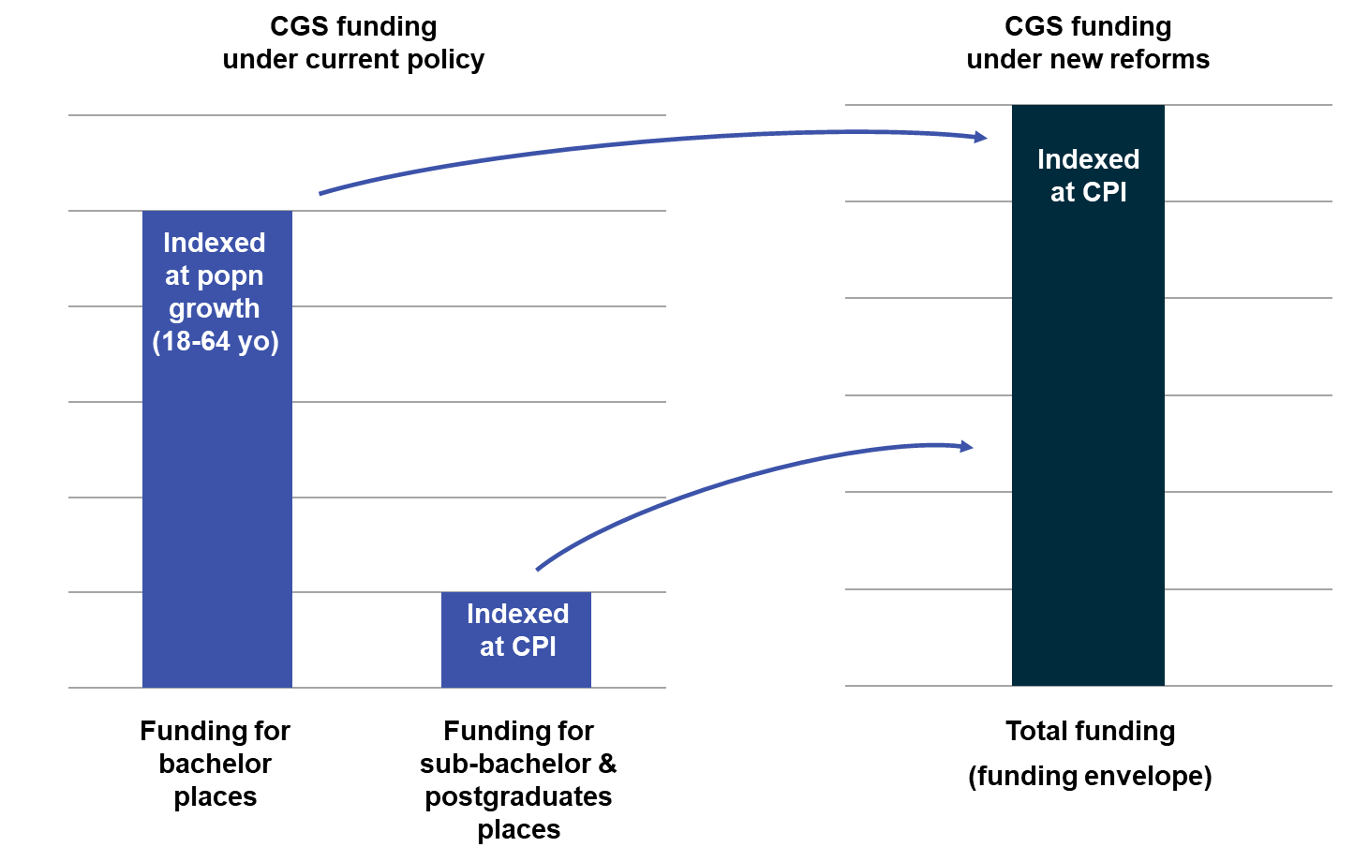

### Dedicated funds to foster closer industry engagement and improve equity

The Indigenous Regional Low Socio-Economic Status Attainment Fund (IRLSAF) is a consolidation of existing equity programs. It will streamline administration and finances, increasing efficiency and maintain the functions of these programs, with a focus on equity and access. The Government will work with the sector on the long-term fund design to improve universities’ ability to facilitate access to higher education for disadvantaged and vulnerable cohorts. The Bill allows universities more flexibility in how they meet engagement and social obligations, and also creates new expectations for transparency and accountability.

The National Priorities and Industry Linkage Fund (NPILF) will provide a dedicated funding stream for universities to carry out engagement with industry, develop industry-relevant course material, optimise the course mix for local economies, promote the teaching of STEM subjects and provide work-integrated learning opportunities for students.

This will both simplify current programs, and introduce a new and unique funding stream to target the Government’s priority of producing job-ready graduates (Figure 15). While recognising that many of these functions already exist, they rely on “profits” from student fees, or cross-subsidisation and have low accountability or transparency The Bill will address this piecemeal approach.

The two new funds will make Government and community expectations for universities clear in terms of the outcomes they achieve for their graduates, their engagement with the business community, and their ability to expand access and participation in higher education.

Figure 15: Driving growth: a simpler funding model better matched to need

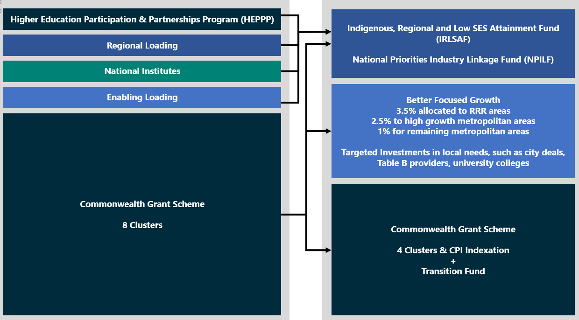

### Working Groups

Industry and universities must work together to ensure course content is relevant and includes effective work placement opportunities. Improved collaboration will promote research that delivers for industry, driving job growth, business opportunities and productivity gains. The $900 million NPILF (2021-2024) will strengthen industry and university partnerships and prepare job-ready graduates. It will allocate block grants to universities to support enhanced university engagement with industry to produce job-ready graduates. On 1 July 2020 the Minister announced a working group to assist the Australian Government to establish the NPILF.

This package is focussed on domestic education funding reforms, nonetheless it is recognised that research capability will drive innovation and jobs and is vital to our economic outcomes. The impact of COVID-19 on the number of international students from 2020 will have flow on impacts for the research pipeline and capability. On 1 July 2020, the Minister announced the Research Sustainability Working Group (RSWG), to advise him on sustainable approaches to research funding during COVID-19 and beyond.

More information about the NPILF working group and the RSWG can be found in Appendix B.

### Improving the cost model

The reforms align funding for higher education units with the best available data on the cost of delivering university education. The Bill ensures the Commonwealth contribution for a subsidised place, coupled with the student contribution amount (SCA) is better aligned with the cost of delivering the course.

The Government’s assessment of the cost of delivering a course was informed by Deloitte research based on university self-reported data on the cost of delivery of teaching and scholarship.[33] In the 2017-18 Budget, the Government committed to work with the higher education sector to establish a more transparent framework to collect financial data from higher education providers.[34] In 2018, the Government established annual data collection on teaching and research expenditure at public universities to enable higher education providers to report the cost of teaching and research by field of education(FOE).[35] Participation rates were high:

* 25 universities participated in the 2018 data collection;
* 32 participated in 2019; and
* 37 were scheduled to participate in the 2020 when it was delayed due to COVID-19.

This data collection showed consistently over three years that some fields were over‑funded while other were underfunded. The Bill provides an opportunity to correct funding arrangements to align with cost of delivery and remove cross-subsidisation by removing over and under funding. This will help remove perverse incentives for universities to rely on the “profits” of student fees, or cross-subsidisation.

Importantly, as outlined below, the package has protections that ensure universities will not receive less funding as a result of the reforms. An integral component of the Government’s economic recovery plan is ensuring the tertiary education system supports people to get the training they need, and supports employers to put people into jobs and grow their businesses.

Figure 16: Comparison of funding models (current)

Figure 17: Comparison of funding models (new system)

**Aims of the Reforms**

* Deliver 100,000 additional places for Australian students to attend university by 2030.
* Direct growth to the regions, ensuring more regional and remote students have access to a university place.
* Simplify funding arrangements for students and better align cost of delivery and national employment priorities.
* Foster industry and university collaboration.

## Consultation

The Job-ready Graduates Package in general, and the Bill specifically, has been developed in close consultation with the higher education sector. This section sets out feedback received through those processes and how that feedback was incorporated into the Bill.

The Minister for Education consulted all Vice-Chancellors, and worked closely with a small group of Vice-Chancellors about addressing their needs and considering potential reforms. Since the 19 June 2020 announcement, [36] the department and Minister for Education have met with Vice-Chancellors of every publicly funded university. The department has engaged universities and peak bodies throughout development of details of the reforms. The Minister received 469 items of correspondence on the package and a summary of issues raised in correspondence is at Appendix C.

### Consultation process

The Job-ready Graduates package was developed in close consultation with stakeholders. Three themes emerged in this consultation, and outcomes are considered in this section:

* Cost of study,
* Equity and access, and
* Integrity of the higher education system and university funding.

At the close of public consultation on the Bill on 17 August 2020, 3,791 submissions were received from individuals or organisations. Those that provided consent are published on the department’s website.[37] By far, the majority of submissions related to the classification of social work and psychology. Most other submissions related to the broad policy positions in the package. A summary of the submissions received is at Appendix D.

The department has provided opportunities to ensure higher education stakeholders could comment on and provide input into reforms. The Minister for Education convened working groups with Vice‑Chancellors of universities (outlined at Appendix B) to ensure the needs of those impacted by the reforms were considered and addressed.

The Minister for Decentralisation and Regional Education convened three Regional Roundtables in July 2020 with universities and peak bodies to hear about the unique challenges faced by the regional higher education sector. Each Roundtable considered and addressed the package as announced and other issues facing the regional higher education sector. Issues discussed included:

* CGS)cluster redesign, funding and impact on universities; and
* the Government’s response to the Napthine Review through the package, including regional measures.

After considering the constructive feedback provided, on 25 August 2020, the Minister for Education and the Minister for Decentralisation and Regional Education announced amendments to the package.[38] These revisions demonstrate commitment to address concerns and avoid unintended consequences.

### Cost of study

#### Additional funding

The package will deliver 100,000 new places for Australian students by 2030. Yet some commentators have suggested there will be less funding through the package.

Between 2020 and 2024, the package will support growth in total payments to the higher education sector of $2 billion – $200 million more than it would have been without reforms. In 2030, universities will have access to $1.7 billion more funding in that year alone. Between 2020 and 2030 overall funding for universities will increase each year. The package allows the higher education sector to expand the places it can provide as rapidly as possible.

#### Continuing students will not pay more for their degree

Continuing students already studying in a CSP will be ‘grandfathered’ so they will pay either the new lower rates or their current student contribution rates. From 1 January 2021, students who enrol in units where the student contribution has decreased will have these reduced amounts applied. Continuing students who enrol in units where the student contribution has increased will have grandfathering arrangements applied.[39]

#### Social work and psychology professional pathways

The inclusion of social work and psychology as society and culture fields of education (FOE) generated significant feedback in the consultation process. In response to this feedback student contributions for certain social work and psychology units will be changed to align with the allied health FOE in funding cluster two / band two. The Bill will create the new disciplines of Professional Pathway Social Work and Professional Pathway Psychology. Students will pay $7,950 per equivalent full-time student load (EFTSL) for these units.

The $7,950 fee will apply to behavioural science and psychology units taken in degrees in the qualifying pathway for professional registration. In 2018, the department estimates around two thirds of units in human welfare studies were undertaken in social work degrees leading to professional recognition and around one-third of units in behavioural science studies and were undertaken in clinical psychology or psychology degrees that lead to professional recognition. A small working group of current and former Vice-Chancellors working in cooperation with professional organisations will provide advice to Government on the criteria of units and courses required for professional pathways in social work and psychology.

#### Increasing the focus on Job-readiness

Employers report very high levels of satisfaction (85 per cent) with graduate employability skills. Nonetheless, industry groups are seeking more from graduates as they enter the workforce.

The Business Council of Australia recommended learners and providers need incentives to ensure education gives learners the skills and knowledge needed for future employment.[40] The Australian Industry Group recommended the expansion of workplace learning to become a delivery component in all tertiary education.[41]

‘Work experience in industry’ (WEI) units are a specific work integrated learning done as part of a course of study with the purpose to obtain relevant work experience. WEI units are currently not eligible for CGS funding but the Bill will make them eligible for CGS funding, increasing the incentive for universities to offer them.[42] This provides the opportunity for universities and industry to work together to implement innovative learning opportunities such as cadetships and advanced apprenticeships.

Further, the NPILF will incentivise greater connections between universities and industry to support course content or experiences that produce job-ready graduates.

#### The price of humanities courses

Despite the ongoing focus on humanities, a nuanced approach has been taken in the Bill, with units focussed on core skills. English and languages other than english, including Indigenous languages, are in the cheapest band.

Creative arts is in the second band for student payments and will see a small total increase in funding providing more capacity for creative arts schools. Social studies and political science are popular courses and have regularly had enrolments of more than 25 per cent of all students.

By contrast, from 2001-2018, some priority fields have seen declines in the share of commencing Bachelor enrolments. For example, the share of commencing Bachelor enrolments in agriculture has fallen by 35 per cent, the share in education has fallen by 24 per cent, and engineering has fallen by 11 per cent. The package addresses this decline in student preference by significantly reducing student contributions in priority fields. Education student contributions will be reduced by 42 per cent, engineering by 18 per cent, and agriculture by 59 per cent.

Figure 18: Share of commencing domestic Bachelor enrolments (2009-2018)[43]

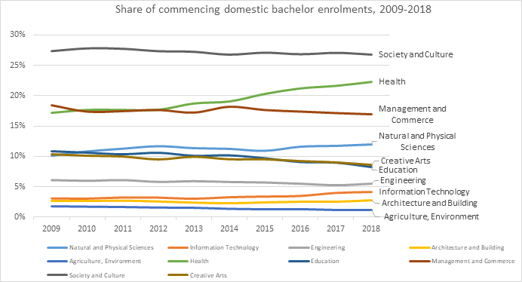

Society and culture units, by international standards, remain competitive. Historical and international evidence shows the cost of this study in Australia is still below that of the United States of America (US) and United Kingdom (UK) where students fees per year can range from $15,384‑$20,358 (US$10,710‑$14,172, sourced using University of Illinois, University of Washington and Arizona State University) or approximately $16,822 (£9,250), respectively.[44]

Additionally, cost changes are based at a unit level, not a degree level. This means that by choosing electives that respond to employer needs in subjects like mathematics, english, science and IT within their degree, students can reduce the total cost of their study.

#### Student Contribution Affordability and the Higher Education Loan Program (HELP)

Students looking to enrol in 2021, including the year 12 class of 2020, will continue to have access to the course of their choice under the HELP. No eligible student will be required to pay tuition fees up front and student loans will only be repaid when the student is earning over $46,620 (in 2020‑21).

HELP is one of the most generous student loan schemes in the world. Access is not determined by age, income or background, and means eligible students can participate in higher education without the barrier of upfront fees.

In comparison, students in the US do not generally have access to income contingent loans to defer their fees. And while students in the UK have access to income contingent loans, the design of the income contingent loan system is different – significantly UK students incur a real interest rate once they are earning a reasonable wage, whereas HELP debts are only indexed by CPI.

Some stakeholders suggested that by increasing the student contribution amount for some fields of education, the Bill may result in students taking longer to repay their HELP loan. The length of time an individual takes to repay their HELP loan is highly dependent not only on the size of the loan, but on how their income changes over time. As such, two individuals that study the same course over the same number of years may each take vastly different lengths of time to repay their HELP loan.

The changes in this package are designed to decrease the cost of undertaking job-relevant units – which will reduce both the cost of study and the value of loans while also increasing the returns a graduate receives.

#### Support for women

Some stakeholders raised concerns that the reforms could disproportionately penalise women. Most importantly, the Bill provides more opportunities for women (and men) to gain the qualifications they will require for the jobs of the future.

The Bill lowers the cost of education in current female dominated careers like teaching and nursing. This lowers the cost of these important careers. The Bill also lowers the costs of STEM subjects, which will help to attract more women (and men) into these fields, particularly given the demand for STEM skills is high and will continue to grow as society tackles the challenges of a digital and technologically-enabled world. Contemporary data suggests women who elect to enrol in units relevant to the jobs of the future – STEM, health, and education – will be more employable and more likely to achieve higher lifetime earnings.[45]

The Grattan Institute’s *Mapping Higher Education 2018* reports shows lifetime earnings are significantly higher for women in these disciplines: [46]

* Performing arts $1,433,890
* Humanities $1,638,968
* Science $1,836,675
* Nursing $2,059,742
* Education $2,116,794
* IT $2,273,436
* Engineering $2,065,969

Women with a STEM, teaching or nursing degree would on average earn between   
10 to 40 per cent more across their lifetime than a woman with a society and culture (humanities) degree. These degrees remain valuable and an important part of our higher education system, contributing to the outcome that a woman with any higher education qualification ($1,991,201) has better job prospects and earnings potential than if they had a year 12 qualification ($1,406,027). [47]

Figure 19: Comparative net median lifetime income ($2016 million) by gender[48]

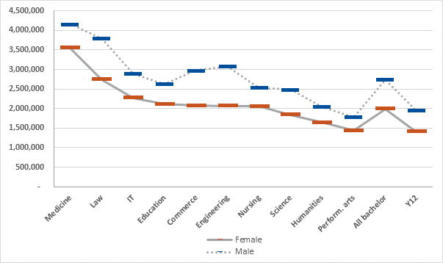

The Grattan report found overall for most disciplines, having a Bachelor degree led to higher lifetime earnings, but there were differences in the net present value between disciplines. The net present value is essentially the lifetime earnings benefit from obtaining a Bachelor degree compared to a year 12 qualification, accounting for the costs incurred in obtaining the Bachelor degree. Results indicated that STEM related subjects provided significantly better outcomes for women compared with society and culture (humanities).

Table 2: Net Present Value of a Bachelor degree

|  |  |  |
| --- | --- | --- |
| **Discipline** | **Net Present Value for women** | **Difference in net present value between humanities and other disciplines for women** |
| Humanities | $134,466 |  |
| Science | $164,688 | $30,222 |
| Mathematics | $393,659 | $259,193 |
| Engineering | $301,028 | $166,562 |
| Information Technology | $481,219 | $346,753 |
| Nursing | $335,475 | $201,009 |
| Education | $419,526 | $285,060 |

The *2019 Graduate Outcomes Survey – Longitudinal* indicated women who graduate from STEM, health and education related subjects had better full time employment rates and labour force participation when compared with those who graduated from society and culture (humanities) studies.[49] Women who study STEM, health, and teaching subjects are more likely to be employed, and studies have shown they have a higher earning potential across their lifetime. Women with a STEM, teaching or nursing degree would on average earn around 25 per cent more across their lifetime than a woman with a society and culture (humanities) degree and over 45 per cent more than a woman with a year 12 qualification.[50]

Figure 20: Full-time employment three years after graduation (as a proportion of those available for full time work) (%) by gender[51]

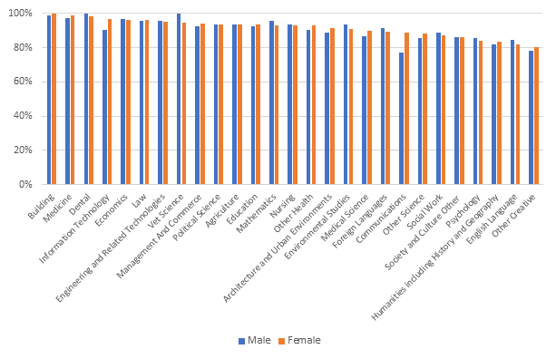

#### Price sensitivity as a factor in student decision making

When choosing a course of study, a number of factors influence student decision making. The cost of a degree, while important, is only one factor influencing student choice. Historical international evidence shows student preferences move away from courses when prices increase and towards courses when prices are reduced. As a result, there will be some shift in enrolment patterns based on price changes. Deloitte Access Economics found demand for higher education responded negatively to price increases (found based on   
2005 HELP changes):[52]

* policy changes impact demand for places modestly compared to prices change
* an increase in the relative price of higher education, for a given field of study, generally results in a small decline in relative demand for university places, and
* school leavers and high SES students are most inelastic to price change. While low SES and mature age students are more sensitive to changes to pricing.

To encourage more students to study maths and science, the *Higher Education Support Amendment (2008 Budget Measures) Act 2008* moved mathematics, statistics and science into the National Priority Band, reducing the maximum student contribution amount from $7,412 to $4,162 between 2009 and 2012.[53] Undergraduate applications in natural and physical sciences in 2009 increased by 17.1 per cent on 2008 (the overall increase was about 5 per cent). Between 2009 and 2012, applications for natural and physical sciences increased by 34.7 per cent.

Increases in applications carried over to an increase in enrolments. In 2009 commencing domestic student numbers in natural and physical sciences increased by 13.6 per cent on 2008 (the overall increase was 9.6 per cent). In 2010 natural and physical sciences enrolments recorded the highest increase of any broad discipline—12.6 per cent from 2009 (overall increase 6.5 per cent). In 2013 student contributions for natural and physical sciences were increased by 78 per cent and demand plateaued.

In 2005 and 2009 economic circumstances were very different, with 5 per cent unemployment and high economic growth. However, at that time a 3.5 per centage point change in the student contribution led to about a 1 per centage point change in demand. Notably, it was prospective students from a low-SES background that were most responsive to changes in student contribution amounts. Enrolments were also controlled by decisions made by universities about the availability of places, accounting for the difference between student preferences and actual enrolments.

International experience also indicates price sensitivity, particularly for mature age students. The UK increased its cap on fees in 2012, resulting in a trebling of fees at most institutions. After the cap was raised and fees increased, there was an initial fall in overall enrolments (around 8.7 per cent). Fee increases affected the application rates for older age groups in the UK with larger declines relative to younger age groups.

Research on student study choices shows personal interest often forms a substantial part of a student’s decision-making process. Students predominantly influenced by personal interest are likely to enrol in a course they find personally satisfying or rewarding regardless of cost. Aspiration or career motivations also play a significant role in choosing a course of study.

The Longitudinal Survey of Australian Youth (LSAY) found expectations of family and the influence of peers plays a role in a students’ decision to study. Students whose parents want them to go to university were around 20 times more likely to aspire to higher education. As such, both parents’ higher education aspiration and peers’ higher education aspiration have a strong influence on students’ plan to attend university.

The Bill is seeking to encourage students to consider future job opportunities when choosing their units and course of study and to encourage students to gain the skills they need to be successful in the workforce, including STEM skills and more vocationally based degrees.

#### Student protections

The Bill includes amendments to strengthen and extend student protection and provider integrity measures, as well as other compliance measures, to all higher education providers. Student protections measures, including quality and accountability requirements, were first introduced for non-university higher education providers in 2017 building on similar student protections in place in the VET sector following lessons learned from VET FEE-HELP.[54]

The package will require universities to ensure that all students are academically suitable for their course and that students are engaged with the course and maintaining a reasonable completion rate. This will ensure universities are supporting students to succeed in their degree. The low-completion measure will ensure students do not accumulate large debts without having a degree to show for it. Universities will have the power to use their common sense if a student’s studies have been impacted by factors outside their control, like ill health, or a bereavement. If a student transfers to another course the low completion rate will not be carried with them. This measure will only apply to courses that start after   
1 January 2022.

A 2018 analysis of university enrolments indicated strengthening accountability requirements for universities would formalise best practices, while extending student protections measures. The Bill responds to evidence and the cases where students have been continuously enrolled at multiple providers at the same time, resulting in excessive HELP debts (from $220,000 to more than $600,000 per individual) with very low pass rates (on average, passing one in five units attempted).

These measures will be critical in maintaining the high quality of Australia’s higher education sector, particularly at a time when the number of online students has increased as a result of COVID‑19. Strengthening student protections in public universities will bring universities into alignment with non-university higher education providers, and strengthen quality and accountability in Australia’s tertiary sector.

The new provisions requiring students who have attempted eight or more units to successfully complete more than 50 per cent of those units would affect 9,654 students, around two per cent of Commonwealth supported students. For most full-time students, this gives universities at least two study periods to identify struggling students and link them with existing support services, including potentially transitioning them to a course they are better-suited to complete.

The Bill will ensure every student in Australia can be confident that wherever they choose to study, they will be assessed as being academically suited to that study, their academic progress and engagement will be monitored throughout the course, and they will be prevented from incurring debt for study for which they are not suited.

### Equity and access

#### Higher education in rural, regional, and remote Australia

The Bill includes a suite of measures that respond to the National Regional, Rural and Remote Tertiary Education Strategy (Napthine Review) and will support bridging the gap in attainment between regional and remote students and metropolitan students. The reforms will drive productivity for the regions and bolster the research capacity of regional universities to foster potential and opportunity in regional communities.

These reforms include establishing an independent Regional Education Commissioner. The Commissioner will work with all tiers of government to halve the disparity in tertiary education outcomes between regional and metropolitan students by 2030. They will oversee the implementation of the Napthine Review recommendations and measures and champion the cause of regional education across all education sectors. This includes early childhood, schools and tertiary education.

The measures included in the Bill – 3.5 per cent funding growth, demand driven Indigenous positions and improvements to Fares Allowance - will ensure regional and remote students have increased access to university and financial support for their higher education study as well as improved travel support, subject to the passage of legislation. Regional communities will benefit from strengthened and newly established Regional University Centres (RUCs), enhanced regional research opportunities and regional growth through additional funding to regional university campuses.

In addition, Indigenous students from rural and regional Australia who are admitted to their university of choice will have a guaranteed Bachelor-level CSP at university.

This Bill includes reform of equity funding to ensure regional and remote students receive greater support in accessing and succeeding in higher education.

The Government’s regional education commitments that form part of the package include:

* $6 million over four years to establish a Regional Education Commissioner to coordinate the implementation and monitoring of the Government’s Regional Education Strategy,
* $0.7 million over four years for improvements to the Fares Allowance from 2021.
* $159.1 million over four years for a Tertiary Access Payment (TAP) to encourage and assist outer regional and remote students to access tertiary study immediately following school (year 12).
* $21 million over four years to establish up to eight additional RUCs and strengthen the existing RUC program to provide the facilities needed to improve the tertiary education experience of regional students.
* A new Regional Partnerships Project Pool will provide $7.1 million over four years to support activities that increase the participation of school students in regional Australia in university.
* $48.8 million over four years for enhanced research capacity of regional universities through an annual grants program for regional universities to enable them to develop research partnerships with other education providers or local industry. The grant will provide valuable support to regional universities that have significant barriers when attempting to increase their research capacity.
* $145 million over four years for regional campuses as part of the measure to provide increased Commonwealth Grant Scheme (CGS) funding to universities based on their campus locations, for each funding agreement period beginning in 2021. The funding will be a percentage increase on non-medical Bachelor (non-designated) funding. This measure will increase funding to regional university campuses by 3.5 per cent a year, improving regional growth by increasing participation rates of students at regional campuses.

#### Support for Indigenous Students

The Napthine Review highlighted the increased challenges and very low higher education participation rates for Indigenous students in regional and remote areas. In 2016, the participation rate for Indigenous students from regional and remote areas was 2.6 per cent, less than half the rate for all regional and remote students (5.3 per cent) and just over a third of the rate for people from metropolitan areas (7.3 per cent).[55]

The Bill introduces demand driven funding for Aboriginal and Torres Strait Islander students from regional areas, when they are admitted to a bachelor-level place in their university of choice. In 2021, an additional 160 Aboriginal and Torres Strait Islander students from regional and remote areas are expected to benefit from this policy. This number is expected to rise to over 1,700 students by 2024.

This will enable universities to provide better support for Indigenous students by providing funding capacity that aligns with enrolment levels. It will also have flow-on benefits for Indigenous communities, including in remote locations, by providing professional services and other enterprises requiring a university educated workforce.

In addition to demand driven funding for regional and remote Indigenous students, from 2021, the HEPPP will be reformed to ensure Indigenous students receive greater support in accessing and succeeding in higher education.

For the first time, Indigenous students and students from regional and remote areas will be recognised as a target group in the distribution of access and equity funding through the HEPPP. The formula for distributing funding, which rewards university performance in meeting the needs of groups of students, will balance the barriers to education faced by low SES (socio-economic status), Indigenous, and regional and remote students.

The formula-based component of the HEPPP will be allocated based on each university’s share of low SES students, regional and remote students and Indigenous students.

Based on current trends, more Indigenous students are studying health and STEM fields. In 2018 Indigenous undergraduates had the same full-time employment outcomes   
(72.9 per cent) as their non-Indigenous counterparts within four months of graduation. Further, Indigenous undergraduates continue to earn larger starting salaries ($65,000) than their non-Indigenous counterparts ($61,000).[56]

Figure 21: How HEPPP allocations will better support regional, remote and Indigenous students (from 2021)

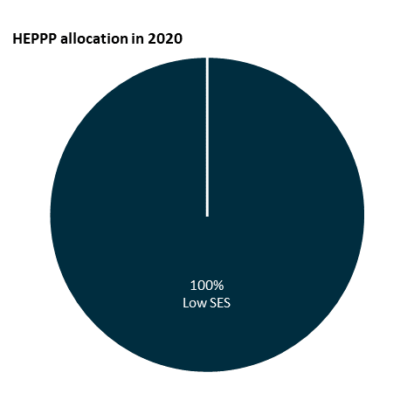

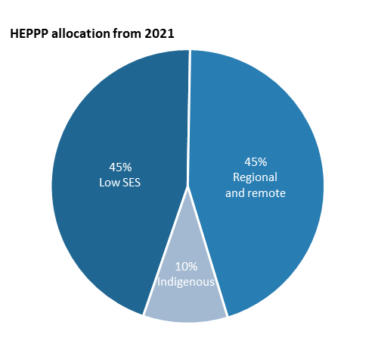

Indigenous students who are choosing to study Health and STEM at university will see a reduction in student contributions under the new funding arrangements and improved job prospects on completion. Since 2014, Indigenous enrolments in Health and STEM have grown by 41 per cent and 32 per cent respectively, both outpacing growth in Indigenous enrolments in Society and Culture (24 per cent). In 2018, one in five Indigenous students at our public universities studied Health, while one in six studied STEM.

All continuing students including Indigenous students will have their student contributions grandfathered at the current rates if they would otherwise have seen an increase. All Australian students, including those who choose to enrol in courses with higher student contributions, will continue to have access to Australia’s world-leading higher education.

#### Young people’s mental health

The Government recognises that 2020 has been a difficult year for students, especially for those studying their final year of school. Supporting the mental health and wellbeing of all Australians remains one of the Government’s highest priorities. The Government is committed to ensuring Australians have access to the right services and support wherever they are around the country.

All education ministers met in April through Education Council and agreed that year 12 students will get a leaving certificate for 2020. There will be no year 13. There will be no mass repeating of year 12.

On 30 January 2020, the Government announced $64 million to support suicide prevention and mental health initiatives as an early response to initial advice from the National Suicide Prevention Adviser. These initiatives will focus on supporting some of the most vulnerable groups, including:

* Australians who have been discharged from hospital after a suicide attempt.
* Families and carers who have lost a loved one to suicide.
* Young Australians, particularly in Aboriginal and Torres Strait Islander communities, and in regional and rural areas.
* Australians in crisis, and in need of immediate assistance.

Since March 2020, the Government has announced emergency response measures to support the mental health and wellbeing of Australians impacted by the COVID-19 pandemic. Services were introduced or scaled up to support early intervention and vulnerable groups, including:

* A free 24/7 Coronavirus Mental Wellbeing Support Service by phone (1800 512 348) or coronavirus.beyondblue.org.au.
* Head to Health (headtohealth.gov.au) provides access to free, low cost phone, and online mental health services and supports and is a good place to start if you, or someone you care about, might need some help coping with anxiety and worry.
* Headspace (headspace.org.au) aims to improve access for young people   
  (12-25 year olds) who have, or are at risk of, mental illness. The eheadspace platform and its digital work and study service is helping younger Australians stay on track in their education and training and prepare them for the workforce.

#### Tertiary Access Payment

The TAP received feedback including concerns the Payment could act as an incentive for large numbers of regional and remote students to move to cities to study, with flow-on effects for the viability of regional institutions and their communities. Stakeholders suggested metropolitan-based institutions might target regional and remote students to offset the drop in international students caused by COVID-19.[57]

Most face-to-face students at regional universities come from the local area or another regional area – in 2018 over 65 per cent of regional and remote university students studied at regionally-headquartered institutions.[58] Students who study in regional areas are more likely to remain in regional areas after graduation with many having studied specific courses that match local industry and agriculture. According to the Regional University Network’s (RUN) 2018 report, seven out of ten regional university graduates go on to work in a regional area, compared with just two in ten who studies in metropolitan institutions.[59]

The Government will amend the entitlement-based scheme delivered through Services Australia so payments of $5,000 for outer regional, rural or remote students who relocate are distributed as a scholarship to universities based on historical enrolment of regional students. This model will offer regional universities, campuses and communities some certainty and stability and support regional students to stay and study in the regions.

The department will establish agreements with individual universities for the administration of the TAP. Payments to eligible students relocating to study at non-university higher education providers (NUHEP) and VET providers will continue to be administered by Services Australia. The initial allocation of scholarships will be made based on their relative share of outer regional and remote students (using 2019 data). The maximum number of students who could receive the TAP would be determined by the proportion of students that have a first address from an outer regional or remote location. Participating universities will be required to report on student data and take up, as well as annual financial acquittal.

#### Why the *status quo* is unsustainable

Some stakeholders sought to maintain the *status quo*. By freezing the Bachelor funding system in the Mid-Year Fiscal Economic Outlook (MYEFO) 2017-18 the Government managed expenditure to better meet budget goals.[60] Indexing total funding for non-medical Bachelor level places by the population growth for 18- 64 year-olds 9which is normally lower than CPI) was introduced in 2020. Universities Australia estimated 10,000 places would be unfunded in the first year of the freeze,[61] while others estimated the freeze removed subsidies from around 23,000 places.[62] This decline in funded places is occurring at the same time as demand for higher education is increasing as a result of demographic shift and pandemic response.

Rather than a system that leads to a year on year reduction in funded places, the package has growth in funded places at its core. It returns indexation of total funding to CPI, ensuring universities receive the full value of funding for each student. It provides funding for additional places based on the location of campuses, with funding for regional campuses increasing. New student places are also being provided for national priorities and demand driven funding for Indigenous students from regional and remote areas accepted into a non-medical bachelor level course at a Table A university. This additional funding will ensure the Australian higher education system is better placed to deal with the anticipated increase in demand for higher education.

### Integrity of the higher education system and university funding

#### Floor – a lower limit to funding, safety net approach.

In feedback to the draft Bill, some submissions raised concerns about the removal of protections in the current Act that means a university’s non-designated Maximum Basic Grant Amount (MBGA) cannot be less than it was the year before.[63] The Government has introduced a funding floor into the Bill, effectively setting a lower limit of what an MBGA for higher education courses can be.

Due to the grandfathering of students and the progressive recalculation of MBGAs for many universities, from 2021 to 2024 the funding formula will be set out in the CGS Guidelines, providing Parliamentary scrutiny of the floor. From 2025 the funding floor will be the amount of the MBGA from the previous year, as is currently the case for non-designated funding. This will be the first time funding for sub-Bachelor and Post-graduate places is subject to a funding floor and provides a safety-net for the sector.

#### A progressive and managed transition

This package has been designed to ensure universities maintain their revenue over the first three years of implementation (see Appendix E). A $650 million transition fund will be established and distributed to universities to ensure fairness across the sector. The change to create a professional pathway for social work and psychology aligned with allied health, rather than society and culture, has reduced the cost of this fund.

The Transition Fund Loading ensures universities are not worse off in base funding   
(ie the combined total of Commonwealth and student contributions) terms under the package between 2021 and 2023, helping universities adjust to the reforms.

The Transition Fund Loading calculation compares:

* base funding universities would receive under the package, including student contribution amounts and Commonwealth funding amounts (taking into account cluster redesign, additional places, NPILF, plus any impacts from the new HEPPP methodology); and
* base funding universities would have received under the current funding system, including student contribution amounts, Commonwealth Grant Scheme and HEPPP amounts.

Universities with any remaining notional shortfall after comparing these amounts for any year during this transition period will receive Transition Fund Loading for the relevant year (see Figure 22).

Figure 22: How Job-ready Graduate Transition Fund Loading will work

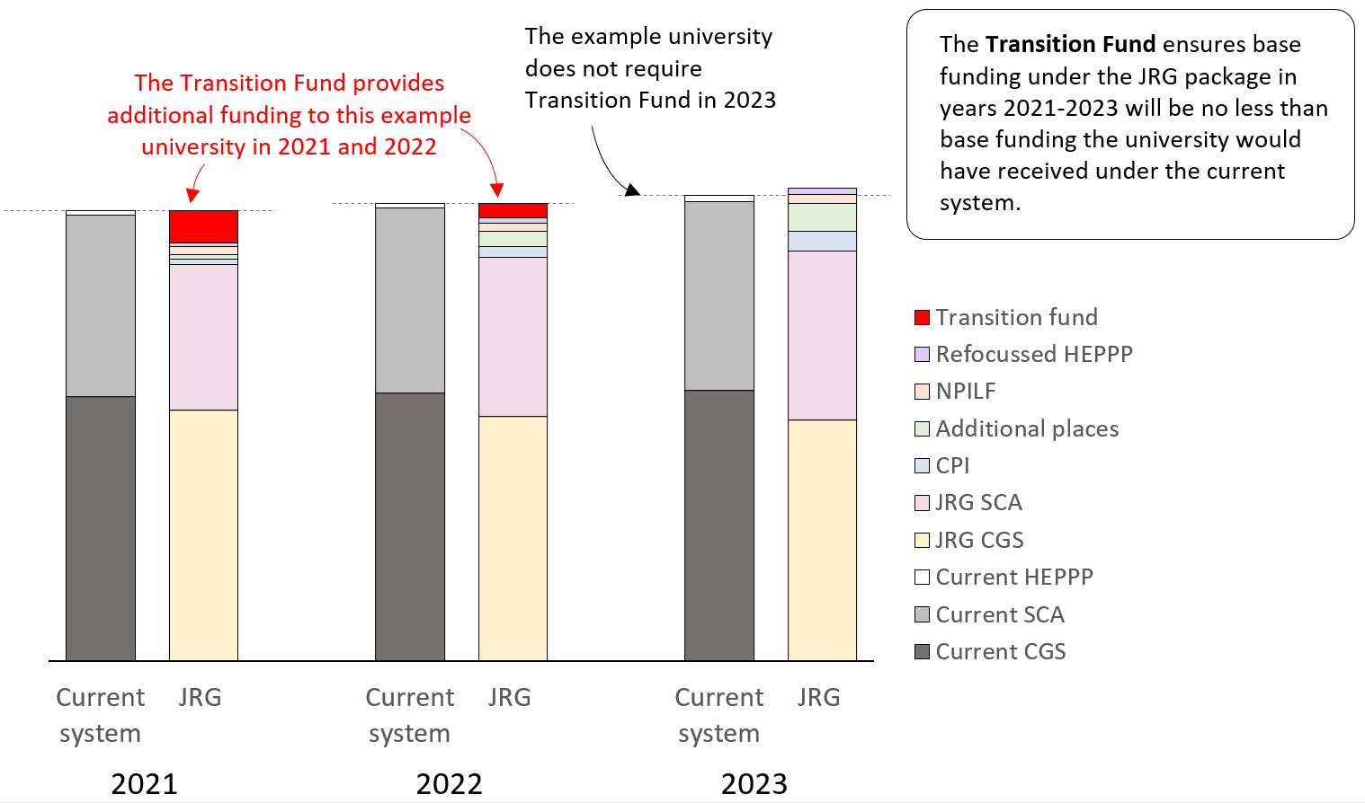

#### Funding for universities will not reduce

Under the package universities will not receive a dollar less from 2021-2023. The package enables universities to continue to teach and support the upskilling of workers displaced by COVID-19. Total university funding will grow from $18 billion in 2020 to $24 billion in 2030.

#### Universities support their communities

Universities must work with industry and meet the needs of their local communities, as well as deliver good learning and employment outcomes for their graduates. This Bill allows universities additional flexibility meeting their obligations and increases transparency and accountability to the public.

The two new funds – the NPILF and the IRLSAF – will make Government and community expectations for universities clear in terms of the outcomes they achieve for their graduates, their engagement with the business community, and their ability to expand access and participation in higher education.

#### Recognising university capital

Some stakeholders have claimed the Deloitte[64] cost data used in resetting the funding arrangements does not take sufficient account of university capital spending. However, consistent with Australian accounting standards, universities were able to account for the depreciation of building and other infrastructure assets in their data submitted to Deloitte. Universities may adopt the revaluation model which uses actuarial estimates to adjust buildings to fair value, or they may use historical book value.

If a university has fully depreciated assets still in use or where historical book value differs from the cost of replacing a building in its current condition, depreciation may not accurately reflect the full economic costs of using these buildings for teaching activities. This may apply to assets other than buildings, such as plant and equipment assets.

Accordingly the annual costings data collection gave universities the option to include a depreciation adjustment. Nine universities reported an optional depreciation adjustment and the increase in cost per EFTSL among these universities was $424 per EFTSL   
(or 2.18 per cent). While this impact is relatively small, the inclusion of below the line items (including in-kind costs) is likely to be more important for some institutions than others in promoting comparability, while accounting for differences in the way partnerships are structured or how depreciation is calculated across the sector.

**Consultation**

* The Job-ready Graduates package was developed in close consultation with stakeholders.
* Since announcement, the department and Minister for Education have met with every publicly funded university. The Minister received 469 items of correspondence on the package and the department received 3,791 submissions on the draft Bill.
* Changes to the costs for studying additional funding for 100,000 new places by 2030, changes to fee structure to social work and psychology professional pathways, supporting women to study national priorities like teaching, nursing and STEM and amendments to strengthen and extend student protection and provider integrity measures.
* Improvements in equity and access to higher education: ongoing access to HELP, support for Indigenous students and price sensitivity as an influence in student decision making and Tertiary Access Payments for students in regional, rural and remote Australia.
* Support for the integrity of the higher education system and university funding: introduction of a funding floor, a progressive and managed transition so universities maintain revenue over the first three years and funding will increase from $18 million in 2020 to $24 billion in 2030.

## Conclusion

There is a need for reform to the higher education sector that will allow the system to adapt and respond quickly to the issues revealed by the COVID-19 pandemic. The current funding model needs to have more flexibility; as the static funding model focused on institutional allocations is no longer fit-for-purpose. Tertiary reform needs to deliver the skills and job outcomes that pave the way for a post-COVID-19 economy and we need better regional outcomes, with more opportunity for regional students. Australia needs better performing universities with increased focus on the national interest, and to ensure students and universities are incentivised to focus on work relevant qualifications that will support growth in a tertiary qualified workforce.

The Job-Ready Graduates package, facilitated by this Bill, will ensure the Australian higher education system is fit for the future, and will support the economy to bounce back better after the COVID-19 pandemic. Specifically, the package will:

* provide 100,000 new places for Australian students to study at university by 2030
* direct growth in a geographically diverse way to where it is needed most
* increase funding for universities from $18 billion in 2020 to $20 billion in 2024
* encourage students to gain the skills needed to assist economic recovery
* encourage universities to produce Job-ready graduates, and
* ensure universities are held accountable for the outcomes they deliver for students, industry and the wider community.

The Government has listened to the concerns raised by stakeholders regarding this Bill, and has made changes and adjustments to ensure universities, industry, students and the government can all work together to contribute to the nation’s recovery from COVID-19 and improve productivity and educational attainment.

The department thanks the Committee for considering this submission. The department will provide any further information to the Committee as required.

Acronyms

|  |  |
| --- | --- |
| ABS | Australian Bureau of Statistics |
| ACU | Australian Catholic University |
| ANU | Australian National University |
| ARC | Australian Research Council |
| BU | Bond University |
| CDU | Charles Darwin University |
| CGS | Commonwealth Grant Scheme |
| CMU | Carnegie Mellon University |
| COVID-19 | Novel coronavirus |
| CPI | Consumer Price index |
| CQU | CQ University |
| CSIRO | Commonwealth Scientific and Industrial Research Organisation |
| CSP | Commonwealth supported place |
| CSU | Charles Sturt University |
| CU | Curtin University |
| DU | Deakin University |
| ECU | Edith Cowan University |
| EFTSL | Equivalent full-time student load |
| FOE | Field of education |
| Flinders | Flinders University |
| FUA | Federation University of Australia |
| GU | Griffith University |
| HECS | Higher Education Contribution Scheme |
| HELP | Higher Education Loan Program |
| HEPPP | Higher Education Participation and Partnerships Program |
| IRLSAF | Indigenous Regional Low Socio-Economic Attainment Fund |
| IT | Information Technology |
| JCU | James Cook University |
| LSAY | Longitudinal Survey of Australian Youth |
| LTU | La Trobe University |
| MBGA | Maximum Basic Grant Amount |
| MU | Macquarie University |
| MU | Monash University |
| MU | Murdoch University |
| MYEFO | Mid-Year Economic and Fiscal Outlook |
| The Napthine Review | National Regional, Rural and Remote Education Strategy |
| NPILF | National Priorities and Industry Linkage Fund |
| NUHEP | Non-university higher education provider |
| OECD | Organisation for Economic Co-operation and Development |
| PBF | Performance-Based Funding |
| QUT | Queensland University of Technology |
| RMIT | RMIT University |
| RSWG | Research Sustainability Working Group |
| RUCs | Regional University Centres |
| SCA | Student contribution amount |
| SCU | Southern Cross University |
| SES | Socio-Economic Status |
| STEM | Science, Technology, Engineering and Maths |
| SUT | Swinburne University of Technology |
| TAP | Tertiary Access Payment |
| The Bill | The Higher Education Support Amendment (Job-Ready Graduates and Supporting Regional and Remote Students) Bill 2020 |
| The department | The Department of Education, Skills and Employment |
| The Government | The Australian Government |
| The package | The Job-ready Graduates Package of reforms to higher education |
| TUA | Torrens University Australia |
| UA | University of Adelaide |
| UC | University of Canberra |
| UCL | University College London |
| UD | University of Divinity |
| UM | University of Melbourne |
| UN | University of Newcastle |
| UNDA | University of Notre Dame Australia |
| UNE | University of New England |
| UNSW | University of New South Wales |
| UQ | University of Queensland |
| US | University of Sydney |
| USA | University of South Australia |
| USC | University of the Sunshine Coast |
| USQ | University of Southern Queensland |
| UT | University of Technology, Sydney |
| UT | University of Tasmania |
| UW | University of Wollongong |
| UWA | University of Western Australia |
| UWS | University of Western Sydney |
| VET | Vocational Education and Training |
| VET FEE-HELP | Vocational Education and Training FEE Higher Education Loan Program |
| VU | Victoria University |
| WEI | Work experience in industry |

# References

AIG (Australian Industry Group) (2019) [*Realising Potential: Solving Australia’s tertiary education challenge*](https://cdn.aigroup.com.au/Reports/2019/REALISING_POTENTIAL.pdf)*,* accessed 10 September 2020

Australian Academy of Science and Australian Academy of Technology and Engineering (2019) [*Women in STEM Decadal Plan*](https://www.science.org.au/files/userfiles/support/reports-and-plans/2019/gender-diversity-stem/women-in-STEM-decadal-plan-final.pdf)*,* Australian Academy of Science website, accessed 10 September 2020

Australian Bureau of Statistics (2017) [*2016 Census QuickStats*](https://quickstats.censusdata.abs.gov.au/census_services/getproduct/census/2016/quickstat/036)*,* ABS website, accessed 9 September 2020

Australian Bureau of Statistics (2019) [*6227.0 Education and Work: Key Statistics*](https://www.abs.gov.au/ausstats/abs@.nsf/mf/6227.0/)*,* ABS website, accessed 9 September 2020

Australian Bureau of Statistics (2020) [*3222.0 Population Projections, Australia, 2017 (base) – 2066 (series B)*](https://www.abs.gov.au/ausstats/abs@.nsf/latestProducts/3222.0Media%20Release12017%20(base)%20-%202066)*,* ABS website, accessed 9 September

Australian Bureau of Statistics*,* [*Labour Force, Australia, Detailed, Quarterly, cat. no. 6291.0.55.003*](https://docs.education.gov.au/node/53035)*,* ABS website accessed 10 September 2020*.*

Australian Qualifications Framework Review Panel (2019) [*Review of the Australian Qualifications Framework Final Report 2019*](https://www.education.gov.au/australian-qualifications-framework-review-0)*,* Department of Education and Training, accessed 10 September 2020

Bolton, R. (2020) *COVID-19 has ended universities’ old ways of working*. Financial Review, <https://www.afr.com/work-and-careers/education/covid-19-has-ended-universities-old-way-of-working-20200811-p55kq9> accessed 10 September 2020

Business Council of Australia (2018) ‘*Future-Proof: Australia’s future post-secondary education and skills system’*

Corliss, M., Daly, A. and Lewis, P. (2018), *The Costs and Benefits of a Bachelor Degree in Australia*, a report to the Department of Education and Training, the Centre for Labour Market Research

Daly, A., Lewis, P., Corliss, M. and Heaslip, T. (2015), [*The private rate of return to a university degree in Australia*,](https://journals.sagepub.com/doi/pdf/10.1177/0004944114565117) Australian Journal of Education, 0(0). 1-16 DOI:10.1177/0004944114565117

Data61, CSIRO (2016), [*Tomorrow’s Digitally Enabled Workforce*](https://publications.csiro.au/rpr/download?pid=csiro:EP161054&dsid=DS1) CSIRO, Australian Government, accessed 10 September 2020

Deloitte Access Economics (2011) *The impact of changes to student contribution levels and repayment thresholds on the demand for higher education,* Deloitte Access Economics, produced for the then Department of Education, Employment and Workplace Relations

Deloitte Access Economics (2019) [*Transparency in Higher Education Expenditure*](https://docs.education.gov.au/documents/2018-transparency-higher-education-expenditure-publication), Department of Education and Training, Australian Government, accessed 10 September 2020

Deloitte Report (2016) [*Driving Innovation, Fairness and Excellence in Australian Higher Education,*](https://docs.education.gov.au/documents/driving-innovation-fairness-and-excellence-australian-education)Department of Education and Training, Australian Government

Department of Education (2019), [*Undergraduate applications, offers and acceptances 2019*](https://docs.education.gov.au/node/53035)*,* Department of Education Skills and Employment, Australian Government, accessed 9 September 2020

Department of Education and Training (2018) [*Consultation Paper on the reallocation of Commonwealth supported places for enabling, sub-Bachelor and Post-graduate courses*](https://docs.education.gov.au/node/51631)*,* Department of Education and Training, Canberra

Department of Education and Training (2019), *Undergraduate Applications, Offers and Acceptances 2019 report, Table 1, p.6,* Department of Education and Training, Australian Government (unpublished)

Department of Education Skills and Employment (2020), [*Selected Higher Education Statistics*](https://www.education.gov.au/selected-higher-education-statistics-2018-student-data)*,* accessed 10 September 2020

Department of Education, Skills and Employment (2020) [*Employment Projections: 2019 Employment projections - for the five years to May 2024*](https://lmip.gov.au/default.aspx?LMIP/GainInsights/EmploymentProjections)*,* Labour Market Information Portal website, accessed 9 September 2020

Department of Education, Skills and Employment (2020) [*The Job-ready Graduates Higher Education Reform Package 2020 Discussion Paper*,](https://www.dese.gov.au/document/job-ready-graduates-discussion-paper) Department of Education, Skills and Employment, Canberra

Department of Education, Skills and Employment (2020) [*uCube – Higher Education Data Cube*](http://highereducationstatistics.education.gov.au/) [data set], education.gov.au, accessed 10 September 2020

Department of Education, Skills and Employment (2020) using data extracted from QILT (Quality Indicators of Learning and Teaching) *2019 Graduate Outcomes Survey – Longitudinal,* [analysed data set unpublished]

Department of Employment, Skills, Small and Family Business (2019) [*Industry Outlook*](https://australianjobs.employment.gov.au/jobs-future/industry-outlook), Australian Jobs website, accessed 9 September 2020

Education Legislation Amendment (Provider Integrity and Other Measures) Act 2017

Frydenberg J and Morrison S (7 August 2020) [*More support for business and workers*](https://ministers.treasury.gov.au/ministers/josh-frydenberg-2018/media-releases/more-support-businesses-and-workers) [media release], Australian Government, accessed 10 September 2020

Hajkowicz et al. (2016) [*Tomorrow’s Digitally Enabled Workforce: Megatrends and scenarios for jobs and employment in Australia over the coming twenty years*](https://publications.csiro.au/rpr/download?pid=csiro:EP161054&dsid=DS1), CSIRO, Brisbane

Higher Education Standards Panel (2019) [*Review of the Higher Education Provider Category Standards,*](https://www.education.gov.au/review-higher-education-provider-category-standards)Department of Education and Training, accessed 10 September 2020

[Higher Education Support Act 2003](http://www.legislation.gov.au/Details/C2020C00197)

Higher Education Support Amendment (2008 Budget Measures) Act 2008

Joyce S, [Strengthening Skills: Expert Review of Australia’s Vocational Education and Training System](https://pmc.gov.au/domestic-policy/vet-review), PMC&C website, accessed 10 September 2020

Labour force participation rates sourced from the Australian Bureau of Statistics (2019) [*Labour Force Survey 6202.0,*](https://www.abs.gov.au/ausstats/abs@.nsf/mf/6202.0)ABS website, accessed 9 September 2020.

Multiple authors (2020) [*Job-ready Graduates Package — draft legislation submissions*](https://docs.education.gov.au/node/54992) Department of Education, Skills and Employment, Australian Government

Norton A., Cherastidtham, I., and Mackey, W. (2018) [Mapping Australian higher education *2018*](https://grattan.edu.au/wp-content/uploads/2018/09/907-Mapping-Australian-higher-education-2018.pdf) Grattan Institute, accessed 10 September 2020

Organisation for Economic Co-operation and Development (2019) *Percentage of the population with a Bachelor degree or above, 25-34 year olds*, extracted from 2019 data

Productivity Commission (2019) [*The Demand-Driven University System: A Mixed Report Card,*](https://www.pc.gov.au/research/completed/university-report-card)Commission Research Paper, Productivity Commission, Australian Government, accessed 10 September 2020

QILT (Quality Indicators of Learning and Teaching) (2019) [*2018 Graduate Outcomes Survey – National Report*,](https://www.qilt.edu.au/docs/default-source/default-document-library/qilt-gos-national-report-2018.pdf?sfvrsn=23f7ec3c_0) Department of Education, Skills and Employment, Australian Government, accessed 10 September 2020

QILT (Quality Indicators of Learning and Teaching) (2019) [*2019 Graduate Outcomes Survey - Longitudinal*](https://www.qilt.edu.au/docs/default-source/gos-reports/2019-gos-l/2019-gos-l-national-report.pdf?sfvrsn=63fdec3c_4), Department of Education, Skills and Employment, Australian Government, accessed 10 September 2020

Regional Education Expert Advisory Group (2019) [*National Regional, Rural and Remote Tertiary Education Strategy - final report*,](https://docs.education.gov.au/node/53035)report to Department of Education and Training, Australian Government, accessed 10 September 2020

Regional Universities Network (2018) [*Jobs and productivity effects of Regional Universities Network*](http://www.run.edu.au/resources/RUN%20Jobs%20and%20productivity%20report%20final.pdf), accessed 10 September 2020

Shergold P (2020) [*Review of senior secondary pathways into work, further education and training*](https://uploadstorage.blob.core.windows.net/public-assets/education-au/pathways/Final%20report%20-%2018%20June.pdf)*,* Pathways review website, accessed 10 September 2020

Tehan D (19 June 2020) *Minister for Education Dan Tehan National Press Club address*[speech], accessed 10 September 2020

Tehan D and Gee A (25 August 2020) [*Job-ready Graduates legislation*](https://ministers.dese.gov.au/tehan/job-ready-graduates-legislation)[media release], Australian Government, accessed 10 September 2020

The Commonwealth of Australia (2018) 2017-18 Budget, The Treasury, Australian Government, accessed 10 September 2020

The Commonwealth of Australia (2018) Mid-Year Fiscal Economic Outlook 2017-2018,   
The Treasury

Universities Australia, (2018) [*Almost 10,000 student places unfunded as uni offers go out*,](https://www.universitiesaustralia.edu.au/media-item/almost-10000-student-places-unfunded-as-uni-offers-go-out/) [media release], accessed 10 September 2020

University of Birmingham (2020), [*Tuition fees for undergraduates*](https://www.birmingham.ac.uk/undergraduate/fees/fees.aspx), University of Birmingham website, accessed 10 September 2020

University of Edinburgh (2020), [*Full-time fees for new students 2020-2021*](https://www.ed.ac.uk/tuition-fees/find/undergraduate/2020-2021/full-time-new-students), University of Edinburgh website, accessed 10 September 2020

Warburton, M. (2020) Unravelling the Tehan vision for higher education, University of Melbourne

# Appendix A: Economic Growth and Labour Force needs

Treasury’s July 2020 sensitivity analysis in the Economic and Fiscal Update suggests the measured unemployment rate could reach between 7 per cent and 10 and three quarter   
per cent by the December quarter 2020. This will depend on how available worked hours are split between existing and new employees and the degree to which labour force participation recovers. [65]

The unprecedented nature of the economic impacts of the COVID‑19 pandemic, and related policy responses, means alternative labour market indicators such as the effective unemployment rate, which takes into account those who have recently dropped out of the labour force and those who worked zero hours but are still attached to their employer (and were classified as employed), is a more useful indicator of spare capacity in the labour market at the current time.

The effective unemployment rate was close to 15 per cent in April 2020 compared to the headline unemployment rate of 6.4 per cent in the same month. The effective unemployment rate has fallen since then and in July was estimated to be 9.9 per cent   
(down from 11.2 per cent in June), while the seasonally adjusted unemployment rate for July was 7.5 per cent (compared to 7.4 per cent in June, and 5.1 per cent in February before COVID-19 restrictions). The July Labour Force Survey showed that employment increased by 114,700 persons in July and the participation rate increased to 64.7 per cent, up from   
64.1 per cent in June, as people returned to the labour force.

While the Australian economy will gradually recover from the severe adverse effects of the pandemic, the road to recovery will be long, bumpy and unpredictable.

Treasury’s latest economic forecasts, released in the July update, show economic activity and employment will likely remain below pre-COVID-19 levels for at least the next   
12 months. This reflects assumptions about continuing restrictions to contain outbreaks of COVID-19 which is keeping sentiment and confidence among consumers and business below average, as well as the dislocation expected from the substantial loss of business and household income. [66]

As shown in the figure below, the headline unemployment is forecast to rise, reflecting a gradual labour market recovery which has more people return to the labour force   
(and resulted reduction in effective unemployment rate).

The effective unemployment rate and headline unemployment rate[67]

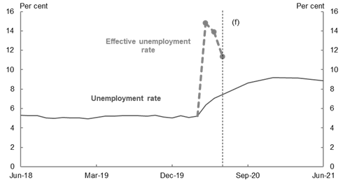

# Appendix B: Working Groups

On 1 July 2020, the Minister for Education, the Hon Dan Tehan MP announced two working groups of university Vice-Chancellors. The working groups are assisting the Australian Government establish the National Priorities and Industry Linkage Fund (NPILF) and advise on sustainable approaches to research funding into the future (the Research Sustainability Working Group (RSWG)).

### Research Sustainability Working Group

The RSWG is chaired by Professor Deborah Terry AO, Vice‑Chancellor of the University of Queensland, and advises on sustainable approaches to research funding for universities during COVID-19 and beyond. The group will continue to meet until at least December 2020.

The RSWG members have been appointed for their individual expertise and to provide advice on the higher education research funding architecture, and options the Government could consider to ensure the ongoing sustainability and strength of Australia’s research system.

As a matter of priority, the RSWG is considering options within the Minister’s portfolio to provide short and medium-term support to university research, to fill the shortfall in revenue experienced as a result of the loss of the international student market.

The RSWG members are:

* Professor Margaret Sheil AO, Vice-Chancellor of Queensland University of Technology
* Professor Duncan Maskell, Vice-Chancellor of the University of Melbourne
* Professor Ian Jacobs, Vice-Chancellor, University of New South Wales
* Professor Rufus Black, Vice-Chancellor of the University of Tasmania
* Professor Simon Maddocks, Vice-Chancellor of Charles Darwin University
* Professor Margaret Gardner, Vice-Chancellor of Monash University
* Professor Attila Brungs, Vice-Chancellor of University of Technology, Sydney
* Professor Geraldine MacKenzie, Vice-Chancellor of the University of Southern Queensland

### National Priorities and Industry Linkage Fund Working Group

The NPILF has a strong focus on STEM jobs and increasing the number and quality of work-integrated learning opportunities for students.

The NPILF working group members have been appointed for their individual expertise and provide advice on the design and implementation of the fund, ahead of its 2024 implementation. The working group is chaired by Professor Attila Brungs, Vice-Chancellor, University of Technology, Sydney.

The final NPILF model will be implemented by 2024 with a transition phase from 2021-23. The transition phase allows for extensive consultation with the sector, industry and the wider community to ensure the fund is dynamic and fit for purpose. This consultation commenced in September 2020.

The NPILF working group members are:

* Professor Brian Schmidt AC, Vice-Chancellor, The Australian National University
* Professor Barney Glover, Vice-Chancellor, University of Western Sydney
* Professor David Lloyd, Vice-Chancellor & President, University of South Australia
* Professor Deborah Terry AO, Vice-Chancellor, The University of Queensland
* Professor Alex Zelinsky AO, Vice-Chancellor, The University of Newcastle
* Professor Eeva Leinonen, Vice-Chancellor, Murdoch University
* Professor Helen Bartlett, Vice-Chancellor, University of the Sunshine Coast

### Regional University Roundtables

In July 2020, the Minister for Decentralisation and Regional Education, Mr Andrew Gee MP, convened three Regional Universities Roundtables with universities and university peak bodies to hear perspectives on the unique challenges faced by the regional higher education sector during these unprecedented times.

The roundtable participants were:

* Mr John Abbott, Chancellor of CQ University
* Dr Michele Allan, Chancellor of Charles Sturt University – attendance not confirmed.
* Ms Patricia Anderson AO, Chairperson, Batchelor Institute Council
* Professor Rufus Black, Vice-Chancellor and President of University of Tasmania
* The Hon John Brumby AO, Chancellor of La Trobe University
* The Hon Julie Bishop, Chancellor of Australian National University
* Ms Jillian Broadbent AO, Chancellor of University of Wollongong
* Dr Andrew Crane, Chancellor of Curtin University
* Professor Greg Craven AO, Vice-Chancellor and President of Australian Catholic University
* Professor John Dewar AO, Vice-Chancellor and President of La Trobe University
* Mr John Dornbusch, Chancellor of University of Southern Queensland
* Professor Robert Elliot, Acting Vice-Chancellor and President of University of the Sunshine Coast
* The Hon John Fahey AC, Chancellor of Australian Catholic University
* Mr Stephen Gerlach AM, Chancellor of Flinders University
* Professor John Germov, A/g Vice-Chancellor of Charles Sturt University
* Mr James Harris, Chancellor of University of New England
* Professor Sandra Harding AO, Vice-Chancellor and President of James Cook University
* Professor Brigid Heywood, Vice-Chancellor and CEO of University of New England
* Air Chief Marshal Sir Angus Houston AK, AFC (Ret’d), Chancellor of Charles Sturt University
* Ms Catriona Jackson, Chief Executive Officer of Universities Australia
* Mr Paul Jeans, Chancellor of University of Newcastle
* Mr Conor King, Executive Director of Innovation Research Universities
* Professor Nick Klomp, Vice-Chancellor and President of CQ University
* Professor Steve Larkin, CEO of Batchelor Institute of Indigenous Education
* Professor Eeva Leinonen, Vice-Chancellor and President of Murdoch University
* Professor Geraldine Mackenzie, Vice-Chancellor of University of Southern Queensland
* Professor Simon Maddocks, A/g Vice-Chancellor and President of Charles Darwin University
* Professor Iain Martin, Vice-Chancellor of Deakin University
* Professor Duncan Maskell, Vice-Chancellor of the University of Melbourne
* Mr Terry Moran, Chancellor Federation University
* Mr Allan J. Myers AC QC, Chancellor of the University of Melbourne
* Dr Caroline Perkins, Executive Director of Regional Universities Network
* Mr Luke Sheehy, Executive Director of the Australian Technology Network of Universities
* Professor Brian Schmidt AC, Vice-Chancellor and President of Australian National University
* Professor Adam Shoemaker, Vice-Chancellor Southern Cross University
* Mr Gary Smith, Chancellor of Murdoch University
* Mr John Stanhope AO, Chancellor of Deakin University
* Professor Colin J Stirling, President and Vice-Chancellor of Flinders University
* Professor Andrew Smith, A/g Vice-Chancellor and President of Federation University of Australia
* Professor Deborah Terry AO, Vice-Chancellor of Curtin University
* Ms Vicki Thomson, Chief Executive of the Group of Eight
* Mr Bill Tweddell, Chancellor of James Cook University
* Professor Paul Wellings CBE, Vice-Chancellor of University of Wollongong
* Professor Alex Zelinsky AO, Vice-Chancellor and President of University of Newcastle

# Appendix C: Summary of Submissions to draft Higher Education Support Amendment (Job‑Ready Graduates and Supporting Regional and Remote Students) Bill 2020 exposure draft consultation

|  |  |
| --- | --- |
| **Category** | **Number of submissions** |
| 1. Universities | 18 |
| 1. Peak Bodies | 17 |
| 1. Political Parties | 2 |
| 1. CGS Funding and Student Contribution Amounts | 206 |
| 1. *Arts, Humanities and Social Sciences* | *122* |
| 1. *Social Work* | *75* |
| 1. *Science, Technology, Engineering and Mathematics (STEM)* | *9* |
| 1. General submissions | 132 |
| 1. Grandfathering and funding envelope | 1 |
| 1. Impact on Indigenous students | 3 |
| 1. Impact on women | 10 |
| 1. Price signal | 3 |
| 1. Impact on regional and remote students | 6 |
| 1. Student protections | 31 |
| Anonymous submissions (not listed) | 13 |
| *Sub-Total* | **442** |
| Save Social Work Australia Campaign (not listed) | 3,349 |
| **Total submissions** | **3,791** |

# 

# Appendix D: Summary of correspondence with the Minister

The table below demonstrates the 469 pieces of correspondence received by the Minister of Education and actioned by the department. The largest proportion of the correspondence (283) considered the package as a whole and some raised multiple issues. The remainder was clearly identified as relating to a specific topic, with most of those outlining concerns about the impact of the package on social work/psychology and humanities/arts studies.

|  |  |
| --- | --- |
| **Correspondence topic** | **Total** |
| Job-ready Graduates | 283 |
| Social work[68] | 84 |
| Humanities | 52 |
| Arts | 14 |
| Psychology | 13 |
| Year 12 | 7 |
| Teaching | 5 |
| Regional | 4 |
| International students | 3 |
| Health | 3 |
| Higher Education Contribution Scheme (HECS) | 1 |
| **TOTAL** | **469** |

# Appendix E: Comparison of expected funding outcomes – current arrangements v Job-ready Graduates package[69]

|  |  |  |  |  |  |  |  |  |  |  |  |  |  |  |  |
| --- | --- | --- | --- | --- | --- | --- | --- | --- | --- | --- | --- | --- | --- | --- | --- |
| **Current model ($bn)** | **2016** | **2017** | **2018** | **2019** | **2020** | **2021** | **2022** | **2023** | **2024** | **2025** | **2026** | **2027** | **2028** | **2029** | **2030** |
| *Teaching and learning* | 13.8 | 14.0 | 14.2 | 14.5 | 15.1 | 15.6 | 15.9 | 16.3 | 16.5 | 16.8 | 17.1 | 17.5 | 17.8 | 18.2 | 18.6 |
| *Research* | 2.8 | 2.8 | 3.1 | 2.9 | 3.0 | 3.1 | 3.1 | 3.1 | 3.3 | 3.4 | 3.5 | 3.6 | 3.7 | 3.7 | 3.8 |
| **Total (current)** | **16.6** | **16.8** | **17.3** | **17.4** | **18.0** | **18.6** | **19.0** | **19.4** | **19.8** | **20.2** | **20.6** | **21.1** | **21.5** | **21.9** | **22.4** |
|  |  |  |  |  |  |  |  |  |  |  |  |  |  |  |  |
| **JRG model ($bn)** | **2016** | **2017** | **2018** | **2019** | **2020** | **2021** | **2022** | **2023** | **2024** | **2025** | **2026** | **2027** | **2028** | **2029** | **2030** |
| *Teaching and learning* | 13.8 | 14.0 | 14.2 | 14.5 | 15.1 | 15.7 | 16.0 | 16.4 | 16.7 | 17.2 | 17.8 | 18.4 | 19.0 | 19.6 | 20.3 |
| *Research* | 2.8 | 2.8 | 3.1 | 2.9 | 3.0 | 3.1 | 3.1 | 3.1 | 3.3 | 3.4 | 3.5 | 3.6 | 3.7 | 3.7 | 3.8 |
| **Total (JRG)** | **16.6** | **16.8** | **17.3** | **17.4** | **18.0** | **18.7** | **19.1** | **19.6** | **20.0** | **20.7** | **21.3** | **22.0** | **22.6** | **23.4** | **24.1** |

# Appendix F: Outstanding HELP debts

Some examples of high HELP debtors include:

* After eight successive years of study in a course with a provider, one HELP debtor passed only   
  31 per cent of the units they undertook in this course and incurred $53,500 in HELP debt. This student was then enrolled in another course with this provider in which they failed all units studied over four years and never received an award qualification.
* Across 13 years between 2005 and 2017, one student was enrolled in seven different courses with a provider while passing only 9 per cent of units and incurring $43,500 in HELP debt. The student is yet to receive an award qualification from this provider.
* In one year, 2018, a student studied with 21 different providers undertaking more than 15 years of study, incurring $113,900 in HELP debt and only passing 6 per cent of the collective set of units they undertook in these courses.

Summary information for individuals with the 30 highest outstanding debts[70]

|  |  |  |  |
| --- | --- | --- | --- |
|  | **Lowest** | **Median** | **Highest** |
| **HELP debt (as at 31 Dec 2019)** | $223,891 | $242,582 | $662,574 |
| **First Year of Study** | 1989 | 2004 | 2013 |
| **Study load** | 5 | 16 | 44 |
| **Number of providers** | 2 | 9 | 31 |
| **Number of courses** | 2 | 10 | 83 |
| **Number of course completions** | 0 | 1 | 10 |
| **Number of units** | 33 | 118 | 337 |
| **Unit completion rate** | 0% | 51% | 100% |
| **% external / online** | 0% | 57% | 97% |

Number of highest 30 HELP debtors enrolled (2005 – 2018)[71]

| **Provider** | **Number of Debtors Enrolled** | **Courses** | **Course Completions** | **Study Load (EFTSL)** | **HELP Debt** |
| --- | --- | --- | --- | --- | --- |
| Open Universities Australia | 16 | 20 | NA | 23.8 | $165,947 |
| The University of New England | 15 | 33 | 4 | 39.1 | $326,471 |
| Deakin University | 13 | 30 | 4 | 33.5 | $353,072 |
| Charles Darwin University | 10 | 22 | 1 | 28.8 | $186,049 |
| Charles Sturt University | 9 | 17 | 0 | 17.7 | $117,912 |
| Macquarie University | 9 | 13 | 3 | 11.8 | $84,890 |
| University of Southern Queensland | 9 | 25 | 3 | 20.4 | $185,358 |
| Swinburne University of Technology | 8 | 16 | 1 | 11.5 | $105,434 |
| James Cook University | 7 | 7 | 0 | 9.3 | $81,683 |
| The University of Sydney | 7 | 9 | 4 | 27.3 | $273,575 |
| University of South Australia | 7 | 9 | 1 | 7.6 | $52,733 |
| The University of Melbourne | 7 | 19 | 4 | 17.3 | $263,572 |
| Southern Cross University | 7 | 11 | 1 | 11.8 | $95,048 |
| Murdoch University | 7 | 10 | 1 | 11.1 | $78,525 |
| Flinders University | 6 | 8 | 0 | 11.5 | $98,907 |
| Curtin University | 6 | 7 | 0 | 9.2 | $35,641 |
| CQ University | 6 | 9 | 0 | 8.2 | $64,676 |
| Griffith University | 6 | 8 | 1 | 3.3 | $32,752 |
| Bond University | 5 | 5 | 1 | 26.6 | $577,907 |
| RMIT University | 5 | 6 | 1 | 3.6 | $32,809 |
| Queensland University of Technology | 5 | 5 | 0 | 4.5 | $38,799 |
| University of Tasmania | 5 | 18 | 0 | 8.0 | $41,891 |
| University of Technology, Sydney | 5 | 13 | 10 | 24.2 | $344,699 |
| Edith Cowan University | 5 | 7 | 0 | 6.4 | $53,981 |
| Monash University | 5 | 9 | 3 | 5.1 | $53,737 |
| La Trobe University | 5 | 7 | 1 | 8.7 | $75,016 |

1. Tehan D (19 June 2020) *Minister for Education Dan Tehan National Press Club address*[speech], accessed 10 September 2020
2. Department of Education, Skills and Employment (2020) [*The Job-ready Graduates Higher Education Reform Package 2020 Discussion Paper*,](https://www.dese.gov.au/document/job-ready-graduates-discussion-paper) Department of Education, Skills and Employment, Canberra, p. 4
3. Department of Education, Skills and Employment (2020) [*Employment Projections: 2019 Employment projections - for the five years to May 2024*](https://lmip.gov.au/default.aspx?LMIP/GainInsights/EmploymentProjections)*,* Labour Market Information Portal website, accessed 9 September 2020
4. Department of Education, Skills and Employment (2020) [*Employment Projections: 2019 Employment projections - for the five years to May 2024*](https://lmip.gov.au/default.aspx?LMIP/GainInsights/EmploymentProjections),Labour Market Information Portal website, accessed 9 September 2020
5. Australian Bureau of Statistics (2019) [*6227.0 Education and Work: Key Statistics*](https://www.abs.gov.au/ausstats/abs@.nsf/mf/6227.0/)*,* ABS website, accessed 9 September 2020
6. Australian Bureau of Statistics (2019) [*Education and Work Key Statistics 6227.0*](https://www.abs.gov.au/ausstats/abs@.nsf/mf/6227.0/), ABS website, accessed 9 September 2020
7. Department of Employment, Skills, Small and Family Business (2019) [*Industry Outlook*](https://australianjobs.employment.gov.au/jobs-future/industry-outlook), Australian Jobs website, accessed 9 September 2020
8. Department of Education and Training (2019), *Undergraduate Applications, Offers and Acceptances 2019 report, Table 1, p.6,* Department of Education and Training, Australian Government (unpublished)
9. Internal analysis undertaken by the Department of Education, Skills and Employment using data extracted from the table builder sourced from the Australian Bureau of Statistics (2019) [*Education and Work Key Statistics 6227.0*](https://www.abs.gov.au/ausstats/abs@.nsf/mf/6227.0/)*,* ABS website, accessed 9 September 2020
10. Labour force participation rates sourced from the Australian Bureau of Statistics (2019) [*Labour Force Survey 6202.0,*](https://www.abs.gov.au/ausstats/abs@.nsf/mf/6202.0)ABS website, accessed 9 September 2020

    Data relating to school leavers’ applications sourced from Department of Education (2019), [*Undergraduate applications, offers and acceptances 2019*](https://docs.education.gov.au/node/53035)*,* Department of Education Skills and Employment, Australian Government, accessed 9 September 2020
11. Australian Bureau of Statistics (2017) [*2016 Census QuickStats*](https://quickstats.censusdata.abs.gov.au/census_services/getproduct/census/2016/quickstat/036)*,* ABS website, accessed on 9 September 2020
12. Productivity Commission (2019) [*The Demand-Driven University System: A Mixed Report Card,*](https://www.pc.gov.au/research/completed/university-report-card)Commission Research Paper, Productivity Commission, Australian Government, accessed 10 September 2020
13. Geodesic distance from a major university campus in the last year of school, estimated from postcode level data. High achievers are those students in the top quartile for literacy and numeracy based on PISA scores. Data are for attendance by age 22 years in 2010 (2003 cohort), 2013 (2006 cohort) and 2016 (2009 cohort).
14. Regional Education Expert Advisory Group (2019) [*National Regional, Rural and Remote Tertiary Education Strategy - final report*,](https://docs.education.gov.au/node/53035)report to Department of Education and Training, Australian Government, accessed 10 September 2020
15. Australian Academy of Science and Australian Academy of Technology and Engineering (2019) [*Women in STEM Decadal Plan*](https://www.science.org.au/files/userfiles/support/reports-and-plans/2019/gender-diversity-stem/women-in-STEM-decadal-plan-final.pdf)*,* Australian Academy of Science website, accessed 10 September 2020
16. Data61, CSIRO (2016), [*Tomorrow’s Digitally Enabled Workforce*](https://publications.csiro.au/rpr/download?pid=csiro:EP161054&dsid=DS1) CSIRO, Australian Government, accessed 10 September 2020
17. Hajkowicz et al. (2016) [*Tomorrow’s Digitally Enabled Workforce: Megatrends and scenarios for jobs and employment in Australia over the coming twenty years*](https://publications.csiro.au/rpr/download?pid=csiro:EP161054&dsid=DS1), CSIRO, Brisbane
18. Department of Education Skills and Employment (2020), [*Selected Higher Education Statistics*](https://www.education.gov.au/selected-higher-education-statistics-2018-student-data)*,* accessed 10 September 2020
19. Daly, A., Lewis, P., Corliss, M. and Heaslip, T. (2015), [*The private rate of return to a university degree in Australia*,](https://journals.sagepub.com/doi/pdf/10.1177/0004944114565117) Australian Journal of Education, 0(0). 1-16. DOI:10.1177/0004944114565117
20. Australian Bureau of Statistics (2020)*,* [*Labour Force, Australia, Detailed, Quarterly, cat. no. 6291.0.55.003*](https://docs.education.gov.au/node/53035)*,* ABS website accessed 10 September 2020*.* National Skills Commission seasonally adjusted data. Data for all occupations will not equal the sum of Skill Level employment data as they are separately seasonally adjusted.
21. Australian Bureau of Statistics (2020),[*Labour Force, Australia, Detailed, Quarterly, cat. no. 6291.0.55.003*](https://docs.education.gov.au/node/53035)*,* ABS website accessed 10 September 2020*.* National Skills Commission seasonally adjusted data. Data for all occupations will not equal the sum of Skill Level employment data as they are separately seasonally adjusted.
22. Frydenberg J and Morrison S (7 August 2020) [*More support for business and workers*](https://ministers.treasury.gov.au/ministers/josh-frydenberg-2018/media-releases/more-support-businesses-and-workers) [media release], Australian Government, accessed 10 September 2020
23. Department of Education Skills and Employment (2020). Providers listed in Table A of the Higher Education Support Act 2003 (also known as ‘HESA’) Act are eligible for all Australian Government grants and their students can receive all forms of assistance. Full list of [Table A.](https://www.legislation.gov.au/Details/C2020C00197)
24. This is an estimate of additional places that would be provided with funding provided under the Job-ready Graduates package. Projections of additional places are sensitive to assumptions regarding university and student decisions regarding enrolments in different disciplines. Increased enrolments in priority areas, which have higher CGS funding rates will reduce the number of places delivered, while increases in disciplines such as law, economics and social studies will significantly increase the number of places able to be delivered.
25. In 2023 and 2024 there is a significant spike in 18 year olds projected. This swell in the population has sometimes been attributed to the policies of the Government in the early-mid 2000s, when the then Treasurer, Peter Costello, popularised the phrase “one for mum, one for dad, and one for the country!” while introducing the baby bonus scheme.
26. Australian Bureau of Statistics (2020) [*3222.0 Population Projections, Australia, 2017 (base) – 2066 (series B)*](https://www.abs.gov.au/ausstats/abs@.nsf/latestProducts/3222.0Media%20Release12017%20(base)%20-%202066)*,* ABS website, accessed 9 September
27. Australian Bureau of Statistics (2020) [*3222.0 Population Projections, Australia, 2017 (base) – 2066 (series B)*](https://www.abs.gov.au/ausstats/abs@.nsf/latestProducts/3222.0Media%20Release12017%20(base)%20-%202066)*,* ABS website, accessed 9 September
28. Organisation for Economic Co-operation and Development, 2019, *Percentage of the population with a Bachelor degree or above, 25-34 year olds*, extracted from 2019 data
29. Regional Education Expert Advisory Group (2019[) *National Regional, Rural and Remote Tertiary Education Strategy - final report*](https://docs.education.gov.au/node/53035)Department of Education and Training, Australian Government, accessed 10 September 2020

    Higher Education Standards Panel (2019) [*Review of the Higher Education Provider Category Standards,*](https://www.education.gov.au/review-higher-education-provider-category-standards)Department of Education and Training, accessed 10 September 2020

    Australian Qualifications Framework Review Panel (2019) [*Review of the Australian Qualifications Framework Final Report 2019*](https://www.education.gov.au/australian-qualifications-framework-review-0)*,* Department of Education and Training, accessed 10 September 2020
30. Joyce S, [Strengthening Skills: Expert Review of Australia’s Vocational Education and Training System](https://pmc.gov.au/domestic-policy/vet-review), PMC&C website, accessed 10 September 2020

    Shergold P (2020) [*Review of senior secondary pathways into work, further education and training*](https://uploadstorage.blob.core.windows.net/public-assets/education-au/pathways/Final%20report%20-%2018%20June.pdf)*,* Pathways review website, accessed 10 September 2020
31. Department of Education and Training (2018) [*Consultation Paper on the reallocation of Commonwealth supported places for enabling, sub-Bachelor and Post-graduate courses*](https://docs.education.gov.au/node/51631)*,* Department of Education and Training
32. The number of underutilised places is an estimate calculated by dividing the underutilised funding by the average non-designated and designated funding amounts per place. The number of places available will vary depending on which funding cluster with which they are associated.
33. Deloitte Access Economics (2019) [*Transparency in Higher Education Expenditure*](https://docs.education.gov.au/documents/2018-transparency-higher-education-expenditure-publication), Department of Education and Training, Australian Government, accessed 10 September 2020

    Universities Australia, (2018) [*Almost 10,000 student places unfunded as uni offers go out*,](https://www.universitiesaustralia.edu.au/media-item/almost-10000-student-places-unfunded-as-uni-offers-go-out/) [media release], accessed 10 September 2020

    Warburton, M., 2020, [*Unravelling the Tehan vision for higher education*,](https://melbourne-cshe.unimelb.edu.au/__data/assets/pdf_file/0010/3477718/Unravelling-the-Tehan-Vision-Final-Saturday-28-8-20.pdf) The University of Melbourne, accessed 10 September 2020

    Deloitte report (2016) [*Driving Innovation, Fairness and Excellence in Australian Higher Education,*](https://docs.education.gov.au/documents/driving-innovation-fairness-and-excellence-australian-education)Department of Education and Training, Australian Government
34. The Treasury (2018) 2017-18 Budget, The Treasury, Australian Government, accessed 10 September 2020
35. Department of Education and Training (2018) [*Consultation Paper on the reallocation of Commonwealth supported places for enabling, sub-Bachelor and Post-graduate courses*](https://docs.education.gov.au/node/51631)*,* Department of Education and Training
36. Tehan D (19 June 2020) *Minister for Education Dan Tehan National Press Club address*[speech], accessed 10 September 2020
37. Multiple authors (2020) [*Job-ready Graduates Package — draft legislation submissions*](https://docs.education.gov.au/node/54992) Department of Education, Skills and Employment, Australian Government
38. Tehan D and Gee A (25 August 2020) [*Job-ready Graduates legislation*](https://ministers.dese.gov.au/tehan/job-ready-graduates-legislation)[media release], Australian Government, accessed 10 September 2020
39. The grandfathered Commonwealth contribution amount in section 33-10 of the Bill relating to item 5 is a drafting error and should be $13,250 and not $13,500. This error is replicated in the Explanatory Memorandum. Both references will be corrected in the final passage of the Bill.
40. Business Council of Australia (2018) ‘[*Future-Proof: Australia’s future post-secondary education and skills system’*](https://d3n8a8pro7vhmx.cloudfront.net/bca/pages/4386/attachments/original/1542258016/LoRes-2018_BCA_EDUC_Future_Proof_WIP1A_%281%29.pdf?1542258016)accessed 10 September 2020
41. AIG (Australian Industry Group) (2019) [*Realising Potential: Solving Australia’s tertiary education challenge*](https://cdn.aigroup.com.au/Reports/2019/REALISING_POTENTIAL.pdf)*,* accessed 10 September 2020
42. [*Higher Education Support Act 2003*](http://www.legislation.gov.au/Details/C2020C00197)
43. Department of Education, Skills and Employment (2020) [*uCube – Higher Education Data Cube*](http://highereducationstatistics.education.gov.au/) [data set], education.gov.au, accessed 10 September 2020
44. University of Edinburgh (2020), [*Full-time fees for new students 2020-2021*](https://www.ed.ac.uk/tuition-fees/find/undergraduate/2020-2021/full-time-new-students), University of Edinburgh website, accessed 10 September 2020; and

    University of Birmingham (2020), [*Tuition fees for undergraduates*](https://www.birmingham.ac.uk/undergraduate/fees/fees.aspx), University of Birmingham website, accessed 10 September 2020
45. Norton, A., Cherastidtham, I., and Mackey, W. (2018) [Mapping Australian higher education *2018*](https://grattan.edu.au/wp-content/uploads/2018/09/907-Mapping-Australian-higher-education-2018.pdf) Grattan Institute, accessed 10 September 2020
46. Norton A., Cherastidtham, I., and Mackey, W. (2018) [Mapping Australian higher education *2018*](https://grattan.edu.au/wp-content/uploads/2018/09/907-Mapping-Australian-higher-education-2018.pdf) Grattan Institute, accessed 10 September 2020
47. Departmental charting of data derived from Norton, A., Cherastidtham, I., and Mackey, W. (2018) [Mapping Australian higher education *2018*](https://grattan.edu.au/wp-content/uploads/2018/09/907-Mapping-Australian-higher-education-2018.pdf) Grattan Institute, accessed 10 September 2020
48. Departmental analysis using data derived from an internal report by Corliss, M., Daly, A. and Lewis, P. (2018), *The Costs and Benefits of a Bachelor Degree in Australia*, a report to the Department of Education and Training, the Centre for Labour Market Research
49. QILT (Quality Indicators of Learning and Teaching) (2019) [*2019 Graduate Outcomes Survey - Longitudinal*](https://www.qilt.edu.au/docs/default-source/gos-reports/2019-gos-l/2019-gos-l-national-report.pdf?sfvrsn=63fdec3c_4), Department of Education, Skills and Employment, Australian Government, accessed 10 September 2020
50. QILT (Quality Indicators of Learning and Teaching) (2019) [*2019 Graduate Outcomes Survey - Longitudinal*](https://www.qilt.edu.au/docs/default-source/gos-reports/2019-gos-l/2019-gos-l-national-report.pdf?sfvrsn=63fdec3c_4), Department of Education, Skills and Employment, Australian Government, accessed 10 September 2020
51. Internal analysis of the 2016 cohort undertaken by the Department of Education, Skills and Employment (2020) using data extracted from QILT (Quality Indicators of Learning and Teaching) *2019 Graduate Outcomes Survey – Longitudinal,* [analysed data set unpublished].
52. Deloitte Access Economics (2011) *The impact of changes to student contribution levels and repayment thresholds on the demand for higher education,* Deloitte Access Economics, produced for the then Department of Education, Employment and Workplace Relations
53. Higher Education Support Amendment (2008 Budget Measures) Act 2008
54. Education Legislation Amendment (Provider Integrity and Other Measures) Act 2017
55. Regional Education Expert Advisory Group (2019) [*National Regional, Rural and Remote Tertiary Education Strategy - final report*](https://docs.education.gov.au/node/53035), Department of Education, Canberra.
56. QILT (Quality Indicators of Learning and Teaching) (2019) [*2018 Graduate Outcomes Survey – National Report*,](https://www.qilt.edu.au/docs/default-source/default-document-library/qilt-gos-national-report-2018.pdf?sfvrsn=23f7ec3c_0) Department of Education, Skills and Employment, Australian Government, accessed 10 September 2020
57. Bolton, R. (2020) *COVID-19 has ended universities’ old ways of working*. Financial Review, <https://www.afr.com/work-and-careers/education/covid-19-has-ended-universities-old-way-of-working-20200811-p55kq9> accessed on 10 September 2020
58. Departmental analysis showed that in 2018 over 65 per cent of regional and remote university students studied at regionally-headquartered universities
59. Regional Universities Network (2018) [*Jobs and productivity effects of Regional Universities Network*](http://www.run.edu.au/resources/RUN%20Jobs%20and%20productivity%20report%20final.pdf), accessed 10 September 2020
60. The Commonwealth of Australia (2018) Mid-Year Fiscal Economic Outlook 2017-2018,   
    The Treasury
61. Universities Australia (2018) Almost 10,000 student places go unfunded as uni offers go out, <https://www.universitiesaustralia.edu.au/media-item/almost-10000-student-places-unfunded-as-uni-offers-go-out/> accessed 10 September 2020
62. Warburton, M. (2020) Unravelling the Tehan vision for higher education, University of Melbourne.
63. Higher Education Support Act 2003, section 30-27(3)
64. Deloitte Access Economics (2011) *The impact of changes to student contribution levels and repayment thresholds on the demand for higher education,* Deloitte Access Economics, produced for the then Department of Education, Employment and Workplace Relations.
65. The Treasury (2020) [*Economic and Fiscal Update July 2020: Part 2 Economic Outlook*](https://budget.gov.au/2020-efu/economic-fiscal-update.htm), The Treasury, Australian Government, p. 35
66. The Treasury (2020) [*Economic and Fiscal Update July 2020: Part 2 Economic Outlook,*](https://budget.gov.au/2020-efu/economic-fiscal-update.htm) The Treasury, Australian Government, p. 17
67. The Treasury (2020) ) [*Economic and Fiscal Update July 2020: Part 2 Economic Outlook*](https://budget.gov.au/2020-efu/economic-fiscal-update.htm), The Treasury, Australian Government, p. 35
68. An additional 3439 emails received in relation to the ‘Save social work’ campaign were sent to the Higher Education Reform inbox and therefore treated as submissions to the public consultation process (see *Annexure: Submissions to draft Higher Education Support Amendment*)
69. Figures represent JRG package as announced on 19 June 2020
70. Internal analysis of the 2016 cohort undertaken by the Department of Education, Skills and Employment using data extracted from QILT (Quality Indicators of Learning and Teaching) *2019 Graduate Outcomes Survey – Longitudinal,* [analysed data set unpublished].  
    Enrolment information in the above table accounts for study undertaken by these students between 2005 and 2018
71. Internal analysis undertaken by the Department of Education, Skills and Employment using data extracted from the Higher Education Information Management System, and from the Australia Taxation Office [analysed data set unpublished].