BELONGING, BEING

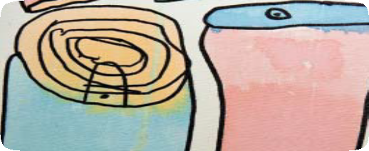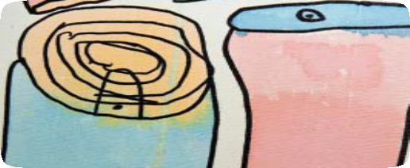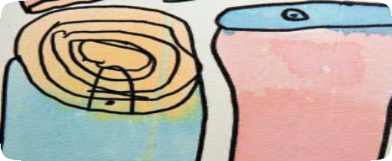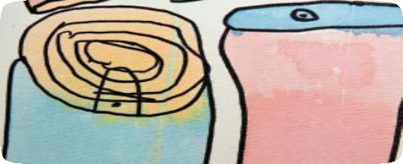

& BECOMING

The Early Years Learning Framework for Australia

Australia’s first national

Early Years Learning Framework aims to extend and enrich children’s learning from birth

to five years and through the transition to school.

The Framework’s vision is that:

*All children experience learning*

*that is engaging and builds success for life.*

Your early childhood service can provide you with further information or you may wish to visit [*www.deewr.gov.au/*](http://www.deewr.gov.au/) *EarlyChildhood/Policy_Agenda*

BELONGING, BEING

& BECOMING

The Early Years Learning Framework for Australia

Australia’s first national

Early Years Learning Framework aims to extend and enrich children’s learning from birth

to five years and through the transition to school.

The Framework’s vision is that:

*All children experience learning*

*that is engaging and builds success for life.*

Your early childhood service can provide you with further information or you may wish to visit [*www.deewr.gov.au/*](http://www.deewr.gov.au/) *EarlyChildhood/Policy_Agenda*

BELONGING, BEING

& BECOMING

The Early Years Learning Framework for Australia

Australia’s first national

Early Years Learning Framework aims to extend and enrich children’s learning from birth

to five years and through the transition to school.

The Framework’s vision is that:

*All children experience learning*

*that is engaging and builds success for life.*

Your early childhood service can provide you with further information or you may wish to visit [*www.deewr.gov.au/*](http://www.deewr.gov.au/) *EarlyChildhood/Policy_Agenda*

BELONGING, BEING

& BECOMING

The Early Years Learning Framework for Australia

Australia’s first national

Early Years Learning Framework aims to extend and enrich children’s learning from birth

to five years and through the transition to school.

The Framework’s vision is that:

*All children experience learning*

*that is engaging and builds success for life.*

Your early childhood service can provide you with further information or you may wish to visit [*www.deewr.gov.au/*](http://www.deewr.gov.au/) *EarlyChildhood/Policy_Agenda*