
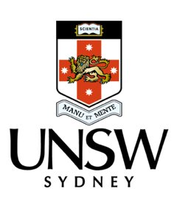
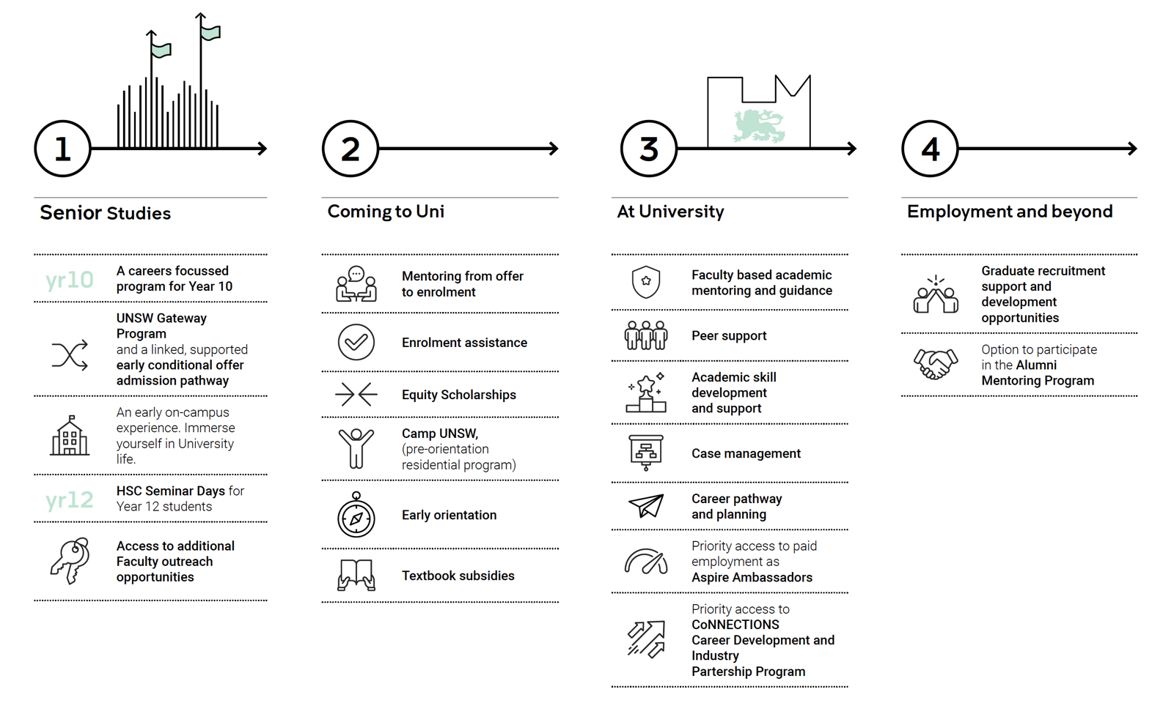

2020 UNSW Access and Participation Plan
Access and Equity (Students) under the Equity Diversity and Inclusion Division (DVC-EDI), leads a holistic university-wide approach to outreach, access and success for underrepresented students at UNSW, in collaboration with DVC-A, Faculties and Schools.
Student Life Cycle
Life cycle of outreach, access and success for students who are underrepresented at university.
1

UNSW Access and Participation Plan for 2020
2 | 

Stage | Program/initiative  (name & description) | Target  cohort | Who’s  responsible | Measurement metric
Pre-access
 | Aspire educational outreach program  Extensive program of outreach and schools engagement with 50 partner schools. The program is multi-modal allowing for online and remote access in response to COVID and for equitable access for regional, remote and rural students.  UNSW Gateway admission pathway and program to approximately 400 targeted schools in NSW. | Recent school leavers  Low-SES | Access and Equity (Students) | Qualitative and quantitative program data including offer and enrolment data from targeted schools.
 | Athlete pathways and community partnerships to target students via sporting programs. | Recent school leavers  Low-SES | DVC-A  UNSW Sport | Qualitative and quantitative program data including enrolment from targeted schools.
Transition
 | Equity scholarships  To the value of $5-10k PA for the course duration awarded to students from low-SES backgrounds. | Low-SES | Scholarships Admissions | Number of scholarships  offered and number of  scholarships awarded.
 | Camp UNSW  A transition-in program that invites  commencing students on to campus for a 3-day residential and early orientation experience. The aim is to provide an opportunity to peer connections and experience college living. | Students are targeted based on postcode and low-SES | DVC-A | Qualitative and quantitative program data inclusive of program offerings, participation and retention rates and participant measures of self-efficacy and sense of belonging.
 | Live chat (an online peer support initiative) available at key transition times, from acceptance of offers to census dates of T1,T2 and T3.  Mentoring program for new students and First year students can access senior student mentors from a range of faculties via online Live Chat. | Targeted promotion low-SES, and broader equity cohorts | DVC-A  Student  experience team – Peer support | Reporting provided by software tool with qualitative and quantitative analysis to determine levels of engagement.
 | Transition support for Gateway Admissions Pathway  (TAG) Program and Faculty of Science Belonging and Transition Program (BAT)  Targeted transition program for students who have entered via the Gateway Admission Pathway: peer facilitated social connection activities; study & life skills workshops; and regular check ins.  Faculty of Science- Belonging and Transition (BAT) Program-targeted transition program for Faculty of Science students- peer facilitated social connections | 1st year low-SES | DVC-A  Equitable learning team – Transition and outreach  Faculty of  Science | Qualitative and quantitative program data inclusive of program offerings, participation and retention rates and participant measures of self - efficacy and sense of belonging

3

Participation
 | Financial support package  Wellbeing and Connection phone calls in response to COVID-19  Every enrolled student from a low-SES background was contacted and alerted to the emergency support payment which they were automatically eligible for and provided with information and referrals to support services, educational supports and to discuss wellbeing.  UNSW is increasing the availability of financial assistance to both domestic and international students, expanding existing programmes and adopting new measures to support students in financial stress. The tiered package of support includes:  - Emergency Support Payments - $500  - Emergency E-Vouchers - $200  - Emergency Grants – up to $2000 | Low-SES targeted package  Additional support for students who intersected multiple equity categories and demonstrated need | A joint initiative of DVC-A and EDI | Financial package:  Quantitative reporting around payments, vouchers and grants provided to students.  Wellbeing and connection phone calls.  Quantitative reporting around the number of calls completed and number of referrals to support services.  Qualitative summary of themes/concerns raised by students during the calls.
 | FIAP  As a national strategy managed by Good Shepherd Microfinance, FIAP aims to promote inclusive growth and reduce inequalities through collaborative action across and between sectors. UNSW is in the process of developing a new 3-year FIAP with meaningful, practical and measurable actions to be implemented across the student life cycle. | Low-SES | DVCA  Student support and success team | Number of actions  completed and enrolment of students from low-SES backgrounds.
 | Law text book scheme:  Piloted a textbook access scheme to support inclusion and success for low-SES students enrolled in Faculty of Law: UNSW bookshop vouchers (value of $500). | Low-SES  Faculty of  Law | DVC-A  Student Support and Success Team  Faculty of Law | Number of students from low-SES backgrounds who received vouchers (Faculty of Law)
Success and transition out
 | Creating your career – CDEV1112  Online course supported by interactive face to face seminars to support students develop graduate employability skills.  Next step program  Full day industry partnership program Virtual internships  Free simulated work experience, that applies academic learning to real life professional projects. | All current students, and targeting low- SES | PVC-E  Student academic & career success | QILT Graduate Employment Outcomes Survey

