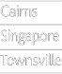

Access, Participation and Success Plan

2018 - 2020

#### jcu.edu.au

##### JCU is a dynamic, multi-campus university with more than 17,000 students. Courses are offered in Townsville,

Cairns, Singapore and Brisbane, with designated study centres at Thursday Island, Mount Isa and Mackay.

Over the past three years, JCU has developed partnerships with a range of 'community hubs' across the region and has worked in collaboration with the Queensland Widening Participation Consortium to support widening participation. This Plan continues this work and these important partnerships.

Demographic data from the Far North Region1 of Queensland indicates the importance of our work to ensure access and successful participation in higher education. The percentage of the population who have completed secondary school (Year 11 or 12), a Bachelor degree or higher remains lower than the State average2. For those who have completed Year 12, there are differences in post-school destinations across geographical regions. As illustrated in (Figure 1), transition to a Bachelor degree is lower in Townsville, Cairns and Outback regions when compared to the State average. Similarly, Australian Aboriginal and Torres Strait Islander students who completed Year 12 in South East Queensland were more likely to transition to a Bachelor Degree (26%) compared to those from Regional Queensland (4 to 20% depending on the region) (DETE, 2016)2.

*Figure 1: Main destinations of Year 12 completers by region, 2016 Next Step survey. 'NILFET' refers to those not in the labour force, education or training. 'VET' refers to Vocational Education and Training.*

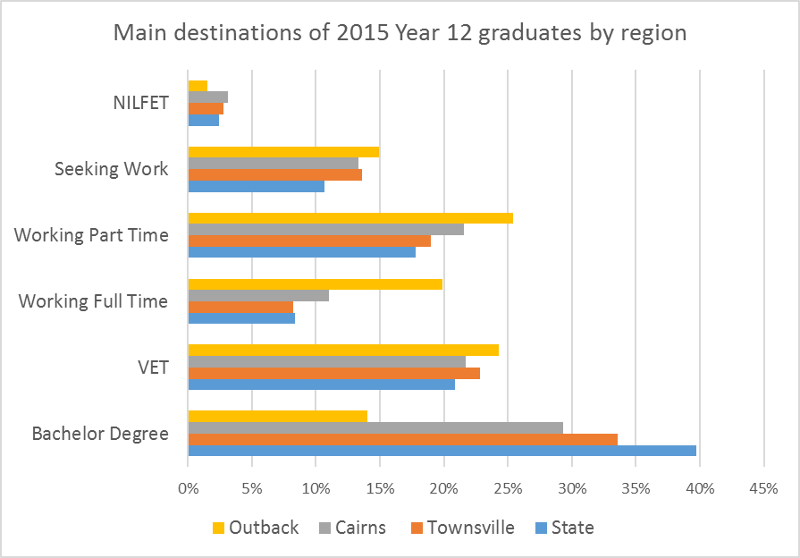

##### The diversity of the current student population reflects our commitment to the region and the success of strategies that engage with diversity. Of JCU's commencing domestic students 18% were from regional areas and 3% were from remote areas. More than half of JCU’s commencing Australian students are the first in their family to attend university, 5% are Aboriginal and/or Torres Strait Islander, 6% are from non-English speaking background, and 6% are students with a disability. Recent regional census data from the Australian Bureau of Statistics indicates that up to 25% of private dwellings do not have internet access, signifying challenges for successful learning in a digital age. Table 1 captures the diversity of domestic students in core JCU undergraduate degrees.

JCU is committed to enhancing students' access, participation and success through a ‘whole-of-institution’ approach to widening participation, learning, teaching and the student experience, including appropriate facilities and access to technologies. Over 2015-2017, JCU enacted a whole-of-institution life-cycle approach to student equity, with well-articulated responsibility across four domains and lead indicators (outcomes) for each area (Figure 2). Revised broad strategies are proposed within each domain in the 2018-2020 Access, Participation and Success Plan (the Plan). The Plan supports JCU’s strategic intent of ‘Creating a brighter future for life in the tropics world-wide through graduates and discoveries that make a difference'.

Informed by increasingly sophisticated university data available from business intelligence systems (I2A), learning analytics and targeted program evaluation, JCU's evidence-based approach to strategies, activities, policies and practices will build on its success in supporting students from diverse backgrounds to access university and succeed in their studies. This Plan has a particular focus on undergraduate students, but includes strategies to promote pathways to Higher Degree by Research (HDR) opportunities for targeted equity groups. The revised plan will be implemented and supported by various funding sources, including core funds, Indigenous Support Funding, strategic initiatives and other grants.

**Table 1: Diversity indicators of the 2017 commencing domestic students in the largest JCU Australian Tropical Campus undergraduate programs.** *Shading indicates higher than University average except for female students, where as per the Martin Indicator, female students comprise less than 40% of the cohort*

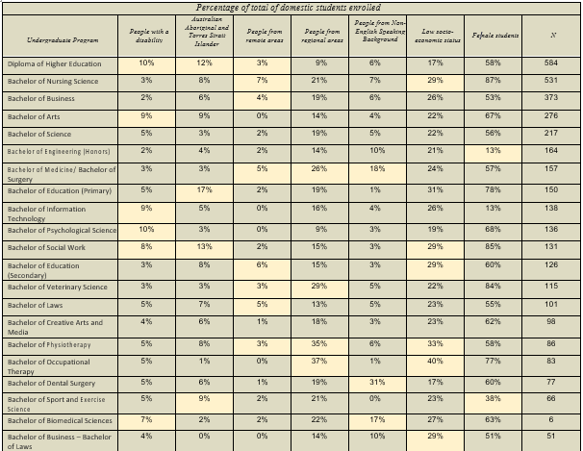

*Figure 2: Domains of Activity to ensure access, participation and success.*

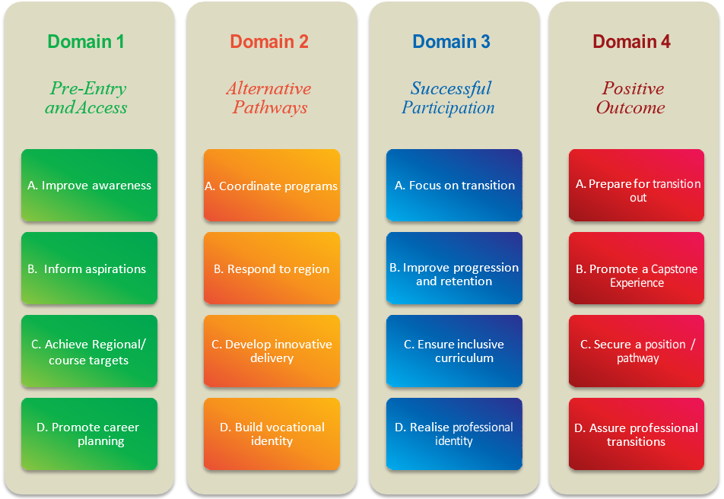

**Domain 1** *Pre-Entry and Access*

|  |  |
| --- | --- |
| **Goal A – Improve awareness** | |
| **Lead Indicator** *Sustain level of applications and enrolments from equity groups and targeted schools* | |
| **Strategies**   1. Actively engage with schools in our region to deliver in-school and on-campus activities, including through the JCU Student Ambassador program. 2. Provide targeted Y6/7, Y10/11 and Y12/post-school transition programs and assistance to schools. Examples could include bursaries and awards to students in targeted regional schools and early outreach (Campus Explorer, Study Explorer). 3. Partner with community, not-for-profit, and pathway organisations to deliver innovative information programs and activities (including information sessions, open days, etc.) that support an improved understanding of university study options and life as a university student. 4. Develop productive and positive relations with the media in recognition of its role as a key stakeholder in successful awareness-raising, including case studies of target group student pathways and outcomes. 5. Engage with key stakeholders and communities outside JCU to build stronger relationships, particularly with Australian Aboriginal and Torres Strait Islander peoples and communities in the Cape, Torres Strait and local region. 6. Promote student-led school and community-based projects to immerse JCU students in targeted schools and communities, with particular focus on social responsibility and sustainability. 7. Develop innovative uses of social media to engage diverse students. | |
| **Collaborators**   * Schools and schooling organisations (e.g. Queensland Department of Education, Catholic Education Offices, etc.) * TAFE * Private providers * Australian Aboriginal and Torres Strait Islander and other community organisations * Queensland Widening Participation Consortium * Higher education providers * Employers and employer organisations | **Progress Indicators**   * Number of participants in activities   + Attendance at events, sessions and meetings   + Response to modes of engagement * Student aspirations pre/post activities * Target schools’ year 12 completion rates * Target schools’ QTAC offer rates * Bursaries and/or awards provided |

|  |  |
| --- | --- |
| **Goal B – Inform aspirations** | |
| **Lead Indicator** *Increased applications and enrolments from equity groups and targeted schools* | |
| **Strategies**   1. Provide a suite of scholarships and bursaries to targeted equity groups. 2. Continue pre-entry university experience programs for secondary students, including Year 10 Residential Camp and UniExperience, and develop and implement similar programs for targeted equity groups. 3. Develop a program for primary school students and their parents, including on-campus experiences, tours and events. 4. Sponsor a range of achievement and academic encouragement awards in secondary schools and registered training organisations to promote educational pathways to university. 5. Provide a STEM program to targeted primary and secondary schools. 6. Actively engage with education providers and community organisations in rural and remote sites, including communities in Cape York, Thursday Island, Mount Isa and Cloncurry to support community goals for university study. 7. Collaborate with schools, education providers and job placement organisations to support increased interest in university pathways for diverse students and targeted equity groups. | |
| **Collaborators**   * Schools and schooling organisations (e.g. Queensland Department of Education, Catholic Education Offices, etc.) * TAFE * Private providers * Australian Aboriginal and Torres Strait Islander and other community organisations * Queensland Widening Participation Consortium * Higher education providers * Employers and employer organisations | **Progress Indicators**   * Number of participants in activities   + Attendance at events, sessions and meetings   + Response to modes of engagement * Prospective student and partner feedback, pre- and post-event surveys * Number of participants in activities * Attendance at events and sessions * Number of scholarships awarded and impact |

3

|  |  |
| --- | --- |
| **Goal C – Achieve regional/course targets** | |
| **Lead Indicator** *Increased applications and enrolments from equity groups and targeted schools* | |
| **Strategies**   1. Contribute to reference groups, including peak bodies and community organisations across the region to engage effectively with regional community requirements and to scope and deliver projects for targeted equity groups. 2. Develop culturally appropriate preparation, participation and engagement activities in partnership with students from targeted equity groups, staff, communities and relevant representative organisations. 3. Establish JCU's health and science infrastructure (e.g. 'Clinical Practice Building' and the 'Science Place') as a key resource for local and regional communities. 4. Continue targeted recruitment activities for equity groups, e.g. for Australian Aboriginal and Torres Strait Islander students. 5. Provide Winter and Summer Residential Schools for Australian Aboriginal and Torres Strait Islander students to increase access to and preparedness for university studies. 6. Establish relationships with regional councils and education providers in order to identify facilities and innovative delivery models for supportive study and access to JCU courses. 7. Actively seek industry partnerships and scholarships to promote regional pathways. | |
| **Collaborators**   * Schools and schooling organisations (e.g. Queensland Department of Education, Catholic Education Offices, etc.) * TAFE * Private providers * Australian Aboriginal and Torres Strait Islander and other community organisations * Queensland Widening Participation Consortium * Higher education providers * Employers and employer organisations | **Progress Indicators**   * Number of participants in activities   + Attendance at events, sessions and meetings   + Response to modes of engagement * Prospective student and partner feedback, pre- and post-event surveying * Number of sustained partnership activities * QTAC applications and offers |

|  |  |
| --- | --- |
| **Goal D – Promote career planning** | |
| **Lead Indicator** *Sustained equity group engagement with career advice and development activities to inform applications* | |
| **Strategies**   1. Map careers, employment service and training providers across the region, particularly providers that specialise in targeted equity groups, and work with providers to develop a coordinated approach to pathways and careers advice. 2. Develop and maintain career development materials for prospective students in the primary, secondary and post-secondary years, increasing the use of digital media. 3. Develop, maintain, update and promote case studies for each of the targeted equity groups, highlighting and role modelling pathways and career outcomes. 4. Expand relevant activities to include the range of individuals and organisations that are providing careers advice and employment services across the region. 5. Provide careers advice to post-secondary students about career paths and study options. 6. Embed careers advice and development modules in pre-enrolment activities (including Year 6 – 12) to engage diverse students in future career planning. 7. Develop individual learning plan and support career plans as on option for Australian Aboriginal and Torres Strait Islander students and non-traditional students including mature age students. 8. Work with employers, industry networks and employer organisations to provide timely information, advice and guidance to employees about study options. | |
| **Collaborators**   * Schools and schooling organisations (e.g. Queensland Department of Education, Catholic Education Offices, etc.) * TAFE * Private providers * Australian Aboriginal and Torres Strait Islander and other community organisations * Queensland Widening Participation Consortium * Higher education providers * Employers and employer organisations | **Progress Indicators**   * Number of participants in activities   + Attendance at events, sessions and meetings   + Response to modes of engagement * Satisfaction with services provided * External review of career planning activities * Number of individual learning plans developed |

**Domain 2** *Alternative Pathways*

|  |  |
| --- | --- |
| **Goal A – Coordinate programs** | |
| **Lead Indicator** *Increased offer and enrolments in preparatory and pathway programs by target equity groups* | |
| **Strategies**   1. Deliver appropriate and supported pathway options to higher education, including a single preparatory Diploma of Higher Education that provides an articulation pathway from a robust and accessible preparatory program, and appropriate options for international students, including the English Language Preparatory Program. 2. Undertake extensive curriculum and assessment mapping across pathways to ensure coherency and articulation from preparatory and pathway programs to degrees. 3. Promote the Indigenous Health Careers Access Program (IHCAP) as a pathway to specialist health programs. 4. Establish winter (Years 10-12) and summer (Year 12) schools Residential schools for Indigenous students. 5. Ensure Introductory Academic Program, UniStart and tertiary access activities are actively promoted and demonstrate sector best practice providing transition support to wide-ranging degrees. 6. Develop collaborative arrangements with local organisations to deliver programs leading to JCU entry. | |
| **Collaborators**   * Regional schools * Queensland Department of Education * TAFE North * Private providers and community organisations | **Progress Indicators**   * Applications for pathways programs * Progression from pathways to degrees for target groups |

|  |  |
| --- | --- |
| **Goal B – Respond to region** | |
| **Lead Indicator** *Increased number of enrolments of target groups in preparatory and pathway programs* | |
| **Strategies**   1. Provide targeted scholarships and bursaries through the JCU Access Fund and Indigenous Commonwealth Scholarships. 2. Continue with an external Pathways Advisory Group of key regional stakeholders to inform and advise on the region's pathway requirements. 3. Actively promote alternative pathways through School-Community-Industry-University partnerships, providing information, university experiences and pathways to inform and facilitate career development and progression, particularly in key areas of science, engineering and health. 4. Increase access to pathways programs for regional and remote students, particularly Australian Aboriginal and Torres Strait Islander students. 5. Ensure pathway programs for international students provide positive transition experiences. 6. Continue targeted transition activities for Australian Aboriginal and Torres Strait Islander students in Medicine, Dentistry and other courses. | |
| **Collaborators**   * Regional schools * Queensland Department of Education * TAFE North * Private providers * Community organisations | **Progress Indicators**   * Number of sustained partnership activities * Enrolment indicators in designated courses * Number of scholarships and bursaries awarded |

|  |  |
| --- | --- |
| **Goal C – Develop innovative delivery** | |
| **Lead Indicator** *Improved student progression within preparatory and pathway programs* | |
| **Strategies**   1. Provide accessible and innovative online readiness assessment tools to support understanding of the requirements of university study, including the skills required for learning in a digital environment. 2. Embed comprehensive transition and academic support in curriculum delivery, including mentoring, PASS (Peer-Assisted Study Sessions), etc. 3. Develop achievable learning and career goals for pathways students. 4. Leverage personalised and adaptive technologies to promote opportunities for success and independent learning. 5. Enact comprehensive student support and targeted interventions for all pathways students, from enrolment through their transition to degree via a whole-of-institution advising and support strategy. 6. Provide support and professional learning opportunities for academics to actively engage with innovative pathway program delivery. | |
| **Collaborators**   * Adaptive learning platform providers | **Progress Indicators**   * Student satisfaction (*YourJCU survey*) * Progression rates * Student conversion rates for Diploma of Higher Education to Bachelor Degrees * Diploma of Higher Education students’ GPA, progression and completion rates * Retention, GPA and completion rates for Students who convert from the Diploma of Higher Education to a Bachelor Degree * Student Experience surveys * Staff participation in Blended Learning and Innovative professional development |

|  |  |
| --- | --- |
| **Goal D – Build vocational identity** | |
| **Lead Indicator** *Improved course progression* | |
| **Strategies**   1. Provide high quality information and meaningful advice about the workforce required in tropical regions, using a range of mediums. 2. Embed career development in pre-enrolment, pathways curriculum and transition activities. 3. Embed *ePortfolio* into pathways programs to support career development learning. 4. Foster partnerships with key employer, industry and professional bodies to inform and support students and their career planning. 5. Develop Indigenous cadetships that create work-placement opportunities for Indigenous UG students related to discipline. | |
| **Collaborators**   * Industry professional and employer bodies * Relevant government agencies | **Progress Indicators**   * Student Experience surveys * Progression and completion rates |

**Domain 3** *Successful Participation*

|  |  |
| --- | --- |
| **Goal A – Focus on transition** | |
| **Lead Indicator** *Improved university retention for all equity groups* | |
| **Strategies**   1. Adopt a coordinated and evidence-based approach to pathways and transitions which promotes the use of relevant data to inform strategic initiatives over the course of the student life-cycle. 2. Ensure a high quality transition and first year student experience through a coordinated whole-of-university approach to cohort identity building, timely access to student support and inclusive curriculum design. 3. Investigate best practice options for streamlined offer-to-enrolment strategies, including online practices. 4. Continue to enact targeted offer-to-enrolment and transition strategies for domestic equity group students. Provide a holistic comprehensive and culturally sensitive transition to university life and learning, including for international students. 5. Adopt and support the use of innovative technology to enhance student learning in all learning environments. 6. Use peer-led transition programs to support new students. 7. Develop and implement a whole-of-institution student mental health and wellbeing strategy. 8. Expand orientation and transition experience websites to provide flexible, inclusive engagement options for students 9. Embed assessments of English language proficiency in transition and early course assessments, providing timely support and advice to students to ensure positive transitions at all levels, including HDR candidates. 10. Support improved awareness of numeracy and mathematics requirements for various courses of study, and coordinate readiness assessments and interventions. 11. Increase awareness of key first-year staff in the Academy who support transitions, such as First Year Experience Coordinators. 12. Deliver a suite of inclusive, student-focused events across the student life cycle to increase a sense of belonging, engage a diverse range of students, and meet the strategic goals of JCU. 13. Disseminate biannual orientation reports with evidence-based recommendations for continual improvement. | |
| **Collaborators**   * Feeder Schools * Community Organisations | **Progress Indicators**   * Student satisfaction surveys * University retention rates * Number of students engaged in programs |

|  |  |
| --- | --- |
| Goal B – Improve progression and retention | |
| Lead Indicator *Improved university and course progression and retention indicators for target courses* | |
| **Strategies**   1. Develop a research-informed, whole-of-university approach to student retention. 2. Strategically raise the profile of student retention issues through communication, information sharing and collaborative partnerships. 3. Promote the use of shared information systems to support a coordinated approach to student support programs. 4. Adopt student support programs as core university business. 5. Implement a monitoring framework for targeted student support services to support program functioning, streamline data collection and reporting and promote continuous improvement. 6. Promote academic staff members’ use of student data to inform improvements in teaching and learning. 7. Actively promote student support services using diverse and culturally appropriate means. 8. Maintain exemplary student support and wellbeing-related support services including raising the awareness of disability, mental health and other issues that impact on students’ success. 9. Use learning analytics and student progression data to identify students at risk of attrition to provide timely and coordinated responses. 10. Normalise academic learning skill development in first-year subjects through the provision of peer based and online academic support programs and embedded development of learning skills within core subjects. 11. Expand the JCU Access Scholarship program to include ongoing financial support for recipients, dependent on academic progress. 12. Ensure the timely development and implementation of Inclusive & Learning Plans for students who register with AccessAbilityServices. 13. Develop 'inherent requirements' in collaboration with academic, industry and professional bodies to ensure student clarity and informed choice in program selection and professional requirements. 14. Continue to develop virtual and physical peer-to-peer learning spaces to enhance sense of belonging in targeted courses. | |
| **Collaborators**   * Professional Bodies * Industry groups * Community mental health and welfare services | **Progress Indicators**   * Student progression and retention rates * Student participation in existing support services * Success and progression of students access loans, bursaries and scholarships * Student satisfaction with student support service |

|  |  |
| --- | --- |
| **Goal C – Ensure inclusive curriculum** | |
| **Lead Indicator** *Improved student satisfaction and success with the quality of learning and teaching* | |
| **Strategies**   1. Provide support and professional learning opportunities for academic staff to actively engage with culturally diverse students, including Australian Aboriginal and Torres Strait Islander perspectives, in both curriculum and pedagogy. 2. Support the development of culturally appropriate learning and cultural spaces for diverse students, including Australian Aboriginal and Torres Strait Islander students. 3. Continue to improve facilities that enhance the accessibility of learning spaces and support services for students with a disability on all campuses. 4. Embed a robust program of staff development to ensure graduates are culturally informed and enabled to contribute to Reconciliation. 5. Engage JCU students and staff in cultural learning to increase their understanding and appreciation of Australian Aboriginal and Torres Strait Islander peoples, histories, cultures and achievements. 6. Consistent with the JCU Model, promote the internationalisation of the curriculum to ensure graduates are global citizens, and culturally competent. 7. Promote and facilitate work-integrated learning and placements in rural and remote settings. 8. Prioritise intentional student-centred blended learning design as outlined in JCU Blended Learning Policy to engage diverse learners. 9. Build and promote an inclusive university environment through diverse pedagogies, celebrations, workshops and contribution to policy review, including the JCU Disability Action Plan (DAP). 10. Leverage personalised and adaptive technologies for the defined equity groups providing opportunities to succeed in a digitally engaged environment. 11. Expand assessment practices to meet the needs of diverse learners, including more authentic and technology-enabled practices. 12. Promote the use of formative assessment to support and monitor student progression.   13. Provide and promote a Student Loan Program for students in financial need and expand support to include financial support for compulsory activities related to study, e.g. field trips, placements, and work integrated learning opportunities. | |
| **Collaborators**   * Australian Aboriginal and Torres Strait Islander community members and organisations * Adaptive learning providers | **Progress indicators**   * Satisfaction with quality of learning and teaching * Student subject engagement * Progression/success (GPA) rates |

|  |  |
| --- | --- |
| Goal D – Realise professional identity | |
| **Lead Indicator** *Improved course retention* | |
| **Strategies**   1. Offer career development learning and other relevant strategies in course design to confirm career choice and optimise career readiness and the transition to the globalised world of work. 2. Increase student engagement with co-curricular and extra-curricular career development employability and entrepreneurship programs and activities. 3. Encourage students to undertake regional and/or an international experience as part of their program of study through a coordinated approach to student mobility. 4. Identify and develop resources and networks to support equity group career development needs. 5. Strengthen the coordination of opportunities for students to participate in workplace integrated learning, workplace-based projects and service learning through curriculum. | |
| **Collaborators**   * Employer and industry groups * Alumni * Community organisations and donors | **Progress indicators**   * Number of students participating in activities * Satisfaction with career services * Number of equity group students accessing services and activities |

**Domain 4** *Positive Outcome*

|  |  |
| --- | --- |
| **Goal A – Prepare for transition out** | |
| **Lead Indicator** *Improved satisfaction and engagement with student support* | |
| **Strategies**   1. Actively engage with industry, employer groups and alumni to create networks for students and pathways to employment. 2. Ensure Individual Learning Plans for Australian Aboriginal and Torres Strait Islander students, map transition to work or further study, incorporating community/industry mentors. 3. Support the case management of diverse learners and equity group students as required for transition out, including students with a disability. 4. Develop a focused transition-out program for international students to support pathways to employment or further study.   6. Provide targeted transition to employment workshops for students in equity groups. | |
| **Collaborators**   * Industry and employer groups | **Progress Indicators**   * Number of students using services and participating in relevant activities * Number of students from equity groups using services and participating in relevant activities |

|  |  |
| --- | --- |
| **Goal B – Promote a Capstone Experience** | |
| **Lead Indicator** *Improved satisfaction with quality of teaching* | |
| **Strategies**   1. Promote and coordinate well-designed 'capstone' experiences to enable students to integrate and synthesise their learning, attain a sense of completion and articulate their learning acquisition. 2. Promote well-designed capstone experiences to enable the transition beyond degree study. 3. Expand support to include financial support for compulsory capstone activities related to study, e.g. field trips, placements and work- integrated learning opportunities.   4. Promote internationalised mobility programs and capstone experiences and enable participation from equity group students. | |
| **Collaborators**   * Industry and employer groups * Community organisations | **Progress Indicators**   * Satisfaction with quality of teaching * Number of students participating in international mobility program. * Number of capstone experiences developed * Feedback from industry and community organisations. |

|  |  |
| --- | --- |
| **Goal C – Secure a position/pathway** | |
| **Lead Indicator** *Improved graduate outcomes for equity groups.* | |
| **Strategies**   1. Develop and implement a JCU Student-Employer Engagement Plan for equity groups. 2. Increase promotion of recruitment opportunities with professional bodies, employers and government agencies. 3. Implement an Australian Aboriginal and Torres Strait Islander Cadetships program to create work-placement opportunities for Australian Aboriginal and Torres Strait Islander undergraduate students related to their discipline area. 4. Promote postgraduate research pathways for high achieving students, particularly Australian Aboriginal and Torres Strait Islander students. 5. Support students' development of self-management and other personal and professional capabilities to effectively manage career and work life.   5. Explore ePortfolio to enable students to provide evidence of their achievements and capabilities when applying for a job or for professional standing. | |
| **Collaborators**   * Employers * Industry groups | **Progress Indicators**   * Satisfaction with course experience * Graduate Outcome Survey results * HDR equity group enrolments * Number of students participating in Cadetship program |

|  |  |
| --- | --- |
| **Goal D – Support professional transitions** | |
| **Lead Indicator** *Improved graduate outcomes* | |
| **Strategies**   1. Foster reciprocal and sustained partnerships between JCU Colleges and community and industry partners, particular for equity group students. 2. Ensure capstone curriculum and experiential learning is informed by the scholarship of career development learning and contemporary workforce requirements. 3. Increase staff awareness and interest in globalised, contemporary industry practices and developments relevant to their discipline.   4. Promote the domestic and international JCU Alumni program to ensure ongoing engagement. | |
| **Collaborators**   * Industry and employer bodies | **Progress Indicators**   * Satisfaction with course experience * Graduate Outcomes Survey * Numbers of graduates participating in Alumni activities |

1 Queensland Government Statistician's Office (2014) *Queensland Regional Profiles*. Retrieved from [http://www.qgso.qld.gov.au/index.php.](http://www.qgso.qld.gov.au/index.php) 'Far North Region' is comprised of the Regional Planning Areas of Far North Queensland, Gulf, Mackay Isaac and Whitsunday, and North West.

2 Department of Education, Training and Employment (2016) *Next Step 2016: A report on the destinations of Year 12 completers from 2013 in Queensland*. Retrieved from [http://education.qld.gov.au/nextstep/nextstep.html.](http://education.qld.gov.au/nextstep/nextstep.html)

For further information, contact: Professor Chris Cocklin

*Provost*

[provost@jcu.edu.au](mailto:provost@jcu.edu.au)

Published February 2018 CRICOS Provider Code 00117J