Technical framework for the capacity to contribute Review process, Version 2

February 2023

Contents

Document history 3

Executive summary 4

Section 1: Introduction 7

Section 2: The capacity to contribute review process 12

Section 3: Recent change in school community economic circumstances 16

Section 4: Recent change in school community population 22

Section 5: Difference between linked and unlinked population 26

Section 6: Area-based score not representative of school community 31

Section 7: Large average family size 35

Section 8: Parental survey 40

Appendix A: Analysis of Impact of COVID-19 on school communities 48

Appendix B: Changes in school community population 53

Appendix C: Comparison of linked and unlinked population 57

Appendix D: Analysis of family size in non-government schools 59

Appendix E: The Hybrid Method 61

Appendix F: Adjusted score for large family size 64

Appendix G: Key sources of income data in Australia 66

Appendix H: Glossary and explanatory notes 68

# Document history

|  |  |  |
| --- | --- | --- |
| **Date** | **Version** | **Description of key changes** |
| February 2023 | Version 2 | 1. Clarified proposed review process for:   * recent change in school community economic circumstances (in particular due to the evolution of data and policy responses to COVID-19 pandemic); * recent change in school community population; * difference between linked and unlinked population; * area-based score not representative of school community; and * large average family size.   2. References to DMI score transition period and use of SES scores made historical, due to end of transition period.  3. References to parental survey updated to reflect proposed use of survey in review processes, given the availability of administrative data.  4. Department of Education, Skills and Employment updated to Department of Education, reflecting Machinery of Government changes in 2022. |
| July 2020 | Version 1 |  |

# Executive summary

### Introduction

This updated technical framework by the Australian Bureau of Statistics (ABS) provides statistical advice which may inform the Department of Education’s (the department’s) review process for capacity to contribute (CTC) scores. CTC scores inform the assessment of non-government school communities’ anticipated capacity to contribute financially to their school operations. A school community refers to the parents and guardians of students at a school.

In 2020, the department implemented a new methodology for calculating CTC scores, known as the Direct Measure of Income (DMI). The department engaged the ABS to develop a technical framework to assist the department and Approved Authorities (AAs), acting on behalf of schools, to identify and address circumstances in which a school’s CTC score may not reflect the anticipated financial capacity of the school community to contribute to the school’s recurrent costs.

This report constitutes the ABS’ response to that engagement. It contains:

* recommendations for a CTC score review technical framework, including data and methods for assessing applications and determining new scores for successful reviews;
* five scenarios that reflect the department’s reasons for review, which primarily constitute extraordinary circumstances not accounted for in the CTC methodology. Each one includes:
  + a description of the scenario;
  + analysis of relevant statistical information;
  + a process for assessing a review, including information the AA can provide to support their business case; and
  + methodological options for calculating a new score.
* recommendations for a parental survey to support the calculation of new scores; and
* a description of publicly available sources of income data, to help AAs to understand income levels over time in different geographic areas.

In 2023, this technical framework was updated to include new data and methods available to assess potential review scenarios and calculate new scores.

### Scope

The scope of this technical framework is limited to advice on data and statistical processes and methods recommended for use by the department when assessing a business case during a review process, and information available to support review applications. The review scenarios discussed in this report have been identified by the department, based on relevant policy settings, historical examples and informed by technical analysis provided by the ABS. While the DMI methodology is expected to form the basis of most CTC scores in future, the proposed review processes also cover instances where an area-based CTC score is used. (This may occur for fitness-for-purpose reasons and is described in more detail below.)

The ABS notes that the proposed analytical processes in this report represent one part of the overall CTC score review process carried out by the department, about which further information is available on the [department’s website](https://www.education.gov.au/quality-schools-package/capacity-contribute-scores-non-government-schools). References by the ABS to aspects of CTC or other education policy settings are correct at the time of writing.

### Review reasons and scenarios

The CTC score review process is intended to ensure that schools with unique characteristics or exceptional circumstances have the opportunity to have these considered and assessed, where appropriate. This technical framework includes a proposed assessment process for the following scenarios.

An unexpected change in circumstances, such as:

1. a recent change in the school community’s economic circumstances
2. a recent change in the school community population, affecting its capacity to contribute

Unique circumstances of the school community or school, such as:

1. schools with a large average family size
2. schools with an unlinked population that has a significantly different capacity to contribute, compared with the linked population

Area-based scores that do not accurately reflect the school community circumstances, for example:

1. members of the school community have different incomes or socio-economic characteristics from the average characteristics of the area in which they reside.

### The parental survey

As the department had a well-established survey to support reviews under the previous socio-economic status (SES) methodology, the ABS has provided recommendations to adapt that survey to support assessments and calculate scores relevant to the DMI methodology. The parental survey is included as an option when there is evidence of exceptional circumstances and fit-for-purpose data is not otherwise available. The ABS’ recommendations aim to maximise the quality of survey data, while minimising the burden on respondents. These include recommendations for:

* survey scope;
* survey mode, including paper and online modes;
* form design, including supporting information such as instructions;
* survey questions;
* survey reference period, considering the implications for various quality dimensions such as timeliness and coherence; and
* target response rate.

The ABS’ recommendations for the parental survey are described in detail in Section 8.

### Summary of proposed technical framework

A summary of the proposed technical framework is provided in figure 0.1. For each scenario, the technical framework describes examples of supporting evidence that appellants may provide in their business cases, the relationship between scenarios and the CTC quality assurance process, available data for determining new scores, the use of the parental survey, and options for calculating new scores.

Figure 0.1: Overview of the review process, for each review scenario.

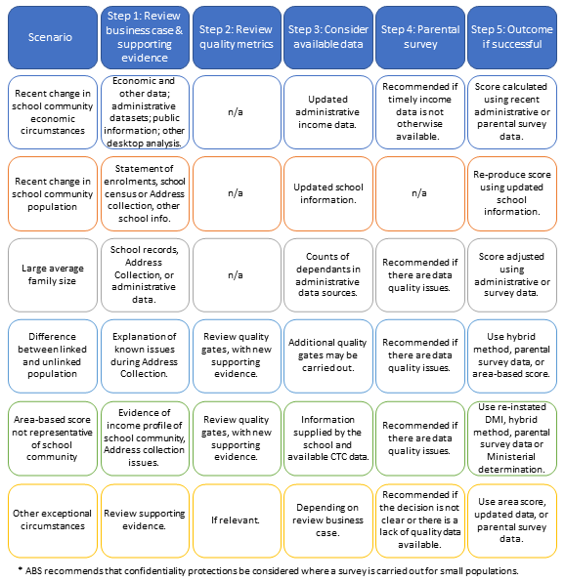

# Section 1: Introduction

## Overview

This report by the Australian Bureau of Statistics (ABS) provides a proposed technical framework for the Department of Education (the department) to assess applications for review of capacity to contribute (CTC) scores from 2022 onwards. The framework can be used by the department to assist non-government schools and Approved Authorities (AAs) to understand the data and methods recommended for use by the department during a review process.

This report contains:

* recommendations for a CTC score review technical framework, including data and methods for assessing applications and determining new scores for successful reviews;
* five scenarios that reflect the department’s reasons for review, which primarily constitute extraordinary circumstances not accounted for in the CTC methodology. Each one includes:
  + a description of the scenario;
  + analysis of relevant statistical information;
  + a process for assessing a review, including information the AA can provide to support their business case; and
  + methodological options for calculating a new score.
* recommendations for a parental survey to support the calculation of new scores, where fit-for-purpose administrative data is not available; and
* a description of publicly available sources of income data, to help AAs to understand income levels over time in different geographic areas.

### The ABS’ role

In 2020, the department engaged the ABS to develop a technical framework to assist AAs to identify, and the department to address, circumstances where a school’s CTC score may not reflect the anticipated financial capacity of persons responsible for students at that school to contribute to the school’s recurrent costs. The scope of this technical framework is limited to technical advice on:

* data and statistical techniques, processes or methods recommended for use by the department when assessing a business case during a review; and
* information or data that an appellant can provide to support their business case.

The review scenarios discussed in this report have been identified by the department, based on relevant policy settings, historical examples and informed by ABS analysis.

References by the ABS to aspects of CTC or other education policy settings are correct at the time of writing.

Between 2020 and 2022, timely new sources of data have become available to support the assessment of applications for review and the calculation of new scores. The ABS has provided technical advice to the department regarding the development of new methods based on this data. These new data sources and methods are described in this updated version of the technical framework.

## Background

The term ‘capacity to contribute’ refers to the measurement of the anticipated capacity of a non-government school community to contribute to the cost of schooling. Throughout this report, school community refers to the parents and guardians of students at a school. Under the Australian Education Act 2013 (Cth), the national school funding model uses capacity to contribute to inform Australian Government funding for non‑government schools.

From 2020, a new method for determining non-government school communities’ anticipated capacity to contribute to school operations was introduced. The new method is the Direct Measure of Income (DMI) score, which replaced the socio-economic status (SES) score. A commitment was also made to introduce a review process.

#### The DMI score

An annual DMI score is based on the median Adjusted Taxable Income (ATI) of each school community. It is created by:

* calculating the total income for each student by summing the incomes of up to two parents or guardians;
* identifying the median family income for each school; and
* converting the median incomes for all schools into DMI scores via standardisation[1].

The resulting DMI score represents the anticipated capacity to contribute of a school community, relative to other school communities.

The calculation of an annual DMI score uses data from the Student Residential Address and Other Information Collection (the Address Collection) to identify the school community population. Income data is obtained via the Multi‑Agency Data Integration Project (MADIP) and includes Personal Income Tax (PIT) data, payment summary data and social security and low income concession card information from DOMINO Centrelink Administrative Data (formerly known as Social Security and Related Information (SSRI) data). These data sources enable the DMI to use the most accurate and timely income data available for school communities. Due to the lag in data availability, the income data used in the DMI calculation are from the financial year ended 18 months earlier. (See table 1.1 for examples of the reference periods of data used in DMI scores.)

For a detailed description of the DMI methodology, see [What is the Direct Measure of Income? - Department of Education, Australian Government](https://www.education.gov.au/quality-schools-package/fact-sheets/what-direct-measure-income).

#### The SES score

The SES score methodology was used prior to 2020, and in 2020 and 2021 as part of the transition to the DMI score methodology. SES scores for non-government schools were calculated as the average of SES scores of the areas (defined as Statistical Areas Level 1) in which the students at each school lived. The SES score for each area was a weighted average of four different socio-economic indexes: 1/3 occupation, 1/3 education, 1/6 household income and 1/6 income of families with children. These scores were calculated every five years using data from the Census of Population and Housing.

#### The refined area-based score

A refined area-based score is similar to an SES score. However, instead of incorporating education and occupation related socio-economic indexes, it only uses the household income and income of families with children socio-economic indexes. From 2022, the refined area-based score is used:

* for new schools, which do not yet have 3 consecutive annual DMI scores; or
* where one or more of the annual DMI scores needed to calculate the 3-year average DMI-based CTC score is not considered fit-for-purpose for quality or confidentiality reasons.

#### The CTC score

In 2020, the DMI-based CTC score was introduced, and was calculated as the average of DMI scores for 2018 and 2019. This was because the first Address Collection to which administrative data in MADIP were linked took place in 2018. Since 2021, the DMI-based CTC score has been the (“rolling”) average of the previous three years’ DMI scores (table 1.1).

Table 1.1 Reference periods of income data used in DMI-based CTC scores.

|  | | Address Collection and DMI score reference year | | | |
| --- | --- | --- | --- | --- | --- |
|  | | **2018** | **2019** | **2020** | **2021** |
| CTC Score | **2020** | 2015-16 income | 2016-17  income |  |  |
| **2021** | 2015-16  income | 2016-17  income | 2017-18  income |  |
| **2022** |  | 2016-17  income | 2017-18  income | 2018-19  income |

2020 and 2021 represented a transition period. During these years, the CTC score was the most beneficial of the rolling average DMI score, the 2016 SES score, or the 2011 SES score. From 2022, the CTC score is either the three-year rolling average DMI or the refined area-based score.

### CTC data quality framework, quality assurance process and scores

A comprehensive data quality framework supports the DMI methodology. This framework describes the fitness-for-purpose of the annual DMI score and the data quality assurance process supporting its production.

The fitness-for-purpose of the annual DMI is assessed against the seven dimensions of quality outlined in the ABS Data Quality Framework – institutional environment, relevance, timeliness, accuracy, coherence, interpretability and accessibility. The ABS Data Quality Framework is based on the Statistics Canada Quality Assurance Framework (2002) and the European Statistics Code of Practice (2005), and is an exemplar for the use-focussed analysis of data quality[2]. The CTC data quality framework is published in A Data Quality Framework for the Australian Government’s Direct Measure of Income for Capacity to Contribute[3].

The data quality assurance process consists of a set of quality checks, known as quality gates. Quality gates are placed throughout the statistical process to manage statistical quality risks. The quality gates in the DMI production process were co-designed by the department and the ABS. Actions to mitigate statistical risks are taken according to pre-defined tolerance levels.

Five quality gates are implemented during the annual DMI score production process, at the data collection, processing, validation, publishing and process evaluation stages. The validation and publishing quality gates are especially relevant to the review process, because at these quality gates, decisions are made which affect the type of score a school receives.

The fitness-for-purpose of each annual DMI score is assessed by the department at the validation quality gate, which includes the following three phases:

1. assessing the coverage, accuracy and volatility of all DMI scores;
2. secondary quality assessment for schools that are flagged in the previous phase;
3. manual review of selected DMI scores that are flagged in the first or second phase of validation. Here, a decision is made as to whether the DMI score is considered fit-for-purpose.

If the DMI score is found not to be fit-for-purpose, a refined area-based score is used.

The risk of disclosure of personal information is assessed in the publishing quality gate. An area-based score is used for the few schools which are so small that publishing their DMI score would introduce an unacceptable risk to the confidentiality and privacy of members of the school community.

### Privacy legislation and policy

Strict legislative and policy controls are in place to ensure the privacy and confidentiality of data used to produce CTC scores, and these are also relevant to the reviews process.

Under the Census and Statistics Act 1905 (Cth), the ABS cannot disclose identifiable personal information, including to any government department or organisation. The department and ABS must comply with the Privacy Act 1988 (Cth) and apply the [Australian Privacy Principles](https://www.oaic.gov.au/privacy/australian-privacy-principles/australian-privacy-principles-quick-reference/) when dealing with personal information. See the [ABS Privacy Policies](https://abs.gov.au/websitedbs/D3310114.nsf/Home/Privacy?opendocument) and the department’s privacy policy (available at [www.education.gov.au)](https://www.education.gov.au/) for more information about how each organisation handles personal information. The [Census Privacy Statement](https://www.abs.gov.au/about/legislation-and-policy/privacy/privacy-abs#from-banner=GB) describes specific protections in place for data from the Census of Population and Housing.

A privacy impact assessment identifies the impact a project may have on the privacy of individuals and sets out recommendations for managing, minimising or eliminating that impact. A [privacy impact assessment](https://www.education.gov.au/school-funding/resources/2018-student-residential-address-collection-additional-required-information-privacy-impact) of the 2018 Address Collection is available on the department’s website and a privacy impact assessment of MADIP is available on the [ABS website](https://www.abs.gov.au/websitedbs/D3310114.nsf/home/Statistical+Data+Integration+-+MADIP+Consultation). Privacy of data used in MADIP is also protected using the [separation principle](https://www.abs.gov.au/about/data-services/data-integration/keeping-integrated-data-safe) and the [five safes framework](https://www.abs.gov.au/ausstats/abs@.nsf/Latestproducts/1160.0Main%20Features4Aug%202017?opendocument&tabname=Summary&prodno=1160.0&issue=Aug%202017&num=&view=), which are described in the glossary and on the ABS website.

# Section 2: The capacity to contribute review process

### The scope of the review process

The department has developed guidelines which describe possible extraordinary circumstances which may constitute grounds for an approved authority seeking a review of their school’s CTC score, including:

1. An “unexpected change in circumstance” not reflected in the DMI or area-based score data or methodology which may not be reflected in a CTC score;
2. “Unique circumstances of the school community or school” not reflected in the CTC score which impact the financial capacity of the school community to contribute to the school’s recurrent costs; and
3. Area-based scores that do not accurately reflect the school community circumstances[4].

#### Scenarios that are within scope of the review process

The ABS has considered these extraordinary circumstances from a statistical perspective and, in collaboration with the department, has investigated a number of scenarios. For each scenario, this report outlines a recommended technical framework for assessing applications for review, including recommended data and methods. The ABS has also provided analysis to assist the department to identify and define key concepts relevant to the above reasons, such as what may be defined as ‘extraordinary’ or ‘unique’ in the context of non-government school communities.

The scenarios described in this report include:

An unexpected change in circumstances, such as:

* a recent change in economic circumstances, affecting the school community
* a recent change in the school community population, affecting the school community’s capacity to contribute.

Unique circumstances of the school community or school, such as:

* schools with a large average family size
* schools with an unlinked population that has a significantly different capacity to contribute, compared with the linked population (for DMI-based scores).

Area-based scores that do not accurately reflect the school community circumstances, for example:

* if members of the school community have different incomes or socio-economic characteristics compared with the average characteristics of the areas in which students reside.

The ABS also investigated an assumed scenario in which the median income might not represent the anticipated capacity to contribute for a sizeable proportion of a school community. Such circumstances may exist if a school community consisted of two very different populations of students, for example, a disadvantaged community and a less disadvantaged community. However, analysis of the income distributions of school communities failed to identify evidence of such school communities in the 2019 Address Collection.

The ABS recognises that there may be other exceptional circumstances not identified in this report.

#### Application of scenarios to DMI and area-based scores

Under the CTC score review process, a school may seek a review of a DMI-based, area-based or ‘deemed’ CTC score, and most review scenarios are relevant to either kind of score. For example, a school with a large average family size may have cause to seek a review, whether its CTC score is DMI-based or area-based, and in this case the proposed process for ‘large average family size’ should be followed. The two exceptions are the ‘difference between linked and unlinked population’ scenario, which is only relevant to DMI-based CTC scores, and the ‘area-based score not representative of school community’ scenario, which is only relevant to area-based scores. A summary of the scenarios is provided in figure 2.2.

Figure 2.2 High level overview of the review process, for each review scenario.

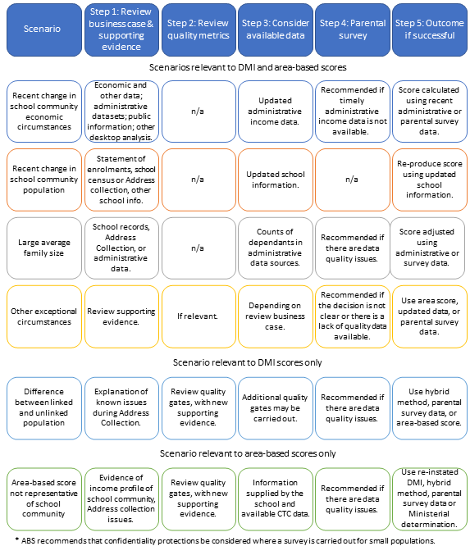

#### Scenarios that are out of scope of the review process

The department has determined that applications based on certain criteria will be out-of-scope of the review process, such as those that:

* contest the DMI methodology in general, including the use of the median income of the school or the use of the rolling average.
* are based on circumstances or events which are already reflected and accounted for in the CTC score.
* rely on the fact that another school in the same area has a lower CTC score. The new CTC methodology accounts for this as it reflects the actual families enrolled at a school.
* are because a school’s recurrent funding has been reduced by its respective state/territory government.
* contest a score based on the school’s fee structure or policies.

For further information, see: [www.education.gov.au/quality-schools-package/fact-sheets/what-capacity-contribute-review-process.](https://www.education.gov.au/quality-schools-package/fact-sheets/what-capacity-contribute-review-process)

### The outcome of a successful review

Where a review process determines that extraordinary circumstances exist such that a school’s CTC score does not accurately reflect the school community’s anticipated capacity to contribute, a new score, called a ‘deemed score’ is used. In this technical framework, the ABS has aimed to provide options for calculating deemed scores which resemble, as closely as possible, the data and methods used in the DMI methodology. This aims to ensure the quality of deemed scores is comparable to that of DMI scores, while addressing the extraordinary circumstances which constitute the reason for the review. For deemed scores based on a median income, the ABS recommends the same process used for the DMI be followed where possible. This includes the summation of up to two parent incomes, standardisation of the school’s score using consistent parameters (i.e.: the same mean and standard deviation used to standardise DMI scores), and the application of the quality gates.

It should be noted that in all cases, calculating a deemed score may not result in a lower score, and could result in a score that is the same or higher.

The ABS understands that, for reviews of:

* DMI-based CTC scores, the deemed score will generally apply for three years, and will be reviewed annually and may be adjusted if appropriate; and
* refined area-based scores, the deemed score will generally apply for three years.

Understanding how deemed scores are calculated and applied is important from a statistical perspective to ensure that relevant dimensions of quality can be considered. Different options for calculating a deemed score introduce different considerations from a data quality perspective and these are summarised alongside the options in each scenario.

# Section 3: Recent change in school community economic circumstances

## About this scenario

Since DMI scores are produced annually, any change in economic circumstances affecting a school community’s income will, in time, be reflected in its DMI-based CTC score. Thus, the DMI methodology reflects changes in economic circumstances, particularly their relative impact across school communities. In this respect, the DMI methodology improves on the SES methodology, which reflected socio-economic circumstances at a single point in time every five years.

To ensure an accurate assessment of the relative capacity to contribute, it was important that the DMI methodology prioritised a robust and coherent measure of income that supports valid comparisons across school communities. However, while the income data used in DMI scores is comprehensive in terms of coverage, is accurate and is updated annually, it takes two years for changes in economic circumstances to be reflected in DMI scores and a third year for them to begin to be reflected in the CTC score. In ordinary circumstances, this is not problematic; however, in exceptional circumstances, it could be appropriate for the review process to consider the timeliness of income data.

From a statistical perspective, there are two relevant factors to consider under this scenario:

* Timing: the change in economic circumstances must have occurred between the reference period of the income data and the application of the CTC score. The reference period of income data, for DMI-based and area-based CTC scores, is described in section 1.
* The relative economic impact: the economic impact on the school community is significantly larger than the impact on all non-government school communities.

The ABS recognises that defining when a relative economic impact is considered ‘significant’ for the purposes of this scenario is a policy decision for the department.

In this section, the ABS has provided a proposed review process which:

1. allows the department to identify when an economic change constitutes an extraordinary circumstance for a school community; and
2. provides options for calculating a new score, enabling relative recent economic change and other factors, including data quality and availability, to be considered.

Under this scenario, a school would be able to seek a review of its CTC score if:

* The recent economic change in the school community is significantly larger than the average recent economic change among all non-government school communities, based on the definition determined by the department.

However, a review under this scenario would be unlikely to result in a change of score if:

* A school community has experienced a recent economic change, however the economic change in the school community is similar to that of school communities overall.
* A proportion of families in the school community have experienced an economic change, however the median income of the school community is not significantly affected, relative to other schools.

## Summary of analysis

In March 2020, the ABS and the ATO fast-tracked work to use new Single Touch Payroll (STP) data to provide near real-time insights on changes in the labour market, in response to the COVID-19 pandemic. On 21 April 2020, the ABS released weekly payroll jobs and wages indexes for the first time, to complement the ABS’ existing labour market statistics. To analyse the impact of COVID-19 on school communities from March 2020 to June 2021, the ABS created a similar set of indexes, using STP data integrated with the Address Collection.

* For parents and guardians in the 2021 Address Collection, the number of payroll jobs dropped by 3.8% after the onset of the pandemic, with the payroll jobs index reaching a low point of 0.962 in late April 2020. The payroll jobs index remained above 1 from July to December 2020, indicating that the number of payroll jobs among parents and guardians exceeded its pre-pandemic level. A second short drop (to 0.987) occurred around 31 December 2020, however this is consistent with labour-market seasonality at year’s end. The index subsequently recovered to remain at or above 1 until June 2021.
* For parents and guardians with a payroll job in the 2021 Address Collection, the median weekly wage index declined by 2.5%, from 12 March 2020 to 24 June 2021.
* The average relative median weekly wage index indicates how a school community’s median weekly wage index changed, relative to that of other schools, on average, between March 2020 and June 2021. An average relative median weekly wage index above 1 indicates that a school’s weekly median wage index was, on average, greater than the index for all schools during the period.
  + Approximately three in four schools (74%) had an average relative median weekly wage index of between 0.950 and 1.049 over this period.
  + Approximately 5% of schools had an average relative median weekly wage index below 0.900 over this period.
* For a description of this analysis, including the scope and coverage of the data, the method for calculating index values, and important assumptions and limitations for interpreting the data, see Appendix A: Analysis of the impact of COVID-19 on school communities.

## Review process and information requirements

### Detailed decision making process

Figure 3.1, below, illustrates a proposed decision-making process for assessing applications for CTC score review based on a recent change in economic circumstances.

Figure 3.1: Proposed evaluation process for CTC reviews based on recent change in school community economic circumstances.

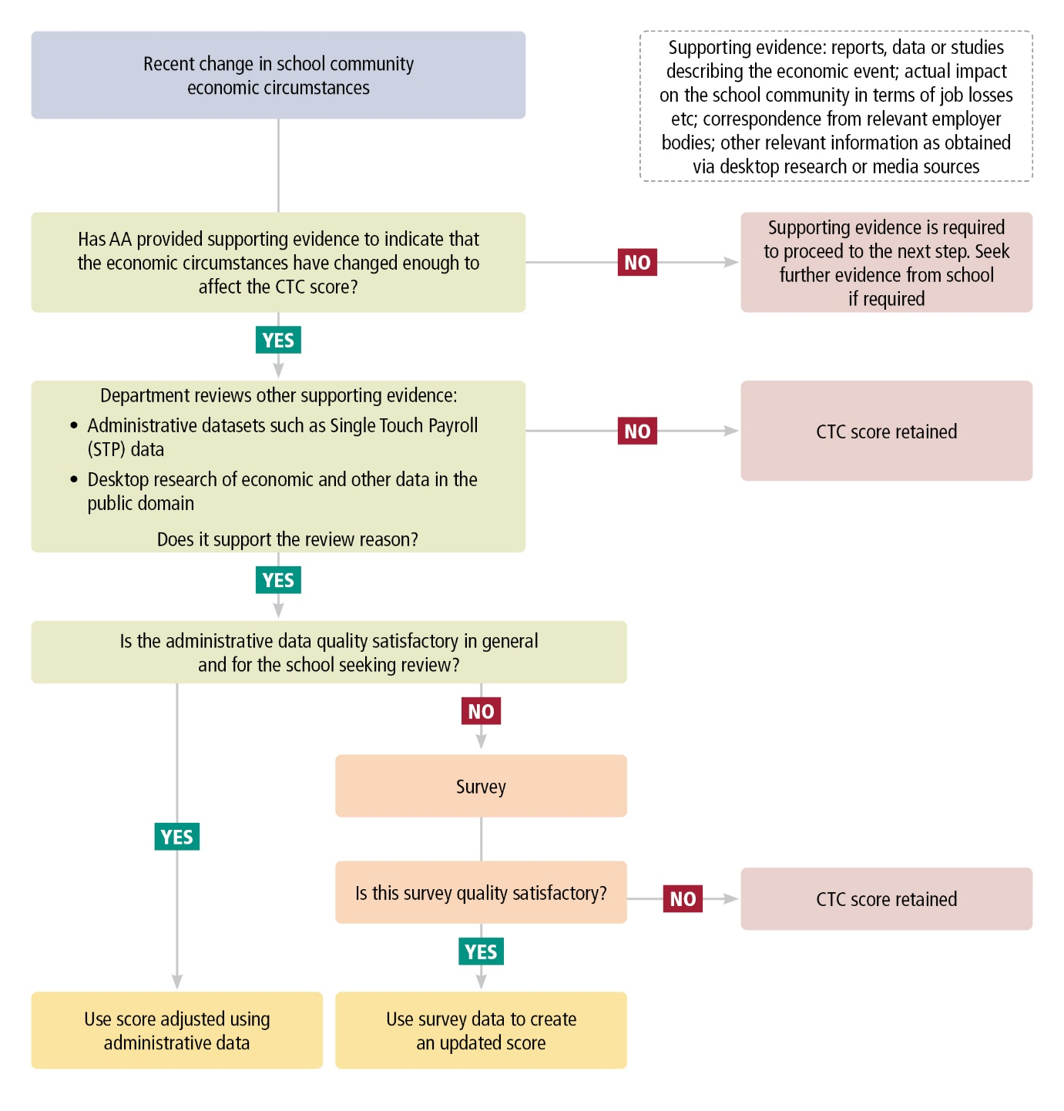

### Review supporting evidence

In this stage, it is expected that the department will check that the appellant has provided evidence as part of the business case which would enable the following questions to be answered.

* What is the reason for the change in the school community’s economic circumstances and in what way have they changed?
  + Information describing the event or economic change such as media articles, financial reports, public statements or private sector announcements or correspondence.
  + Data that may describe the impact of the change in the local community.
  + Evidence of when the economic event or change occurred.
  + Any data collected by the school about the income and circumstances of parents.
* How has this event or change in circumstances affected the members of the school community? How many members of the school community are estimated or known to be affected, and to what extent?
  + Description of the impact of the economic event or changed circumstances on the members of the school community.

If the department considers that the business case is supported by sufficient evidence and demonstrates that exceptional circumstances exist, the next step would be to collect and review relevant data and calculate a new score.

### Availability of data to assess recent economic change affecting a school community

The ABS has summarised key sources of income data which provide contextual information in Appendix G: Key sources of income data in Australia. Since a non-government school community is likely to represent a small proportion of a local economy, area-based economic data, of itself, cannot be expected to show the specific impact on the school community. However, it is useful for understanding economic changes over time in different areas in Australia.

Several sources of timely, integrated administrative data may support the department to assess recent economic change in school communities. These include:

* STP data, which includes employment and wage information from businesses with STP-enabled payroll and accounting software. Several analyses that may be undertaken to inform the assessment of recent economic change in a school community using STP data are described in Appendix A.
* Social Security data (DOMINO) from the Department of Social Services, comprising payments administered by Services Australia under the *Social Security Act 1991, A New Tax System (Family Assistance) Act 1999* and the *Student Assistance Act 1973.* It includes student and labour market related payments, family assistance and other payments. The main payment types for parents and guardians in the Address Collection include Family Tax Benefit, Job Seeker, Carer and Parenting payments.

### Calculating a deemed score

The methodological options for calculating a deemed score are described below.

#### Option 1

Under option 1, the average relative weekly median wage index for each school community is calculated using STP data. This indicates how the weekly median wage in each school community changed, on average, since the DMI score was created, relative to other schools.

The reference period for the index extends from the end of the reference period of the income data used in the DMI score, to the end of the most recently completed financial year. For example, for reviews of a 2022 DMI score, the average relative weekly median wage for school communities would be calculated from July 2020 to June 2022. To adjust a school’s DMI score, the median family income used in the DMI calculation is multiplied by the school’s average relative weekly median wage index, and the resulting adjusted median income is standardised to create a new, adjusted score.

In applying option 1, the fitness of the available administrative data for the purpose of adjusting a school’s score should be considered. In particular, the ABS recommends the following indicators be reviewed:

* the proportion of parents with STP data; and
* the proportion of income earners by main source of income.

If the proportion of parents with STP data is low, or the proportion of parents who earn income from other sources, such as own unincorporated businesses, government payments, and investments / superannuation, is high, then option 2 may be preferable for the school.

Further information about the index calculation method and fitness-for-purpose assessment of administrative data for option 1 is provided in Appendix A.

#### Option 2

If option 1 does not produce a fit-for-purpose score, a parental survey would enable timely income data to be obtained for the school community. The parental survey would ask about the most recently completed financial year in which the economic impact occurred, after its completion and be subject to the availability of data of satisfactory quality.

The parental survey is described in section 8. If the quality metrics associated with the parental survey (such as the response rate) are satisfactory, parental survey data can be used to calculate a deemed score, using the same methodology as the DMI.

An area-based score is not considered a fit-for-purpose option in this scenario, because it has been demonstrated that the school community’s capacity to contribute has changed since the reference period of income data used in area-based scores.

### Consideration of quality dimensions

Both options for calculating a deemed score use updated income data and are therefore timelier than existing CTC scores. This reduces their coherence with other schools’ CTC scores.

For option 1, the population remains the same as that used in the most recent DMI score. Since the income data used to adjust the school’s median income in option 1 differs from that used in DMI scores, there may be an impact on coherence and accuracy (see Appendix A).

Option 2 uses the population of the school community in the review year. This means the population is more relevant, but coherence with other schools’ CTC scores is reduced. Since the income data in option 2 is collected using survey, rather than administrative data, there may be an impact on coherence and accuracy (see section 8).

As deemed scores are proposed to apply for three years in most circumstances, but CTC scores are produced each year, the dimensions of quality change over time. Both deemed score options become more coherent with DMI-based CTC scores in terms of the income reference periods used. The timeliness of option 1 reduces and by the third year it is less timely than the DMI-based CTC score. The relevance also reduces for both deemed score options because the population used in the deemed scores does not change over the three year period.

# Section 4: Recent change in school community population

## About this scenario

In some cases, a school may experience such a significant change in population that its CTC score no longer represents the capacity to contribute of the school community when the new population is taken into account. This scenario could occur, for example, when:

1. a large group of new students join a school during the year, for example, as a result of another school, or a campus of another school, unexpectedly closing;
2. two schools merge, without creating a new school; or
3. a school community changes significantly because the school has changed (either reduced or increased) the range of year levels which it offers.

The ABS understands that a separate process would be undertaken by the department if a structural change resulted in a new school being established.

From a statistical perspective, a change in CTC score as a result of school population change would require all of the following factors:

1. Size: the change in population must represent a sufficiently large proportion of the school community to have an effect on the CTC score.
2. Income: the parental incomes of the new cohort must be sufficiently different from those of the existing school community to have an effect on the CTC score.
3. Timing: the population change must be relevant to one or more years included in the CTC score being reviewed, but must not be included in the score. This could occur, for example, where a structural change at a school occurred after the Address Collection, but before the end of the year.

Two common circumstances which are unlikely to result in a change of score are:

* The regular change in school cohort associated with new students beginning and final year students finishing school. This population change will be reflected in the following year’s CTC score.
* The intake of students that occurs at mid-year, for schools in some jurisdictions. This will be reflected in the following year’s CTC score.

These circumstances are not expected to result in a CTC score change, for several reasons. Firstly, the size of these changes is expected to be smaller than the structural changes in examples A-C. Secondly, unless there is evidence to the contrary, it is assumed that the income profile of those who leave the school community is similar to that of those who join the school community each year. Thirdly, the population changes will be reflected in CTC scores in the following years.

## Summary of analysis

* The ABS analysed the impact of introducing a new cohort of students on a school’s DMI score, under different assumptions about the size of the new cohort and the income distribution of parents. This analysis is provided in Appendix B.
* The difference in income between new and existing parents is the most important factor in indicating whether a school’s CTC score will change. If the parents of students in the new cohort have the same income distribution as parents already in the school community, then including the new cohort in the DMI is unlikely to change a school’s score, even if the new cohort is relatively large (i.e. it represents 20% of the school population).
* Where at least one of the parents of each student in the new cohort has a low income concession card, a new cohort size of 10% can be enough to change the DMI score for schools of up to 1000 students. For schools with over 1000 students, a new cohort size of 5% can be enough to change the DMI score in such circumstances.

## Proposed review process and information requirements

### Proposed review process

Figure 4.1, below, illustrates a proposed decision-making process which the department can use to assess applications for CTC score review based on a recent change in the school community population.

Figure 4.1: Proposed process for assessing requests for CTC score review based on a recent change in a school community population.

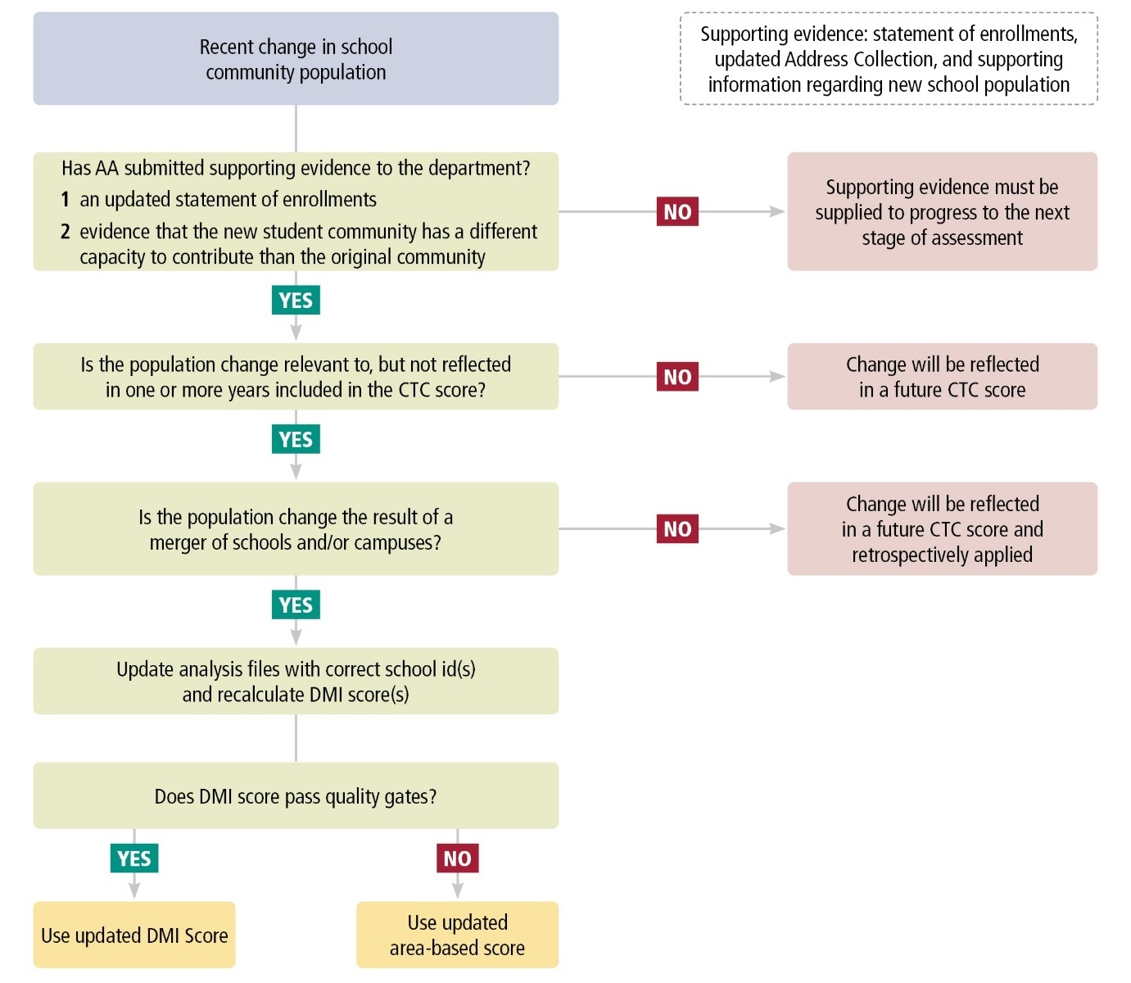

### Review supporting evidence

In this stage, it is expected that the department will check that the appellant has provided evidence as part of the business case which would enable the following questions to be answered.

1. Has the school or AA provided evidence as part of the business case about the size and assumed income of the new cohort, and the timing of the population change? Supporting evidence may come from such sources, as:
   * updated statement of enrolments;
   * School Census;
   * updated Address Collection;
   * explanation of why the new school community is expected to differ from the previous year’s school community; and
   * explanation of when the school population changed and any reasons for the change.

If the department considers that the business case is supported by sufficient evidence, the next step in the proposed process is to decide how a new score may be calculated.

### Calculating a new score

#### Option 1

When the population change is the result of the merger (or de-merger) of schools or campuses, a new school median income and score can be calculated by updating the relevant school information and re-analysing the existing data available via the MADIP. This is the same process used to create the original DMI score, but with updated school information which reflects the change in school community population.

This approach could be applied to DMI scores for one or more years used in the rolling average. Because this approach amends the school information and recalculates the score using the information already available via the MADIP, it is consistent with other DMI-based CTC scores.

Where the population change is not the result of a merger (or de-merger) of schools or campuses, it is not possible to re-calculate the school’s score using existing administrative data. In this case, the change in school population will be reflected in the following year’s Address Collection, and, in the event of a successful review, the corresponding score can be retrospectively applied.

The ABS does not recommend undertaking a parental survey as part of the review process under this scenario, because:

* the necessary input data sources – updated school information and income data consistent with that used for all other schools – are available; and
* there are no known or suspected issues with the quality of the data.

This minimises the burden on the school community and maintains, where possible, a consistent use of data and methodology, with the normal CTC score creation process.

### Consideration of quality dimensions

By recalculating the CTC score using the same income data , this approach maintains the coherence of the income data used in the DMI score.

# Section 5: Difference between linked and unlinked population

## About this scenario

DMI scores are calculated by linking data from the Address Collection to analytical data from the MADIP data asset. Data quality assurance occurs throughout this process to maximise the quality of DMI scores. This process is described in detail in A Data Quality Framework for the Australian Government’s Direct Measure of Income for Capacity to Contribute[5].

Quality assurance activities supporting data linking include:

* checking student counts for each school to make sure the expected number of Address Collection responses are obtained;
* the cleaning, standardisation and anonymisation of name information;
* the geocoding of addresses;
* applying standard formatting to linkage variables on all datasets; and
* gradually broadening linking criteria where necessary to identify more matches.

Despite the quality assurance process, some records may not link. This can happen for various reasons, such as when a name or address is recorded differently on two datasets (e.g. when a person has moved house), or an address cannot be geocoded with precision. In such cases, it is not possible to obtain income data for the unlinked population and include them in the DMI score. If the unlinked population is sufficiently large and has a different income distribution to the linked population, the DMI score may not represent the capacity to contribute of the school community.

The validation quality gate, described in the introduction, supports decision-making about the fitness-for-purpose of each DMI score. This includes analysis of known information about the school community using a range of quality metrics. Therefore, from a statistical perspective, reviewing a score under this scenario requires new information about the unlinked population to be provided.

The key factors relevant to assessing this scenario are:

* the incomes of members of the unlinked population must be significantly different from those of the linked population; and
* the unlinked population must represent a sufficiently large proportion of the school community to have an effect on the CTC score.

As an example, this scenario could occur when members of a school community:

* have significantly lower incomes than the broader community of the school;
* are less likely to link to income data. For example, they have addresses that are more difficult to geocode, are from populations that move more frequently, such as renters, or are recent migrants whose details were not recorded in administrative datasets at the time of data compilation; and
* the group is large enough to affect the DMI score, given the size of the school.

As an example, a school which experienced difficulties in geocoding a number of addresses during the Address Collection may have grounds to seek a review under these circumstances. However, in addition to the potential issues with addresses, satisfactory evidence of a difference between the incomes of the members of the school community who did and did not experience issues with their address data, would also need to be provided.

## Summary of analysis

* The analysis of a change in school community population, described in the preceding section and in Appendix B, is also relevant to this scenario. This is because including the unlinked population in the DMI score is similar to including a new cohort in a school population.
* The size of the unlinked population and its income affect whether a DMI score would change as a result of including the unlinked population. Of these, income is the most important. If the unlinked population has the same income distribution as the linked population, then including the unlinked population in the DMI is unlikely to change a school’s score, even if the unlinked population is relatively large.
* Where the income distribution of the unlinked population is significantly lower, the inclusion of an unlinked population representing 10% of students can be enough to change the DMI score for schools with up to 1000 students. For schools with over 1000 students, the inclusion of an unlinked population representing 5% of students can be enough to change the DMI score.
* The ABS also investigated the socio-economic characteristics of the areas in which members of the linked and unlinked populations live. This analysis is described in Appendix C.
  + Analysis of the 2019 Address Collection suggests that members of the linked and unlinked populations lived in areas with similar levels of access to economic resources. For both the linked and unlinked groups, parents were most likely to live in areas classified in the 10th (highest) decile of the 2016 SEIFA index of economic resources (18.8% of those who linked and 18.2% of those who did not link). Similarly, for both groups, parents were least likely to live in areas classified in the 1st (lowest) decile (4.2% of those who linked and 5.7% of those who did not link). Members of the unlinked population were slightly more likely to live in areas in the lower deciles of the index of economic resources than those who linked.
  + Analysis of the 2021 Address Collection indicates that families with and families without income information in administrative data live in areas of similar relative socio-economic disadvantage. Among students with a family income available in administrative data, 29.6% lived in areas in the highest quintile of relative socio-economic disadvantage (i.e. the areas of least disadvantage), compared with 31.1% of students with missing family income. Students typically have a missing family income because their parent(s) do not link to MADIP.

## Proposed review process and information requirements

### Proposed review process

Figure 5.1, below, illustrates a proposed process for assessing applications for DMI score review based on a difference between the linked and unlinked school community population.

Figure 5.1: Proposed assessment process – differences between the linked and unlinked population.

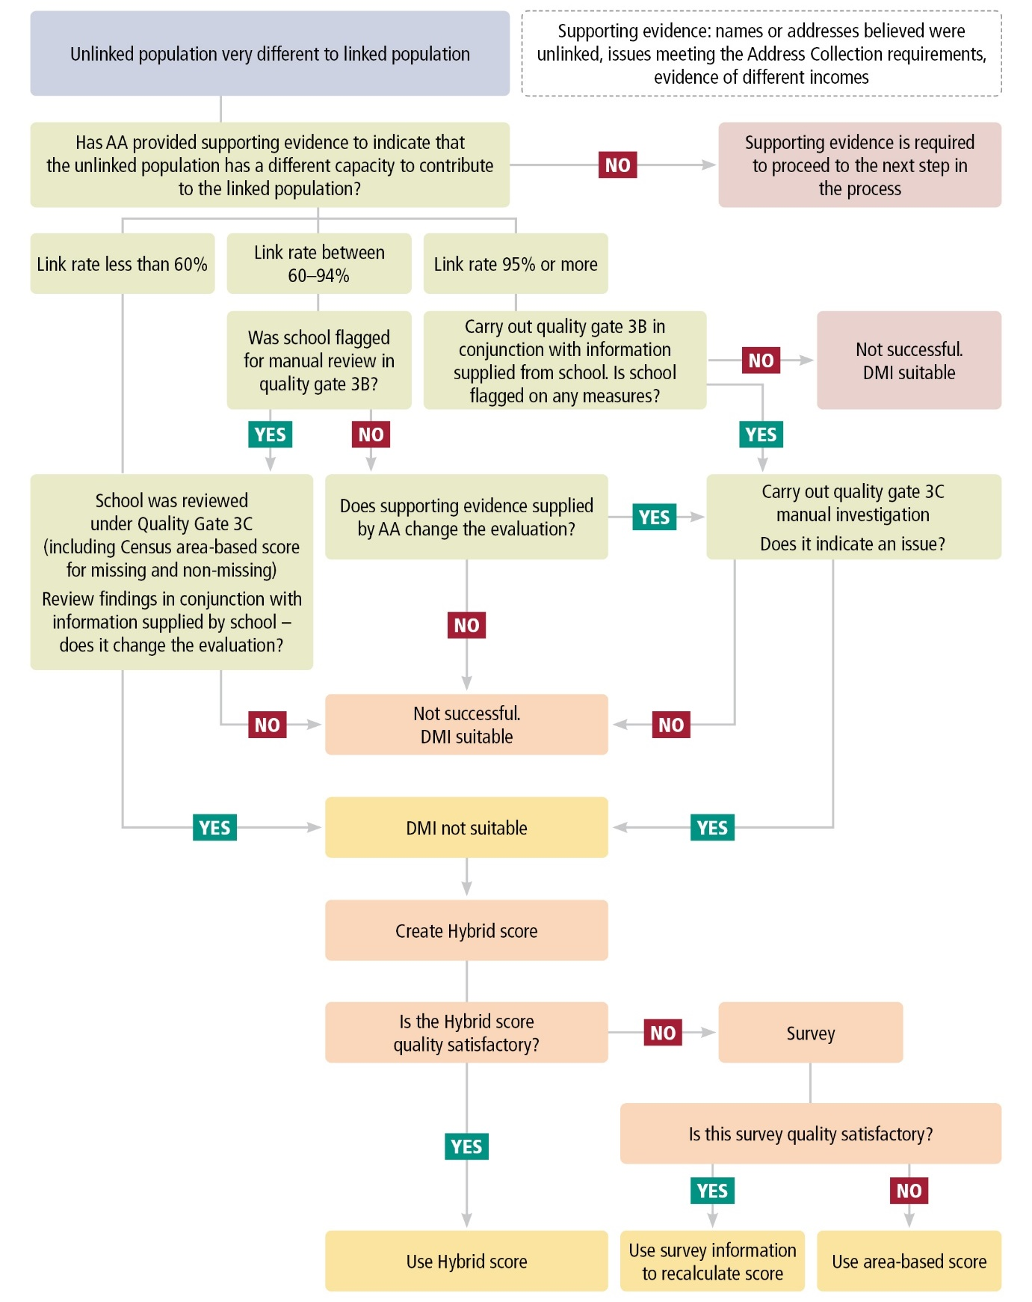

### Review supporting evidence

In this stage, it is expected that the department will check that the appellant has provided evidence as part of the business case which enables the following questions to be answered.

1. What is the estimated size of the unlinked population? Does it represent a sufficiently large proportion of the school community to affect the DMI score?
   * If possible, the appellant should provide an estimate of the size of the unlinked population as a proportion of the total school population. The ABS notes that the release of this information is subject to a disclosure risk assessment, to protect the confidentiality of personal information. As a result, it may be possible for the department to provide some information about the size of the unlinked population, such as an approximate figure, or a range in which the unlinked population falls. However, in some cases, it may not be possible to provide this information.
2. What reasons are believed or known to have contributed to any data quality issues with the Address Collection?
   * For example, there may have been a known issue at the time of or subsequent to the Address Collection, or some of the risk factors for linkage quality described in this section may be present in the school community.
3. What evidence is there to suggest the unlinked population would have a sufficiently different income distribution from the linked population to have an effect on the DMI score?
   * Describe the diversity of the school community, providing information that may support the description wherever possible. Such information may include the proportion of the school community which has a low income concession card, the proportion of students from low SES areas, etc.

If the department considers the business case is supported by sufficient evidence, the next step in the proposed process is to review the quality metrics associated with the school’s DMI score.

### Review quality metrics

In this stage of the review, the ABS understands that the department will reconsider the quality metrics produced and analysed for the school as part of the validation of its DMI scores in the series of quality checks known as Quality Gate 3[6]. All of the quality metrics used to validate DMI scores may be useful for reviews of this type. Two quality metrics which are especially relevant to analysing the potential differences between the linked and unlinked population are:

1. The difference between area-based scores created for the group of parents who linked to MADIP and the group which did not link. As this indicator uses area data, it does not compare the actual incomes of parents in the school community. Rather, it indicates the differences in average incomes of residents in the areas where members of the school community live. The ABS notes that these differences can be volatile where the unlinked group is small.
2. The lower bound sensitivity measure. This is a hypothetical measure which assumes that parents who are missing from the DMI score have systematically lower incomes than those included. Therefore, it is an indicator of the sensitivity of the median income to assumptions about the incomes of parents who are missing from the DMI. Similarly, an “upper-bound” sensitivity measure can be created, whereby parents who are missing from the DMI score are assumed to have an income from the higher end of the distribution.

For schools with a lower linkage rate (<60%) and some schools with a medium linkage rate (between 60-94%), a manual evaluation of the school’s DMI score, including assessment of a range of quality metrics, will have already been done, and this review will have concluded that the DMI score was fit-for-purpose. It is proposed that the department review this process in light of the new information provided by the appellant in the business case.

For schools with a very high linkage rate (≥95%) and some schools with a medium linkage rate (60-94%), a manual evaluation may not previously have been done. It is proposed that the evaluation be undertaken at this stage, if required.

### Calculating a new score

#### Option 1

If the evidence presented in the business case, together with the quality metrics developed as part of the manual evaluation indicate that the DMI is not fit-for-purpose, then it is proposed a hybrid score be used instead of the DMI. The hybrid score uses the same data as the DMI, where a family income value is available for a student using administrative data, and an area-based income for students whose family income is missing. The hybrid method is described in Appendix E.

#### Option 2

If the hybrid score is not considered fit-for-purpose, a parental survey may be undertaken to enable a fit-for-purpose score to be calculated. The parental survey is described in section 8. If the survey quality is sufficient (for example, response rate and other relevant quality metrics are satisfactory), it can be used to calculate a deemed score, consistent with the DMI methodology.

### Consideration of quality dimensions

Appendix E provides a summary of quality dimensions associated with the use of the hybrid method.

Consideration of quality dimensions where the parental survey is used are described in section 8.

# Section 6: Area-based score not representative of school community

## About this scenario

From 2022, a refined area-based score will be used for new schools, schools whose DMI score is not fit-for-purpose, and schools whose DMI score cannot be released for confidentiality reasons.

From a statistical perspective, an area-based score may not be a fit-for-purpose representation of a school community’s capacity to contribute under two main circumstances. These are:

1. if the quality of a significant number of addresses is poor and they cannot be geocoded with precision, then some members of the school community may not be included in the score. If the socio-economic characteristics of the areas where those members live differ from those of the members included in the score, then the score may not be fit-for-purpose.
2. if the socio-economic characteristics of members of the school community differ greatly from those of the other residents in their local area.

The proposed process for assessing reviews under this scenario is recommended for schools with an area-based score which may not be fit-for-purpose, either as a result of the data quality issues described above, or because an available (validated) annual DMI score is considered by the appellant to be a more fit-for-purpose estimate of anticipated capacity to contribute.

## Proposed review process and information requirements

### Proposed review process

Figure 6.1, below, illustrates a proposed process and key information requirements for requests for review based on quality issues associated with an area-based score.

Figure 6.1: Proposed review process for an area-based score which may not represent the school community.

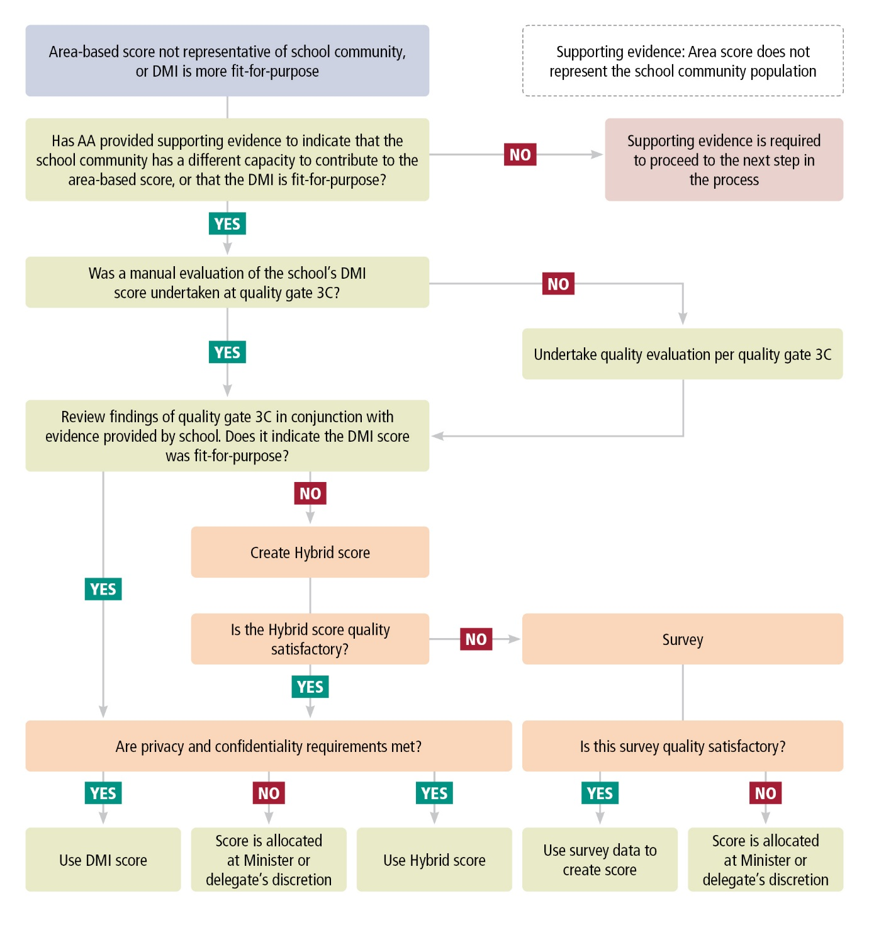

### Review supporting evidence

In this stage, it is anticipated that the department will check that the appellant has provided evidence as part of the business case which would enable the following questions to be answered.

* Has the appellant provided supporting evidence to indicate that the area-based score is not representative of the school community? For example:
  + A description of known quality issues associated with the addresses of a number of members of the school community.
  + Any records the school may have of the socio-economic status of families in the school, such as the proportion with a low income concession card (including a low income health care card, family tax benefit health care card, other health care card or pension card). Small area socio-economic data, such as counts of recipients of certain government pensions and allowances in [Data by Region](https://www.abs.gov.au/ausstats/abs@.nsf/mf/1410.0), may provide useful context.
  + An explanation of why the DMI score, rather than the area-based score, is perceived to be more fit-for-purpose by the school.

If the department considers that the business case is supported by sufficient evidence and that the area-based score is not fit-for-purpose, the next step would be to review the quality metrics associated with the school’s DMI score.

### Review quality metrics

In this stage, it is anticipated that the department will reconsider the quality metrics produced and analysed for the school as part of the validation of its DMI score in Quality Gate 3. All of the quality metrics used to validate DMI scores may be useful for reviews of this type. For schools which received an area-based score during the transition period, a manual evaluation per Quality Gate 3C may not have been done. It is proposed that the evaluation be undertaken at this stage, if required.

### Calculating a new score

#### Option 1: DMI score is fit-for-purpose

If the review of quality metrics, in conjunction with the information provided in the business case, indicates that the DMI score is fit-for-purpose, then the DMI score can be used, subject to an assessment of disclosure risk.

#### Option 2: Hybrid score

If the review of quality metrics, in conjunction with the information provided in the business case, does not indicate that the DMI score is fit-for-purpose, then a hybrid score can be used. The hybrid score uses the family income value from administrative data for students, where available, and an area-based income for students whose family income is missing. The hybrid score is described in Appendix E.

#### Option 3: Parental survey

If the review of quality metrics, in conjunction with the information provided in the business case, indicates that neither the DMI nor the hybrid score is fit-for-purpose, the ABS recommends that schools undertake a parental survey to obtain income data for the school community population. Further information about the parental survey is provided in section 8. If the quality of the parental survey is satisfactory, the survey data can be used to create a deemed score for the school, subject to an assessment of disclosure risk.

If the parental survey cannot be carried out, or survey quality indicators such as response rate are not satisfactory, then the department may conclude that a new score cannot be calculated and the existing score is retained.

#### Assessing quality, including confidentiality

Once a score has been determined for the school, the ABS recommends its quality be reviewed according to the department’s quality assurance process. This includes assessing confidentiality and disclosure risk. If the score is assessed as fit-for-purpose and the school is large enough that releasing the score does not pose a risk of disclosure of personal information, the ABS recommends the score be used.

For very small schools, for example those with less than 10 families, the privacy and confidentiality protections established under legislation such as the Census and Statistics Act 1905 (Cth) and the Privacy Act 1988 (Cth), may prevent a score from being released. In this case, the ABS recommends the department request that a score be allocated based on ministerial discretion. The ABS estimates this approach would affect a very small number of schools (less than 10 schools in 2019).

### Consideration of quality dimensions

Appendix E provides a summary of quality dimensions associated with the use of the hybrid method.

Consideration of quality dimensions where the parental survey is used are described in section 8.

# Section 7: Large average family size

## About this scenario

Some Australian Government policies, such as Family Tax Benefit[7], take family composition into account in their methodology. However, neither the DMI nor the area-based methodologies for CTC scores currently incorporate family size. For the purposes of this technical review framework, the ABS has considered the question of family size in a manner consistent with the approach used by the department under the previous SES method. That is, as family size is not taken into account in the DMI or area-based methodologies, it may be appropriate to consider family size in the review process. In this section, the ABS has designed a proposed review process which:

1. allows the department to identify where a large average family size constitutes an extraordinary circumstance for a school community; and
2. provides options for calculating a new score, enabling family size and other factors, including data quality and availability, to be considered.

Under this scenario, a school would be able to seek a review of its CTC score if:

* The average family size of the school community is significantly larger than the average family size of all non-government school communities, based on the definition determined by the department.

However, a review under this scenario would be unlikely to result in a change of score if:

* There are several large families in the school community, however the average family size of the school community overall is not significantly large.

## Summary of analysis

The ABS undertook analysis to assist the department to define a ‘significantly large average family size’ within non-government school communities, for the purpose of this process. This analysis is updated annually to inform the assessment of a ‘significantly large average family size’ in school communities.

* For schools in the 2019 Address Collection, the average number of dependants in families is 2.16. This is based on 2016 Census of Population and Housing data, where a dependant is defined as a child under the age of 15 or a member of the household under the age of 24 who is a full-time student.
* The average number of dependants in families, for schools, is approximately normally distributed with a standard deviation of 0.26. Therefore, there is an approximately 95% probability that the average number of dependants in families at a school is less than 2.58. There is an approximately 99% probability that the average number of dependants in families at a school is less than 2.76.
* The annual assessment of the average number of dependants in families, in school communities, uses the most recent Census data available.
* For a description of this analysis, including discussion about the definition of family size and the available data, see Appendix D: Analysis of family size in non-government schools.

## Proposed review process and information requirements

### Proposed review process

Figure 7.1 illustrates a proposed decision-making process which the department can use to assess applications for CTC score review based on a significantly large average family size.

Figure 7.1: Proposed process for assessing reviews based on significantly large average family size.

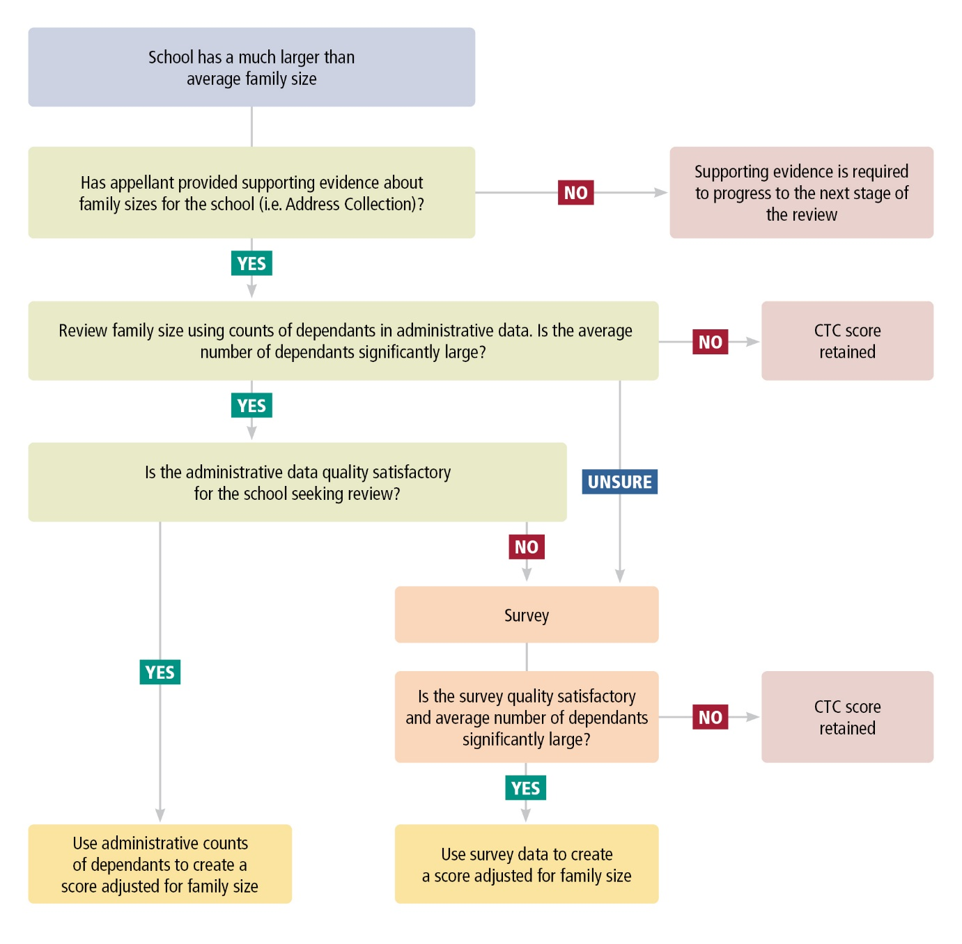

### Review supporting evidence

In this stage, it is expected that the department will check that the appellant has provided evidence as part of the business case which would enable the following question to be answered.

* Has the school or AA provided supporting evidence to indicate the existence of a significantly large average family size in the school community? For example: any information the school may have about the number of dependants in families.

It may be possible for the department to provide an estimate of the average number of dependants in the school to assist the AA with the business case.

### Determining average family size in the school community

If the department considers the business case is supported by sufficient evidence, the next step in the proposed process is to determine the counts of dependants in each family and obtain the average family size of the school community.

#### Available data sources

Potential data sources include counts of dependants available in the administrative data used to calculate the DMI scores and in the Census of Population and Housing. The ABS notes that the coverage of this data for each school community varies, so a combination of the data sources may improve quality.

If the administrative data do not provide a count of dependants of sufficient quality, for example, if there is insufficient coverage of the school community in the data, then a parental survey may be undertaken to obtain fit-for-purpose data. The survey is described in section 8.

If the analysis of the number of dependants, using administrative or survey data as appropriate, indicates that the school has a significantly large average family size, according to the definition determined by the department, then the next step is to calculate a new score.

If the analysis of the number of dependants indicates that the school does not have a significantly large average family size, or if the survey is not able to achieve sufficient quality, the existing CTC score is retained.

### Calculating a new score

The ABS considered several options for adjusting scores to take family size and composition into account. However, these options are not currently recommended due to the availability of data. These options are described in Appendix F.

#### Option 1: Income is adjusted for large families in the school only

Under this option, income is adjusted for large families only. A new median income is calculated for the school using un-adjusted income for families which are not defined as large and adjusted income for large families. This new median income is standardised using the existing distribution of median incomes for all schools. The median incomes and scores of other schools are not adjusted in the process.

The method used to facilitate the comparison of incomes between households of differing size and composition is known as income equivalisation.[8] Under this method, incomes are equivalised using an “equivalence factor”. An equivalence factor is applied to each household income depending on the composition of the household, which adjusts the income to support the comparison across households.

The adjustment of income for large families can be made using the ABS’ standard equivalence factors. To calculate the equivalence factor for a family, each family member is allocated equivalence points:

* 1 point to the first adult;
* 0.5 points to a second adult and persons over the age of 15; and
* 0.3 to each child under the age of 15.

For example:

* a family with two adults and two children under 15 has an equivalence factor of 1 + 0.5 + 2*0.3 = 2.1
* a family with two adults and six children under 15 has an equivalence factor of 1 + 0.5 + 6*0.3 = 3.3

Since standard equivalence factors enable the comparison of households of varying compositions to households with a single adult, the ABS recommends that under this option, the equivalence factors be applied so that large families can be compared with average-sized families. This means incomes for large families are standardised to a ‘base’ family size defined for this purpose as 1 or 2 parents and 2 children under 15 years.

For example, adjusting the income of the aforementioned family with two adults and six children to make it comparable with that of a family with two adults and two children, is achieved by:

* dividing the family income by 3.3 (the factor for a family with two adults and six children); and
* multiplying it by 2.1 (the factor for a family with two adults and two children).

This approach is non-standard but the ABS considers it a valid option in the context of the CTC review process, in which adjustments to CTC scores can be made where extraordinary circumstances at a school or among a school community have been established. There are several advantages to this option. Firstly, it is a relatively simple way to apply a family-size adjustment to specific families whose capacity to contribute is considered different to that of other families, due to their large size. Secondly, it only requires data for large families in the school whose score is being reviewed. Therefore, it can be carried out with the minimum data requirement.

This option requires a “large family" to be defined for the purpose of adjusting a family’s income based on its perceived capacity to contribute. It is important to note the definition of a large family for this purpose differs from the identification of a large average family size among a school community.

### Consideration of quality dimensions

There are implications for the dimensions of quality that depend on the method of collection of the income and dependants data used in the adjusted scores.

Using administrative data maintains the timeliness and coherence of the data sources used in the adjusted and DMI scores. The definitions of dependants vary in different administrative data sources. Therefore, the quality of an adjusted score associated with a choice of one or more administrative sources would need to be assessed.

Using parental survey data to calculate a score adjusted for family composition improves the timeliness of the income data and the relevance of the school community population.

# Section 8: Parental survey

## Role of the parental survey in CTC score reviews

The parental survey is available as part of the proposed CTC score review process and supports the calculation of new scores where there are established exceptional or unique circumstances and fit-for-purpose data is not otherwise available.

## The history of the survey

A parental survey was also used to support the review process under the SES approach. Recognising there could be exceptional circumstances under which the SES score for a school did not accurately reflect the anticipated capacity to contribute of the school community, AAs could request a review of a school’s CTC assessment based on the SES score. In some cases, the school community was asked to complete a survey (the Survey of Non-Government School Parents, or SNGSP) which asked questions about:

* family composition, including the number of people in the family, their age and gender; and
* for persons aged over 15, their:
  + highest level of education attained;
  + labour force status, including hours of work and occupation; and
  + income from all sources.

The target response rate for the survey was 95%. The survey was used to construct a social profile for the school, including education, income and occupation dimensions. This social profile was then compared to a benchmark dataset of social profiles for all non-government schools. Where a review was successful, a new SES score was calculated using a weighted average SES score of the schools with the most similar social profiles in the benchmark data.

## Updating the survey to reflect the DMI methodology

The ABS was engaged by the department to provide advice about how to adapt the survey to support decisions about reviews under the new CTC methodology. The following sections contain the ABS’ recommendations for that survey. In its advice, the ABS has aimed to maximise the quality of information available to support decision-making by the department, while minimising the burden on respondents.

### Summary of recommendations for parental survey

1. Survey scope
   1. The ABS recommends the survey scope enable scores to be produced which can align with the DMI methodology as well as provide accurate adjusted family income. Therefore, it should include responses from up to two parents or guardians in each household in which students live.
   2. Where both parents live in the same household, they should complete a single survey form.
   3. Where the parents live in separate households, a separate form should be provided for each household. If possible, these should be linked by a random number so that the combined family income can be derived.
   4. Where multiple families live together, the scope should be limited to the family of the student.
2. Survey mode
   1. To obtain the highest possible response rate, the ABS recommends that both an online and paper-based survey form be developed.
3. Survey form design
   1. The ABS recommends the survey instructions be expanded to include the purpose of the survey and documentation that will be required to facilitate responses.
   2. A question enabling respondents to provide feedback on the survey is recommended.
4. Survey questions and responses
   1. The ABS recommends removing questions which are not relevant to expected review reasons or the DMI methodology, and expanding the income questions to support the measurement of ATI by the survey.
5. Target response rate
   1. The ABS has been advised that the department plans to aim for a 100% response rate.
   2. Where such a high response rate cannot be achieved, the ABS recommends that the department require a response rate that is higher than the income coverage rate used to produce the school’s DMI score or the proportion of parent addresses used in an area-based score.
6. Quality assurance
7. The ABS recommends the department consider defining a quality assurance process for the survey data, that incorporates checks of:
   1. input data quality, including coverage and completeness of responses collected;
   2. processing, where the processed survey data reflect logical and valid responses; and
   3. outputs (e.g. new score and associated quality metrics), including confrontation against other available data sources.

These topics and associated recommendations are discussed in the following sections.

## The new parental survey

### Survey scope

To support both the production of scores that align with the DMI methodology and estimates of adjusted family income, the ABS recommends the survey scope include responses from up to two parents or guardians in each household in which students live.

Where both parents live in the same household, they should complete a single survey form on behalf of the family. Where the parents live in separate households, a separate form should be provided for each household. The form should be completed by the student’s family. So that a combined parental income can be derived, these survey forms could be linked by a random number, to maintain the privacy protections in place for the survey. Where multiple families or members of the student’s extended family live together, only the family of the student should be in scope.

These approaches also facilitate the calculation of the response rate for the survey.

### Mode of survey

There are advantages to using both paper and online forms in surveys. Paper forms can be convenient, as they can be printed and provided directly to respondents. They are also required for people who do not have access to a computer or other device, do not have suitable internet access, or are less accustomed to completing tasks online. Online forms have the advantage of additional functionality, such as the ability to provide explanatory information or help text using automatic prompting or links, the ability to automatically skip questions that are not relevant to a particular respondent, and the ability to support as many respondents as necessary. Therefore, the ABS recommends that both paper and online survey forms be developed for the new survey.

Given the functionality associated with each survey mode, survey form design usually differs according to the mode, and it is preferable that a questionnaire designed for paper is not directly converted to an online form. In the parental survey, it is important that the online form can loop and skip questions, if required. For example, if a family has two parents and two children, the online form should be able to ask questions relating to the income of the two parents by looping through those questions for the first parent, then the second parent, and skip those questions for the children. It is also important that both the online and paper forms are tested thoroughly for usability, system performance (load), security and the quality of the outputs before use.

The paper form should provide supporting information about any questions which may be difficult to understand. For example, in the previous survey, the question about the age of each family member included information on how to include newborns and people aged over 99 in the form. In the online version of the form, the respondent should be prompted with further information by including an information icon. The online form should be made easy to read by maximising white space, grouping questions on related topics together and enabling the forward key to direct people to the next topic or question. A status bar and progress bar would also help respondents know how long the survey is likely to take to finish.

### Form design: instructions and feedback

To ensure that surveys provide data of the best possible quality, it is important to provide respondents with background information, such as:

* information about the survey;
* its purpose;
* who should complete the survey;
* how the respondent can complete the survey;
* what information the respondent will need to complete the survey and where to find it; and
* how their personal information will be used and their privacy protected.

The background information provided by the department as part of conducting the SNGSP is of a high standard, including the instructions provided to respondents. To further support respondents to complete the survey, the ABS recommends the department also provide:

* information about the purpose of the survey;
* together with the existing instructions, advice to respondents about the kind of supporting documentation, such as their completed income tax returns and financial statements, they should have available to help them answer the survey questions; and
* a comments section at the end of the survey to give respondents the opportunity to provide feedback.

### Survey questions and respondents

#### Family composition

The family composition questions in the SNGSP, including the questions about the age and the relationship between members of the household, provide necessary information to support reviews, are clear and fit-for-purpose. Therefore, the ABS recommends these questions be retained.

#### Education

The ABS recommends the questions about educational attendance be retained to support the measurement of dependants, which is used in the analysis of large average family size.

To reduce respondent burden, it is recommended that the question on household members’ highest level of educational attainment be removed from the survey, as this information is no longer used in calculating CTC scores, and does not provide information expected to be used in a review.

#### Employment

The ABS recommends that the questions about employment and hours of work be removed, as they are not relevant to the DMI methodology. Though demonstrating a change in employment status or a reduction in hours of work may be of interest where there has been a recent economic change, ultimately, this would be expected to be reflected in a person’s income.

#### Occupation and industry

Previously, the ABS recommended that questions about occupation and industry of employment be included, to support the assessment of the impact of economic events on the school community. However, due to the availability of timely data on industry of employment via Single Touch Payroll, the ABS considers these questions no longer needed.

#### Income

Obtaining the best possible data about income is critical to ensuring that the parental survey provides fit-for-purpose information to update a school’s CTC score. The ABS recommends the questions about income are asked of all members of the family over the age of 15. This is particularly important if the survey is being conducted to understand family size at the school.

The parental survey should also ensure that income information obtained aligns with the Adjusted Taxable Income (ATI) definition used in the DMI. Parents should be reminded to refer to information from their income tax return, available via MyGov or their tax accountant, as this will provide the most accurate income data.

The ABS has done extensive testing on the best way to ask questions about income, for ABS surveys and the Census of Population and Housing. Income can be asked in a single question or as a set of questions, each asking about a different component of total income or ATI. ABS analysis shows there is a trade-off between the accuracy of the income data and the respondent burden associated with responding to multiple questions. To support accuracy and where the length of the questionnaire allows, the ABS recommends income be asked as a set of questions rather than one question. This is because, where income is asked in a single question, respondents (even with the best intentions):

* tend not to read all of the inclusions and exclusions;
* may forget to include certain types of income they have earned; and
* tend to approximate the total rather than adding together exact amounts of the different sources of income they have earned.

As a result, there is a risk respondents may under-report income when responding to a single income question. The ABS recommends income questions ask about taxable income and other income items relevant to the ATI definition (such as reportable superannuation contributions, child support payments, etc) to align with ATI and improve comparability with the DMI. To reduce respondent burden, it may be reasonable to exclude some elements of ATI, such as target foreign income, which are expected to represent a negligible amount of income among the target population. While ATI is a complex concept for people to report on, using additional prompts and questions will help respondents step through the income component more easily.

Other recommendations for asking about income include:

* Income questions should ask the respondent their income for a specific financial year. This should relate to a time period that has ended, as many people have difficulty estimating their annual income for time periods that have not ended, particularly if they are casual workers, need to report profits or losses from unincorporated businesses, or work in contract jobs. Therefore, respondents should be asked to provide information for a previous financial year, not the current or ‘usual’ year, an incomplete year, or an expected amount. The ABS also notes that people, especially those with a variety of sources of income, may not complete their tax assessments immediately after the end of the financial year. As this may affect their ability to complete the income questions in the survey, it should be taken into account when determining the timing of the parental survey.
* Collecting income in ranges is not recommended, as this reduces the utility of the data for analytical purposes, such as the ability to calculate accurate medians.
* When collecting income from government payments, allowances and pensions, it is good practice to include a prompt with a list of payments to remind the respondent of payments they may have received.
* The ABS recommends amounts paid in child support be collected separately. These are deducted from taxable income in the calculation of ATI.

## Reference period

The parental survey should ask respondents to consider their circumstances as at a particular time or during a particular period when answering the questions. This is especially important for the income questions. The ABS recognises the choice of reference period for income questions in the parental survey introduces certain trade-offs from a data quality perspective. Specifically:

* Accuracy is improved by asking about completed financial years, as noted above, because respondents have access to supporting documentation (e.g. tax returns) and do not need to estimate their future income. Accuracy may also be improved if the reference year is more recent, as people may be able to find their supporting documentation more easily.
* Timeliness is improved by asking about the most recent completed financial year. For 2022 DMI scores being reviewed in 2023, this would be the 2021-22 financial year. Timeliness is of particular interest for certain review scenarios, such as recent economic change.
* Coherence refers to how comparable the deemed scores based on parental survey data are with CTC scores based on the DMI. Since the deemed scores replace the CTC rolling averages for a period of time (e.g. three years), it is not possible that they are directly comparable (without introducing significant respondent and administrative burden and a high level of complexity). The most coherent approach, under the circumstances, would be for the survey reference period to match the income reference period of the DMI score it replaces (for reviews of 2022 DMI scores applied in CTC scores in 2023, this would mean an income reference period of 2019-20).

To summarise, an approach that prioritises accuracy and timeliness over coherence would use the most recent, complete, financial year (2021-22 for 2023 CTC scores). On the other hand, an approach that prioritises coherence over timeliness (and to a lesser extent, accuracy) would use the same income reference year as the score being reviewed (2019-20 for DMI-based CTC scores in 2023). Where a timelier income reference period is collected in the parental survey, the median income obtained via the survey could be adjusted using the Wage Price Index, so it is more comparable with the reference period used in CTC scores.

## Response rate

There are various factors to consider when setting a target response rate for the parental survey, such as the fitness-for-purpose of the data, the administrative burden for the school, and the burden on respondents.

As the DMI methodology aims to incorporate all members of the school community, as recorded in the Address Collection, it is consistent that a target response rate also aim to include 100% of the school community. In practice, however, a school’s DMI score may not be based on 100% of the school community, for data quality and other reasons (e.g. new students may join a school during the year). Therefore, the ABS recommends that, at a minimum, the target response rate be higher than the proportion of the school community for which income data (including supplementary sources) is available in the DMI, or the proportion for which addresses are available in an area-based score.

It is important to note that a small amount of non-response can affect the median income, if there is bias in the non-respondents. That is, if a small percentage of responses are missing, but they belong to members of the school community with a different income distribution than the surveyed population, this may affect the median income obtained via the survey. This is consistent with the analysis in Appendix B.

Additional factors the department may wish to consider in setting a target response rate include:

* the types of income (ATI, payment summary, concession card, etc) used in the DMI;
* the proportion of the school community which was missing from the DMI or area-based score;
* indicators of a difference between the incomes of people present in and those missing from the DMI calculation (for example, comparing Census data for the two groups or the area-based scores of the two groups); and
* the school community’s income distribution, for example where it appears or is suspected that there may be distinct income sub-groups within the school community.

## Further considerations

### Cohort differences

Due to timing differences, the survey will cover a different school community population than that which was included in the school’s CTC score. For example, the analytical population for a 2022 DMI score is the parents of children enrolled in the school in 2022. However, the analytical population for a survey undertaken in 2023 will be the parents of children enrolled in the school in 2023. This is another reason why scores created using survey data are not expected to match DMI scores.

The extent to which this affects the comparability of DMI and deemed scores depends on the difference in parental income between the new and former students. If schools tend to attract similar families each year, then the distribution of incomes in a given cohort is likely to be similar to that of the previous year. The ABS notes that one of the quality metrics assessed during the validation of DMI scores is volatility. This enables the department to obtain a picture over time of the annual change in DMI scores. If, over time, it becomes evident that the change in cohort does affect the comparability of scores, then this could be analysed and scores adjusted if necessary.

### Quality assurance

The ABS recommends survey results be validated and the survey process be evaluated as part of the department’s CTC process. While this section does not constitute a detailed quality assurance process, some broad recommendations are provided.

#### Collection management

Once the survey has been conducted and the target response rate achieved, the survey responses should be checked for completeness. Any duplicate or out of scope responses should be removed.

#### Editing

Editing refers to checks to ensure survey responses do not contain invalid values. For example, income values should be numeric with symbols or words removed. Editing values for components such as income is critical to ensure there are no systematic issues with reporting. An editing strategy outlining what values are valid or invalid for a given survey question, how to treat invalid responses, and how to manage versions of data (such as pre- and post-edited data) may be helpful.

#### Derivation, coding, internal consistency checks

New variables, such as counts of dependants and equivalisation factors, should be derived. Responses should be coded where applicable; for example, occupation or industry data may be coded from written responses into pre-defined categories.

Internal consistency checks should be applied to ensure the respondent has interpreted and filled in the survey correctly. Examples include checking the number of people included in the survey response, the relationships between the family members seem consistent and are consistent with whether the person works and / or studies, and responses for occupation, industry, employment and income are not incompatible.

#### Summary statistics and confrontation

After survey responses are processed, it is recommended to check that summary statistics seem sensible and as expected. Examples of summary statistics that may be used include the number of students and parents at the school, median income, proportion employed and income distribution. Summary statistics from the survey can be compared with the business case and recent DMI and Address Collection data to identify any systematic or large differences. Some summary statistics, such as counts of dependants, may be able to be confronted with administrative data at the school level. Depending on the review scenario, changes in these variables may or may not be expected.

#### Survey evaluation

Evaluation of a survey typically involves checking which questions appear difficult for respondents to answer and whether the feedback at the end of the form indicates any common or recurring issues.

# Appendix A: Analysis of Impact of COVID-19 on school communities

## Data

In 2020, the ABS sought new, timely sources of data to understand the impacts of the COVID-19 pandemic and inform policy responses. Single Touch Payroll (STP) data is one such data source and is collected by the Australian Taxation Office (ATO)[9] from businesses with STP-enabled payroll and accounting software. The ABS has used STP data to analyse the impact of COVID-19 on the capacity to contribute of non-government school communities.

The analysis involved creating indexes from administrative data integrated with the Address Collection to measure changes in the number of payroll jobs and median weekly wages of school communities, from March 2020 to June 2021. Schools which did not have a fit-for-purpose DMI score in 2021 and very small schools were excluded from the analysis, for confidentiality reasons.

## Method

Two indexes were created by compiling, for parents and guardians of students in the 2021 Address Collection:

1. Weekly counts of the number of payroll jobs belonging to parents and guardians during that week. A parent or guardian may have multiple payroll jobs.
2. The median weekly compensation (wage) of parents and guardians with a payroll job during that week. Where a parent has multiple payroll jobs, the amounts are summed together. Where a parent has a payroll income value in the data, but in a subsequent week is not present in the data, they are assumed to have $0 income.

The indexes focus on relative changes (rather than level estimates) after the onset of the COVID-19 pandemic and the associated measures to manage it. To compare changes over time, the week in which Australia recorded its 100th confirmed COVID-19 case (i.e. the week ending 12 March 2020) is used as the reference period for constructing the indexes and given an index value of 1.

The indexes allow comparison of data between two points in time, and the points in time can be adjacent (this week and the previous week) or many weeks apart. Movements in the index from one period to another can be expressed as either points or percentage change. For example, a change from 1.0 to 1.05 can be expressed as a 0.05 point increase or a 5% increase in the number of payroll jobs.

## Key findings

For parents and guardians in the Address Collection in 2021, the payroll jobs index dropped sharply in April 2020 and reached a low point of 0.962 in late April (figure A1). Following the low, the index rose and remained above 1 from July to December 2020, indicating that the number of payroll jobs among parents or guardians exceeded its pre-pandemic level. A second drop (to 0.987) occurred on 31 December 2020 – however, this is consistent with labour market seasonality at year’s end. The index subsequently rose and remained above 1 until June 2021.

**Figure A1. Index of parents or guardians with payroll job, CTC Address Collection 2021, indexed to the week of 12 March 2020.**

**Line graph showing index of parents or guardians with payroll job, weekly, from 12 March 2020 to 24 June 2021. Includes parents in the CTC Address Collection 2021, with values indexed to the week ending 12 March 2020.
The key features of the graph are described in the text.**

For parents and guardians with a payroll job in the 2021 Address Collection, the median weekly wage index declined by 2.5%, from 12 March 2020 to 24 June 2021 (figure A2).

Figure A2. Index of median weekly wage of parents or guardians with a payroll job, CTC Address Collection 2021, indexed to the week of 12 March 2020

Line graph showing index of median weekly wage of parents or guardians with a payroll job, from 12 March 2020 to 24 June 2021. Includes parents in the CTC Address Collection 2021, values indexed to the week ending 12 March 2020.
The key features of the graph are described in the text.

## Using indexes to assess relative economic impact

The median weekly wage index can be used to assess the economic impact of a change in economic circumstances for a school, relative to other schools, over a defined period of time. This approach estimates the change in median weekly wage for a school seeking a review, since the income data reference period of its most recent DMI score, relative to the change in median weekly wage for all schools over the same period.

The following steps are taken:

1. Calculate the median weekly wage for all schools, and for the CTC population overall.

* The CTC population overall provides the national baseline against which individual schools are compared.
* Weekly compensation amounts are derived for parents in the CTC population, using STP data.

1. Convert the median weekly wage value into an index.

* The index value of 1 is given to the median weekly wage index on 12 March 2020; this date is used to designate the start of the pandemic.

1. For each school, calculate the relative median weekly wage index.

* This is each school's median wage index value divided by the index value for the CTC population overall in the same week.
* It represents each school's median wage index as a proportion of the overall CTC population median wage index each week.
* If a school's relative median weekly wage index is greater than one, it means the school's weekly median wage index is greater than the index value for the CTC population in that week.

1. Calculate the average relative median weekly wage index for each school over the period
   * For example, for a review of a 2021 DMI score, the average relative index value from March 2020 (the beginning of the pandemic) to June 2021 is taken.

* The average relative weekly median wage index indicates the extent to which each school's weekly median wage index is above or below the overall CTC population index, on average, over the period. For example, an average relative weekly median wage index value of 0.90 means that the school's weekly wage index was 10% below that of the overall CTC population, on average, over the period.

1. If the relative economic change in the school is significantly large, the school’s score is adjusted by multiplying the school's median income used in the DMI score by its average relative weekly median compensation index.

* In the above example, this would mean multiplying the school's median income by 0.90, or, in other words, reducing it by 10%.

1. Finally, the school's adjusted median income is converted into a score using the DMI methodology's standardisation process.

The average relative median weekly wage index, as defined above, provides an indicator of the average change in the median wage from payroll jobs among a school community, relative to that of other schools, over a defined period. Where the data is considered fit-for-purpose (see: Assumptions and limitations, below), this methodology can support the identification of schools disproportionately affected by the COVID-19 pandemic, relative to other schools.

Figure A3, below, provides the distribution of average relative median weekly wage indexes, from March 2020 to June 2021, for schools in the 2021 CTC population. Approximately three in four schools (74%) had an average relative median weekly wage index of between 0.95 and 1.049 over this period. In other words, these schools’ median weekly wage indexes were within 5% of the overall CTC population index, on average, from March 2020 to June 2021. Approximately 5% of schools had an average relative median weekly wage index below 0.9 over this period. This indicates that these schools’ weekly median wage index was at least 10% below that of the overall CTC population, on average, over the period.

Figure A3: Distribution of average relative median weekly wage indexes, March 2020 – June 2021, 2021 Address Collection.

Proportion of schools in the 2021 Address Collection with a given average relative median weekly wage index over the period 12 March 2020 to 24 June 2021.
Less than 0.9: 5%
0.9 to 0.94: 10%
095 to 0.99: 35%
1.0 to 1.04: 39%
1.05 or more: 11%


## Assumptions and limitations

There are several assumptions inherent in using administrative data to assess recent economic changes in school communities. The ABS recommends these assumptions be assessed as part of the review process, as described below.

1. The scope and coverage of STP data

Payroll jobs reported to the ATO via STP include employees at businesses reporting via the STP system. As such, not all jobs and sources of income are reflected in this data. For example, owner-managers of unincorporated enterprises and persons who earn income from sources other than employment, for example investments, superannuation, annuities and government payments are excluded.

Businesses reporting via STP make up a large proportion of all businesses. Although the ATO commenced onboarding all employers to the STP platform in July 2018, not all businesses were using the STP platform in 2020. It is estimated that 99% of businesses with 20 or more employees had onboarded by this time, and 77% of employers with less than 20 employees were being onboarded[10]. For employers that onboarded during the analysis period, data was adjusted to ensure the weekly estimates best reflected changes in the labour market over time through payment activities, rather than changes in the uptake of STP reporting by the businesses. This is consistent with methods applied to STP data released by the ABS in [Weekly Payroll Jobs and Wages in Australia](https://www.abs.gov.au/statistics/labour/earnings-and-work-hours/weekly-payroll-jobs-and-wages-australia/latest-release).

Coverage rates of STP data among parents with income in schools and in the CTC population overall tend to be high. In 2021, an STP record was available for 77% of the linked CTC parent population, and 82% of the parent population with an Adjusted Taxable Income (ATI). The proportion of parents included in the STP data varied across schools. Approximately seven in ten schools (71%) had a coverage rate of 80% or above for parents with an ATI.

In considering the fitness of STP data for assessing recent economic change for a school, the ABS recommends the proportion of parents with STP data and the proportion of income earners by main source of income be assessed. If the proportion of parents with STP data is low, or the proportion of parents who earn income from other sources, such as own unincorporated businesses, government payments, and investments / superannuation, is high, then another approach (such as a parental survey) may be preferable for the school.

2. The income concept

The income concept used in the DMI is ATI, while the income concept available in STP is total wages. Therefore, this method assumes that the impact of the pandemic on total wages is representative of the impact on ATI.

3. The use of weekly parental wage data

The median weekly wage index is calculated using weekly parental wage data. This differs from the DMI, which is based on the median annual family income (income of up to two parents or guardians). Further investigation would be required to understand the impact on income at the family level.

4. Availability of data for 2021 DMI score reviews

To calculate the change in income at a school since the reference period of the income data used in the 2021 DMI score would require STP data from July 2019 to June 2021. However, STP data is available from 12 March 2020, representing the onset of the COVID-19 pandemic. This introduces an assumption that incomes were stable from July 2019 until the onset of the pandemic.

# Appendix B: Changes in school community population

This appendix summarises the ABS’ analysis of how DMI scores may be expected to change when the school community population included in a DMI score changes. This could occur when:

* a new cohort of children join the school, for example in the case of a school merger;
* parents previously excluded from the DMI score calculation, due to not linking to MADIP are included in the calculation; and
* when a cohort of students leaves a school community, for example if the year levels offered by the school changes.

To understand the impact of the change in analytical population on the DMI score, the following questions need to be answered:

* how big is the new cohort relative to the population included in the DMI score?
* how different is its income distribution from that of the population included in the DMI score?

## Analysis: changes in school community population

The ABS analysed the change in 2019 DMI scores associated with different levels of change in the school community population. This analysis was performed by sampling students from the current school population and using their income records to create an assumed new cohort of students. This resampling was run three times. In the first case, the new students were drawn from the full school population. In the other two cases, the new students were drawn from a subset of the school population - either students with a low income concession card flag, or students without a low income concession card flag. The low income concession card flag indicates whether at least one of a student's parents has a low income health care card, family tax benefit health care card, other health care card or pension card. Once the new cohort was added to the school population, the school median income was recalculated taking into account the current and new records, and standardised to create a new DMI score.

Summary statistics describing the DMI score changes are provided for schools of different sizes and for population changes of different sizes. Summary statistics include the average (mean) change in DMI score, the standard deviation of the change in DMI score, the 95% confidence interval for expected DMI score changes and the proportion of schools in each size category with no DMI score change as a result of the population change. These results are provided below.

## Key findings

1. The most important factor in determining whether the DMI score is likely to change is the income distribution of the new cohort. The size of the new cohort is the next most important factor, followed by the size of the school.
2. If all students in the new cohort have at least one parent with a low income, then the DMI score is likely to decrease.
   1. This occurs more often when the new cohort is relatively large. For example, when the new cohort represents 20% of students, DMI scores decrease for between 79% and 100% of schools. In contrast, when the new cohort represents only 5% of students, DMI scores decrease for between 44% and 78% of schools (table B1).
   2. The size of the decrease in DMI score is larger when the new cohort is relatively large (figure B1). When the new cohort represents 5% of students, the average decrease in score is between 0.6 and 1.1 points, depending on the size of the school. However, when the new cohort represents 20% of students, the average decrease in score is between 2.3 and 4.2 points.

Figure B1: Average DMI score change by new cohort size and school size, when new cohort is from a low income population.

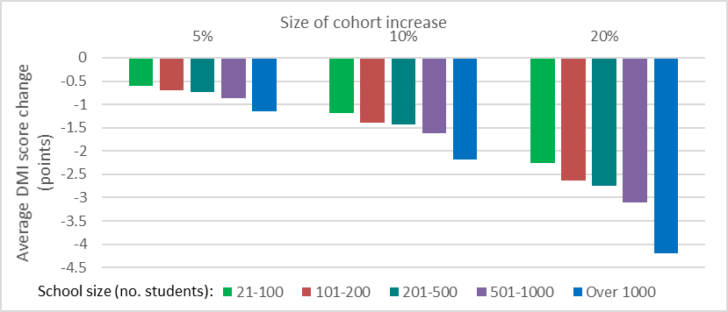

1. When none of the new students’ parents have a low income concession card, then DMI scores are likely to increase slightly as a result of including the new population in the DMI score calculation (figure B2). The average increase is less than one point, with slightly larger average score changes when the new cohort is relatively large.

Figure B2: Average DMI score change, by new cohort size and school size, when new cohort is not from a low income population.

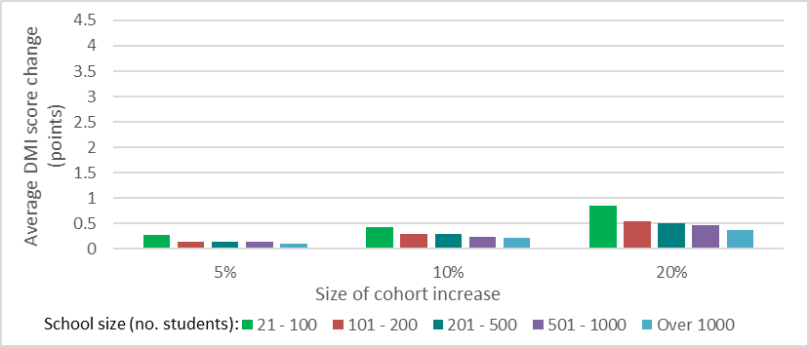

1. When the new cohort has the same income distribution as the existing school community, then the school’s DMI score is unlikely to change.

Table B1 shows the mean, standard deviation and expected range of the difference in DMI scores associated with student population changes of various sizes and under different assumptions about parental incomes. The expected range of the difference in score is a 95% confidence interval – that is, the mean plus or minus approximately two standard deviations. The proportion of schools in each size category with no change in DMI score is also provided.

Considering the first row of the table as an example, 70% of schools with 21-100 students will have no change in score if there is a 5% increase in student numbers, when the new parents have the same income distribution as the existing members of the school community. The expected score change under this circumstance ranges from a 1.59 point decrease to a 1.69 point increase, based on a 95% level of confidence. The average score change for such a school is a 0.05 point increase, with a standard deviation of 0.82 points.

Table B1: Change in 2019 DMI scores associated with a new student cohort, by assumed parent income and school size.

| Increase in no. of students | School size (no. students) | Mean of difference | Standard deviation of difference | Expected range of difference (95% CI) | Proportion of schools in size category with no change |
| --- | --- | --- | --- | --- | --- |
| Assumed income distribution of new cohort: Same population | | | | | |
| 5% | 21 - 100 | 0.05 | 0.82 | (-1.59 to 1.69) | 0.70 |
| 5% | 101 - 200 | -0.02 | 0.48 | (-0.98 to 0.94) | 0.78 |
| 5% | 201 - 500 | 0 | 0.47 | (-0.94 to 0.94) | 0.84 |
| 5% | 501 - 1000 | -0.02 | 0.36 | (-0.74 to 0.7) | 0.87 |
| 5% | Over 1000 | -0.01 | 0.35 | (-0.71 to 0.69) | 0.89 |
| 10% | 21 - 100 | -0.02 | 1.02 | (-2.06 to 2.02) | 0.66 |
| 10% | 101 - 200 | 0 | 0.62 | (-1.24 to 1.24) | 0.72 |
| 10% | 201 - 500 | 0.02 | 0.62 | (-1.22 to 1.26) | 0.79 |
| 10% | 501 - 1000 | 0 | 0.42 | (-0.84 to 0.84) | 0.83 |
| 10% | Over 1000 | 0.01 | 0.44 | (-0.87 to 0.89) | 0.83 |
| 20% | 21 - 100 | -0.02 | 1.31 | (-2.64 to 2.6) | 0.56 |
| 20% | 101 - 200 | 0.01 | 0.76 | (-1.51 to 1.53) | 0.66 |
| 20% | 201 - 500 | 0.04 | 0.68 | (-1.32 to 1.4) | 0.72 |
| 20% | 501 - 1000 | -0.01 | 0.5 | (-1.01 to 0.99) | 0.79 |
| 20% | Over 1000 | -0.01 | 0.53 | (-1.07 to 1.05) | 0.77 |
| Assumed income distribution of new cohort: Low income population | | | | | |
| 5% | 21 - 100 | -0.6 | 1.06 | (-2.72 to 1.52) | 0.56 |
| 5% | 101 - 200 | -0.7 | 0.83 | (-2.36 to 0.96) | 0.44 |
| 5% | 201 - 500 | -0.74 | 0.71 | (-2.16 to 0.68) | 0.37 |
| 5% | 501 - 1000 | -0.86 | 0.72 | (-2.3 to 0.58) | 0.29 |
| 5% | Over 1000 | -1.14 | 0.94 | (-3.02 to 0.74) | 0.22 |
| 10% | 21 - 100 | -1.18 | 1.55 | (-4.28 to 1.92) | 0.36 |
| 10% | 101 – 200 | -1.4 | 1.23 | (-3.86 to 1.06) | 0.22 |
| 10% | 201 - 500 | -1.43 | 1.05 | (-3.53 to 0.67) | 0.14 |
| 10% | 501 - 1000 | -1.61 | 1.16 | (-3.93 to 0.71) | 0.06 |
| 10% | Over 1000 | -2.19 | 1.62 | (-5.43 to 1.05) | 0.02 |
| 20% | 21 - 100 | -2.26 | 2.33 | (-6.92 to 2.4) | 0.21 |
| 20% | 101 - 200 | -2.64 | 1.98 | (-6.6 to 1.32) | 0.09 |
| 20% | 201 - 500 | -2.74 | 1.77 | (-6.28 to 0.8) | 0.03 |
| 20% | 501 - 1000 | -3.1 | 2.01 | (-7.12 to 0.92) | 0.01 |
| 20% | Over 1000 | -4.2 | 2.93 | (-10.06 to 1.66) | 0 |
| Assumed income distribution of new cohort: No low income concession cards | | | | | |
| 5% | 21 - 100 | 0.27 | 0.8 | (-1.33 to 1.87) | 0.67 |
| 5% | 101 - 200 | 0.15 | 0.53 | (-0.91 to 1.21) | 0.74 |
| 5% | 201 - 500 | 0.15 | 0.48 | (-0.81 to 1.11) | 0.77 |
| 5% | 501 - 1000 | 0.14 | 0.42 | (-0.7 to 0.98) | 0.82 |
| 5% | Over 1000 | 0.1 | 0.4 | (-0.7 to 0.9) | 0.83 |
| 10% | 21 - 100 | 0.43 | 0.97 | (-1.51 to 2.37) | 0.58 |
| 10% | 101 - 200 | 0.3 | 0.77 | (-1.24 to 1.84) | 0.62 |
| 10% | 201 - 500 | 0.3 | 0.61 | (-0.92 to 1.52) | 0.63 |
| 10% | 501 - 1000 | 0.23 | 0.51 | (-0.79 to 1.25) | 0.72 |
| 10% | Over 1000 | 0.21 | 0.5 | (-0.79 to 1.21) | 0.73 |
| 20% | 21 - 100 | 0.86 | 1.38 | (-1.9 to 3.62) | 0.43 |
| 20% | 101 - 200 | 0.54 | 0.92 | (-1.3 to 2.38) | 0.51 |
| 20% | 201 - 500 | 0.51 | 0.77 | (-1.03 to 2.05) | 0.48 |
| 20% | 501 - 1000 | 0.46 | 0.62 | (-0.78 to 1.7) | 0.55 |
| 20% | Over 1000 | 0.38 | 0.62 | (-0.86 to 1.62) | 0.59 |

# Appendix C: Comparison of linked and unlinked population

Analysis of the unlinked population is limited to that which can be based on address data.

In 2019, the ABS compared two groups of parents from the Address Collection – those who did and did not link to MADIP – according to the socio-economic characteristics of the area in which they live.

The socio-economic characteristics of each area were defined using the Socio-Economic Indexes for Area (SEIFA) Index of Economic Resources. This index summarises income and wealth indicators from the 2016 Census of Population and Housing, and indicates relative access to economic resources. The first decile refers to areas among the lowest 10% and the 10th decile refers to areas among the highest 10% in terms of residents’ relative access to economic resources. The area definition used is the Statistical Area Level 1 (SA1).

Parents in the Address Collection in 2019 were most likely to live in areas classified in the 10th decile, regardless of whether they linked to MADIP (18.8% of those who linked and 18.2% of those who did not link to MADIP; figure C1). Similarly, parents in the Address Collection in 2019 were less likely to live in areas classified in the lowest decile (4.2% of those who linked and 5.7% of those who did not link to MADIP). Members of the unlinked population were slightly more likely to live in lower SEIFA deciles than those who linked.

Figure C1: Proportion of linked and unlinked population from Address Collection, 2019, by SEIFA Index of Economic Resources decile, 2016. (Excludes parents / guardians with no SA1 code or SEIFA code available.)

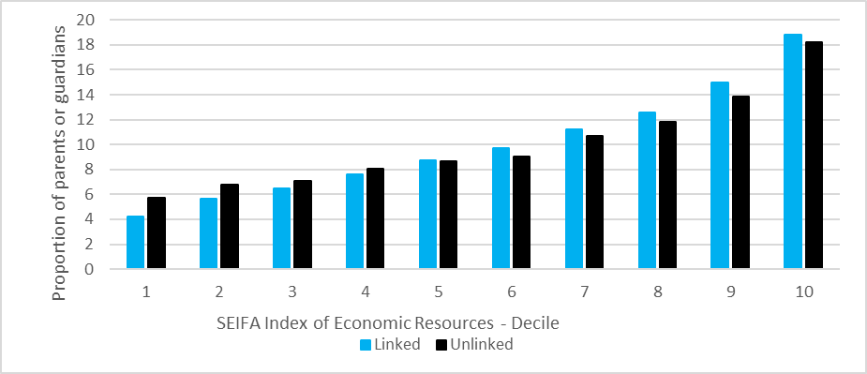

In interpreting the information in this graph, it should be remembered that:

1. The groups analysed above differ greatly in size. There are approximately 2.5 million parent records in the 2019 Address Collection. (Due to the nature of the collection, these are non-unique records, as, for example, a parent may appear multiple times if they have children at different non-government schools.) Approximately 2.1 million parent records linked to MADIP and approximately 400,000 did not link.
2. Poor address quality is one reason why a record may not link to MADIP and this is reflected in the fact that a further 3.1% of the unlinked records could not be coded to an SA1, compared with a further 0.3% of the linked records.

In 2021, the ABS compared students who did and did not have a family income available via MADIP, according to the socio-economic characteristics of the area in which they lived.

The socio-economic characteristics of each area were defined using the SEIFA Index of Relative Socio-Economic Disadvantage (IRSD). This index summarises measures of relative disadvantage from the 2016 Census of Population and Housing, such as the number of households with low income, number of people with no qualifications, and number of people in low skill occupations[11]. The first quintile refers to the 20% of areas with highest relative socio-economic disadvantage and the 5th quintile refers to the 20% of areas with the lowest relative socio-economic disadvantage. The area definition used is the SA1.

Students in the Address Collection in 2021 were most likely to live in areas classified in the 5th quintile, regardless of whether they had a family income available in administrative data (29.6% of those with a family income and 31.1% of those without; figure C2). Students were least likely to live in areas classified in the first quintile (11.7% of those with a family income and 12.1% of those without).

Figure C2: Proportion of students with and without an administrative family income, Address Collection, 2021, by SEIFA IRSD quintile, 2016. (Excludes students with no SA1 code or SEIFA code available.)

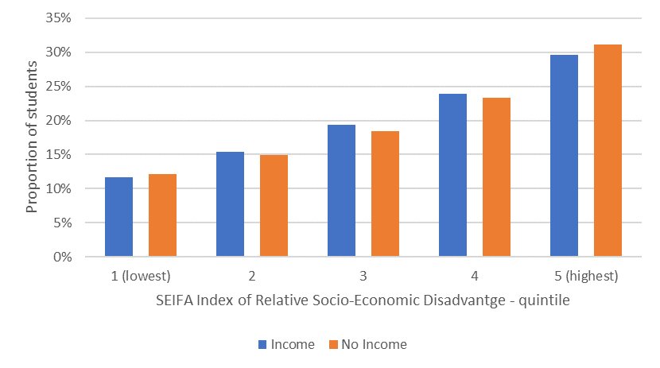

Students typically have a missing family income because their parent(s) do not link to MADIP. In 2021, 80.4% of students without a family income in administrative data had no parents who linked to MADIP.

# Appendix D: Analysis of family size in non-government schools

## Counts of dependants in families

The ABS analysed the average (mean) family size of each non-government school, using the number of dependants as the indicator of family size. Dependants were defined according to the Census of Population and Housing, as “children under the age of 15 and members of the household under the age of 24 who are full-time students”[12].

While various data sources (Census, PIT, DOMINO, Address Collection) provide information about the number of dependants in a family, the Census is the most consistent data source for all families. This is because not all families are present in each source of income data, and the Address Collection only includes dependants that attend non-government schools, meaning it excludes dependants at other schools and those older or younger than school age. For the purposes of this analysis, 2016 Census data and the 2019 Address Collection were used. Although some years have passed since the Census, as an indicator of family size, it is expected to be robust because family size has been stable in Australia in recent years. For example, birth rates in Australia have been decreasing since 2008 (2.02 births per female), and were stable from 2017 to 2018 (at 1.74 births per female)[13].

According to this analysis, the average number of dependants in families for non-government schools is 2.16. The distribution of the average number of dependants per family for each school is shown in figure D1 below.

Figure D1: Distribution of average number of dependants per family, by school. Source: Address Collection 2019, Census of Population and Housing, 2016, excludes schools with less than 10 students.

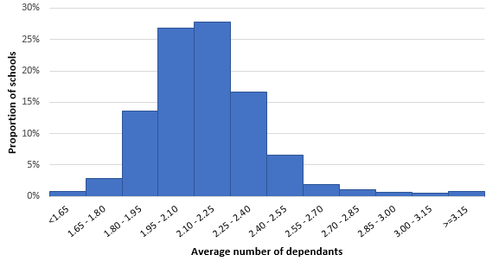

The distribution of the average number of dependants per family in non-government schools is close to normal. The number of dependants in a family can only have discrete values or counts of whole numbers and is unlikely to have large outliers. Therefore, it is appropriate to use the mean as an indicator of central tendency, rather than median, which is typically used when the data is skewed and has large outliers, such as an income distribution. Using the mean number of dependants per family at a school also allows greater precision than the median as the number of dependants per family is a discrete variable. In other words, a mean of 2.16 can be identified, compared with a median of 2.

The standard deviation of the distribution of the average number of dependants per family for each school is 0.26. Therefore, based on this distribution, there is an approximately 95% probability that the average number of dependants in families at a given school is less than 2.58. There is an approximately 99% probability that the average number of dependants in families at a given school is less than 2.76.

# Appendix E: The Hybrid Method

## Calculation of a hybrid score

### Step one: Assign family incomes using available administrative data

1. Assign family incomes according to the DMI methodology, using available administrative data to obtain a family income for students whose parents have administrative data.

### Step two: Assign family incomes for remaining students using Census area data

1. For students with a missing family income, the median income of the area (defined as the Statistical Area Level 1) in which they live is assigned as follows:
   1. For students with two parents recorded in the Address Collection, the median combined personal income of parents in two-parent families with children attending a non-government school is used. If this variable is unavailable for the SA1, the median combined personal income of parents in all families with children attending a non-government school is used.
   2. For students with one parent recorded in the Address Collection, the median personal income of parents in one-parent families with children attending a non-government school is used. If this variable is unavailable for the SA1, the median combined personal income of parents in all families with children attending a non-government school is used.

### Step three: Adjust the Census area incomes to align with the current year’s income

1. Adjust area-based incomes:
   1. The weekly median SA1 income is converted to an annual income by multiplying by 52.
   2. The annual SA1 income is converted to the relevant year dollars using the Wage Price Index (WPI). This treatment ensures the income data from the Census year used is consistent with the wage level of the income data used in the corresponding DMI scores.

### Step four: Calculate an adjusted median income and hybrid score for schools

1. Calculate each school’s median income and hybrid score:
   1. The median annual family income of students at each school is calculated.
   2. The median incomes for all schools are converted into hybrid scores using standardisation. The standardisation method is the same as that used in the DMI methodology, with an average score of 103 and a standard deviation of 12, weighted by enrolments.
   3. Students with a missing family income and a missing SA1 median income are excluded from the calculation of the school’s median income and score.

## Key dimensions of the quality of the hybrid method

### Relevance

* The area-based income used in the hybrid method, derived from the total personal income of parents or guardians of children attending a non-government school, differs from the target concept of median Adjusted Taxable Income (ATI) used in the DMI.
* There is a high degree of relevance between the population used to derive the area-based incomes and the CTC target population, as both are limited to parents and guardians of children attending a non-government school. However, it should be noted that the area-based income used in the hybrid method is likely to include families in an area with children attending various non-government schools.
* There is a high degree of relevance between the concept of family income under the DMI and hybrid methods, as both are a combination of the income(s) of one or two parents of students attending a non-government school.

### Timeliness

* The Census data used to derive area-based income values used in the hybrid method is collected every five years. The administrative income data is collected annually.
* The area-based income values are adjusted using the WPI to ensure administrative and area-based income values are measured on a consistent basis. This adjustment does not, however, account for changes in the socio-economic characteristics of the areas since the Census.

### Accuracy

#### Income coverage and missingness under the DMI methodology

* Income coverage rates under the DMI methodology are generally high. In 2021, a family income was available for 94.2% of students and missing for 5.8% of students.
* In 2021, students who lived in areas of greater relative disadvantage had similar rates of income coverage to those who lived in areas with a relative lack of disadvantage.
* Linkage to MADIP is a key factor affecting income data availability. Four in five students with missing family income in 2021 had no parents who linked to MADIP.

#### Income imputation under the hybrid method

* In investigating the application of the hybrid method to all schools in 2021, an area-based income was imputed for 4.6% of students under the hybrid method. As a result, the proportion of students with missing family income reduced from 5.8% to 1.2%.
* The use of the hybrid method increased income coverage at the school level. Under the hybrid method, 0.5% of schools had an income coverage rate (defined as the proportion of students in a school with a family income available) of less than 90%, compared with 11.1% of schools under the DMI method.

#### Difference between administrative and area-based income values

* The median area-based income assigned under the hybrid method was similar to the median administrative income, with the latter approximately $6,000 larger than the former. The variation in administrative incomes was approximately 1.7 times the variation in area-based incomes assigned using the hybrid method, based on the inter-quartile range.
* Median incomes for most schools were similar under the hybrid and DMI methods. For almost 90% of schools, the hybrid median income was within $5,000 of the median under the DMI method.

### Coherence

#### Difference between hybrid and DMI scores

* Hybrid and DMI scores tend to be similar. In 2021, the hybrid method and DMI scores were the same for 72.3% of schools. For 95.5% of schools, the hybrid score was within one point of the DMI score.
* Differences between hybrid and DMI scores were more prevalent for schools with above-average DMI scores and schools with a lower income coverage rate under the DMI method.

### Assumptions and fitness-for-purpose of the hybrid method

The key difference between the hybrid and DMI methods is their treatment of missing family incomes. Under the DMI methodology, students with a missing family income are excluded from the calculation of the DMI score. This approach assumes that the income profile of the school community is representative of the incomes of families with missing income data. In contrast, the hybrid method assumes that the income profile of similar families in the area in which students live is representative of the incomes of families with missing income data.

Analysis of the socio-economic characteristics of students with and without a family income in the administrative data, showed that the availability of administrative income data was similar among students in areas with differing levels of relative socio-economic disadvantage. This does not support the assumption that the socio-economic characteristics of students with missing family income differ systematically from those with non-missing family income.

For this reason, the ABS recommends the hybrid method be applied for a school where it is supported by analysis of the assumptions underpinning missingness. For example, it may be reasonable to apply the hybrid method where there is evidence to suggest that, for a school, there is a difference between the socio-economic characteristics of families with and without administrative income data. In applying the hybrid method, consideration should be given to the relative size of the cohort with missing income, and the potential limitation of area-based incomes to approximate some family incomes, in particular, those at the upper end of the income distribution.

# Appendix F: Adjusted score for large family size

## Calculating the adjusted score

### Step one: Assign number of dependants and number of parents to each student

1. For each parent, the number of dependants is allocated from the available data sources.
2. If the number of dependants differs for parents of a student in different data sources, the higher number is taken.
3. For each student:
   1. Dependant information from Personal Income Tax (PIT) data is assigned to the student if it is available and non-zero.
   2. If PIT dependant information is zero or missing, the higher dependant count from either DOMINO or the Address Collection is assigned to the student.
4. For each student, the number of parents is assigned from the Address Collection.

### Step two: Adjust family incomes, where number of dependants is large

1. For students from a family with three or less dependants, the family income is unadjusted.
2. For students from a family with four or more dependants, the family income is adjusted to be comparable to a family with two dependants using the OECD adjusted equivalence factor (1 point to the first adult, 0.5 points to a second adult, and 0.3 to each dependant).
   1. The family income of students from one parent households is adjusted to a family with one parent and two dependants.
 $$Adjusted Income= \frac{Family Income}{1+ \left(0.3 ×Number of Dependants\right)} × \left(1+ \left(0.3 × 2\right)\right)$$

  2. The family income of students from two parent households is adjusted to a family with two parents and two dependants.

$$Adjusted Income= \frac{Family Income}{1+0.5 + \left(0.3 ×Number of Dependants\right)} × \left(1+ 0.5 + \left(0.3 × 2\right)\right)$$

### Step three: Calculate the median family income

1. Calculate the median family income from the school’s adjusted income distribution.

### Step four: Calculate the adjusted score

1. The median income for the school is converted into an adjusted score by standardising using the existing distribution of median incomes for all schools. The median incomes and scores of other schools are not adjusted.

## Accounting for family composition in CTC scores

The ABS considered several options for adjusting scores to take family size and composition into account, including the two equivalisation-based options described below. These options are not currently recommended due to the availability of data.

Under these options, a school’s equivalised income is compared to the equivalised incomes of other schools. Consequently, these options depend on:

* the availability of an agreed method for using administrative data to count dependants; and
* administrative data of sufficient quality to equivalise scores for some or all schools.

The ABS recognises that further research into the data and methods may be required before these options can be applied.

#### Option A: The school’s equivalised income is compared with equivalised incomes for all schools

Where a school has a significantly large average family size, a new DMI score can be created using the median equivalised income. The school’s median equivalised income can be calculated from the administrative data available via MADIP, or, where a parental survey was undertaken, from the survey data.

To equivalise income, combined parental income (ATI) is divided by the equivalence factor derived for each family. The median equivalised family income is then identified for each school.

To create a deemed score under this option, the ABS recommends the median equivalised income for the school be compared with equivalised incomes for all schools, created in the same manner using available data. This ensures the school’s equivalised income is compared to other schools’ equivalised incomes, and the revised score is an indicator of the school’s capacity to contribute relative to other schools. A potential disadvantage with this approach is that there may be data quality issues with the counts of dependants for some schools, which may affect their equivalised median income.

#### Option B: The school’s equivalised income is compared with equivalised incomes for a sample of schools

Option B is similar to option A, but addresses the potential data quality issues which may be associated with the equivalised median incomes for some schools. Under this option, an equivalised median income is created for the school, as described under option A. However, instead of standardising this median income relative to the distribution of equivalised incomes for all schools, it is standardised using a sample of equivalised school median incomes. The aim is for this sample to be representative of the distribution for all schools, but created using only schools for which the available administrative data is of a high quality (e.g. rates of missingness are low).

At the time of writing, the ABS has not undertaken this analysis, though it is technically feasible. The main disadvantage of this option is its complexity.

# Appendix G: Key sources of income data in Australia

Table G1, below, introduces a number of Australian income data sources. These sources provide information for schools and Approved Authorities about typical incomes across Australia. The median income is usually used for this purpose. Income data is available for various types of income, such as wage and salary income and investment income. It is also available for a range of geographic areas, including Australia, the states and territories, and smaller areas such as SA2s.

The ability to compare median income data from the sources described below with median incomes produced using the DMI methodology is limited. There are three main reasons for this. Firstly, the median incomes of school communities produced using the DMI methodology are distinct population groups which may differ from the general population included in administrative or survey based collections. Secondly, the time period which the collections reflect may differ from that of the DMI. Thirdly, different definitions of income are collected in the various sources.

All of the data described below is freely available at the links provided, except Census Table Builder data, which is available by either free (Table Builder Basic) or paid (Table Builder Pro) subscription. Some Survey of Income and Housing data is only available to approved researchers in ABS DataLab. ABS statistical products supporting the measurement of the impact of COVID-19 are available at: [www.abs.gov.au/covid19](http://www.abs.gov.au/covid19).

Table G1: Income data in Australia

| **Data Source** | **Income data item** | **Frequency** | **Geography** | **Scope** |
| --- | --- | --- | --- | --- |
| [Average Weekly Earnings, Australia](https://www.abs.gov.au/statistics/labour/earnings-and-working-conditions/average-weekly-earnings-australia/latest-release) (cat. no. 6302.0) | Average weekly earnings, defined as mean gross (before tax) earnings of employees. | Biannually – June and December quarter. | Australia,  State and Territory. | All wage and salary earners who received pay for the reference period, except people excluded from the Labour Force Survey and supplementary surveys[14]. |
| [Census of Population and Housing, 2016, Table Builder](https://www.abs.gov.au/websitedbs/D3310114.nsf/Home/2016%20TableBuilder), Basic or Pro. | Weekly and annual total income, in ranges.  Median total income, based on mid-point of income range. | 5 yearly. | Australia,  State and Territory.  SA2 data is available in Table Builder. | All people usually resident in Australia on Census night. |
| [Characteristics of Employment, Australia](https://www.abs.gov.au/statistics/labour/earnings-and-working-conditions/characteristics-employment-australia/aug-2021) (cat. no. 6333.0) | Median weekly earnings, defined as ‘total pay’ (before taxation, salary sacrifice and deductions) from wages and salaries. | Annual. | Australia  State/Territory  Greater capital city and rest of state. | Employees aged 15 years and over, except people excluded from the Labour Force supplementary surveys and those living in Aboriginal and Torres Strait Islander communities. |
| [Data by Region](https://www.abs.gov.au/statistics#data-region) (cat. no. 1410.0) | Compilation of various socio-economic indicators, including modelled estimates. | Annual. | Small area, including Local Government Area and SA2. | Various. |
| [Employee Earnings and Hours, Australia](https://www.abs.gov.au/statistics/labour/earnings-and-working-conditions/employee-earnings-and-hours-australia/latest-release) (cat. no. 6306.0) | Average weekly total cash earning for employees, defined as ordinary time cash earnings. | 2 yearly. | Australia  State/Territory. | Includes employees who received pay from public and private sector employing organisations in Australia. For exclusions, see: [Methodology.](https://www.abs.gov.au/methodologies/employee-earnings-and-hours-australia-methodology/may-2021) |
| [Household, Income and Labour Dynamics in Australia](https://melbourneinstitute.unimelb.edu.au/hilda) (HILDA) | Median disposable household income, median equivalised household income. | Annual. | Australia. | Longitudinal survey of members of non-remote Australian private dwellings, conducted in waves. |
| [Household Income and Wealth, Australia](https://www.abs.gov.au/statistics/economy/finance/household-income-and-wealth-australia/latest-release) (cat. no. 6523.0).  Microdata available in Table Builder and ABS DataLab. | Detailed income information, for persons and households, including median weekly gross income. | 2 yearly. | Australia  State/Territory  Microdata includes SA4, with high standard errors flagged. | Sample survey of usual residents of private dwellings in urban and rural areas of Australia, excluding households:   * in very remote areas; * containing members of non-Australian defence forces or diplomatic personnel.   Income data is collected from persons aged 15 years and over. |
| [Personal Income in Australia](https://www.abs.gov.au/statistics/labour/earnings-and-working-conditions/personal-income-australia/latest-release) (cat. no. 6524.0.55.002). | Median personal income, including employee, own unincorporated business, investment and superannuation income. | Annual. | Australia, State and Territory, SA2 and larger areas, and local government areas. | Data are compiled from the Linked Employer Employee Dataset, based on administrative data from the Australian taxation system. Includes people who interacted with the tax system during the reference period, for whom personal income is identified. |
| [Weekly Payroll Jobs and Wages in Australia](https://www.abs.gov.au/statistics/labour/jobs/weekly-payroll-jobs-and-wages-australia/latest-release) (cat. no. 6160.0.55.001). | Changes in payroll jobs and total wages indexed to the week ending 14 March 2020. A weekly timeseries from 4 January 2020 is available, for age group, sex, industry and SA4. | Fortnightly. | Australia, State / Territory, SA4. | Indicative information on the impact of COVID-19 on employees, including changes in payroll jobs, total wages paid, and average weekly wages per job. Payroll jobs reported to the Australian Taxation Office through Single Touch Payroll are in scope of these estimates. |

# Appendix H: Glossary and explanatory notes

#### Adjusted taxable income (ATI)

For the 2016-17 tax year, the Australian Taxation Office defined a person’s adjusted taxable income (ATI) as the sum of the following amounts:

* taxable income
* adjusted fringe benefits (total reportable fringe benefits amounts multiplied by 0.51)
* reportable employer superannuation contributions
* deductible personal superannuation contributions
* certain tax-free government pensions or benefits received
* target foreign income (income and certain other amounts from sources outside Australia not included in taxable income or received as a fringe benefit)
* net financial investment loss (the amount by which the person's deductions attributable to financial investments exceeded their total financial investment income)
* net rental property loss (the amount by which the person's deductions attributable to rental property exceeded their rental property income)
* less any child support payments the person provided to another person.

#### Administrative data

Administrative data refers to information maintained by governments and other entities that is made available for statistical purposes. In general, it includes data used for registrations, transactions and record keeping, usually during the delivery of a service. Administrative data can improve and expand the range of statistics available to the Australian community, while reducing the cost to the taxpayer and burden on potential respondents to surveys and censuses.

#### Approved Authority (AA)

An Approved Authority (AA) for a school is the legal entity the Australian Government holds responsible for the administration of the school, in accordance with the Australian Education Act 2013 (Cth) and the Australian Education Regulation 2013 (Cth).

#### Area-based Census income measure

A measure based on school community median income calculated using the median income of the area (SA2) in which each parent lives. The income assigned to each parent is based on the median equivalised household income of parents in the area who have children attending schools of the same type (i.e. primary or secondary, Catholic or other non-government). This measure may be used as a quality metric during data validation.

#### Capacity to contribute

A measure of the anticipated capacity of a non-government school community to financially contribute to the cost of schooling.

#### Capacity to contribute (CTC) data quality framework

Quality framework based on the seven dimensions of quality outlined in the ABS Data Quality Framework - institutional environment, relevance, timeliness, accuracy, coherence, interpretability and accessibility. See A Data Quality Framework for the Australian Government’s Direct Measure of Income for Capacity to Contribute, available at [www.education.gov.au](http://www.education.gov.au).

#### Capacity to contribute (CTC) score

A CTC score is a measure of the anticipated capacity of a non-government school community to contribute to the recurrent costs of the school. A school’s CTC score affects the amount of base recurrent funding the school receives from the Australian Government under the Australian Education Act 2013 (Cth). CTC scores may use a DMI or area-based methodology.

#### Cash wages and salaries

Remuneration for time worked or work done and for time not worked, such as recreation and other types of paid leave. Comprises regular and irregular payments, including salary sacrificed amounts. Wages and salaries in cash are gross amounts, that is, before tax and other items (e.g. superannuation) are deducted.

#### Direct measure of income (DMI)

A methodology used to calculate capacity to contribute based on the median income of parents or guardians of students at a non-government school. The score derived from this methodology is called the DMI score.

#### Large family size

The average family size of a school community that is significantly larger than the average family size of all non-government school communities.

#### Lower bound sensitivity measure

By excluding some parents for whom there is no income information available, the DMI assumes that the missing parents’ income distribution is similar to that of the parents included in the measure. In reality, this assumption may not hold – parents who do not link to any available income data may be more likely to have lower incomes. The lower bound sensitivity measure shows what a school community’s median income might be if parents missing from the DMI score had systematically lower incomes than other parents, by assigning:

* zero income to any parent who linked to MADIP but did not have income data; and
* the first quartile parental income from the school community’s DMI calculation to all remaining parents without an income.

The lower bound sensitivity measure can be considered a reasonable lower bound estimate of a school community’s median income. A large difference between the lower bound and the DMI indicates the DMI score is sensitive to the assumptions made about the incomes of missing parents.

#### Ordinary time cash earnings

Payment for award, standard or agreed hours of work, including allowances, penalty payments, payments by measured result and regular bonuses and commissions. Ordinary time cash earnings are inclusive of amounts salary sacrificed. Excluded are non-cash components of salary packages, overtime payments, retrospective pay, pay in advance, leave loadings, severance pay, and termination and redundancy payments.

#### Parental survey

A survey of the school community to support the calculation of a new score where there are established exceptional or unique circumstances and fit-for-purpose data is not otherwise available.

#### Person-level Census income measure

A measure based on school community median income calculated using income data from the Census of Population and Housing, linked to the Address Collection via MADIP for use as a validation indicator. Since income data in the Census is collected in ranges, this measure assigns each parent the mid-point of their respective income bracket from the Census. For DMI scores prior to 2022, the 2016 Census was used for this analysis. Since 2022, data from the 2021 Census data has been used.

The person-level Census income measure is calculated as below:

* Parents who link to MADIP and have a Census income are assigned the mid-point of the personal income bracket.
* For each student with two parents, both parents’ incomes are summed together, otherwise the parents are excluded from the measure. This approach differs from the DMI in that there is no assumption of zero income for a second parent where the other parent has an income amount. It reflects the assumption that missingness in Census data is not related to income.
* Where a student has one parent, that parent’s income is used, otherwise the parent is excluded from the measure.
* The school community median is calculated, the medians are ranked and converted into a score in the same way as the DMI score.

#### Quality gate

Quality gates are a statistical risk mitigation strategy designed to improve the early detection of errors or flaws in any part of the statistical process cycle. They act as a checkpoint at which an assessment of the quality of the process is made, to determine whether to proceed to the next stage of the process. This is done using the six components of a quality gate, which act as acceptance criteria. For more information, see: [1540.0 - Quality Management of Statistical Processes Using Quality Gates, Dec 2010 (abs.gov.au)](https://www.abs.gov.au/AUSSTATS/abs@.nsf/39433889d406eeb9ca2570610019e9a5/16afe884d1b113b2ca257801000e4a81!OpenDocument).

#### Refined area-based score

An area-based score using data from the Census of Population and Housing that creates a score from two income indexes rather than incorporating four different socio-economic indexes.

#### School community

The parents and guardians of the students at a school.

#### Socio-Economic Indexes for Areas (SEIFA)

SEIFA is a suite of four summary measures that have been created from 2016 Census information to assist in assessment of the welfare of Australian communities. The indexes can be used to explore different aspects of socio-economic conditions by geographic areas.

#### Socio-economic status (SES) score

SES scores for non-government schools are calculated as the average of SES scores of the areas (defined as Statistical Areas Level 1) in which the students of each school live. The SES score for each area is a weighted average of four different socio-economic indexes: 1/3 occupation, 1/3 education, 1/6 household income and 1/6 income of families with children. These scores were calculated every five years using data from the Census of Population and Housing.

#### Separation principle

When undertaking data integration activities, the ABS applies the [Separation Principle](https://www.abs.gov.au/about/data-services/data-integration/keeping-integrated-data-safe) to store identifiable personal information (such as name and address) separately from other information, and access to data is restricted according to functional separation roles and what is necessary for a person’s function or role. A person working on a project can only hold one role at a time. This means that identifiable and analytical information cannot be accessed at the same time and no person can see identifiable and analytical information together at any point in the process.

#### Statistical Area Level 1 (SA1)

SA1s are geographic areas designed to maximise spatial detail available for Census data. SA1s identify areas with different geographic characteristics within suburb and locality boundaries. Most SA1s have a population of between 200 and 800 persons, with an average of 400 persons.

#### Statistical Area Level 2 (SA2)

SA2s are geographic aggregations of SA1s that generally have a population of 3,000 to 25,000 persons, with an average of 10,000 persons. SA2s often reflect one or more related suburbs.

#### Statistical Area Level 4 (SA4)

Statistical Areas Level 4 (SA4s) are designed for the output of Labour Force data and reflect labour markets within each State and Territory within the population limits imposed by the Labour Force Survey sample. In regional areas, SA4s tend to have lower populations (100,000 to 300,000). In metropolitan areas, the SA4s tend to have larger populations (300,000 to 500,000).

For more information about these geographies, see the [Australian Statistical Geography Standard](https://www.abs.gov.au/statistics/statistical-geography/australian-statistical-geography-standard-asgs).

#### Total income

Also referred to as gross income, total income is the sum of income received from all sources before any deductions such as income tax, the Medicare Levy or salary sacrificed amounts are taken out.

#### Wage Price Index (WPI)

Wage Price Indexes measure changes over time in the price of wages and salaries unaffected by changes in the quality or quantity of work performed. For further information, see [Wage Price Index: Concepts, Sources and Methods, 2012](https://www.abs.gov.au/statistics/detailed-methodology-information/concepts-sources-methods/wage-price-index-concepts-sources-and-methods/2012).

1. Standardisation is a common statistical process which converts a set of numbers, which may have any average and spread, into a pre-determined average and spread. It does not change the order of school communities in the distribution.
2. Groves, RM & Lyberg, L (2010) Total Survey Error: Past, Present, and Future.Public Opinion Quarterly. 74:5, pp 849-879.
3. Available at www.education.gov.au/quality-schools-package/resources/abs-capacity-contribute-data-quality-framework.
4. Department of Education (2020). What is the capacity to contribute review process? Available at: <https://www.education.gov.au/quality-schools-package/fact-sheets/what-capacity-contribute-review-process>
5. ABS (2020) ‘A Data Quality Framework for the Australian Government’s Direct Measure of Income for Capacity to Contribute’. Available at: [https://docs.education.gov.au/documents/abs-capacity-contribute-data-quality-framework](https://www.dese.gov.au/quality-schools-package/resources/abs-capacity-contribute-data-quality-framework).
6. For a detailed explanation of quality gates and description of the checks undertaken to validate DMI scores,

   see Section 4 of ‘A Data Quality Framework for the Australian Government’s Direct Measure of Income for Capacity to Contribute’.
7. Further information about Family Tax Benefit is available from Services Australia, at: [www.servicesaustralia.gov.au/family-tax-benefit](http://www.servicesaustralia.gov.au/family-tax-benefit).
8. For more information about the equivalisation of Census income data, see: [Equivalised Total Household Income (weekly) (HIED)](https://www.abs.gov.au/ausstats/abs@.nsf/Lookup/2901.0Chapter31502016), in the Census Dictionary, 2016.
9. STP data is supplied by the ATO to the ABS under the Taxation Administration Act 1953, which requires that such data is only used for the purposes of administering the Census and Statistics Act 1905. Any discussion of data limitations or weaknesses is made in the context of using the data for statistical purposes, and is not related to the ability of the data to support the ATO's core operational requirements.
10. See: [www.abs.gov.au/methodologies/weekly-payroll-jobs-and-wages-australia-methodology/week-ending-27-february-2021#how-data-are-collected](http://www.abs.gov.au/methodologies/weekly-payroll-jobs-and-wages-australia-methodology/week-ending-27-february-2021#how-data-are-collected).
11. For more information, see: [2033.0.55.001 - Census of Population and Housing: Socio-Economic Indexes for Areas (SEIFA), Australia, 2016 (abs.gov.au)](https://www.abs.gov.au/ausstats/abs@.nsf/Lookup/by%20Subject/2033.0.55.001~2016~Main%20Features~IRSD~19).
12. Source: Census of Population and Housing: Understanding the Census and Census data, 2016, (cat. no. 2900.0), see: [Count of dependent children in family](https://www.abs.gov.au/ausstats/abs@.nsf/Lookup/by%20Subject/2900.0~2016~Main%20Features~CDCF%20Count%20of%20Dependent%20Children%20in%20Family~10096).
13. Source: Births, Australia, 2018 (cat. no. 3310.0). Available at: <https://www.abs.gov.au/ausstats/abs@.nsf/mf/3301.0>.
14. The scope of the Labour Force survey is restricted to people aged 15 years and over and excludes:

    members of the permanent defence forces;

    certain diplomatic personnel of overseas governments;

    overseas residents in Australia; and

    members of non-Australian defence forces and their dependants.

    Students at boarding schools, patients in hospitals, residents of homes (e.g. retirement homes, homes for people with disabilities), and inmates of prisons are excluded from all Labour Force supplementary surveys.