Review of approaches to costing educational adjustments
  - Matthew Gray, Australian National University

October 2019

Introduction
This paper provides a high-level summary of the different approaches to estimating what it costs to make educational adjustments for children from different backgrounds and individual characteristics including disability. It also provides an overview of the findings from selected key international studies.
There is extensive literature on the costs of educating students from different backgrounds and with different needs. Much of this research has been undertaken in the context of informing the development of schools funding formulas that often include, in addition to the number of students and school year level, various needs based variables including students with disabilities and students coming from disadvantaged socio-economic backgrounds. Studies of the costs of providing education for students with different needs are often heavily influenced by the education system context in which they are undertaken.
While there are many studies of the extra costs of educating students from different backgrounds and characteristics, relatively few studies focus specifically on the adjustment costs for students with disability, with disability sometimes being considered as one factor amongst a number that contributes to educational costs.

Methods for estimating education costs
There are four broad methods used to estimate the additional costs of educating students from specific backgrounds or with particular sets of characteristics such as disability. These are:
- Professional judgement approach;
- Evidence based (also known as the state of the art approach);
- Successful schools approach; and
- Regression based (also known as the cost function approach).
Fazekas (2012) provides a good overview of these approaches and the description in this paper relies heavily upon the OECD report. The professional judgment approach involves asking experienced educators to assess the costs of reaching a given educational standard. The evidence-based approach is related to the professional judgement approach, but rather than consulting practitioners it uses a set of successful educational interventions that have been identified in education literature which have been evaluated and demonstrated to be effective.
The successful schools approach aims at determining the minimum sufficient, i.e. adequate, level of funding for reaching an absolute output standard by identifying the schools which are successful in reaching that standard and calculating the adequate level of funding based on their programme-level costs.
In contrast to the professional judgement and evidence based approaches, the regression-based (cost function) approach uses historical educational expenditure, student and school characteristics and student outcomes to estimate, using regression models, the relationship between spending and student outcomes. These four approaches can be placed on a continuum from methods which focus most heavily on resources (inputs) professional judgement) to the methods that focus more on performance (Taylor, Baker and Vedlitz 2005). The professional judgement and evidenced based approaches are at the resources end and the successful schools and cost function approaches are at the performance end of the spectrum.
Which is the best and most reliable method is debated, the debate relating to underlying conceptual and data related issues for all four methods (for discussion of these issues see Duncombe 2006, Fazekas 2012, Harr et al. 2006, and Loeb 2007). Challenges common to all of the methods include determining the ‘standard of education’ that is required; a lack of clarity about the casual relationship between student outcomes, and cost; and poor quality or non-existent data. The problem from a policy perspective is that the different approaches and estimation methods can result in very different estimates of the relative costs of educating students from different levels of adjustment required and with different natures of disability, the reasons for the differences are often unclear. A further challenge is that ‘expected standards’ are typically higher than what schools currently achieve.
The advantages of the professional judgement and evidence-based approaches are that they enable the identification of the specific adjustments that are required in order for a student with a particular set of needs to receive education at a pre-defined standard. There are several limitations of the professional judgement approach. First, it inevitably requires that normative judgements be made about the adjustments that are required and how they should be provided in order to achieve a particular standard of education. For some types of adjustments there are guidelines and best practice that can provide guidance, but how they provide to a particular student will require judgement and this can lead to criticism. The difficulty is how the normative standards can be defined without undermining the ability of professional judgement to reflective normative judgements about needs, as opposed to the resource constraints that influence actual adjustments that are made.
Given that one of the main applications of professional judgements of educational needs is to provide an independent benchmark for assessing resource needs, it is important that the standards do not mirror the effects of the constraints under which different schools operate. A further practical limitation of the professional judgement approach is that it is only feasibly to undertake the exercise for a limited number of ‘case study’ students. This means that it is difficult to translate the adjustments required for each ‘case study’ student into a formula that can be applied across a large number of students with a wide range of needs in a range of types of schools.
The successful schools approach involves undertaking case studies of schools that are considered be particularly effective schools. This approach, while potentially providing valuable data, does rely upon the selection of successful schools and the criteria that are used to select schools are often debatable. Second, the success of a school is often a function of particularly effective school leadership and thus the experience of the school may not be generalizable to other schools with less effective leadership.
The professional judgement approach (and the successful schools) approach generally results in standards and costs that are higher than what schools achieve (DIUS 2008; Fazekas 2012). Regression based (cost functions) use data on student characteristics and needs, outcomes and actual expenditure in order to estimate the costs of achieving a given quality of education. While this approach provides a sense of objectivity and scientific rigour, it does require judgements being made about how to measure educational quality, outcomes or participation and the results can be very sensitive to the precise statistical models estimated and their specification. The method also produces cost estimates that are derived from the resource constrained choices made by schools and may not necessarily reflect the resources that would be required to achieve the pre-determined level of education quality.
In summary, all methods suffer from the following issues: variability in expected standards; lack of adequate data; an incomplete understanding of casual relationship between education costs and student performance; and that expected standards are typically higher than what schools currently achieve.
While it is challenging to estimate the extra costs of educating students from different backgrounds, estimating the educational adjustments required in order to allow students with a disability to participate in education on an equal basis as other students is particularly challenging. This is for two main reasons. First, there is often only limited data available on participation or outcomes for students with a disability. This is the case also for Australia. Second, defining participation on an equal basis in way that is measurable is hard and there appears to be no consensus as to how to do this.

Examples of international estimates of disability adjustment costs
There are a large number of estimates of the cost of reaching a given educational standard for schools with different student compositions, including level and nature of disability. The majority of existing studies appear to have been undertaken for specific US states in the context of assessing the adequacy of state based school funding formula (often termed ‘costing out studies’). The majority of the existing estimates are based upon the professional judgement or regression based approaches (cost function).
A range of terms are used to describe the additional cost of educating a student with a disability including ‘cost weights’ and ‘marginal cost’. The additional funding requirements are often expressed relative to the ‘base cost’ of education an average student. So for example if the ‘base cost’ was $8,000 per annum and the additional cost of educating a student with disability was $16,000 then the disability cost weight would be 2.0 and the funding required for a student with disability would be $8,000 base cost plus $16,000 disability cost weight giving a total cost of $24,000.
A summary of selected US estimates of the disability cost weight is provided in Table 1. Of particular interest is the estimate of Imazeki (2006) who produces an estimated cost weight of 1.47 by taking the average of 12 professional judgement studies for US states. For the studies reviewed, the professional judgement cost weights tend to be higher than those estimated using the cost function approach. There is also a great deal of variation in the estimated cost weights between studies.
Table 1. Examples of estimates of disability cost weights
School system (year) | 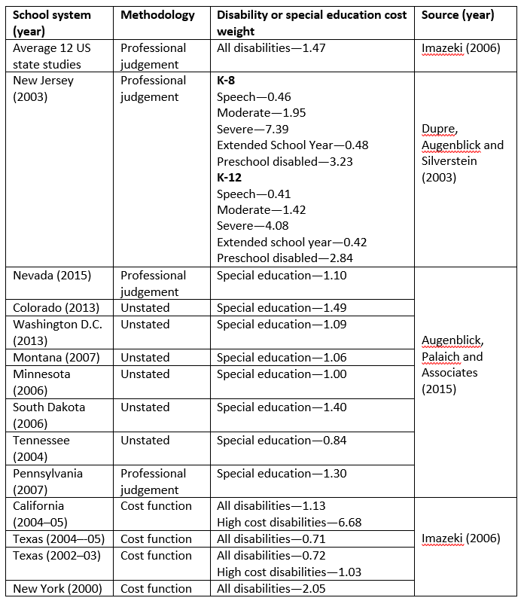  Methodology | Disability or special education cost weight | Source (year)
Average 12 US state studies | Professional judgement | All disabilities—1.47 | Imazeki (2006)
New Jersey (2003) | Professional judgement | K-8:  Speech–0.46  Moderate—1.95  Severe—7.39  Extended School Year—0.48  Preschool disabled—3.23 | Dupre, Augenblick and Silverstein (2003)
New Jersey (2003) | Professional judgement | K–12:  Speech—0.41  Moderate—1.42  Severe—4.08  Extended school year—0.42  Preschool disabled—2.84 | Dupre, Augenblick and Silverstein (2003)
Nevada (2015) | Professional judgement | Special education—1.10 | Augenblick, Palaich and Associates (2015)
Colorado (2013) | Unstated | Special education—1.49 | Augenblick, Palaich and Associates (2015)
Washington D.C. (2013) | Unstated | Special education—1.09 | Augenblick, Palaich and Associates (2015)
Montana (2007) | Unstated | Special education—1.06 | Augenblick, Palaich and Associates (2015)
Minnesota (2006) | Unstated | Special education—1.00 | Augenblick, Palaich and Associates (2015)
South Dakota (2006) | Unstated | Special education—1.40 | Augenblick, Palaich and Associates (2015)
Tennessee (2004) | Unstated | Special education—0.84 | Augenblick, Palaich and Associates (2015)
Pennsylvania (2007) | Professional judgement | Special education—1.30 | Augenblick, Palaich and Associates (2015)
California  (2004–05) | Cost function | All disabilities—1.13  High cost disabilities—6.68 | Imazeki (2006)
Texas (2004–-05) | Cost function | All disabilities—0.71 | Imazeki (2006)
Texas (2002–03) | Cost function | All disabilities—0.72  High cost disabilities—1.03 | Imazeki (2006)
New York (2000) | Cost function | All disabilities—2.05 | Imazeki (2006)

There is data available for several countries on per student expenditure on special education. However, as outlined above, expenditure data on its own does not provide estimates of adjustment costs. The most up-to-date US data that we have been able to identify is from selected states and is for the late 1990s. The data for 1999-2000 indicated that the ratio of spending per special education student compared to per student spending for students with no supplemental services is 1.90 (estimates from Chambers et al. (2005) reported in Parrish, Harr-Robins and Chambers (2015)). The US expenditure data also shows considerable variation in average expenditure by type of disability and degree of need with the cost varying from a low of $10,558 for students with specific learning disability to $20,095 for students with multiple disabilities.

Conclusion
There are several methods for estimating the additional costs of educating students with disability. There is no agreement in the literature as to which is the best method and they all have strengths and weaknesses. From a policy perspective, a challenge is that the different methods can produce very different cost estimates. There are relatively few estimates of the additional costs of making the necessary adjustments for students with disability and most of the estimates are from the US. It is not possible to directly translate US estimates to the Australian context due to differences in the educational systems and other differences.

References
Augenblick, Palaich and Associates (2015), Professional Judgement Study Report, Augenblick, Palaich and Associates.
Chambers, J., Pérez, M., Harr J. and Shkolnik, J. (2005), ‘Special education spending estimates from 1999–2000’, Journal of Special Education Leadership, 18 (1), 5–13.
Department for Innovation, Universities and Skill (DIUS) (2008), Autumn Performance Report, Department for Innovation, Universities and Skills, London.
Duncombe, W., (2006). ‘Responding to the charge of alchemy: Strategies for evaluating the reliability and validity of costing-out research’, Journal of Education Finance, 32(2), 137-169.
Duncombe, W. and Yinger, J. (2005), ‘How much more does a disadvantaged student cost?’, Economics of Education Review, 24, 513-532.
Duncombe, W., Lukemeyer, A. and Yinger, J. (2004), ‘Education finance reform in New York: calculating the cost of a ‘sound basic education’ in New York City’, Center for Policy Research Policy Brief 28/2004, Syracuse University, Syracuse, NY.
Duncombe, W. and Yinger, J. (2008), ‘Measurement of cost differentials’, in H. Ladd and E. Fiske (eds.), Handbook of Research in Education Finance and Policy, Routledge, New York.
Dupree, A., Augenblick, J. and Silverstein, J. (2003), Report on the Cost of Education, Augenblick, Palaich and Associatios.
Fazekas, M. (2012), ‘School funding formulas: Review of main characteristics and impacts’, OECD Education Working Papers N. 74, OECD Publishing.
Gray, M. and Stanton, D. (2010), ‘Costs of children and equivalence scales: A review of methodological issues’, Australian Journal of Labour Economics, 13(1), 99-115.
Harr, J., Parrish, T., Chambers, J., Levin, J. and Segarra, M. (2006), Considering Special Education Adequacy in California, American Institute for Research.
Imazeki, J. (2006), ‘Assessing the Costs of K-12 Education in California Public Schools’, mimeo, San Diego State University, San Diego.
Loeb, S. (2007), ‘Difficulties of estimating the costs of achieving education standards’, School of Finance Redesign Project Working Paper 23, University of Washington, Washington.
Maryland Commission on Education Finance, Equity, and Excellence (2002), Final Report, Maryland Commission on Education Finance, Equity, and Excellence, Baltimore.
Parish, T., Harr-Robins, J. and Chambers, J. (2015), ‘Special education’, in H.F. Ladd and M.E. Goertz, M.E. (eds), Handbook of Research in Education Finance and Policy, Routledge, New York and London.
Picus L., Odden, A. and Fermanich, M. (2003), A Professional Judgement Approach to School Finance Adequacy in Kentucky, Report prepared for the Kentucky Department of Education.
Roemer, J. (1998), Equality of Opportunity, Harvard University Press, Cambridge, MA.
Taylor, L., Baker, B. and Vedlitz, A. (2005), Measuring Educational Adequacy in Public Schools, Texas A&M University, Bush School of Government and Public Service, College Station, Texas.

A comparable question from outside education is what income is required in order to achieve a given standard of living for households of different sizes and compositions. The equivalent of the professional judgement approach is the budget standards approach which experts defining what goods and services are required to achieve a particular living standard. Budget standards approaches typically result in costs that are substantially higher than those produced by other methods (Gray and Stanton, 2010).

