

Post-school education aspirations

Comparisons between students from metro and non-metro areas

# Overview

The Longitudinal Surveys of Australian Youth (LSAY) show that most young people[1] aspire to some form of post-school education or training. According to data on young Australians who were aged 24 in 2018[2], the majority of young people achieve their post-school educational aspirations. However, there are noticeable differences in aspirations and attainment for young people from non-metro[3] areas, compared to those from metro areas.

By their mid-twenties, high-achieving young people from non-metro schools are more likely to have followed a Vocational Education and Training (VET) pathway and less likely to have gone on to higher education than their metro peers. Overall, around three quarters of young people from non-metro schools attain a tertiary qualification by their mid-twenties, but this is less likely to be a university level qualification than is the case for their metro counterparts.

The Regional Education Taskforce has highlighted the challenges young people from non-metro areas face in participating in further education.[4] Evidence from LSAY suggests that limited higher-level study options in their home location, and the need to move to pursue higher education, bring with them financial and social challenges that impact on educational attainment.

## Key findings

* Around two thirds (68%) of young people from metro schools who aspired to higher education completed a Bachelor degree or higher by age 24 compared to about half (55%) of young people from non-metro schools.
* Young people from non-metro schools are less likely to aspire to higher education and more likely to aspire to VET.
* Those young people from non-metro schools who go on to higher education are four times more likely to be living away from home in their first year of study.

## The education aspirations of secondary school students

Most students plan to undertake further study after leaving school regardless of whether they attend school in a metro or non-metro area (92% and 89% respectively). However, young people from non-metro schools are less likely to aspire to higher education and more likely to aspire to VET study after leaving school. Around 11 per cent of young people from non-metro schools had no post-school study plans compared to 8 per cent from metro schools (Figure 1).

Figure : Post-school study plans at age 16 by school location

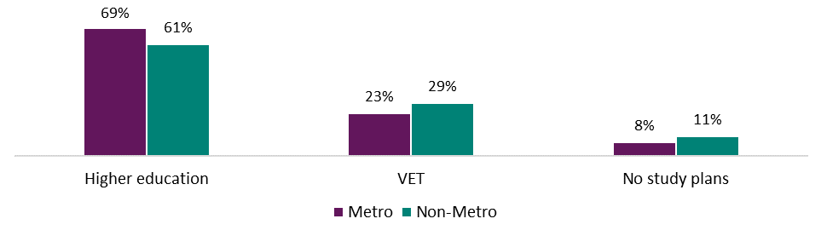Secondary school students from non-metro areas are more likely to perceive barriers to post-school study and this may factor into their future study aspirations. LSAY data[5] shows that many students from non-metro schools perceive financial difficulty (32%), location (21%) and family responsibilities (16%) as barriers to further study.

## Young people aspiring to higher education

The different levels of higher education attainment for young people from metro and non-metro areas at age 24 reflect both differences in aspirations and the extent to which these aspirations are realised. More than two thirds (68%) of students from metro areas who aspired to higher education at age 16 had completed a Bachelor degree by age 24. By contrast, just over half (54%) of the students from non-metro areas who aspired to higher education had completed a Bachelor degree by age 24 (Figure 2).

Figure 2: Highest educational attainment[6] at 24 for young people who aspired to higher education

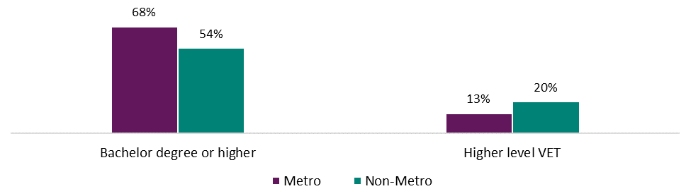

### Moving for study

A contributing factor to lower university participation among non-metro youth is their greater likelihood of moving out of home to undertake higher-level study and the associated financial and social challenges. Around 56 per cent of LSAY respondents from non-metro areas who commenced university study between 2010 and 2018 had moved out of the family home in their first year of study compared to only 13 per cent from metro areas (Figure 3).

Figure 3: Moving out of home for the first year of higher education, 2010 to 2018

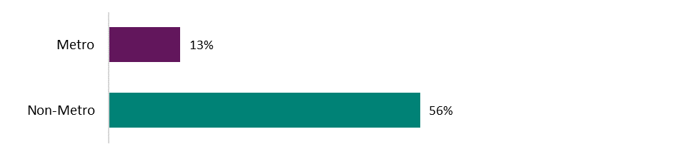Analysis of LSAY data by the Productivity Commission found that location accounts for around 30 per cent of the gap in university participation for non-metro youth after controlling for factors such as academic achievement and socio-economic status.[7] Other research has identified part-time study as a major risk factor to dropping out of higher education, and young people who live away from home are more likely to study part-time to support themselves financially.[8]

## Young people aspiring to VET

Around 29 per cent of young Australians have a VET qualification at Certificate III, Certificate IV, Diploma or Advanced Diploma level by the age of 24 (including around 3% who also attain a higher education qualification).

Young people from non-metro schools are more likely to aspire to VET at age 16 (29% compared to 23% for young people from metro schools). A majority of young people with VET aspirations go on to complete a post-school qualification at Certificate III level or higher (around 59%) regardless of location.

Young people from non-metro areas, however, are less likely to change their plans and pursue a higher education pathway. Of those young people who planned to study VET at age 16, 12 per cent of metro students had obtained a higher education qualification by age 24 while only 4 per cent of non-metro students had taken this path (Figure 4). Young people from non-metro areas who aspired to VET were more likely to complete a higher-level VET qualification by age 24 (57% compared to 45% in metro areas).

Young people from non-metro areas were also more likely to move out of home to pursue higher-level VET study (23% compared to 13% in metro areas), although the difference was much smaller than for those undertaking higher education (shown in Figure 3).

Figure 4: Highest qualification by age 24 for young Australians who aspired to VET

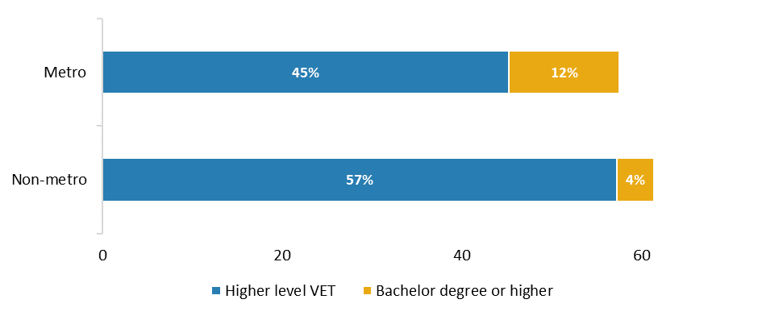

### Apprenticeships and traineeships

Young people from non-metro areas are more likely to complete an apprenticeship or traineeship than those from metro areas (25% compared to 12%). Aspirations are a significant factor. Around half of those young people from non-metro areas who aspired to a post-school VET qualification, and a quarter of those from metro areas, had completed an apprenticeship or traineeship by age 24.

## Young people without post-school study plans

Almost one in ten young people did not have any post-school study plans at age 16, and over 40 per cent of these young people had not achieved a post-school qualification at Certificate III level or above by age 24. Those who did go on to further study were most likely to be studying in the VET sector (Figure 5). There were no statistically significant differences related to location, suggesting that young people with low aspirations are disadvantaged regardless of location.

Figure 5: Educational participation at age 24 for young people who did not plan on further study at age 16

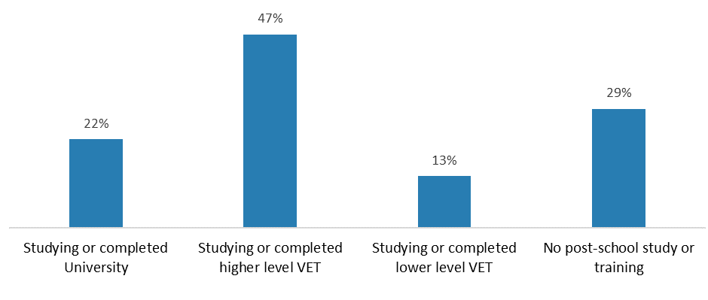

1. ‘Young people’ or ‘young Australians’ are defined as people between the ages of 15 and 24 (inclusive).
2. Data is from the 2009 LSAY cohort, which is comprised of young people who were aged 15 in 2009 and were surveyed annually. Reported outcomes data is weighted from the 2018 survey responses, collected when respondents were 24-years-old.
3. Non-metro or non-metropolitan categorisation at age 15 (or where respondents are “from”) is based on the Ministerial Council on Employment, Education, Training and Youth Affairs (MCEETYA) classification. This classification is based on the location of the school they attended at age 15.
4. Regional Education Expert Advisory Group, Issues Paper 2: Improving access, opportunity and choice in tertiary education for non-metro, rural and remote learners, Department of Education, Canberra. 2019
5. Data on barriers to post-school study was sourced from wave 2 of the LSAY Y15 cohort, in 2016, when respondents were 16 years old. All other analysis uses data from the Y09 cohort.
6. Higher level VET refers to VET qualifications at Certificate III, Certificate IV, Diploma or Advanced Diploma level.
7. Productivity Commission, *The demand driven university system: a mixed report card*, Canberra, 2019
8. Cherastidtham, I., Norton, A. and Mackey, W. (2018), *University attrition: what helps and what hinders university completion?*, Grattan Institute, 2018