Career aspirations and opportunities

Insights from the Longitudinal Surveys of Australian Youth

# Overview

The relationship between career goals and decisions young people[1] make about where to live is complex. Over the last ten years increasing numbers of young people are moving away from non-metro areas,[2] often to pursue post-school education and employment opportunities. The Longitudinal Surveys of Australian Youth (LSAY) [3] shows that non-metro areas experienced a net loss of 18 per cent of their young people between 2006 and 2016. The data also allows for an examination of career aspirations and the extent to which they are realised. LSAY, in combination with other data sources, highlights a potential relationship between where young people live, their career aspirations, job availability, and post-school study choices.

## Key Findings

* Young Australians from both metro and non-metro areas have high career aspirations. In 2016 nearly two thirds of all young people wanted to work in the most highly skilled occupation groups, Managers and Professionals.
* Less than half of all young people were working in their desired occupation by age 25.
* Over 40 per cent young people wanted to work as a Professional by age 30.
  + Young people from non-metro areas were more likely to move to a metro area if they aimed to work in the Professional occupation groups of Business, Human Resources and Marketing or Design, Science and Engineering where there were higher proportions of jobs in metro areas.
* Compared to those who move to undertake post-school study, young people who stay in non‑metro areas are more likely to live there five years later.
  + Those who aspire to work in the Technicians and Trades occupation were less likely to move to a metro area and those living in a non-metro area were less likely to meet this career goal by age 25 than those living in a metro area.

# Career aspirations

Nearly two thirds of 25-year-olds would like to work in the most highly skilled occupation groups, Managers (21%) and Professionals (44%). Many young people from both metro (47%) and non‑metro areas (39%) aspired to work in the most popular occupation Professionals by age 30. Managers was the second most popular occupation category for those from metro areas (22%) and was only slightly less popular with those from non-metro areas (19%) (see Figure 1). The third most popular occupation for those from non-metro areas was Technicians and Trades (17%). More specifically Education Professionals, Health Professionals and Specialist Managers were the three most aspired to occupation groups[4] for youth from both metro and non-metro areas at age 25.

Figure 1: Expected occupation[5] at age 303  by initial area of residence

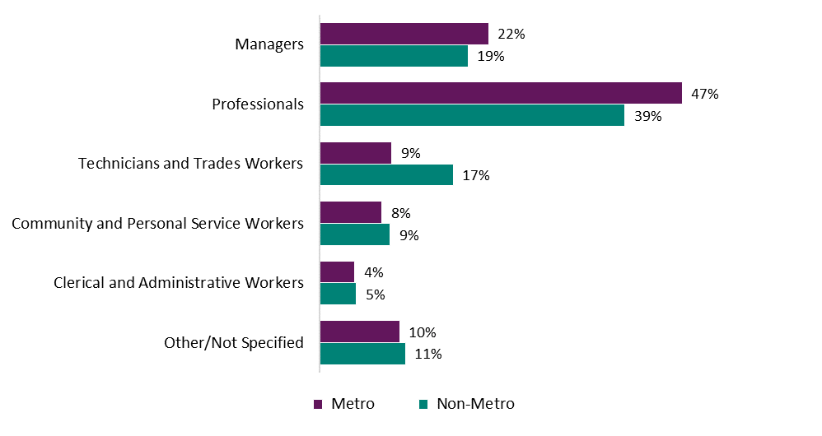

# Relocation

One third (34%) of young people who resided in non-metro areas at age 15 were living in metro areas at the age of 25. This equates to 10 per cent of all young people. The decision to relocate appears to be driven by a number of factors, including study options in their home location, career aspirations, and the availability of jobs in their chosen field.

Research using the Australian Census Longitudinal Dataset[6] (ACLD) has shown that the number of young people relocating to metro areas **for study** increased substantially over the last decade. The ACLD shows that less than one in five young people who moved for study returned to non-metro areas after five years, a trend that is also reflected in LSAY data. Conversely over three quarters of those who stay in a non-metro areas to undertake post-school study are living there five years later.6

Flows between metro and non-metro areas are not one-way, as young people move in both directions. LSAY shows that seven per cent of the youth population from metro areas had relocated to non-metro areas by the age of 25. This accounts for five per cent of all young people (see Figure 2).

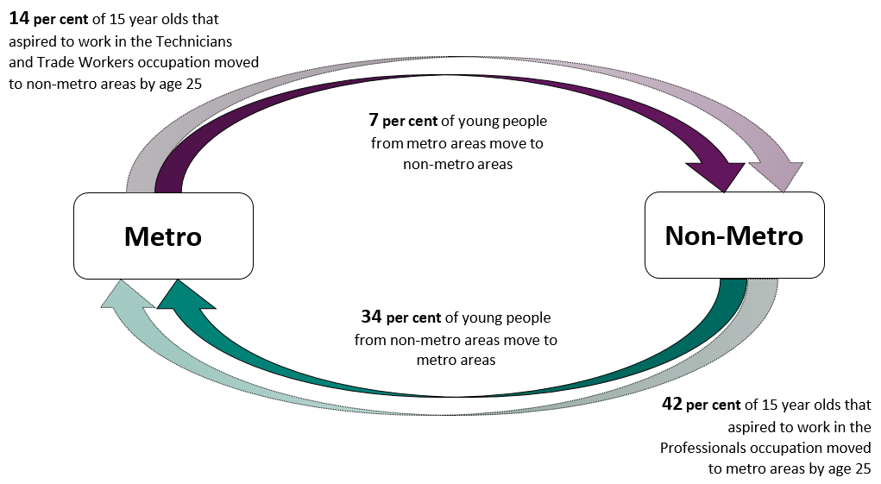Figure 2: Flows of young people from and to metro areas between the ages of 15 and 25

# Career opportunities

Career opportunities may impact on young people’s decisions to move away from or return to non-metro areas. In 2016, job opportunities in the most aspired to occupation, Professionals, were comparatively limited in non-metro areas, accounting for 16 per cent of all jobs in non-metro areas and 25 per cent of all jobs in metro areas. **[7]** Census 2016 data[8] showed increased growth in higher skilled jobs in metro, compared to non-metro areas. LSAY data shows that young people with higher occupational aspirations such as Managers (41%) and Professionals (42%) were more likely than average to move to a metro area between the ages of 15 and 25.

According to the Australian Bureau of Statistics (ABS) the employment shares of Health and Education Professionals were fairly evenly distributed in both metro and non-metro areas (see Figure 3). Only 26 per cent of LSAY respondents who aspired to be Education Professionals moved to metro areas, [9] compared to an average of 34%. However there was variation in the employment opportunities available to young people in non-metro areas within the Professional occupation class (see Figure 3). Those aspiring to work as Professionals in the Business, Human Resources and Marketing or Design, Engineering, Science and Transport were more likely than average to relocate to metro areas (48%). There were also comparatively higher shares of jobs in these occupations in metro areas (see Figure 3), which suggests that job availability may influence the relocation decisions of young people with higher occupational aspirations.

Figure 3: Professional sub-group employment shares by location, ABS**[10]**

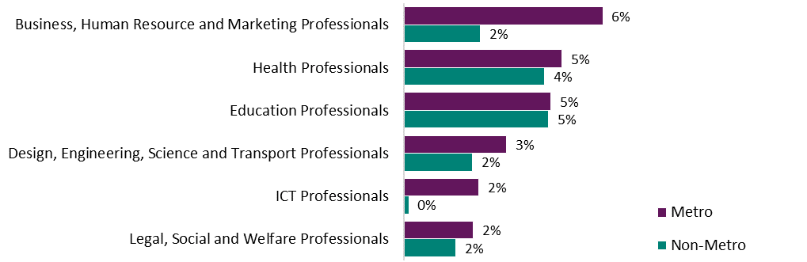

Young people from non-metro areas were more likely than metro youth to aspire to and work in the Technician and Trades occupation where there were relatively more job opportunities (15% of jobs in non‑metro areas, compared to 13% in metro).10 However those living in metro areas were more likely to be working in their intended occupation of Technicians and Trades (64%) than those in non-metro areas (58%) (see Figure 4). Overall, those who aspire to work in Technician and Trades occupation had a higher rate of meeting their career aspiration than average. Less than half of all young people were working in their aspired to occupation by age 25 (48%).

Figure 4: Proportion of 25-year-olds who are working in their aspired to occupation group[11], by occupation and area of residence at age 25

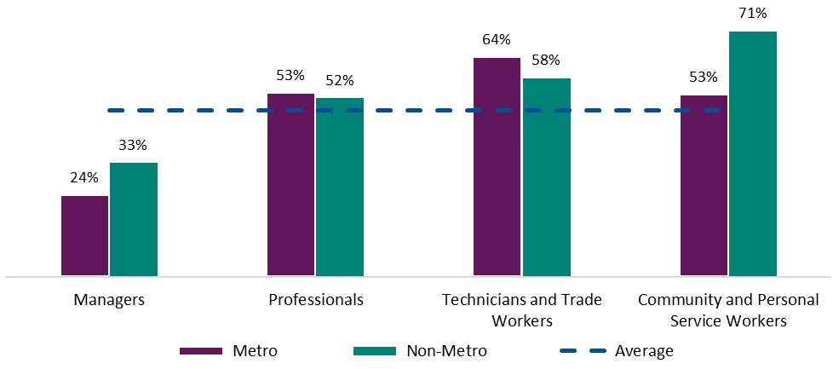

Note: The average line represents the proportion of all 25-year-olds who achieved their career aspiration (48%).

Over half of those who wanted to work as Professionals by age 30 were doing so at age 25 (see Figure 4). Although a similar proportion of metro and non-metro youth aspired to work in Community and Personal Services, in 2016 there was a slightly higher share of jobs in non-metro areas (12% of jobs in non-metro areas compared to 10% in metro).10 Those who aspired to work in Community and Personal Services and lived in a non-metro area at age 25 were also more likely to be working in that occupation (71% compared to 53% of those living in metro areas).

1. ‘Young people’ or ‘young Australians’ are defined as people between the ages of 15 and 25 (inclusive).
2. Non-metro or non-metropolitan categorisation at age 15 (or where respondents are “from”) is based on the Ministerial Council on Employment, Education, Training and Youth Affairs (MCEETYA) classification. Home postcode at age 25 was mapped to the Accessibility and Remoteness Index of Australia (ARIA+). An LSAY respondent is considered to live in a non-metropolitan area at age 25 if their home location is categorised as ‘Inner Regional’, ‘Outer Regional’, ‘Remote’ or ‘Very remote’ under the ARIA+ index.
3. Data is from the 2006 LSAY cohort, which is comprised of young people who were aged 15 in 2006 and were surveyed annually. Data reported is weighted from 2016 survey responses, collected when respondents were 25-years-old. Survey questions ask about expected occupation at age 30. Results are reported for those who plan to work at age 30. Approximately 12 per cent of 25-year-olds did not expect to be working at age 30.
4. Occupation is coded at the two digit level (Sub-Major Group level) using the Australian and New Zealand Standard Classification of Occupations.
5. Occupation is coded at the one digit level (Major Group level) using the Australian and New Zealand Standard Classification of Occupations.
6. The Grattan Institute, 2019, ‘More regional Australians are moving to the city to study. Few return when they’ve finished’, available online at <<https://blog.grattan.edu.au/2019/04/more-regional-australians-are-moving-to-the-city-to-study-few-return-when-theyve-finished/>>.
7. Information derived from the Australian Bureau of Statistics’ ABS.Stat, Census 2016 data, Table G57, ‘Occupation by Age by Sex (SA2+)’.
8. CSIRO, 2017, ‘The growing skills gap between jobs in Australian cities and the regions’, available online at <<https://theconversation.com/the-growing-skills-gap-between-jobs-in-australian-cities-and-the-regions-88477>>.
9. Analysis on Professional occupation subgroups uses LSAY data from the Y03 and Y06 cohorts. All other analysis uses data from the Y06 cohort.
10. Information derived from the Australian Bureau of Statistics, Tablebuilder, Census 2016 data.
11. This graph only presents data for most popular 1 digit occupation groups. With the exception of Community and Personal Service Workers, differences are not statistically significant at the 5% level.