

15 going on 25

Insights from the Longitudinal Surveys of Australian Youth (LSAY)

Opportunity through learning

© Commonwealth of Australia 2020

With the exception of the Commonwealth Coat of Arms, the department’s logo, any material protected by a trade mark and where otherwise noted all material presented in this document is provided under a Creative Commons Attribution – NonCommercial-ShareAlike 3.0 Australia licence. The details of the relevant licence conditions are available on the Creative Commons website (see link) as is the full legal code for the CC BY-NC-SA 3.0 AU licence ([creativecommons.org/licenses/by-nc-sa/3.0/au/legalcode](http://creativecommons.org/licenses/by-nc-sa/3.0/au/legalcode)).

The terms of use for the Commonwealth Coat of Arms are available from: [www.pmc.gov.au/government/commonwealth-coat-arms](http://www.pmc.gov.au/government/commonwealth-coat-arms).

Suggested citation:

The Department of Education, Skills and Employment *15 going on 25: Insights from the Longitudinal Surveys of Australian Youth (LSAY),* Canberra: Australia Government Department of Education

The findings and views expressed in this report are those of the authors and do not reflect the views of the Department of Education.

**Disclaimer:** The Department of Education, Skills and Employment acknowledges diversity and respectfully uses both the terms ‘Indigenous’ and Aboriginal and Torres Strait Islander peoples’ interchangeably throughout this document.

# Contents

Contents 3

Executive Summary 6

1. Introduction 7

1.1 What is LSAY? 7

1.2 Context for Australian Education Policy 9

2. The School Years 11

2.1 Plans and Aspirations 11

2.1.1 Year 12 Completion Plans 11

2.1.2 Post-school plans 12

2.1.3 Parental and Peer Expectations 14

2.2 Student engagement and attitudes towards school 15

2.3 School Retention and Year 12 Completion 17

2.4 Subject Selection 19

2.5 VET participation 21

3. Post-school Study 23

3.1 Participation in post school study 23

3.2 Field of Study 27

3.3 Achievement of aspirations 28

3.4 Post-school pathways 29

3.5 Student income 30

4. Labour market outcomes 32

4.1 Employment by qualification level 32

4.2 Employment at Skill Level 36

4.3 Field of Study 36

5. Social Outcomes 38

5.1 Financial and Social independence 38

5.2 Stress and Wellbeing 40

5.3 Life and career satisfaction 41

5.4 Satisfaction with macro-issues 43

Conclusion 45

**List of Figures**

Figure 1.1: Timeline of LSAY data collection 9

Figure 1.2: Timeline of Australian socioeconomic events, 1995 onwards 10

Figure 2.1: Year 12 completion by plans to complete year 12 12

Figure 2.2: Post-school aspirations at age 16 13

Figure 2.3: Year 12 completion rate by plans for post school study 14

Figure 2.4: Post school plans of 15 year olds, their parents and peers 15

Figure 2.5: Measures of school engagement, by secondary school completion status 16

Figure 2.6: Individual items regarding attitude to school, early school leavers compared to Year 12 completers Y06 cohort 16

Figure 2.7: Year 12 completion and school retention 17

Figure 2.8: School completion status at age 19 18

Figure 2.9: Students studying any maths, by post-school study plans 19

Figure 2.10: Students studying any science, by post-school study plans 20

Figure 2.11: Participation at age 16 in VET delivered in schools 22

Figure 2.12: VET in Schools (VETIS) and post-school VET participation for students who originally planned non-VET pathways 22

Figure 3.1: Participation in any post school study by age 22 24

Figure 3.2: Participation in post-school study sectors by age 22 24

Figure 3.3: Participation in higher education by age 22 by disadvantaged groups 25

Figure 3.4: Participation in apprenticeships and traineeships by age 22 26

Figure 3.5: Participation in higher education by field of study* 27

Figure 3.6: Participation in apprenticeship or traineeship, by field of study* 28

Figure 3.7: Achievement of initial study goals by age 25 29

Figure 3.8: Study pathways for the Y06 cohort 30

Figure 3.9: Income sources for higher education (left) and non-apprentice VET (right) students aged 19 31

Figure 4.1: Labour force status by qualification level at age 25 33

Figure 4.2: Periods of unemployment between 21 and 25, by qualification level at age 25 35

Figure 4.3: Skill level of occupation compared to qualification at age 25 36

Figure 4.4: Labour force status at age 25 by field of post-school study, Y03 and Y06 cohorts 37

Figure 5.1: Transitions from full-time study to full-time work 38

Figure 5.2: Percentage of young people living in and out of the parental home 39

Figure 5.3: Living arrangements at age 25 (left); Family status at age 25 (right) 40

Figure 5.4: Proportion of 25 year olds experiencing high financial stress, by qualification level 41

Figure 5.5: Proportion of 25 year olds “at risk of serious mental illness” by qualification level 41

Figure 5.6: Averaged life satisfaction measures over time 42

Figure 5.7: Averaged satisfaction with macro issues over time, by cohort 43

Figure 5.8: Averaged satisfaction with macro issues over time, by issue 44

# Executive Summary

This report analyses six cohorts of the Longitudinal Surveys of Australian Youth (LSAY), focusing particularly on changes in participation in secondary and post-school education, participation in the labour force and measures of satisfaction and wellbeing over time. It briefly explores the socioeconomic environment for these changes and aims to provide a holistic overview of education activity and transitions into the workforce for youth between 1995 and 2016[1].

The method of analysis for this report is descriptive and focuses on trends and changes in measures of aspirations, participation, engagement, satisfaction and wellbeing as reported by respondents in the LSAY program since 1995. The results suggest that more young people are completing Year 12 and an increasing proportion of those who have plans to leave school early are changing their minds. Those who do leave school early are predominantly going into vocational education, though there is still a proportion who do no further education. Participation in post-school education has increased, driven predominantly by an increase in higher education participation. Fewer young people are transitioning to full-time work by age 25, with unemployment seen mainly among those with no or low-level vocational qualifications. There has been a decline in home ownership and an increase in 25-year-olds still living in the family home. Levels of financial and psychological stress have increased, particularly among those with a higher qualification or an Apprenticeship[2].

Although the Australian youth population is more educated than ever, the returns on investment in their education are not necessarily being realised in the workforce and in the social environment, based on their employment status and satisfaction up to age 25. However, compared with those who have no post-school qualifications—and particularly those with no Year 12 certificate—higher qualifications and Apprenticeships still provide a significant advantage in the labour market. The protective effect of higher skilled qualifications in the labour market does not appear to extend to wellbeing, and it appears that the financial and psychological situation is worsening among those who may have once enjoyed more financial and psychological security as a result of investment in their education and subsequent transition to the workforce.

There are limitations to the descriptive analysis used in this report. The results presented are not inferential and cannot provide evidence for causation, particularly where the effects of policy or socioeconomic events are concerned. Where the report has commented on potential relationships, these have been presented as merely correlational. Further analysis could be done to better understand the effects of particular events on education and workforce participation, satisfaction and wellbeing.

# Introduction

The transition from adolescence to young adulthood is a time of rapid change. During this period, young people will finish up their mandatory schooling, a stage in which they have remained for over a decade and move into unfamiliar territory as they undertake further education, training, employment or other activities. Transitions made between age 15 and age 25 are significant as they have long-term impacts on an individual’s life outcomes.

Through various policy initiatives, successive governments in Australia have worked to broaden the range of school-to-work pathways by increasing the range of options and encouraging flexibility so that young people can move more easily through different institutions and sectors. This has had the effect of making these pathways more individualised and complex. What is often considered to be a linear pathway from school to work is actually multidimensional, with young people moving in and out of educational options and different areas or types of employment.

The transition from school to the workforce is not necessarily straightforward, but it can be distilled down to a series of decisions that young people make regarding what they want and how they will achieve their goals as they get older. While possibly the most influential factors in these transitions are the educational choices made by individuals, other factors such as labour market conditions, family life and the social environment also influence how young people transition from schooling to the labour market. LSAY provides insight into these transitions by following the same groups of people from age 15 to 25 as they progress through senior secondary school and into post-school study and work destinations.

This report presents the results of a project undertaken by the Department of Education, Skills and Employment to produce a descriptive analysis of approximately 20 years of LSAY data. It investigates how the experiences of young people between the ages of 15 and 25 change over time as they move from school to post-school education and into the labour market. It also attempts to understand these changes within the wider changing economic and policy landscape. Analysis of these educational choices and the eventual pathways they form provide important evidence for policy makers about the implications of various policy settings, as well as contribute to the evidence base for shaping future policy initiatives.

## What is LSAY?

LSAY is a nationally representative survey program that follows young Australians over 11 years, from 15 to 25 years of age, as they move through school to further study, work and beyond. It helps us understand what young people are doing at different stages of their lives, what pathways they take, and some of the reasons for the choices they make.

While the main focus of LSAY is on educational activities and labour market outcomes, other important and influential factors such as social outcomes, satisfaction and wellbeing are collected to provide a more complete picture. Details known only to the participants, such as their aspirations for later in life and their satisfaction with their activities, provide an extra dimension to their educational journey and help to answer more in-depth questions. Instead of merely knowing what young people are doing, we can ask questions such as ‘what did they want to do?’, ‘did they achieve what they wanted to or were there barriers?’, and ‘were they satisfied with the choices they made?’. The breadth and depth of the LSAY datasets make them invaluable sources of information for researchers and policy makers.

The longitudinal nature of LSAY also helps us to better understand these experiences over time. The lives of young people are fluid, and their education and labour market activities and status can change considerably from one year to the next. Another benefit of LSAY is its longevity. As the first LSAY group commenced in 1995, available data currently spans over 20 years in total, for six groups of young people. This makes it possible to see how students’ educational choices and transitions have changed over time, particularly in the context of changing economic, social and policy environments.

Groups of survey participants are collectively known as ‘cohort’. There are currently four complete and two active LSAY cohorts. Each cohort contains a group of people of similar age at a particular point in time who are chosen to be representative of the broader Australian student age population. The first LSAY cohort began in 1995 (the Y95 cohort), followed by additional cohorts in 1998 (Y98), 2003 (Y03), 2006 (Y06) and 2009 (Y09). The most recent cohort began in 2015 (Y15). The timing of all six LSAY cohorts is summarised in Figure 1.1: Timeline of LSAY data collectionFigure 1.1.

Each cohort starts with a nationally representative sample of around 10,000 young people in Australian schools. Since the Y03 cohort, participants have been recruited from Australian school students aged 15 who took part in the Programme for International Student Assessment (PISA), an international test undertaken by the Organisation for Economic Co-operation and Development (OECD) countries to measure the educational progress of students worldwide. The two earlier cohorts (Y95 and Y98) were recruited from the population of Year 9 school students.

Figure .: Timeline of LSAY data collection

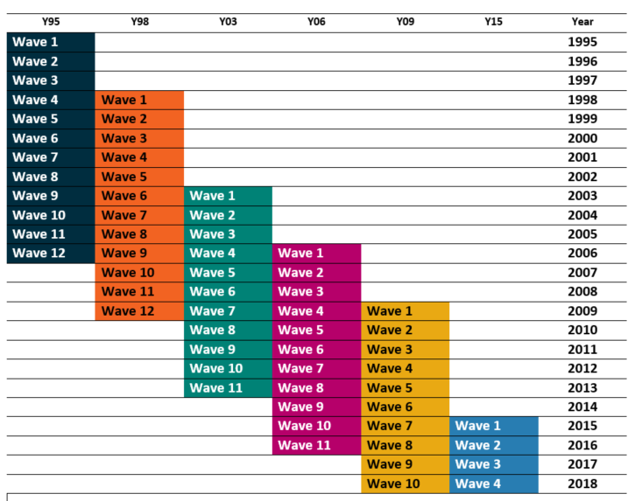

## Context for Australian Education Policy

The educational choices young people make provide an important buffer for external shocks that might affect the labour market and therefore their chances of obtaining future stable employment. Making choices that increase educational attainment and skills facilitates adaptation in times of rapid change or uncertainty.

However, young people do not make their choices in a vacuum. Education policy plays an important role in guiding them towards decisions that will be beneficial to themselves and to the wider community and economy. At its simplest level, education policy aims to ensure that people are engaged and have the knowledge and skills needed to become fully participating members of the community. To achieve this, policy has mostly aimed to increase participation and completion of education by increasing the school leaving age, making study more flexible, removing barriers to access, and making study financially viable.

Figure .: Timeline of Australian socioeconomic events, 1995 onwards

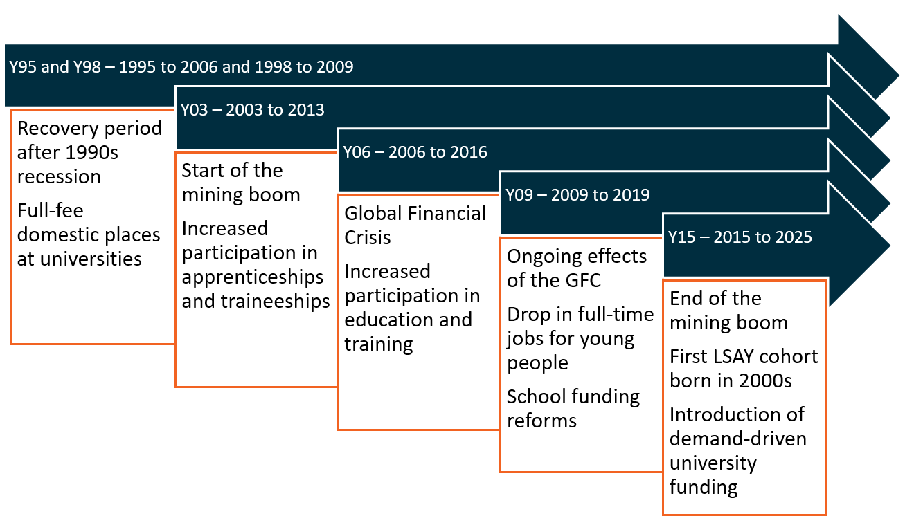

The agenda for education policy is also defined by the broader labour market and economic conditions of the time. As outlined in Figure 1.2, since the early 1990s there have been two major economic downturns, as well as a period of economic prosperity associated with the mining boom. The context for policy development has varied widely as a result of these economic changes. Education policies that have been developed during this period have aimed to not only build a more trained and qualified workforce in the competitive international market, but to also keep young people engaged in school, training or work during economically difficult times.

# The School Years

School plays a central role in the lives of young people. There is strong evidence that quality schooling beneficially impacts the individual, the community and the economy. A high quality schooling system lays the foundation for a skilled, innovative and productive workforce. It also plays a critical role in the social development of individuals during their formative years, contributing towards the development of resilient and cohesive communities.

Governments have consistently emphasised increasing school retention rates, and more recently have reacted with concern to declining PISA results. Recently, focus has also been placed upon student wellbeing and teacher quality in Australian schools. From 2003 particularly, the richness of LSAY data, now built on the PISA instrument, enables deeper analysis of respondents’ behaviour and perspectives while at school. Items from PISA such as career and post school study aspirations, as well as peer and parental expectations, provide information on highly influential factors in educational choices such as school completion and subjects studied at school.



## Plans and Aspirations

Young people plan in response to many factors including their immediate goals, their parents’ and peers’ expectations, and the current economic climate. The choices that they make during their school years are geared to making progress towards later goals for further study or work. Plans and aspirationsfor the future are important drivers of educational outcomes, with goal setting and planning contributing positively to achievement of longer-term goals. Understanding how these influences interact with each other and direct young people’s future plans is key to developing policy that will optimise the transition between school, post school study and the workforce for young Australians.

## Year 12 Completion Plans

The decision of whether to leave school early or complete Year 12 is often made early, and plans to complete Year 12 are generally realised.The vast majority of 16 year olds plan to complete Year 12 (92% for Y03, 85% for Y06 and 89% for Y09). The rate of follow-through on their plans is high (Figure 2.1), around nine out of every ten 15 year olds who plan to complete Year 12 go on to complete Year 12 by age 19. This trend has not changed much over the last decade. Those planning to leave school before Year 12 constituted a small and decreasing proportion of young people (6% for Y03, 5% for Y06 and 4% for Y09), while most of those planning to leave do become early school leavers, the proportion who change their mind and stay to complete Year 12 has been increasing. While this trend is a positive one, the reality is that most of those who leave school early did not originally plan to, meaning that they are likely to have encountered some sort of influence or barrier that either changed their plans or prevented them from achieving their goal.

The remainder of young people reported being unsure about whether they planned to complete Year 12. This group fluctuated in size over time (3% for Y03, 9% for Y06 and 7% for Y09). Positively, despite being unsure, a growing proportion of these young people completed Year 12 (36 per cent for Y03 and 56 per cent for Y09). This could reflect changes in the perceived attractiveness of post-school study compared to the labour market.

Figure .: Year 12 completion by plans to complete year 12

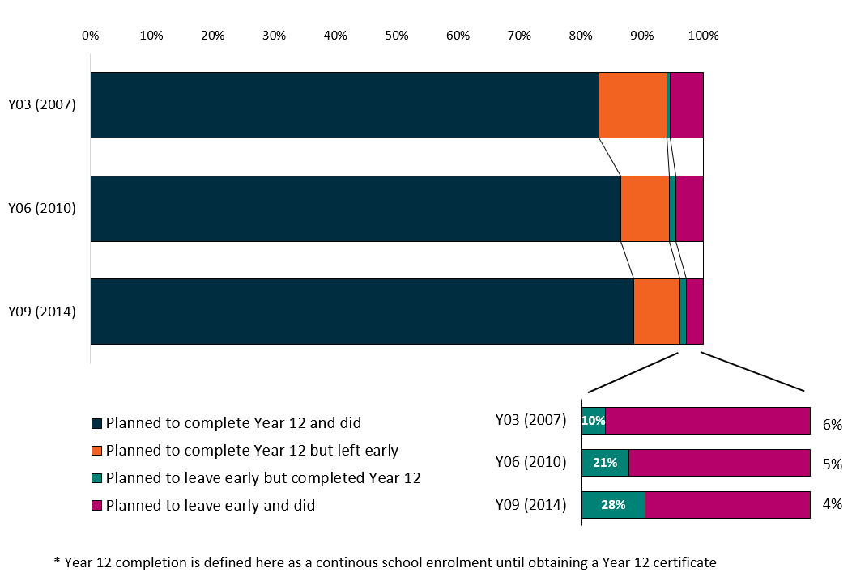

**Note:** Bracketed year is the year of measurement for the cohort. This graph excludes young people who were unsure about whether they wanted to complete Year 12.

On average, young people who complete Year 12 tend to transition more successfully from education to work than those who do not. It is not surprising therefore, that numerous governments have introduced policies that promote Year 12 completion[3].

## Post-school plans

Young people’s plans for post-school have changed very little over time. Figure 2.2 shows the distribution of plans for each cohort, who were asked about their post-school plans at age 16. The majority planned to go to university. Vocational post-school study is the second most commonly planned activity and encompasses both on-the-job courses (apprenticeships and traineeships) and classroom only courses at TAFEs and other vocational institutions. Between 2004 and 2007 there was a relatively large increase from five per cent to 12 per cent for Apprenticeship aspirations, likely in response to the booming mining and construction sectors of the Australian economy at that time. Overall, aspirations to vocational post-school study have declined in more recent times alongside increases in plans for university and going straight into work.[4]

Figure .: Post-school aspirations at age 16

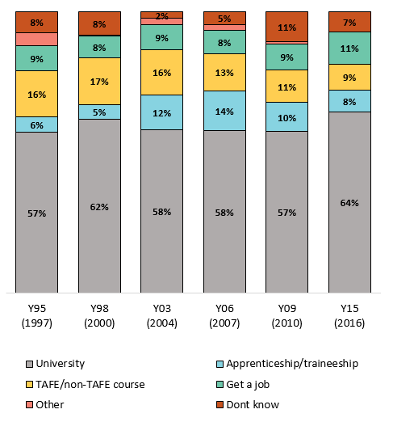

**Note:** Bracketed year is the year of measurement for the cohort

Completing year 12 education has traditionally been more suited to those with academic aspirations, and the data shows that aspiring to go to university has always been associated with very high Year 12 completion rates (see Figure 2.3), and while completion rates have indeed improved over time, they have not increased uniformly when considering young people’s post-school plans. Students with non-university plans may not benefit from staying to finish Year 12 to the same extent as those with plans to go to university; however, despite not necessarily requiring a Year 12 certificate to fulfil their plans, these students are increasingly recognising the importance of completing a Year 12 education. The only aspiration group for whom completion rates are still relatively low are those who are planning to do an Apprenticeship. For these students, there may be more value in getting started on their plans than obtaining a year 12 certificate.

Figure .: Year 12 completion rate by plans for post school study

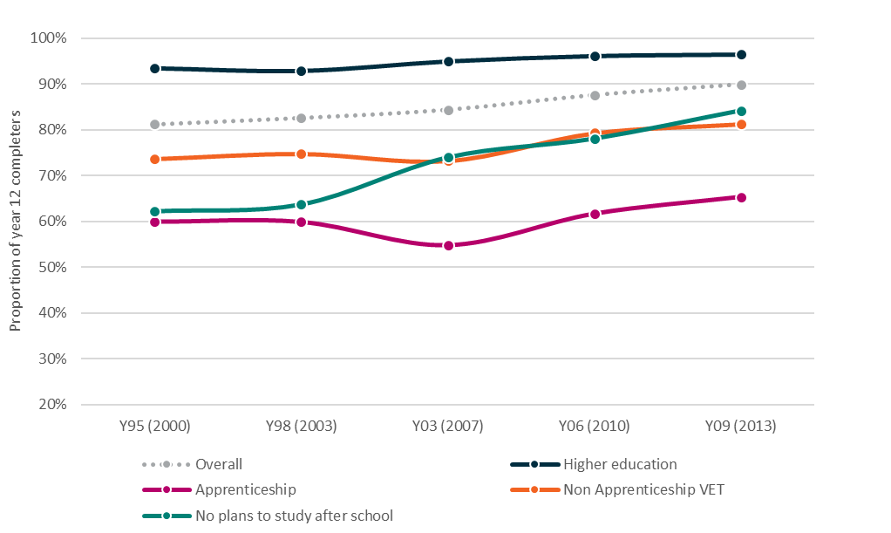Note: Bracketed year is the year of measurement for the cohort

## Parental and Peer Expectations

Parents and friends are both significant sources of information and influence when it comes to making plans for life after school. Parental background and educational attainment play a role in parents’ aspirations for their children’s future, with expectations instilled in their children from an early age. For the Y09 cohort, young people’s plans aligned with their parents 76 per cent of the time, while alignment with friends’ plans was lower at around 65 per cent (Figure 2.4).[5] Agreement between all three parties—the individual, their parents and their friends—was also quite common, occurring just over half of the time. Educational goals have a definite intergenerational component and parents play a large role in forming the aspirations of their children. Although not shown here, educational plan alignment is similar for earlier cohorts, suggesting a stable and enduring relationship over time.

Figure 2.4: Post school plans[6] of 15 year olds, their parents and peers

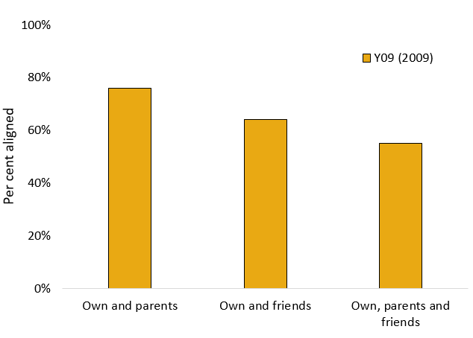

**Note**: Bracketed year is the year of measurement for the cohort

Other work[7] using LSAY has shown that students whose parents expected them to attend university were more likely to complete Year 12 and much more likely to go to university compared with those whose parents expected them to choose a non-university pathway. These findings suggest that policies and interventions aimed at raising educational outcomes should not stop at the school gate, but could also target the attitudes and aspirations of parents and the wider community.

## Student engagement and attitudes towards school

Student engagement with school is of policy interest since there is strong evidence that a student’s engagement with school is linked to their educational attainment and outcomes. A student who enjoys being at school, sees the value in education and has a good relationship with their teachers has a far better chance of reaching their potential than a student who feels negatively towards school and teachers and views learning as a waste of time.

A student’s attitude towards school, their relationships with teachers, the value they ascribe to school and their sense of achievement at school all have a strong relationship with their school completion (Figure 2.5). In particular, early school leavers tend to have a negative attitude to school despite having generally positive views about the value of school. Early school leavers have also reported lower engagement with teachers and a lower sense of achievement at school.

Figure 2.6 provides an example of respondent differences in three of the questions that underlie the attitude to school engagement scale.

Figure .: Measures of school engagement, by secondary school completion status

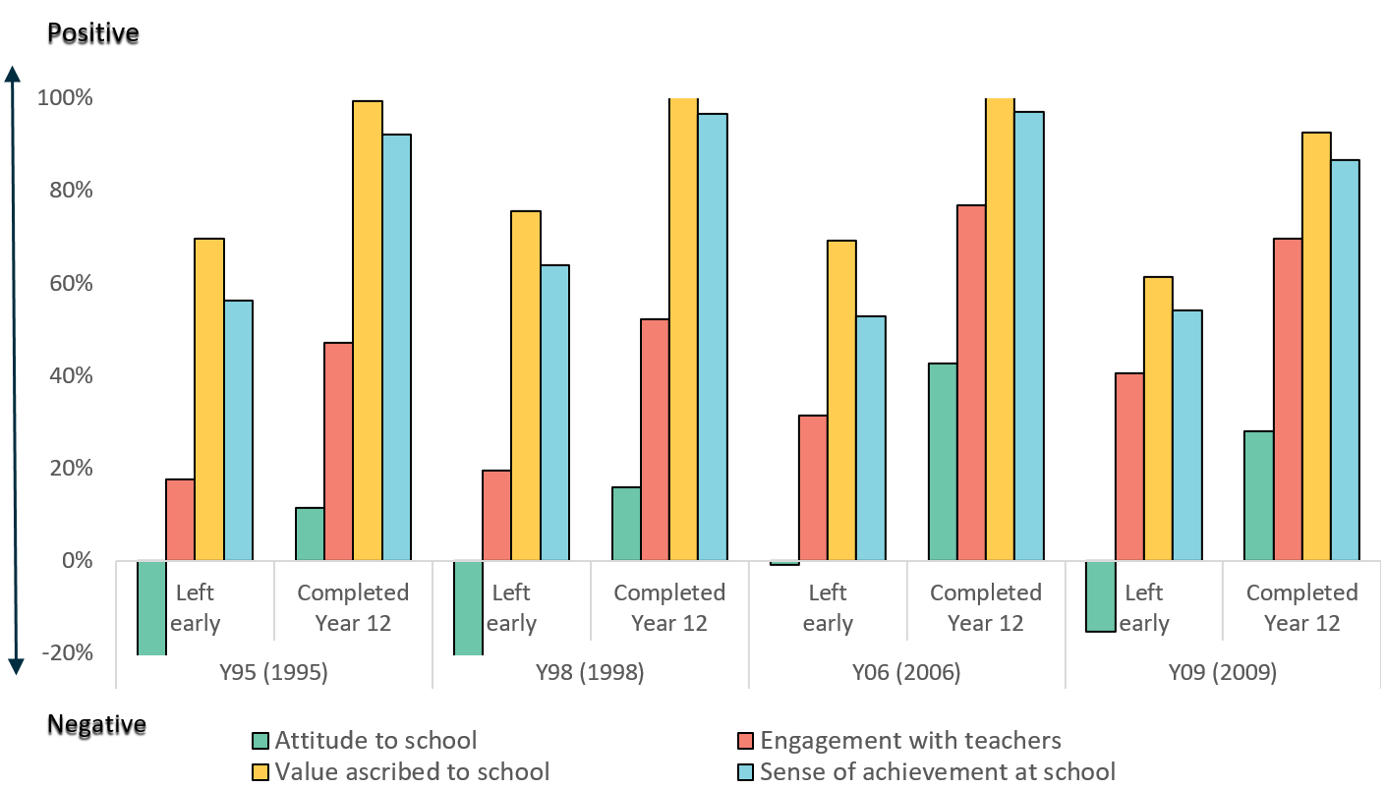

**Note:** Bracketed year is the year of measurement for the cohort

Figure .: Individual items regarding attitude to school, early school leavers compared to Year 12 completers Y06 cohort

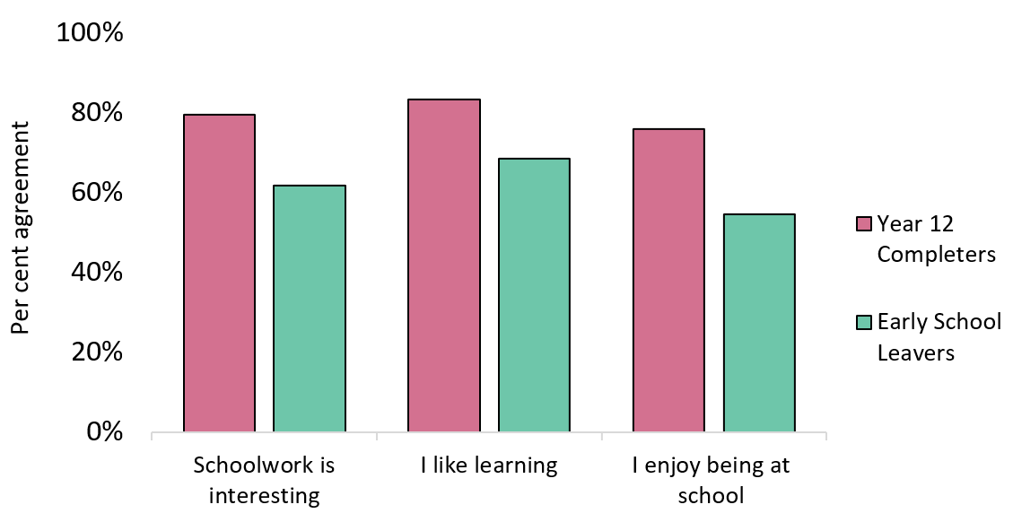

Policy changes aiming to increase participation in post-school education or Year 12 completion could benefit from targeting the factors that influence student’s attitudes and engagement towards school. Further investigation into what direct influence schools can have over the development of students’ attitudes to their school environment and how this affects their plans for further study could be considered.

## School Retention and Year 12 Completion

A secondary-level school education has become an increasingly important foundation for life after school regardless of background, aptitude or plans. Encouragingly, young people are increasingly staying on to later years of secondary school.

An increase in school completion and retention is apparent in the years between the 2006 and 2009 LSAY cohorts, with the increase of 6 per cent an equivalent size as that seen in the decade prior. Retention of young people from Year 9 to Year 10 and from Year 10 to Year 11 has increased, as has Year 12 completion (Figure 2.7). However, one in ten students still leave school before completing Year 12. This indicates that while young people are staying in school longer, for some the decision to leave may simply be delayed by a year.

Figure .: Year 12 completion and school retention

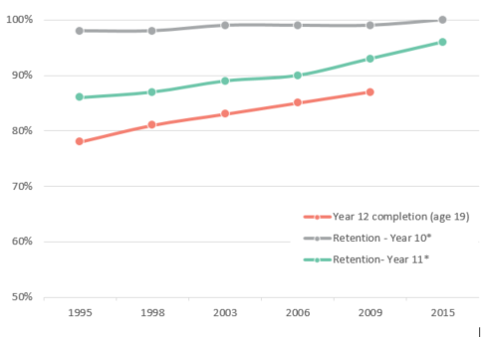

*Based on enrolment data for all students, Schools Australia, ABS

Importantly, Year 12 completion rates also increased among disadvantaged groups (Figure 2.8). Completion rates among low achieving students (as measured by reading achievement) and low SES students have both risen steadily since 2007. Year 12 completion for young people of Aboriginal and Torres Strait Islander descent has seen the largest relative increase, but is not shown on the graph due to sample size limitations.

Figure .: Year 12 completion status at age 19

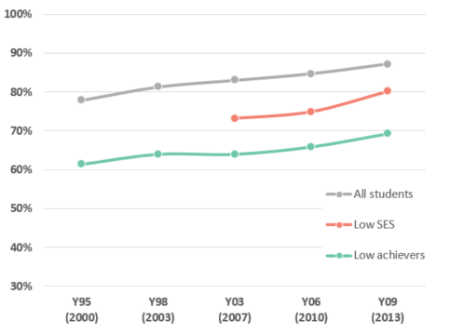

**Note:** Bracketed year is the year of measurement for the cohort.

The improvements in school retention may partly be due to the 2009 Compact with Young Australians[8], which aimed to increase engagement with education and training through:

* changes to the school leaving age, which required young people to participate in schooling until they completed Year 10 or an approved equivalent and then to undertake at least 25 hours per week of education, training or employment (or a combination of these) until   
  age 17;
* changes to Youth Allowance, which required those under 21 without a Year 12 certificate to undertake at least 25 hours of study or training per week to qualify for income support; and
* entitlement to government funded training for all young Australians.

A range of policy initiatives that aim to reduce educational disadvantage have also been introduced. The National Indigenous Reform Agreement was introduced in 2007 and included targets to halve the gap for Indigenous students in reading, writing and numeracy within a decade, and to halve the gap for Indigenous people aged 20-24 in Year 12 attainment or equivalent attainments by 2020. The National Partnership Agreement on Low Socio-Economic Status School Communities was introduced in 2008 and provided additional Commonwealth funding to schools that were determined to be in need or to most likely benefit from the intervention. The performance indicators for this intervention included increased school enrolment, attendance rates and Year 12 completion among young Indigenous and low SES people.

Further analysis shows that young people are more likely to leave school early if they are disengaged with school, have low academic achievement or come from a low socioeconomic background. Young people who leave school before completing Year 12 often cite having or wanting a job or an apprenticeship/traineeship and not liking school as the main reasons influencing their decision.

## Subject Selection

Subjects studied in the senior secondary years have significant influence on the educational and career options available to young people after school, and there is current policy interest in patterns of subject choice. Subject choices of secondary students are, in part, driven by students’ post-school study plans, but they may also be driven by perceptions of effort to reward in terms of final grades. While retention rates to Year 12 have increased, fewer of those staying in school are studying Science Technology Engineering and Maths (STEM) subjects. Due to this downward trend, there is increasing concern that students are missing the foundations for technical skills they will need in their future work.

LSAY data show a decline in the proportion of students studying maths (Figure 2.9). Students who aspire to university after school are more likely to study maths, but even amongst that group the proportion studying maths is falling.

Figure .: Students studying any maths, by post-school study plans

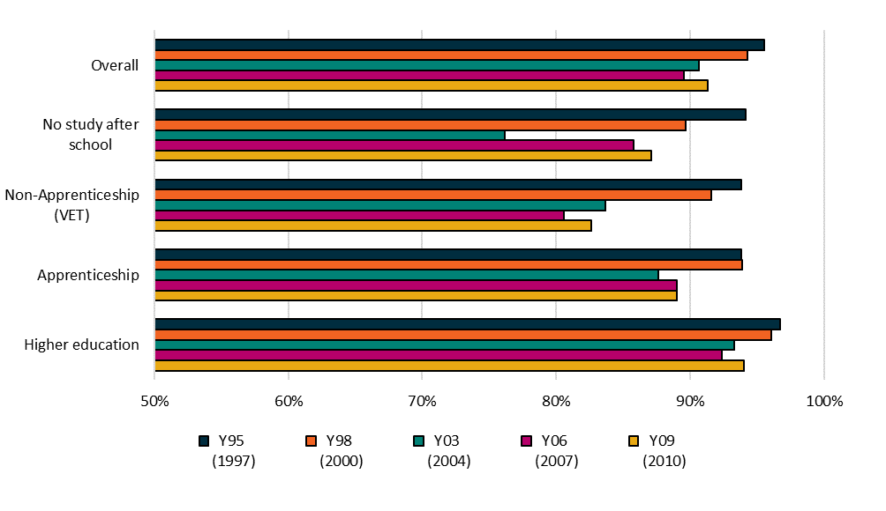

**Note:** Bracketed year is the year of measurement for the cohort

One possible factor in this decline is that maths is no longer a compulsory subject in Year 11 and 12 in many states, and the requirements around how much maths is mandatory vary from state to state. In New South Wales, Victoria and the ACT, maths is no longer compulsory for Year 11 and 12 students to receive a Year 12 certificate. In Queensland and South Australia, students are only required to undertake one compulsory semester of maths in their final two years of high school. In the Northern Territory, maths is compulsory in Year 11 but not in Year 12. In Tasmania, students have to demonstrate they can pass a basic unit called Everyday Maths. In Western Australia, Year 12 students are required to do one STEM subject, which does not necessarily have to be maths.

As with maths, the proportion of students studying science subjects has fallen over time (Figure 2.10). Those who aspire to go to university are more likely to study science, but even among those students science subjects are on the decline. The quantitative and critical thinking skills developed in the science classroom are important foundations for many vocational as well as tertiary study pathways.

Figure .: Students studying any science, by post-school study plans

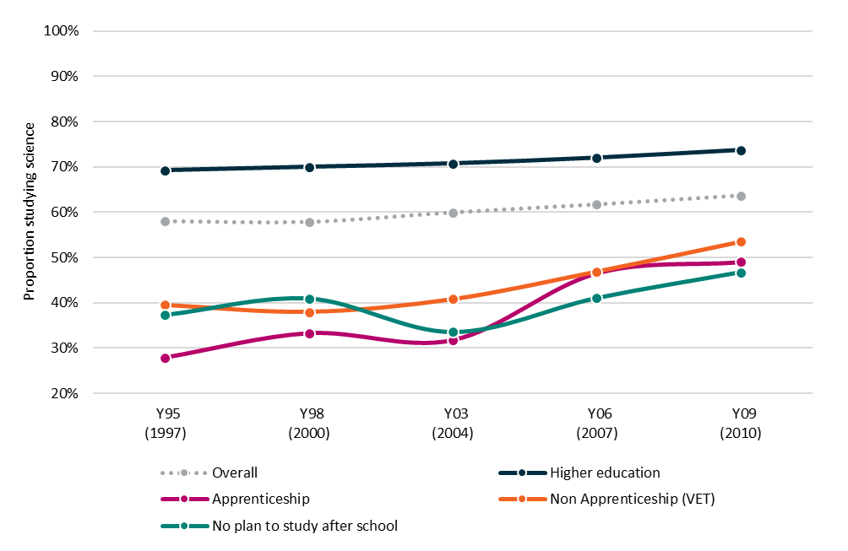

**Note:** Bracketed year is the year of measurement for the cohort

The decline in STEM participation has been modest amongst those that go onto higher education, falling from 74 per cent in 1997 to 69 per cent in 2009 and most pronounced for those pursuing Apprenticeships, where participation decreased from 49 per cent to 28 per cent over the equivalent period.

The current concern that not enough young Australians are engaging with STEM subjects may suggest that young people do not currently perceive the value for their efforts in studying STEM. However, a report by PwC[9] states that 75% of future jobs will involve STEM skills, raising concerns about the viability of future science and mathematics-based jobs among a shortage of STEM qualified workers. The 2015 National STEM School Education Strategy and the 2016 Strengthening School-Industry STEM Skills Partnerships Project (also known as the Finkel Review) have aimed to address the potential future issues that may arise by providing national leadership on the teaching of STEM in schools.

Further compounding these issues, many university courses have no entry pre-requisites for maths or science, placing no obligation on those who want to pursue STEM degrees to have done a particular level of maths or science in school. A review into the mathematical sciences by the Australian Academy of Science in 2016 identified this as a major issue, and as a result some universities have begun to reintroduce maths prerequisites for science, engineering and commerce degrees starting in 2019.

## VET participation

Nationally recognised VET qualifications undertaken as part of a senior secondary certificate were introduced in 1996 to meet a perceived need for broader access to structured vocational training and to encourage young Australians who did not desire an academic pathway to complete year 12. In 2006, close to 40% of upper secondary school students participated in a VET in Schools program. There is a strong regional effect, with students in remote and regional areas more likely to participate in VET in schools than those from metropolitan areas.

Several initiatives have been introduced over the last two decades to increase the effectiveness of VET in schools:

* The School-Based New Apprenticeships scheme (SNAPs) was introduced as part of the New Apprenticeships scheme in 1998 and allows students to start a part-time apprenticeship or traineeship while still attending school. Uptake of VET subjects while at school increased after the introduction of SNAPs: one in four students in the LSAY 1998 cohort took a VET school subject at age 16, compared with one in six among the 1995 cohort (Figure 2.11).
* Australian Technical Colleges (ATCs) were introduced in 2004 as an alternative type of senior secondary school with an entirely vocational focus. In 2009 the program was dismantled and all ATCs either merged with other senior secondary schools or changed to include the entire school curriculum.
* Trade Training Centres (TTCs) were introduced in 2008 as specialised training centres within existing senior secondary schools, or as training hubs serving a cluster of schools. These may have affected participation in school-based Apprenticeships in the Y15 cohort.

Over time, schools have been encouraged to expand their curriculum to include more VET subjects. VET in schools enables students to undertake nationally recognised training and to receive a Statement of Attainment and/or an Australian Qualification Framework (AQF) qualification after successful completion of their course. This training intends to serve multiple purposes:

* Preparing students in school for the full-time workforce, or providing them with a qualification for part-time work while they engage in further study.
* Kick-starting students on a vocational qualification pathway by giving them the initial qualification levels of their chosen vocation.
* Encouraging students who initially did not plan any post-school study to undertake further vocational study.
* Keeping young people who might not otherwise continue with their schooling engaged in school, by providing training that they see as valuable and relevant to their chosen pathway.

Figure .: Participation at age 16 in VET delivered in schools

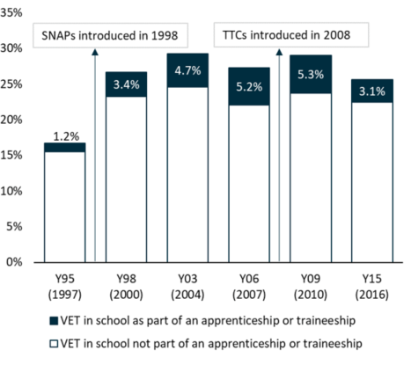

**Note:** Bracketed year is the year of measurement for the cohort

From Figure 2.12 we can see that VET in schools (VETIS) may have successfully encouraged further vocational training among students who originally did not plan further vocational study. This is especially true among the 2009 cohort, where participation in VET at school resulted in young people being 19 per cent more likely to pursue VET as a post school study option. This suggests that VET in schools may be becoming more important as a pathway for post-school VET.

Figure .: VET in Schools (VETIS) and post-school VET participation for students who originally planned non-VET pathways

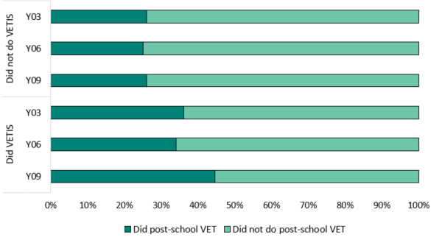

# Post-school Study

The decision about whether or not to undertake further study after school is an important choice that young people make. There is a wide variety of post-school study options available, and these can be grouped into three broad areas: higher education, including bachelor degrees and subsequent post-graduate study; on-the-job vocational qualifications, including apprenticeships and traineeships; and vocational qualifications without an on-the-job component. The types of study that young people choose are based on their interests and needs, the cost of courses, as well as what will be valuable in the context of the broader economy and labour market.

Participation in education and training after leaving school is an important pathway for young people. Generally, post-school study improves long-term employment prospects and wellbeing. However, choosing to do further study also comes with potential extra burdens such as increased debt and delayed job stability. Despite requiring some extra planning and potentially prolonged dependence, an increasing proportion of young people are choosing to go into further study after they finish school.



## Participation in post school study

With significant social and economic changes in Australia in the last two decades, characterised by a period of extended growth which included two economic downturns, successive Australian governments have recognised the importance of building a highly trained and qualified workforce to meet the needs of the Australian economy.

This is reflected in a high proportion of young people undertaking post-school education. Overall, almost 93% of young people from the Y09 cohort reported participating in some form of post-school study by age 22, compared to 87% of the Y95 cohort (Figure 3.1). Participation in post school study is not only increasing among those who complete Year 12, but also those who leave school early. Post-school qualifications are becoming increasingly important for early school leavers, as finding employment for this group has become more difficult under the tight labour market conditions since the global financial crisis (GFC). In addition, Commonwealth policies such as “Earn or Learn” have augmented the pressure on young people to participate in post-school study as a condition of receipt of income support payments.

The overall increase in post-school education reflects a number of policies of successive governments that have aimed to increase participation in post-school study. These policies have not only promoted participation, but have also expanded access by providing greater flexibility and a wider variety of options for financial assistance. For example, Commonwealth Supported Places (CSPs) was created in 2005 to subsidise tuition costs for higher education students. This complements FEE-HELP, which was created to assist full fee-paying students to attend university. In 2009, FEE-HELP was expanded to include VET FEE-HELP, extending the loan system to those in vocational courses. In 2012, the government moved to a demand driven university funding system, lifting previously imposed caps on the allocation of university places.

Figure .: Participation in any post school study by age 22

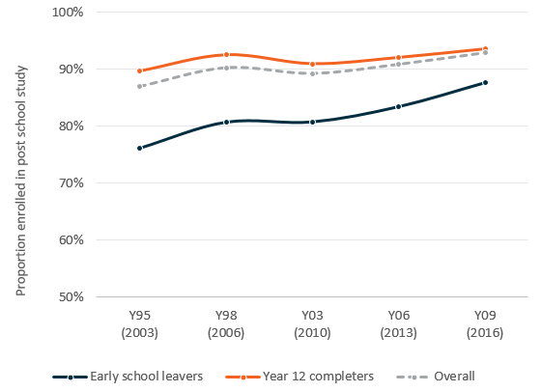

**Note:** Bracketed year is the year of measurement for the cohort

The increase in post-school education has not occurred equally across sectors. While the higher education sector has expanded, the vocational sector has tended to experience little, if any, change in enrolments (Figure 3.2).

Figure .: Participation in post-school study sectors by age 22

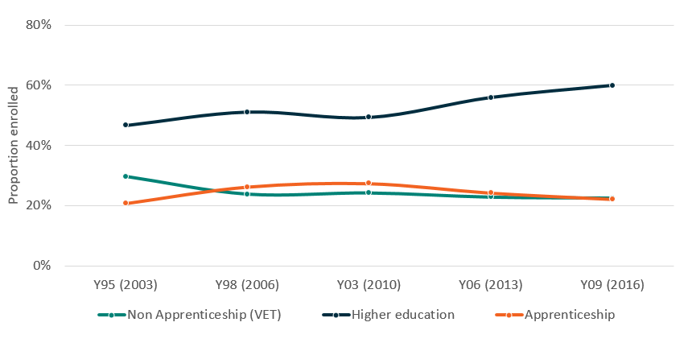

**Note:** Bracketed year is the year of measurement for the cohort

*Data is from LSAY survey responses and may not be comparable to official higher education and VET statistics

Going to university is considered an important post-school pathway for young people as it provides entry to professional and other higher skilled occupations. University has consistently been the preferred post-school destination, with around 60 per cent of the Y09 cohort undertaking higher education in 2016. It is therefore not surprising that the introduction of access-expanding higher education policies has led to a rapid increase in participation in higher education. At the same time, participation in apprenticeships, traineeships and other vocational courses has gradually declined. While some of the decline seen in vocational study—particularly for Apprenticeships—is likely due to the winding down of the mining boom and manufacturing industry, it is likely that some young people who might otherwise have studied vocationally are instead going into the expanded higher education system.

Higher education policy has also aimed to make attending university a more viable option for disadvantaged groups such as Indigenous, low SES and non-metropolitan young people. The Higher Education Participation and Partnerships Program (HEPPP), implemented in 2010, provides funding to assist some universities to undertake activities and implement strategies that improve access to undergraduate courses for people from low SES backgrounds and improve the retention and completion rates of those students.

Figure .: Participation in higher education by age 22 by disadvantaged groups

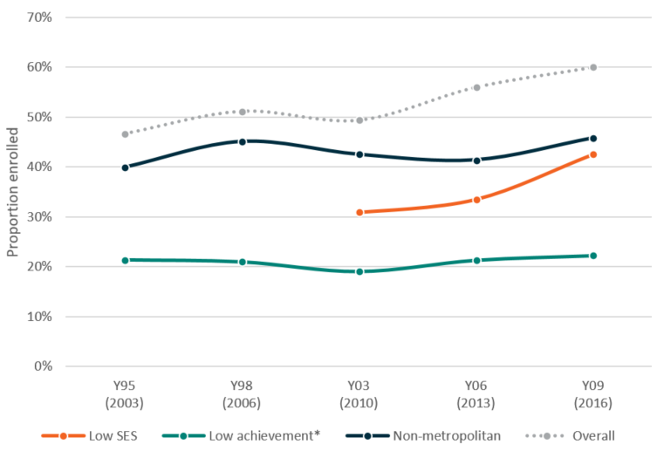

**Note:** Bracketed year is the year of measurement for the cohort

*Low achievement refers to those in the lowest quarter for PISA reading achievement

While the increase in participation seen for low achieving and non-metropolitan young people has been modest (Figure 3.3), there has been a relatively steep increase in participation among young people from low SES backgrounds, particularly following the introduction of the HEPPP and the move to a demand driven system. The relatively small increase seen in the non-metropolitan and low achieving* groups likely reflects the ongoing presence of the barriers faced by these young people in going to university, including issues of access, different aspirations and societal expectations, and lower university entrance scores.

Though not shown in the graph due to sample size limitations, participation of Indigenous young people in higher education has seen an increase in recent years; however, they are still underrepresented in the Australian university population. In 2017, Australian universities rolled out a national strategy to increase Indigenous representation in higher education by 50 per cent above the growth rate of non-Indigenous students and set targets of equal completion rates for Indigenous and non-Indigenous students. At the time this report was published it is too early to see outcomes from this policy.

Despite the lack of growth in total VET enrolments, the importance of the VET sector has increased in recent years as a way for vulnerable young people to remain engaged in a difficult labour market (Figure 3.4). The job market for young people was particularly difficult following the GFC, and this was especially true for those who were fresh out of school, unskilled and had low educational attainment.

Early school leavers choose to do apprenticeships and traineeships at a higher rate than those who complete year 12, as they provide a direct pathway into work and allow young people to earn money while they learn valuable skills. Often these benefits, along with disengagement from schooling, contribute to the choice to leave school in the first place. Fortunately, entering an Apprenticeship early as an alternative to completing school appears to offset the potential employment disadvantages of not completing year 12.

Similarly, low achieving students have also felt the pinch of the job market when they finish school. With fewer jobs and an increasing proportion of students choosing higher education, Apprenticeships have provided a good way for low achieving students to participate in further education and be competitive in the job market[10]. The falling participation in apprenticeships and traineeships amongst lower SES can be explained by the increasing proportion choosing to pursue higher education (Figure 3.3)

Figure .: Participation in apprenticeships and traineeships by age 22

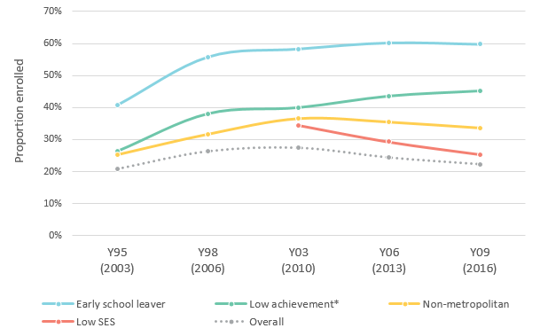

**Note:** Bracketed year is the year of measurement for the cohort. SES was measured differently for the Y95 and Y98 cohorts and is unable to be directly compared.

*Low achievement refers to those in the lowest quarter for PISA reading achievement

## Field of Study

Field of study for university students is an important determining factor for both short-term and long-term career prospects. Information on future demand, combined with students’ preferences, aptitudes and potential competitive advantage, form the basis for their choice of field of study. Nevertheless, despite ongoing needs for skilled workers in areas such as engineering and architecture, it appears that young people’s preferences for particular fields have been relatively persistent over time.

Shifts in demand for particular fields between LSAY cohorts have been, for the most part, minimal and gradual (Figure 3.5). Society and Culture, which includes the subfields of Law, Political Science, Psychology and History, has remained the most common field and appears to have grown in popularity more recently. Interestingly, Behavioural Science courses have driven the sudden increase in participation in Society and Culture between the Y06 to the Y09 LSAY cohorts. Prior to this, Law courses were the main driver of the high proportion of people studying within Society and Culture.

Figure .: Participation in higher education by field of study*

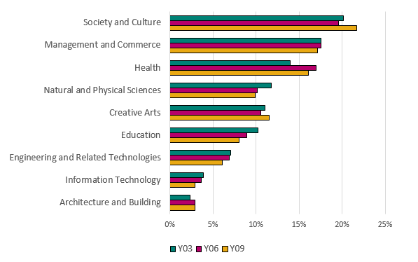

*Data is from LSAY survey responses and may not be comparable to official higher education statistics

Field of study is perhaps even more important for employability among those studying for a vocational qualification. A well-chosen field of study in an area of skill need can boost employment prospects significantly; however, it becomes more difficult to differentiate oneself in the labour market with a certificate or diploma level qualification that is not in demand. Around one third of apprenticeships and traineeships undertaken by LSAY participants have been in the field of Engineering and Related Technologies, with the most popular courses being Electrical, Mechanical and Automotive Engineering (Figure 3.6). This is positive, as these skills are consistently required, although those with Mechanical Engineering qualifications may have been adversely affected by the recent decline of the manufacturing industry in Australia.

The proportion of young people undertaking traineeships in the field of Management and Commerce showed a relatively large decrease for the Y09 cohort (Figure 3.6). The reasons for this shift are unclear; however, it does coincide with a sharp decline from 2012 in the number of commencements in government sector traineeships[11].

Figure .: Participation in apprenticeship or traineeship, by field of study*

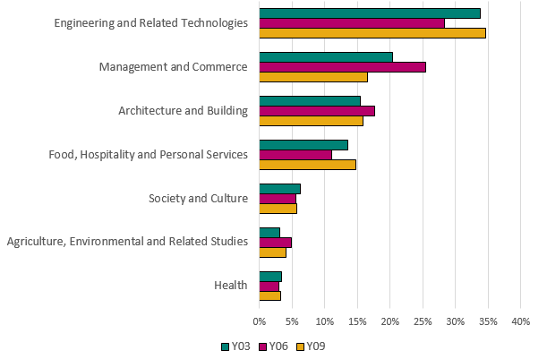

*Data is from LSAY survey responses and may not be comparable to official VET statistics

## Achievement of aspirations

By age 25 around half of young people have achieved their original study goals, and this proportion has crept upwards over time by about 10 percentage points between the Y95 and Y06 cohorts (Figure 3.7). As shown earlier in this report, many young people aspire to go to university after they finish school, and the gradual increase seen in the proportion of young people actually going to university has no doubt contributed to the increase in the proportion achieving their study goals. Other young people pursuing post-school study exited the system with a different qualification to the one they planned, and others who planned to pursue some form of post-school study had not completed any qualifications by age 25. The proportion of 25 year olds who had attained a post-school qualification in 2016 increased from 14 per cent in 2013 to 23 per cent (Figure 3.7). This is likely due to an increase in the proportion of young people planning to undertake post-school study (Figure 2.2) and an increase in the amount of time take to complete post-school study (Section 5.1).

Figure .: Achievement of initial study goals by age 25

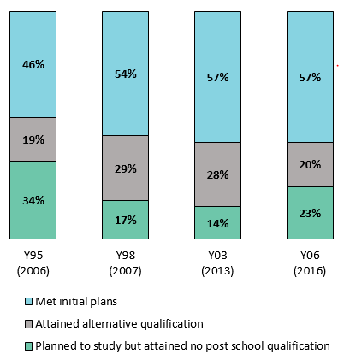

**Note:** Bracketed year is the year of measurement for the cohort

Where young people are not achieving their educational goals, two questions need to be asked: is not meeting study aspirations a cause for concern; and, if so, what can be done about it from a policy perspective. If these people have willingly changed their minds to pursue alternative goals, then there is little cause for concern. If, however, they experience academic, financial or social barriers to achievement, then there is a potential role for government in ensuring that these young people have every opportunity to pursue their goals.

## Post-school pathways

By looking a little deeper at young people’s early aspirations, their first educational destination and their final attainment (Figure 3.8), it is possible to get a better idea of the pathways through which they achieve—or deviate from—their initial study plans.

In many cases, pathways are very straightforward. Most young people want to do further study after school and do so, and many achieve their initial goals by taking a direct path from school into their chosen study destination. This is particularly true for those who attained university qualifications, where the vast majority originally planned to go into higher education and initially went to a university.

Figure .: Study pathways for the Y06 cohort

Figure 3.8 shows the study pathways for the Y06 cohort, it depicts their plans at age 16, followed by their first study activity after school, and finally their highest qualification at age 25.

It illustrates the range of pathways young people take after secondary school through to their post school education and eventual qualifications.

The pathways are less homogenous for other levels of attainment. Among those who attained a certificate or diploma, almost half initially aspired to go to university, but went into a different type of study instead. In fact, the aspiration of post-school university study is so widespread that most levels of attainment are comprised of young people who initially wanted to go to university. The exception to this is the small early school-leaver group, who mostly aspired to doing an apprenticeship or traineeship. Once the Y09 LSAY cohort has completed in 2019, it will be possible to see if the uncapping of university places has resulted in a higher concentration of university aspirants going into university and completing higher qualifications.

## Student income

There are many ways for young people to support themselves while they are undertaking post-school study. At age 19, when the majority of young people who will study are undertaking their qualification, most—between 70 and 80 per cent—will be keeping their living expenses down by staying in the family home. However, having additional income while studying is an important way for young people to support themselves and maintain their independence while they work towards their qualifications.

The two main sources of income for those who are studying are income earned through paid employment and income received through government allowances available to students who meet certain conditions, such as Abstudy or Youth Allowance (student). Since the first LSAY cohort, a consistent one in two university students have juggled work and study with no extra support via government payments (Figure 3.9left), though parents and guardians may well have contributed to financial support. Those reliant on government support alone are a comparatively small group for all cohorts, with between 10 and 17 per cent of students relying solely on a government allowance. Working part-time is by far the most common means of earning an income, with those working full-time while studying making up a small minority of students.

Figure .: Income sources for higher education (left) and non-Apprenticeship VET (right) students aged 19

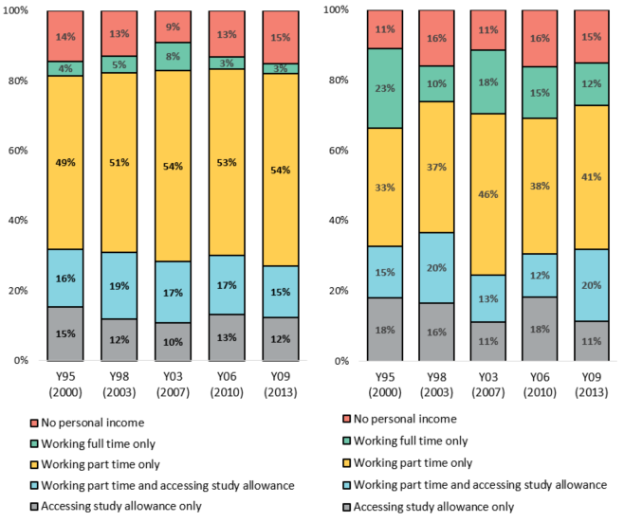

**Note:** Bracketed year is the year of measurement for the cohort

The patterns of study, work and government allowance access for those studying for non-Apprenticeship vocational qualifications (Figure 3.9 right) are broadly similar to university students (Figure 3.9 left), with the exception being that a higher proportion of those studying VET are working on a full-time basis. This may reflect the tendency for vocational study to be supplementary to work as a way to upskill, reskill or engage with further education.

# Labour market outcomes

The choices that young people make along their journey from school to the workforce are now more important than ever in ensuring a successful transition to stable work, a satisfying and suitable job and a good sense of independence and wellbeing. There have been significant social and economic changes in Australia that have impacted on young Australians over the past two decades. A 2018 youth stocktaking report[12] by the OECD states that today’s young people are worse off than the generation that came before them. The labour market has not recovered for young people as it has for other age groups since the GFC, and availability of jobs is lower as many older employees are remaining in the workforce for longer. Both skilled and unskilled entry level positions have become harder to find and many employers may be less inclined to take on inexperienced and professionally unpolished young people. The effect of this is that many young people who stayed engaged through study in times of uncertainty are finding themselves without a job to go to or the professional experience necessary to be competitive. Add to this the impact of increased casualisation in industries that typically employ young people and an increased demand for particular skills or professionally qualified workers, and it results in a comparatively more complex transition from education to the labour market for young people than for their predecessors.



## Employment by qualification level

The choices that young people make around education have an impact on their later labour force outcomes. The youth labour market in Australia has generally seen higher rates of unemployment and underemployment when compared with higher age ranges, and young people are particularly susceptible to the effects of changes in the job market or economic events. Since the 1990s, patterns of employment for young people have progressively leaned more towards part-time[13] and casual work[14], resulting in an increasingly smaller proportion of young people able to obtain full-time ongoing work following their transition from education to the labour market.

Figure 4.1 shows patterns over the life of LSAY in labour force and employment status for different levels of educational attainment. Those who have lower levels of educational attainment tend to be more exposed to economic challenges. Early school leavers generally have poorer transitions to the labour market than those who complete Year 12, and those with only Year 12 or equivalent attainment struggle more than those who have a higher education qualification or have completed an apprenticeship or traineeship. In 2006, less than half of early school leavers who undertook no further study were working in full-time ongoing jobs by age 25, and this proportion has declined further over subsequent LSAY cohorts. This group also has a higher proportion who are unemployed or not in the labour force at age 25.

Figure .: Labour force status by qualification level at age 25

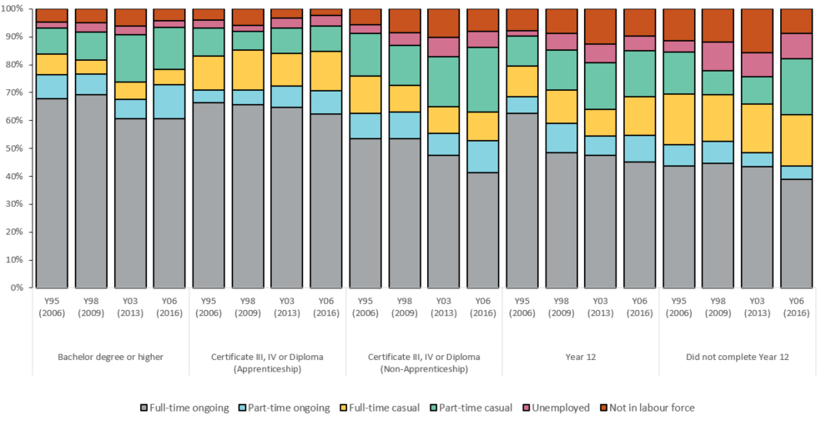

**Note:** Bracketed year is the year of measurement for the cohort

LSAY collects not only point in time labour force status, but also length of time in months spent unemployed in a given survey year. This is used to identify the prevalence of periods of unemployment and to look more closely at the duration of these spells. Figure 4.2 shows two measures: the proportion of young people who experienced a period of at least one month of unemployment in three or more years out of the five years between ages 21 and 25, and the median duration in months of the longest unemployment spell. The median refers to the middle point in the total reported months in unemployment, and is more robust to unusually high outlying values than the mean. This is further disaggregated by educational attainment at age 25.

There is a clear difference in both occurrence and duration of unemployment between those who were established in the labour force prior to the GFC and those who finished school and emerged into a job market already affected by the economic downturn. Small differences can be seen between the first three cohorts, most notably a slight uptick in year 12 non-completers and an improvement for those with an apprenticeship or traineeship during the mining boom years. For the 2006 cohort, however, who were 21 in 2012 and 25 in 2016, the proportion who experienced multiple periods of unemployment increased substantially—tripling the previous cohorts’ figures in some attainment levels—and the median duration of the longest period of unemployment increased across all attainment levels by an average of 3 months. While some people would have been engaged with education in this time, most will have reached their full attainment and have struggled to find work. The percentage increase in unemployment spells for those with a bachelor degree or higher is similar to those with other types of educational attainment, suggesting that while employment prospects are still better for those with a higher education qualification, they are similarly affected by changes in labour market conditions.

Figure .: Periods of unemployment between 21 and 25, by qualification level at age 25

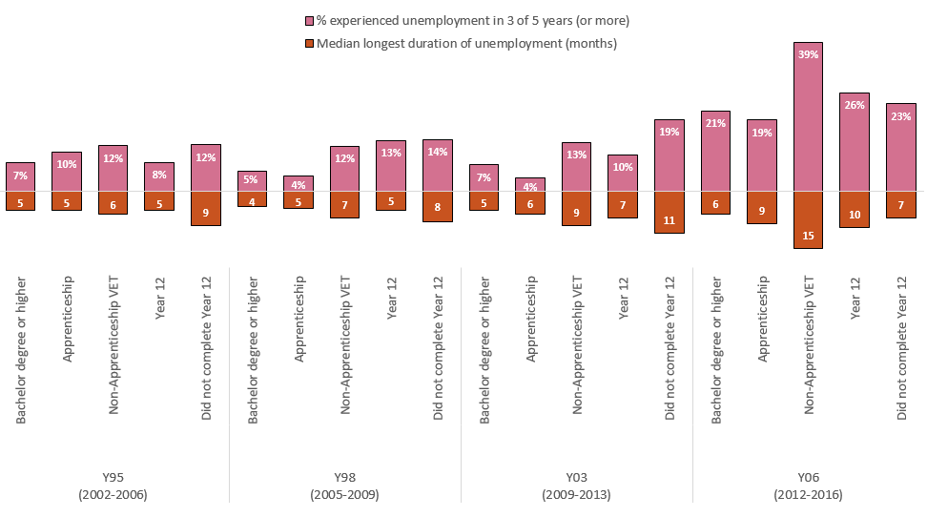

**Note**: Bracketed year is the year of measurement for the cohort

## Employment at Skill Level

It is important to look beyond just whether or not people with various levels of attainment are employed and on what basis. One of the key reasons for pursuing further study is to invest in a future career, reflected by obtaining secure and appropriately skilled work. This helps to increase the likelihood of finding satisfying work and being financially secure, psychologically healthy and sufficiently independent down the track.

Figure .: Skill level of occupation compared to qualification at age 25

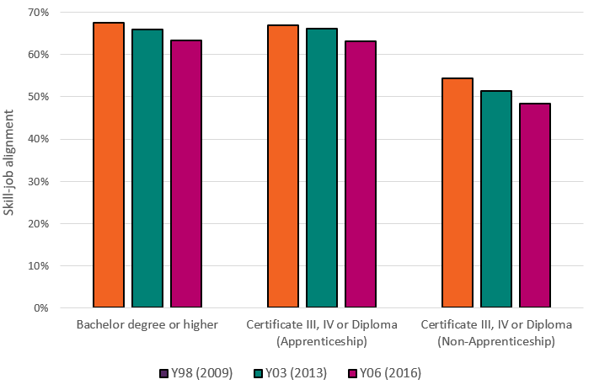

**Note:** Occupational and qualification alignment denotes young people employed in a job requiring skills that match their level of educational attainment. Bracketed year is the year of measurement for the cohort.

*Low and high skill jobs classifications are derived from the Australian New Zealand Occupational Classification (ANZOC)

Figure 4.3 shows that those with higher education qualifications or an Apprenticeship-based vocational qualification have higher rates of gaining employment at or above their skill level than non-Apprenticeship vocational qualifications. The proportion of 25 year olds employed in an occupation at or above their skill level is reducing over cohorts. This suggests that more young people are overqualified for the jobs they are in. A secondary but very important consequence is that those without qualifications are increasingly competing with overqualified individuals for low-skilled jobs. This, combined with a tight middle- and low-skilled job market, has resulted in the increased marginalisation of those without further qualifications in the job market.

## Field of Study

Fields of study that involve the acquisition and application of specialist skills and knowledge, such as Engineering and Related Studies or Management and Commerce, tend to lead to higher rates of secure and stable employment (Figure 4.4). Conversely, more generalist courses (for example, Creative Arts or Agriculture, Environment and Related Studies) tend to lead to lower rates of ongoing employment. When compared with the labour force profile of those who did no post-school study, eight out of eleven fields of study had a higher rate of ongoing employment, a higher rate of participation in work and a lower rate of labour force non-participation.

Figure .: Labour force status at age 25 by field of post-school study, Y03 and Y06 cohorts

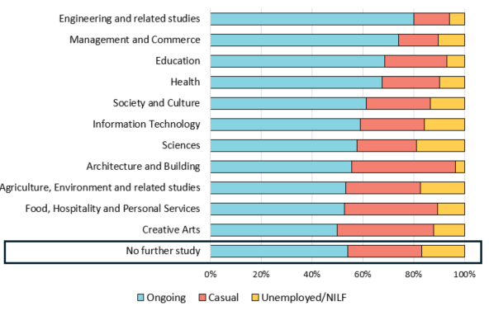

**Note:** Ongoing and casual refers to both full time and part time employment.

Although these results suggest that some fields of study may be less beneficial than not studying at all, the results may be explained by the following limitations. Some participants will still be studying at the conclusion of the 10-year follow up period, which is especially true for longer degrees that tend to have higher pay off in terms of positive labour force outcomes over the long term. Similarly, many of these people will have only recently completed their qualifications, and may be waiting to see pay off in terms of finding work and becoming established in their field. Additionally, this particular figure pools together vocational and higher education qualifications, and those with vocational qualifications will generally have had a longer period of time to get a foothold in the workforce than their equivalent field university student counterparts.

# Social Outcomes

The choices that young people make along their journey from school to the workforce are important in ensuring a successful transition to stable work, a satisfying and suitable job and a good sense of independence and wellbeing. Changes in the labour market can be seen to be influencing social outcomes, with delays in financial and social independence, reduced life and career satisfaction, reduced satisfaction with the government and the economy, and increased psychological and financial stress.



## Financial and Social independence

While the concept of ‘adulthood’ is broad and cannot be measured by any one event or milestone, the achievement of independent living and stable employment are two metrics that can be considered as relevant for adulthood. On both these metrics, the transition to adulthood is taking longer.

Figure .: Transitions from full-time study to full-time work

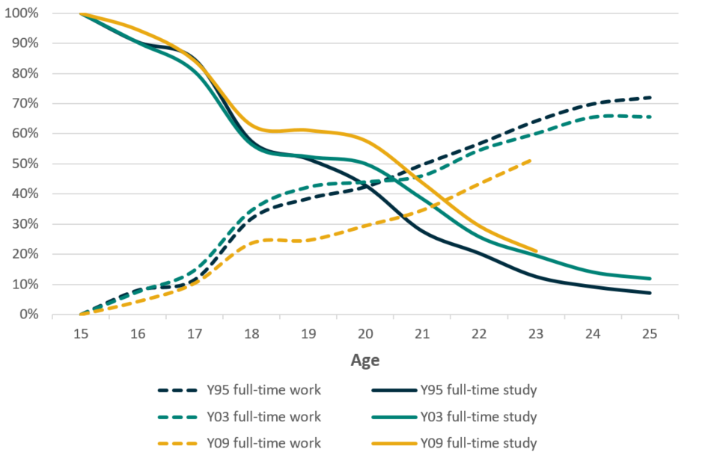

The intersection points in Figure 5.1 and Figure 5.2— where the proportion in full-time work are equivalent to those in full-time study, and the proportion living independently is equivalent to those living with parents—are occurring at a later age for each cohort. In the case of full-time education, this is largely driven by the lower proportion of young people who are able to find full-time work. For Y03 and Y09 there are a similar proportion of young people still studying full time however the proportion of those in full-time work for Y09 is tracking well below where it was for the previous cohorts. In the case of living situations, young people are making the switch from living at home to living independently later and later. By age 25 around a third of young people are still living at home, and this is increasing.

Figure .: Percentage of young people living in and out of the parental home

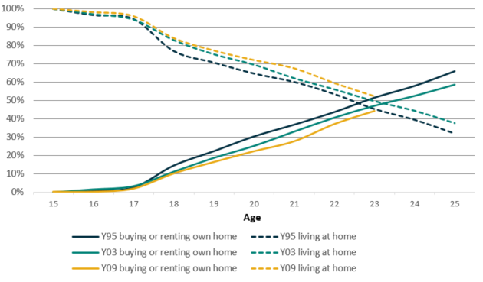

Delays in milestones such as moving out of the family home and finding full-time work often have flow-on effects for other milestones such as owning a home, forming relationships and having children. Figure 5.3 (left) illustrates a decline in home ownership. Part of this decline is due to an increase in longer-term study choices, and therefore later entry into full-time employment and the resultant income boost. The remaining effects of the GFC on employment, the reduction in housing affordability, and the relatively high proportion of youth employed in casual jobs are also factors in reduced home ownership.

Young people are now less likely than ever to be purchasing their home, and as a result, they are slightly more likely to be renting. However, the drop in home ownership is on the whole not offset by renters, but rather by young people staying in the family home.

Despite the changing trends in living situation, young people are not significantly less likely to be forming relationships and cohabiting with their partner, with approximately two in five young people being married or in a de facto relationship by age 25 (Figure 5.3 right). However, the proportion of young people starting a family by age 25 has decreased by a third to just under one in ten.

Figure .: Living arrangements at age 25 (left); Family status at age 25 (right)

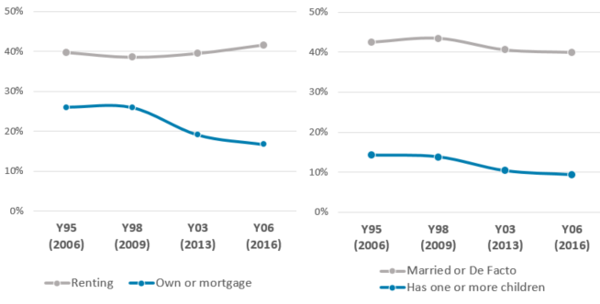**Note:** Bracketed year is the year of measurement for the cohort

## Stress and Wellbeing

Financial stress and psychological distress provide two important indicators of wellbeing. Feeling stressed financially, or feeling anxious or depressed, are closely related to overall poorer health and can have a severe impact on quality of life and the ability to acquire or keep a job. Overall, both financial stress and psychological distress have been on the increase among young adults (Figure 5.4 and Figure 5.5).

Those who do not complete year 12 are most likely to experience financial and psychological distress, and higher educational attainment no longer provides as great a comparative advantage financially or psychologically as it once did. Financial stress is likely a large contributor to psychological distress. Policy focus is increasingly being drawn to ensure the mental wellbeing of young people, and such policy should acknowledge the impact financial stress can have on mental wellbeing.

Figure .: Proportion of 25 year olds experiencing high financial stress, by qualification level

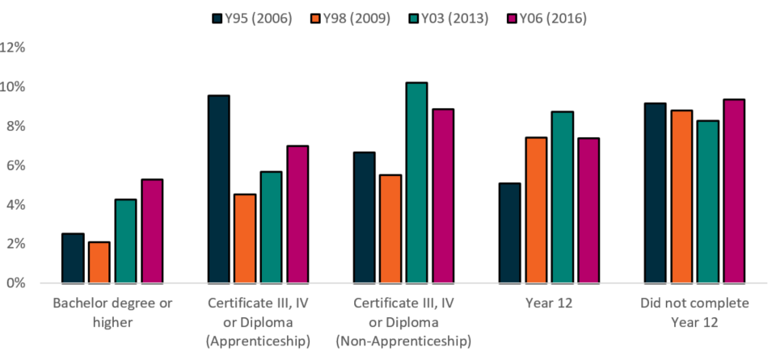

**Note:** Bracketed year is the year of measurement for the cohort

Figure .: Proportion of 25 year olds “at risk of serious mental illness” by qualification level

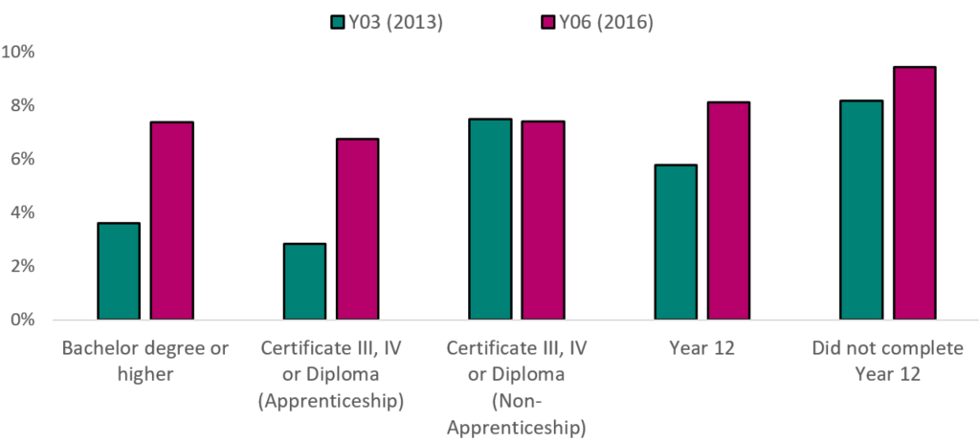

**Note:** Bracketed year is the year of measurement for the cohort

* Respondents “at risk of serious mental illness” have been identified according to the Kessler 6 scale

## Life and career satisfaction

Positively, young people have been—and still are—generally satisfied with most aspects of both their lives and their careers. There has, however, been a downward trend in both life and career satisfaction since 2011 across all three LSAY cohorts, particularly among Y09, the youngest of the cohorts (Figure 5.6).

Previous research[15] using data from the Y95 cohort demonstrated that young Australians who were fully allocated (either engaged in full time work, full time study or work and study) had significantly higher life satisfaction than those who were partially allocated, who in turn had significantly higher life satisfaction than those who were unallocated. Given the increase we have seen in youth unemployment and underemployment rates since the Y95 cohort, the decrease in satisfaction seen among the Y03, Y06 and Y09 cohorts is likely to be a reflection in part of the difficult state of the youth labour market, increased and prolonged study and the resulting delay in social and career development.

Figure .: Averaged life satisfaction measures over time

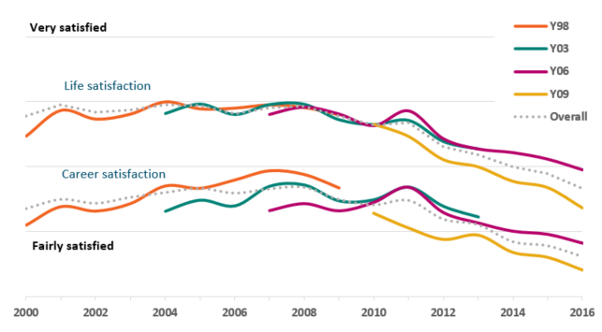

Despite being a measure of individual satisfaction with one’s own circumstances, life and career satisfaction are influenced greatly by the wider economy and the government of the day. Satisfaction with government and the economy—or the macro environment—are following a similar trend to life and career satisfaction.

## Satisfaction with macro-issues

Early on in the LSAY program young Australians were, on average, feeling positively about the macro issues affecting Australia. Figure 5.7 shows averaged responses to two questions: one about satisfaction with the economy and the other about satisfaction with the way the country is run. There has been a steady decline in these satisfaction levels since the GFC, and for the last few years young people have trended towards feeling indifferent on average. The relatively steep and consistent decline in satisfaction from 2010 onwards in this graph aligns closely with increases in both unemployment and underemployment for Australians aged 15 to 24 years.

Figure .: Averaged satisfaction with macro issues over time, by cohort

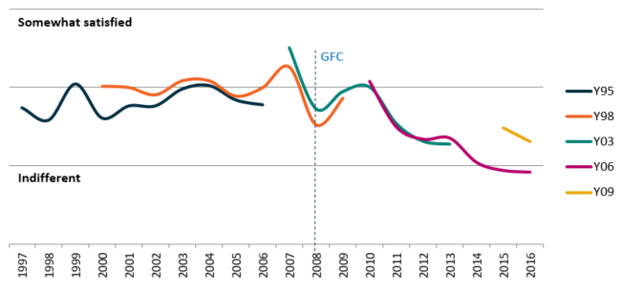

If the questions are taken individually (Figure 5.8) it can be seen that satisfaction with the government and the economy are closely correlated. However, in the year 2008, average satisfaction with the economy dropped sharply at around the time of the GFC, while satisfaction with the government was smooth from 2007 to 2009. The divergence of these measures from each other may reflect an awareness of the repercussions of the global economic downturn, and a willingness not to blame the Australian government of the time for events beyond their control. Since 2009 satisfaction with both government and the economy have fallen together, as the global downturn started to affect Australian employment markets, government interventions to protect against the GFC were wound up, and the mining boom came to an end.

Figure .: Averaged satisfaction with macro issues over time, by issue

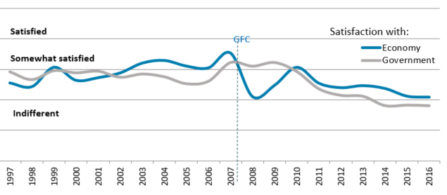

# Conclusion

The pathways that youth take from school to the labour force are diverse and dynamic. Decisions that young people make regarding school and post-school study affect their future labour market and social outcomes. Such decisions are significantly influenced by the socioeconomic context. The longitudinal data collected across multiple LSAY cohorts provides an invaluable insight into these decisions and the ways in which they have been affected by changing social and economic conditions.

The decisions that are made in school have been undergoing change, with reduced selection of maths and science subjects, increased school completion, and future aspirations altering in response to changes in the labour market. Post-school study choices have also been undergoing change, with more higher education participation, and shifts in the demand for certain fields of study.

There is consensus among those with a knowledge of youth affairs that young people were having an increasingly tough time even before the COVID-19 pandemic. Despite unprecedented high levels of educational attainment, a sluggish labour market can put young people’s transitions from school to the workforce in jeopardy. Even the most educated of young Australians can have difficulty finding secure work and those with lower attainment struggle more than ever to get a foot in the door. Delayed financial independence can be seen to be keeping young people in the family home for longer and delaying home ownership. Financial and psychological stress have been increasing amongst youth, with higher education qualifications and apprenticeship qualifications offering less financial and psychological security than they used to.

Positively, education policy seems to be succeeding in its goal of keeping young people engaged through economically difficult periods. As time goes on, we may see even more young people participating in post school study, including those from low SES backgrounds.

1. 2016 is the latest year of LSAY data that includes information on participants from the ages of 15 to 25 (inclusive). Data for the latest two cohorts of LSAY, who commenced the survey in 2009 and 2015 respectively, is used in analysis where suitable.
2. The term Apprenticeship refers to Australian Apprenticeships, which include apprentices and trainees.
3. The 1999 Adelaide declaration included in its goals that “All students have access to the high quality education necessary to enable the completion of school education to Year 12 or its vocational equivalent and that provides clear and recognised pathways to employment and further education and training”.
4. The 2006 cohort participants given the option of writing in an alternative response if their plans were “other”. The most common response was to take a break or gap year before returning to formal study. This option has been included as an option in all surveys since and one in six participants has selected it.
5. There were some differences is response frames for this question and rates across cohort, however investigation shows that this did not seem to effect the distribution of responses. Only 41 per cent of the Y09 cohort sample provided answers on their plans, their parents’ plans and their friends’ plans, compared to 81 per cent of the Y06 sample.
6. Groups in this figure are not mutually exclusive and can add to more than 100 per cent.
7. Gemici, S., Bednarz, A., Karmel, T., Lim, P. (2014) *The factors affecting the educational and occupational aspirations of young Australians*
8. Compact with Young Australians was a federal government policy initiative implemented through COAG. The compact included three components; 1) a requirement to participate in schooling to Year 10 or approved education, training or employment, until 17. 2) a guarantee to young people under the age of 25 to an education or training place, subject to admission requirement and course availability; and a strengthening of participation requirements for some types of income support.
9. PricewaterhouseCoopers (2015) *A smart move: Future-proofing Australia’s workforce by growing skills in science, technology, engineering and maths (STEM)*
10. Moschion, J. Polidano, C. Castillo, M. (2019) *Vocational pathways and post-school transitions from VET delivered to school students* Melbourne Institute Applied Economic & Social Research Available at: <https://melbourneinstitute.unimelb.edu.au/__data/assets/pdf_file/0006/3194403/Vocational-pathways-2019.pdf>
11. Commencements by reporting period for Government employer type, Apprentices and Trainees – December 2017, NCVER
12. OECD (2018) Youth stocktaking report: engaging and empowering youth in OECD countries – how to bridge the governance gap
13. Labour Force Australia, cat no. 6202.0, Table 13. Labour force status for 15-24 year olds by Sex - Trend, Seasonally adjusted and Original, ABS 2018
14. Australian Labour Market Statistics, cat no. 6105.0, Table 1. Employment Type: Employed persons by Sex, Full-time/part-time and Age, August 1992—August 2007 and November 2008—November 2012, ABS 2014
15. Hillman, K., McMillan, J. (2005) *Life Satisfaction of Young Australians: Relationships between Further Education, Training and Employment and General and Career Satisfaction*