

Higher Degrees by Research Completions

Cohort Analysis, 2007-2017



Opportunity through learning

ISBN

978-1-76051-902-5 [PDF]  
978-1-76051-903-2 [DOCX]

Creative Commons

With the exception of the Commonwealth Coat of Arms, the Department’s logo, any material protected by a trade mark and where otherwise noted all material presented in this document is provided under a [Creative Commons Attribution 4.0 International](http://dnet.hosts.network/education/Resources/Documents/Creative%20Commons%20Attribution%204.0%20International) (http://creativecommons.org/licenses/by/3.0/au/) licence.

The details of the relevant licence conditions are available on the Creative Commons website (accessible using the links provided) as is the full legal code for the [CC BY 4.0 International](http://dnet.hosts.network/education/Resources/Documents/CC%20BY%204.0%20International) (http://creativecommons.org/licenses/by/4.0/legalcode).

The document must be attributed as *Higher Degrees by Research Cohort Analysis, 2007-2017.*

Contents

Executive Summary 4

Key Messages 4

Preface 6

Analysis 7

HDR courses 7

Scope 7

Four year outcomes 8

Outcomes by course level 8

Type of attendance 8

Gender 9

Age 9

Research Training Scheme (RTS) and scholarship status 9

Indigenous indicator 9

Regional classification 10

Broad field of education 10

Six year outcomes 10

Nine year outcomes 10

Appendix - detailed tables and charts 11

# Executive Summary

In response to the 2016 *Review of Australia’s Research Training System*, the Australian Government made a commitment to develop a methodology for a cohort study for commencing higher degree research (HDR) students.

For this study, the Department of Education (the department) utilised data from its Higher Education Student Data Collection (HESDC) to analyse trends on HDR completion rates and completion timeframes for domestic students.

This report presents selected cohort data on how many students completed their studies, how many were still studying, and how many were neither studying nor had completed a HDR course over the period 2007 to 2017.

Completion outcomes for cohorts have been analysed four, six and nine years after commencement.

Analysis commentary is presented on a subset of the selected cohort data for characteristics that are in groups of interest to Government and the sector. A full set of table and charts are provided for the selected data to enable broader use of the data.

This report also presents student completion rates for each higher education institution listed as a Table A or Table B institution in the *Higher Education Support Act 2003*, being institutions eligible for significant research and research training funding.

# Key Messages

As at the end of 2017, for analysis of cohorts four years after commencement:

* 20.3 per cent of domestic HDR students in the 2014 cohort completed their studies. This comprises of 15.4 per cent for Doctorate by Research students 34.5 per cent for Masters by Research students, which reflects the different course lengths.
* Completion rates for males is marginally higher (20.7 per cent) than females (20.0 per cent).
* Other cohorts with the highest completions rates are:
  + Younger students (24 and under), 27.4 per cent
  + Receiving scholarship support (both Research Training Scheme (RTS) and Australian Postgraduate Awards (APA), 22.1 per cent
  + Non-Indigenous students, 20.5 per cent
  + High socio-economic status (SES) students, 23.2 per cent
  + Metropolitan students, 21.2 per cent
  + Students undertaking creative arts related research; 28.2 per cent

Six years after commencement:

* Completion rates for domestic HDR students have trended up from 44.5 per cent for the 2007 cohort to 48.3 per cent for the 2012 cohort. This increase in completion rate is consistent across metropolitan, regional and remote cohorts.
* 65.1 per cent of students aged 24 and under at the time of commencement completed versus 34.1 per cent for students aged 55 to 64. However, the completion rate for students aged 65 and over (40.3 per cent) is higher than completion rates for students aged 35 to 64 (ranging from 33.9 per cent to 36.3 per cent).
* There is a clear gap in completion rates for the 2012 cohort who are identified as Indigenous students (30.6 per cent) versus non-Indigenous students (48.7 per cent).

Cohort analysis over a nine year period provides indicative final outcomes for HDR students. For the 2009 cohort, 70.6 per cent of students studying full-time and 44.1 per cent of students studying part‑time students completed their studies.

Completion rates for international students are consistently higher than domestic students at four, six and nine years after commencement.

# Preface

The 2016 *Review of Australia’s Research Training System*, conducted by the Australian Council of Learned Academies, included a finding that available data is inadequate to determine the performance of the research training system and its value to Australia’s economic and social wellbeing.

In response to the Review, stakeholders developed a Research Training Implementation Plan (RTIP), released by the Australian Government in December 2017. The RTIP includes a number of action items related to improving data and evidence to better monitor higher degree by research system performance. Among these is a commitment to develop a methodology to undertake cohort studies, subject to funding availability, drawing on consultation with relevant experts in the sector who have undertaken such studies (Action 5.1).[1]

Given the need to minimise the administrative burden for universities, in the first instance the department is undertaking the first HDR cohort analysis using existing data.

The department has undertaken a cohort analyses of domestic bachelor students since 2014.[2] Department cohort analysis methodology analyses outcomes for cohorts of higher education students using data from the *Higher Education Statistics Collection*. Commencing student cohorts are tracked using student ID (within institution) and Commonwealth Higher Education Student Support Number, CHESSN[3] (across institutions) which provides an overview of student outcomes four, six and nine years after students commenced a course. That is, how many students had completed their studies[4], how many were still studying, and how many were neither studying nor had completed an award and therefore were no longer at the original institution or the institution to which they had transferred. The department has applied this methodology in undertaking this cohort study of domestic HDR students.

A HDR is a Doctorate by Research or Masters by Research. A Doctorate by Research means a Level 10 Doctoral Degree (Research) qualification as described in the Australian Qualifications Framework[5] and a Masters by Research means a Level 9 Master’s Degree (Research) qualification as described in the Australian Qualifications Framework.

Some minor modifications have been made to the methodology to only report on students who commenced and completed at the HDR level, rather than any level as per the methodology used for cohort analyses of domestic bachelor students.

The department’s cohort study methodology is limited to existing data sets for enrolled and completed students.

This report is one of a number of responses to the RTIP released by the department. It presents selected data on enrolments, commencements and completions for Masters by Research (MRes) and Doctorates by Research (DoR) over the period 2007 to 2017 (the most recent year for which data is available), organised by the themes. The data refers to all Australian institutions that enrol HDR students, both universities and a small number of other higher education institutions (NUHEIs). In all cases the data is based on custom queries to the department’s internal databases; due to the coding used to remove duplicate enrolments the results may differ slightly from other public data.

This report does not address the position of international students except as a point of comparison.

Future HDR cohort data will be made available on department’s website together with other higher education statistics[6] following the release of 2018 student data statistics.

# Analysis

## HDR courses

In order to place the observations about domestic HDR students for this cohort analysis in context, it is useful to outline the expected completion timeframes for HDR courses.

A traditional full-time MRes is designed to be completed in two years and a traditional full-time DoR course takes four years to complete.

## Scope

Data is limited to those students who commenced an HDR course and finished an HDR course. This differs from standard methodology used in University Statistics publications, where a completion is counted as a student finishing any course level.

Data for this cohort analysis includes all higher education providers with HDR courses.

Student characteristics analysed include:

* course level,
* type of attendance,
* gender,
* age,
* Research Training Scheme (RTS) scholarship status,
* Indigenous indicator,
* regional classification,
* broad field of education,
* STEM (science, technology, engineering and mathematics) / HASS (humanities, arts and social sciences) / Other courses,
* high cost / low cost HDR courses, and;
* a comparison of total domestic versus international HDR students.

# Four year outcomes

Four year student outcomes for domestic commencing HDR students at higher education providers have been assessed for cohorts from 2007 to 2014 (Table 1 and Chart 1). The size of these cohorts ranged from approximately 9,000 students in 2007 to approximately 10,000 students in 2014.

For the most recent cohort available (2014 cohort), four years after commencement, 20.3 per cent of students had completed a course, 59.5 per cent were still enrolled, and the remainder had either re-enrolled, but dropped out before 2017 (13.6 per cent) or never returned after 2014 (6.6 per cent). This equates to 79.8 per cent of the cohort being engaged in higher degrees by research (completed or still enrolled) and 20.2 per cent disengaged (re-enrolled, but dropped out, or never came back after the first year). These outcomes were similar across all cohorts analysed.

A distinct cohort of international HDR students was constructed for comparison purposes. It is not possible, however, to determine what percentage of international students may have completed their studies at another institution because they do not have a CHESSN. The completion rate for international HDR students for the 2014 cohort was 26.0 per cent after four years, higher than the completion rate for domestic HDR students (20.3 per cent).

## Outcomes by course level

Student outcomes showed variation between DoR and MRes levels and between cohort years for MR courses. For the 2014 domestic commencing cohort, DoR courses had a 15.4 per cent completion rate after four years. Less than a fifth (17.3 per cent) of DoR students were disengaged after four years, with 5.5 per cent of students dropping out after the first year. The proportion of DoR students who had completed a course after four years ranged from 16.2 per cent for the 2008 cohort to 13.7 per cent for the 2013 cohort.

The completion rate for MRes grew from 25.7 per cent for the 2007 domestic commencing cohort to 34.5 per cent for the 2014 cohort.

The proportion of MRes students disengaged after four years has steadily declined since the 2009 cohort (32.0 per cent) to the 2017 cohort (28.5 per cent).

## Type of attendance

A little under a quarter of full-time 2014 domestic commencing HDR students (24.8 per cent) had completed a course four years after commencement. Part-time students were significantly less likely to complete a course within four years. For the 2014 cohort, 9.8 per cent of part-time students had completed a course within four years. The completion rates for full-time and part-time students were fairly consistent across all cohorts analysed.

The lower completion rate for part-time students is partly a function of extending a HDR course over a longer period. However, part-time students also have a higher drop-out rate, evident through lower engagement rates.

## Gender

Male domestic HDR students had a slightly higher four year completion rate (an average of 19.2 per cent across all cohorts), compared with female students (an average of 17.5 per cent across all cohorts).

The data indicates that both male and females are remaining similarly engaged after four years, as the proportion of still enrolled students out of all engaged students is 59.3 per cent (on average) for females across the cohorts and 62.2 per cent (on average) for males.

For each cohort analysed, a slightly higher proportion of males did not come back after the first year (an average of 7.4 per cent across the cohorts), compared with females (an average of 6.7 per cent across the cohorts).

## Age

Analysis shows a correlation between four year domestic HDR completion rates and student age, with older students having lower completion rates. The youngest age group (24 years and under) had an average four year completion rate of 24.4 per cent across cohorts, compared with just 15.8 per cent for students aged 25 and over. This trend is partly associated with the tendency for older students to study part-time, taking longer to complete a course. The level of engagement for students remains fairly unchanged with age, however, from an average of 62.0 per cent for the 24 and under age group across cohorts to 59.7 per cent for the 25 years and over groups.

## Research Training Scheme (RTS) and scholarship status

For the most recent cohort available (2014 cohort), commencing students awarded fees-offset through RTS and stipend through the Australian Postgraduate Awards (APA) have higher completion rates (22.1 per cent) compared to RTS only students (19.7 per cent) and students not receiving a scholarship support (17.8 per cent)

There is a minor declining trend in completion rates for RTS and APA students across all cohorts analysed. These schemes were replaced by the Research Training Program (RTP) on 1 January 2017. The effects of this change will take several years to become apparent due to the pipeline effect of RTS and APA students remaining in the system beyond 2016.

## Indigenous indicator

Commencing domestic HDR students identified as Indigenous had a lower four year completion rate for each cohort year, compared to non-Indigenous students with the exception of the 2013 cohort. The size of this difference fluctuated across years, with a maximum difference of 12.2 per cent (for 2011) and a minimum difference of 0.7 per cent (for 2013). This variation is partly due to the relatively low number of students identified as Indigenous.

## Regional classification

Students are classified as having a background in a metropolitan, regional or remote area of Australia. Domestic HDR students from a metropolitan background had a higher four year completion rate (18.8 per cent on average), compared with students from a regional area (15.0 per cent on average) and remote area (12.1 per cent on average). The first year drop-out rate was also higher for remote students at 11.6 per cent, on average across cohorts, compared with 7.5 per cent for regional students and 6.9 per cent for metropolitan students.

## Broad field of education

Notable four year outcomes, on average across cohorts, by field of education for commencing HDR students were:

* Creative Arts had the highest completion rate (30.6 per cent) which is relatively high in comparison to other fields of education. Engineering and Related Technologies had the next highest completion rate (22.1 per cent).
* Agriculture, Environment and Related Studies had the highest level of student engagement after four years (82.6 per cent).
* The lowest completion rate was for Education (10.6 per cent) followed by Agriculture Environment and Related Studies (14.4 per cent). Education also had the highest rate of disengagement after four years with 32.5 per cent students no longer studying.

# Six year outcomes

Outcomes for commencing HDR outlined in Table 2 and Chart 2 for cohorts from 2007 to 2012 show a similar pattern of results to the four year data.

For the 2012 cohort, the most recent available, the overall completion rate shifted from 17.9 per cent after four years to 48.3 per cent after six years. That is, 30.4 per cent of the student cohort completed a course between four and six years after commencement. Across the same time period, an additional 7.7 per cent of the 2012 cohort became disengaged.

# Nine year outcomes

Nine year student outcomes for commencing HDR are outlined in Table 3 and Chart 3 for cohorts from 2007 to 2009. For the 2009 cohort the overall completion rate increased from 48.3 per cent after six years to 61.6 per cent after nine years. At the end of 2017, 5.6 per cent of this cohort were still enrolled and 32.8 per cent had become disengaged.

# Appendix - detailed tables and charts

**Table 1: Cohort Analysis for domestic students commencing a higher degree research course in 2007 to 2014 over a four year period. 2007‑2010, 2008-2011, 2009-2012, 2010-2013,2011-2014, 2012-2015, 2013-2016 and 2014-2017**

|  |  |  |  |  |  |
| --- | --- | --- | --- | --- | --- |
|  | **Cohort group** | **Completed (in any year)** | **Still enrolled at the end of the 4 year cohort period** | **Re-enrolled, but dropped out** | **Never came back after the first year** |
| National Total (Domestic students) | 2007 | 18.4% | 59.4% | 13.9% | 8.2% |
| 2008 | 18.4% | 60.8% | 13.2% | 7.7% |
| 2009 | 17.3% | 61.1% | 14.4% | 7.1% |
| 2010 | 18.8% | 59.1% | 14.4% | 7.7% |
| 2011 | 17.7% | 61.7% | 13.6% | 6.9% |
| 2012 | 17.9% | 62.2% | 13.9% | 6.0% |
| 2013 | 17.5% | 63.0% | 13.5% | 6.0% |
| 2014 | 20.3% | 59.5% | 13.6% | 6.6% |
| Comparison figure for Overseas students | 2007 | 30.9% | 54.5% | 9.1% | 5.4% |
| 2008 | 29.5% | 58.6% | 8.0% | 3.8% |
| 2009 | 27.6% | 60.6% | 8.4% | 3.4% |
| 2010 | 28.6% | 59.6% | 7.6% | 4.2% |
| 2011 | 27.0% | 61.9% | 7.4% | 3.7% |
| 2012 | 24.7% | 65.2% | 6.8% | 3.3% |
| 2013 | 25.4% | 63.7% | 7.3% | 3.6% |
| 2014 | 26.0% | 64.1% | 6.8% | 3.0% |
| **Course Level** |  |  |  |  |  |
| Doctorate by Research | 2007 | 15.9% | 65.5% | 11.4% | 7.2% |
| 2008 | 16.2% | 65.6% | 11.7% | 6.5% |
| 2009 | 14.1% | 68.2% | 12.2% | 5.5% |
| 2010 | 15.4% | 65.9% | 12.7% | 6.0% |
| 2011 | 15.1% | 67.7% | 11.5% | 5.7% |
| 2012 | 14.5% | 69.2% | 11.4% | 4.9% |
| 2013 | 13.7% | 69.6% | 11.9% | 4.8% |
| 2014 | 15.4% | 67.3% | 11.8% | 5.5% |
| Master's by Research | 2007 | 25.7% | 42.1% | 21.1% | 11.1% |
| 2008 | 25.3% | 46.0% | 17.5% | 11.2% |
| 2009 | 26.1% | 41.9% | 20.6% | 11.4% |
| 2010 | 28.3% | 40.1% | 19.3% | 12.3% |
| 2011 | 26.1% | 42.8% | 20.3% | 10.8% |
| 2012 | 28.3% | 40.9% | 21.3% | 9.5% |
| 2013 | 30.1% | 41.2% | 18.6% | 10.1% |
| 2014 | 34.5% | 36.9% | 18.5% | 10.0% |

|  |  |  |  |  |  |
| --- | --- | --- | --- | --- | --- |
|  | **Cohort group** | **Completed (in any year)** | **Still enrolled at the end of the 4 year cohort period** | **Re-enrolled, but dropped out** | **Never came back after the first year** |
| **Type of Attendance** |  |  |  |  |  |
| Full-time | 2007 | 22.2% | 59.5% | 11.5% | 6.9% |
| 2008 | 23.2% | 60.3% | 10.7% | 5.9% |
| 2009 | 21.9% | 61.2% | 11.4% | 5.5% |
| 2010 | 20.9% | 60.6% | 12.3% | 6.2% |
| 2011 | 20.3% | 62.7% | 11.5% | 5.5% |
| 2012 | 21.7% | 63.1% | 10.9% | 4.3% |
| 2013 | 20.9% | 63.6% | 10.8% | 4.7% |
| 2014 | 24.8% | 58.8% | 11.1% | 5.4% |
| Part-time | 2007 | 12.2% | 59.4% | 18.0% | 10.4% |
| 2008 | 10.1% | 61.6% | 17.5% | 10.8% |
| 2009 | 8.5% | 60.9% | 20.4% | 10.1% |
| 2010 | 14.9% | 56.4% | 18.3% | 10.4% |
| 2011 | 13.1% | 60.0% | 17.4% | 9.5% |
| 2012 | 11.5% | 60.5% | 19.0% | 9.0% |
| 2013 | 11.3% | 61.8% | 18.4% | 8.5% |
| 2014 | 9.8% | 61.2% | 19.4% | 9.6% |
| **Gender** |  |  |  |  |  |
| Male | 2007 | 19.3% | 58.5% | 13.7% | 8.5% |
| 2008 | 19.9% | 58.4% | 13.2% | 8.5% |
| 2009 | 18.5% | 59.1% | 15.1% | 7.2% |
| 2010 | 20.2% | 57.4% | 14.3% | 8.1% |
| 2011 | 18.1% | 60.5% | 14.1% | 7.4% |
| 2012 | 19.2% | 60.5% | 14.4% | 6.0% |
| 2013 | 18.0% | 61.6% | 14.3% | 6.2% |
| 2014 | 20.7% | 58.1% | 14.0% | 7.2% |
| Female | 2007 | 17.6% | 60.3% | 14.1% | 8.0% |
| 2008 | 17.2% | 62.8% | 13.1% | 6.9% |
| 2009 | 16.3% | 62.9% | 13.8% | 6.9% |
| 2010 | 17.6% | 60.6% | 14.5% | 7.3% |
| 2011 | 17.5% | 62.8% | 13.2% | 6.6% |
| 2012 | 17.0% | 63.5% | 13.4% | 6.1% |
| 2013 | 17.2% | 64.1% | 12.8% | 5.9% |
| 2014 | 20.0% | 60.7% | 13.2% | 6.2% |

|  |  |  |  |  |  |
| --- | --- | --- | --- | --- | --- |
|  | **Cohort group** | **Completed (in any year)** | **Still enrolled at the end of the 4 year cohort period** | **Re-enrolled, but dropped out** | **Never came back after the first year** |
| **Age** |  |  |  |  |  |
| 24 and under | 2007 | 23.2% | 62.5% | 8.7% | 5.6% |
| 2008 | 24.1% | 62.4% | 8.1% | 5.3% |
| 2009 | 22.4% | 63.3% | 8.7% | 5.5% |
| 2010 | 24.8% | 60.7% | 9.3% | 5.2% |
| 2011 | 23.4% | 63.0% | 8.8% | 4.8% |
| 2012 | 26.0% | 60.9% | 8.5% | 4.6% |
| 2013 | 23.8% | 63.3% | 8.2% | 4.6% |
| 2014 | 27.4% | 60.2% | 7.7% | 4.7% |
| 25-34 | 2007 | 20.0% | 56.3% | 15.6% | 8.1% |
| 2008 | 19.5% | 58.8% | 13.9% | 7.8% |
| 2009 | 18.9% | 60.3% | 14.6% | 6.2% |
| 2010 | 21.0% | 57.1% | 14.1% | 7.8% |
| 2011 | 19.5% | 60.7% | 13.1% | 6.7% |
| 2012 | 19.2% | 61.4% | 13.2% | 6.2% |
| 2013 | 19.1% | 62.3% | 13.1% | 5.5% |
| 2014 | 21.2% | 58.9% | 13.5% | 6.4% |
| 35-44 | 2007 | 15.3% | 60.2% | 15.4% | 9.2% |
| 2008 | 15.6% | 60.3% | 15.3% | 8.8% |
| 2009 | 14.5% | 60.4% | 17.0% | 8.1% |
| 2010 | 13.9% | 60.0% | 17.1% | 9.1% |
| 2011 | 13.3% | 62.0% | 16.2% | 8.5% |
| 2012 | 13.4% | 63.2% | 17.1% | 6.3% |
| 2013 | 14.0% | 63.6% | 15.7% | 6.7% |
| 2014 | 15.2% | 61.7% | 15.8% | 7.3% |
| 45-54 | 2007 | 12.4% | 60.5% | 16.3% | 10.9% |
| 2008 | 12.6% | 62.0% | 16.2% | 9.1% |
| 2009 | 10.7% | 61.8% | 18.3% | 9.2% |
| 2010 | 13.5% | 61.2% | 16.3% | 9.0% |
| 2011 | 12.5% | 63.6% | 16.7% | 7.2% |
| 2012 | 10.8% | 65.4% | 17.0% | 6.9% |
| 2013 | 11.5% | 63.4% | 17.8% | 7.3% |
| 2014 | 15.6% | 59.3% | 16.6% | 8.5% |
| 55-64 | 2007 | 17.0% | 56.3% | 16.6% | 10.2% |
| 2008 | 13.6% | 61.6% | 15.1% | 9.8% |
| 2009 | 12.9% | 59.4% | 18.2% | 9.4% |
| 2010 | 11.5% | 57.4% | 22.5% | 8.6% |
| 2011 | 13.6% | 57.7% | 17.8% | 10.9% |
| 2012 | 11.4% | 63.2% | 17.8% | 7.6% |
| 2013 | 11.1% | 63.6% | 17.0% | 8.3% |
| 2014 | 14.9% | 57.2% | 19.2% | 8.8% |

|  |  |  |  |  |  |
| --- | --- | --- | --- | --- | --- |
|  | **Cohort group** | **Completed (in any year)** | **Still enrolled at the end of the 4 year cohort period** | **Re-enrolled, but dropped out** | **Never came back after the first year** |
| **Age continued…** |  |  |  |  |  |
| 65 and over | 2007 | 15.5% | 66.0% | 12.4% | 6.2% |
| 2008 | 12.2% | 64.6% | 17.1% | 6.1% |
| 2009 | 27.1% | 50.0% | 15.6% | 7.3% |
| 2010 | 20.9% | 53.6% | 15.5% | 10.0% |
| 2011 | 18.8% | 59.8% | 16.1% | 5.4% |
| 2012 | 20.2% | 47.9% | 26.1% | 5.9% |
| 2013 | 14.3% | 57.8% | 17.5% | 10.4% |
| 2014 | 22.2% | 46.8% | 23.4% | 8.2% |
| **Highest Educational attainment** | |  |  |  |  |
| Completed Bachelor course | 2007 | 20.3% | 60.1% | 12.3% | 7.3% |
| 2008 | 21.2% | 60.8% | 11.6% | 6.5% |
| 2009 | 19.4% | 61.0% | 13.3% | 6.2% |
| 2010 | 21.3% | 59.4% | 12.5% | 6.8% |
| 2011 | 21.1% | 60.8% | 12.1% | 5.9% |
| 2012 | 21.7% | 60.5% | 12.3% | 5.5% |
| 2013 | 20.1% | 61.5% | 12.4% | 6.1% |
| 2014 | 23.7% | 57.9% | 12.3% | 6.1% |
| Completed Postgraduate course | 2007 | 15.2% | 60.6% | 15.5% | 8.7% |
| 2008 | 15.3% | 60.6% | 14.9% | 9.2% |
| 2009 | 14.4% | 61.9% | 15.9% | 7.7% |
| 2010 | 15.3% | 60.1% | 16.3% | 8.4% |
| 2011 | 13.8% | 63.3% | 14.9% | 8.0% |
| 2012 | 14.1% | 64.7% | 14.7% | 6.5% |
| 2013 | 14.3% | 65.5% | 13.9% | 6.3% |
| 2014 | 16.1% | 62.0% | 15.0% | 6.9% |
| **RTS and Scholarship status** | | | | | |
| Both RTS and APA | 2007 | 24.3% | 62.7% | 8.8% | 4.2% |
| 2008 | 23.7% | 63.0% | 8.7% | 4.7% |
| 2009 | 21.4% | 67.7% | 7.1% | 3.8% |
| 2010 | 22.5% | 64.6% | 9.0% | 3.9% |
| 2011 | 21.9% | 65.5% | 8.4% | 4.2% |
| 2012 | 22.1% | 66.8% | 7.6% | 3.5% |
| 2013 | 21.2% | 68.1% | 7.3% | 3.4% |
| 2014 | 22.1% | 66.6% | 8.0% | 3.3% |

|  |  |  |  |  |  |
| --- | --- | --- | --- | --- | --- |
|  | **Cohort group** | **Completed (in any year)** | **Still enrolled at the end of the 4 year cohort period** | **Re-enrolled, but dropped out** | **Never came back after the first year** |
| **RTS and Scholarship status continued…** | | |  |  |  |
| No RTS and No Scholarship | 2007 | 14.2% | 50.5% | 16.4% | 18.9% |
| 2008 | 15.4% | 49.7% | 19.4% | 15.5% |
| 2009 | 13.8% | 52.2% | 19.9% | 14.1% |
| 2010 | 16.2% | 48.5% | 21.3% | 14.0% |
| 2011 | 16.3% | 51.4% | 20.4% | 12.0% |
| 2012 | 15.1% | 55.8% | 21.0% | 8.2% |
| 2013 | 15.5% | 54.9% | 19.2% | 10.5% |
| 2014 | 17.8% | 49.2% | 20.1% | 12.9% |
| RTS only | 2007 | 17.7% | 59.8% | 14.7% | 7.8% |
| 2008 | 17.6% | 61.7% | 13.4% | 7.3% |
| 2009 | 16.5% | 60.2% | 16.1% | 7.3% |
| 2010 | 17.6% | 58.3% | 15.7% | 8.4% |
| 2011 | 16.1% | 61.0% | 15.2% | 7.7% |
| 2012 | 16.2% | 60.5% | 16.2% | 7.0% |
| 2013 | 16.0% | 61.5% | 15.7% | 6.8% |
| 2014 | 19.7% | 57.2% | 15.5% | 7.6% |
| **Indigenous Indicator** |  |  |  |  |  |
| Indigenous | 2007 | 14.0% | 52.3% | 22.1% | 11.6% |
| 2008 | 9.6% | 58.7% | 21.2% | 10.6% |
| 2009 | 12.7% | 52.0% | 24.5% | 10.8% |
| 2010 | 7.4% | 54.7% | 29.5% | 8.4% |
| 2011 | 5.7% | 58.6% | 24.1% | 11.5% |
| 2012 | 7.2% | 63.1% | 25.2% | 4.5% |
| 2013 | 18.3% | 58.5% | 11.0% | 12.2% |
| 2014 | 12.7% | 56.7% | 23.1% | 7.5% |
| Not Indigenous | 2007 | 18.6% | 59.4% | 13.9% | 8.1% |
| 2008 | 18.7% | 60.7% | 13.0% | 7.6% |
| 2009 | 17.4% | 61.4% | 14.2% | 6.9% |
| 2010 | 19.1% | 59.1% | 14.1% | 7.6% |
| 2011 | 18.0% | 61.8% | 13.4% | 6.8% |
| 2012 | 18.2% | 62.0% | 13.7% | 6.1% |
| 2013 | 17.6% | 63.0% | 13.4% | 6.0% |
| 2014 | 20.5% | 59.7% | 13.3% | 6.5% |
| **Socio-Economic Status** |  |  |  |  |  |
| Low SES | 2007 | 15.4% | 59.4% | 15.7% | 9.5% |
| 2008 | 15.9% | 59.2% | 14.7% | 10.2% |
| 2009 | 15.8% | 61.1% | 15.8% | 7.3% |
| 2010 | 17.4% | 57.4% | 16.5% | 8.7% |
| 2011 | 16.0% | 60.0% | 16.7% | 7.3% |
| 2012 | 16.7% | 61.0% | 14.8% | 7.5% |
| 2013 | 15.0% | 64.9% | 13.1% | 7.1% |
| 2014 | 14.9% | 59.4% | 14.9% | 10.7% |
|  | **Cohort group** | **Completed (in any year)** | **Still enrolled at the end of the 4 year cohort period** | **Re-enrolled, but dropped out** | **Never came back after the first year** |
| **Socio-Economic Status continued…** | |  |  |  |  |
| Medium SES | 2007 | 16.9% | 59.6% | 14.4% | 9.1% |
| 2008 | 16.6% | 61.3% | 14.1% | 8.0% |
| 2009 | 15.6% | 61.1% | 15.2% | 8.1% |
| 2010 | 16.4% | 59.9% | 16.1% | 7.6% |
| 2011 | 15.8% | 61.7% | 14.6% | 7.9% |
| 2012 | 16.3% | 61.7% | 15.1% | 6.9% |
| 2013 | 15.8% | 63.7% | 14.3% | 6.2% |
| 2014 | 18.4% | 60.2% | 14.4% | 6.9% |
| High SES | 2007 | 20.1% | 59.3% | 13.3% | 7.3% |
| 2008 | 20.1% | 60.9% | 12.1% | 6.9% |
| 2009 | 18.5% | 62.0% | 13.4% | 6.0% |
| 2010 | 20.6% | 58.9% | 12.8% | 7.7% |
| 2011 | 19.4% | 61.9% | 12.5% | 6.2% |
| 2012 | 19.3% | 62.9% | 12.8% | 5.0% |
| 2013 | 19.2% | 62.2% | 12.9% | 5.7% |
| 2014 | 23.2% | 58.5% | 12.7% | 5.6% |
| **Regional Classification(b)** |  |  |  |  |  |
| Metropolitan | 2007 | 19.0% | 59.5% | 13.7% | 7.8% |
| 2008 | 18.7% | 61.1% | 12.8% | 7.4% |
| 2009 | 17.3% | 61.7% | 14.1% | 7.0% |
| 2010 | 19.3% | 58.8% | 14.1% | 7.7% |
| 2011 | 18.2% | 61.4% | 13.3% | 7.1% |
| 2012 | 18.6% | 61.8% | 13.7% | 5.9% |
| 2013 | 18.3% | 62.4% | 13.3% | 6.0% |
| 2014 | 21.2% | 59.1% | 13.6% | 6.1% |
| Regional | 2007 | 15.2% | 59.1% | 15.3% | 10.2% |
| 2008 | 15.9% | 60.2% | 15.8% | 8.0% |
| 2009 | 16.5% | 61.2% | 15.5% | 6.7% |
| 2010 | 14.5% | 61.5% | 16.1% | 7.9% |
| 2011 | 15.1% | 63.3% | 15.6% | 6.0% |
| 2012 | 13.6% | 65.3% | 15.1% | 6.0% |
| 2013 | 12.2% | 66.9% | 14.9% | 6.1% |
| 2014 | 16.7% | 60.6% | 13.4% | 9.3% |
| Remote | 2007 | 10.2% | 59.2% | 14.3% | 18.4% |
| 2008 | 17.0% | 51.1% | 12.8% | 21.3% |
| 2009 | 13.3% | 53.3% | 22.2% | 11.1% |
| 2010 | 6.4% | 59.6% | 21.3% | 10.6% |
| 2011 | 9.1% | 59.1% | 20.5% | 9.1% |
| 2012 | 8.9% | 58.9% | 21.4% | 8.9% |
| 2013 | 20.0% | 66.0% | 8.0% | 4.0% |
| 2014 | 11.9% | 57.1% | 21.4% | 9.5% |

|  |  |  |  |  |  |
| --- | --- | --- | --- | --- | --- |
|  | **Cohort group** | **Completed (in any year)** | **Still enrolled at the end of the 4 year cohort period** | **Re-enrolled, but dropped out** | **Never came back after the first year** |
| **Institution Groupings** |  |  |  |  |  |
| Innovative Research Universities | 2007 | 9.8% | 69.9% | 12.0% | 8.3% |
| 2008 | 9.4% | 72.4% | 11.9% | 6.3% |
| 2009 | 8.2% | 70.1% | 16.4% | 5.3% |
| 2010 | 10.4% | 69.7% | 14.1% | 5.8% |
| 2011 | 9.3% | 69.7% | 14.7% | 6.3% |
| 2012 | 9.2% | 72.9% | 13.3% | 4.7% |
| 2013 | 9.8% | 68.8% | 14.7% | 6.6% |
| 2014 | 10.0% | 71.7% | 13.2% | 5.1% |
| Group of Eight | 2007 | 22.5% | 57.8% | 12.9% | 6.8% |
| 2008 | 23.1% | 59.4% | 11.4% | 6.1% |
| 2009 | 21.1% | 60.7% | 12.1% | 6.2% |
| 2010 | 23.6% | 57.4% | 12.5% | 6.4% |
| 2011 | 22.6% | 60.0% | 11.4% | 6.0% |
| 2012 | 21.9% | 60.4% | 12.3% | 5.4% |
| 2013 | 21.6% | 61.8% | 11.2% | 5.4% |
| 2014 | 23.7% | 59.4% | 11.8% | 5.1% |
| Other Table A and B institutions | 2007 | 13.8% | 64.1% | 13.7% | 8.4% |
| 2008 | 13.4% | 64.5% | 13.7% | 8.3% |
| 2009 | 13.1% | 62.5% | 16.4% | 8.0% |
| 2010 | 14.5% | 61.5% | 15.9% | 8.1% |
| 2011 | 13.4% | 64.3% | 14.5% | 7.8% |
| 2012 | 15.0% | 62.7% | 15.1% | 7.2% |
| 2013 | 12.0% | 66.3% | 15.2% | 6.5% |
| 2014 | 21.8% | 53.8% | 15.5% | 8.9% |
| Regional Universities Network | 2007 | 17.5% | 48.3% | 18.2% | 16.0% |
| 2008 | 19.9% | 44.4% | 21.6% | 14.1% |
| 2009 | 17.9% | 50.0% | 20.4% | 11.7% |
| 2010 | 11.6% | 54.4% | 21.1% | 12.9% |
| 2011 | 13.4% | 56.5% | 19.6% | 10.5% |
| 2012 | 12.4% | 58.8% | 19.8% | 9.0% |
| 2013 | 15.7% | 57.2% | 19.2% | 7.9% |
| 2014 | 13.5% | 58.5% | 16.3% | 11.8% |
| Australian Technology Network | 2007 | 16.6% | 56.6% | 17.4% | 9.4% |
| 2008 | 13.8% | 59.5% | 16.0% | 10.7% |
| 2009 | 15.5% | 58.9% | 17.3% | 8.3% |
| 2010 | 16.7% | 55.1% | 17.0% | 11.3% |
| 2011 | 15.5% | 60.1% | 16.4% | 8.0% |
| 2012 | 17.5% | 60.6% | 15.6% | 6.4% |
| 2013 | 18.4% | 60.5% | 15.0% | 6.1% |
| 2014 | 16.2% | 60.3% | 15.7% | 7.8% |

|  |  |  |  |  |  |
| --- | --- | --- | --- | --- | --- |
|  | **Cohort group** | **Completed (in any year)** | **Still enrolled at the end of the 4 year cohort period** | **Re-enrolled, but dropped out** | **Never came back after the first year** |
| **Institution Groupings continued…** | |  |  |  |  |
| Other higher education institutions | 2007 | 7.1% | 50.0% | 14.3% | 28.6% |
| 2008 | 26.7% | 36.7% | 23.3% | 13.3% |
| 2009 | 31.6% | 31.6% | 13.2% | 23.7% |
| 2010 | 20.8% | 39.6% | 22.9% | 16.7% |
| 2011 | 10.0% | 35.0% | 37.5% | 17.5% |
| 2012 | 3.7% | 37.0% | 33.3% | 25.9% |
| 2013 | 17.9% | 41.1% | 23.2% | 17.9% |
| 2014 | 18.9% | 45.9% | 23.0% | 12.2% |
| **Broad Field of Education (c)** | | | | | |
| Natural and Physical Sciences | 2007 | 18.4% | 65.9% | 9.6% | 6.1% |
| 2008 | 19.4% | 66.6% | 8.6% | 5.5% |
| 2009 | 16.1% | 69.9% | 8.7% | 5.2% |
| 2010 | 19.9% | 63.4% | 10.1% | 6.6% |
| 2011 | 18.6% | 66.7% | 9.8% | 5.0% |
| 2012 | 18.6% | 66.4% | 11.1% | 3.9% |
| 2013 | 18.0% | 67.1% | 10.0% | 4.9% |
| 2014 | 21.8% | 64.8% | 8.9% | 4.5% |
| Information Technology | 2007 | 27.1% | 46.2% | 15.3% | 11.5% |
| 2008 | 16.7% | 58.1% | 12.6% | 12.6% |
| 2009 | 15.3% | 54.6% | 18.5% | 11.6% |
| 2010 | 17.4% | 54.3% | 18.7% | 9.6% |
| 2011 | 12.4% | 60.1% | 16.6% | 10.9% |
| 2012 | 11.0% | 61.5% | 19.5% | 8.0% |
| 2013 | 19.4% | 59.3% | 14.8% | 6.5% |
| 2014 | 12.2% | 59.2% | 19.7% | 8.9% |
| Engineering and Related Technologies | 2007 | 24.2% | 55.6% | 12.9% | 7.3% |
| 2008 | 22.5% | 58.0% | 13.1% | 6.4% |
| 2009 | 21.0% | 54.8% | 16.5% | 7.7% |
| 2010 | 23.5% | 54.0% | 14.1% | 8.4% |
| 2011 | 21.2% | 56.7% | 13.6% | 8.6% |
| 2012 | 22.7% | 57.1% | 12.7% | 7.5% |
| 2013 | 19.0% | 58.4% | 15.5% | 7.1% |
| 2014 | 22.4% | 56.1% | 14.1% | 7.4% |
| Architecture and Building | 2007 | 17.7% | 59.3% | 17.7% | 5.3% |
| 2008 | 20.8% | 59.4% | 14.2% | 5.7% |
| 2009 | 17.6% | 58.8% | 21.3% | 2.2% |
| 2010 | 11.7% | 62.0% | 17.5% | 8.8% |
| 2011 | 12.1% | 70.7% | 12.9% | 4.3% |
| 2012 | 9.7% | 65.7% | 20.1% | 4.5% |
| 2013 | 16.9% | 64.7% | 11.8% | 6.6% |
| 2014 | 12.3% | 68.1% | 13.5% | 6.1% |

|  |  |  |  |  |  |
| --- | --- | --- | --- | --- | --- |
|  | **Cohort group** | **Completed (in any year)** | **Still enrolled at the end of the 4 year cohort period** | **Re-enrolled, but dropped out** | **Never came back after the first year** |
| **Broad Field of Education continued…** | |  |  |  |  |
| Agriculture, Environmental and Related Studies | 2007 | 13.8% | 67.0% | 12.6% | 6.6% |
| 2008 | 20.1% | 65.9% | 9.6% | 4.4% |
| 2009 | 12.6% | 72.2% | 10.9% | 4.3% |
| 2010 | 13.5% | 68.3% | 12.4% | 5.8% |
| 2011 | 13.7% | 69.2% | 12.0% | 5.1% |
| 2012 | 13.2% | 69.0% | 11.2% | 6.6% |
| 2013 | 13.0% | 71.4% | 12.7% | 2.9% |
| 2014 | 15.1% | 62.6% | 14.0% | 8.3% |
| Health | 2007 | 19.4% | 61.9% | 12.6% | 6.1% |
| 2008 | 18.9% | 62.1% | 12.8% | 6.2% |
| 2009 | 19.6% | 63.5% | 11.7% | 5.2% |
| 2010 | 22.1% | 59.9% | 12.3% | 5.6% |
| 2011 | 20.4% | 62.6% | 11.1% | 6.0% |
| 2012 | 20.0% | 62.6% | 11.9% | 5.4% |
| 2013 | 20.6% | 61.4% | 12.5% | 5.5% |
| 2014 | 18.7% | 61.8% | 12.4% | 7.1% |
| Education | 2007 | 13.6% | 53.4% | 19.6% | 13.4% |
| 2008 | 9.6% | 58.7% | 18.4% | 13.3% |
| 2009 | 9.7% | 54.4% | 22.2% | 13.7% |
| 2010 | 9.8% | 56.2% | 21.5% | 12.5% |
| 2011 | 10.9% | 54.8% | 23.4% | 10.9% |
| 2012 | 11.1% | 54.9% | 23.6% | 10.4% |
| 2013 | 9.3% | 62.0% | 18.9% | 9.8% |
| 2014 | 10.6% | 60.7% | 20.3% | 8.4% |
| Management and Commerce | 2007 | 14.2% | 54.3% | 16.7% | 14.8% |
| 2008 | 16.8% | 51.8% | 17.1% | 14.3% |
| 2009 | 17.0% | 53.6% | 19.0% | 10.4% |
| 2010 | 17.5% | 53.8% | 19.2% | 9.5% |
| 2011 | 16.0% | 59.9% | 14.9% | 9.2% |
| 2012 | 16.0% | 59.9% | 16.4% | 7.7% |
| 2013 | 15.8% | 58.1% | 18.1% | 8.1% |
| 2014 | 14.8% | 54.3% | 18.0% | 12.9% |
| Society and Culture | 2007 | 14.9% | 63.6% | 13.9% | 7.6% |
| 2008 | 15.4% | 63.4% | 13.8% | 7.4% |
| 2009 | 14.1% | 64.2% | 15.3% | 6.4% |
| 2010 | 14.4% | 63.5% | 14.9% | 7.2% |
| 2011 | 14.5% | 64.6% | 14.2% | 6.6% |
| 2012 | 14.2% | 66.4% | 13.8% | 5.6% |
| 2013 | 13.9% | 66.4% | 13.6% | 6.0% |
| 2014 | 22.6% | 57.3% | 13.9% | 6.2% |

|  |  |  |  |  |  |
| --- | --- | --- | --- | --- | --- |
|  | **Cohort group** | **Completed (in any year)** | **Still enrolled at the end of the 4 year cohort period** | **Re-enrolled, but dropped out** | **Never came back after the first year** |
| **Broad Field of Education continued…** | |  |  |  |  |
| Creative Arts | 2007 | 29.2% | 46.5% | 17.0% | 7.3% |
| 2008 | 31.3% | 47.8% | 14.5% | 6.4% |
| 2009 | 31.0% | 47.2% | 14.5% | 7.3% |
| 2010 | 33.4% | 45.0% | 13.9% | 7.7% |
| 2011 | 30.0% | 50.2% | 13.8% | 6.0% |
| 2012 | 33.2% | 50.1% | 11.5% | 5.2% |
| 2013 | 28.9% | 54.2% | 12.3% | 4.6% |
| 2014 | 28.2% | 53.0% | 14.5% | 4.3% |
| **STEM/HASS/Other** |  |  |  |  |  |
| STEM | 2007 | 20.2% | 61.4% | 11.3% | 7.0% |
| 2008 | 20.1% | 63.6% | 10.2% | 6.1% |
| 2009 | 17.2% | 64.5% | 12.0% | 6.3% |
| 2010 | 20.1% | 60.4% | 12.2% | 7.3% |
| 2011 | 18.3% | 63.6% | 11.6% | 6.5% |
| 2012 | 18.7% | 63.7% | 12.1% | 5.5% |
| 2013 | 17.9% | 64.5% | 12.2% | 5.4% |
| 2014 | 20.8% | 61.7% | 11.6% | 6.0% |
| HASS | 2007 | 16.9% | 57.3% | 16.0% | 9.8% |
| 2008 | 17.1% | 58.5% | 15.2% | 9.2% |
| 2009 | 16.7% | 58.1% | 16.8% | 8.4% |
| 2010 | 17.0% | 57.8% | 16.5% | 8.6% |
| 2011 | 16.5% | 59.9% | 15.9% | 7.7% |
| 2012 | 16.8% | 60.8% | 15.7% | 6.7% |
| 2013 | 16.0% | 62.5% | 14.9% | 6.7% |
| 2014 | 20.9% | 56.7% | 15.4% | 6.9% |
| Other | 2007 | 19.3% | 61.7% | 13.0% | 6.0% |
| 2008 | 19.1% | 61.9% | 12.9% | 6.1% |
| 2009 | 19.4% | 63.0% | 12.6% | 5.0% |
| 2010 | 21.2% | 60.1% | 12.8% | 5.9% |
| 2011 | 19.7% | 63.2% | 11.2% | 5.9% |
| 2012 | 19.3% | 62.9% | 12.5% | 5.4% |
| 2013 | 20.4% | 61.7% | 12.4% | 5.6% |
| 2014 | 18.2% | 62.3% | 12.5% | 7.0% |

|  |  |  |  |  |  |
| --- | --- | --- | --- | --- | --- |
|  | **Cohort group** | **Completed (in any year)** | **Still enrolled at the end of the 4 year cohort period** | **Re-enrolled, but dropped out** | **Never came back after the first year** |
| **High Cost/Low Cost Course** | |  |  |  |  |
| High Cost | 2007 | 20.0% | 64.0% | 10.1% | 5.9% |
| 2008 | 19.8% | 64.8% | 10.2% | 5.2% |
| 2009 | 17.5% | 66.5% | 10.8% | 5.2% |
| 2010 | 20.3% | 61.8% | 11.5% | 6.4% |
| 2011 | 19.8% | 63.7% | 10.6% | 5.9% |
| 2012 | 20.2% | 64.0% | 11.0% | 4.8% |
| 2013 | 19.7% | 64.4% | 11.1% | 4.8% |
| 2014 | 21.2% | 62.5% | 10.8% | 5.5% |
| Low Cost | 2007 | 17.3% | 56.3% | 16.6% | 9.8% |
| 2008 | 17.4% | 57.8% | 15.3% | 9.4% |
| 2009 | 17.2% | 57.2% | 17.1% | 8.5% |
| 2010 | 17.7% | 57.1% | 16.6% | 8.6% |
| 2011 | 16.2% | 60.2% | 15.9% | 7.7% |
| 2012 | 16.2% | 60.8% | 16.1% | 7.0% |
| 2013 | 15.8% | 61.8% | 15.3% | 7.0% |
| 2014 | 19.6% | 57.0% | 15.8% | 7.5% |

(a) SES is based on the students' postcode of permanent home residence, with the SES value derived from the 2006 Socio-Economic Indexes for Areas (SEIFA) Education and Occupation Index for postal areas, where postal areas in the bottom 25% of the population aged 15-64 are classified as low SES.

(b) The student’s postcode of permanent home residence is mapped to a regional category using the Ministerial Council on Education, Employment, Training and Youth Affairs (MCEETYA) classification. The MCEETYA codes are derived from the Australian Standard Geographical Classification with some adjustments to cater for Education’s special needs.

(c) Field of Education is based on the Australian Standard Classification of Education (ASCED) 2001.

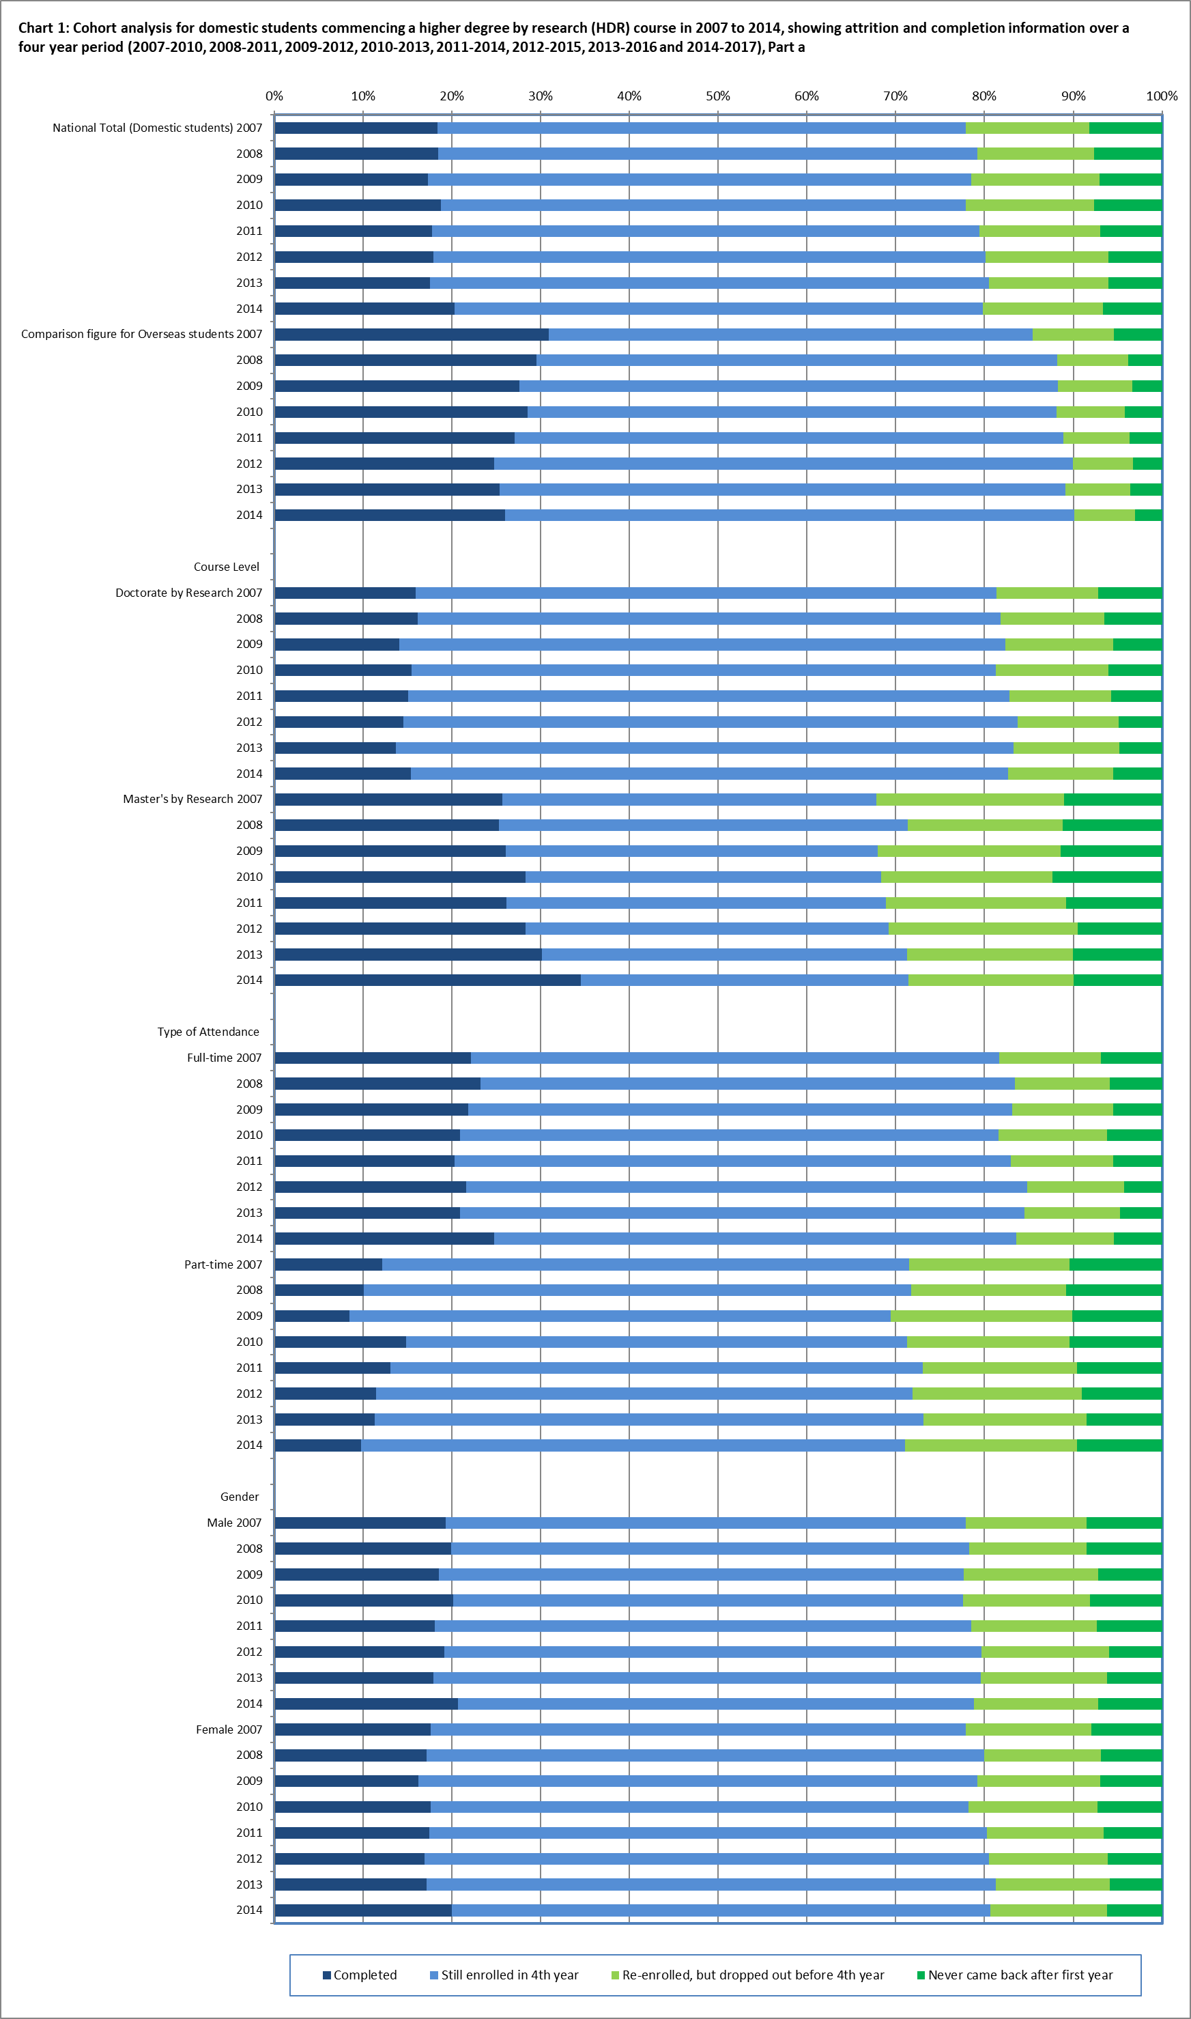

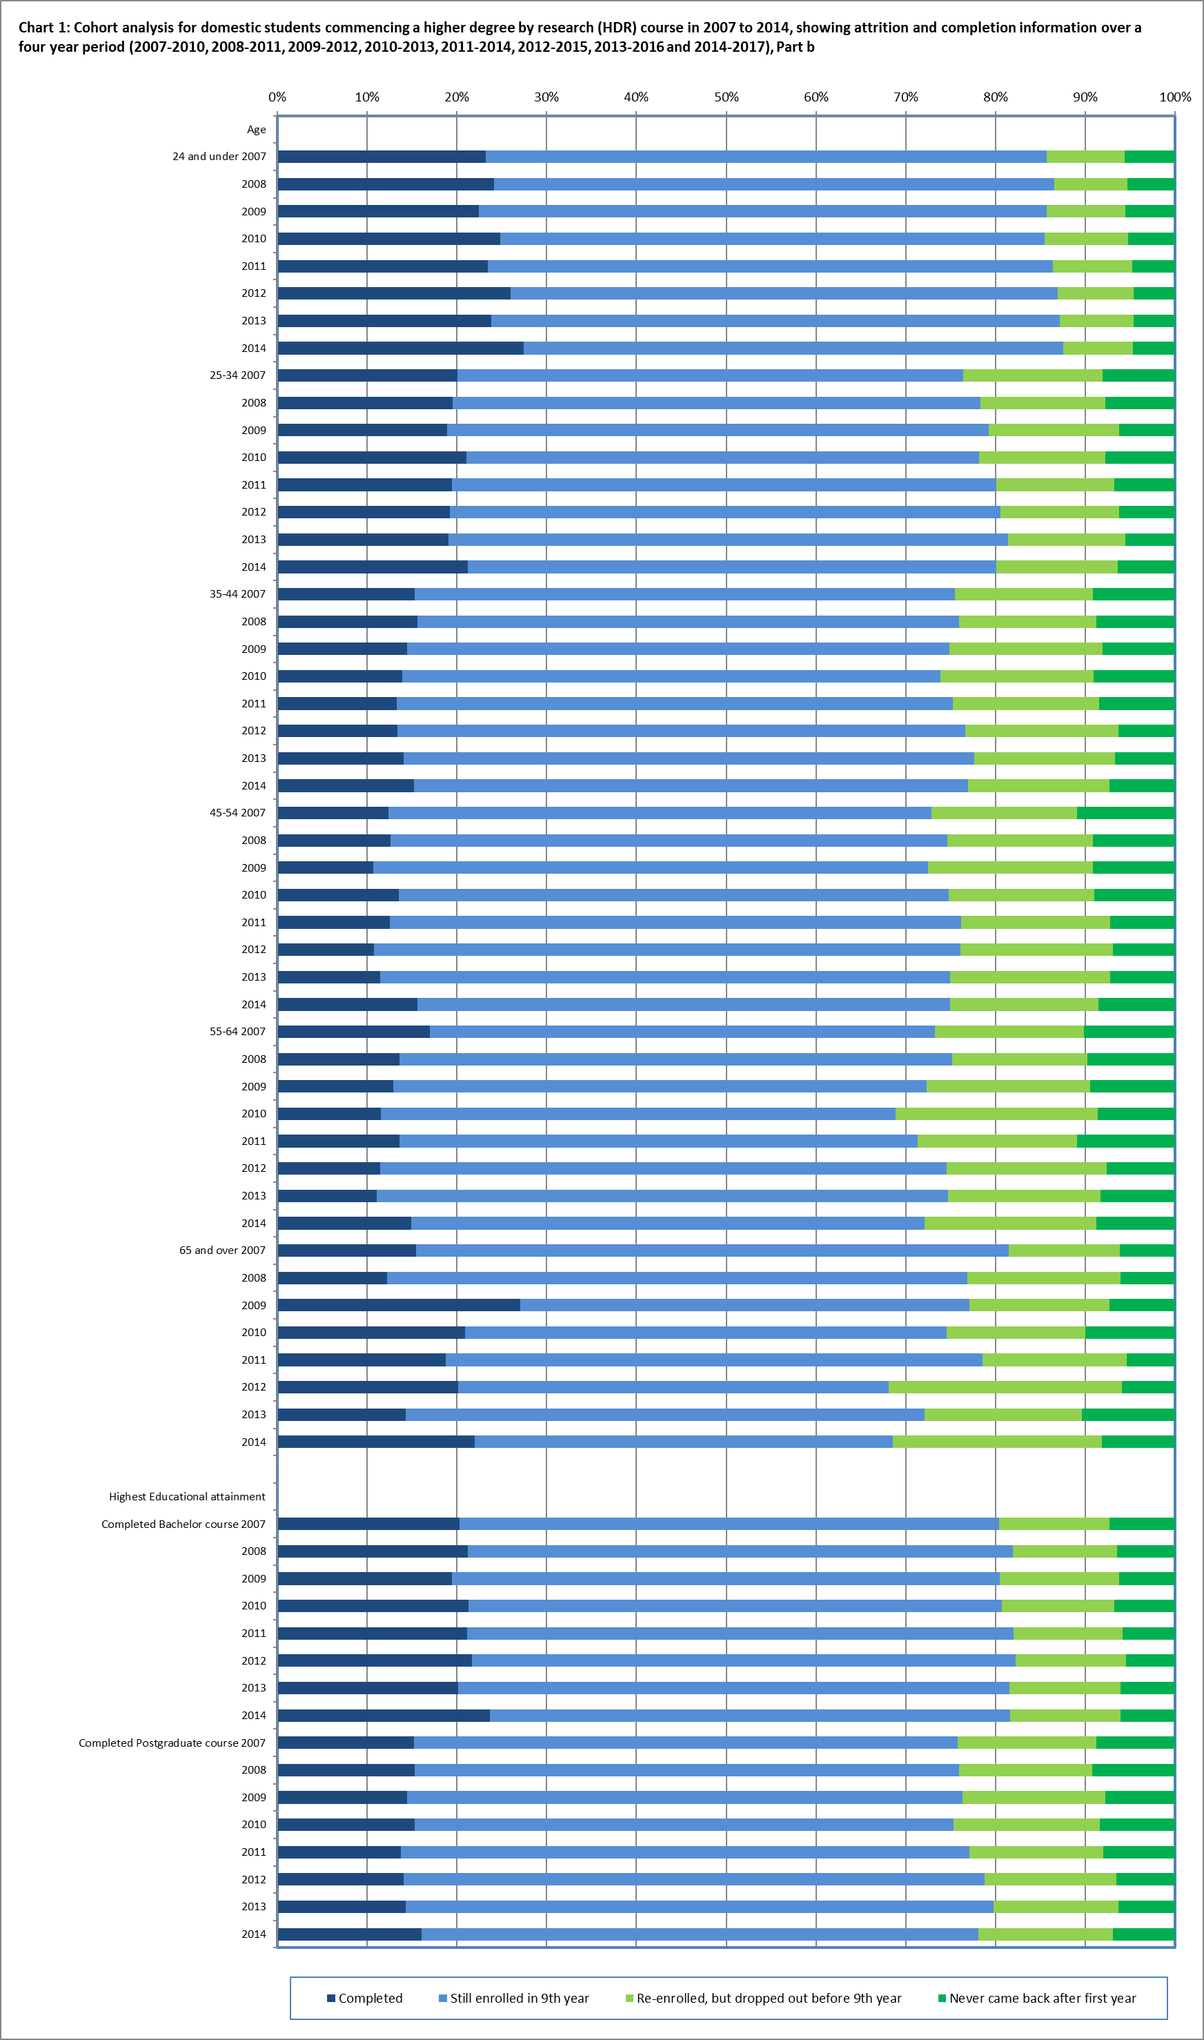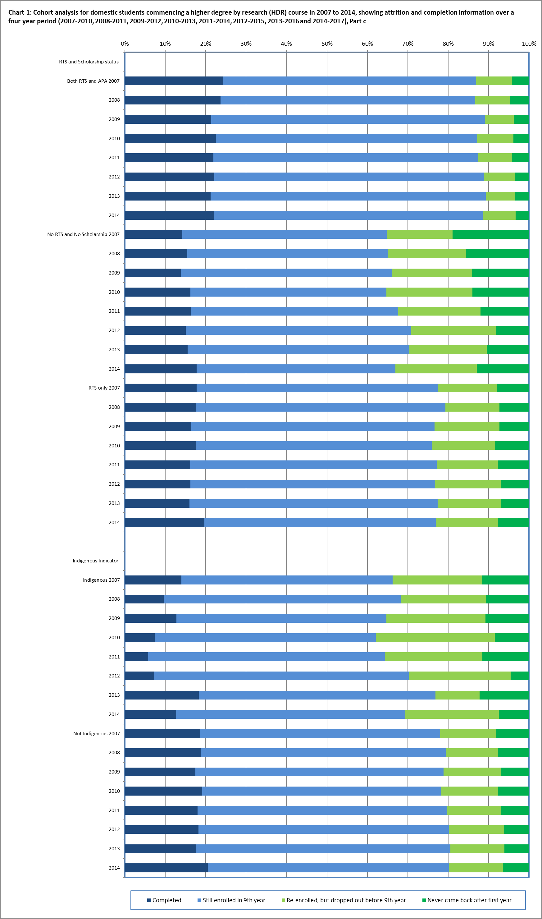

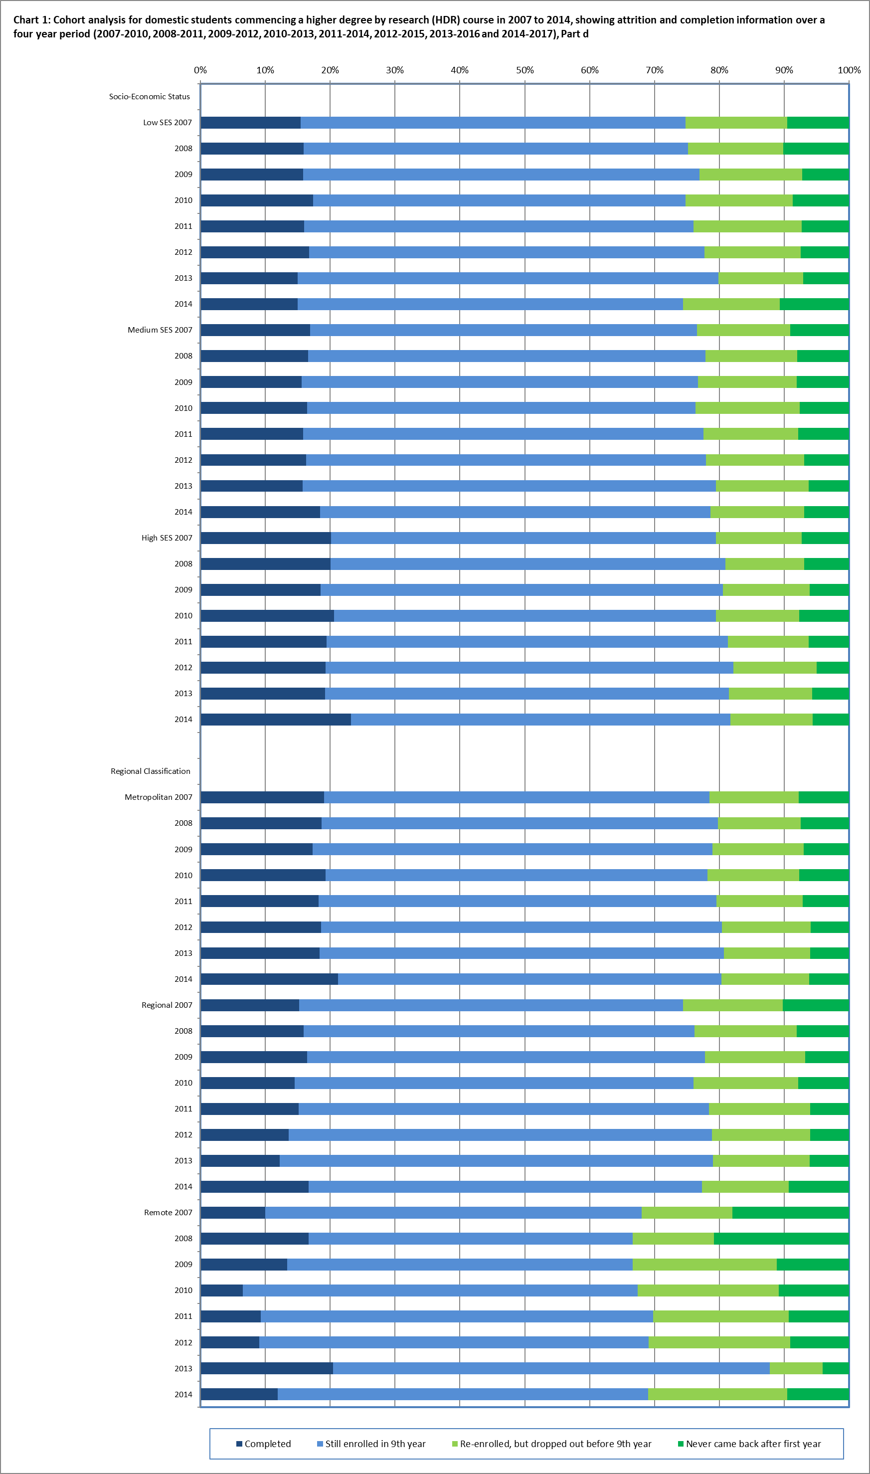

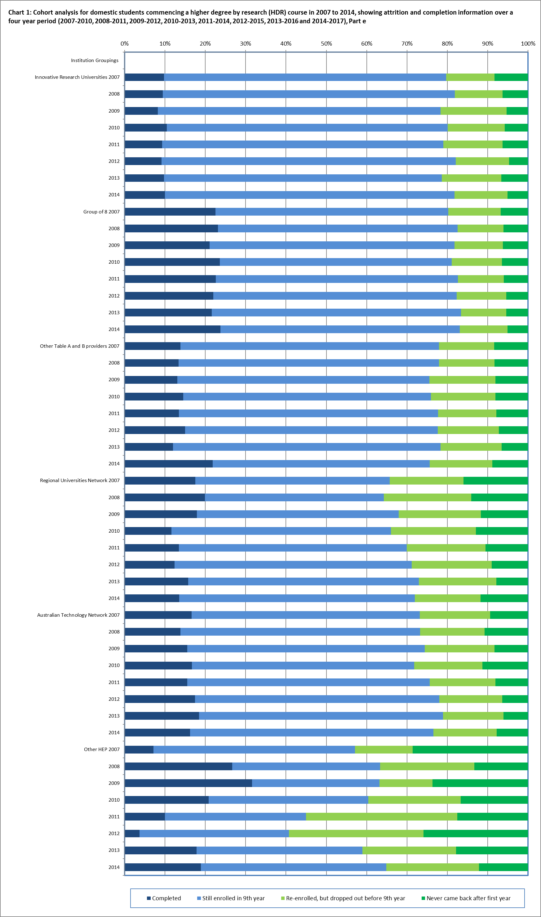

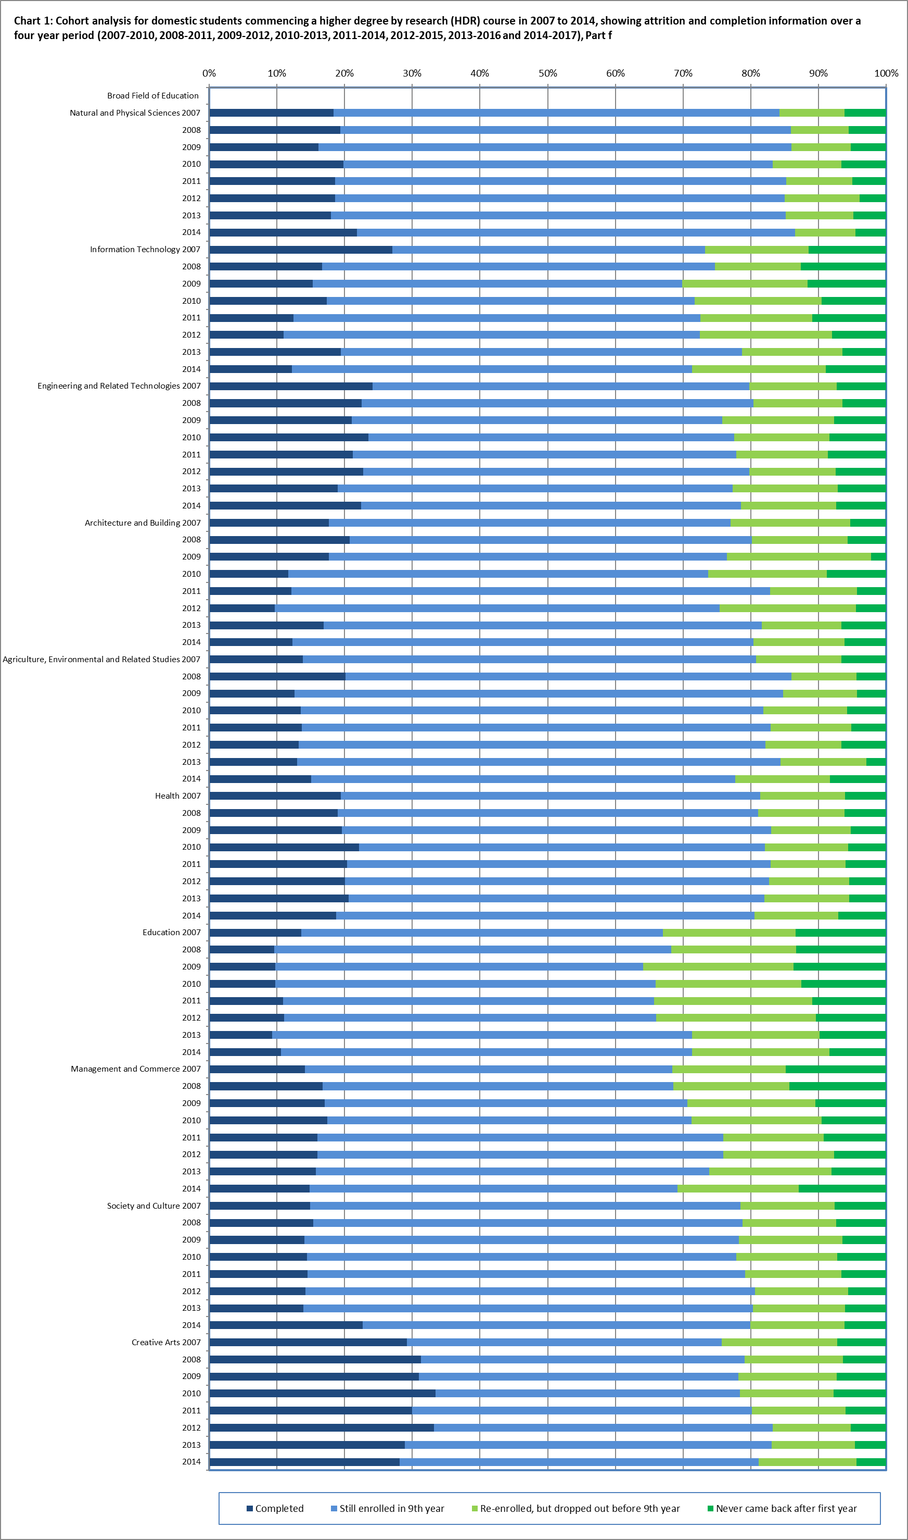

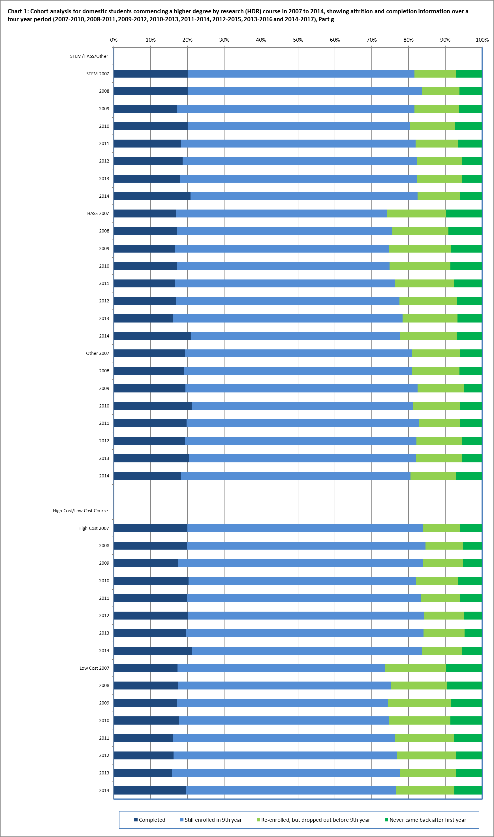

**Table 2: Cohort analysis for domestic students commencing a higher degree by research (HDR) course in 2007 to 2012 over a six year period, 2007-2010, 2008-2011, 2009-2012, 2010-2013, 2011‑2014, 2012-2015, 2013-2016 and 2014-2017**

|  |  |  |  |  |  |
| --- | --- | --- | --- | --- | --- |
|  | **Cohort group** | **Completed (in any year)** | **Still enrolled at the end of the 6 year cohort period** | **Re-enrolled, but dropped out** | **Never came back after the first year** |
| National Total  (Domestic students) | 2007 | 44.5% | 25.5% | 21.9% | 8.1% |
| 2008 | 46.9% | 23.7% | 21.9% | 7.5% |
| 2009 | 46.5% | 23.5% | 23.1% | 6.9% |
| 2010 | 46.7% | 23.2% | 22.6% | 7.5% |
| 2011 | 47.4% | 23.8% | 22.0% | 6.8% |
| 2012 | 48.3% | 24.3% | 21.6% | 5.9% |
| Comparison figure for Overseas students | 2007 | 70.3% | 9.4% | 14.9% | 5.4% |
| 2008 | 73.0% | 9.6% | 13.6% | 3.8% |
| 2009 | 72.0% | 9.1% | 15.5% | 3.3% |
| 2010 | 73.6% | 9.4% | 12.8% | 4.2% |
| 2011 | 74.3% | 9.4% | 12.6% | 3.7% |
| 2012 | 76.3% | 8.4% | 12.0% | 3.2% |
| **Course Level** |  |  |  |  |  |
| Doctorate by Research | 2007 | 45.2% | 28.6% | 19.1% | 7.1% |
| 2008 | 47.6% | 26.0% | 20.1% | 6.3% |
| 2009 | 47.3% | 26.4% | 20.9% | 5.3% |
| 2010 | 46.8% | 26.2% | 21.0% | 5.9% |
| 2011 | 48.2% | 26.3% | 19.9% | 5.6% |
| 2012 | 49.1% | 27.0% | 19.0% | 4.8% |
| Master's by Research | 2007 | 42.4% | 16.5% | 30.1% | 11.0% |
| 2008 | 44.7% | 16.9% | 27.5% | 11.0% |
| 2009 | 44.1% | 15.5% | 29.3% | 11.1% |
| 2010 | 46.1% | 14.8% | 26.9% | 12.2% |
| 2011 | 45.0% | 16.0% | 28.6% | 10.5% |
| 2012 | 45.7% | 15.8% | 29.2% | 9.4% |
| **Type of attendance** |  |  |  |  |  |
| Full-time | 2007 | 54.5% | 20.0% | 18.7% | 6.8% |
| 2008 | 57.3% | 18.3% | 18.7% | 5.7% |
| 2009 | 57.1% | 18.0% | 19.6% | 5.4% |
| 2010 | 54.4% | 19.2% | 20.4% | 6.1% |
| 2011 | 56.3% | 18.9% | 19.4% | 5.3% |
| 2012 | 59.0% | 18.7% | 18.0% | 4.2% |
| Part-time | 2007 | 27.5% | 34.8% | 27.3% | 10.3% |
| 2008 | 28.7% | 33.3% | 27.5% | 10.5% |
| 2009 | 25.9% | 34.2% | 30.1% | 9.8% |
| 2010 | 32.5% | 30.6% | 26.7% | 10.2% |
| 2011 | 31.2% | 32.7% | 26.7% | 9.4% |
| 2012 | 29.5% | 33.9% | 27.7% | 8.9% |

|  |  |  |  |  |  |
| --- | --- | --- | --- | --- | --- |
|  | **Cohort group** | **Completed (in any year)** | **Still enrolled at the end of the 6 year cohort period** | **Re-enrolled, but dropped out** | **Never came back after the first year** |
| **Gender** |  |  |  |  |  |
| Males | 2007 | 44.4% | 24.2% | 23.0% | 8.4% |
| 2008 | 46.5% | 22.3% | 22.8% | 8.3% |
| 2009 | 46.2% | 22.1% | 24.6% | 7.1% |
| 2010 | 46.9% | 21.8% | 23.4% | 8.0% |
| 2011 | 47.2% | 22.0% | 23.6% | 7.2% |
| 2012 | 48.8% | 22.5% | 22.8% | 5.8% |
| Females | 2007 | 44.5% | 26.6% | 21.0% | 7.9% |
| 2008 | 47.1% | 25.0% | 21.1% | 6.8% |
| 2009 | 46.7% | 24.8% | 21.8% | 6.7% |
| 2010 | 46.4% | 24.5% | 21.9% | 7.1% |
| 2011 | 47.6% | 25.4% | 20.6% | 6.4% |
| 2012 | 47.8% | 25.6% | 20.5% | 6.0% |
| **Age** |  |  |  |  |  |
| 24 and under | 2007 | 62.4% | 16.2% | 15.8% | 5.6% |
| 2008 | 65.6% | 14.1% | 15.0% | 5.3% |
| 2009 | 64.3% | 14.2% | 16.1% | 5.4% |
| 2010 | 64.3% | 13.7% | 16.9% | 5.1% |
| 2011 | 66.4% | 14.2% | 14.7% | 4.7% |
| 2012 | 67.6% | 14.0% | 14.0% | 4.4% |
| 25-34 | 2007 | 45.9% | 23.5% | 22.7% | 8.0% |
| 2008 | 47.6% | 22.6% | 22.2% | 7.6% |
| 2009 | 48.6% | 22.3% | 23.0% | 6.1% |
| 2010 | 49.7% | 20.8% | 22.0% | 7.5% |
| 2011 | 49.7% | 22.5% | 21.2% | 6.6% |
| 2012 | 50.9% | 22.2% | 20.7% | 6.2% |
| 35-44 | 2007 | 35.2% | 31.1% | 24.6% | 9.1% |
| 2008 | 36.8% | 29.1% | 25.6% | 8.6% |
| 2009 | 37.3% | 28.5% | 26.5% | 7.7% |
| 2010 | 36.8% | 28.4% | 25.9% | 8.9% |
| 2011 | 37.1% | 28.9% | 25.8% | 8.2% |
| 2012 | 36.3% | 31.1% | 26.3% | 6.3% |
| 45-54 | 2007 | 30.0% | 34.3% | 25.1% | 10.7% |
| 2008 | 33.4% | 31.3% | 26.3% | 9.0% |
| 2009 | 31.1% | 31.6% | 28.4% | 8.9% |
| 2010 | 31.7% | 35.1% | 24.3% | 8.8% |
| 2011 | 32.6% | 33.0% | 27.4% | 7.0% |
| 2012 | 33.9% | 33.3% | 26.2% | 6.7% |

|  |  |  |  |  |  |
| --- | --- | --- | --- | --- | --- |
|  | **Cohort group** | **Completed (in any year)** | **Still enrolled at the end of the 6 year cohort period** | **Re-enrolled, but dropped out** | **Never came back after the first year** |
| **Age continued…** |  |  |  |  |  |
| 55-64 | 2007 | 31.1% | 31.8% | 26.9% | 10.2% |
| 2008 | 32.7% | 32.9% | 25.3% | 9.1% |
| 2009 | 33.0% | 30.9% | 26.8% | 9.2% |
| 2010 | 30.2% | 27.9% | 33.3% | 8.6% |
| 2011 | 33.0% | 28.3% | 27.9% | 10.7% |
| 2012 | 34.1% | 31.8% | 26.5% | 7.6% |
| 65 and over | 2007 | 37.1% | 38.1% | 18.6% | 6.2% |
| 2008 | 30.5% | 35.4% | 28.0% | 6.1% |
| 2009 | 41.7% | 21.9% | 29.2% | 7.3% |
| 2010 | 42.7% | 25.5% | 21.8% | 10.0% |
| 2011 | 43.8% | 27.7% | 23.2% | 5.4% |
| 2012 | 40.3% | 21.8% | 31.9% | 5.9% |
| **Highest Educational attainment** | | | | | |
| Completed Bachelor course | 2007 | 51.0% | 21.3% | 20.5% | 7.2% |
| 2008 | 53.7% | 19.7% | 20.3% | 6.3% |
| 2009 | 52.4% | 19.6% | 21.9% | 6.1% |
| 2010 | 53.4% | 19.5% | 20.5% | 6.7% |
| 2011 | 54.3% | 19.9% | 20.1% | 5.7% |
| 2012 | 55.8% | 19.2% | 19.6% | 5.4% |
| Completed Postgraduate course | 2007 | 36.7% | 31.6% | 23.0% | 8.6% |
| 2008 | 39.5% | 27.7% | 23.9% | 8.9% |
| 2009 | 39.4% | 28.5% | 24.5% | 7.6% |
| 2010 | 39.5% | 27.8% | 24.6% | 8.2% |
| 2011 | 40.1% | 28.3% | 23.7% | 7.8% |
| 2012 | 41.2% | 29.9% | 22.5% | 6.4% |
| **RTS and Scholarship** |  |  |  |  |  |
| Both RTS and APA | 2007 | 61.7% | 18.9% | 15.2% | 4.2% |
| 2008 | 63.9% | 15.7% | 15.8% | 4.7% |
| 2009 | 65.1% | 16.6% | 14.6% | 3.7% |
| 2010 | 63.2% | 16.5% | 16.5% | 3.8% |
| 2011 | 63.4% | 17.8% | 14.6% | 4.2% |
| 2012 | 65.4% | 17.1% | 14.0% | 3.4% |
| No RTS and No Scholarship | 2007 | 28.7% | 27.4% | 25.0% | 18.9% |
| 2008 | 30.3% | 27.6% | 26.8% | 15.3% |
| 2009 | 32.5% | 26.9% | 27.2% | 13.4% |
| 2010 | 30.2% | 27.6% | 28.7% | 13.5% |
| 2011 | 32.5% | 25.8% | 29.9% | 11.8% |
| 2012 | 33.2% | 30.7% | 27.9% | 8.2% |

|  |  |  |  |  |  |
| --- | --- | --- | --- | --- | --- |
|  | **Cohort group** | **Completed (in any year)** | **Still enrolled at the end of the 6 year cohort period** | **Re-enrolled, but dropped out** | **Never came back after the first year** |
| **RTS and Scholarship continued…** | | | | | |
| RTS only | 2007 | 42.7% | 26.6% | 22.9% | 7.7% |
| 2008 | 45.1% | 25.1% | 22.7% | 7.1% |
| 2009 | 42.2% | 25.3% | 25.4% | 7.1% |
| 2010 | 42.0% | 25.4% | 24.3% | 8.2% |
| 2011 | 42.1% | 26.2% | 24.3% | 7.4% |
| 2012 | 41.5% | 27.0% | 24.5% | 6.9% |
| **Indigenous Indicator** |  |  |  |  |  |
| Indigenous | 2007 | 26.7% | 31.4% | 30.2% | 11.6% |
| 2008 | 29.8% | 27.9% | 31.7% | 10.6% |
| 2009 | 21.6% | 29.4% | 39.2% | 9.8% |
| 2010 | 20.0% | 30.5% | 41.1% | 8.4% |
| 2011 | 19.5% | 35.6% | 34.5% | 10.3% |
| 2012 | 30.6% | 33.3% | 32.4% | 3.6% |
| Not Indigenous | 2007 | 44.8% | 25.4% | 21.8% | 8.0% |
| 2008 | 47.3% | 23.6% | 21.7% | 7.4% |
| 2009 | 47.0% | 23.4% | 22.8% | 6.8% |
| 2010 | 47.4% | 23.0% | 22.2% | 7.5% |
| 2011 | 47.9% | 23.7% | 21.7% | 6.7% |
| 2012 | 48.7% | 24.0% | 21.3% | 6.0% |
| **Socio-Economic Status** |  |  |  |  |  |
| Low SES | 2007 | 41.6% | 26.5% | 22.4% | 9.5% |
| 2008 | 41.1% | 23.9% | 24.8% | 10.2% |
| 2009 | 44.8% | 22.4% | 25.7% | 7.1% |
| 2010 | 42.4% | 23.3% | 25.7% | 8.6% |
| 2011 | 43.7% | 22.5% | 26.5% | 7.3% |
| 2012 | 46.8% | 24.2% | 21.6% | 7.3% |
| Medium SES | 2007 | 41.0% | 26.7% | 23.3% | 9.0% |
| 2008 | 43.9% | 25.2% | 23.1% | 7.8% |
| 2009 | 43.3% | 24.6% | 24.2% | 7.9% |
| 2010 | 43.5% | 24.3% | 24.8% | 7.4% |
| 2011 | 44.4% | 25.2% | 22.7% | 7.7% |
| 2012 | 45.1% | 25.7% | 22.3% | 6.8% |
| High SES | 2007 | 47.6% | 24.5% | 20.8% | 7.2% |
| 2008 | 49.6% | 23.0% | 20.7% | 6.7% |
| 2009 | 48.7% | 23.6% | 21.9% | 5.9% |
| 2010 | 49.0% | 22.8% | 20.7% | 7.5% |
| 2011 | 50.0% | 23.2% | 20.8% | 6.0% |
| 2012 | 50.5% | 23.6% | 21.0% | 4.9% |

|  |  |  |  |  |  |
| --- | --- | --- | --- | --- | --- |
|  | **Cohort group** | **Completed (in any year)** | **Still enrolled at the end of the 6 year cohort period** | **Re-enrolled, but dropped out** | **Never came back after the first year** |
| **Regional Classification** |  |  |  |  |  |
| Metropolitan | 2007 | 45.7% | 25.1% | 21.5% | 7.7% |
| 2008 | 48.0% | 23.4% | 21.3% | 7.3% |
| 2009 | 47.2% | 23.3% | 22.7% | 6.8% |
| 2010 | 47.6% | 22.9% | 21.9% | 7.5% |
| 2011 | 48.2% | 23.4% | 21.5% | 6.9% |
| 2012 | 48.7% | 24.1% | 21.4% | 5.9% |
| Regional | 2007 | 37.1% | 28.1% | 24.5% | 10.2% |
| 2008 | 37.8% | 28.1% | 26.1% | 7.8% |
| 2009 | 40.2% | 27.2% | 26.1% | 6.5% |
| 2010 | 37.8% | 26.8% | 27.7% | 7.8% |
| 2011 | 41.9% | 27.4% | 24.8% | 5.9% |
| 2012 | 44.2% | 27.1% | 22.7% | 5.9% |
| Remote | 2007 | 30.6% | 28.6% | 24.5% | 18.4% |
| 2008 | 31.9% | 23.4% | 23.4% | 21.3% |
| 2009 | 35.6% | 26.7% | 26.7% | 11.1% |
| 2010 | 23.4% | 36.2% | 29.8% | 10.6% |
| 2011 | 31.8% | 20.5% | 38.6% | 9.1% |
| 2012 | 35.7% | 30.4% | 23.2% | 8.9% |
| **Institution Groupings** |  |  |  |  |  |
| Innovative Research Universities | 2007 | 37.6% | 35.4% | 18.7% | 8.3% |
| 2008 | 35.7% | 34.1% | 24.0% | 6.2% |
| 2009 | 36.6% | 32.3% | 26.0% | 5.1% |
| 2010 | 37.8% | 30.2% | 26.3% | 5.7% |
| 2011 | 37.6% | 30.2% | 25.9% | 6.3% |
| 2012 | 40.8% | 32.1% | 22.5% | 4.6% |
| Group of Eight | 2007 | 51.5% | 20.4% | 21.3% | 6.7% |
| 2008 | 54.8% | 19.4% | 20.0% | 5.9% |
| 2009 | 53.3% | 19.3% | 21.3% | 6.1% |
| 2010 | 54.4% | 19.0% | 20.4% | 6.3% |
| 2011 | 55.3% | 20.0% | 18.9% | 5.9% |
| 2012 | 54.7% | 20.6% | 19.4% | 5.3% |
| Other Table A and B institutions | 2007 | 36.4% | 34.8% | 20.6% | 8.2% |
| 2008 | 40.0% | 29.8% | 21.9% | 8.3% |
| 2009 | 41.0% | 27.5% | 23.6% | 7.8% |
| 2010 | 41.0% | 28.0% | 23.0% | 8.0% |
| 2011 | 42.1% | 29.7% | 20.8% | 7.4% |
| 2012 | 42.6% | 27.9% | 22.4% | 7.1% |

|  |  |  |  |  |  |
| --- | --- | --- | --- | --- | --- |
|  | **Cohort group** | **Completed (in any year)** | **Still enrolled at the end of the 6 year cohort period** | **Re-enrolled, but dropped out** | **Never came back after the first year** |
| **Institution Groupings continued…** | |  |  |  |  |
| Regional Universities Network | 2007 | 34.4% | 20.3% | 29.3% | 16.0% |
| 2008 | 36.6% | 20.6% | 29.2% | 13.6% |
| 2009 | 33.1% | 27.6% | 28.6% | 10.7% |
| 2010 | 29.2% | 27.6% | 30.7% | 12.5% |
| 2011 | 33.3% | 23.2% | 33.7% | 9.8% |
| 2012 | 35.4% | 27.5% | 28.6% | 8.6% |
| Australian Technology Network | 2007 | 38.7% | 26.8% | 25.1% | 9.3% |
| 2008 | 40.2% | 25.1% | 24.2% | 10.6% |
| 2009 | 40.6% | 25.8% | 25.4% | 8.2% |
| 2010 | 40.6% | 24.1% | 24.4% | 10.9% |
| 2011 | 41.5% | 24.4% | 26.1% | 8.0% |
| 2012 | 45.2% | 24.5% | 24.1% | 6.2% |
| Other higher education Institutions | 2007 | 21.4% | 28.6% | 21.4% | 28.6% |
| 2008 | 30.0% | 26.7% | 30.0% | 13.3% |
| 2009 | 42.1% | 13.2% | 21.1% | 23.7% |
| 2010 | 27.1% | 33.3% | 22.9% | 16.7% |
| 2011 | 15.0% | 15.0% | 52.5% | 17.5% |
| 2012 | 7.4% | 22.2% | 44.4% | 25.9% |
| **Broad Field of Education** |  |  |  |  |  |
| Natural and Physical Sciences | 2007 | 57.6% | 19.6% | 16.7% | 6.1% |
| 2008 | 58.9% | 19.0% | 16.6% | 5.5% |
| 2009 | 56.8% | 20.5% | 17.6% | 5.2% |
| 2010 | 59.4% | 16.6% | 17.6% | 6.4% |
| 2011 | 57.7% | 19.2% | 18.1% | 4.9% |
| 2012 | 58.5% | 20.4% | 17.2% | 3.9% |
| Information Technology | 2007 | 44.4% | 18.8% | 25.3% | 11.5% |
| 2008 | 40.9% | 24.2% | 22.2% | 12.6% |
| 2009 | 34.7% | 21.8% | 31.9% | 11.6% |
| 2010 | 43.5% | 20.4% | 26.5% | 9.6% |
| 2011 | 39.4% | 24.4% | 25.4% | 10.9% |
| 2012 | 37.5% | 22.5% | 32.0% | 8.0% |
| Engineering and Related Technologies | 2007 | 51.8% | 18.7% | 22.2% | 7.3% |
| 2008 | 52.4% | 18.2% | 22.9% | 6.4% |
| 2009 | 50.9% | 16.3% | 25.3% | 7.5% |
| 2010 | 52.2% | 18.0% | 21.4% | 8.4% |
| 2011 | 52.3% | 16.9% | 22.3% | 8.6% |
| 2012 | 52.3% | 19.1% | 21.2% | 7.5% |

|  |  |  |  |  |  |
| --- | --- | --- | --- | --- | --- |
|  | **Cohort group** | **Completed (in any year)** | **Still enrolled at the end of the 6 year cohort period** | **Re-enrolled, but dropped out** | **Never came back after the first year** |
| **Broad Field of Education continued…** | |  |  |  |  |
| Architecture and Building | 2007 | 35.4% | 33.6% | 25.7% | 5.3% |
| 2008 | 42.5% | 30.2% | 21.7% | 5.7% |
| 2009 | 41.9% | 27.2% | 28.7% | 2.2% |
| 2010 | 35.8% | 28.5% | 27.7% | 8.0% |
| 2011 | 46.4% | 25.7% | 23.6% | 4.3% |
| 2012 | 31.3% | 35.8% | 28.4% | 4.5% |
| Agriculture, Environmental and Related Studies | 2007 | 48.7% | 24.2% | 20.4% | 6.6% |
| 2008 | 52.8% | 22.7% | 20.1% | 4.4% |
| 2009 | 46.0% | 27.5% | 22.2% | 4.3% |
| 2010 | 45.2% | 24.8% | 24.2% | 5.8% |
| 2011 | 51.9% | 21.1% | 21.9% | 5.1% |
| 2012 | 55.4% | 16.8% | 21.1% | 6.6% |
| Health | 2007 | 50.6% | 24.1% | 19.4% | 5.9% |
| 2008 | 51.9% | 20.9% | 21.2% | 6.0% |
| 2009 | 52.1% | 23.8% | 19.1% | 5.0% |
| 2010 | 52.2% | 22.5% | 19.9% | 5.5% |
| 2011 | 53.4% | 23.7% | 17.1% | 5.8% |
| 2012 | 50.7% | 24.6% | 19.4% | 5.4% |
| Education | 2007 | 27.6% | 30.9% | 28.2% | 13.2% |
| 2008 | 28.8% | 31.5% | 26.8% | 12.9% |
| 2009 | 26.6% | 29.2% | 30.8% | 13.4% |
| 2010 | 25.4% | 32.2% | 30.0% | 12.4% |
| 2011 | 26.8% | 29.0% | 33.3% | 10.9% |
| 2012 | 30.2% | 28.1% | 31.5% | 10.3% |
| Management and Commerce | 2007 | 29.0% | 29.3% | 26.9% | 14.8% |
| 2008 | 38.0% | 24.7% | 23.4% | 13.9% |
| 2009 | 39.0% | 24.9% | 25.9% | 10.3% |
| 2010 | 39.0% | 24.1% | 27.8% | 9.1% |
| 2011 | 38.8% | 29.2% | 23.1% | 8.9% |
| 2012 | 42.0% | 25.0% | 25.4% | 7.5% |
| Society and Culture | 2007 | 37.9% | 32.2% | 22.5% | 7.5% |
| 2008 | 40.1% | 29.1% | 23.7% | 7.1% |
| 2009 | 41.0% | 27.6% | 25.3% | 6.1% |
| 2010 | 40.1% | 28.9% | 24.0% | 7.0% |
| 2011 | 41.4% | 29.0% | 23.2% | 6.3% |
| 2012 | 43.3% | 29.1% | 22.2% | 5.4% |
| Creative Arts | 2007 | 49.2% | 20.9% | 22.8% | 7.1% |
| 2008 | 53.6% | 18.0% | 22.3% | 6.2% |
| 2009 | 54.5% | 17.4% | 20.7% | 7.3% |
| 2010 | 55.6% | 16.2% | 20.7% | 7.6% |
| 2011 | 56.1% | 15.6% | 22.4% | 5.9% |
| 2012 | 59.2% | 19.0% | 16.7% | 5.1% |
|  | **Cohort group** | **Completed (in any year)** | **Still enrolled at the end of the 6 year cohort period** | **Re-enrolled, but dropped out** | **Never came back after the first year** |
| STEM | 2007 | 53.9% | 19.8% | 19.4% | 7.0% |
| 2008 | 55.1% | 19.7% | 19.1% | 6.1% |
| 2009 | 52.3% | 20.0% | 21.4% | 6.2% |
| 2010 | 54.5% | 18.2% | 20.2% | 7.2% |
| 2011 | 54.2% | 19.1% | 20.3% | 6.4% |
| 2012 | 55.0% | 19.8% | 19.7% | 5.4% |
| HASS | 2007 | 36.4% | 29.6% | 24.3% | 9.7% |
| 2008 | 40.0% | 27.1% | 24.0% | 8.9% |
| 2009 | 40.6% | 25.7% | 25.5% | 8.1% |
| 2010 | 39.7% | 26.9% | 25.0% | 8.4% |
| 2011 | 40.7% | 26.9% | 24.9% | 7.5% |
| 2012 | 43.1% | 26.8% | 23.5% | 6.6% |
| Other | 2007 | 49.4% | 24.8% | 19.9% | 5.9% |
| 2008 | 51.1% | 21.7% | 21.2% | 6.0% |
| 2009 | 51.2% | 24.1% | 20.0% | 4.8% |
| 2010 | 50.7% | 23.0% | 20.6% | 5.7% |
| 2011 | 52.8% | 23.9% | 17.6% | 5.7% |
| 2012 | 49.3% | 25.4% | 20.0% | 5.3% |
| **High Cost/Low Cost Course** | |  |  |  |  |
| High Cost | 2007 | 55.6% | 20.6% | 18.0% | 5.9% |
| 2008 | 56.3% | 19.6% | 19.0% | 5.2% |
| 2009 | 55.0% | 20.5% | 19.5% | 5.1% |
| 2010 | 55.5% | 18.8% | 19.4% | 6.3% |
| 2011 | 56.3% | 19.4% | 18.4% | 5.8% |
| 2012 | 57.4% | 19.7% | 18.1% | 4.8% |
| Low Cost | 2007 | 36.6% | 29.0% | 24.7% | 9.7% |
| 2008 | 40.0% | 26.8% | 24.0% | 9.2% |
| 2009 | 40.2% | 25.7% | 25.9% | 8.2% |
| 2010 | 39.9% | 26.6% | 25.0% | 8.4% |
| 2011 | 40.7% | 27.2% | 24.7% | 7.5% |
| 2012 | 41.2% | 27.8% | 24.2% | 6.8% |

(a) SES is based on the students' postcode of permanent home residence, with the SES value derived from the 2006 Socio-Economic Indexes for Areas (SEIFA) Education and Occupation Index for postal areas, where postal areas in the bottom 25% of the population aged 15-64 are classified as low SES.

(b) The student’s postcode of permanent home residence is mapped to a regional category using the Ministerial Council on Education, Employment, Training and Youth Affairs (MCEETYA) classification. The MCEETYA codes are derived from the Australian Standard Geographical Classification with some adjustments to cater for Education’s special needs.

(c) Field of Education is based on the Australian Standard Classification of Education (ASCED) 2001.

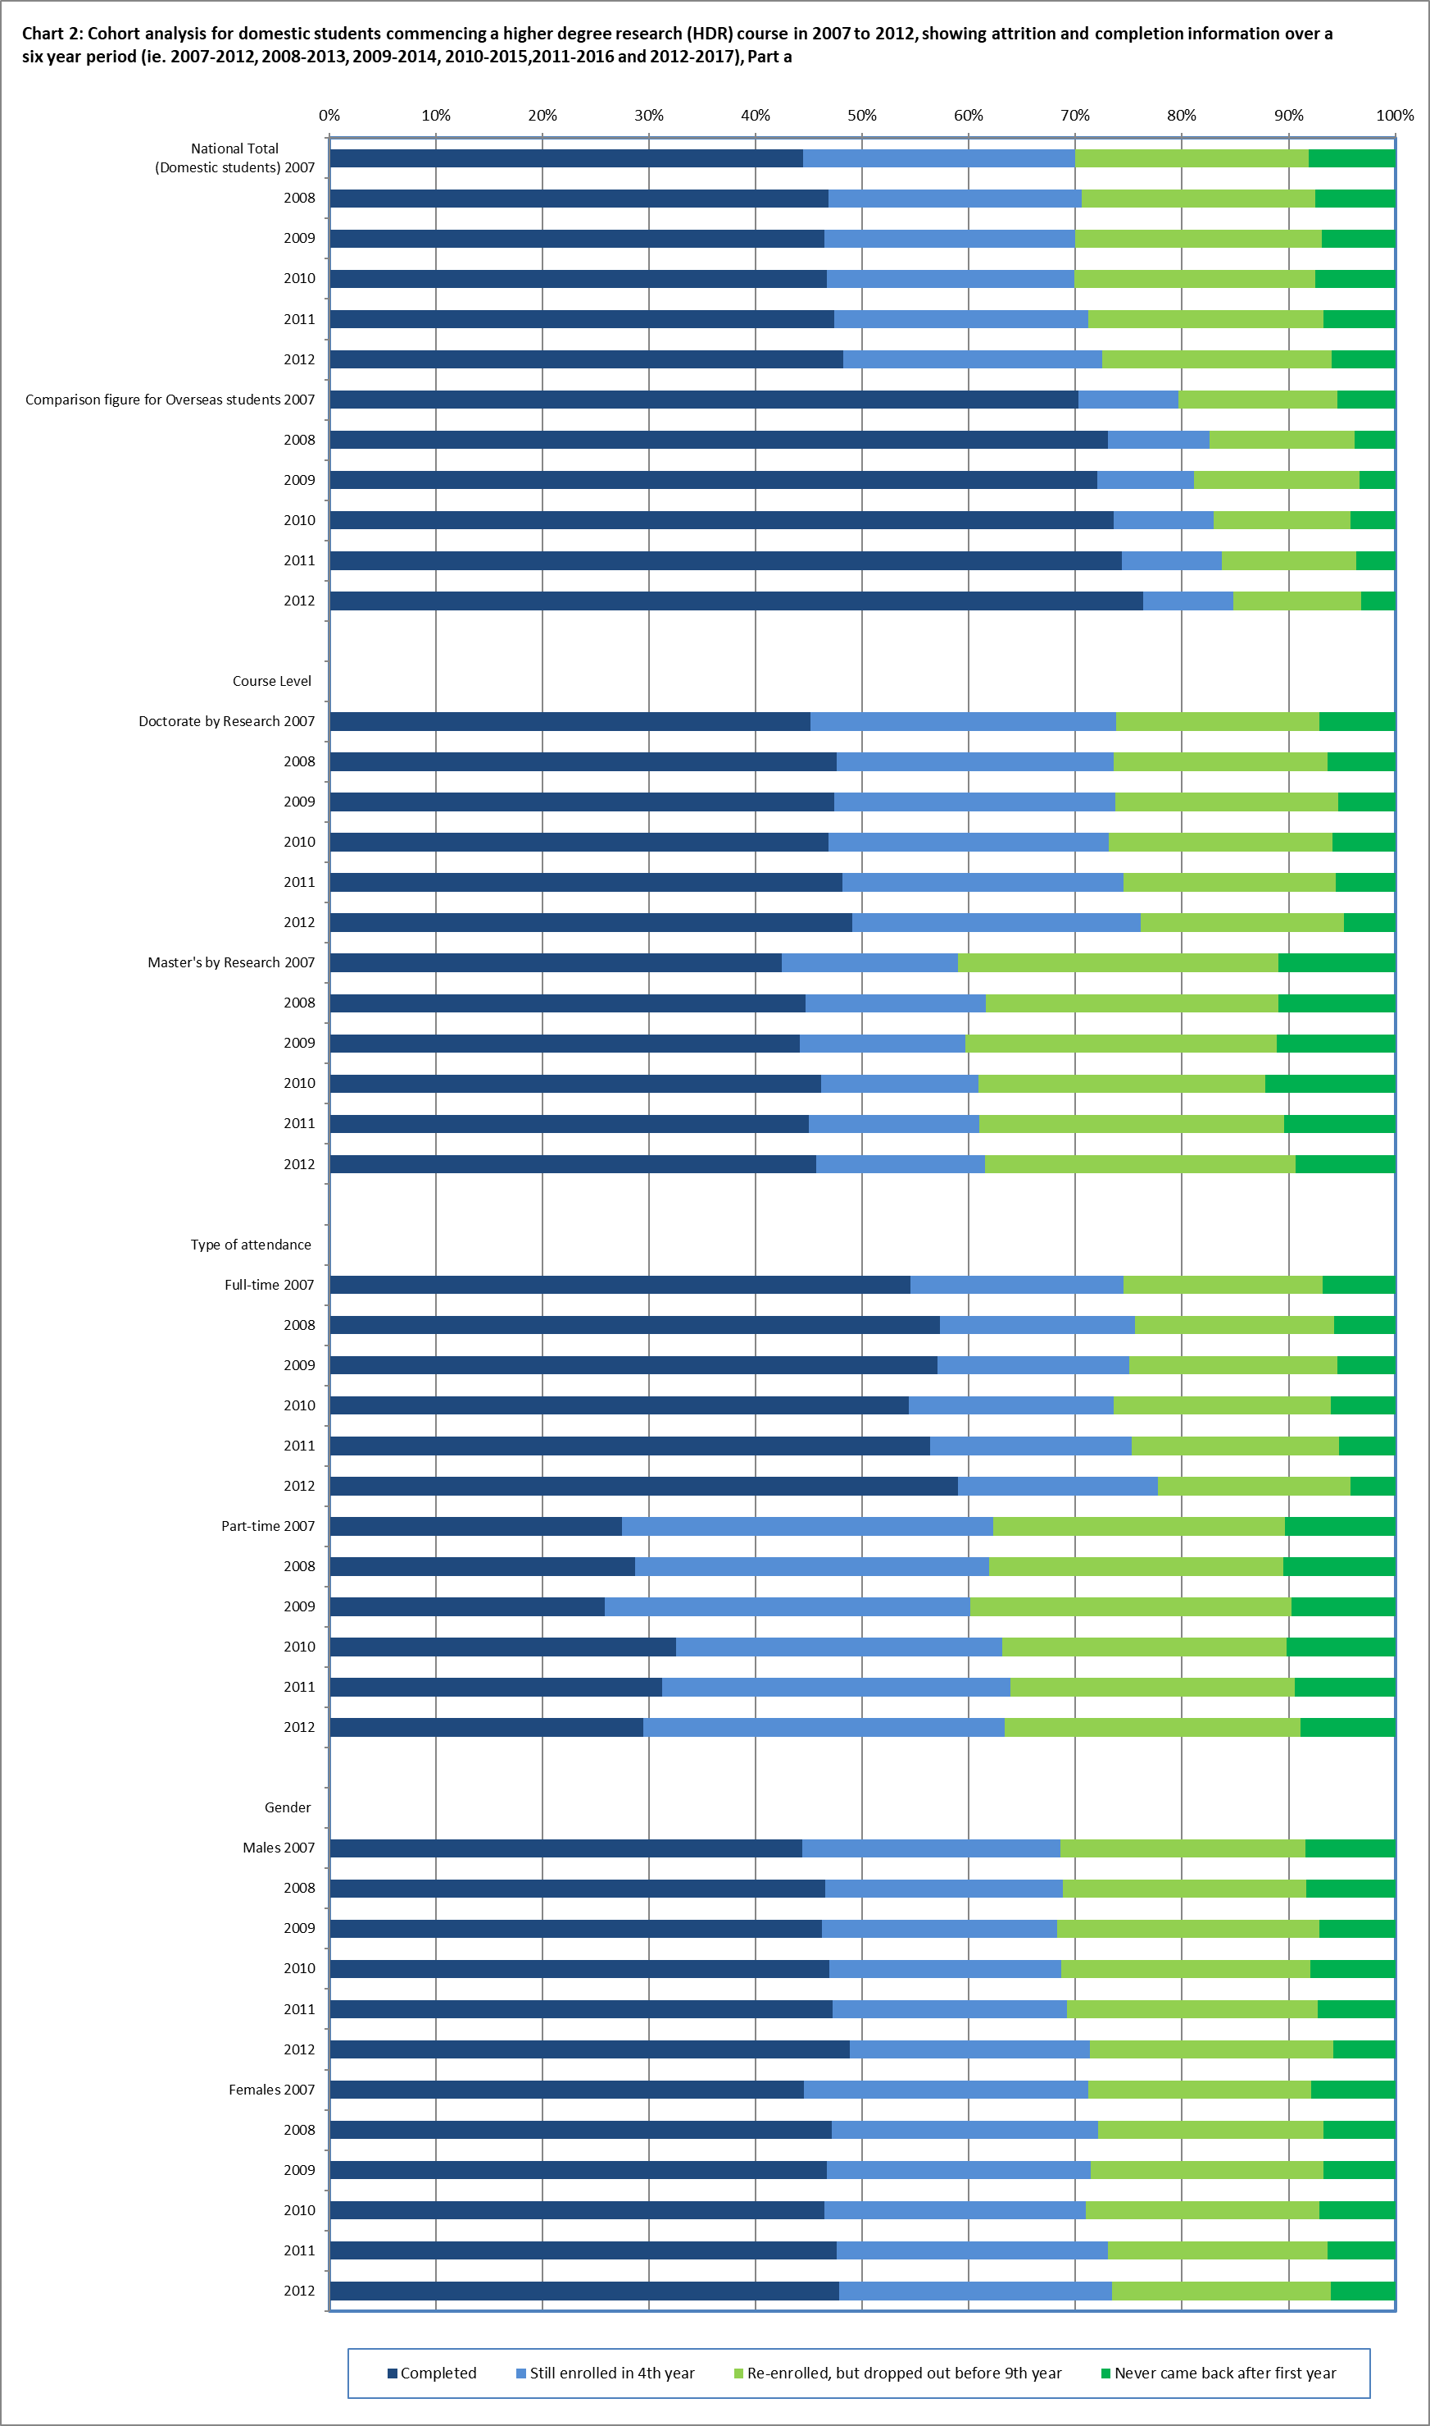

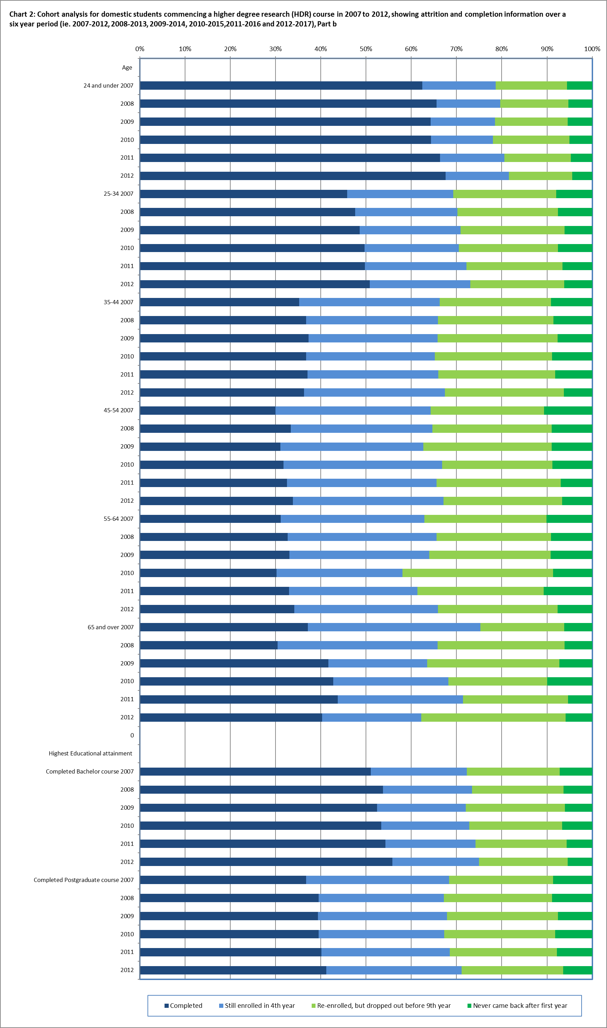

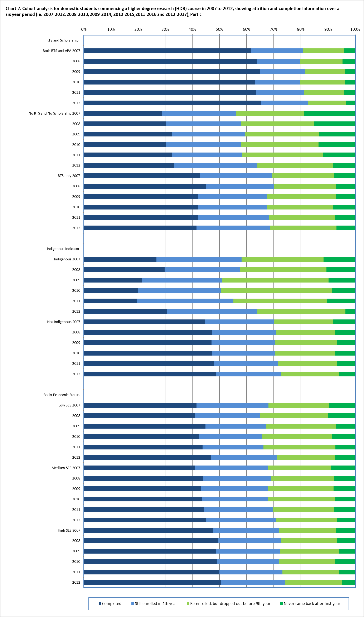

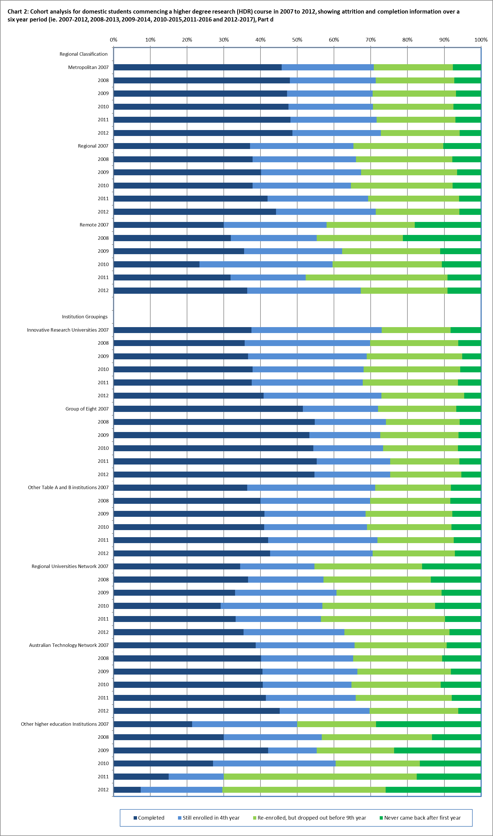

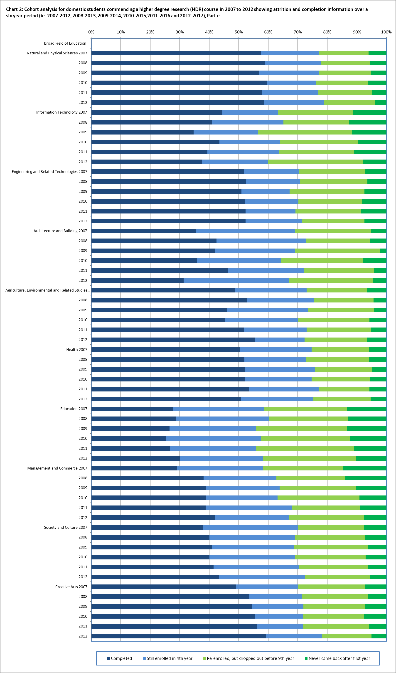

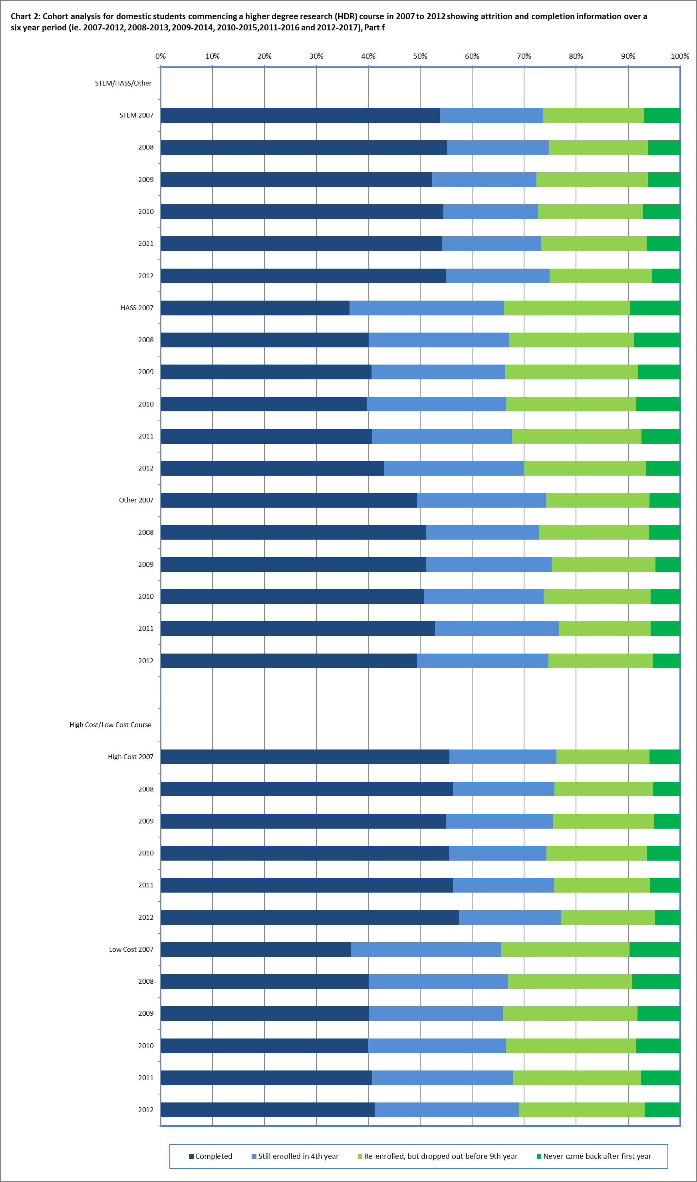

**Table 3: Cohort analysis for domestic students commencing a higher degree by research (HDR) course in 2007 to 2009 over a nine year period, 2007-2015, 2008-2016 and, 2009-2017**

|  |  |  |  |  |  |
| --- | --- | --- | --- | --- | --- |
|  | **Cohort group** | **Completed** | **Still enrolled in the 9th year** | **Re-enrolled, but dropped out** | **Never came back after first year** |
| National Total  (Domestic students) | 2007 | 59.7% | 6.5% | 25.7% | 8.0% |
| 2008 | 61.6% | 6.4% | 24.8% | 7.3% |
| 2009 | 61.6% | 5.6% | 26.0% | 6.8% |
| Comparison figure for Overseas students | 2007 | 78.1% | 1.6% | 14.8% | 5.4% |
| 2008 | 81.2% | 1.3% | 13.7% | 3.8% |
| 2009 | 81.0% | 0.9% | 14.8% | 3.3% |
| **Course Level** |  |  |  |  |  |
| Doctorate by Research | 2007 | 62.2% | 7.2% | 23.5% | 7.0% |
| 2008 | 63.6% | 6.7% | 23.5% | 6.2% |
| 2009 | 64.4% | 6.2% | 24.2% | 5.3% |
| Master's by Research | 2007 | 52.6% | 4.6% | 32.0% | 10.8% |
| 2008 | 55.4% | 5.5% | 28.5% | 10.7% |
| 2009 | 54.1% | 3.8% | 31.2% | 11.0% |
| **Type of Attendance** |  |  |  |  |  |
| Full-time | 2007 | 68.3% | 3.6% | 21.4% | 6.7% |
| 2008 | 70.5% | 3.0% | 20.9% | 5.6% |
| 2009 | 70.6% | 2.9% | 21.2% | 5.4% |
| Part-time | 2007 | 45.4% | 11.5% | 33.0% | 10.1% |
| 2008 | 46.0% | 12.3% | 31.5% | 10.3% |
| 2009 | 44.1% | 10.8% | 35.5% | 9.6% |
| **Gender** |  |  |  |  |  |
| Males | 2007 | 58.8% | 6.0% | 26.9% | 8.2% |
| 2008 | 59.7% | 6.2% | 25.9% | 8.1% |
| 2009 | 60.2% | 5.1% | 27.8% | 7.0% |
| Females | 2007 | 60.6% | 7.0% | 24.7% | 7.8% |
| 2008 | 63.2% | 6.5% | 23.7% | 6.6% |
| 2009 | 62.9% | 6.0% | 24.5% | 6.6% |
| **Age** |  |  |  |  |  |
| 24 and under | 2007 | 75.1% | 2.1% | 17.2% | 5.5% |
| 2008 | 77.3% | 2.0% | 15.5% | 5.1% |
| 2009 | 76.8% | 1.6% | 16.3% | 5.4% |
| 25-34 | 2007 | 61.1% | 5.3% | 25.7% | 7.9% |
| 2008 | 62.4% | 5.2% | 25.0% | 7.4% |
| 2009 | 63.0% | 5.1% | 25.9% | 6.0% |
| 35-44 | 2007 | 53.0% | 9.8% | 28.4% | 8.8% |
| 2008 | 53.0% | 9.8% | 28.9% | 8.3% |
| 2009 | 54.7% | 7.9% | 30.0% | 7.5% |
| 45-54 | 2007 | 45.6% | 10.6% | 33.3% | 10.5% |
| 2008 | 49.1% | 10.4% | 31.8% | 8.7% |
| 2009 | 48.7% | 8.7% | 33.8% | 8.8% |
| 55-64 | 2007 | 47.2% | 9.5% | 33.1% | 10.2% |
| 2008 | 51.8% | 9.3% | 29.7% | 9.1% |
| 2009 | 49.8% | 8.2% | 32.8% | 9.2% |
| 65 and over | 2007 | 55.7% | 10.3% | 27.8% | 6.2% |
| 2008 | 48.8% | 11.0% | 34.1% | 6.1% |
| 2009 | 54.2% | 9.4% | 29.2% | 7.3% |

|  |  |  |  |  |  |
| --- | --- | --- | --- | --- | --- |
|  | **Cohort group** | **Completed** | **Still enrolled in the 9th year** | **Re-enrolled, but dropped out** | **Never came back after first year** |
| **Highest Educational attainment** | |  |  |  |  |
| Completed Bachelor course | 2007 | 65.1% | 4.6% | 23.2% | 7.1% |
| 2008 | 67.2% | 4.8% | 22.0% | 6.0% |
| 2009 | 66.6% | 4.1% | 23.3% | 6.0% |
| Completed Postgraduate course | 2007 | 53.9% | 9.0% | 28.7% | 8.5% |
| 2008 | 67.2% | 4.8% | 22.0% | 6.0% |
| 2009 | 66.6% | 4.1% | 23.3% | 6.0% |
| **Highest Educational attainment** | |  |  |  |  |
| Completed Bachelor course | 2007 | 65.1% | 4.6% | 23.2% | 7.1% |
| 2008 | 67.2% | 4.8% | 22.0% | 6.0% |
| 2009 | 66.6% | 4.1% | 23.3% | 6.0% |
| Completed Postgraduate course | 2007 | 53.9% | 9.0% | 28.7% | 8.5% |
| 2008 | 67.2% | 4.8% | 22.0% | 6.0% |
| 2009 | 66.6% | 4.1% | 23.3% | 6.0% |
| **RTS and Scholarship status** |  |  |  |  |  |
| Both RTS and APA | 2007 | 77.0% | 2.6% | 16.2% | 4.2% |
| 2008 | 76.7% | 1.6% | 17.2% | 4.6% |
| 2009 | 78.0% | 2.2% | 16.1% | 3.7% |
| No RTS and No Scholarship | 2007 | 44.0% | 8.1% | 29.1% | 18.8% |
| 2008 | 43.1% | 11.0% | 31.1% | 14.9% |
| 2009 | 47.2% | 6.4% | 33.0% | 13.4% |
| RTS only | 2007 | 58.0% | 7.2% | 27.3% | 7.5% |
| 2008 | 60.5% | 6.9% | 25.7% | 6.9% |
| 2009 | 58.1% | 6.5% | 28.4% | 7.0% |
| **Indigenous Indicator** |  |  |  |  |  |
| Indigenous | 2007 | 37.2% | 15.1% | 37.2% | 10.5% |
| 2008 | 39.4% | 6.7% | 43.3% | 10.6% |
| 2009 | 39.2% | 11.8% | 39.2% | 9.8% |
| Not Indigenous | 2007 | 60.1% | 6.4% | 25.6% | 7.9% |
| 2008 | 62.1% | 6.3% | 24.4% | 7.2% |
| 2009 | 62.2% | 5.5% | 25.7% | 6.7% |
| **Socio-Economic Status** |  |  |  |  |  |
| Low SES | 2007 | 55.1% | 8.8% | 27.0% | 9.0% |
| 2008 | 56.5% | 5.3% | 28.3% | 9.8% |
| 2009 | 57.9% | 4.4% | 30.6% | 7.1% |
| Medium SES | 2007 | 56.9% | 6.9% | 27.4% | 8.8% |
| 2008 | 59.3% | 7.1% | 26.1% | 7.5% |
| 2009 | 58.3% | 7.0% | 26.9% | 7.8% |
| High SES | 2007 | 62.6% | 5.9% | 24.4% | 7.1% |
| 2008 | 64.1% | 6.1% | 23.2% | 6.6% |
| 2009 | 64.4% | 5.2% | 24.8% | 5.7% |

|  |  |  |  |  |  |
| --- | --- | --- | --- | --- | --- |
|  | **Cohort group** | **Completed** | **Still enrolled in the 9th year** | **Re-enrolled, but dropped out** | **Never came back after first year** |
| **Regional Classification** |  |  |  |  |  |
| Metropolitan | 2007 | 60.6% | 6.4% | 25.4% | 7.6% |
| 2008 | 62.6% | 6.2% | 24.1% | 7.1% |
| 2009 | 62.1% | 5.7% | 25.5% | 6.7% |
| Regional | 2007 | 54.3% | 7.1% | 28.6% | 10.0% |
| 2008 | 54.3% | 8.3% | 29.7% | 7.6% |
| 2009 | 57.2% | 6.1% | 30.2% | 6.4% |
| Remote | 2007 | 49.0% | 12.2% | 20.4% | 18.4% |
| 2008 | 48.9% | 6.4% | 25.5% | 19.1% |
| 2009 | 48.9% | 8.9% | 33.3% | 11.1% |
| **Institution Groupings** |  |  |  |  |  |
| Innovative Research Universities | 2007 | 55.7% | 10.0% | 26.1% | 8.2% |
| 2008 | 54.2% | 8.5% | 31.7% | 5.6% |
| 2009 | 57.3% | 7.7% | 29.9% | 5.1% |
| Group of Eight | 2007 | 65.3% | 4.4% | 23.7% | 6.6% |
| 2008 | 68.6% | 4.4% | 21.3% | 5.7% |
| 2009 | 67.4% | 4.0% | 22.6% | 5.9% |
| Other Table A and B institutions | 2007 | 56.4% | 10.3% | 25.3% | 8.0% |
| 2008 | 57.3% | 9.8% | 24.6% | 8.2% |
| 2009 | 57.4% | 7.2% | 27.7% | 7.7% |
| Regional Universities Network | 2007 | 47.0% | 6.1% | 31.3% | 15.7% |
| 2008 | 47.6% | 8.4% | 30.7% | 13.2% |
| 2009 | 48.8% | 7.7% | 32.8% | 10.7% |
| Australian Technology Network | 2007 | 52.4% | 7.1% | 31.3% | 9.2% |
| 2008 | 53.6% | 6.3% | 29.6% | 10.5% |
| 2009 | 53.6% | 6.8% | 31.5% | 8.0% |
| Other higher education Institutions | 2007 | 35.7% | 14.3% | 21.4% | 28.6% |
| 2008 | 36.7% | 13.3% | 36.7% | 13.3% |
| 2009 | 50.0% | 2.6% | 23.7% | 23.7% |
| **Broad Field of Education** |  |  |  |  |  |
| Natural and Physical Sciences | 2007 | 72.2% | 3.8% | 18.1% | 6.0% |
| 2008 | 72.9% | 3.7% | 18.1% | 5.4% |
| 2009 | 72.0% | 3.2% | 19.7% | 5.2% |
| Information Technology | 2007 | 54.2% | 3.8% | 30.6% | 11.5% |
| 2008 | 51.0% | 6.6% | 29.8% | 12.6% |
| 2009 | 48.6% | 3.7% | 36.1% | 11.6% |
| Engineering and Related Technologies | 2007 | 64.8% | 2.7% | 25.2% | 7.3% |
| 2008 | 63.8% | 4.5% | 25.4% | 6.3% |
| 2009 | 62.9% | 2.9% | 26.8% | 7.4% |
| Architecture and Building | 2007 | 53.1% | 7.1% | 34.5% | 5.3% |
| 2008 | 59.4% | 9.4% | 25.5% | 5.7% |
| 2009 | 58.8% | 5.1% | 33.8% | 2.2% |
| Agriculture, Environmental and Related Studies | 2007 | 66.4% | 5.7% | 21.4% | 6.6% |
| 2008 | 71.7% | 4.1% | 20.1% | 4.1% |
| 2009 | 64.6% | 4.6% | 26.5% | 4.3% |
| Health | 2007 | 65.9% | 6.1% | 22.2% | 5.8% |
| 2008 | 66.3% | 5.2% | 22.6% | 5.8% |
| 2009 | 68.6% | 6.2% | 20.3% | 4.9% |

|  |  |  |  |  |  |
| --- | --- | --- | --- | --- | --- |
|  | **Cohort group** | **Completed** | **Still enrolled in the 9th year** | **Re-enrolled, but dropped out** | **Never came back after first year** |
| **Broad Field of Education continued…** | | | | | |
| Education | 2007 | 41.2% | 10.6% | 35.3% | 12.9% |
| 2008 | 44.0% | 12.8% | 30.8% | 12.5% |
| 2009 | 41.5% | 9.7% | 35.7% | 13.0% |
| Management and Commerce | 2007 | 44.9% | 8.7% | 31.6% | 14.8% |
| 2008 | 51.0% | 7.3% | 27.7% | 13.9% |
| 2009 | 52.2% | 5.9% | 31.7% | 10.3% |
| Society and Culture | 2007 | 55.4% | 8.8% | 28.4% | 7.3% |
| 2008 | 57.2% | 8.0% | 28.0% | 6.8% |
| 2009 | 57.7% | 7.6% | 28.7% | 6.0% |
| Creative Arts | 2007 | 64.0% | 5.4% | 23.6% | 7.0% |
| 2008 | 65.7% | 4.2% | 24.0% | 6.1% |
| 2009 | 66.4% | 3.3% | 23.2% | 7.1% |
| **STEM/HASS/Other** |  |  |  |  |  |
| STEM | 2007 | 67.9% | 3.7% | 21.5% | 6.9% |
| 2008 | 68.8% | 4.1% | 21.1% | 6.0% |
| 2009 | 66.8% | 3.3% | 23.7% | 6.2% |
| HASS | 2007 | 52.4% | 8.6% | 29.5% | 9.5% |
| 2008 | 55.5% | 8.1% | 27.8% | 8.6% |
| 2009 | 55.7% | 7.0% | 29.3% | 8.0% |
| Other | 2007 | 64.9% | 6.1% | 23.2% | 5.7% |
| 2008 | 65.8% | 5.5% | 22.8% | 5.8% |
| 2009 | 67.7% | 6.1% | 21.5% | 4.6% |
| **High Cost/Low Cost Course** | |  |  |  |  |
| High Cost | 2007 | 70.3% | 4.1% | 19.8% | 5.8% |
| 2008 | 70.4% | 4.2% | 20.3% | 5.1% |
| 2009 | 70.0% | 3.7% | 21.3% | 5.0% |
| Low Cost | 2007 | 52.3% | 8.2% | 29.9% | 9.5% |
| 2008 | 55.2% | 7.9% | 28.0% | 8.9% |
| 2009 | 55.4% | 7.0% | 29.5% | 8.1% |

(a) SES is based on the students' postcode of permanent home residence, with the SES value derived from the 2006 Socio-Economic Indexes for Areas (SEIFA) Education and Occupation Index for postal areas, where postal areas in the bottom 25% of the population aged 15-64 are classified as low SES.

(b) The student’s postcode of permanent home residence is mapped to a regional category using the Ministerial Council on Education, Employment, Training and Youth Affairs (MCEETYA) classification. The MCEETYA codes are derived from the Australian Standard Geographical Classification with some adjustments to cater for Education’s special needs.

(c) Field of Education is based on the Australian Standard Classification of Education (ASCED) 2001.

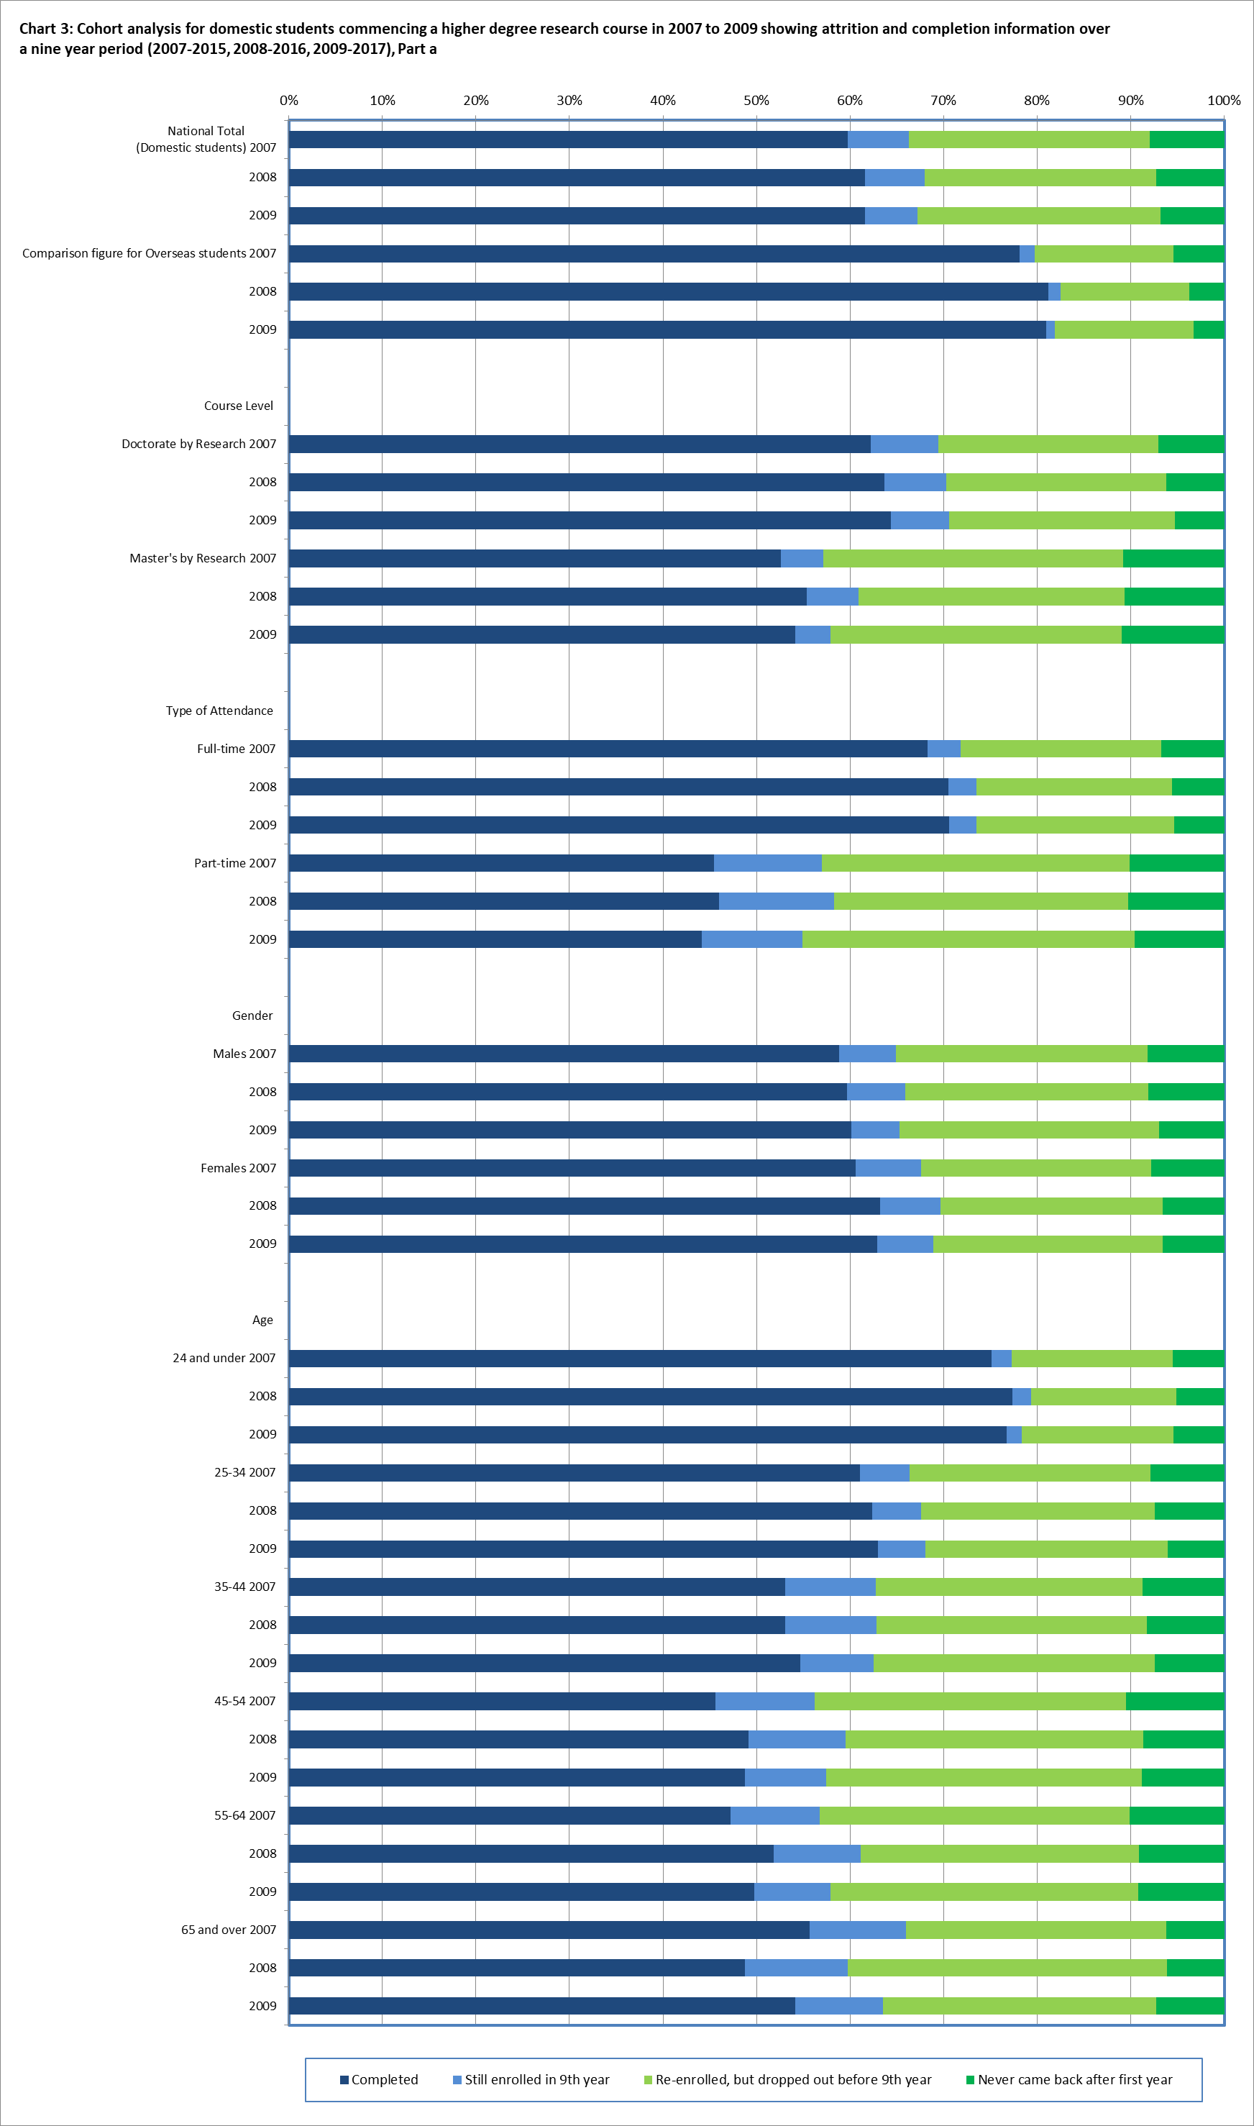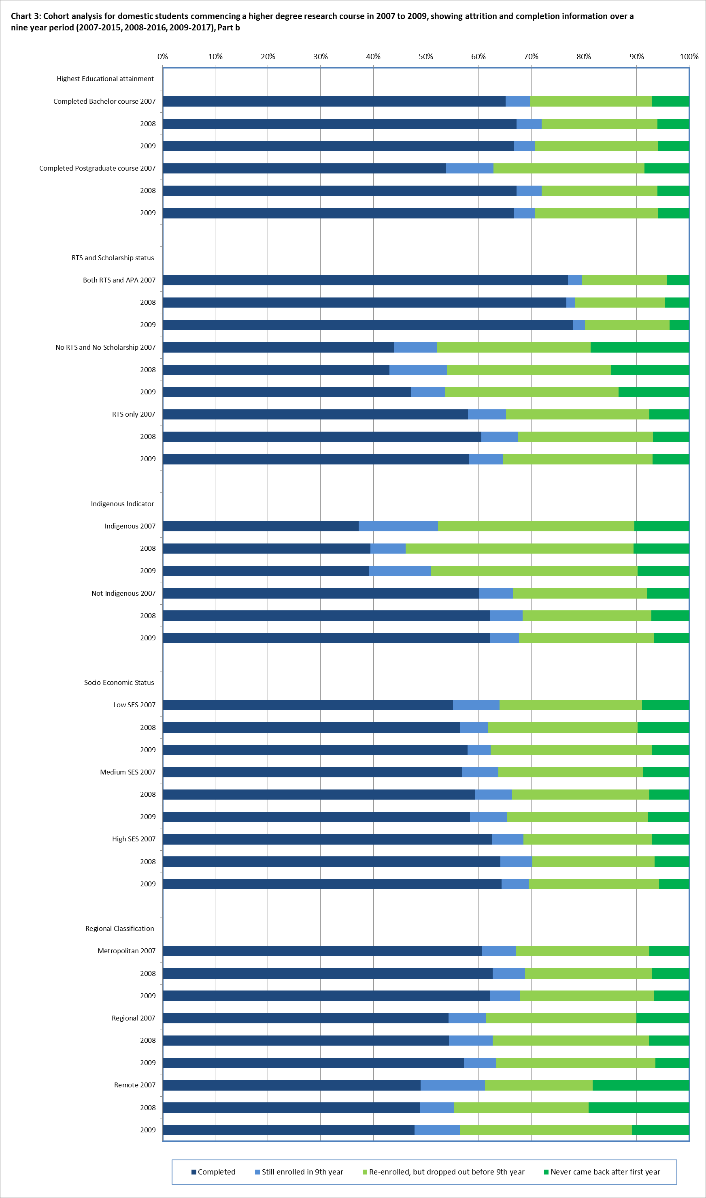

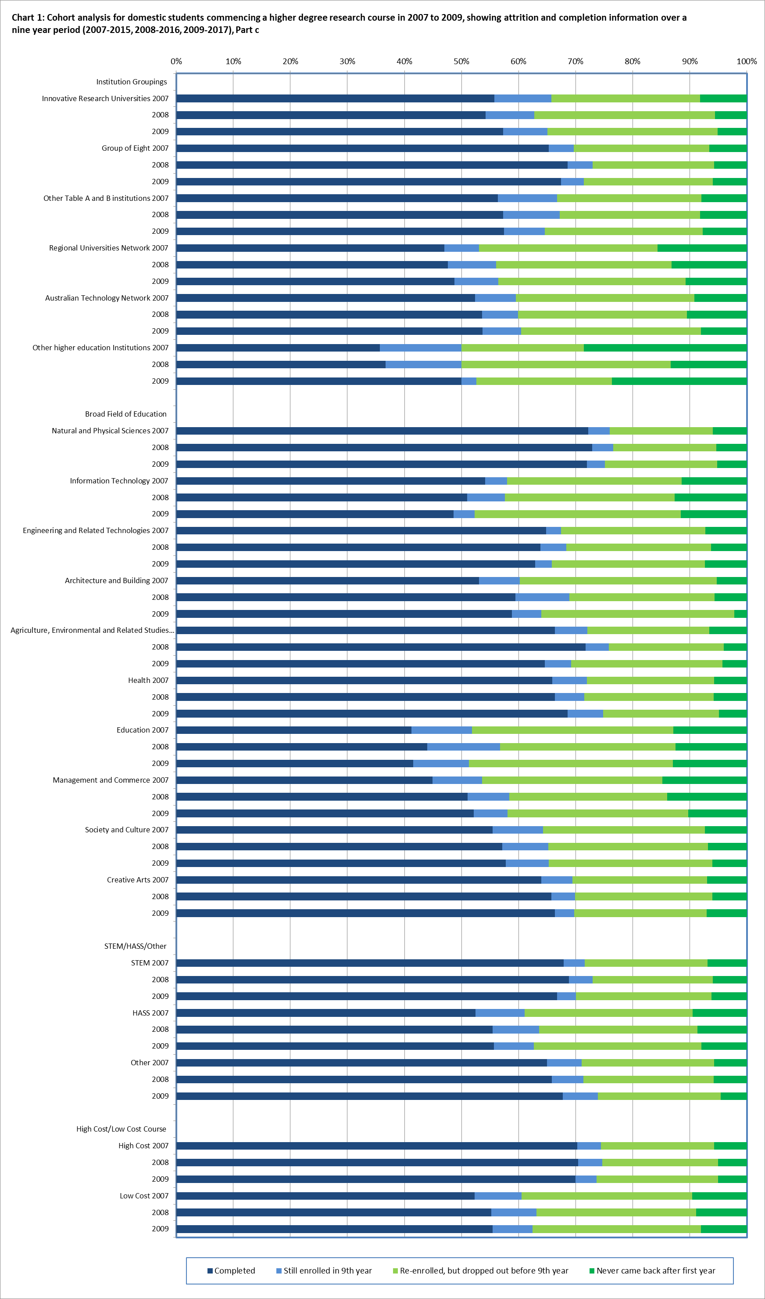

**Table 4: Four year completion rates for commencing Higher Degree Research (HDR) students by institution, 2007-2010, 2008-2011, 2009-2012, 2010-2013, 2011‑2014, 2012-2015, 2013-2016 and 2014-2017,%**

|  |  |  |  |  |  |  |  |  |  |
| --- | --- | --- | --- | --- | --- | --- | --- | --- | --- |
|  | | **2007** | **2008** | **2009** | **2010** | **2011** | **2012** | **2013** | **2014** |
| **Table A Institutions** |  |  |  |  |  |  |  |  |  |
| New South Wales | Charles Sturt University | 4.2 | 2.3 | 4.0 | 2.0 | 7.1 | 10.9 | 6.9 | 7.8 |
| Macquarie University | 15.7 | 11.3 | 10.8 | 9.5 | 12.3 | 14.0 | 11.3 | 72.4# |
| Southern Cross University | 8.1 | 1.5 | 10.1 | 6.9 | 11.7 | 14.1 | 20.3 | 13.6 |
| The University of New England | 12.9 | 27.0 | 19.7 | 7.8 | 11.1 | 15.5 | 17.5 | 19.4 |
| The University of Newcastle | 12.8 | 11.3 | 14.5 | 10.5 | 11.1 | 13.7 | 16.5 | 10.7 |
| The University of Sydney | 39.2 | 37.1 | 34.5 | 37.5 | 34.2 | 32.6 | 35.9 | 35.8 |
| University of New South Wales | 34.4 | 33.9 | 33.0 | 34.9 | 33.0 | 29.3 | 26.7 | 34.5 |
| University of Technology Sydney | 11.6 | 7.1 | 9.0 | 9.2 | 11.7 | 14.0 | 10.3 | 11.2 |
| University of Wollongong | 14.4 | 16.9 | 19.7 | 17.3 | 13.7 | 16.2 | 11.9 | 11.0 |
| Western Sydney University | 20.2 | 11.2 | 12.0 | 15.6 | 7.4 | 9.4 | 10.6 | 11.4 |
| Victoria | Deakin University | 18.6 | 17.9 | 12.8 | 14.3 | 21.7 | 22.3 | 17.2 | 13.9 |
| Federation University Australia | 5.1 | 11.1 | 11.1 | 7.1 | 10.0 | 7.8 | 11.3 | 9.5 |
| La Trobe University | 11.3 | 7.8 | 6.8 | 11.3 | 7.2 | 8.6 | 8.4 | 7.7 |
| Monash University | 18.5 | 18.7 | 16.4 | 18.6 | 23.0 | 20.0 | 17.4 | 19.4 |
| RMIT University | 10.2 | 12.0 | 11.2 | 12.9 | 12.8 | 16.3 | 14.5 | 11.7 |
| Swinburne University of Technology | 4.8 | 16.3 | 9.1 | 12.0 | 4.6 | 8.8 | 10.2 | 15.4 |
| The University of Melbourne | 17.7 | 21.4 | 16.2 | 18.1 | 15.8 | 17.0 | 16.9 | 13.4 |
| Victoria University | 11.0 | 12.4 | 5.9 | 9.9 | 9.1 | 9.8 | 7.8 | 11.9 |
| Queensland | Central Queensland University | 24.4 | 21.2 | 21.6 | 16.2 | 11.5 | 11.7 | 9.9 | 9.3 |
| Griffith University | 5.8 | 8.3 | 7.3 | 10.1 | 7.7 | 10.8 | 11.1 | 11.8 |
| James Cook University | 8.0 | 13.5 | 3.0 | 7.3 | 5.7 | 4.5 | 7.2 | 8.7 |
| Queensland University of Technology | 30.1 | 26.6 | 27 | 27.7 | 23.4 | 24.3 | 32.3 | 28.3 |
| The University of Queensland | 10.5 | 11.3 | 10.9 | 10.7 | 12.2 | 13.6 | 13.5 | 14.0 |
| University of Southern Queensland | 22.9 | 18.7 | 21.3 | 17.7 | 23.4 | 11.3 | 21.1 | 11.4 |
| University of the Sunshine Coast | 20.5 | 28.0 | 24.2 | 20.0 | 15.6 | 10.4 | 12.5 | 16.2 |
| Western Australia | Curtin University | 9.1 | 6.2 | 8.4 | 8.6 | 11.4 | 7.4 | 9.9 | 7.2 |
| Edith Cowan University | 20.8 | 13.4 | 12.1 | 21.0 | 17.1 | 28.3 | 14.5 | 24.6 |
| Murdoch University | 10.0 | 7.3 | 7.4 | 3.3 | 8.7 | 3.9 | 5.8 | 7.9 |
| The University of Western Australia | 13.6 | 12.7 | 14.3 | 13.0 | 11.3 | 15.9 | 16.8 | 16.6 |
| South Australia | Flinders University | 8.9 | 11.3 | 10.6 | 9.7 | 18.9 | 14.7 | 13.5 | 12.5 |
| The University of Adelaide | 15.9 | 20.8 | 18.4 | 25.7 | 22.8 | 23.3 | 22.6 | 29.6 |
| University of South Australia | 13.5 | 14.5 | 19.1 | 16.7 | 13.5 | 22.7 | 18.9 | 18.5 |
| Tasmania | University of Tasmania | 14.4 | 19.3 | 19.9 | 24.1 | 18.6 | 10.3 | 9.9 | 11.2 |
| Northern Territory | Batchelor Institute of Indigenous Tertiary Education | - | - | - | - | 16.7* | - | - | - |
| Charles Darwin University | 8.7 | 7.7 | 10.0 | 11.8 | 10.0 | 4.5 | 7.7 | 4.9 |
| Australian Capital Territory | The Australian National University | 10.8 | 9.9 | 9.2 | 8.6 | 9.3 | 11.6 | 8.5 | 9.1 |
| University of Canberra | 6.2 | 13.3 | 16.7 | 15.7 | 13.3 | 11.5 | 6.3 | 7.8 |
| Multi-State | Australian Catholic University | 11.3 | 5.9 | 2.8 | 8.4 | 3.2 | 9.3 | 7.2 | 16.1 |
| **Table B Institutions** |  |  |  |  |  |  |  |  |  |
| Victoria | University of Divinity | 20.0 | 15.8 | 36.8 | 43.8 | 47.4 | 18.5 | 11.1 | 3.8 |
| Queensland | Bond University | 31.7 | 15.4 | 5.9 | 18.9 | 5.0 | 18.5 | 27.3 | 13.3 |
| Western Australia | The University of Notre Dame Australia | 12.5* | - | 15.0 | 13.3 | 15.6 | 17.7 | 12.5 | 9.0 |
| **Non University Higher Education Providers (NUHEIs)** | |  |  |  |  |  |  |  |  |
| New South Wales | Australian Film, Television and Radio School | - | - | 81.8 | 44.4* | 14.3* | - | - | - |
| Avondale College of Higher Education | - | - | - | 25.0 | 18.2 | - | 10.0* | 6.3* |
| Moore Theological College | - | 50.0 | - | 25.0* | - | - | 50.0* | 66.7* |
| National Art School | - | - | - | - | - | - | 66.7* | 60.0 |
| Sydney College of Divinity | - | - | - | - | - | - | 14.3* | 25.0* |
| Victoria | MIECAT | - | - | 50.0* | - | 16.7* | - | - | - |
| South Australia | Adelaide College of Divinity | - | - | - | - | - | - | - | 25.0* |
| Australian Institute of Business | - | - | - | - | - | - | - | 50.0* |
| University College London | - | - | - | 100* | - | - | - | - |
| Multi-State | Australian College of Theology | 12.5* | 20.0* | 33.3* | - | - | 7.7 | - | 3.8 |
| **Total for Table A and B Institutions and NUHEIs** | | **18.4** | **18.4** | **17.3** | **18.8** | **17.7** | **17.9** | **17.5** | **20.3** |

#The high rate of completions for MRes courses in 2014 is a result of Macquarie University introducing its two year hybrid MRes program in 2013 and reporting its first MRes completions through this program in 2014.

*Calculation is based on less than 10 students.

**Table 5: Six year completion rates for commencing Higher Degree Research (HDR) students by institution, 2007-2012, 2008-2013, 2009-2014, 2010-2015 and 2011-2016, %**

|  |  |  |  |  |  |  |  |
| --- | --- | --- | --- | --- | --- | --- | --- |
|  | | **2007** | **2008** | **2009** | **2010** | **2011** | **2012** |
| **Table A Institutions** | | | | | | | |
| New South Wales | Charles Sturt University | 26.3 | 21.6 | 28.0 | 21.2 | 25.0 | 34.1 |
| Macquarie University | 44.3 | 44.8 | 45.0 | 46.3 | 53.2 | 53.0 |
| Southern Cross University | 18.9 | 15.4 | 20.2 | 25.0 | 31.7 | 28.2 |
| The University of New England | 31.8 | 43.5 | 35.2 | 25.0 | 34.2 | 43.6 |
| The University of Newcastle | 30.3 | 37.1 | 44.0 | 44.4 | 48.5 | 43.4 |
| The University of Sydney | 61.7 | 64.7 | 61.5 | 62.1 | 61.9 | 59.0 |
| University of New South Wales | 60.8 | 61.6 | 62.0 | 62.2 | 62.0 | 56.5 |
| University of Technology Sydney | 36.8 | 41.3 | 38.2 | 41.5 | 41.1 | 43.6 |
| University of Wollongong | 35.6 | 40.4 | 44.0 | 41.1 | 37.1 | 47.1 |
| Western Sydney University | 50.6 | 45.6 | 45.8 | 42.2 | 35.8 | 41.5 |
| Victoria | Deakin University | 42.8 | 55.6 | 46.2 | 41.4 | 48.2 | 50.9 |
| Federation University Australia | 25.6 | 35.6 | 37.0 | 25.7 | 30.0 | 21.6 |
| La Trobe University | 37.1 | 34.6 | 37.0 | 42.6 | 32.2 | 37.3 |
| Monash University | 46.6 | 50.2 | 47.2 | 50.6 | 57.8 | 54.3 |
| RMIT University | 34.3 | 43.0 | 43.4 | 45.5 | 40.5 | 52.8 |
| Swinburne University of Technology | 28.9 | 40.7 | 36.4 | 40.7 | 36.8 | 27.5 |
| The University of Melbourne | 49.7 | 51.6 | 49.1 | 49.8 | 52.9 | 52.5 |
| Victoria University | 30.8 | 21.9 | 25.9 | 30.6 | 31.4 | 38.2 |
| Queensland | Central Queensland University | 42.6 | 38.5 | 45.1 | 33.8 | 28.1 | 26.0 |
| Griffith University | 29.9 | 36.7 | 38.5 | 34.4 | 34.3 | 43.0 |
| James Cook University | 46.6 | 40.5 | 32.8 | 32.9 | 39.0 | 44.3 |
| Queensland University of Technology | 49.0 | 45.3 | 48.7 | 48.8 | 49.8 | 45.3 |
| The University of Queensland | 43.7 | 53.5 | 54.4 | 51.9 | 51.6 | 57.2 |
| University of Southern Queensland | 33.7 | 33.3 | 36.3 | 32.3 | 37.5 | 38.8 |
| University of the Sunshine Coast | 46.2 | 44.0 | 30.3 | 40.0 | 43.8 | 52.1 |
| Western Australia | Curtin University | 29.9 | 29.7 | 27.8 | 27.1 | 34.2 | 29.8 |
| Edith Cowan University | 37.6 | 37.8 | 39.0 | 41.3 | 42.3 | 47.1 |
| Murdoch University | 32.9 | 19.8 | 30.6 | 26.4 | 38.3 | 37.9 |
| The University of Western Australia | 42.0 | 45.5 | 50.3 | 43.7 | 46.9 | 51.6 |
| South Australia | Flinders University | 46.3 | 39.1 | 33.3 | 44.1 | 48.8 | 44.7 |
| The University of Adelaide | 50.5 | 51.3 | 51.8 | 56.0 | 54.3 | 53.7 |
| University of South Australia | 38.4 | 42.2 | 43.8 | 37.8 | 38.9 | 56.2 |
| Tasmania | University of Tasmania | 43.6 | 52.6 | 54.5 | 55.9 | 54.6 | 47.3 |
| Northern Territory | Batchelor Institute of Indigenous Tertiary Education | - | - | - | 25.0* | 16.7* | - |
| Charles Darwin University | 28.3 | 23.1 | 27.5 | 31.4 | 42.0 | 34.1 |
| Australian Capital Territory | The Australian National University | 45.9 | 48.2 | 43.2 | 46.5 | 39.0 | 45.3 |
| Australian Capital Territory | University of Canberra | 23.1 | 28.9 | 42.4 | 31.4 | 40.8 | 38.5 |
| Multi-State | Australian Catholic University | 33.8 | 23.5 | 23.6 | 26.2 | 26.6 | 26.3 |
| **Table B Institutions** | | | | | | | |
| Victoria | University of Divinity | 30.0 | 36.8 | 42.1 | 43.8 | 63.2 | 33.3 |
| Queensland | Bond University | 48.8 | 53.8 | 11.8 | 37.8 | 35.0 | 40.7 |
| Western Australia | The University of Notre Dame Australia | 50.0* | 57.1* | 25.0 | 26.7 | 28.1 | 35.5 |
| **Non University Higher Education Providers (NUHEIs)** | | | | | | | |
| New South Wales | Australian Film, Television and Radio School | - | - | 81.8 | 44.4* | 14.3* | - |
| Avondale College of Higher Education | - | - | 9.1 | 41.7 | 27.3 | - |
| Moore Theological College | - | 50.0 | - | 25.0* | - | - |
| Sydney College of Divinity | - | - | - | - | 20.0* | - |
| Victoria | MIECAT | - | - | 100* | - | 16.7* | - |
|  | Tabor Adelaide | - | - | 50.0* | 16.7* | - | - |
| University College London | - | - | - | 100* | - | - |
| Multi-State | Australian College of Theology | 37.5* | 40.0* | 50.0* | - | - | 15.4* |
| **Total for Table A and B Institutions and NUHEIs** | | **44.5** | **46.9** | **46.5** | **46.7** | **47.4** | **48.3** |

*Calculation is based on less than 10 students.

**Table 6: Nine year completion rates for commencing Higher Degree Research (HDR) students by institution, 2007-2015, 2008-2016 and 2009-2017, %**

|  |  |  |  |  |
| --- | --- | --- | --- | --- |
|  | | **2007** | **2008** | **2009** |
| **Table A Institutions** | | | | |
| New South Wales | Charles Sturt University | 57.9 | 38.6 | 53 |
| Macquarie University | 66.7 | 60.9 | 63.9 |
| Southern Cross University | 33.8 | 26.2 | 32.6 |
| The University of New England | 43.2 | 55.0 | 52.5 |
| The University of Newcastle | 56.4 | 57.0 | 58.5 |
| The University of Sydney | 70.9 | 73.8 | 71.8 |
| University of New South Wales | 68.1 | 70.3 | 69.0 |
| University of Technology Sydney | 56.1 | 54.9 | 53.8 |
| University of Wollongong | 53.3 | 61.2 | 62.2 |
| Western Sydney University | 69.7 | 64.8 | 71.1 |
| Victoria | Deakin University | 64.1 | 71.6 | 63.6 |
| Federation University Australia | 35.9 | 42.2 | 51.9 |
| La Trobe University | 58.7 | 50.3 | 54.8 |
| Monash University | 61.4 | 65.9 | 63.6 |
| RMIT University | 50.4 | 57.0 | 57.8 |
| Swinburne University of Technology | 43.4 | 59.3 | 51.9 |
| The University of Melbourne | 65.1 | 67.6 | 67.3 |
| Victoria University | 50.5 | 41.9 | 45.9 |
| Queensland | Central Queensland University | 55.1 | 51.9 | 60.8 |
| Griffith University | 46.1 | 56.7 | 58.9 |
| James Cook University | 64.8 | 58.1 | 58.2 |
| Queensland University of Technology | 57.7 | 56.5 | 58.2 |
| The University of Queensland | 64.8 | 69.8 | 70.0 |
| University of Southern Queensland | 43.4 | 45.3 | 53.8 |
| University of the Sunshine Coast | 66.7 | 52.0 | 45.5 |
| Western Australia | Curtin University | 42.9 | 47.1 | 42.6 |
| Edith Cowan University | 53.5 | 55.1 | 51.1 |
| Murdoch University | 50.7 | 35.4 | 51.2 |
| The University of Western Australia | 54.5 | 60.4 | 61.2 |
| South Australia | Flinders University | 59.3 | 60.9 | 56.9 |
| The University of Adelaide | 65.4 | 66.8 | 66.7 |
| University of South Australia | 54.1 | 52.4 | 56.2 |
| Tasmania | University of Tasmania | 58 | 68.4 | 68.6 |
| Northern Territory | Batchelor Institute of Indigenous Tertiary Education | - | 33.3* | 8.3 |
| Charles Darwin University | 54.3 | 43.6 | 32.5 |
| Australian Capital Territory | The Australian National University | 64.9 | 67.5 | 65.7 |
| University of Canberra | 52.3 | 40 | 56.1 |
| Multi-State | Australian Catholic University | 43.7 | 36.8 | 33.3 |
| **Table A and B Institutions** | | | | |
| Victoria | University of Divinity | 40.0 | 52.6 | 57.9 |
| Queensland | Bond University | 58.5 | 53.8 | 29.4 |
| Western Australia | The University of Notre Dame Australia | 75.0* | 71.4* | 35.0 |
| **Non University Higher Education Providers (NUHEIs)** | | | | |
| New South Wales | Australian Film, Television and Radio School | - | - | 81.8 |
| Avondale College of Higher Education | - | - | 18.2 |
| Moore Theological College | 50.0* | 57.1 | - |
| Sydney College of Divinity | - | - | 50.0* |
| Victoria | MIECAT | - | - | 100* |
|  | Tabor Adelaide | - | - | 50.0* |
| Multi-State | Australian College of Theology | 50.0* | 60.0* | 66.7* |
| **Total for Table A and B Institutions and NUHEIs** | | 59.7 | 61.6 | 61.6 |

*Calculation is based on less than 10 students.

1. The [Research Training Implementation Plan](https://docs.education.gov.au/documents/research-training-implementation-plan.) is available on the Department of Education’s website.
2. [Completion Rates and Cohort Analyses](https://www.education.gov.au/completion-rates-cohort-analyses) is available on the Department of Education’s website
3. The CHESSN was first implemented in the Higher Education Student Data Collection in 2005 under new policy initiatives introduced through the *Higher Education Support Act 2003* (HESA).
4. Students who completed an award course. The award course may not necessarily be the same course that the student initially enrolled in. For example, a student who commenced a Bachelor’s Pass degree in 2010 and by 2017, their award course completion could be for a Bachelor’s Honours degree. Similarly for field of education, a student may have commenced a Science degree but completed an Arts degree. Likewise, a student may have commenced study at one institution, but completed their study at a different institution.
5. The [Australian Qualifications Framework](https://www.aqf.edu.au/) is available online
6. [Higher Education Statistics](https://www.education.gov.au/higher-education-statistics) is available on the Department’s website